Massachusetts Universal Newborn Hearing Program 2016 Data
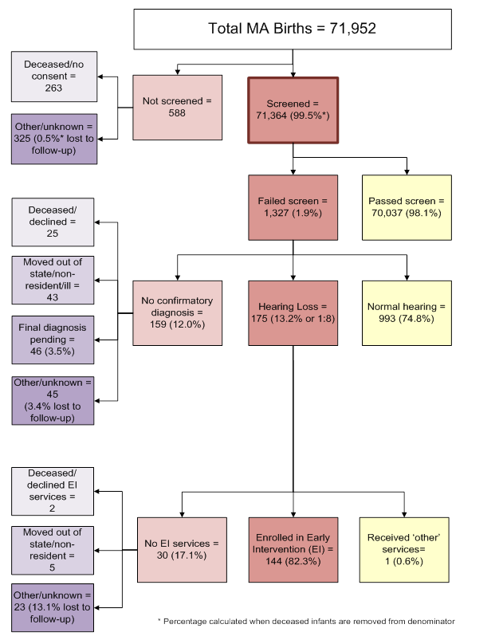

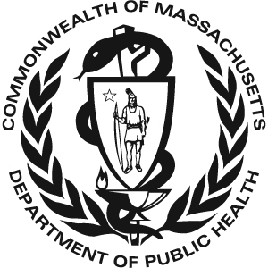 Massachusetts Universal Newborn Hearing 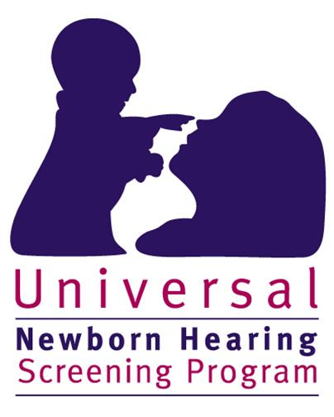
Screening Program
2016 Data

There were 71,952 total births in Massachusetts in 2016. 71,364 (99.5%*) of these infants received a hearing screen. 588 infants were not screened. Of the 588 infants that did not receive a screen:
• 263 died before a screen was performed or their parents/guardians did not provide consent to perform the screen
• 325 (0.5%*) had unknown screening status or did not receive a screen for unknown reasons (lost to screening follow-up)

Of the 71,364 infants that were screened:
• 70,037 (98.1%) passed the screen
• 1,327 (1.9%) failed the screen

Of the 1,327 infants that failed the hearing screen:
• 993 (74.8%) were diagnosed with normal hearing
• 175 (13.2%) were diagnosed with hearing loss
• 159 (12.0%) did not have a final confirmatory diagnosis when this data was reported. Of these infants without a final confirmatory diagnosis:
➢ 25 were deceased or their parents/guardians declined follow-up diagnostic services
➢ 43 moved out of state, did not reside in Massachusetts, or were gravely ill
➢ 46 received diagnostic testing but were pending a final diagnosis
➢ 45 (3.4% of the 1,327 infants that failed the screen) were lost to diagnostic follow-up

Of the 175 infants with hearing loss:
• 144 (82.3%) were enrolled in Early Intervention (EI)
• 1 (0.6%) received ‘other’ services such as monitoring services or non-Part C EI
• The remaining 30 infants (17.1%) were not documented to be receiving EI services for the following reasons:
➢ 2 were deceased or declined EI services
➢ 5 moved out of state or did not reside in Massachusetts
➢ 23 were not receiving EI services for other or unknown reasons (13.1% lost to EI follow-up)

* % screened is calculated when deceased children without a screen are not included in the denominator

