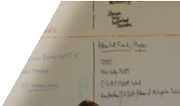Fiscal Year 2016 Annual Report

Massachusetts
State Rehabilitation Council

General Information about the State Rehabilitation Council
The Massachusetts Rehabilitation Advisory Council was created in March 1994 by the Executive Order of the Governor to implement the requirements of the Federal Rehabilitation Act of 1973 as amended by P.L. 102-569 in 1992.
The WORK FORCE INVESTMENT Act, Title IV of 1998 reauthorized the Rehabilitation Act and changed the State Rehabilitation Advisory Council to the state Rehabilitation Council, section 105.
The major purpose of the council are as set out in the Rehabilitation Act, Section 105, which include among others the following:
Review, analyze and advise MRC regarding the agency’s priorities, performance of responsibilities of the Rehabilitation Act Title 1, Title 6c and title 7;
- To encourage the personal and Vocational growth and development of the Commonwealth’s Citizens with Disabilities;
- To affirmatively promote barrier-free access for citizens with disabilities;
- To ensure the full participation of citizens with disabilities in their communities and work place.
Membership in the council is open to commonwealth citizens whose personal, public and private community activities have demonstrated their outstanding dedication to the integrity and maintenance of the Public Vocational Rehabilitation Program and Independent Living Services for people with disabilities.
The Governor shall appoint 20 statutory members of the council. Nominations for council membership are submitted to the Director of Consumer Involvement Program at Massachusetts Rehabilitation Commission.
The General Council meets a minimum of four times a year for the transaction of any business that may be brought before the council. The council also holds an annual meeting in September to December to elect its officers and set the annual agenda and/ or goals.
The Council encourages public participation in its general council meetings and has established 15 positions as ex-officio memberships. The ex-officio members serve to contribute in the business of the council but shall not exercise the options to vote on council decisions. Each ex-officio member is nominated annually and must represent a disability related advocacy group.

Table of Contents
1
Letter from Chairperson 2
MA State Rehabilitation Council Organizational Chart 3
Massachusetts Rehabilitation Commission Accomplishments 4
Fiscal Year 2016 Council Leadership 7
MA State Rehabilitation Council Members 8
Council Committees 9
Committee Accomplishments 10
Recommendations to the MA Rehabilitation Commission 11
Join the MRC State Rehabilitation Council 13

Letter from Chairperson
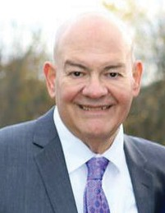
I am pleased to represent the Massachusetts State Rehabilitation Council (SRC) regarding the submission of the Annual Report for 2016.
The SRC includes a diverse group of volunteers dedicated to the improvement of the lives of citizens with disabilities in the Commonwealth of Massachusetts. As an advisory group to the
MRC, SRC members come from a wide background, each having pertinent skills obtained in both the public and private sector. This Annual Report provides an accurate snapshot of the valuable work being done by the Council.
The SRC serves as a partner to the Massachusetts Rehabilitation Commission in an advisory capacity, working closely with the Commissioner and MRC staff to promote the organizations mission: service to the disabled community to obtain and maintain meaningful employment and independence.
Each year, the SRC holds four quarterly meetings, spread throughout the Commonwealth. Included is the Boston area, and the southern central, and western regions. The SRC Executive Committee meets prior to the meetings to establish
the agenda. During the quarterly meetings, numerous issues and deliberations are discussed, with the goal of ensuring that the disabled population receives the
necessary services to maximize employment possibilities and thus lead to a lifestyle of independent living. New issues for discussion and recommendations are brought to the forefront which include the effect of WIOA on the MRC’s functioning, and the penetration of new industries with training for the disabled, such as the dynamic Biotech industry.
My sincere thanks go out to the members of the SRC for their dedication and time expended to achieve our goals. As SRC Chair, it has been most gratifying to work with the members of the committee, as they use their valuable abilities to advise the MRC on a regular basis.
Sincerely,

Alan Greene
Chairperson, SRC

2

MA State Rehabilitation Council Organizational Chart
Massachusetts Rehabilitation Commission
MA State Rehabilitation Council

Executive Committee

State Plan & Inter-agency Relations
Comprehensive Needs Assessment

Bylaws, Nomination, Policy and Regulations
Consumer Satisfaction Survey

Unserved and Underserved Populations
Business and Employment Opportunity

3
Artists Beyond Challenges

Legend:

Statewide Committee
Recommendations based on advisement
Statewide Sub-committee

Massachusetts Rehabilitation Commission Accomplishments
In fiscal year 2016, the MRC divisions and programs were able to produce the following results for serving citizens of the commonwealth with disabilities.

Community Living Division:
The Community Living Division is comprised of a variety of programs, supports, and services that address the diverse needs of adults and transition age youth with disabilities to fulfill their desire/need for community integration, to gain maximum control of their destiny, and to participate fully in their community. These programs include Consumer Involvement, Independent Living & Assistive Technology, Home Care Assistance, Home and Community-based Waiver Management, Protective Services, the Statewide Head Injury Program, Nursing Home Initiative, and Transition for Youth with Disabilities.

Total consumers actively receiving services: | 12,267
Total funds expended: | $49,640,740
Cost per consumer served: | $4,047

Number of Consumers Receiving Services

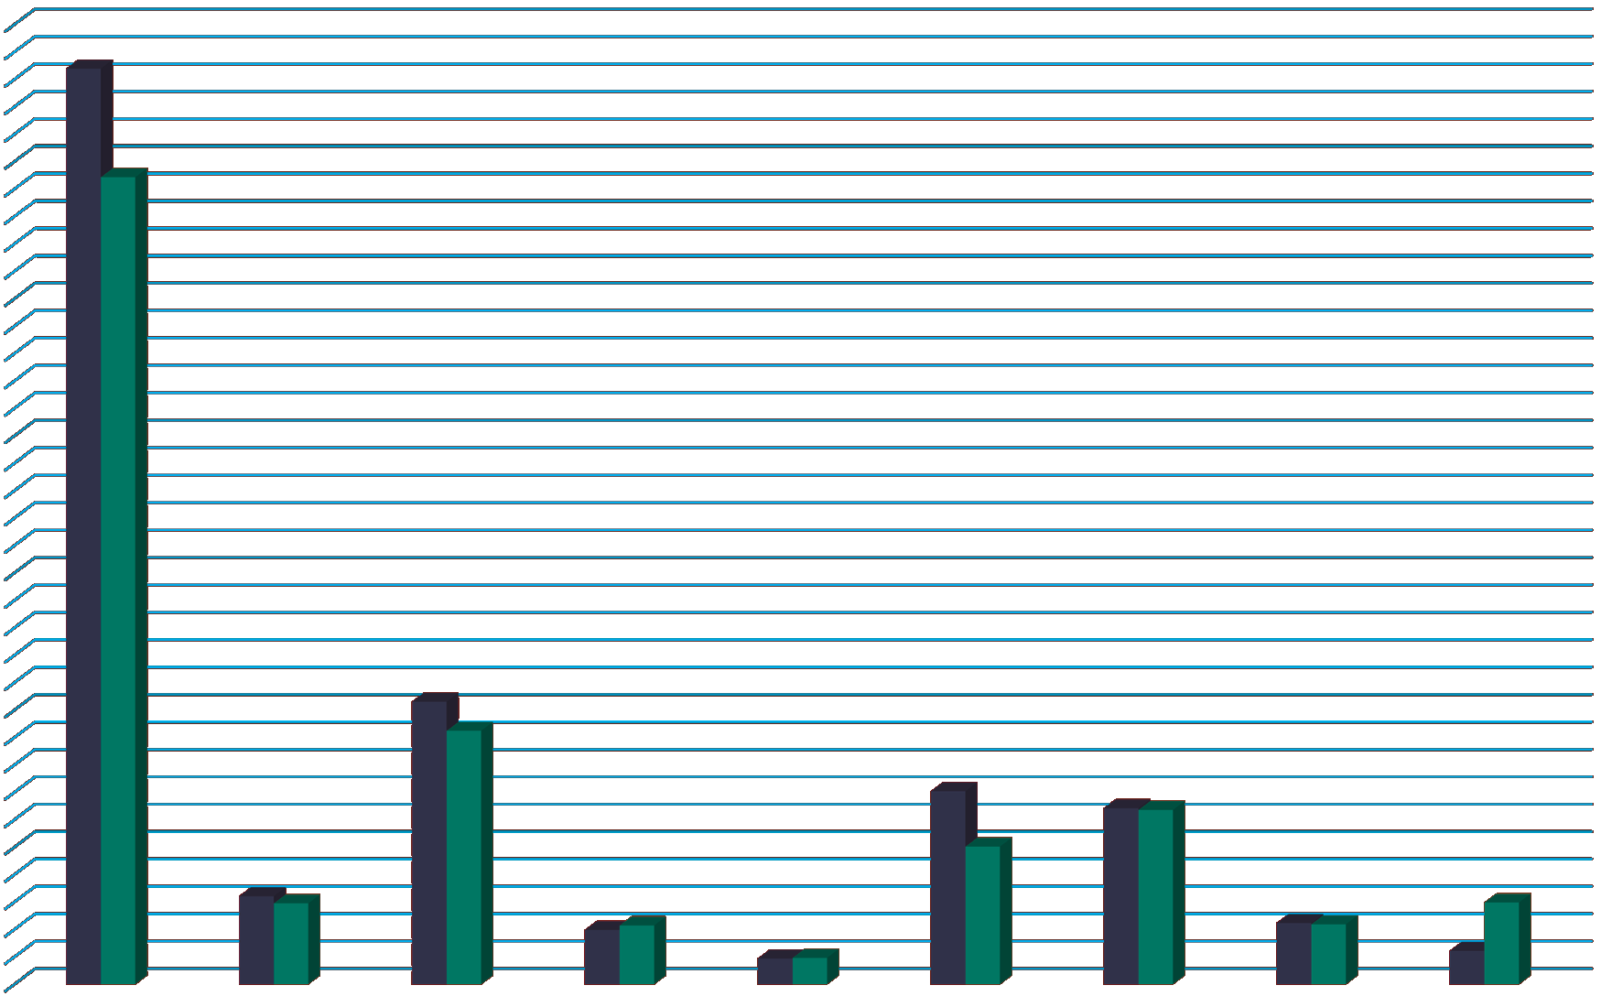7,000
6,679
5,887
2,062
1,850
1,409
1,285 1,273
1,006
643 591
597
397 430 448 439
189
194
244

6,000

5,000

4,000
Axis Title

3,000

2,000

1,000

0
Independent | Turning 22 | Assistive | Housing | Supportive | Brain Injury | Home Care | Protective | Community
Living Centers | Services | Technology | Registry | Living Services  Axis Title | Services | Services | Services | Living Waivers

FY 15
4
FY 16

Disability Determination Services:
The Disability Determination Services (DDS) Division is funded by the Social Security Administration (SSA) and determines the initial and reconsideration applications (first level of appeal after a denial), and continued eligibility for federal Supplemental Security Income (SSI) and Social Security Disability Insurance (SSDI) benefits. Special outreach efforts are made to homeless clients, individuals with HIV/AIDS, and veterans injured during military service.

Total Budget: | $50,350,907
Cost Per Case: | $549.34
Total Disposition of SSI/DI Cases: | 91,657
Accuracy of Initial Decisions: | 98.6%
Federal Accuracy of Decision Standard: | 90.6%

Vocational Rehabilitation Division:
The Vocational Rehabilitation Program assists individuals with physical, psychiatric and/or learning disabilities in facing the challenges of the modern workplace. This may include identifying job goals based on individual interests and aptitudes, providing funds for college and vocational training, assessing work site accommodations, educating an employer about the Americans with Disabilities Act (ADA), or assisting an individual returning to work. Vocational rehabilitation services can often reduce or remove barriers to employment. Priority is given
to those individuals who have the most significant disabilities in areas such as communication, learning disabilities, mobility, work tolerance and work skills.

Consumers actively receiving services | 25,125
Consumers enrolled in training/education programs | 16,513
Consumers with disabilities competitively employed | 100%/3,816
Consumers employed with medical insurance | 95.9%
Consumers satisfied with services | 84.0%
Average Age of Consumer | 33
Average Hourly Wage | $13.18
Average Work Hours Weekly | 26.8  5

Consumer Disabilities
Other, 7.40% Traumatic Brain Injury, 1.40%
Neurological Disabilities, 2.40%

Deaf and Hard of Hearing, 6%
Developmental Disabilities, 1.80%

Psychiatric Disabilities, 40%

Learning Disabilities, 22.20%

Orthopedic Disabilities, 10.20%

Substance Abuse, 8.70%

90.00%

80.00%

70.00%

60.00%

50.00%

40.00%

30.00%
Race/Ethnicity of VR Consumers

84.00%
79.70%
17.60%
11.80%
3.40% 3.80%
5.40%
6.80%
1.00% 0.20%

20.00%
6

10.00%

  - %

Asian/Pacific Islander

Black Hispanic Native American White MRC Consumers % of MA Population

Fiscal Year 2016 Council Leadership
Chairperson: Alan Greene
Alan is a retired Human Resources professional with over 20 years’ experience in the HR field. He is currently working as an Independent Educator/Substitute Teacher at the secondary level for the towns of Canton, Sharon, and Easton. Alan holds a B.A. from the University of Massachusetts Boston and an MS from Xavier University in Cincinnati, Ohio.

Vice Chairperson: Dawn Clark, D. Min
Dawn has served many years in a variety of community and pastoral positions. She currently works for the City of Worcester as the Disability Intake Coordinator and lives with the life long experience of having a disability. Dawn holds a B.A. from Ricker College, Houlton, Maine, a Master of Divinity from Boston University School of Theology, Boston, Massachusetts, and a Doctorate of Ministry from Bangor Theological Seminary, Bangor, Maine.

Secretary: Dr. Lusa Lo
Dr. Lo is an Associate Professor at the University of Massachusetts, Boston, Massachusetts. Dr. Lo holds a B.A. in Liberal Arts, an M.A. in special Education from Holy Name University, Oakland, California and an Ed. D in Learning and Instruction from the University of San Francisco, California.

Member at Large: Lisa Chiango
Lisa has a long employment history in the media and communication fields. Ms. Chiango holds a technical degree from Rochester Institute of Technology, Rochester, New York, a B.A. in Computer Science from Gallaudet University, Washington, D.C. and an M.A. in visual Media Arts-Video Production from Emerson College, Boston, MA.
Member at Large: Naomi Goldberg
Naomi is the Assistant Director, Client Services, Massachusetts Office on Disability and is the Director of the federally-mandated and funded Client Assistance Program (CAP) in Massachusetts. CAP specifically addresses information and advocacy concerns for clients and applicants of the Commonwealths Vocational Rehabilitation (VR) and Independent Living Programs (IL) Services.

7

MA State Rehabilitation Council Members
8

Governor Appointed Members:
Paula Peters - Disabilities Representative
Lisa Chiango - Disabilities Representative
Rosanna Woodmansee - Business/Labor/Industries Representatives
Naomi Goldberg - Client Assistance Program Representative
Dawn Clark - Disabilities Representative
Bonnie Jones - Statewide Independent Living Center Representative
Dr. Lusa Lo - Higher Edcuation Representative
Matthew Bander - Disabilities Representative
Stephen Aalto - Community Rehabilitation Services Provider Representative
Heather Watkins - Disabilities Representative
Roxanne Hoke-Chandler - Parent Training/Information Center Representative
Alan Greene - Business/Labor/Industries Representative

Ex-Officio Members:
Anne Marie Paulson Hang Lee
Kevin Goodwin Faith Behum Amy Partelow Joseph Panciotti
Christiana Erekosima Rita Sagalyn
Ruth Unger Kristin Britton Joe Bellil

Council Committees
9

Comprehensive Statewide Needs Assessment Committee
Chairperson: Richard Colantonio
Mission: The Comprehensive Statewide Needs Assessment Committee works in collaboration with the MRC to conduct and Annual Comprehensive Statewide Needs Assessment (CSNA). The MRC conducts the assessment on an annual basis with the information and findings incorporated into MRC’s State Plan, strategic planning, and quality assurance activities. The CSNA provides the agency with detailed information regarding the needs of the consumers served by MRC and to fulfill the federal requirements that the agency conducts a needs assessment at least every three years.

Consumer Satisfaction Committee
Chairperson: Currently Vacant
Mission: The mission of the Consumer Satisfaction Committee (CSC) is to ensure consumer perspectives are included in the process of evaluating MRC consumer satisfaction and to serve in an advisory capacity to improve services provided to consumers. On an annual basis, the MRC surveys all consumers with closed cases on their satisfaction of MRC’s services.

Business and Employment Opportunity Committee
Chairperson: Alan Greene
Mission: The SRC Employment and Business Development Committee is responsible for providing advice and guidance to the MRC on methods and best practices for employment and employment services.

Joint Committee: Bylaws, Nomination, Policy and Regulation Committee
Chairperson: Naomi Goldberg and Heather Watkins
Mission: The SRC Joint Committee of the By-Law and Nominations mission is to work toward determining and selecting interested persons eligible for membership in the State Rehabilitation Council in accordance to the SRC By-Laws. Further
this committee meets with the MRC Consumer Involvement Director to develop a roster of interested persons who would be appropriate for future SCR needs.

Joint Committee State Plan & Interagency Relations Committee
Chairperson: Joe Bellil
Mission: The mission of this Committee is to assure the State Rehabilitation Council (SRC) meets its obligations regarding input from consumers in the development of both the Massachusetts Rehabilitation Commission (MRC) Public Vocational Rehabilitation State Plan and the Unified Workforce State Plan. The committee also advises and assist in the development of the agency’s policies and regulations, including, but not limited to, scheduling procedures for public input and publications in the Massachusetts Register by the Office of the Secretary of the Commonwealth.

Unserved/Underserved Population Committee
Chairperson: Dawn Clark
Mission: The mission of the Unserved/Underserved Population Committee is to identify unserved or underserved populations within the Massachusetts
Rehabilitation Commission Vocational Rehabilitation Program and advise the agency on programs and services that may help meet the needs of these populations.

Committee Accomplishments:
    - The executive committee reviewed the work being completed by all of the committees and were able to condense topics into fewer committees. The committees are now able to have higher attendance at meetings and are able to run committees more efficiently that are on similar topics.
    - The Consumer Satisfaction Committee and the Statewide Comprehensive Needs Committee have both completed assessments that have given the SRC areas of needed improvement on service delivery. Once the reports are finalized, the results will be posted on the MRC web page.
    - A new committee has been formed, the Business and Employment Opportunity committee, to provide advice and guidance to the MRC on methods and best practices for employment and employment services.
    - The State Plan and Interagency relations committee created an avenue for submitting recommendations to the MRC through the use of the annual report. This plan allows for timely recommendations to the MRC when the issues are present.
10

Recommendations to the MA Rehabilitation Commission
The Commonwealth of MA recently passed an ‘employment bill’ that requires the Supplier Diversity Office to consult with the MA Office on Disability to establish goals for participation of individuals with disabilities in all areas of state
procurement contracting. The MA State Rehabilitation Council (SRC) recommends that the MA Rehabilitation Commission take a proactive approach to this bill and work with contractors to employee consumers of the vocational rehabilitation program with state contractors, as well as, utilizing contractors who meet or exceed the goals put forth by the MA Office on Disability and the Supplier Diversity Office. Bill text can be found at: https://malegislature.gov/Bills/189/House/H4534
The Annual Statewide Needs Assessment produced the following recommendations based on the information received back from vocational rehabilitation consumers:
  - Focus on improving communication between consumers and counselors by creating a work group of counselors and consumers to develop strategies to reduce the number of unsuccessful closures resulting as lack of contact, and to work on how to better communicate with consumers when there is staff turnover amongst counselors.
  - Additional focus should be made to connect and refer the underserved populations of MA, with specific efforts put towards Asian communities.
  - Increase consumer awareness of transportation options and explore other options for consumer transportation. This includes looking at innovative approaches to using ride share programs such as Uber and Lyft for transportation of consumers. We also recommend MRC develop partnerships with the State and Federal Departments of Transportation. The council also feels that this partnership with the ride share programs could additionally provide employment options for consumers who are looking to find employment with flexible time requirements.
A marketing strategy should be produced to update all information to external audiences on a timelier basis. This would include, but not limited to, the MRC external website, brochures, etc. The following are sections that also need to be addressed in the marketing strategy.
  - A list of programs and services should be available for external audiences to make current/potential consumers aware of what is available to them as a discussion topic with their counselors. This document would also include an internal guide for counselors to know who to contact for these programs and services.

11

    - Public input sessions and consumer committee meetings have not been well attended over the past fiscal year. MRC and the partnering committees,
should devise a strategy to increase attendance at sponsored events to ensure sufficient public input is received.
MRC should create a partnership with other New England states’ State Rehabilitation Councils to gather new ideas surrounding the vocational rehabilitation programs and share best practices for the council and employment opportunities that could be used by other states. This recommendation also includes the MRC providing support for the MA SRC becoming a participating member in the National Coalition of State Rehabilitation Councils.
The MRC and the MA Human Resources Division should create a direct flow of communication that notifies all vocational rehabilitation staff of new openings throughout the Commonwealths’ public agencies once posted. This would provide counselors with up to date information regarding possible employment opportunities and allow the Commonwealth of MA to be a model employer for
hiring people with disabilities in the private and public sectors throughout the state.
All MRC Vocational Rehabilitation Consumers should be offered benefits counseling during their intake process to ensure that all consumers are aware of the effect employment/earning income will have on any public benefits that they may be receiving.

MRC Response to the Recommendations:
The leadership team at MRC has received the recommendations in late October of 2016. The MRC Consumer Involvement Program will be working with the
leadership team to review what recommendations have been implemented over the next six months. An amendment to this report will be published no later than May 2017, with the finding of those results.

12

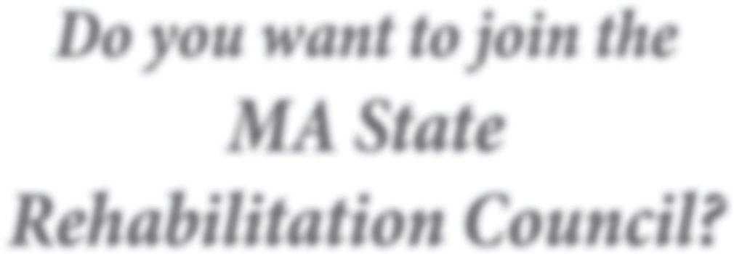
Do you want to join the MA State Rehabilitation Council?

Contact us to join the general council or a committees?

Committee descriptions can be found on page 9-10

Email:
consumer.involvement@mrc.state.ma.us Call:
617-204-3665

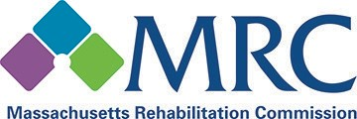

Mission:

The MRC promotes equality, empowerment, and independence of individuals with disabilities. These goals are achieved through enhancing and encouraging personal choice and the right to succeed or fail in the pursuit of independence and employment in the community.

Vision:

The MRC provides comprehensive services to people with disabilities that maximize their quality of life and economic self-sufficiency in the community.

Charles D. Baker
Governor
Adelaide “Nicky” Osborne
Commissioner
Kasper Goshgarian
Deputy Commissioner
Joan Phillips Assistant Commissioner, Vocational Rehabilitation
Josh Mendelsohn Assistant Commissioner, Community Living
Pat Roda Assistant Commissioner, Disability Determination

600 Washington St | Boston | MA | 02111-1704 (800) 245-6543 | (617) 204 - 3600

www.mass.gov/mrc

