2017

Environmental Toxicology Program
Bureau of Environmental Health
Massachusetts Department of Public Health
250 Washington Street
Boston, MA 02108
Email: dph-beach@state.ma.us
Phone: (617) 624-5757

Massachusetts Beach Testing
Results: Annual Report
Plum Island Beach, Newbury, MA

Executive Summary
Swimming at Massachusetts beaches is one of the most popular recreational activities in the state, with over 111 million individual trips to one of the 1,100 beaches each year (EOEEA, 2007; EOHED, 2016). Essential for a safe and enjoyable beach visit is good water quality. Therefore, it is critical to both monitor beach water quality and immediately notify the public of any potential water quality concerns. Each year, the Environmental Toxicology Program at the Massachusetts Department of Public Health (DPH), Bureau of Environmental Health collects water quality data from local health departments as well as the Massachusetts Department of Conservation and Recreation. This report provides a description of that information and is summarized below.
- Water quality: In 2017, a total of 15,519 water samples were collected from 583 marine and 595 freshwater beach sampling locations. These locations represent 526 marine and 553 freshwater beaches with 100% of marine and freshwater beach communities reporting water quality information to DPH. Approximately 4.1% and 3.8% of samples exceeded the Massachusetts water quality standards (based on bacteria) for marine and freshwater beaches, respectively. The overall low exceedance rates indicate that Massachusetts beaches have generally high water quality. Elevated bacteria accounted for 63% of poor water quality notifications (i.e., beach postings days); other reasons for notifications included cyanobacterial harmful algae blooms, rainfall (typically associated with elevated bacteria), and other hazards (e.g., sewage spills, water clarity/visibility issues).

- Field data: In 2017, a majority of water samples (approximately 97%) submitted to DPH had accompanying field data. Rainfall and pollution sources at sampling sites were identified as two important factors that contributed to elevated bacteria levels at recreational waterbodies. As seen in previous years, the number of exceedances dropped exponentially as the days since rainfall increased. Pollution sources, particularly the presence of larger number of birds, were associated with higher levels of bacteria.

- Public notification: The DPH marine beaches website (http://ma.healthinspections.us/public_21/) provides near real-time information on bacteria levels at public marine beaches, as well as information on historical bacteria levels. DPH is also able to gauge usage of its beaches website by recording the number of unique visitors. In 2017, the number of website users increased over two-fold during the summer months compared to 2016. Individuals were also notified of unsafe conditions at beaches through the use of physical signage that is required to be posted by beach operators. As part of the public notification requirement, 99% marine and 88% of freshwater beaches were in compliance.

Introduction
Water quality-associated health risks to swimmers have been documented in numerous studies (Marion et al., 2010; Wade et al., 2003). Beachgoers may be exposed to pathogens through recreational activities in and around polluted waterbodies (Hlavsa et al., 2015). In the United States, most swimming-associated diseases are caused by a variety of pathogens associated with fecal contamination (Cabelli et al., 1982; USEPA, 2012). Human fecal matter can enter beach water in a variety of ways, including sewage treatment system failures, combined sewer overflows, discharge of sewage by boats, re-suspension of sediments, and rainfall and resulting surface runoff (Galfi et al., 2016; Rodrigues et al., 2016).

To address concerns over swimming-associated illness, improve public health for beachgoers, and notify the public about the quality of beach water, DPH regulations have required regular water quality monitoring and public notification of unsafe conditions since 2001. All public and semi-public bathing beaches in Massachusetts are monitored for fecal indicator bacteria (FIB), and on occasion, harmful algae. Monitoring occurs during the beach season which generally begins when the school year finishes in mid-June and ends during the weekend of Labor Day.

DPH adopted the USEPA criteria for enterococci and E. coli in marine and freshwater in 2001. These criteria consist of both a single sample and geometric mean (geomean) value reported as colony forming units per 100 milliliter of water (CFU/100mL) (see Table 1). When beach water does not meet these water quality standards, DPH requires that the beach be posted with a notice alerting the public to the possible risk of swimming. At a majority of beaches in Massachusetts, water quality is considered to be unacceptable when two samples collected on consecutive days exceed the water quality standards. Beaches with a history of multi-day elevated bacteria levels are required to post after a single exceedance. Posting is also required when the geomean of the five most recent non-rainfall impacted samples exceeds the geomean standard.

Beach Type | Indicator | Single Sample | Geomean
Marine | Enterococci | >104 | >35
Freshwater | Enterococci | >61 | >33
 | E. coli | >235 | >126
Table 1. DPH recreational water quality criteria (CFU/100 mL)

In addition to water samples, field data such as days since rainfall and potential pollution sources are required to be collected at the time of sample collection. Field data help facilitate the interpretation of bacteria data and can improve the understanding of water quality at the local and state level.

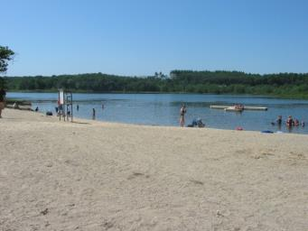
Chilson Beach, Franklin, MA

Water Quality
Marine beach exceedances. During the 2017 beach season, a total of 7,814 samples were collected and analyzed from 583 marine sampling locations. Of these 583 locations, 169 (29%) in the 60 communities with marine beaches had at least one bacterial exceedance (see Figure 1). A total of 320 out of the 7,814 samples exceeded the 104 CFU/100 mL standard bringing the percentage of exceedance for marine waters to 4.1%, which is lower than the historical average exceedance rate of 4.8%. The number of marine beach exceedances in each community is shown in Figure 1. The marine beaches in Boston, Lynn, and Quincy had the highest number of exceedances.
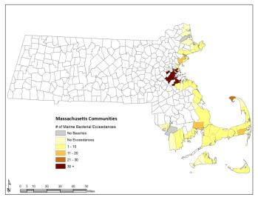Figure 1. Marine beach water quality exceedances in 2017
Freshwater beach exceedances. During the 2017 beach season, 7,705 samples from 595 freshwater sampling locations were collected and analyzed for the approved FIB (i.e. E. coli or enterococci). Most freshwater beaches (91%) used E. coli. Among the 595 freshwater locations, 133 (22%) in the 182 communities reporting beach data had at least one bacterial exceedance (Figure 2). A total of 291 out of 7,705 samples exceeded the standard bringing the percentage of freshwater exceedance to 3.8%, which is lower than the historical average exceedance rate of 3.9%. The number of freshwater beach exceedances in each community is shown in
Figure 2. Freshwater exceedances varied among communities with the highest number occurring in Ashby, Sturbridge, and Templeton.

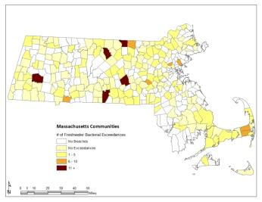
Figure 2. Freshwater beach water quality exceedances in 2017

Posting beaches. During the 2017 beach season, poor water quality and/or unsafe conditions required the postings of beaches on 330 occasions, advising individuals not to swim or bathe in the water. Figure 3 displays the causes of postings with the majority of postings due to the exceedance or expected exceedance (i.e., rainfall) of water quality standards. For marine beaches, there were 187 postings due to elevated bacteria, rainfall, or other reasons (e.g., sewage spills, missed sample). For freshwater beaches, there were 143 postings due to elevated bacteria, cyanobacterial harmful algae blooms, sewage spills, or poor water clarity.

Figure 3. Posting details for marine and freshwater beaches in 2017
Field Data
Potential pollution sources. Starting in 2017, beach operators were asked to report the number of swimmers, birds, and dogs present in the water when the sample was collected. Information on these potential sources of bacteria was not consistently reported in the past, and if it was, it was typically reported as either present or absent. Figure 4 shows the mean bacteria levels of samples at marine and freshwater beach locations compared to the number of reported bathers, birds, and dogs present. This preliminary data set indicates that an increase in bird populations during sampling is associated with an increase in bacteria levels, while the impact of dogs and humans is less consistent. Note that results for enterococci at freshwater beaches were not evaluated due to the low number of samples.

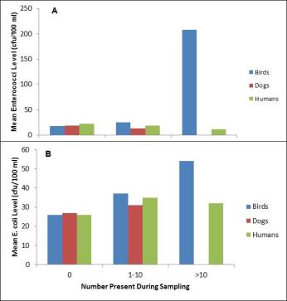
Figure 4. Mean bacteria levels and numbers of birds, dogs, and humans at (A) marine and (B) freshwater beaches

Rainfall. Rainfall is recognized as one of the major drivers of bacterial exceedances in beach water (Harder-Lauridsen et al., 2013). An exponential drop in the number of exceedances occurs as the time between rainfall and sample collection increases (Figure 5). For marine beaches, 216 of 320 bacterial exceedances occurred within 24 hours after a rain event; at freshwater beaches, 124 of 291 exceedances were observed within 24 hours after a rain event.
Figure 5. Relationship between the number of bacterial exceedances and days since rainfall in 2017
The historical relationship between exceedances of water quality criteria at marine and freshwater beaches and the total amount of rainfall between June and August is shown in Figure 6. The rainfall data were obtained from the National Oceanic and Atmospheric Administration (NOAA, 2017). Data sets from Boston and Chatham were used to represent monthly rainfall amounts at marine beaches; data sets from Amherst and Ashburnham, along with those from Boston and Chatham, were used to represent rainfall amounts at freshwater beaches. For both marine and freshwater beaches, exceedances generally rise and fall with rainfall amounts, with some exceptions. In 2017, Massachusetts received double the amount of rain than the previous year’s beach season. The larger rainfall average is likely a primary reason for the higher exceedance rates seen in 2017 as compared to 2016.
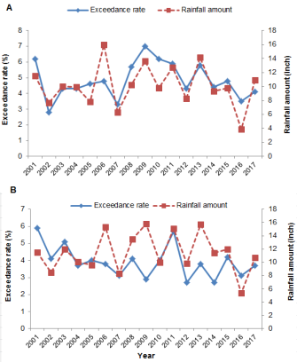
Figure 6. The historical relationship between rainfall amounts and exceedance rates at (A) marine and (B) freshwater beaches in Massachusetts from the 2001 to 2017 beach seasons

Public Notification
Beach website. The DPH beach monitoring website (http://ma.healthinspections.us/public_21/) provides the public with the most up-to-date marine beach testing and posting information and presents the data in an easy-to-use format. In 2017, approximately 11,000 users visited the website during beach season (this includes both new and returning users), a significant increase from the 4,000 visitors in 2016. An analysis of weekly usage data demonstrated an increase in the number of users as the beach season progressed (Figure 6) with a maximum number of users (n=4,686) occurring in week 10 at the end of July and early August. The second and third busiest weeks occurred during late July (week 9) and the week leading into July 4th (week 5), when 1,739 and 1,090 people visited the site.

Beach postings. When water quality standards are exceeded or other safety concerns exist, beach operators are required to post signage at the beach advising individuals of the hazard and recommending they stay out of the water. This is an essential part of the public notification system. Marine and freshwater beaches were posted properly 99% and 88% of the time, respectively.

Figure 7. Number of DPH marine beach website users per week during the 2017 beach season

Conclusions
In 2017, the exceedance rates at marine and freshwater beaches were slightly lower than historical averages. Rainfall is a significant driver of bacteria exceedances, and spikes in exceedances were seen during significant rain events that occurred in the months of July and August throughout the state. However, given the number of beaches sampled in Massachusetts, the average historical exceedance rates of less than 5% indicate that Massachusetts has beaches with generally high water quality. Public notification of marine results and postings via DPH’s monitoring website continued to be a highly utlized means of communicating with the public.

Acknowledgements
This work was partially supported by a U.S. EPA Beaches Environmental Assessment and Coastal Health grant. DPH received assistance from local, regional, and state partners, including Massachusetts boards of health, regional health networks, and the Massachusetts Department of Conservation and Recreation, in ensuring that bathing beaches were tested and data were submitted appropriately.

References
Cabelli, V.J., Dufour, A.P., McCabe, L.J., Levin, M.A. 1982. Swimming-associated gastroenteritis and water quality. American Journal of Epidemiology 115, 606-616.

Executive Office of Energy and Environmental Affairs (EOEEA). 2007. Massachusetts Outdoors 2006: Statewide Comprehensive Outdoor Recreation Plan. http://archives.lib.state.ma.us/handle/2452/335705

Executive Office of Housing and Economic Development (EOHED). 2016. 2015 Annual Report of the Massachusetts Office of Travel and Tourism.
http://www.massvacation.com/wp-content/uploads/2016/09/2015-annual-report-9-27-16.pdf

Galfi, H., Österlund, H., Marsalek, J., Viklander, M. 2016. Indicator bacteria and associated water quality constituents in stormwater and snowmelt from four urban catchments. Journal of Hydrology 539, 125-140.

Harder-Lauridsen, N.M., Kuhn, K.G., Erichsen, A.C., Mølbak, K., Ethelberg, S. 2013. Gastrointestinal Illness among Triathletes Swimming in Non-Polluted versus Polluted Seawater Affected by Heavy Rainfall, Denmark, 2010-2011. PLOS ONE 8, e78371.

Hlavsa, M., Roberts, V., Kahler, A., Hilborn, E., Mecher, T., Beach, M., Wade, T., Yoder, J. 2015. Outbreaks of Illness Associated with Recreational Water - United States, 2011–2012. Morbidity and Mortality Weekly Report, Center for Disease Control and Prevention 64, 668-672.

Marion, J.W., Lee, J., Lemeshow, S., Buckley, T.J. 2010. Association of gastrointestinal illness and recreational water exposure at an inland U.S. beach. Water Research 44, 4796-4804.

National Oceanic and Atmospheric Administration (NOAA). 2018. National Weather Service NOWData-Online Weather Data. http://w2.weather.gov/climate/xmacis.php?wfo=box

Rodrigues, V.F.V., Rivera, I.N.G., Lim, K.-Y., Jiang, S.C. 2016. Detection and risk assessment of diarrheagenic E. coli in recreational beaches of Brazil. Marine Pollution Bulletin 109, 163-170.

U.S. Environmental Protection Agency (US EPA), 2012. 2012 Recreational Water Quality Criteria USEPA 820-F-12-058, Office of Water.

Wade, T.J., Pai, N., Eisenberg, J.N., Colford, J.M.J. 2003. Do U.S. Environmental Protection Agency Water Quality Guidelines for Recreational Waters Prevent Gastrointestinal Illness? A Systematic Review and Meta-analysis. Environmental Health Perspectives 111.

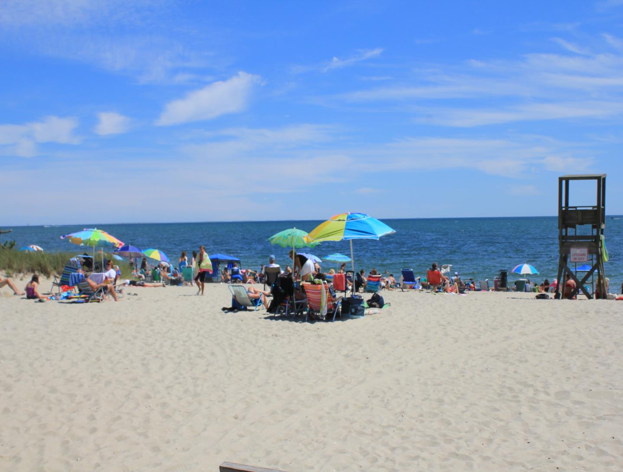
For more information, please visit:

DPH Beaches and Algae website: http://www.mass.gov/dph/beaches

DPH Marine Beach website: http://ma.healthinspections.us/public_21/

Or contact:

Environmental Toxicology Program
Bureau of Environmental Health
Massachusetts Department of Public Health
250 Washington Street
Boston, MA 02108
Email: dph-beach@state.ma.us
Phone: (617) 624-5757
Fax: (617) 624-5183

Earle Road, Harwich, MA

