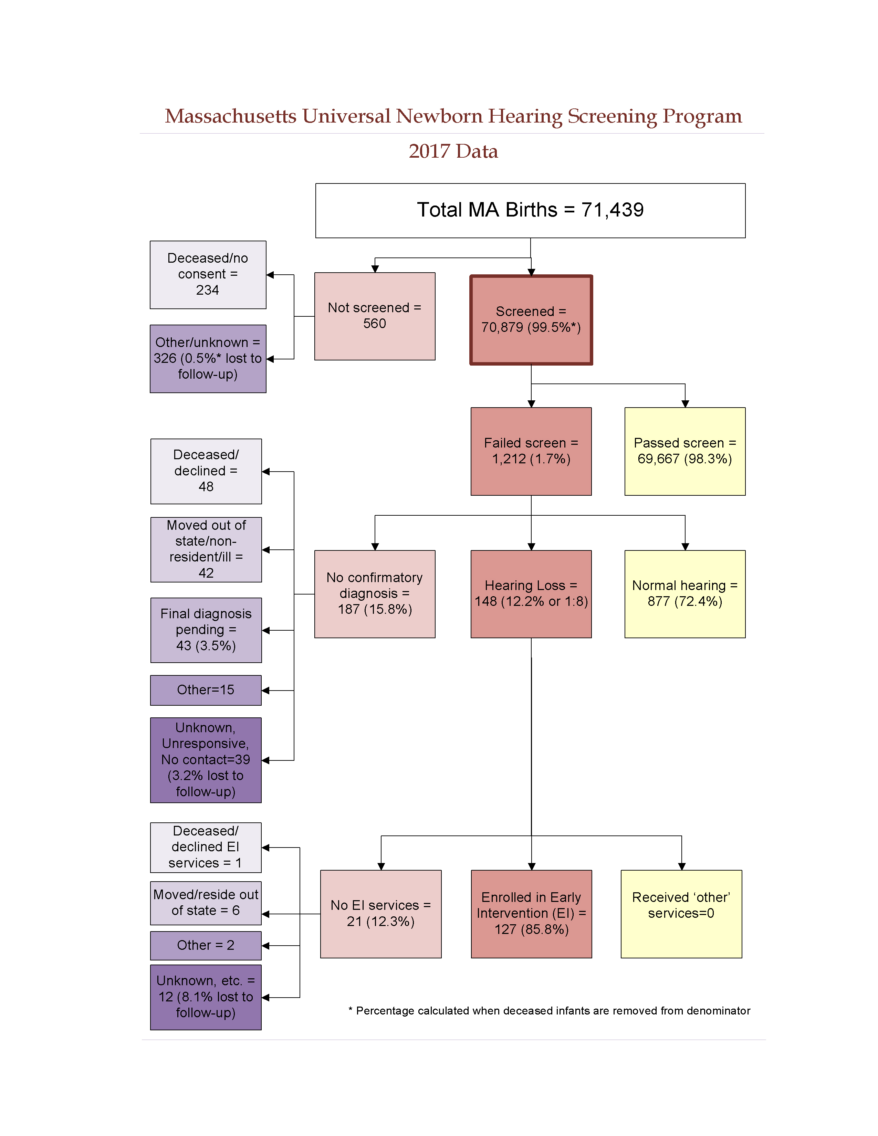

There were 71,439 total births in Massachusetts in 2017. 70,879 (99.5%*) of these infants received a hearing screen. 560 infants were not screened. Of the 560 infants that did not receive a screen:
- 234 died before a screen was performed or their parents/guardians did not provide consent to perform the screen
- 326 (0.5%*) had unknown screening status or did not receive a screen for unknown reasons (lost to screening follow-up)

Of the 70,879 infants that were screened:
- 69,667 (98.3%) passed the screen
- 1,212 (1.7%) failed the screen

Of the 1,212 infants that failed the hearing screen:
- 877 (72.4%) were diagnosed with normal hearing
- 148 (12.2%) were diagnosed with hearing loss
- 187 (15.8%) did not have a final confirmatory diagnosis when the data were reported. Of these infants without a final confirmatory diagnosis:
  - 48 were deceased (n=6) or their parents/guardians declined follow-up diagnostic services (n=42)
  - 42 moved out of state or did not reside in Massachusetts
  - 43 received diagnostic testing but were pending a final diagnosis
  - 15 were not screened due medical reasons or lack of pediatrician referral
  - 39 (3.2% of the 1,212 infants that failed the screen) were lost to documentation or diagnostic follow-up

Of the 148 infants with hearing loss:
- 127 (85.8%) were enrolled in Early Intervention (EI)
- The remaining 21 infants (12.3%) were not documented to be receiving EI services for the following reasons:
  - 1 was deceased (n=0) or declined EI services (n=1)
  - 6 moved out of state or did not reside in Massachusetts
  - 2 were too medically fragile to receive EI services
  - 12 were not receiving EI services for unknown reasons (8.1% lost to EI follow-up)

* % screened is calculated when deceased children without a screen are not included in the denominator

