Environmental Monitoring Report
For 2017

Pilgrim, Seabrook, and Vermont Yankee
Nuclear Power Station
Emergency Planning Zones

Prepared by:
Environmental Toxicology Program
Bureau of Environmental Health
Massachusetts Department of Public Health
250 Washington Street
Boston, Massachusetts 02108

July 2019

Executive Summary 1
1. Introduction 2
Environmental Radiation 3
Laboratory Methods 4
2. Environmental monitoring and Sampling 6
A. Pilgrim Nuclear Power Station 6
B. Seabrook Nuclear Power Station 9
C. Vermont Yankee Nuclear Power Station 11
3. 2016 Environmental Monitoring Results 13
A. Pilgrim Nuclear Power Station 13
B. Seabrook Nuclear Power Station 14
C. Vermont Yankee Nuclear Power Station 15
D. References 16
E. RESULTS Tables 17

Executive Summary
The Massachusetts Department of Public Health (MDPH) Bureau of Environmental Health’s (MDPH/BEH) Environmental Toxicology and Radiation Control Programs collaborate to conduct routine environmental monitoring in the three nuclear power station Emergency Planning Zones (EPZs) within the Commonwealth. This monitoring is part of the Department’s regulatory responsibility, and provides a system of watchfulness over environmental radiation in Massachusetts communities surrounding nuclear power plants. These EPZs include communities located within a 10-mile radius of Pilgrim Nuclear Power Station (Pilgrim) in Plymouth, MA, Seabrook Nuclear Power Station (Seabrook) in Seabrook, NH, and the Vermont Yankee Nuclear Power Station (VY), in Vernon, VT. VY ceased operations on December 29, 2014 and is undergoing decommissioning. This report summarizes the 2017 monitoring activities and results for each nuclear plant EPZ.
Radiation monitoring results in 2017 for areas surrounding the three nuclear power stations affecting Massachusetts have been either non-detect, naturally occurring, at levels expected to be present in the environment from background fallout from historic bomb testing and past nuclear accidents, or attributable to a known source. Iodine-131 was detected in one sample of Irish moss collected at a background location outside the Seabrook EPZ. Iodine-131 has been detected in Irish moss at this background location in previous years and, based on its location, is most likely from either a water treatment plant or medical facility located nearby, due to use of Iodine-131 for treating certain thyroid disorders. Cesium-137 was detected in two of four fish samples collected inside the former VY EPZ. MDPH/BEH has determined the Cesium-137 is attributable to historic radiation fallout in the environment.
Overall, no radiation indicators or radionuclides were detected at a level of health concern.

Introduction
The MDPH/BEH radiation environmental monitoring program is designed to monitor radiation levels and to protect residents in the Commonwealth from exposure to radiation. Samples of environmental media collected within and just outside the EPZs surrounding nuclear power plants by MDPH/BEH or provided by the utilities that operate the nuclear power plants, are analyzed for radiation by the MDPH/BEH Massachusetts Environmental Radiation Laboratory (MERL). Environmental media analyzed in 2017 include: air, surface water, milk, fish, shellfish, sediment, vegetation and food crops. In addition to the samples analyzed for radiation by MERL, MDPH/BEH has a network of stationary monitors surrounding Pilgrim that measures gamma radiation in real-time, which is monitored online by MDPH/BEH staff. The C-l0 Research & Education Foundation, Inc., a non-profit organization under contract to MDPH/BEH, conducts direct radiation monitoring in Massachusetts communities within the Seabrook EPZ and provides summary reports to MDPH/BEH.
The radiation environmental monitoring of Pilgrim and Seabrook EPZs has been in place since the 1980s. The environmental monitoring program for Massachusetts communities within the VY EPZ began in 2011. A focused investigation of tritium in groundwater on the Pilgrim Nuclear Power Plant property is ongoing and not part of this report. Updates on this monitoring effort are posted on the MDPH website: Tritium investigation update reports.
The U.S. Nuclear Regulatory Commission (NRC) requires specific environmental monitoring and annual reporting by operating nuclear power plants. The reports summarizing Seabrook’s and Pilgrim’s environmental monitoring can be found on the NRC website: Pilgrim’s 2017 Environmental Radiological Monitoring Report and Seabrook's 2017 Environmental Radiological Monitoring Report. Vermont Yankee’s reports are no longer on the NRC website.
MDPH/BEH’s monitoring activities for each nuclear plant are described in the Environmental Monitoring sections of this report. This report contains background information regarding environmental radiation and laboratory methods used to analyze samples for radiation; sample location and analyses for each of the three EPZs; and a summary of the monitoring results for each EPZ.

Environmental Radiation
Background radiation in the environment comes from three general sources: naturally occurring radiation, radioactive fallout from past weapons testing or nuclear accidents, and man-made sources.
Naturally occurring radionuclides, such as Potassium-40 and Beryllium-7, are present in most environmental media. Potassium-40 is a radioactive form of potassium, which is an essential nutrient. Beryllium-7 is produced when cosmic energy collides with nitrogen and oxygen in the atmosphere (Delaygue et al., 2015). Additional natural sources of radiation, including cosmic radiation, radon, and carbon-14, contribute to an annual background radiation dose of approximately 310 mrems/year (US NRC, 2017a). Man-made sources include medical procedures (e.g., diagnostic x-rays) and various consumer products (e.g., certain construction material, combustible fuels, televisions, smoke detectors) (US NRC 2017b). Background and man-made sources contribute to the estimated 620 mrem annual dose of environmental radiation for average U.S. residents (US NRC, 2017c).

Table 1. Background Radiation Dose for Average U.S. Resident
Source | Millirems/year
Natural background radiation | 310
Man-made sources | 310
Total of all sources | 620

Source: US NRC, 2017c
Background radiation includes fallout radiation from historic weapons testing, which occurred primarily in the 1950s and 1960s, and from nuclear power plant accidents such as Chernobyl and Fukushima. This fallout includes radioisotopes such as Cesium-137 (Cs-137) and Strontium-90 (Sr-90), which persist in the environment due to their 28-30 year half-lives.
During active operation, nuclear power plants emit direct gamma radiation from nuclear reactor systems; noble gases, tritium, Iodine-131, Carbon-14, and particulates from the station’s air stack; and discharge water containing tritium as well as alpha, beta and gamma radiation (UNSCEAR, 2008). Noble gases are chemically inert, have short half-lives, disperse quickly in the environment, and do not bioconcentrate or easily incorporate into biological tissue. Tritium is created when water passes through the reactor core; the hydrogen atoms in the water molecules and other trace elements like boron absorb neutrons from the fission of the reactor fuel. Tritium is lighter and more mobile in water than other radionuclides and is a sentinel indicator of radionuclides in water bodies. Both Iodine-131 and particulates (notably Cesium-137, Cobalt-60, Iron-59, Magnesium-54, Stontium-90 and Zinc-65) have environmental and public health significance: their half-lives range from weeks to years, they are readily incorporated into biological tissue, and they will bioconcentrate. Iodine-131 is usually the first radioactive element detected in the event of an accidental release of power plant radiation (UNSCEAR, 2008).
Exposure to radiation from nuclear power plants may occur from permitted air or liquid discharges or from unmonitored releases or leaks. MDPH/BEH evaluates possible routes of exposure for radionuclides, particularly those that accumulate in the food chain, and samples environmental media along these routes to measure potential exposure to radiation.

Laboratory Methods
The MDPH/BEH Radiation Control Program’s Massachusetts Environmental Radiation Laboratory (MERL) analyzes samples of air, water, milk, seafood, sediment, vegetation and food crops. MERL maintains its standard of excellence in analytical capability through participation with several federal agencies in inter-laboratory quality assurance measures.

MERL analyzes samples for a suite of more than 30 radioactive isotopes (e.g., radioisotopes, or radionuclides). Gamma spectroscopy is used to identify and detect environmentally significant and naturally-occurring radioisotopes; gas proportion counters measure gross beta and alpha radiation; and liquid scintillation counters measure tritium. Environmental media sample results are compared to typical background levels. In the event that gamma emitters are present above typical background, the MERL protocol calls for additional testing at an outside laboratory for alpha emitters, such as transuranic (high atomic number) elements, and beta emitters, such as Strontium-90.

Analysis methods by media are summarized below:

Air
Air filters are collected weekly and analyzed for gross alpha and gross beta radioactivity using a gas proportion counter. Gross alpha and beta analysis is a screening-level tool that does not identify individual radionuclides; therefore, air filters are also analyzed quarterly for gamma emitting radionuclides using gamma spectroscopy. Results are compared to results from a background monitor located in Boston.
Air cartridges are analyzed weekly for iodine-131 using gamma spectroscopy.
Direct gamma radiation in air is measured with thermoluminescent dosimeters (TLDs) and analyzed using gamma spectroscopy.

Water
Surface water samples are tested for total alpha and beta radioactivity with a gas proportional counter, and for gamma-emitting radionuclides with a gamma spectrometer. Water samples are also tested for tritium with a liquid scintillation counter.

MILK
Milk is a good indicator media for radioactive elements, particularly iodine-131, which can be detected in milk soon after cows graze on contaminated pastures or feed. Hence, cow’s milk is tested for gamma radionuclides, including iodine-131, using gamma spectroscopy.

seafood, SEDIMENT, VEGETATION, AND FOOD Crops
Seafood, sediment, vegetation and food crops were chosen to represent various stages of the food chain where radionuclides may be identified. Mollusks (such as clams and mussels) filter-feed sediment and sand where heavy and sediment-bound radionuclides may accumulate; lobsters eat clams, mussels and small fish; and radionuclides biomagnify from smaller to larger surface-dwelling fish.
Analyses of vegetation and crop samples aim to identify radionuclides that may settle on surfaces, or that may be absorbed through the roots. Samples are tested for gamma-emitting radionuclides using a gamma spectrometer.

Quality Assurance
Laboratory sample detection levels are affected by sample size, time between collection and analysis, and equipment processing and counting time. Where detection levels fall outside our analytic sensitivity guidelines they are noted in the tables as “NR” (Result is not reported for quality control reason).

Environmental monitoring and Sampling
This section describes the three nuclear power station EPZs in Massachusetts and summarizes the environmental samples collected and analyzed in 2017.

Pilgrim Nuclear Power Station
The Pilgrim Nuclear Power Station (Pilgrim) is located in Plymouth, MA. Five Massachusetts communities are included in the 10-mile EPZ of Pilgrim: Carver, Duxbury, Kingston, Marshfield, and Plymouth, all shown below in Figure 1.

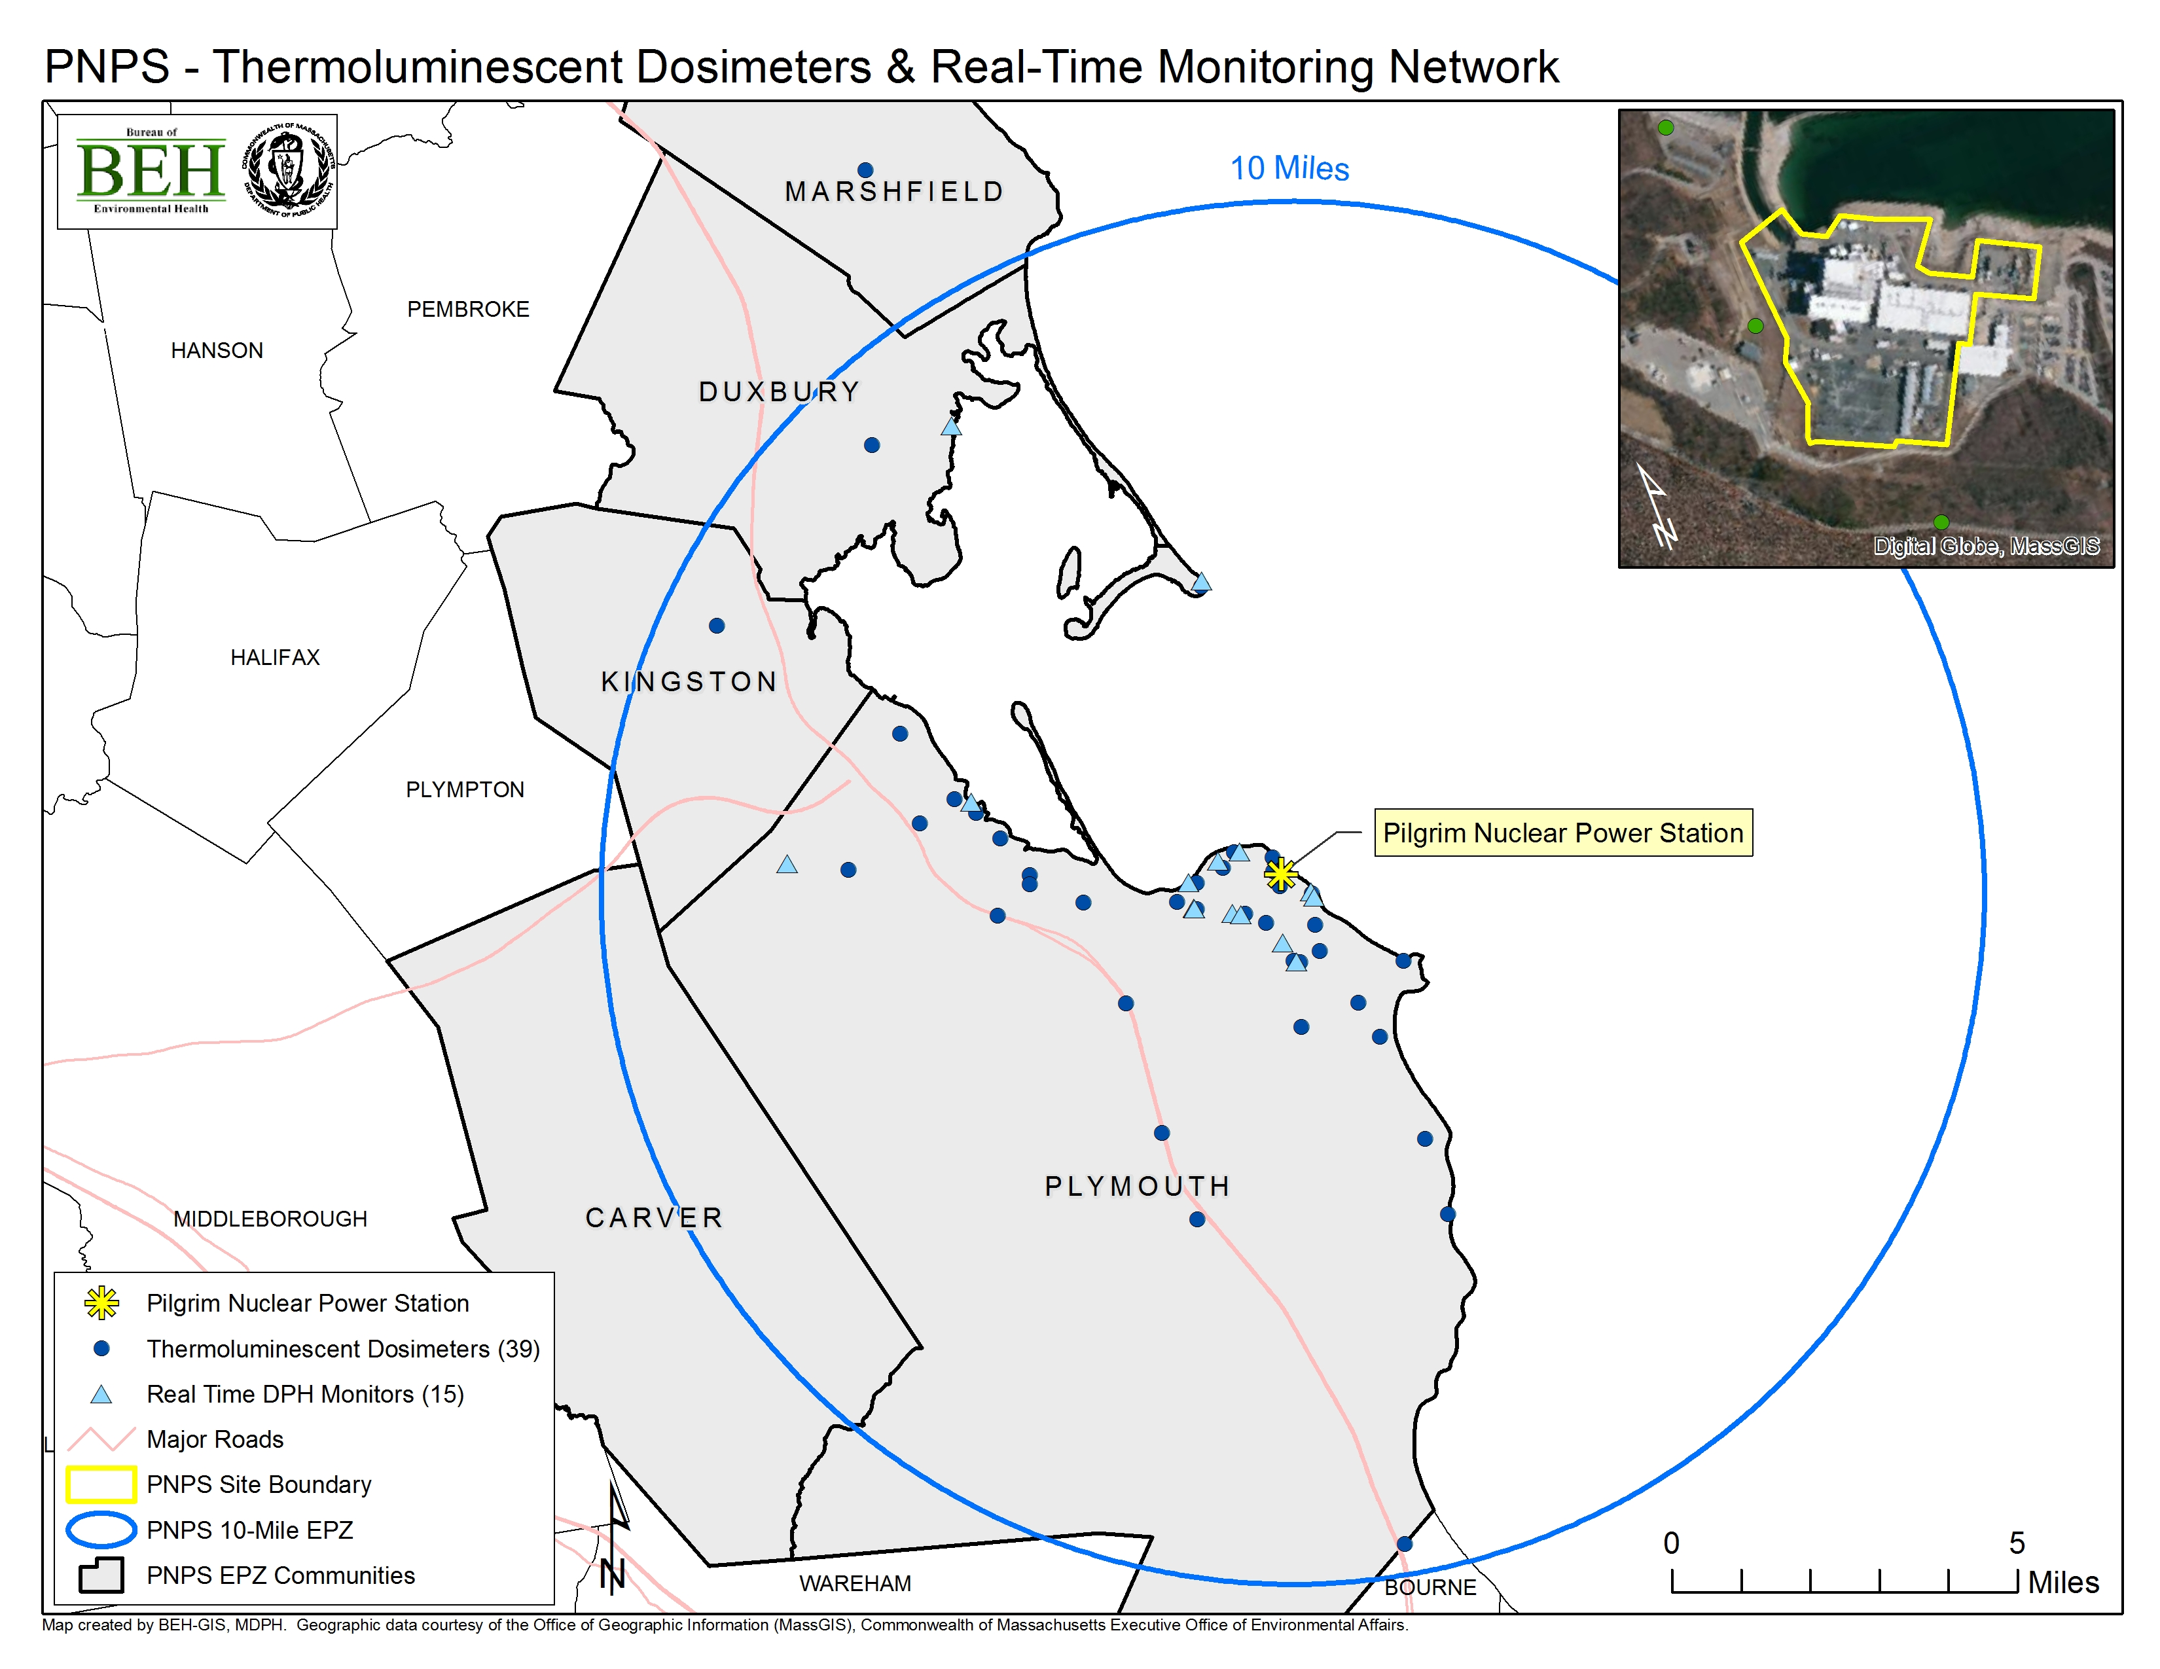

Figure 1. The MDPH/BEH Radiation -monitoring network at Pilgrim

MDPH/BEH’s radiation monitoring conducted within and outside the Pilgrim EPZ is a combination of independent direct monitoring of airborne radiation; air, milk and cranberry sampling; and analysis of split samples provided by Entergy, the utility that owns Pilgrim, of water, fish, shellfish, sediment, Irish moss, and crops. Figure 1 shows locations of the air monitors for Pilgrim. Sample locations for water, fish and shellfish, sediment, Irish moss and crops are shown in Figure 2.

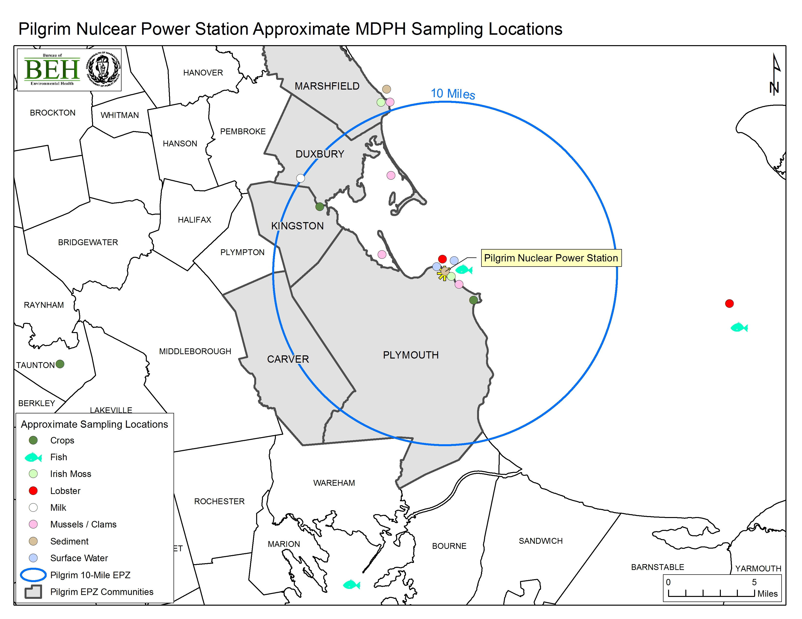

Figure 2. Pilgrim EPZ and sampling locations

Air/Direct Radiation
MDPH/BEH’s direct radiation monitoring at Pilgrim is comprised of three systems operating on real-time, weekly, and quarterly bases. The redundant systems are designed to independently monitor the land areas within the 10-mile EPZ and to verify the utility’s radiation monitoring.
MDPH/BEH maintains a network of 15 stationary radiation monitoring stations that detects gamma radiation in real-time and transmits data to a computer which is remotely accessed by staff. Emergency alerts are sent to MDPH and Massachusetts Emergency Management Agency (MEMA) officials if radiation is detected at levels greater than three times the typical background level. In 2016, MDPH/BEH completely replaced the older system with new monitors and servers, and installed an internet-based communication system.
MDPH/BEH analyzes samples collected from an air particulate filter and a charcoal air cartridge located just outside the Pilgrim utility’s fence. Filters are analyzed for gross beta and gross alpha radioactivity and cartridges are analyzed for iodine-131. A filter composite sample is also analyzed quarterly for additional gamma-emitting radionuclides. The same analyses are done for an air particulate filter and charcoal cartridge collected from a background location in Boston.
MDPH/BEH also has a network of 39 TLDs placed throughout the Pilgrim EPZ and surrounding communities, which measure total gamma radiation in milliroentgen (mR). The majority of the TLDs are located in the inner region of the EPZ, and three are near the plant border. These TLDs are collected and analyzed quarterly, and the results are compared to those of a background location in Boston.

Surface Water
Entergy collects seawater on a monthly basis from the Pilgrim discharge canal and the Powder Point Bridge in Duxbury and provides split samples to MDPH/BEH for analysis of gamma-emitting radionuclides. MERL also analyzes composite surface water samples from both locations for tritium.

Milk

MDPH/BEH collects samples of cow’s milk monthly from a farm in Duxbury. The milk is analyzed for gamma-emitting radionuclides, including Iodine-131. Although this farm is located just outside the EPZ (11 miles from Pilgrim), it is the closest dairy farm to Pilgrim with available milk samples.

Fish and Shellfish
Entergy provides split samples of fish and shellfish collected from Plymouth Harbor, Marshfield Bay and the Pilgrim discharge canal to MERL for analysis. Entergy also provides MERL with split samples of background fish and shellfish from Cape Cod Bay.
Entergy collects mussels semiannually from Green Harbor in Marshfield and collects clams semiannually from Duxbury Bay and Plymouth Harbor. These three locations are reported to be background locations by Entergy for federal reporting requirements, but are considered to be “indicator” locations by MDPH/BEH because they fall within the 10-mile EPZ. MERL analyzes the split samples for gamma-emitting radionuclides. In 2017 Entergy also collected mussels from Plymouth Harbor and from the Pilgrim discharge canal.

Sediment
Entergy collects sediment from the Pilgrim discharge canal and Green Harbor in Marshfield semiannually and Duxbury Bay annually; MERL analyzes the split samples.

Irish moss
Irish moss (i.e., Chondrus) readily absorbs iodine and is a good reference indicator of iodine-131 in the environment. Entergy collects samples of Irish moss from the Pilgrim discharge canal and a background location at Brant Rock in Marshfield semiannually; split samples are analyzed by MERL.

Crops
MDPH/BEH collects and analyzes background cranberry samples from a bog in East Taunton annually.
In 2017 Entergy collected samples of tomatoes and summer squash during the growing season from a farm in Plymouth and a farm in Kingston. A representative portion of the samples are analyzed by MERL.

Seabrook Nuclear Power Station
The Seabrook Nuclear Power Station (Seabrook) is located in Seabrook, New Hampshire, approximately two miles north of the Massachusetts border. Six Massachusetts communities are included in the 10-mile EPZ of Seabrook: Amesbury, Merrimac, Newbury, Newburyport, Salisbury, and West Newbury as shown in Figure 3.

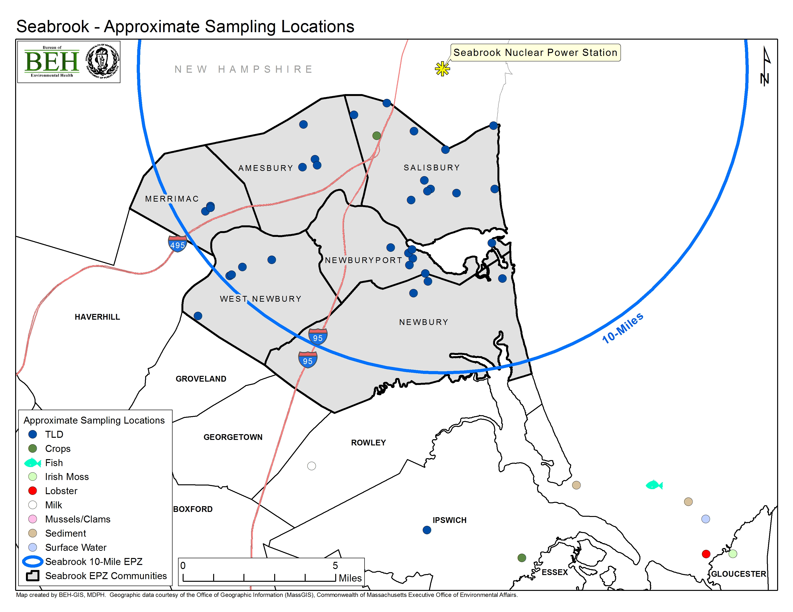

Figure 3. Seabrook EPZ and sampling locations within Massachusetts

Radiation monitoring conducted within and outside the Seabrook EPZ includes the following environmental media: air, surface water, fish, shellfish, sediment, Irish moss, crops, and milk. MDPH/BEH receives split samples from Nextera, the utility that owns Seabrook, for all media except milk and air. Sampling locations and activities within Massachusetts are described below. Sampling locations are shown in Figure 3.

Air/Direct Radiation
MDPH/BEH collects air particulate filters and charcoal cartridges weekly at the Salisbury Fire Station. Filters are analyzed for gross beta and alpha radioactivity, and cartridges for iodine-131. Additionally, a filter composite is analyzed quarterly for gamma-emitting radionuclides. The same analyses are done for air particulate filters and charcoal cartridges collected at the background location in Boston.
MDPH/BEH measures total ambient gamma radiation using a network of 34 TLDs placed at locations throughout the Seabrook EPZ in Massachusetts. These are collected and analyzed quarterly and results are compared to those of a background location in Boston.
MDPH/BEH contracts with the C-l0 Research & Education Foundation, Inc. to conduct radiation monitoring in Massachusetts communities located in the Seabrook EPZ. The C-10 system consists of a network of 14 real-time radiation sensors and weather probes located in Massachusetts within a 10-mile radius of Seabrook station. Beta, gamma, and weather data are collected and uploaded every 15 minutes to a secure web-based central repository. C-10 compiles and graphs the data monthly and sends reports to MDPH/BEH. The 14 monitoring sites within the Seabrook 10-mile EPZ are located at private homes, schools, and businesses. MDPH and MEMA officials receive text alerts from C-10 if levels are greater than three times the typical background readings.

Surface Water
Seawater samples are typically collected monthly by Nextera from a background location in Ipswich Bay. MERL analyzes split samples for gamma-emitting radionuclides. MERL also analyzes surface water samples for tritium.

Milk
MDPH/BEH collects samples of cow’s milk monthly from a farm located in Rowley and MERL analyzes the samples for gamma-emitting radionuclides, including iodine-131.

Fish, Lobster, and Shellfish
Nextera semi-annually collects samples of fish and shellfish, including Modiolus (Atlantic mussels) and Mytilus (Blue mussels), from Ipswich Bay, which is considered a background location; MERL analyzes the split samples for gamma-emitting radionuclides.

Sediment
Nextera semi-annually collects sediment samples from Ipswich Bay and the tidal flats on Plum Island, both background locations; MERL analyzes the split samples for gamma-emitting radionuclides.

Irish moss
As noted earlier, Irish moss readily absorbs iodine and is a sentinel indicator of environmental iodine-131. Nextera collects samples of Irish moss semiannually from a background location in Ipswich Bay, and split samples are analyzed by MERL for gamma-emitting radionuclides.

Crops
In 2017 Nextera collected strawberries and tomatoes from a farm located within the Seabrook EPZ in Salisbury, and collects strawberries, tomatoes, and squash from a farm in Ipswich, which is outside the Seabrook EPZ. Split samples of these crops are analyzed by MERL for gamma-emitting radionuclides.

Vermont Yankee Nuclear Power Station
The Vermont Yankee Nuclear Power Station (VY) is located in Vernon, VT, approximately four miles north of the Massachusetts border. The reactor was permanently shut down on December 29, 2014, and the fuel was removed on January 12, 2016. The plant is no longer producing any radioactive material. On April 16, 2016 the US Nuclear Regulatory Commission (NRC) reduced the EPZ of Vermont Yankee to the perimeter line of the plant in Vernon, VT.
Seven Massachusetts communities were located in the 10-mile EPZ of VY: Bernardston, Colrain, Gill, Greenfield, Leyden, Northfield, and Warwick. In 2017, radiation monitoring in the former 10-mile EPZ of VY included surface water and fish, as shown in Figure 4. All environmental monitoring of the VY EPZ, including 3 years after closure, indicate that radionuclide levels are either non-detectable or comparable to background or naturally occurring radiation sources (e.g., Beryllium-7).

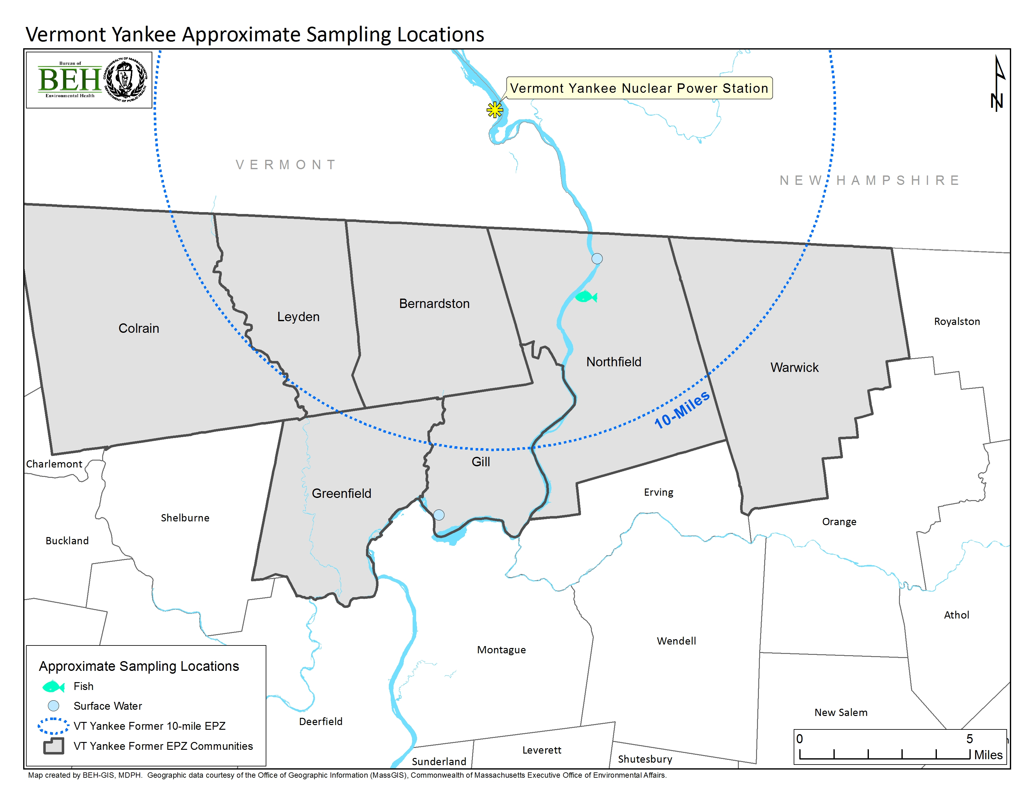

Figure 4. VY EPZ and Sampling Locations within Massachusett

Surface Water
MDPH/BEH collected surface water samples from the Connecticut River in Northfield, MA. Surface water samples were analyzed for gamma radionuclides and for tritium.

Fish
MDPH/BEH collected fish from the Connecticut River in Northfield, MA and analyzed them for gamma radionuclides.

2017 Environmental Monitoring Results
Radiation monitoring results in 2017 for Massachusetts have been either non-detect, naturally occurring (i.e., Potassium-40, Beryllium-7), or at levels expected to be present in the environment from historic background fallout and nuclear accidents including Chernobyl and Fukushima Dai-chi (i.e., Cesium-137). No detectible radionuclides were at levels of health concern or were indicative of an unintentional release of radiation at Pilgrim, Seabrook, or VY. I-131 was detected in one sample of Irish moss collected at a background location outside the Seabrook EPZ. Cesium-137, attributable to historic fallout, was detected in fish samples within the former VY EPZ.
Results of environmental monitoring conducted by MDPH/BEH in the Massachusetts communities in the vicinity of each of the three nuclear power stations are discussed below and presented in Tables 1-8. The tables are organized by nuclear power station and by sample media. Sampling results presented in this report include:
- Air particulate filters for gross alpha and beta radiation, and radionuclides; air cartridges for radioactive iodine; and thermoluminescent devices (TLDs) for gamma radiation.
- Individual surface water samples for gamma-emitting radionuclides, and composite surface water samples for tritium.
- Milk, fish, shellfish, sediment, vegetation and food crops for gamma-emitting radionuclides.

Pilgrim Nuclear Power Station
Results are provided in Tables 2, 3 and 4.
With the exception of composite air samples for the 2nd and 4th quarters of 2017, naturally occurring Potassium-40 was detected in all samples of environmental media analyzed for potassium-40 from both within and outside of the Pilgrim EPZ. Beryllium-7, which is also naturally occurring, was detected in all four of the quarterly composite air samples, and also in clams from Duxbury Harbor, Irish moss, and cranberries. No other radionuclides were detected in any of the samples collected within Pilgrim’s EPZ.
In addition to naturally occurring Beryllium-7 and Potassium-40, air filter and cartridge analyses indicated low levels of gross alpha and gross beta radiation. Levels of gross alpha and beta radiation measured in the Pilgrim EPZ ranged from 0.001 – 0.018 and 0.012 – 0.039 pCi/m³, respectively. These levels are consistent with those measured at the background location in Boston, of 0.002 – 0.020 and 0.013 – 0.044 pCi/m³, respectively. No gamma-emitting radionuclides of concern were detected in quarterly composite air samples.
With the exception of the monitor located at the Pilgrim overlook, real-time monitoring did not detect radiation greater than typical background levels of approximately 0.007 - 0.009 mRoentgen/hour with the exception of brief increases up to 0.02 mRoentgen/hour. Brief increases are expected due to rainfall washout from naturally occurring radionuclides such as airborne radon daughters, and cosmic radiation events. No alerts at three times background were recorded. TLD total gamma exposure results (excluding the Pilgrim overlook monitor) ranged from 11.7 to 20.7 mRoentgen/quarter (i.e., 0.005 – 0.009 mRoentgen/hour) with an average of 15.2 mRoentgen/quarter (0.007 mRoentgen/hour). This value is compared to an average value of 13.0 mRoentgen/quarter measured at a background location in Boston, and corresponds to an average gamma exposure of 2.2 mRoentgen/quarter above background. Quarterly gamma exposure levels at the Pilgrim overlook monitor ranged from 46.8 to 72.3 mRoentgen, with an average of 57.6 mRoentgen/quarter. This corresponds to an average gamma exposure of 44.6 mRoenten/quarter above background.

Seabrook Nuclear Power Station
Seabrook sampling results are provided in Tables 5, 6 and 7.
Naturally occurring Potassium-40 was detected in all samples of environmental media from both within and outside the Seabrook EPZ. Naturally occurring Beryllium-7 was detected in Irish moss (i.e., chondrus) and common mussels (i.e., mytilus) collected from the background sampling location in Ipswich Bay, and in the four quarterly air samples collected at the Salisbury Fire Station. In addition to naturally occurring Beryllium-7 and Potassium-40, analyses of air filter and cartridge samples found low levels of gross alpha and gross beta radiation, consistent with levels measured at the background location in Boston. No gamma radionuclides of concern were detected in quarterly composite air samples.
Although not detected at levels of human health concern (Delacroix et al., 2002), Iodine-131 was detected at a level of 162 pCi/kg in the Irish moss (i.e., chondrus) sample collected in May 2017 from the background location in Ipswich Bay, approximately 20 miles from the Seabrook EPZ. Radioactive iodine was found in Irish moss from the same location in previous years (2011, 2012, 2014 and 2015). Iodine-131 is monitored carefully as it may be released from nuclear power plants. Iodine-131 is also commonly used for treating individuals with overactive thyroids and thyroid cancer, which can result in discharge of Iodine-131 into sanitary sewers (Rose et al., 2012). Thus, sewage discharge and a nearby medical center are the most likely sources of the Iodine-131 detected in the Irish Moss. Iodine-131 was not detected in any of the surface water samples collected from Ipswich Bay.
In 2017, real-time monitoring for the Seabrook EPZ did not show gamma radiation levels above typical background levels at most stations (approximately 0.010 mRoentgen/hour) with the exception of brief increases (up to 0.02 mRoentgen/hour). Brief increases are expected due to rainfall washout from naturally occurring radionuclides such as airborne radon daughters, and cosmic radiation events. Beta readings ranged from approximately 40 to 50 counts per minute with the exception of brief increases similar to the gamma results.
TLD results for total gamma exposure ranged from 8.0 to 21.5 mRoentgen/quarter (0.004 – 0.010 mRoentgen/hour) with an average exposure of 16.7 mRoentgen/quarter (0.008 mRoentgen/hour), compared to an average of 13.4 mRoentgen/quarter at the background location in Boston. The result is an average gamma exposure level of 3.3 mRoentgen/quarter over background.

Vermont Yankee Nuclear Power Station
Vermont Yankee sampling results are provided in Tables 8 and 9.
Naturally occurring Potassium-40 was detected in one of the two surface water samples, which were both collected from the Connecticut River, and from the four fish samples also collected from the Connecticut River. Beryllium-7 was not detected in any of the fish samples.
Cesium-137 was detected in two of the four fish samples collected from the Connecticut River, at levels of 4.83 and 14.7 pCi/kg. These results are lower than those from other locations reported in the scientific literature, and are considered attributable to historical fallout from weapons testing and past nuclear power plant accidents (VTDOH, 2012; Burger et al., 2007; ATSDR, 2004; Amund et al., 1996). Other power plant-produced radionuclides were not detected in the fish, nor was Cs-137 detected in surface water collected from the Connecticut River, supporting the conclusion that residual deposition is the source of the Cs-137. These concentrations of Cs-137 in fish present a very low health risk.
Aside from Potassium-40 and Cesium-137, no other radionuclides were detected in surface water or fish samples.

References
Amund et al., 1996. Contaminants in Fish and Sediments in the North Atlantic Ocean. TemaNord.
ATSDR, 2004. U.S. Agency for Toxic Substances and Disease Registry. Toxicological Profile for Cesium.
Burger et al., 2007. “Radionuclides in Marine Fishes and Birds from Amchitka and Kiska Islands in the Aleutians: Establishing a baseline.” Health Physics. March 2007, Vol. 92, No.3.
Delacroix et al., 2002. “Radionuclide and Radiation Protection Data Handbook 2002.” Radiation Protection Dosimetry 98(1)
Delaygue et al., 2015. “Modelling the stratospheric budget of beryllium isotopes.” Chemical and Physical Meterology. 67:1
Rose et al., 2012. “Medically-derived I-131 in municipal sewage effluent”. Water Research 46 (2012):5663-5671.
United Nations Scientific Committee on the Effects of Atomic Radiation, 2008. Volume I: Sources and Effects of Ionizing Radiation. Accessed at: https://www.unscear.org/unscear/publications/2008_1.html
US NRC (United States Nuclear Regulatory Commission, 2017a. Natural Background Sources. https://www.nrc.gov/about-nrc/radiation/around-us/sources/nat-bg-sources.html.
US NRC (United States Nuclear Regulatory Commission, 2017b. Man-Made Sources. https://www.nrc.gov/about-nrc/radiation/around-us/sources/man-made-sources.html.
US NRC (United States Nuclear Regulatory Commission, 2017c. Doses in Our Daily Lives. http://www.nrc.gov/about-nrc/radiation/around-us/doses-daily-lives.html.
VTDOH (Vermont Department of Health), 2012. Tritium Investigation Archive 2012. Fish Data Comparison: Lake Carmi – Connecticut River. Accessed at: http://healthvermont.gov/enviro/rad/yankee/tritium_archive_2012.aspx.

RESULTS Tables

Table 2. Pilgrim Nuclear Power Station 2017 Environmental Monitoring Data - Air Samples
Sample Type | Location | Date | I-131*  (pCi/m³) | Be-7*  (pCi/m³) | K-40*  (pCi/m³) | Mn-54*  (pCi/m³) | Fe-59*  (pCi/m³) | Co-60*  (pCi/m³) | Zn-65*  (pCi/m³) | Cs-137*  (pCi/m³) | Gross Alpha  (pCi/m³) | Gross Beta  (pCi/m³)
Air | Pilgrim Station | 1/5/2017 | <0.0228 | - | - | - | - | - | - | - | 0.00567 | 0.0212
Air | Pilgrim Station | 1/12/2017 | <0.0189 | - | - | - | - | - | - | - | 0.00540 | 0.0219
Air | Pilgrim Station | 1/19/2017 | <0.0173 | - | - | - | - | - | - | - | 0.00741 | 0.0284
Air | Pilgrim Station | 1/27/2017 | <0.0166 | - | - | - | - | - | - | - | 0.00472 | 0.0180
Air | Pilgrim Station | 2/1/2017 | <0.0263 | - | - | - | - | - | - | - | 0.00754 | 0.0236
Air | Pilgrim Station | 2/8/2017 | <0.0423 | - | - | - | - | - | - | - | 0.00620 | 0.0247
Air | Pilgrim Station Quarterly composite | 2/15/2017 | - | 0.119 | 0.095 | <0.001 | <0.009 | <0.001 | <0.002 | <0.001 | - | -
Air | Pilgrim Station | 2/17/2017 | <0.0141 | - | - | - | - | - | - | - | 0.00406 | 0.0176
Air | Pilgrim Station | 2/23/2017 | <0.0172 | - | - | - | - | - | - | - | 0.00624 | 0.0290
Air | Pilgrim Station | 3/1/2017 | <0.0220 | - | - | - | - | - | - | - | 0.00569 | 0.0233
Air | Pilgrim Station | 3/8/2017 | <0.0195 | - | - | - | - | - | - | - | 0.00485 | 0.0248
Air | Pilgrim Station | 3/17/2017 | <0.0195 | - | - | - | - | - | - | - | 0.00565 | 0.0246
Air | Pilgrim Station | 3/22/2017 | <0.0313 | - | - | - | - | - | - | - | 0.00457 | 0.0310
Air | Pilgrim Station | 3/29/2017 | <0.0168 | - | - | - | - | - | - | - | 0.00595 | 0.0229
Air | Pilgrim Station | 4/21/2017 | <0.0163 | - | - | - | - | - | - | - | 0.00611 | 0.0205
Air | Pilgrim Station | 4/27/2017 | <0.0175 | - | - | - | - | - | - | - | 0.00461 | 0.0160
Air | Pilgrim Station | 5/5/2017 | <0.0153 | - | - | - | - | - | - | - | 0.00365 | 0.0177
Air | Pilgrim Station | 5/11/2017 | <0.0183 | - | - | - | - | - | - | - | 0.00478 | 0.0166
Air | Pilgrim Station Quarterly composite | 5/15/2017 | - | 0.121 | <0.019 | <0.001 | <0.004 | <0.001 | <0.002 | <0.001 | - | -
Air | Pilgrim Station | 5/19/2017 | <0.0148 | - | - | - | - | - | - | - | 0.00495 | 0.0190
Air | Pilgrim Station | 5/24/2017 | <0.0195 | - | - | - | - | - | - | - | 0.00588 | 0.0219
Air | Pilgrim Station | 6/1/2017 | <0.0136 | - | - | - | - | - | - | - | 0.00255 | 0.0122
Air | Pilgrim Station | 6/9/2017 | <0.0139 | - | - | - | - | - | - | - | 0.00288 | 0.0127
Air | Pilgrim Station | 6/16/2017 | <0.0124 | - | - | - | - | - | - | - | 0.00311 | 0.0267
Air | Pilgrim Station | 6/22/2017 | <0.0191 | - | - | - | - | - | - | - | 0.00236 | 0.0196
Air | Pilgrim Station | 6/28/2017 | <0.0196 | - | - | - | - | - | - | - | 0.00341 | 0.0269
Air | Pilgrim Station | 7/6/2017 | <0.0164 | - | - | - | - | - | - | - | 0.00411 | 0.0187
Air | Pilgrim Station | 7/13/2017 | <0.0154 | - | - | - | - | - | - | - | 0.00495 | 0.0259
Air | Pilgrim Station | 7/21/2017 | <0.0148 | - | - | - | - | - | - | - | 0.00588 | 0.0240
Air | Pilgrim Station | 7/27/2017 | <0.0185 | - | - | - | - | - | - | - | 0.00465 | 0.0191
Air | Pilgrim Station | 8/2/2017 | <0.0179 | - | - | - | - | - | - | - | 0.00341 | 0.0203
Air | Pilgrim Station | 8/11/2017 | <0.0084 | - | - | - | - | - | - | - | 0.00480 | 0.0220
Air | Pilgrim Station Quarterly composite | 8/15/2017 | - | 0.116 | 0.093 | <0.001 | <0.002 | <0.001 | <0.001 | <0.0005 | - | -
Air | Pilgrim Station | 8/18/2017 | <0.0135 | - | - | - | - | - | - | - | 0.00254 | 0.0188
Air | Pilgrim Station | 8/22/2017 | <0.0302 | - | - | - | - | - | - | - | 0.00473 | 0.0350
Air | Pilgrim Station | 8/30/2017 | <0.0115 | - | - | - | - | - | - | - | 0.00289 | 0.0227
Air | Pilgrim Station | 9/7/2017 | <0.0112 | - | - | - | - | - | - | - | 0.00210 | 0.0250
Air | Pilgrim Station | 9/15/2017 | <0.0144 | - | - | - | - | - | - | - | 0.00172 | 0.0245
Air | Pilgrim Station | 9/20/2017 | <0.0227 | - | - | - | - | - | - | - | 0.00287 | 0.0327
Air | Pilgrim Station | 9/26/2017 | <0.0183 | - | - | - | - | - | - | - | 0.00101 | 0.0171
Air | Pilgrim Station | 10/6/2017 | <0.0118 | - | - | - | - | - | - | - | 0.00854 | 0.0217
Air | Pilgrim Station | 10/12/2017 | <0.0209 | - | - | - | - | - | - | - | 0.01320 | 0.0308
Air | Pilgrim Station | 10/19/2017 | <0.0169 | - | - | - | - | - | - | - | 0.00988 | 0.0257
Air | Pilgrim Station | 10/27/2017 | <0.0149 | - | - | - | - | - | - | - | 0.01290 | 0.0336
Air | Pilgrim Station | 11/3/2017 | <0.0188 | - | - | - | - | - | - | - | 0.01780 | 0.0390
Air | Pilgrim Station | 11/9/2017 | <0.0201 | - | - | - | - | - | - | - | 0.01520 | 0.0342
Air | Pilgrim Station Quarterly composite | 11/15/2017 | - | 0.101 | <0.017 | <0.001 | <0.004 | <0.001 | <0.001 | <0.001 | - | -
Air | Pilgrim Station | 11/16/2017 | <0.0144 | - | - | - | - | - | - | - | 0.01220 | 0.0315
Air | Pilgrim Station | 11/22/2017 | <0.0168 | - | - | - | - | - | - | - | 0.01120 | 0.0312
Air | Pilgrim Station | 12/1/2017 | <0.0098 | - | - | - | - | - | - | - | 0.00985 | 0.0304
Air | Pilgrim Station | 12/8/2017 | <0.0198 | - | - | - | - | - | - | - | 0.01280 | 0.0363
Air | Pilgrim Station | 12/14/2017 | <0.0180 | - | - | - | - | - | - | - | 0.01140 | 0.0375
Air | Pilgrim Station | 12/22/2017 | <0.0175 | - | - | - | - | - | - | - | 0.00924 | 0.0281
Air | Background | 1/3/2017 | <0.0428 | - | - | - | - | - | - | - | 0.02030 | 0.0442
Air | Background | 1/10/2017 | <0.0228 | - | - | - | - | - | - | - | 0.01400 | 0.0284
Air | Background | 1/17/2017 | <0.0197 | - | - | - | - | - | - | - | 0.01420 | 0.0332
Air | Background | 1/25/2017 | <0.0209 | - | - | - | - | - | - | - | 0.01090 | 0.0246
Air | Background | 1/30/2017 | <0.0258 | - | - | - | - | - | - | - | 0.01700 | 0.0384
Air | Background | 2/6/2017 | <0.0175 | - | - | - | - | - | - | - | 0.01660 | 0.0317
Air | Background quarterly composite | 2/15/2017 | - | 0.147 | 0.270 | <0.001 | <0.015 | <0.001 | <0.003 | <0.001 | - | -
Air | Background | 2/17/2017 | <0.0141 | - | - | - | - | - | - | - | . | .
Air | Background | 2/21/2017 | <0.0170 | - | - | - | - | - | - | - | 0.01590 | 0.0344
Air | Background | 2/23/2017 | <0.0172 | - | - | - | - | - | - | - | . | .
Air | Background | 2/27/2017 | <0.0247 | - | - | - | - | - | - | - | 0.01370 | 0.0325
Air | Background | 3/6/2017 | <0.0177 | - | - | - | - | - | - | - | 0.01300 | 0.0355
Air | Background | 3/8/2017 | <0.0195 | - | - | - | - | - | - | - | . | .
Air | Background | 3/13/2017 | <0.0189 | - | - | - | - | - | - | - | 0.01280 | 0.0340
Air | Background | 3/20/2017 | <0.0233 | - | - | - | - | - | - | - | 0.00771 | 0.0217
Air | Background | 3/27/2017 | <0.0208 | - | - | - | - | - | - | - | 0.00893 | 0.0274
Air | Background | 4/3/2017 | <0.0249 | - | - | - | - | - | - | - | 0.00592 | 0.0187
Air | Background | 4/10/2017 | <0.0235 | - | - | - | - | - | - | - | 0.00431 | 0.0167
Air | Background | 4/18/2017 | <0.0357 | - | - | - | - | - | - | - | 0.00788 | 0.0253
Air | Background | 5/1/2017 | <0.0357 | - | - | - | - | - | - | - | 0.00843 | 0.0404
Air | Background | 5/8/2017 | <0.0155 | - | - | - | - | - | - | - | 0.00420 | 0.0172
Air | Background | 5/15/2017 | <0.0181 | - | - | - | - | - | - | - | 0.00206 | 0.0130
Air | Background quarterly composite | 5/15/2017 | - | 0.114 | 0.209 | <0.001 | <0.005 | <0.001 | <0.002 | <0.001 | - | -
Air | Background | 5/22/2017 | <0.0178 | - | - | - | - | - | - | - | 0.00485 | 0.0221
Air | Background | 5/30/2017 | <0.0120 | - | - | - | - | - | - | - | 0.00222 | 0.0137
Air | Background | 6/5/2017 | <0.0171 | - | - | - | - | - | - | - | 0.00294 | 0.0163
Air | Background | 6/12/2017 | <0.0185 | - | - | - | - | - | - | - | 0.00299 | 0.0189
Air | Background | 6/19/2017 | <0.0176 | - | - | - | - | - | - | - | 0.00216 | 0.0226
Air | Background | 6/26/2017 | <0.0171 | - | - | - | - | - | - | - | 0.00275 | 0.0259
Air | Background | 7/3/2017 | <0.0173 | - | - | - | - | - | - | - | 0.00712 | 0.0239
Air | Background | 7/10/2017 | <0.0136 | - | - | - | - | - | - | - | 0.00442 | 0.0215
Air | Background | 7/17/2017 | <0.0161 | - | - | - | - | - | - | - | 0.00597 | 0.0268
Air | Background | 7/24/2017 | <0.0156 | - | - | - | - | - | - | - | 0.00665 | 0.0289
Air | Background | 7/31/2017 | <0.0167 | - | - | - | - | - | - | - | 0.00578 | 0.0203
Air | Background | 8/7/2017 | <0.0155 | - | - | - | - | - | - | - | 0.00627 | 0.0239
Air | Background | 8/14/2017 | <0.0159 | - | - | - | - | - | - | - | 0.00676 | 0.0290
Air | Background quarterly composite | 8/15/2017 | - | 0.109 | <0.024 | <0.001 | <0.003 | <0.001 | <0.002 | <0.0005 | - | -
Air | Background | 8/21/2017 | <0.0173 | - | - | - | - | - | - | - | 0.00461 | 0.0300
Air | Background | 8/28/2017 | <0.0180 | - | - | - | - | - | - | - | 0.00498 | 0.0320
Air | Background | 9/5/2017 | <0.0108 | - | - | - | - | - | - | - | 0.00176 | 0.0170
Air | Background | 9/11/2017 | <0.0200 | - | - | - | - | - | - | - | 0.00373 | 0.0284
Air | Background | 9/18/2017 | <0.0173 | - | - | - | - | - | - | - | 0.00227 | 0.0235
Air | Background | 9/25/2017 | <0.0123 | - | - | - | - | - | - | - | 0.00177 | 0.0262
Air | Background | 10/2/2017 | <0.0137 | - | - | - | - | - | - | - | 0.01170 | 0.0208
Air | Background | 10/10/2017 | <0.0152 | - | - | - | - | - | - | - | 0.01410 | 0.0324
Air | Background | 10/16/2017 | <0.0201 | - | - | - | - | - | - | - | 0.01260 | 0.0302
Air | Background | 10/23/2017 | <0.0166 | - | - | - | - | - | - | - | 0.01750 | 0.0364
Air | Background | 10/30/2017 | <0.0131 | - | - | - | - | - | - | - | 0.01420 | 0.0235
Air | Background | 11/6/2017 | <0.0125 | - | - | - | - | - | - | - | 0.01510 | 0.0336
Air | Background | 11/13/2017 | <0.0173 | - | - | - | - | - | - | - | 0.01330 | 0.0312
Air | Background quarterly composite | 11/15/2017 | - | 0.105 | 0.261 | <0.001 | <0.004 | <0.001 | <0.002 | <0.001 | - | -
Air | Background | 11/20/2017 | <0.0198 | - | - | - | - | - | - | - | 0.01310 | 0.0291
Air | Background | 11/27/2017 | <0.0148 | - | - | - | - | - | - | - | 0.01350 | 0.0390
Air | Background | 12/4/2017 | <0.0182 | - | - | - | - | - | - | - | 0.01250 | 0.0366
Air | Background | 12/11/2017 | <0.0152 | - | - | - | - | - | - | - | 0.01150 | 0.0374
Air | Background | 12/18/2017 | <0.0188 | - | - | - | - | - | - | - | 0.01160 | 0.0294
Air | Background | 12/26/2017 | <0.0166 | - | - | - | - | - | - | - | 0.00757 | 0.0234

Table 3. Pilgrim Nuclear Power Station 2017 Environmental Monitoring Data – Liquid Matrices
Sample Type | Location | Date | K-40* (pCi/L) | Mn-54* (pCi/L) | Fe-59* (pCi/L) | Co-60* (pCi/L) | Zn-65* (pCi/L) | I-131* (pCi/L) | Cs-134* (pCi/L) | Cs-137* (pCi/L) | Ba-140* (pCi/L) | H-3* (pCi/L)
Surface water | Discharge Canal | 1/15/2017 | - | - | - | - | - | - | - | - | - | <300
Surface water | Discharge Canal | 1/31/2017 | 1000 | <4 | <23.9 | <3.5 | <8.4 | NR | - | <3.6 | - | -
Surface water | Discharge Canal | 2/15/2017 | - | - | - | - | - | - | - | - | - | <300
Surface water | Discharge Canal | 2/27/2017 | 345 | <3.4 | <13 | <3 | <7.3 | NR | - | <2.8 | - | -
Surface water | Discharge Canal | 3/15/2017 | - | - | - | - | - | - | - | - | - | <300
Surface water | Discharge Canal | 3/28/2017 | 1010 | <3 | <9 | <3.1 | <6.6 | <31.7 | - | <3.5 | - | -
Surface water | Discharge Canal | 4/15/2017 | - | - | - | - | - | - | - | - | - | <300
Surface water | Discharge Canal | 5/2/2017 | 295 | <2.7 | <6.1 | <2.7 | <5.7 | <7.1 | - | <2.9 | - | -
Surface water | Discharge Canal | 5/15/2017 | - | - | - | - | - | - | - | - | - | <300
Surface water | Discharge Canal | 5/30/2017 | 1370 | <3.1 | <6.5 | <3.2 | <6.9 | <10.3 | - | <3 | - | -
Surface water | Discharge Canal | 6/15/2017 | - | - | - | - | - | - | - | - | - | <300
Surface water | Discharge Canal | 6/27/2017 | 245 | <3.3 | <9 | <2.8 | <7 | NR | - | <2.8 | - | -
Surface water | Discharge Canal | 7/15/2017 | - | - | - | - | - | - | - | - | - | <300
Surface water | Discharge Canal | 8/1/2017 | 281 | <3 | <6.1 | <3 | <6.2 | <6.2 | - | <2.8 | - | -
Surface water | Discharge Canal | 8/15/2017 | - | - | - | - | - | - | - | - | - | <300
Surface water | Discharge Canal | 8/29/2017 | 306 | <3.1 | <10.4 | <2.7 | <6.9 | <120 | - | <2.8 | - | -
Surface water | Discharge Canal | 9/15/2017 | - | - | - | - | - | - | - | - | - | <300
Surface water | Discharge Canal | 10/4/2017 | 294 | <2.9 | <6.4 | <2.7 | <5.8 | <5.8 | - | <2.9 | - | -
Surface water | Discharge Canal | 10/31/2017 | 323 | <2.5 | <5.8 | <2.8 | <5.1 | <4.9 | - | <2.7 | - | -
Surface water | Discharge Canal | 11/28/2017 | 324 | <3.2 | <6 | <2.9 | <6.5 | <5.6 | - | <2.8 | - | -
Surface water | Powder Point Bridge¹ | 1/15/2017 | - | - | - | - | - | - | - | - | - | <300
Surface water | Powder Point Bridge¹ | 1/31/2017 | 264 | <3.1 | <18.4 | <3 | <7.3 | NR | - | <2.8 | - | -
Surface water | Powder Point Bridge¹ | 2/15/2017 | - | - | - | - | - | - | - | - | - | <300
Surface water | Powder Point Bridge¹ | 2/27/2017 | 292 | <3.6 | <14.8 | <3.1 | <7.6 | NR | - | <3 | - | -
Surface water | Powder Point Bridge¹ | 3/15/2017 | - | - | - | - | - | - | - | - | - | <300
Surface water | Powder Point Bridge¹ | 3/28/2017 | 320 | <2.6 | <7.3 | <2.5 | <6.1 | <25.4 | - | <2.8 | - | -
Surface water | Powder Point Bridge¹ | 4/4/2017 | 242 | <3.2 | <7.2 | <3 | <6.3 | <7.9 | - | <3.1 | - | -
Surface water | Powder Point Bridge¹ | 4/15/2017 | - | - | - | - | - | - | - | - | - | <300
Surface water | Powder Point Bridge¹ | 5/15/2017 | - | - | - | - | - | - | - | - | - | <300
Surface water | Powder Point Bridge¹ | 6/15/2017 | - | - | - | - | - | - | - | - | - | <300
Surface water | Powder Point Bridge¹ | 5/30/2017 | 266 | <2.5 | <4.9 | <2.6 | <5.2 | <5.1 | - | <2.7 | - | -
Surface water | Powder Point Bridge¹ | 6/27/2017 | 317 | <2.5 | <7.6 | <2.7 | <5.3 | NR | - | <2.6 | - | -
Surface water | Powder Point Bridge¹ | 7/15/2017 | - | - | - | - | - | - | - | - | - | <300
Surface water | Powder Point Bridge¹ | 8/1/2017 | 308 | <2.5 | <4.8 | <2.7 | <5.3 | <4.7 | - | <2.6 | - | -
Surface water | Powder Point Bridge¹ | 8/15/2017 | - | - | - | - | - | - | - | - | - | <300
Surface water | Powder Point Bridge¹ | 8/29/2017 | 315 | <2.4 | <8.4 | <2.4 | <5.7 | NR | - | <2.7 | - | -
Surface water | Powder Point Bridge¹ | 9/15/2017 | - | - | - | - | - | - | - | - | - | <300
Surface water | Powder Point Bridge¹ | 10/4/2017 | 288 | <2.4 | <4.5 | <2.7 | <5.2 | <2.2 | - | <2.5 | - | -
Surface water | Powder Point Bridge¹ | 10/15/2017 | - | - | - | - | - | - | - | - | - | <300
Surface water | Powder Point Bridge¹ | 10/31/2017 | 333 | <3.3 | <6.7 | <3.1 | <6.5 | <8 | - | <3 | - | -
Surface water | Powder Point Bridge¹ | 11/15/2017 | - | - | - | - | - | - | - | - | - | <300
Surface water | Powder Point Bridge¹ | 11/28/2017 | 315 | <2.4 | <5.1 | <2.6 | <5.5 | <4.4 | - | <2.4 | - | -
Surface water | Powder Point Bridge¹ | 12/15/2017 | - | - | - | - | - | - | - | - | - | <300
Milk | Duxbury | 1/12/2017 | 1370 | - | - | - | - | <2.5 | <2.4 | <2.9 | <10.3 | -
Milk | Duxbury | 2/16/2017 | 1340 | - | - | - | - | <2.5 | <2.5 | <2.8 | <9.3 | -
Milk | Duxbury | 3/29/2017 | 1100 | - | - | - | - | <4.6 | <3 | <3.5 | <15.9 | -
Milk | Duxbury | 4/13/2017 | 1350 | - | - | - | - | <3.3 | <2.7 | <3.1 | <10.9 | -
Milk | Duxbury | 5/11/2017 | 974 | - | - | - | - | <3.4 | <3.4 | <4.1 | <12.8 | -
Milk | Duxbury | 6/22/2017 | 961 | - | - | - | - | <3 | <3 | <3.5 | <11.5 | -
Milk | Duxbury | 7/13/2017 | 1410 | - | - | - | - | NR | <2.6 | <3 | <21.6 | -
Milk | Duxbury | 8/22/2017 | 1300 | - | - | - | - | <2.4 | <2.4 | <3 | <9.6 | -
Milk | Duxbury | 9/26/2017 | 1310 | - | - | - | - | <2.4 | <2.3 | <3 | <9.5 | -
Milk | Duxbury | 10/19/2017 | 1220 | - | - | - | - | <2.3 | <2.4 | <2.7 | <9.2 | -
Milk | Duxbury | 11/16/2017 | 1280 | - | - | - | - | <3.5 | <2.9 | <3.2 | <11.6 | -
Milk | Duxbury | 12/14/2017 | 1370 | - | - | - | - | <2.8 | <2.5 | <3.2 | <10 | -
(1) Sample considered “background” for the purpose of NRC regulations, but considered “indicator” by MDPH because it falls within the 10-mile EPZ.

Table 4. Pilgrim Nuclear Power Station 2016 Environmental Monitoring Data – Solid matrices
Sample | Location | Date | Be-7* (pCi/kg) | K-40* (pCi/kg) | Mn-54* (pCi/kg) | Fe-59* (pCi/kg) | Co-60* (pCi/kg) | Zn-65* (pCi/kg) | Cs-137* (pCi/kg) | I-131* (pCi/kg)
Bluefish | PNPS Discharge Canal | 9/27/2017 | <159 | 3480 | <5.6 | <56.5 | <5.3 | <14.9 | <5.4 | -
Bluefish | Buzzard's Bay (background) | 9/25/2017 | <1370 | 3830 | <43.5 | <398 | <35.9 | <94.8 | <34.3 | -
Striped Bass | Buzzard's Bay (background) | 9/7/2017 | <190 | 3970 | <6 | <73.8 | <4.9 | <14.7 | <4.5 | -
Tautog | Buzzard's Bay (background) | 9/30/2017 | <730 | 4290 | <25.9 | <225 | <24.3 | <60.3 | <22 | -
White Flounder | PNPS Discharge Canal | 5/3/2017 | <77 | 3080 | <5 | <23.1 | <5.4 | <12.8 | <5.2 | -
White Flounder | Cape Cod Bay (background) | 5/4/2017 | <83 | 3340 | <5.6 | <23.9 | <5.5 | <13.4 | <5.5 | -
Softshell Clams | Duxbury | 4/30/2017 | 67.6 | 3430 | <4.3 | <18.9 | <3.9 | <9.7 | <3.7 | -
Softshell Clams | Duxbury | 11/2/2017 | <78 | 1340 | <5.1 | <23.9 | <4.2 | <11.2 | <4.1 | -
Softshell Clams | Plymouth Harbor | 4/30/2017 | <67 | 3350 | <4.6 | <18.4 | <3.9 | <10.2 | <3.5 | -
Softshell Clams | Plymouth Harbor | 11/3/2017 | <81 | 1400 | <4.5 | <22.3 | <4.5 | <10.6 | <4.2 | -
Mussels | Green Harbor-Marshfield | 5/30/2017 | <47 | 1750 | <3.9 | <13.8 | <4.2 | <8.4 | <3.6 | -
Mussels | Green Harbor-Marshfield | 10/18/2017 | <104 | 1390 | <5.7 | <30.9 | <5.4 | <13.2 | <4.7 | -
Mussels | Plymouth Harbor | 4/30/2017 | <78 | 1880 | <4.3 | <21.9 | <4.5 | <10.7 | <4 | -
Mussels | PNPS Discharge Canal | 6/13/2017 | <58 | 1560 | <4 | <14.5 | <4.2 | <9.1 | <3.6 | -
Mussels | PNPS Discharge Canal | 12/14/2017 | <48 | 1220 | <4.4 | <10.8 | <4.9 | <10.2 | <4.4 | -
Lobster | PNPS Discharge Canal | 8/27/2017 | <187 | 1900 | <5.8 | <69.8 | <4.6 | <13.4 | <4.1 | -
Lobster | Cape Cod Bay (background) | 7/27/2017 | <254 | 2110 | <5 | <105 | <4.6 | <14.2 | <4 | -
Irish Moss | PNPS Discharge Canal | 6/13/2017 | 799 | 53600 | NR | NR | NR | NR | NR | NR
Irish Moss | PNPS Discharge Canal | 12/14/2017 | 2290 | 20400 | NR | NR | NR | NR | NR | <65.2
Irish Moss | Brant Rock (background) | 5/30/2017 | 404 | 15400 | NR | NR | NR | NR | NR | <84.6
Irish Moss | Brant Rock (background) | 12/2/2017 | 779 | 18000 | <15.8 | <40.8 | <16.4 | <38.1 | <15.2 | <68.1
Sediment | Green Harbor-Marshfield | 5/30/2017 | - | 6950 | - | - | <18.8 | - | <18.9 | -
Sediment | Green Harbor-Marshfield | 10/18/2017 | - | 10600 | - | - | <23.3 | - | <23.9 | -
Sediment | PNPS Discharge Canal | 6/13/2017 | - | 16700 | - | - | <19.2 | - | <20.1 | -
Sediment | PNPS Discharge Canal | 12/14/2017 | - | 12500 | - | - | <22.4 | - | <20.9 | -
Summer Squash | Cretinon's Farm, Kingston | 8/30/2017 | <34.1 | 1600 | <3.9 | <8.9 | <4.4 | <9.2 | <3.9 | -
Summer Squash | Holmes Farm, Plymouth | 8/30/2017 | <47.4 | 1470 | <5.1 | <10.9 | <5.6 | <11.3 | <5.9 | -
Tomatoes | Cretinon's Farm, Kingston | 8/30/2017 | <26.3 | 2000 | <3.2 | <6.5 | <3.3 | <7.3 | <3.2 | -
Tomatoes | Holmes Farm, Plymouth | 8/30/2017 | <32.8 | 941 | <3.8 | <8.8 | <3.5 | <8.4 | <3.9 | -
Cranberries | Taunton(background) | 9/29/2017 | 91.3 | 651 | <3.3 | <6.4 | <3 | <7.4 | <3.3 | -
Cranberries | Taunton(background) | 9/29/2017 | 56 | 759 | <2.9 | <5.7 | <3.2 | <5.9 | <3 | -

Table 5. Seabrook Nuclear Power Station 2017 Environmental Monitoring Data - Air Samples
Sample Type | Location | Date | I-131* (pCi/m³) | Be-7* (pCi/m³) | K-40* (pCi/m³) | Mn-54* (pCi/m³) | Fe-59* (pCi/m³) | Co-60* (pCi/m³) | Zn-65* (pCi/m³) | Cs-137* (pCi/m³) | Gross Alpha (pCi/m³) | Gross Beta (pCi/m³)
Air | Salisbury Fire Station | 1/4/2017 | <0.0232 | - | - | - | - | - | - | - | 0.01170 | 0.0289
Air | Salisbury Fire Station | 1/11/2017 | <0.0234 | - | - | - | - | - | - | - | 0.00948 | 0.0247
Air | Salisbury Fire Station | 1/19/2017 | <0.0152 | - | - | - | - | - | - | - | 0.01060 | 0.0272
Air | Salisbury Fire Station | 1/25/2017 | <0.0287 | - | - | - | - | - | - | - | 0.00854 | 0.0211
Air | Salisbury Fire Station | 2/1/2017 | <0.0168 | - | - | - | - | - | - | - | 0.00823 | 0.0235
Air | Salisbury Fire Station | 2/8/2017 | <0.0310 | - | - | - | - | - | - | - | 0.00888 | 0.0209
Air | Salisbury Fire Station | 2/15/2017 | <0.0243 | - | - | - | - | - | - | - | 0.00677 | 0.0308
Air | Salisbury Fire Station quarterly composite | 2/15/2017 | - | 0.087 | 0.221 | <0.001 | <0.015 | <0.001 | <0.003 | <0.001 | - | -
Air | Salisbury Fire Station | 2/22/2017 | <0.0255 | - | - | - | - | - | - | - | 0.00629 | 0.0236
Air | Salisbury Fire Station | 3/1/2017 | <0.0204 | - | - | - | - | - | - | - | 0.00620 | 0.0210
Air | Salisbury Fire Station | 3/7/2017 | <0.0287 | - | - | - | - | - | - | - | 0.00654 | 0.0223
Air | Salisbury Fire Station | 3/13/2017 | <0.0279 | - | - | - | - | - | - | - | 0.00593 | 0.0261
Air | Salisbury Fire Station | 3/21/2017 | <0.0322 | - | - | - | - | - | - | - | 0.00704 | 0.0318
Air | Salisbury Fire Station | 3/28/2017 | <0.0228 | - | - | - | - | - | - | - | 0.00678 | 0.0247
Air | Salisbury Fire Station | 4/5/2017 | <0.0135 | - | - | - | - | - | - | - | 0.00359 | 0.0141
Air | Salisbury Fire Station | 4/12/2017 | <0.0140 | - | - | - | - | - | - | - | 0.00487 | 0.0160
Air | Salisbury Fire Station | 4/20/2017 | <0.0201 | - | - | - | - | - | - | - | 0.00466 | 0.0166
Air | Salisbury Fire Station | 4/26/2017 | <0.0269 | - | - | - | - | - | - | - | 0.00236 | 0.0158
Air | Salisbury Fire Station | 5/3/2017 | <0.017 | - | - | - | - | - | - | - | 0.00405 | 0.0152
Air | Salisbury Fire Station | 5/10/2017 | <0.0145 | - | - | - | - | - | - | - | 0.00316 | 0.0157
Air | Salisbury Fire Station quarterly composite | 5/15/2017 | - | 0.069 | 0.257 | <0.001 | <0.004 | <0.001 | <0.002 | <0.001 | - | -
Air | Salisbury Fire Station | 5/17/2017 | <0.0193 | - | - | - | - | - | - | - | 0.00232 | 0.0122
Air | Salisbury Fire Station | 5/24/2017 | <0.0187 | - | - | - | - | - | - | - | 0.00459 | 0.0235
Air | Salisbury Fire Station | 5/31/2017 | <0.0166 | - | - | - | - | - | - | - | 0.00325 | 0.0118
Air | Salisbury Fire Station | 6/7/2017 | <0.0153 | - | - | - | - | - | - | - | 0.00187 | 0.0137
Air | Salisbury Fire Station | 6/14/2017 | <0.0179 | - | - | - | - | - | - | - | 0.00313 | 0.0251
Air | Salisbury Fire Station | 6/20/2017 | <0.0220 | - | - | - | - | - | - | - | 0.00385 | 0.0174
Air | Salisbury Fire Station | 6/28/2017 | <0.0129 | - | - | - | - | - | - | - | 0.00294 | 0.0178
Air | Salisbury Fire Station | 7/5/2017 | <0.0195 | - | - | - | - | - | - | - | 0.00931 | 0.0228
Air | Salisbury Fire Station | 7/12/2017 | <0.0189 | - | - | - | - | - | - | - | 0.00575 | 0.0199
Air | Salisbury Fire Station | 7/19/2017 | <0.0194 | - | - | - | - | - | - | - | 0.00629 | 0.0253
Air | Salisbury Fire Station | 7/26/2017 | <0.0135 | - | - | - | - | - | - | - | 0.00556 | 0.0224
Air | Salisbury Fire Station | 8/2/2017 | <0.0171 | - | - | - | - | - | - | - | 0.00520 | 0.0194
Air | Salisbury Fire Station | 8/9/2017 | <0.0188 | - | - | - | - | - | - | - | 0.00459 | 0.0191
Air | Salisbury Fire Station quarterly composite | 8/15/2017 | - | 0.116 | 0.161 | <0.001 | <0.003 | <0.001 | <0.002 | <0.001 | - | -
Air | Salisbury Fire Station | 8/16/2017 | <0.0179 | - | - | - | - | - | - | - | 0.00516 | 0.0251
Air | Salisbury Fire Station | 8/23/2017 | <0.0167 | - | - | - | - | - | - | - | 0.00393 | 0.0241
Air | Salisbury Fire Station | 8/29/2017 | <0.0231 | - | - | - | - | - | - | - | 0.00329 | 0.0245
Air | Salisbury Fire Station | 9/6/2017 | <0.0173 | - | - | - | - | - | - | - | 0.00203 | 0.0193
Air | Salisbury Fire Station | 9/13/2017 | <0.0125 | - | - | - | - | - | - | - | 0.00262 | 0.0252
Air | Salisbury Fire Station | 9/21/2017 | <0.0152 | - | - | - | - | - | - | - | 0.00226 | 0.0220
Air | Salisbury Fire Station | 9/27/2017 | <0.0222 | - | - | - | - | - | - | - | 0.00211 | 0.0299
Air | Salisbury Fire Station | 10/3/2017 | <0.0192 | - | - | - | - | - | - | - | 0.01480 | 0.0297
Air | Salisbury Fire Station | 10/10/2017 | <0.0175 | - | - | - | - | - | - | - | 0.01660 | 0.0339
Air | Salisbury Fire Station | 10/18/2017 | <0.0122 | - | - | - | - | - | - | - | 0.01280 | 0.0251
Air | Salisbury Fire Station | 10/25/2017 | <0.0255 | - | - | - | - | - | - | - | 0.01590 | 0.0383
Air | Salisbury Fire Station | 11/1/2017 | <0.0186 | - | - | - | - | - | - | - | 0.00995 | 0.0234
Air | Salisbury Fire Station | 11/8/2017 | <0.0197 | - | - | - | - | - | - | - | 0.01400 | 0.0300
Air | Salisbury Fire Station | 11/15/2017 | <0.0162 | - | - | - | - | - | - | - | 0.01060 | 0.0228
Air | Salisbury Fire Station quarterly composite | 11/15/2017 | - | 0.091 | 0.096 | <0.001 | <0.003 | <0.001 | <0.001 | <0.001 | - | -
Air | Salisbury Fire Station | 11/20/2017 | <0.0273 | - | - | - | - | - | - | - | 0.01570 | 0.0319
Air | Salisbury Fire Station | 11/29/2017 | <0.0166 | - | - | - | - | - | - | - | 0.01060 | 0.0299
Air | Salisbury Fire Station | 12/5/2017 | <0.0170 | - | - | - | - | - | - | - | 0.01460 | 0.0388
Air | Salisbury Fire Station | 12/13/2017 | <0.0200 | - | - | - | - | - | - | - | 0.01040 | 0.0317
Air | Salisbury Fire Station | 12/20/2017 | <0.0161 | - | - | - | - | - | - | - | 0.01140 | 0.0341
Air | Salisbury Fire Station | 12/27/2017 | <0.0182 | - | - | - | - | - | - | - | 0.01000 | 0.0297
Air | Background | 1/3/2017 | <0.0428 | - | - | - | - | - | - | - | 0.02030 | 0.0442
Air | Background | 1/10/2017 | <0.0228 | - | - | - | - | - | - | - | 0.01400 | 0.0284
Air | Background | 1/17/2017 | <0.0197 | - | - | - | - | - | - | - | 0.01420 | 0.0332
Air | Background | 1/25/2017 | <0.0209 | - | - | - | - | - | - | - | 0.01090 | 0.0246
Air | Background | 1/30/2017 | <0.0258 | - | - | - | - | - | - | - | 0.01700 | 0.0384
Air | Background | 2/6/2017 | <0.0175 | - | - | - | - | - | - | - | 0.01660 | 0.0317
Air | Background quarterly composite | 2/15/2017 | - | 0.147 | 0.270 | <0.001 | <0.015 | <0.001 | <0.003 | <0.001 | - | -
Air | Background | 2/17/2017 | <0.0141 | - | - | - | - | - | - | - | . | .
Air | Background | 2/21/2017 | <0.0170 | - | - | - | - | - | - | - | 0.01590 | 0.0344
Air | Background | 2/23/2017 | <0.0172 | - | - | - | - | - | - | - | . | .
Air | Background | 2/27/2017 | <0.0247 | - | - | - | - | - | - | - | 0.01370 | 0.0325
Air | Background | 3/6/2017 | <0.0177 | - | - | - | - | - | - | - | 0.01300 | 0.0355
Air | Background | 3/8/2017 | <0.0195 | - | - | - | - | - | - | - | . | .
Air | Background | 3/13/2017 | <0.0189 | - | - | - | - | - | - | - | 0.01280 | 0.0340
Air | Background | 3/20/2017 | <0.0233 | - | - | - | - | - | - | - | 0.00771 | 0.0217
Air | Background | 3/27/2017 | <0.0208 | - | - | - | - | - | - | - | 0.00893 | 0.0274
Air | Background | 4/3/2017 | <0.0249 | - | - | - | - | - | - | - | 0.00592 | 0.0187
Air | Background | 4/10/2017 | <0.0235 | - | - | - | - | - | - | - | 0.00431 | 0.0167
Air | Background | 4/18/2017 | <0.0357 | - | - | - | - | - | - | - | 0.00788 | 0.0253
Air | Background | 5/1/2017 | <0.0357 | - | - | - | - | - | - | - | 0.00843 | 0.0404
Air | Background | 5/8/2017 | <0.0155 | - | - | - | - | - | - | - | 0.00420 | 0.0172
Air | Background | 5/15/2017 | <0.0181 | - | - | - | - | - | - | - | 0.00206 | 0.0130
Air | Background quarterly composite | 5/15/2017 | - | 0.114 | 0.209 | <0.001 | <0.005 | <0.001 | <0.002 | <0.001 | - | -
Air | Background | 5/22/2017 | <0.0178 | - | - | - | - | - | - | - | 0.00485 | 0.0221
Air | Background | 5/30/2017 | <0.0120 | - | - | - | - | - | - | - | 0.00222 | 0.0137
Air | Background | 6/5/2017 | <0.0171 | - | - | - | - | - | - | - | 0.00294 | 0.0163
Air | Background | 6/12/2017 | <0.0185 | - | - | - | - | - | - | - | 0.00299 | 0.0189
Air | Background | 6/19/2017 | <0.0176 | - | - | - | - | - | - | - | 0.00216 | 0.0226
Air | Background | 6/26/2017 | <0.0171 | - | - | - | - | - | - | - | 0.00275 | 0.0259
Air | Background | 7/3/2017 | <0.0173 | - | - | - | - | - | - | - | 0.00712 | 0.0239
Air | Background | 7/10/2017 | <0.0136 | - | - | - | - | - | - | - | 0.00442 | 0.0215
Air | Background | 7/17/2017 | <0.0161 | - | - | - | - | - | - | - | 0.00597 | 0.0268
Air | Background | 7/24/2017 | <0.0156 | - | - | - | - | - | - | - | 0.00665 | 0.0289
Air | Background | 7/31/2017 | <0.0167 | - | - | - | - | - | - | - | 0.00578 | 0.0203
Air | Background | 8/7/2017 | <0.0155 | - | - | - | - | - | - | - | 0.00627 | 0.0239
Air | Background | 8/14/2017 | <0.0159 | - | - | - | - | - | - | - | 0.00676 | 0.0290
Air | Background quarterly composite | 8/15/2017 | - | 0.109 | <0.024 | <0.001 | <0.003 | <0.001 | <0.002 | <0.0005 | - | -
Air | Background | 8/21/2017 | <0.0173 | - | - | - | - | - | - | - | 0.00461 | 0.0300
Air | Background | 8/28/2017 | <0.0180 | - | - | - | - | - | - | - | 0.00498 | 0.0320
Air | Background | 9/5/2017 | <0.0108 | - | - | - | - | - | - | - | 0.00176 | 0.0170
Air | Background | 9/11/2017 | <0.0200 | - | - | - | - | - | - | - | 0.00373 | 0.0284
Air | Background | 9/18/2017 | <0.0173 | - | - | - | - | - | - | - | 0.00227 | 0.0235
Air | Background | 9/25/2017 | <0.0123 | - | - | - | - | - | - | - | 0.00177 | 0.0262
Air | Background | 10/2/2017 | <0.0137 | - | - | - | - | - | - | - | 0.01170 | 0.0208
Air | Background | 10/10/2017 | <0.0152 | - | - | - | - | - | - | - | 0.01410 | 0.0324
Air | Background | 10/16/2017 | <0.0201 | - | - | - | - | - | - | - | 0.01260 | 0.0302
Air | Background | 10/23/2017 | <0.0166 | - | - | - | - | - | - | - | 0.01750 | 0.0364
Air | Background | 10/30/2017 | <0.0131 | - | - | - | - | - | - | - | 0.01420 | 0.0235
Air | Background | 11/6/2017 | <0.0125 | - | - | - | - | - | - | - | 0.01510 | 0.0336
Air | Background | 11/13/2017 | <0.0173 | - | - | - | - | - | - | - | 0.01330 | 0.0312
Air | Background quarterly composite | 11/15/2017 | - | 0.105 | 0.261 | <0.001 | <0.004 | <0.001 | <0.002 | <0.001 | - | -
Air | Background | 11/20/2017 | <0.0198 | - | - | - | - | - | - | - | 0.01310 | 0.0291
Air | Background | 11/27/2017 | <0.0148 | - | - | - | - | - | - | - | 0.01350 | 0.0390
Air | Background | 12/4/2017 | <0.0182 | - | - | - | - | - | - | - | 0.01250 | 0.0366
Air | Background | 12/11/2017 | <0.0152 | - | - | - | - | - | - | - | 0.01150 | 0.0374
Air | Background | 12/18/2017 | <0.0188 | - | - | - | - | - | - | - | 0.01160 | 0.0294
Air | Background | 12/26/2017 | <0.0166 | - | - | - | - | - | - | - | 0.00757 | 0.0234

Table 6. Seabrook Nuclear Power Station 2017 Environmental Monitoring Data – Liquid Matrices
Sample Type | Location | Date | K-40* (pCi/L) | Mn-54* (pCi/L) | Fe-59* (pCi/L) | Co-60* (pCi/L) | Zn-65* (pCi/L) | I-131* (pCi/L) | Cs-134* (pCi/L) | Cs-137* (pCi/L) | Ba-140* (pCi/L) | H-3* (pCi/L)
Surface water | Ipswich bay¹ | 1/15/2017 | - | - | - | - | - | - | - | - | - | <300
Surface water | Ipswich bay¹ | 1/18/2017 | 287 | <3.9 | <28 | <3.1 | <8.5 | NR | - | <3.2 | -
Surface water | Ipswich bay¹ | 2/14/2017 | 296 | <3.1 | <16.3 | <3.1 | <7.2 | NR | - | <2.9 | - | <300
Surface water | Ipswich bay¹ | 3/13/2017 | 988 | <3.7 | <13.3 | <3.6 | <8.1 | NR | - | <3.6 | -
Surface water | Ipswich bay¹ | 3/14/2017 | - | - | - | - | - | - | - | - | - | <300
Surface water | Ipswich bay¹ | 4/10/2017 | 198 | <2.8 | <6.4 | <2.8 | <5.4 | <10.9 | - | <3 | - | <300
Surface water | Ipswich bay¹ | 5/16/2017 | 988 | <3.4 | <8.4 | <3.3 | <6.8 | <21.7 | - | <3.4 | - | <300
Surface water | Ipswich bay¹ | 6/13/2017 | 226 | <3.1 | <10.7 | <2.7 | <6.5 | NR | - | <2.8 | - | <300
Surface water | Ipswich bay¹ | 7/10/2017 | 263 | <2.4 | <5.9 | <2.4 | <5.4 | <10.5 | - | <2.3 | -
Surface water | Ipswich bay¹ | 7/17/2017 | - | - | - | - | - | - | - | - | - | <300
Surface water | Ipswich bay¹ | 8/14/2017 | 275 | <3.1 | <10.1 | <2.5 | <6.5 | NR | - | <2.7 | - | <300
Surface water | Ipswich bay¹ | 9/12/2017 | 1,060 | <3 | <9 | <3.1 | <7.2 | <30.4 | - | <3.2 | -
Surface water | Ipswich bay¹ | 10/17/2017 | 323 | <2.8 | <6.7 | <2.8 | <6.2 | <20.6 | - | <2.8 | -
Surface water | Ipswich bay¹ | 11/13/2017 | 304 | <3 | <8.4 | <3 | <5.8 | <31.5 | - | <2.8 | - | <300
Surface water | Ipswich bay¹ | 11/15/2017 | - | - | - | - | - | - | - | - | - | <300
Surface water | Ipswich bay¹ | 12/6/2017 | 334 | <3.2 | <8.1 | <3 | <6.8 | <23.5 | - | <2.9 | -
Surface water | Ipswich bay¹ | 12/15/2017 | - | - | - | - | - | - | - | - | - | <300
Milk | Rowley | 1/4/2017 | 1,100 | - | - | - | - | <3 | <3.1 | <3.4 | <11.8
Milk | Rowley | 1/4/2017 | 1,370 | - | - | - | - | <2.6 | <2.6 | <2.8 | <10.4
Milk | Rowley | 2/1/2017 | 1,070 | - | - | - | - | <2.9 | <3 | <3.4 | <12.3
Milk | Rowley | 3/22/2017 | 1,380 | - | - | - | - | <3.3 | <2.6 | <3.1 | <10.8
Milk | Rowley | 4/5/2017 | 1,400 | - | - | - | - | <2.8 | <2.6 | <3.1 | <10.6
Milk | Rowley | 5/3/2017 | 1,380 | - | - | - | - | <2.4 | <2.4 | <2.8 | <9.5
Milk | Rowley | 6/7/2017 | 1,040 | - | - | - | - | <2.8 | <2.9 | <3.7 | <11.6
Milk | Rowley | 7/12/2017 | 1,050 | - | - | - | - | <3.2 | <3.1 | <3.5 | <12.2
Milk | Rowley | 8/2/2017 | 1,460 | - | - | - | - | <2.4 | <2.4 | <2.8 | <9.9
Milk | Rowley | 9/6/2017 | 1,420 | - | - | - | - | <2.4 | <2.3 | <2.8 | <8.8
Milk | Rowley | 10/10/2017 | 1,320 | - | - | - | - | <2.3 | <2.2 | <2.8 | <9.4
Milk | Rowley | 11/1/2017 | 1,370 | - | - | - | - | <3.1 | <2.6 | <3 | <10.7
Milk | Rowley | 11/1/2017 | 1,250 | - | - | - | - | <2.4 | <2.4 | <2.9 | <9.4
Milk | Rowley | 12/5/2017 | 1,400 | - | - | - | - | <3.3 | <2.8 | <3.2 | <10.8
(1) Background sample

Table 7. Seabrook Nuclear Power Station 2017 Environmental Monitoring Data –Solid Matrices
Sample | Location | Date | Be-7* (pCi/kg) | K-40* (pCi/kg) | Mn-54* (pCi/kg) | Fe-59* (pCi/kg) | Co-60* (pCi/kg) | Zn-65* (pCi/kg) | Cs-137* (pCi/kg) | I-131* (pCi/kg)
Mackerel | Ipswich Bay (background) | 5/16/2017 | <276 | 4480 | <6.4 | <124 | <4.7 | <17.3 | <4.7 | -
Mackerel | Ipswich Bay (background) | 8/14/2017 | <530 | 5090 | <30.8 | <144 | <22.8 | <68.5 | <25.8 | -
Sculpin | Ipswich Bay (background) | 11/22/2017 | <1090 | 4730 | <52 | <283 | <48.3 | <126 | <47.6 | -
Skate | Ipswich Bay (background) | 2/14/2017 | NR | 3040 | NR | NR | <78.4 | NR | <88.2 | -
Modiolus¹ | Ipswich Bay (background) | 5/16/2017 | <48 | 1560 | <5.6 | <11.2 | <5.5 | <13.1 | <5.7 | -
Modiolus¹ | Ipswich Bay (background) | 11/22/2017 | <61 | 1240 | <4.6 | <16.6 | <4 | <10.4 | <4.2 | -
Mytilus¹ | Ipswich Bay (background) | 11/13/2017 | 133 | 1670 | <4.2 | <18.7 | <4.2 | <9.6 | <3.9 | -
Mytilus¹ | Ipswich Bay (background) | 5/15/2017 | <98 | 1790 | <4.2 | <29.3 | <4.4 | <10.7 | <3.9 | -
Lobster | Ipswich Bay (background) | 5/18/2017 | <226 | 2160 | <5.7 | <88.5 | <4.3 | <14 | <3.9 | -
Lobster | Ipswich Bay (background) | 11/14/2017 | <98 | 2060 | <4.4 | <32.4 | <4.9 | <11.9 | <4.3 | -
Irish Moss | Ipswich Bay (background) | 5/16/2017 | 722 | 40700 | NR | NR | NR | NR | NR | 162
Irish Moss | Ipswich Bay (background) | 11/22/2017 | 789 | 29500 | <15.6 | <48.5 | <14.7 | <38 | <13.9 | NR
Sediment | Ipswich Bay- beach (background) | 5/15/2017 | - | 22900 | - | - | <21.6 | - | <21.4 | -
Sediment | Ipswich Bay- beach (background) | 11/13/2017 | - | 15800 | - | - | <22.9 | - | <21.8 | -
Sediment | Ipswich Bay-Subtidal (background) | 5/16/2017 | - | 10400 | - | - | <26.9 | - | <28.4 | -
Sediment | Ipswich Bay-Subtidal (background) | 11/22/2017 | - | 11800 | - | - | <24.1 | - | <25.1 | -
Strawberries | Bartlett Farm/Salisbury | 6/19/2017 | <30.4 | 888 | <3.5 | <6.8 | <3.6 | <7.3 | <3.6 | -
Strawberries | Bartlett Farm/Salisbury | 7/19/2017 | <37.7 | 1980 | <4.5 | <9.3 | <4.7 | <9.8 | <4.6 | -
Strawberries | Russell Orchards/Ipswich | 6/19/2017 | <30.8 | 774 | <3.3 | <7 | <3.8 | <7.3 | <3.6 | -
Summer Squash | Russell Orchards/Ipswich | 7/19/2017 | <38.9 | 1750 | <4.3 | <9.7 | <5 | <10.4 | <4.6 | -
Tomatoes | Bartlett Farm/Salisbury | 8/15/2017 | <38.2 | 1610 | <4.5 | <9 | <5 | <10 | <5 | -
Tomatoes | Russell Orchards/Ipswich | 8/15/2017 | <29.3 | 2520 | <3.6 | <8.4 | <4.3 | <8.2 | <3.9 | -
¹Mytilus (i.e., common mussel) samples collected on Plum Island; Modiolus (i.e., giant mussel) samples collected offshore.

Table 8. Vermont Yankee Nuclear Power Station 2017 Environmental Monitoring Data – Liquid Matrices
Sample Type | Location | Date | K-40* (pCi/L) | Mn-54* (pCi/L) | Fe-59* (pCi/L) | Co-60* (pCi/L) | Zn-65* (pCi/L) | I-131* (pCi/L) | Cs-137* (pCi/L) | H-3* (pCi/L)
Surface water | CT River - Northfield | 8/19/2017 | 1,090 | <2.7 | <5.6 | <2.9 | <5.6 | <4.5 | <2.9 | <300
Surface water | CT River - Northfield | 8/19/2017 | <71 | <2.6 | <4.5 | <2.4 | <5.0 | <3.4 | <2.7 | <300

Table 9. Vermont Yankee Nuclear Power Station 2016 Environmental Monitoring Data – Solid matrices
Sample Type |  |  | Be-7* (pCi/kg) | K-40* (pCi/kg) | Mn-54* (pCi/kg) | Fe-59* (pCi/kg) | Co-60* (pCi/kg) | Zn-65* (pCi/kg) | Cs-137* (pCi/kg)
 | Location | Date
Bluegill | CT River - Northfield | 8/8/2017 | <53.9 | 3750 | <6.55 | <13.9 | <6.43 | <14 | 14.7
Small mouth bass | CT River - Northfield | 8/8/2017 | <45.4 | 4250 | <6.11 | <12.3 | <6.45 | <14 | <7.67
White crappie | CT River - Northfield | 8/8/2017 | <362 | 3430 | <48 | <88.5 | <41.9 | <84.7 | <43.7
White suckers | CT River - Northfield | 8/8/2017 | <30.1 | 3290 | <3.61 | <8.53 | <3.56 | <8.57 | 4.83

