DATA BRIEF 2017
SUICIDES AND SUICIDAL IDEATION
IN MASSACHUSETTS

Injury Surveillance Program, Massachusetts Department of Public Health Fall 2020
Suicide and self-inflicted injuries are a significant yet largely preventable public health problem. The purpose of this bulletin is to provide information for practitioners and prevention specialists on the magnitudes, trends, and risk factors of suicides and suicidal ideation in Massachusetts. While suicide refers to those who die by suicide, suicidal ideation refers to those who have thoughts of suicide and may be at higher risk of dying by suicide. The Massachusetts Department of Public Health Suicide Prevention Program works in collaboration with multiple state, national, and local partners to reduce these deaths and injuries.
Suicide Counts and Rates

Number and Trends of Suicides in MA

- In 2017, 688 suicides occurred in Massachusetts.

- The number of suicides was nearly two times higher than the number of motor vehicle-related deaths (n=347) and nearly four times higher than homicides (n=174).

- Massachusetts has a lower rate of suicides compared to the rest of the U.S. In 2017, the age-adjusted rate for the U.S. was 14.0/100,000 persons compared to 9.5/100,000 persons for MA.¹

- Age-adjusted suicide rates in MA increased an average of 1.8% per year between 2007 and 2017.² The overall increase was 23.4%: from 7.7 to 9.5/100,000 persons. There were 34.1% more suicides in 2017 than in 2007. This rise exceeds that of the U.S. age-adjusted suicide rates, which increased 23.9% between 2007 and 2017.¹

- There were 3.5 times more male suicides than female suicides in 2017: 535 male deaths (15.3/100,000 persons, age-adjusted) compared to 153 female deaths (4.1/100,000 persons, age-adjusted).

- While males made up the majority (77.8%) of suicides in MA in 2017, there have been steady increases in the age-adjusted rates of suicides for both sexes. From 2007 to 2017, the age-adjusted suicide rate increased 21.4% for males and 28.1% for females.²

¹ CDC, WISQARS Fatal Injury Reports, National, Regional and State, 1981-2017.
² Statistically significant at an alpha level of 0.05.
688
Figure 1. Suicides, Homicides, and Motor Vehicle Deaths,
MA 2004-2017
Motor Vehicle Deaths
Suicides
Homicides
Sources: MA Violent Death Reporting System, MA Department of Public Health; Fatality Analysis Reporting System, National Highway Traffic Safety Administration

Sources: MA Violent Death Reporting System, MA Department of Public Health; National Center for Health Statistics Vintage 2018 Postcensal Estimates of Resident Population

Suicides by Sex, Age Group, and Race/Ethnicity
Suicides by Age Group

- Most suicides that occurred in 2017 were among individuals age 45-64 years (n=258, 37.5%). Between 2007 and 2017, the rate of suicides in this age group increased an average of 1.7% per year.³

- The highest male suicide rate was among individuals age 85 years or older (35.8/100,000 persons, n=19).⁴

- The highest female suicide rate was among individuals age 35-44 years (7.6/100,000 persons, n=32).

Suicides by Sex and Race/Ethnicity

- For 2013-2017, the average annual age-adjusted suicide rate was highest among white, non-Hispanic (NH) males (15.6/100,000 persons, n=2,054).

- Similarly, white, non-Hispanic females had a higher average annual age-adjusted suicide rate (4.8/100,000 persons, n=665) compared to black, non-Hispanic, Hispanic, and Asian, non-Hispanic females.

- Since 2013, the age-adjusted suicide rate among Hispanic males has increased 76.3%, from 7.6/100,000 persons to 13.4/100,000 persons. This rate increase is over three times higher than the increase experienced by white, non-Hispanic males, which rose 22.7%, from 14.1/100,000 persons to 17.3/100,000 persons, during the same time period (not depicted on graph).
Source: MA Violent Death Reporting System, MA Department of Public Health
Source: MA Violent Death Reporting System, MA Department of Public Health
*Rates are not calculated on counts less than six. See Methods section for additional information on rates.

Sources: MA Violent Death Reporting System, MA Department of Public Health; National Center for Health Statistics Vintage 2018 Postcensal Estimates of Resident Population

³ Statistically significant at an alpha level of 0.05.
⁴ Rates based on counts less than 20 are considered unstable and should be interpreted with caution.
⁵ Rates are age-adjusted using the Standard US Census 2000 population. The five most recent years of data were used to improve stability of rates.
⁶ Total n includes 23 suicides for whom race/ethnicity was American Indian/Alaska Native, other race, or unknown. Rates were not calculated for these groups due to numbers less than six or lack of denominator information.

Suicides by Method
Source: MA Violent Death Reporting System, MA Department of Public Health

Suicides by Method

- Overall, the most common suicide methods in Massachusetts were hanging/suffocation (n=348, 50.6%) and firearm (n=160, 23.3%).

- The most common suicide methods in Massachusetts are reversed when compared nationally, with the most common suicide methods in the U.S. being firearm (n=23,854, 50.6%) and hanging/suffocation (n=13,075, 27.7%).⁸

- The most common suicide methods for men in Massachusetts were hanging/suffocation (n=269, 50.3%) and firearm (n=146, 27.3%).

- The most common suicide methods for women in Massachusetts were hanging/suffocation (n=79, 51.6%) and poisoning (n=44, 28.8%).

- The most common suicide methods in Massachusetts did not differ by race/ethnicity, although hanging/suffocation was an even more common suicide method for Hispanic and Asian, non-Hispanic individuals.

- For suicides by poisoning/overdose in Massachusetts, antidepressants and opiates were the most common classes of substances used.

⁷ Percentages may not sum to 100% due to rounding.
⁸ Kochanek KD, Murphy SL, Xu JQ, Arias E. Deaths: Final data for 2017. National Vital Statistics Reports; vol 68 no 9. Hyattsville, MD: National Center for Health Statistics. 2019.

Circumstances Associated with Suicide

Source: MA Violent Death Reporting System, MA Department of Public Health
Suicide Circumstances

- Certain circumstances are more likely to be known/reported on than others. Some of the most commonly noted circumstances are presented in Figure 6A. Among suicides in 2017:

- 56.8% of suicide decedents had a current diagnosed mental health problem. Females were more likely to have a current diagnosed mental health problem compared to males (77.1% vs. 51.0%, respectively).

- 45.6% had a history of treatment for mental illness and/or a substance use problem, and 40.7% were currently receiving treatment for mental illness and/or a substance use problem. Females were also more likely to have had both a history and be currently receiving treatment compared to males (68.0% and 63.4% vs. 39.3% and 34.2%, respectively).

- 30.2% had an alcohol and/or other substance use problem. This proportion was similar for females and males (28.1% vs. 30.8%, respectively).

- 20.6% experienced an intimate partner problem prior to their death, such as a divorce, break-up, or conflict with an intimate partner. Among females, 17.6% experienced an intimate partner problem, while that proportion was 21.5% among males.

- 16.1% had a physical health problem. This proportion was almost identical among females and males (15.0% vs. 16.4%, respectively).

- 15.6% had a known history of prior suicide attempts. Females were more likely to have had prior suicide attempts compared to males (26.1% vs. 12.5%, respectively).

- 12.8% disclosed their suicide intent to someone prior to their death. 10.5% of females disclosed their intent, compared to 13.5% of males.

- 12.5% had a job and/or other financial problem. 10.5% of females had a job and/or other financial problem, compared to 13.1% of males.

⁹ Circumstances are not mutually exclusive; more than one circumstance may be noted on each suicide.
Circumstances Associated with Suicide Continued
Suicide Circumstances by Age Group

- Circumstances for suicides varied by age group in 2017:

- 15-24 year olds had the highest percentage that disclosed their suicide intent.

- 25-44 year olds had the highest percentage of current diagnosed mental health problem, alcohol and/or substance use problem, intimate partner problem, and history of suicide attempts.

- 45-64 year olds had the highest percentage with job/financial problems.

- Individuals 65 or older had the highest percentage with physical health problems.
Homicide-Suicide Incidents
Source: MA Violent Death Reporting System, MA Department of Public Health
Homicide-Suicide Incidents

- There were 30 homicide-suicide incidents in Massachusetts between 2013 and 2017.

- From those 30 homicide-suicide incidents, a total of 61 individuals died. 31 died by homicide, while 30 died by suicide.

- Among the 30 who died by suicide:

- 29 (96.7%) were male, and 1 (3.3%) was female.

- 17 (56.7%) died by firearm, and 7 (23.4%) died by hanging/suffocation.

- 24 (80.0%) had an intimate partner problem.

- 6 (20.0%) had an alcohol or other substance use problem.

¹⁰ Circumstances are not mutually exclusive; more than one circumstance may be noted on each suicide.
Source: MA Violent Death Reporting System, MA Department of Public Health
Geography of Suicide
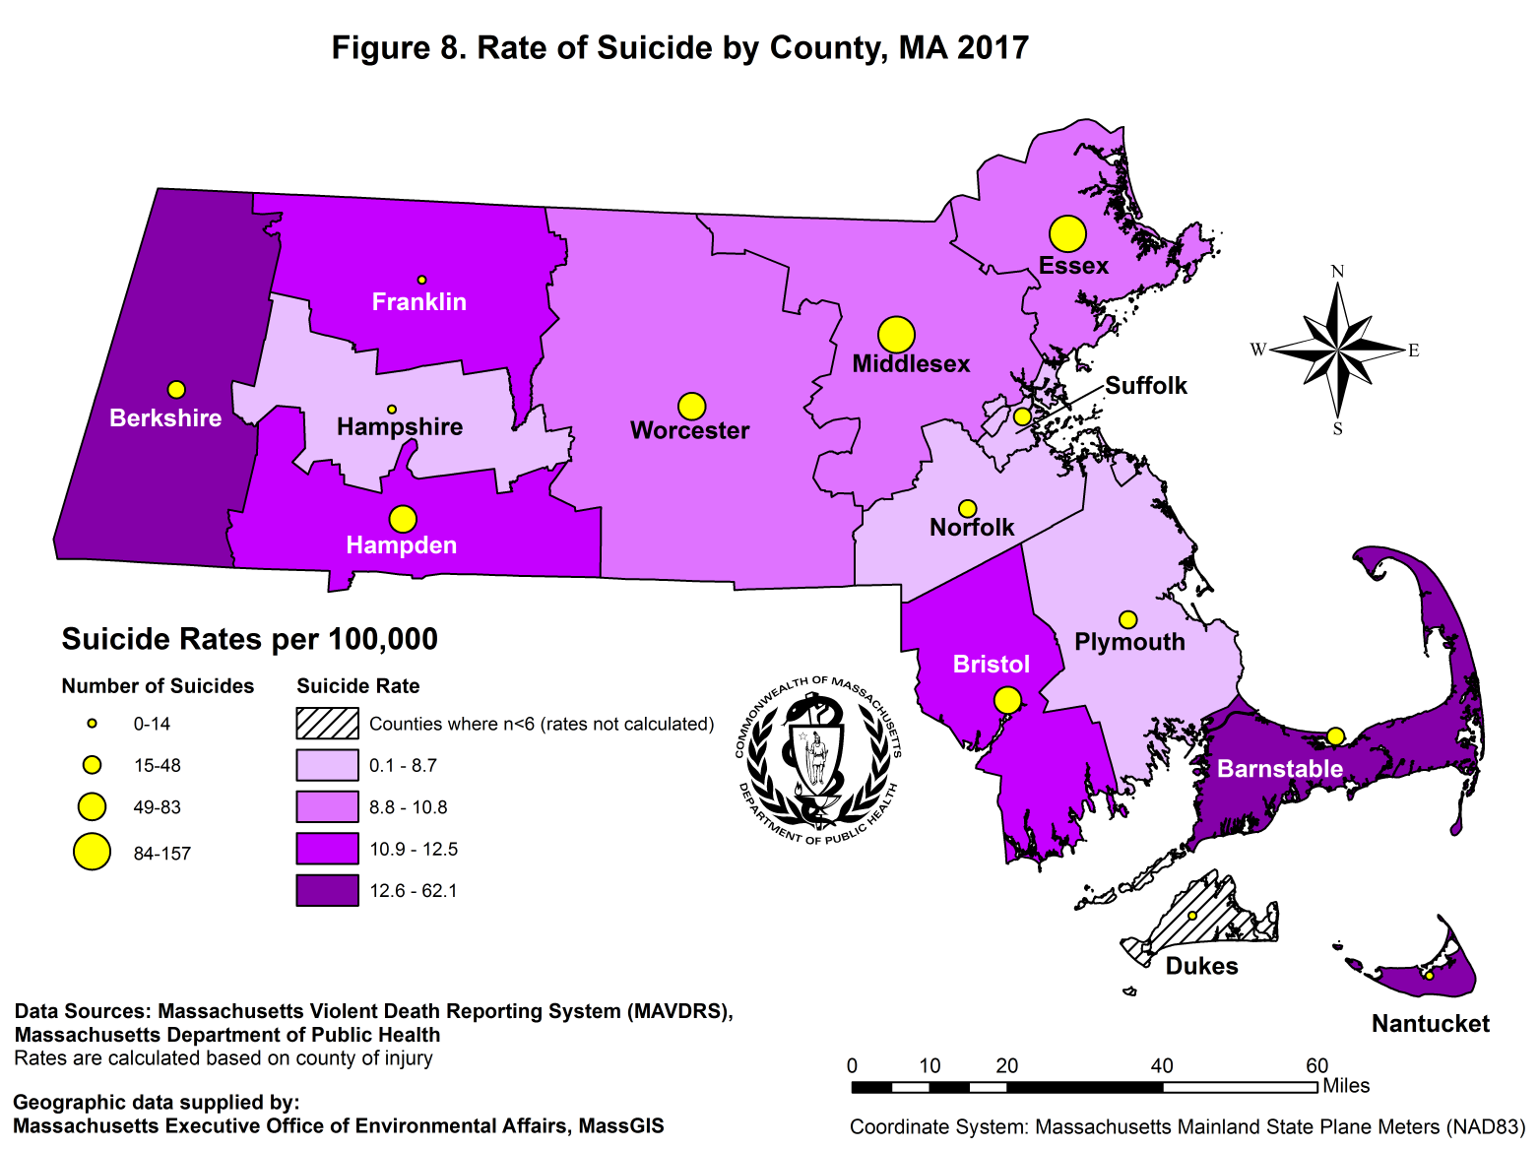
- Suicide rates in Massachusetts varied by county in 2017:

- In 2017, Nantucket (62.1/100,000 persons, n = 7), Berkshire (17.4/100,000 persons, n = 22), and Barnstable (15.9/100,000 persons, n = 34) counties had the highest rates of suicide. Please note that rates based on counts less than 20 are considered unstable and should be interpreted with caution.

- Suffolk County had the lowest measurable rate of suicide in 2017 (6.0/100,000 persons, n = 48). In addition, Dukes County had no reported suicides in 2017.

- Middlesex County had the highest number of suicides in 2017 (n = 157, 9.8/100,000 persons).

- Suicide rates in Massachusetts also varied by city/town:

- 286 cities/towns reported at least one suicide between 2015 and 2017.

- Among the cities/towns that reported at least 20 suicides between 2015 and 2017, Haverhill (16.6/100,000 persons, n = 31), Fall River (14.2/100,000 persons, n = 38), and Taunton (14.2/100,000 persons, n = 24) had the highest suicide rates.

- Among the cities/towns that reported at least 20 suicides between 2015 and 2017, Springfield (6.5/100,000 persons, n = 30), Boston (7.3/100,000 persons, n = 144), and Lynn (7.6/100,000 persons, n = 21) had the lowest suicide rates.
Suicidal Thoughts and Behaviors in Adults
Race/Ethnicity¹¹
Sex
Income
Education
Age
Source: MA Behavioral Risk Factor Surveillance System 2016-2018, weighted data

MA Behavioral Risk Factor Surveillance System (BRFSS)
- The MA BRFSS is an annual telephone survey that collects information on the health issues and risk factors of adults age 18 and older. Between 2016 and 2018, survey participants were asked if they had seriously considered attempting suicide over the past 12 months. Figure 9 displays the proportions among each group that responded yes and their associated 95% confidence intervals. Among the results:

- 3.7% of respondents seriously considered attempting suicide over the past 12 months.

- Adults age 18-34 were significantly more likely to report seriously considering attempting suicide compared to those aged 35-54 and those aged 55 or older (6.7% vs. 3.1% and 1.9%, respectively).

- Adults with at least a college degree were significantly less likely to report seriously considering attempting suicide compared to those with some college and those with a high school diploma or less (2.0% vs. 4.8% and 4.7%, respectively).

- Adults who made less than $25,000 were significantly more likely to report seriously considering attempting suicide compared to adults who made between $25,000 and $74,999 and those who made $75,000 or more (7.4% vs. 3.6% and 2.1%, respectively).
Helpline Data

- In 2017, the Massachusetts Samaritans and the United Way of Tri-County’s Call2Talk Center responded to 168,521 crisis phone calls and 5,382 text conversations.¹²
¹¹ Persons of Color includes those for whom race/ethnicity was Black, non-Hispanic; Hispanic; Asian; or other race and have been grouped together due to small sample sizes for each individual race/ethnicity.
¹² This number includes repeat callers and texters and callers who were concerned about others.

Suicidal Thoughts and Behaviors in Youth

MA Youth Risk Behavior Survey
(MA YRBS)

- The MA YRBS is an anonymous, written self-report survey of youth in public high schools in MA. In 2015 and 2017, results showed that:

- 13.6% of students seriously considered suicide during the past year.

- 6.2% made a suicide attempt, and of those, 39.7% resulted in an injury or required medical attention.

- The proportion of students who reported suicidal thoughts and behaviors has remained relatively constant over the past five surveys with some minor fluctuations.

Victimization and Suicide Attempts

- Survey findings from the MA YRBS show that as the number of victimization types a student experiences rises, the percent of suicide attempts rises as well. The five victimization types from YRBS include:

- Students who had ever been bullied on school property during the past 12 months.

- Students who did not go to school on one or more of the past 30 days because they felt they would be unsafe at school or on their way to or from school.

- Students who had been threatened or injured with a weapon (e.g. gun, knife, club) on school property one or more times during the previous 12 months.

- Students who had ever been hurt physically by a date or someone they were going out with.

- Students who responded that someone had ever had sexual contact with them against their will.
Source: MA Youth Risk Behavior Survey 2015 and 2017, weighted data

Source: MA Youth Risk Behavior Surveys 2009, 2011, 2013, 2015, and 2017, weighted data

Source: MA Youth Risk Behavior Survey 2013, 2015, and 2017, weighted data

Suicidal Thoughts and Behaviors in Youth by Sex, Race/Ethnicity, and LGBT Status

MA YRBS Data by Sex

- Females were significantly more likely to report non-suicidal self-injury, seriously considering suicide, making a suicide plan, and attempting suicide compared to males

- 27.4% of high school students reported feeling “so sad” or “depressed daily” for at least two weeks during the previous year that they discontinued usual activities. A significantly larger percentage of females (35.4%) than males (19.5%) reported feeling this way (not depicted on graph).

MA YRBS Data by Race/Ethnicity

- High school students who identified as Hispanic were significantly more likely to report attempting suicide compared to students who identified as white, non-Hispanic. They were also more likely to report non-suicidal self-injury and seriously considering suicide, although the results were not statistically significant.

MA YRBS Data by LGBT Status

- High school students who identified as lesbian, gay, bisexual, or transgender (LGBT) were significantly more likely to report all suicidal thoughts and behaviors compared to students who identified as heterosexual.

- A significantly higher proportion of high school students who identified as LGBT reported feeling “so sad” or “depressed daily” for at least two weeks during the previous year that they discontinued usual activities compared to students who identified as heterosexual (55.3% vs. 23.7%) (not depicted on graph).
Source: MA Youth Risk Behavior Survey 2015 and 2017, weighted data

Source: MA Youth Risk Behavior Survey 2015 and 2017, weighted data

Source: MA Youth Risk Behavior Survey 2015 and 2017, weighted data

For more information, contact these programs at
Massachusetts Department of Public Health,
250 Washington Street,
Boston, MA 02108
Where to go for help
__________________

MA Coalition for Suicide Prevention
(617) 297-8774
info@masspreventssuicide.org
__________________

24 hour help lines

NATIONAL LIFELINE
(800) 273-TALK (8255)
Press 1 for Veterans
TTY: (800) 799-4TTY (4889)

SAMARITANS (call or text)
(877) 870-HOPE (4673)

CALL2TALK (call only)
(508) 532-2255

INJURY SURVEILLANCE PROGRAM (ISP)
Bureau of Community Health and Prevention (BCHAP)
(617) 624-5664 (MAVDRS)
(617) 624-5648 (General injury information)
http://mass.gov/injury-surveillance-program

SUICIDE PREVENTION PROGRAM (SPP)
Bureau of Community Health and Prevention (BCHAP)
(617) 624-5460
http://mass.gov/suicide-prevention-program

BUREAU OF SUBSTANCE ADDICTION SERVICES (BSAS)
(800) 327-5050
TTY: (888) 448-8321
http://mass.gov/orgs/bureau-of-substance-addiction-services

Methods

General Notes:
All data were ascertained using guidelines recommended by the Centers for Disease Control and Prevention (CDC) and are based upon the International Classification of Disease codes (ICD-10) for morbidity and mortality. The most recently available year of data for each data source was used for this bulletin. Rates reported in this bulletin are crude rates unless otherwise specified. Age-adjusted rates are used in certain figures to minimize distortions that may occur from differences in age distribution among compared groups. Rates presented in this bulletin cannot be compared to bulletins published prior to 2008 due to a methodology change. In prior bulletins, individuals less than 10 years old were excluded in both the numerator and denominator due to the rarity of this age group completing suicide. For consistency with other publications, the analysis was modified to include all ages for both numerator and denominator, this change results in slightly lower rates. Rates are not calculated on counts of less than five, and rates based on counts less than 20 are considered unstable. Prior to data year 2010, death data used in the bulletin was from the Massachusetts Registry of Vital Records and Statistics (MA RVRS) and included Massachusetts residents regardless of where the death occurred.

Data Sources:
- Death Data: MA Violent Death Reporting System (MAVDRS), MA Department of Public Health (DPH). The National Violent Death Reporting System (NVDRS) is a CDC-funded system in all 50 states, the District of Columbia, and Puerto Rico that links data from death certificates, medical examiner files, and police reports to provide a more complete picture of the circumstances surrounding violent deaths. MAVDRS operates within the Injury Surveillance Program (ISP) at DPH. MAVDRS captures all violent deaths (homicides, suicides, deaths of undetermined intent, and all firearm deaths) occurring in MA, regardless of residency, and has been collecting data since 2003. Data reported are for calendar year and were analyzed by ICD-10 code.
- Suicide Crisis Call Data: United Way of Tri-County Call2Talk; Samaritans, Inc.; Samaritans of Fall River; Samaritans of Merrimack Valley; Samaritans on the Cape & Islands.
- MA Behavioral Risk Factor Surveillance System: MA Department of Public Health, Office of Data Management and Outcomes Assessment, Health Survey Program
- MA Youth Risk Behavior Survey: MA Department of Education, MA Department of Public Health, & CDC MMWR Vol. 67, No. 8, June 2018.
- Population Data: National Center for Health Statistics. Vintage 2018 postcensal estimates of the resident population of the United States (April 1, 2010, July 1, 2010-July 1, 2018), by year, county, single-year of age (0, 1, 2, ..., 85 years and over), bridged race, Hispanic origin, and sex. Prepared under a collaborative arrangement with the U.S. Census Bureau. Available from: http://www.cdc.gov/nchs/nvss/bridged_race.htm as of June 25, 2019, following release by the U.S. Census Bureau of the unbridged Vintage 2018 postcensal estimates by 5-year age group on June 20, 2019.
- U.S. injury rates and U.S. population were accessed from CDC, National Center for Injury Prevention and Control (NCIPC), and the Web-based Injury Statistics Query and Reporting System (WISQARS).

Statistical Significance: A statistically significant p-value indicates strong evidence against the null hypothesis. For example, if your null hypothesis is that Group A is equal to Group B and you obtain a small p-value (<0.05), that indicates that Group A likely does not equal Group B. These tests can tell you if groups differ in an outcome (for example, men versus women dying by suicide) or if a factor is associated with an outcome (for example, are financial circumstances associated with dying by suicide). Statistical significance does not necessarily imply importance and should not be the only consideration when exploring an issue. Because a rate is not “statistically significant” does not mean there is not a real problem that could or should be addressed.

This publication was supported by cooperative agreement #U17/CE002606 from the CDC. Its contents are solely the responsibility of the authors and do not represent the official views of the CDC.

