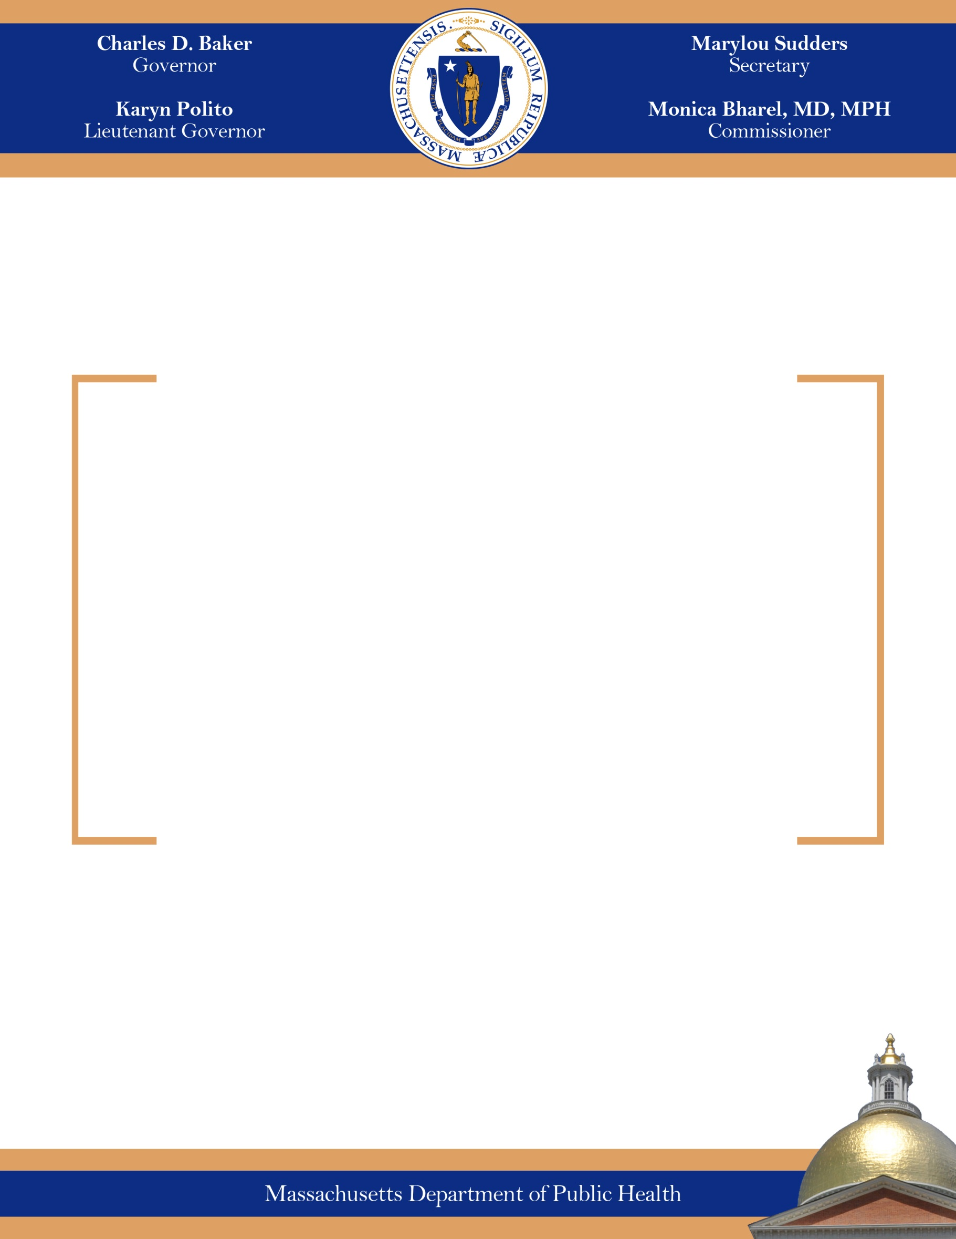
January 2019
MASSACHUSETTS COMMISSION ON FALLS PREVENTION
Massachusetts Department of Public Health
2018 Annual Progress Report

Reporting Period: 9/2017-9/2018

MARYLOU SUDDERS
Secretary
MONICA BHAREL, MD, MPH Commissioner

Tel: 617-624-6000
www.mass.gov/dph


The Commonwealth of Massachusetts
Executive Office of Health and Human Services
Department of Public Health
250 Washington Street, Boston, MA 02108-4619

CHARLES D. BAKER
Governor
KARYN E. POLITO
Lieutenant Governor

January 30, 2019

Steven T. James
House Clerk
State House Room 145
Boston, MA 02133

William F. Welch
Senate Clerk
State House Room 335
Boston, MA 02133

Dear Mr. Clerk,

Please find attached the Massachusetts Commission on Falls Prevention, 2018 Annual Progress Report in accordance with Chapter 111, Section 224 of the Massachusetts General Laws.

Sincerely,

Monica Bharel, MD, MPH
Commissioner
Department of Public Health
Legislative Mandate

The following report is hereby issued pursuant to Section 224 of Chapter 111, Massachusetts General Laws.

Section 224 of Chapter 111 of the Massachusetts General Laws reads, in relevant part, as follows:

There shall be a commission on falls preventions within the department. The commission shall consist of the commissioner of public health or the commissioner’s designee, who shall chair the commission; the secretary of elder affairs or the secretary’s designee; the director of MassHealth or the director’s designee; and 8 members to be appointed by the governor, 1 of whom shall be a member of the Home Care Alliance of Massachusetts, Inc., 1 of whom shall be a member of the AARP, 1 of whom shall be a member of the Massachusetts Senior Care Association, Inc., 1 of whom shall be a member of the Massachusetts Association of Councils on Aging, Inc. 1 of whom shall be a member of the Massachusetts Medical Society Alliance, Inc., 1 of whom shall be a member of the Massachusetts Assisted Living Facilities Association, 1 of whom shall be a member of Mass Home Care and 1 of whom shall be a member of the Massachusetts Pharmacists Association Foundation, Inc.

The commission on falls prevention shall make an investigation and comprehensive study of the effects of falls on older adults and the potential for reducing the number of falls by older adults. The commission shall monitor the effects of falls by older adults on health care costs, the potential for reducing the number of falls by older adults and the most effective strategies for reducing falls and health care costs associated with falls. The commission shall:

(1) consider strategies to improve data collection and analysis to identify fall risk, health care cost data and protective factors;

(2) consider strategies to improve the identification of older adults who have a high risk of falling;

(3) consider strategies to maximize the dissemination of proven, effective fall prevention interventions and identify barriers to those interventions;

(4) assess the risk and measure the incidence of falls occurring in various settings;

(5) identify evidence-based strategies used by long-term care providers to reduce the rate of falls among older adults and reduce the rate of hospitalizations related to such falls;

(6) identify evidence-based community programs designed to prevent falls among older adults;

(7) review falls prevention initiatives for community-based settings; and

(8) examine the components and key elements of the above falls prevention initiatives, consider their applicability in the commonwealth and develop strategies for pilot testing, implementation and evaluation.

The commission on falls prevention shall submit to the secretary of health and human services and the joint committee on health care financing, not later than September 22, annually, a report that includes findings from the commission’s review along with recommendations and any suggested legislation to implement those recommendations. The report shall include recommendations for:

(1) intervention approaches, including physical activity, medication assessment and reduction of medication when possible, vision enhancement and home-modification strategies;

(2) strategies that promote collaboration between the medical community, including physicians, long-term care providers and pharmacists to reduce the rate of falls among their patients;

(3) programs that are targeted to fall victims who are at a high risk for second falls and that are designed to maximize independence and quality of life for older adults, particularly those older adults with functional limitations;

(4) programs that encourage partnerships to prevent falls among older adults and prevent or reduce injuries when falls occur; and

(5) programs to encourage long-term care providers to implement falls- prevention strategies which use specific interventions to help all patients avoid the risks for falling in an effort to reduce hospitalizations and prolong a high quality of life.

I. INTRODUCTION/BACKGROUND

In the United States, more than one in four adults age 65 or older experiences a fall every year. Once a fall happens, their risk for falling again is then doubled. Although not all these falls cause bodily harm, at least one in five results in serious injuries for older adults, including broken bones (e.g. wrist, ankle, and hips) and traumatic brain injuries (TBI).

Nationally and in the Commonwealth of Massachusetts, unintentional falls are the leading cause of nonfatal injuries as well as injury-related deaths within the older adult population (≥ age 65). In 2014, 528 older adults in Massachusetts died from fall-related injuries representing 83% of all fall deaths that occurred in the state. That same year falls were also the leading cause of TBI deaths (85%) in this age group. In fiscal year 2014, falls were associated with 22,315 hospital stays and 48,753 Emergency Department visits. Every week, approximately 900 older adults visit Massachusetts emergency departments and approximately 400 are admitted for hospitalization, all because of fall-related events. Despite these concerning facts, prevailing research in this area continues to assert that older adult falls are mostly preventable when certain evidence-based interventions are applied. Falling should never be accepted as a normal and expected part of the aging process.

The Massachusetts Commission on Falls Prevention (referred to as the Commission for the remainder of the report) is a public body of thirteen members, under the aegis of the Massachusetts Department of Public Health (DPH) with the Commissioner of Public Health/their designee serving as Chair. There are three state agency (ex-officio) members on the Commission as well as ten stakeholder organization members who are appointed by the Governor (see Appendix A for a list of current Commission members and the organizations they represent). The Commission was created under a provision within health care reform legislation passed by the Massachusetts Legislature in 2010 and first began convening in August 2012. The Commission was tasked with examining the public health problem of older adult falls in Massachusetts including the health care cost burden associated with fall-related injuries and making recommendations on best ways to reduce them.

In September 2015, the Commission with assistance from public health consultants from
JSI Research & Training Institute, Inc. fulfilled this charge with the submission to the Massachusetts Secretary of Health and Human Services and Massachusetts Legislature (Joint Committee on Health Care Financing) of a final blueprint of consensus recommendations reflecting best strategies for Massachusetts to reduce older adult falls and costly fall-related injuries. The document was entitled Phase 2 Report: Recommendations of the Massachusetts Commission on Falls Prevention.
http://www.mass.gov/eohhs/docs/dph/com-health/injury/falls-prevention-phase-2-report.pdf

Prior to this report, in September 2013 a document entitled Phase 1 Report: The Current Landscape had been prepared and submitted.

The following DPH summary provides an update of the Commission’s activities during the current reporting period of 9/2017 through 9/2018.

II. SUMMARY OF ACTIVITIES

During this reporting period the MA Commission on Falls Prevention convened three open meetings on the following dates:

- November 9, 2017
- February 13, 2018
- May 7, 2018

Note: in adherence with the state’s Open Meeting Law, a meeting scheduled for June 28, 2018 was cancelled by the Chair due to lack of the required physical quorum of members.

Meeting minutes that were formally accepted by the Commission membership can be found on-line at: https://www.mass.gov/lists/massachusetts-commission-on-falls-prevention-meeting-materials

The following provides brief highlights of those meetings, including key issues and featured presenters:

November 9, 2017
During the meeting Laura Kersanske, Injury and Violence Prevention Epidemiologist at DPH under the Bureau of Community Health and Prevention gave a presentation to the Commission members on the most recently available, preliminary, Massachusetts older adult fall injury data (from calendar year 2014 and fiscal year 2015). For people age 65 and older falls are the leading cause of injury deaths (53%) and hospitalizations (67%) in the state. There has been only a slight increase in the number of Emergency Department visits and deaths associated with falls in this age group for the last five years of available data.

February 13, 2018
At the meeting it was announced that the position of designated Commission Chair under DPH had changed from Leonard Lee, Director of the Division of Violence and Injury Prevention (DVIP) within the Bureau of Community Health and Prevention (BCHAP) to Rebekah Thomas, Director of the Injury Prevention and Control Program within DVIP. Ms. Thomas was present for the meeting and introduced herself to the Commission members. She then led a discussion to gather input from the members on thoughts about the role of the Commission now and potential work plans for the future.

The new Chair noted that Governor Baker had established a “Council to Address Aging in Massachusetts” in April 2017 that released a preliminary report in January 2018 entitled “Shaping the Future, Initial Blueprint Recommendations”. The report sets forth the Council’s main mission: formulating a plan to achieve the goal of making the Commonwealth of Massachusetts the most age-friendly state for people of all ages. The report also identifies some guiding principles that have been adopted as recommendations under this important state initiative (e.g., reframing aging as an asset and viewing it as something that should be planned for).

Much of the dialogue between the members at the meeting focused on ways to call attention to the considerable work the Commission had already accomplished with the submission of their 2015 Phase 2 Report of consensus recommendations. The Chair proposed reviewing the Council’s report to see where there might be synergy with the Commission’s report and activities. During the meeting some Commission members suggested inviting Secretary Alice Bonner who serves on the Council or lead members of her staff from the MA Executive Office of Elder Affairs (EOEA) to the next Commission meeting to engage in a conversation about where the ongoing work of the new Council and the Commission’s recommendations to reduce older adult fall-related injuries might possibly intersect. In addition, with the groundswell of activity surrounding the age-friendly/healthy aging movement spearheaded in Massachusetts by the Massachusetts Healthy Aging Collaborative (MHAC) and AARP, James Fuccione, the Senior Director of MHAC was also identified as a key individual who should be asked to participate at the next meeting.

May 7, 2018
For this open meeting, the Commission convened at the EOEA. EOEA Chief of Staff and Chief Strategy officer, Robin Lipson provided a thorough overview of the Governor’s Council to Address Aging in Massachusetts, covering background about the Council, its broad-based membership, work plan and latest Blueprint report released in April.

A second presenter, James Fuccione, the Senior Director from MHAC explained the vibrant age-friendly movement happening throughout communities and cities/towns across the state. He emphasized how community leaders must look at the future through an age-friendly lens, because in twenty years people age 60 or older will comprise approximately 30% or more of the population in a majority of Massachusetts communities.

Both presenters acknowledged some parallels in efforts by the Falls Commission in making recommendations to reduce older adult falls injuries and keep older adults safe and independent with the long-range focus of the Governor’s Council to make and implement recommendations that facilitate the needs of people as they age in their communities and promote “healthy aging”. During the meeting Commission members were encouraged by the presenters to reach out to the Council chairs to highlight the Commission’s Phase 2 Report and recommendations while the Council continues with their ongoing work.

Additional Activities
In March 2018, Dr. Jonathan Howland, Director of the Boston Medical Center Injury Prevention Center, delivered a final report and project findings that were vetted and accepted by DPH. Dr. Howland served as the principle investigator for a three year project designed to assess Massachusetts Primary Care Providers’ (PCP) attitudes, beliefs and practices related to fall risk screening and assessment of patients age 65 and older and the Centers for Disease Control and Prevention’s Stopping Elderly Accidents, Deaths & Injuries (STEADI) toolkit. Two multispecialty practice groups (92% were doctors of medicine) were surveyed on behalf of the Commission as well as other stakeholder organizations to help inform their work and gain greater insight about the extent to which the Massachusetts medical community is trying to address the reduction of falls and fall injuries within the older adult patient population. The study found that while most respondents believed that older adults should be assessed for falls risk, and that falls could be prevented, only half of the respondents believed they had the expertise to conduct a fall risk assessment.

III. NEXT STEPS

For the year ahead the MA Commission on Falls Prevention plans to:
- Hold quarterly meetings as agreed upon by members (provided an Open Meeting Law quorum of members can be achieved) and invite relevant speakers/experts to present and inform the Commission on current initiatives, etc.;
- Continue the dialogue on identifying ways to engage key stakeholders/partners in adopting and/or committing to certain Phase 2 Commission Report recommendations.

APPENDIX A
Members of the Massachusetts Commission on Falls Prevention

Member Name/Title | Organization Representing:
- Rebekah Thomas (Commission Chair) Director, Injury Prevention and Control Program (Division of Injury Prevention and Control-Bureau of Community Health and Prevention) | MA Department of Public Health (DPH)  (state agency)
- Almas Dossa, Assistant Director, Fee-For-Service Programs, Home Health, Hospice, and Therapy Services, MassHealth Office of Long Term Care Services & Supports | MassHealth (state agency)
- Annette Peele, Director of Community Programs | MA Exec. Office of Elder Affairs (EOEA)  (state agency)
- Colleen Bayard, Director of Regulatory and Clinical Affairs | Home Care Alliance of MA
- Ish Gupta, Assistant Professor of Internal Medicine, University of MA Medical School | MA Medical Society
- Melissa Jones, Practicing PT | American Physical Therapy Assn. of MA
- Jennifer Kaldenberg, Clinical Asst. Professor, Boston Univ., College of Health and Rehab. Sciences: Sargent College | MA Assn. for Occupational Therapy
- Helen Magliozzi, Director of Regulatory Affairs | MA Senior Care Assn.
- Joanne Moore, Director, Duxbury Senior Center | MA Assn. of Councils on Aging
- Emily Shea, Commissioner, Commission on Affairs of the Elderly (City of Boston) | Mass Home Care
- Mary Sullivan, Pharmacy Manager, Senior Whole Health | MA Pharmacists Assn. Foundation
- Deborah Washington, Director of Diversity, Patient Care Services, MA General Hospital | American Assn. of Retired Persons  (AARP)-MA Chapter
- Vacancy – new candidate pending | MA Assisted Living Assn. (Mass-ALA)

Endnotes

Massachusetts Data Brief, Special Emphasis Report: Unintentional Fall Injuries among Older Adults, 2006-2014 https://www.mass.gov/files/documents/2018/07/19/special-emphasis-older-adult-falls-jun-2018.pdf
A Pilot Survey of Massachusetts Primary Care Providers: Older Adult Fall-Risk Assessment, Intervention & Referral, J Howland, PhD, MPH, MPA et al https://www.mass.gov/files/documents/2018/08/08/PCP%20Falls%20Survey%20rpt.pdf

