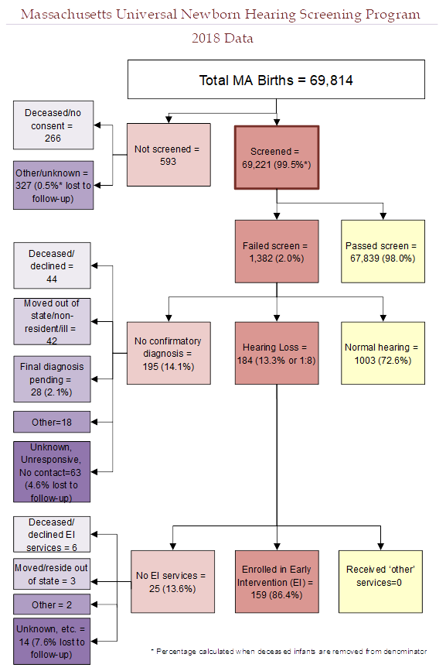

There were 69,814 total births in Massachusetts in 2018. 69,221 (99.5%*) of these infants received a hearing screen. 593 infants were not screened. Of the 593 infants that did not receive a screen:
- 266 died before a screen was performed or their parents/guardians did not provide consent to perform the screen
- 327 (0.5%*) had unknown screening status or did not receive a screen for unknown reasons (lost to screening follow-up)

Of the 69,221 infants that were screened:
- 67,839 (98.0%) passed the screen
- 1,382 (2.0%) failed the screen

Of the 1,382 infants that failed the hearing screen:
- 1003 (72.6%) were diagnosed with normal hearing
- 184 (13.3%) were diagnosed with hearing loss
- 195 (14.1%) did not have a final confirmatory diagnosis when the data were reported. Of these infants without a final confirmatory diagnosis:
  - 44 were deceased (n=4) or their parents/guardians declined follow-up diagnostic services (n=40)
  - 42 moved out of state or did not reside in Massachusetts
  - 28 received diagnostic testing but were pending a final diagnosis
  - 18 were not screened due medical reasons or lack of pediatrician referral
  - 63 (4.6% of the 1,382 infants that failed the screen) were lost to documentation or diagnostic follow-up

Of the 184 infants with hearing loss:
- 159 (86.4%) were enrolled in Early Intervention (EI)
- The remaining 25 infants (13.6%) were not documented to be receiving EI services for the following reasons:
  - 6 were deceased (n=0) or declined EI services (n=6)
  - 3 moved out of state or did not reside in Massachusetts
  - 2 were too medically fragile to receive EI services
  - 14 were not receiving EI services for unknown reasons (7.6% lost to EI follow-up)

* % screened is calculated when deceased children without a screen are not included in the denominator

