Fall 2018 Report on Dealership Lemon Law Compliance
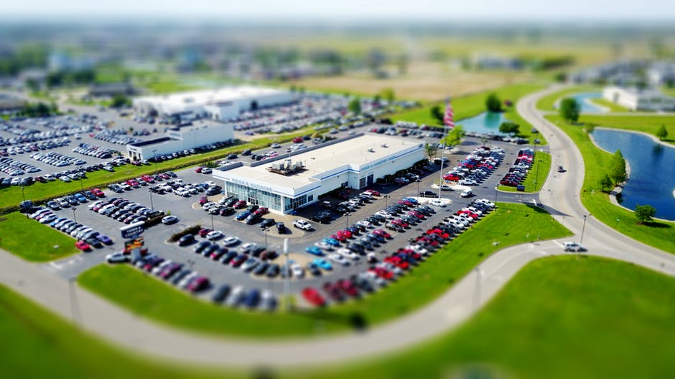

COMMONWEALTH OF MASSACHUSETTS
Office of Consumer Affairs and Business Regulation
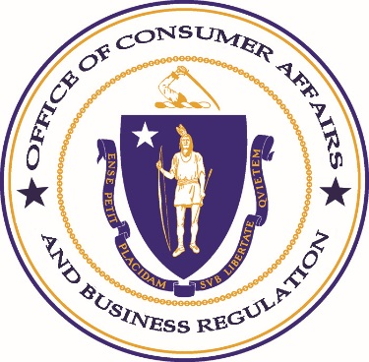
CHARLES D. BAKER  GOVERNOR  KARYN E. POLITO  LIEUTENANT GOVERNOR |  | JAY ASH  SECRETARY OF HOUSING AND ECONOMIC DEVELOPMENT  JOHN C. CHAPMAN  UNDERSECRETARY

In an effort to assess and encourage compliance with regulations regarding the state’s Lemon Laws, the Office of Consumer Affairs and Business Regulation (OCABR) conducts semi-annual dealership audits to identify the number of vehicles properly displaying Lemon Law stickers. Massachusetts law requires that every new or used vehicle offered or displayed for sale in the state must bear a sticker informing the consumer of their rights under the Lemon Laws. The requirements are set forth in M.G.L. Chapter 90 § 7N1/2, 7N1/4, and 201 CMR 11:00. Dealerships that fail to comply are subject to potential penalties at the discretion of the municipality in which they operate.
During the fall 2018 audit, 17 auditors from OCABR, its five regulatory agencies, and partners from the Office of the Attorney General’s (AGO) local consumer programs inspected 127 dealerships in 70 municipalities.
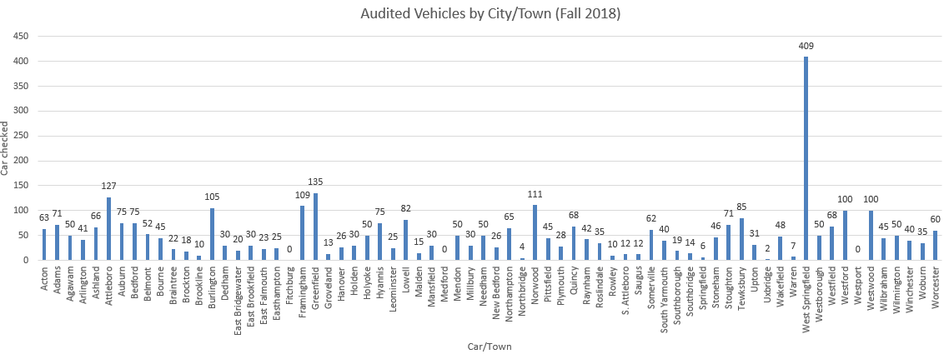
West Springfield dealerships had the most audited vehicles (409 vehicles), followed by Greenfield dealerships (135 vehicles) and Attleboro dealerships (127 vehicles). Below are visual representations of the number of vehicles audited within the various municipalities and counties:

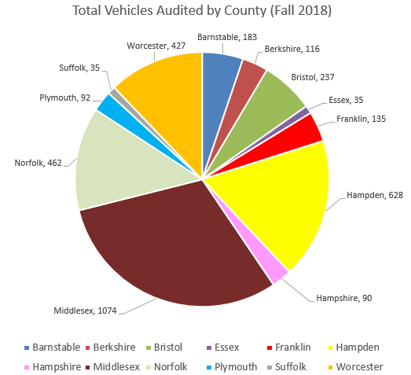
A total of 54 dealerships of the 127 (~42%) dealerships which had vehicles audited achieved a 100% compliance, meaning all of these audited vehicles featured a “form” of a Lemon Law sticker. The breakdown of overall dealership compliance is listed below with a comparison to the spring 2018 audit.
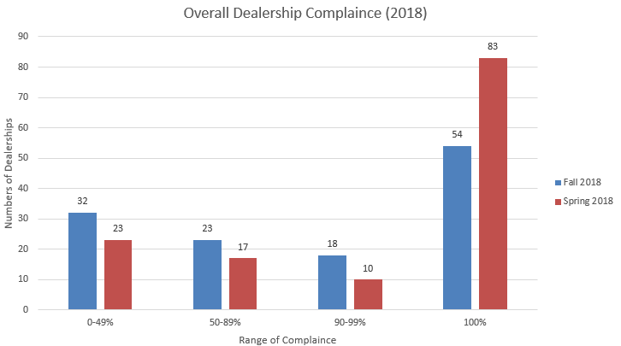
Although total compliance is the ultimate goal of the Office conducting the dealership audits, the Office recognizes the efforts and commends dealerships with a compliance rate of 90%. Based on this criteria, 72 of the 127 dealerships audited (~56%) featured Lemon Law stickers at a satisfactory rate, a 13% decrease from the 93 dealerships with a satisfactory rate audited during the spring audit earlier this year.

Among the 133 dealerships audited during this spring and the 127 dealerships audited this fall, 25 of those dealerships were visited during both audit periods. Three dealerships have closed down leaving 22 dealerships remaining. Of these 22 dealerships, seven were at 100% compliance, five were between 90% and 99% compliance, three were between 80% and 89% compliance, three were between 70% and 79% compliance, one was at 10% compliance, and six were at 0% compliance. Eleven have shown more than a 70% improvement in compliance.
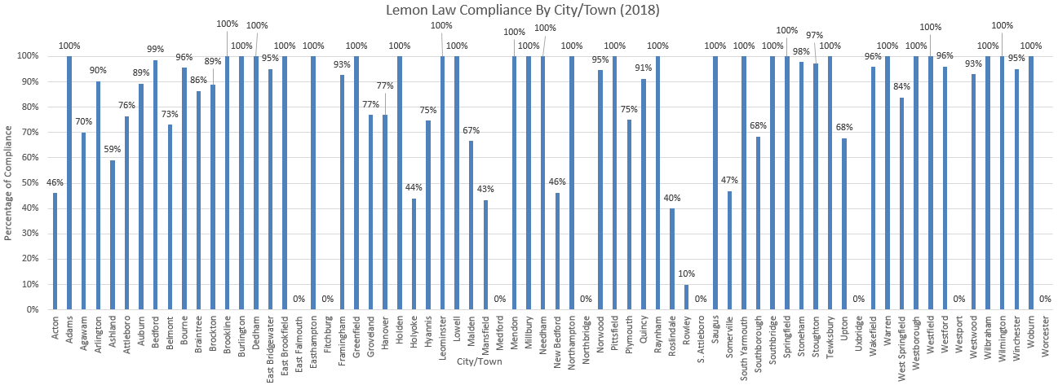
As noted below, of the 70 municipalities where dealerships were audited in fall 2018, 27 were 100% compliant with the Lemon Laws. 15 municipalities had less than an average of 50% compliance by dealerships operating within them, including eight municipalities with 0% compliance:

The Office also analyzed general compliance trends by multiple municipalities within the 12 counties in the fall 2018 audit. Berkshire, Franklin, and Hampshire counties all achieved 100% compliance. Norfolk was the next in compliance at 95% and Suffolk County was the least compliant with a 40% Lemon Law compliance rating. Below is the breakdown of the fall 2018 performance: 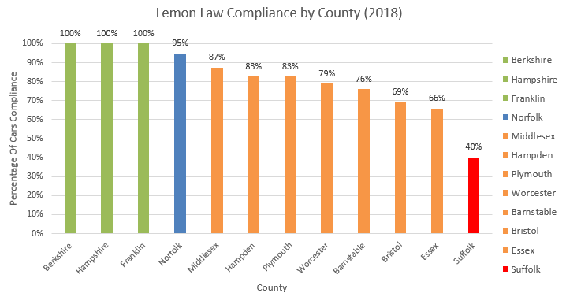
The following counties were audited during both the fall 2018 audit and the spring 2018 audit. Barnstable, Bristol, Essex, Middlesex, Norfolk, Plymouth, Suffolk, and Worcester. Based on the recent audit results two counties - Barnstable and Middlesex - exhibited improvements in compliance while three counties - Essex, Bristol, and Suffolk - decreased in compliance by 15% or more. The graph below visually depicts the fall 2018 audit and spring 2018 audit comparison.
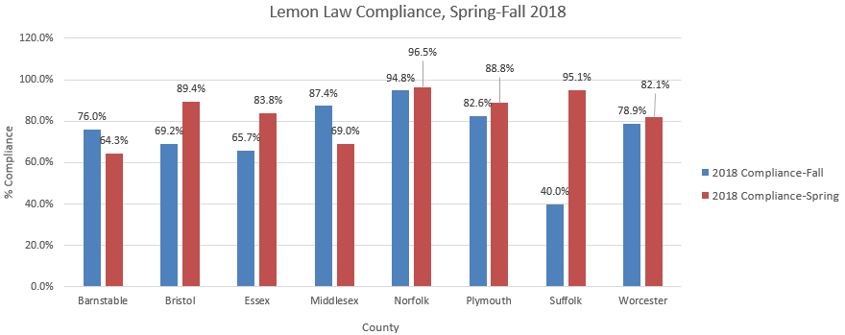

While every Massachusetts municipality is not represented in the report, the data provides a sampling of statewide compliance rates. The purpose of our efforts is to enhance consumer protection and collaborate with individual municipalities to encourage compliance for all dealerships.

