For Immediate Release: <DATE>
Contact: <NAME>, <Tel>
www.mass.gov/keepwarmkeepsafe

Chief <name> and State Fire Marshal Ostroskey Urge Residents to
Keep Warm, Keep Safe this Winter

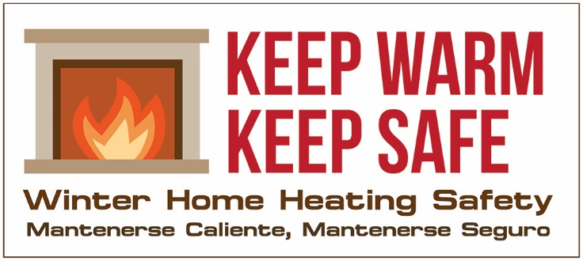
<COMMUNITY> -- Chief <full name> and State Fire Marshal Peter J. Ostroskey urge residents to Keep Warm, Keep Safe this winter by taking a few simple steps to ensure home heating safety this winter. Heating has long been the second leading cause of residential fires which are most common in winter months. Home fires peak from December through February when the cold weather drives people indoors, heating systems are in regular use, and people turn to alternatives such as space heaters and wood or pellet stoves.
Heating a Leading Cause of Fire Deaths
In 2017, Massachusetts fire departments responded to 1,253 heating related fires that caused 14 civilian injuries, 27 firefighter injuries, six civilian deaths, one firefighter death, and $7.2 million in property damage.
Working Smoke Alarms Key to Fire Safety
Chief <lname> said, “No one thinks fire will happen to them, but having working smoke alarms on every level of your home will make sure you have time to escape if one does occur.” <Lname> added, “Replace aging alarms – generally ten years for smoke alarms and 5-7 for CO alarms. Expired alarms cannot be counted on to alert you and your family to danger” There are newer model alarms that have 10-year sealed, non-replaceable batteries. After ten years the entire alarm needs to be replaced, but no more replacing batteries. <S/He> added, “Working smoke alarms coupled with a practiced escape plan increase your family’s chances of surviving a fire.”
Easy Steps to Prevent Heating Fires
State Fire Marshal Ostroskey said, “As we turn on the furnaces and light up the woodstoves and fireplaces, it is important to give them a check-up to make sure they’re ready to heat our homes safely this winter. Preventive maintenance like having the chimney cleaned or the furnace checked out by a certified professional can save money and prevent fires and carbon monoxide poisoning.”
Efficiently running furnaces cost less to run and are less likely to become a source of carbon monoxide in the home. Natural gas and fuel oil are both safe and efficient, but remember to get yearly tune-ups.
If you heat your home by burning solid fuels such as coal, firewood, or pellets, have the chimney cleaned by a certified professional each year who can also check for cracked and broken mortar. Most chimney fires start when built up creosote ignites or when heat escapes the chimney through a crack and ignites the structure.
Dispose of Ashes Safely
Dispose of the ashes in a metal container, with a secure lid, away from the house. A single ember can stay hot for days without being detected and easily fanned back to life. So many fires have started when ashes were placed inside cardboard boxes, paper bags or plastic containers, and then stored inside the garage, the breezeway, or under the porch.
Space Heaters Need Space
Space heater fires are rare but often deadly. Plug space heaters directly into the wall outlet; do not use extension cords. Most space heater fires are extension cord fires. Place heaters 3-feet away from things that can catch fire such as furniture, bedding, newspapers, drapes, and clothes. Teach children to keep 3-giant steps away from heaters, all stoves and fireplaces.
Keep Warm, Keep Safe
If you have any questions about home heating, contact your local fire department or visit the web site, www.mass.gov/keepwarmkeepsafe . By working together we can keep warm and keep safe.

-30-

