Massachusetts Department of Public Health

2018 Statewide Antibiogram Report
Bureau of Infectious Disease and Laboratory Sciences
Massachusetts Department of Public Health
305 South Street
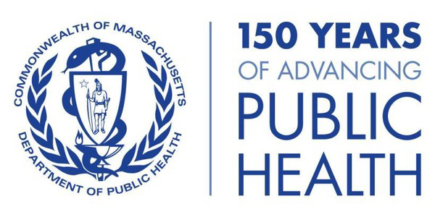
Jamaica Plain, MA 02130 Tel: (617) 983-6550
Fax: (617) 983-6925

Acknowledgements:
Joe Gerth, MPH
Quynh Vo, MPH
Melissa Cumming, MSPH
Alfred DeMaria, Jr., MD
Larry Madoff, MD
Catherine Brown, DVM, MSc, MPH
Eileen McHale, BSN, RN
Gillian Haney, MPH
Scott Troppy, MPH, PMP, CIC

Requests for additional data can be emailed to: dph-antibiogram@state.ma.us

In 2018, hospital antibiotic susceptibility data, in the form of antibiograms, were submitted representing the testing performed in 75 (100%) acute care hospital clinical microbiology laboratories. These data are included in this statewide report. Data are shown by species, with each page displaying the average percent susceptibility of bacterial isolates to relevant antibiotics (red dots, with standard deviation as red bars). These data are representative of the antibiotic susceptibility patterns of 226,541 bacterial isolates from cultures performed on inpatients and outpatients at the reporting acute care hospitals and practices they serve. These data do not represent the full extent of antibiotic resistance in Massachusetts.
Table of Contents (Percent Susceptibility)
Acinetobacter baumannii 2
Enterobacter cloacae 3
Escherichia coli 4
Klebsiella aerogenes 5
Klebsiella oxytoca 6
Klebsiella pneumoniae 7
Pseudomonas aeruginosa 8
Serratia marcescens 9
Stenotrophomonas maltophilia 10
Staphylococcus aureus 11
Streptococcus pneumoniae 12
Antibiogram Collection Form 2018 13
Reporting Facilities 14
Antibiotic Susceptibility Testing Guidelines 15

This page is intentionally left blank.

Acinetobacter baumannii Percent Susceptibility

Overall State Mean (with 1 SD)

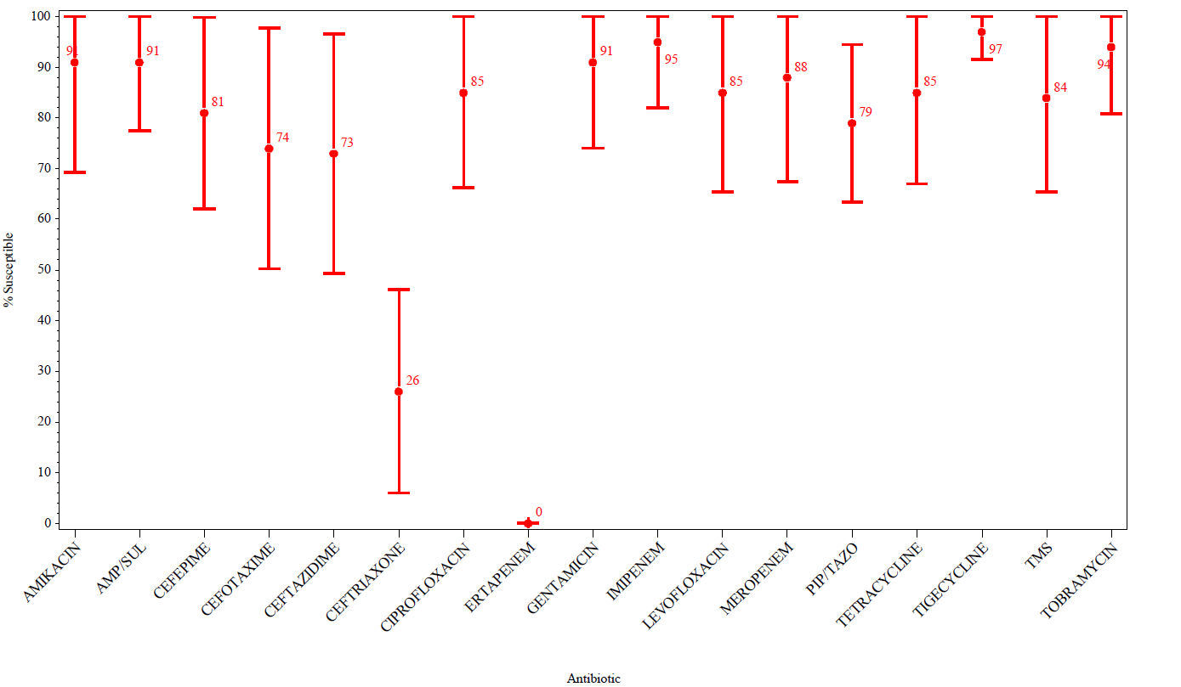

Enterobacter cloacae Percent Susceptibility

Overall State Mean (with 1 SD)

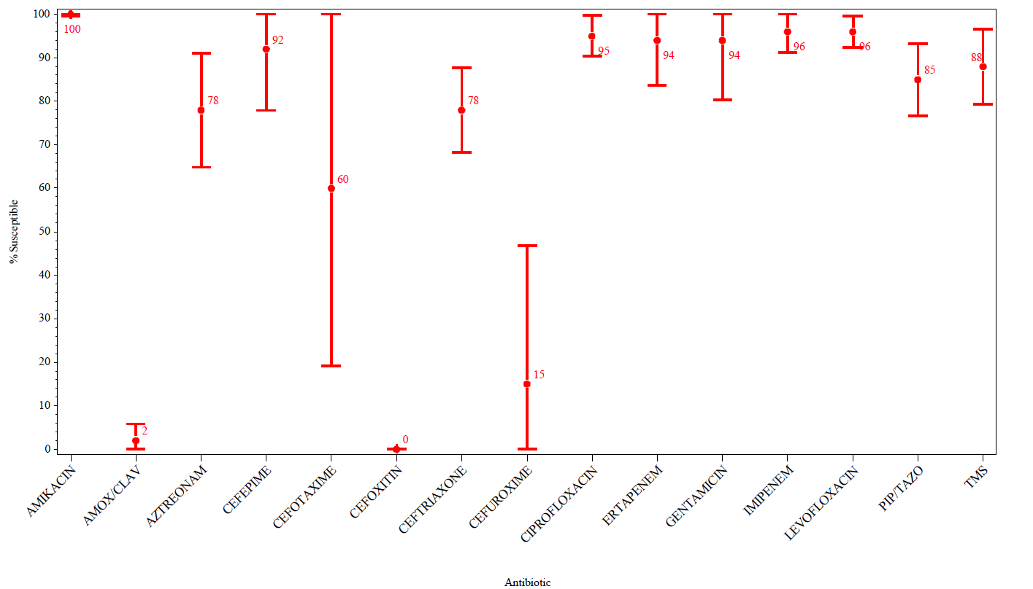

Escherichia coli Percent Susceptibility

Overall State Mean (with 1 SD)

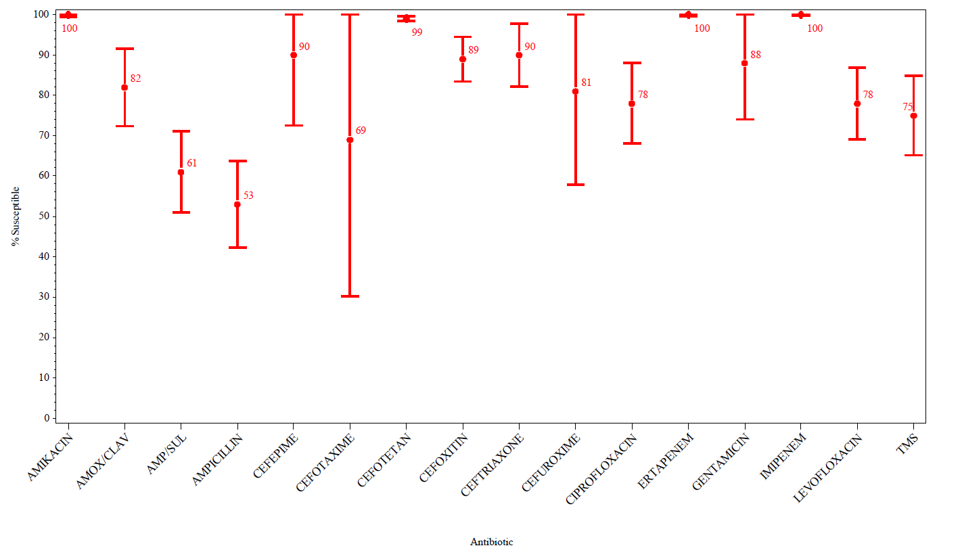

Klebsiella aerogenes Percent Susceptibility

Overall State Mean (with 1 SD)

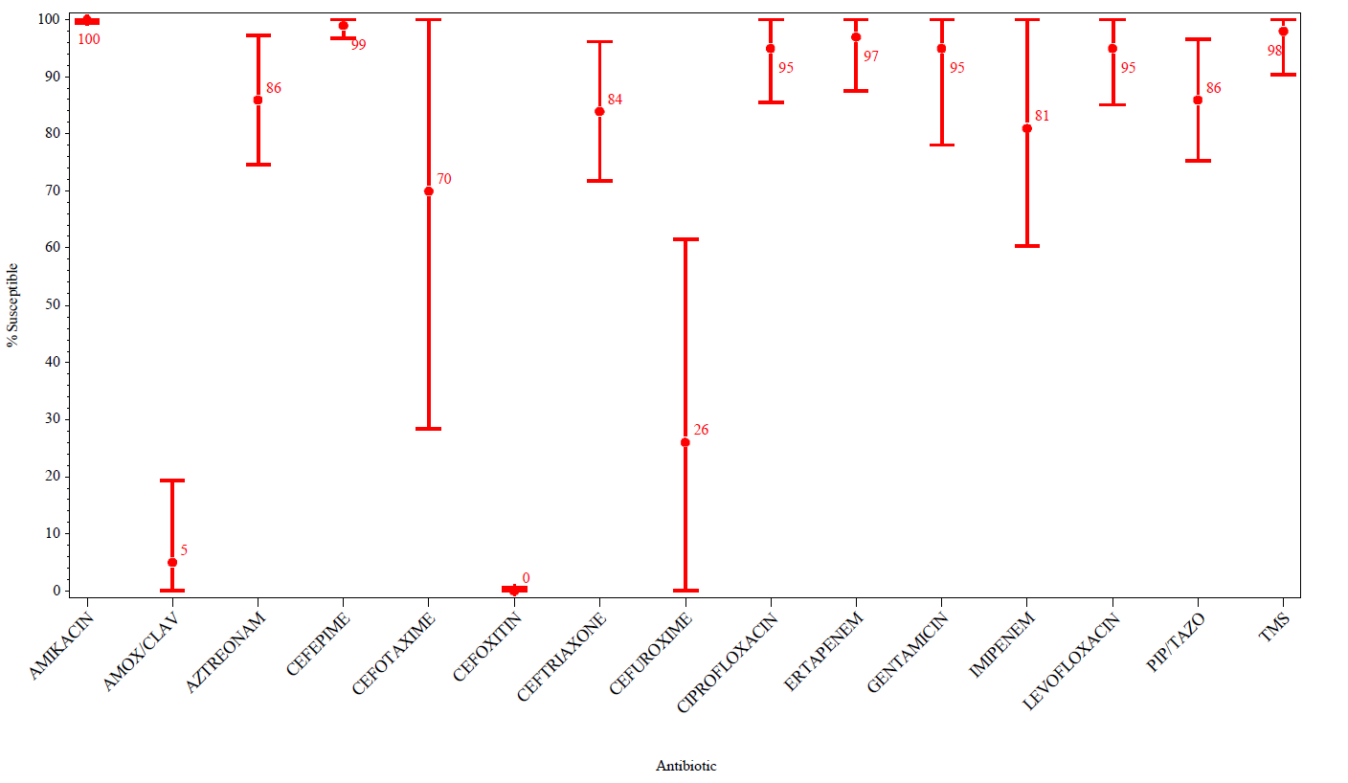

Klebsiella oxytoca Percent Susceptibility

Overall State Mean (with 1 SD)

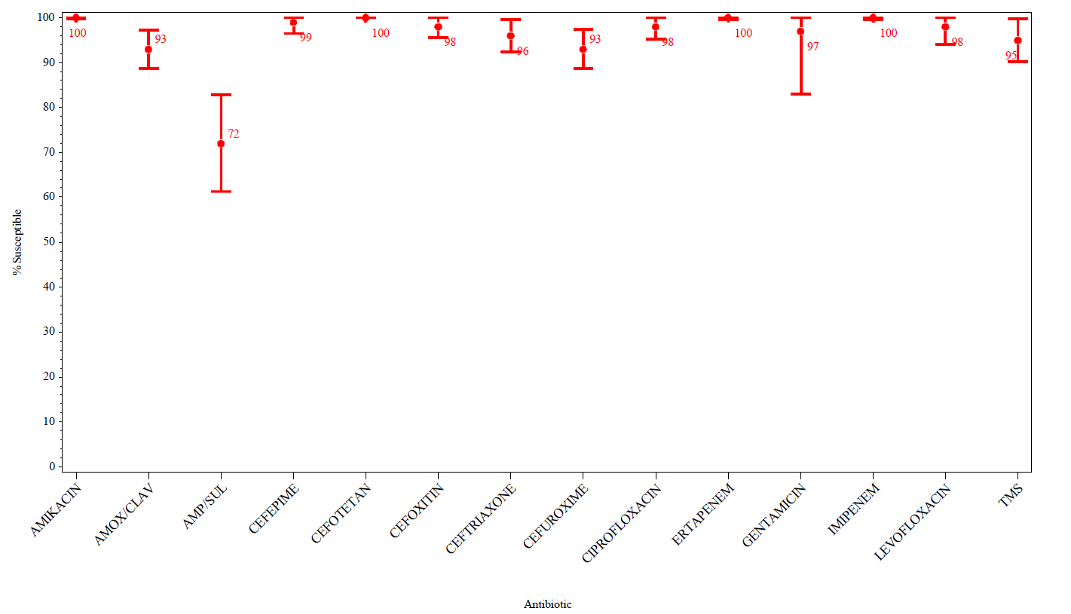

Klebsiella pneumoniae Percent Susceptibility

Overall State Mean (with 1 SD)

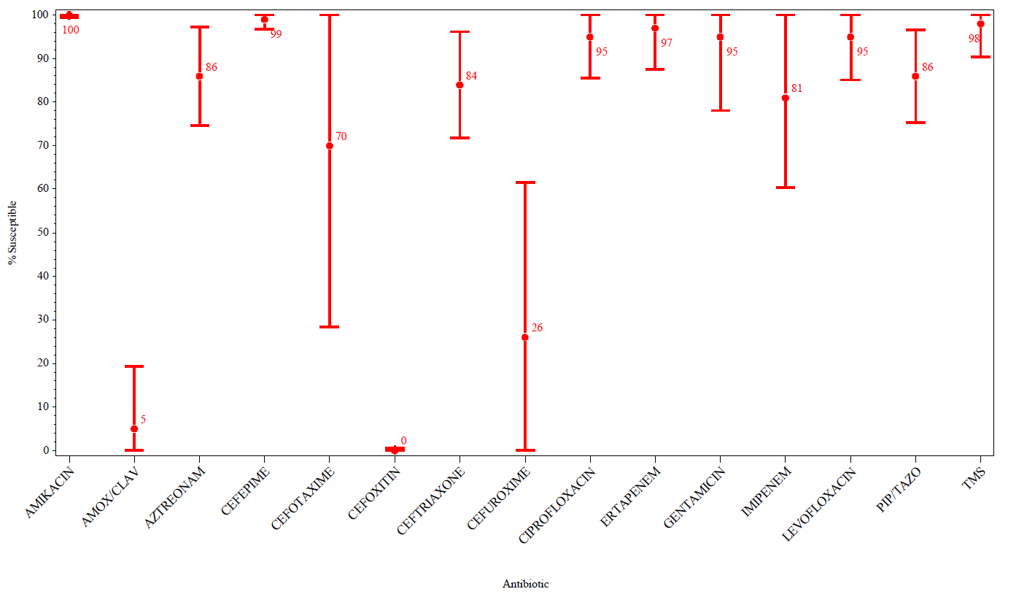

Pseudomonas aeruginosa Percent Susceptibility

Overall State Mean (with 1 SD)

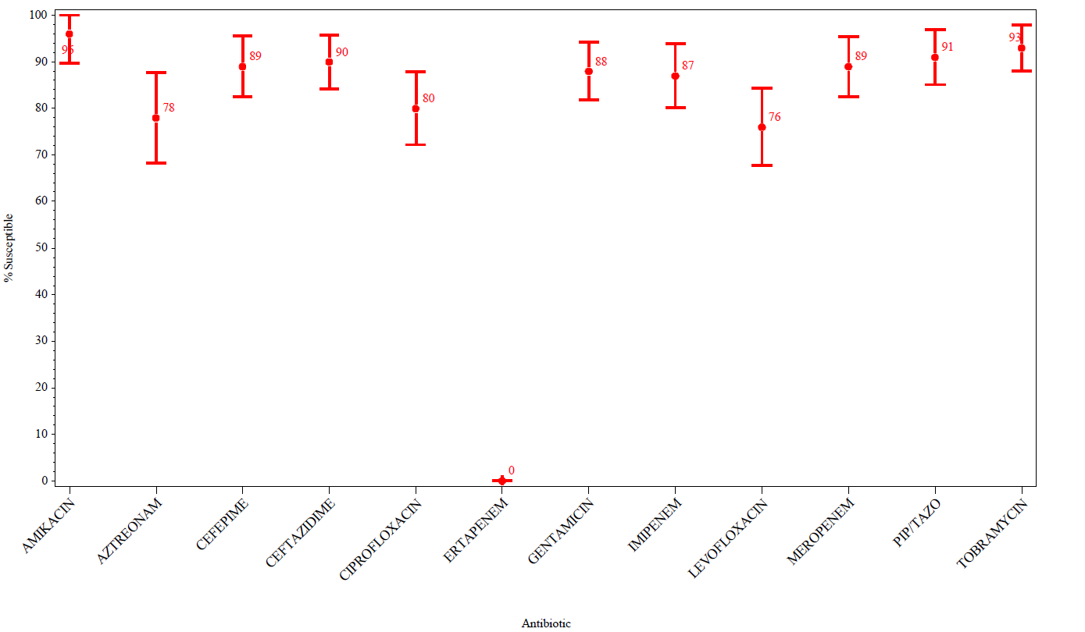

Serratia marcescens Percent Susceptibility

Overall State Mean (with 1 SD)

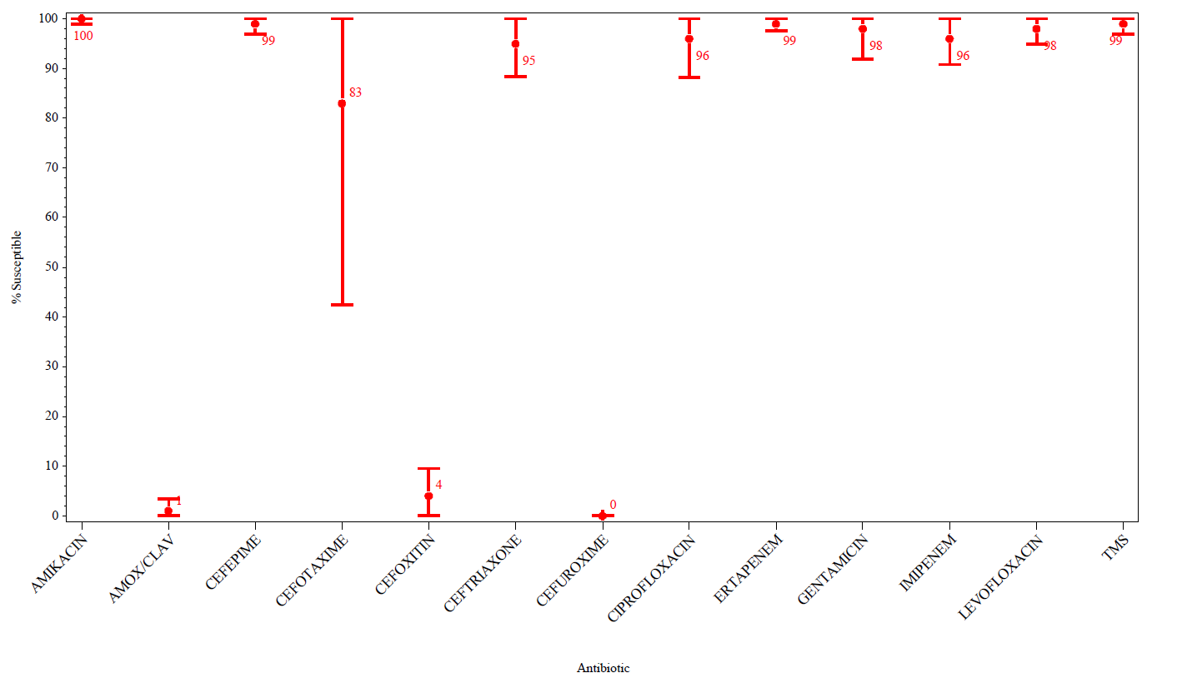

Stenotrophomonas maltophilia Percent Susceptibility

Overall State Mean (with 1 SD)

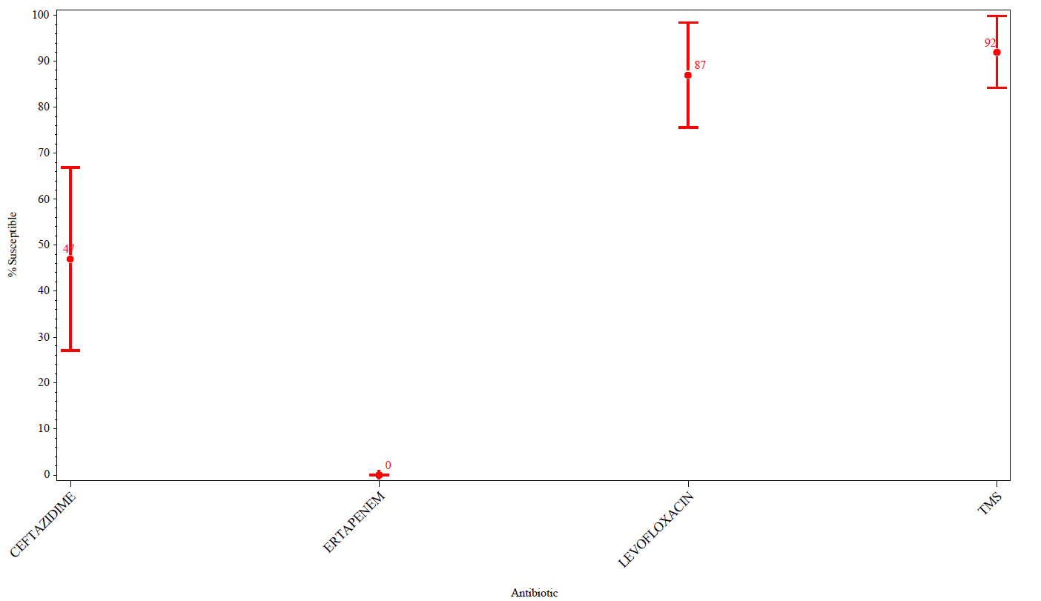

Staphylococcus aureus Percent Susceptibility

Overall State Mean (with 1 SD)

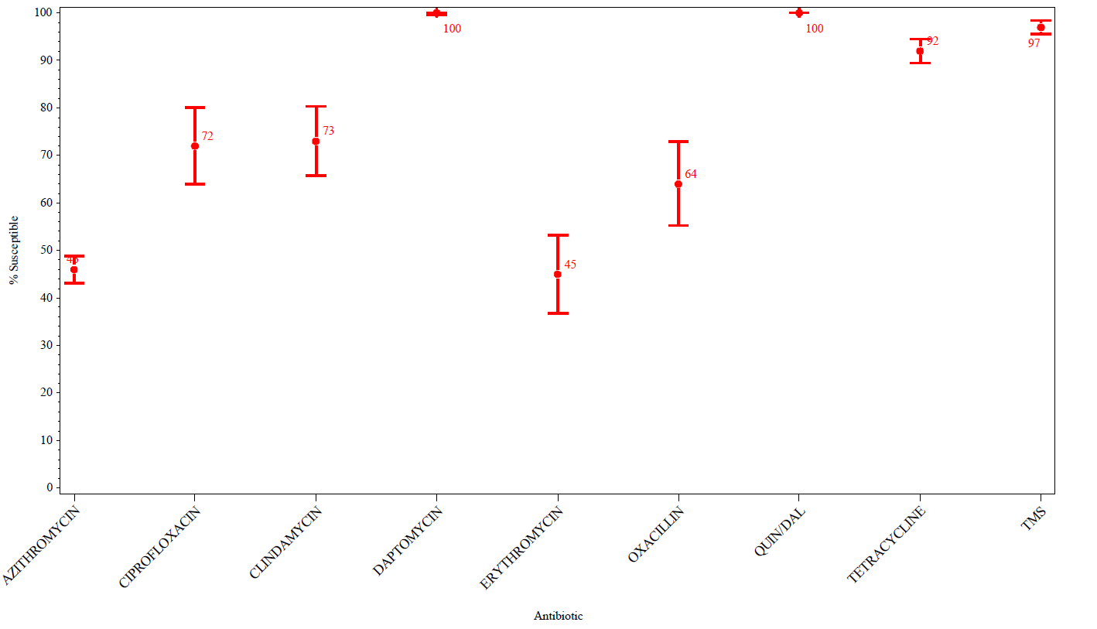

Streptococcus pneumoniae Percent Susceptibility

Overall State Mean (with 1 SD)

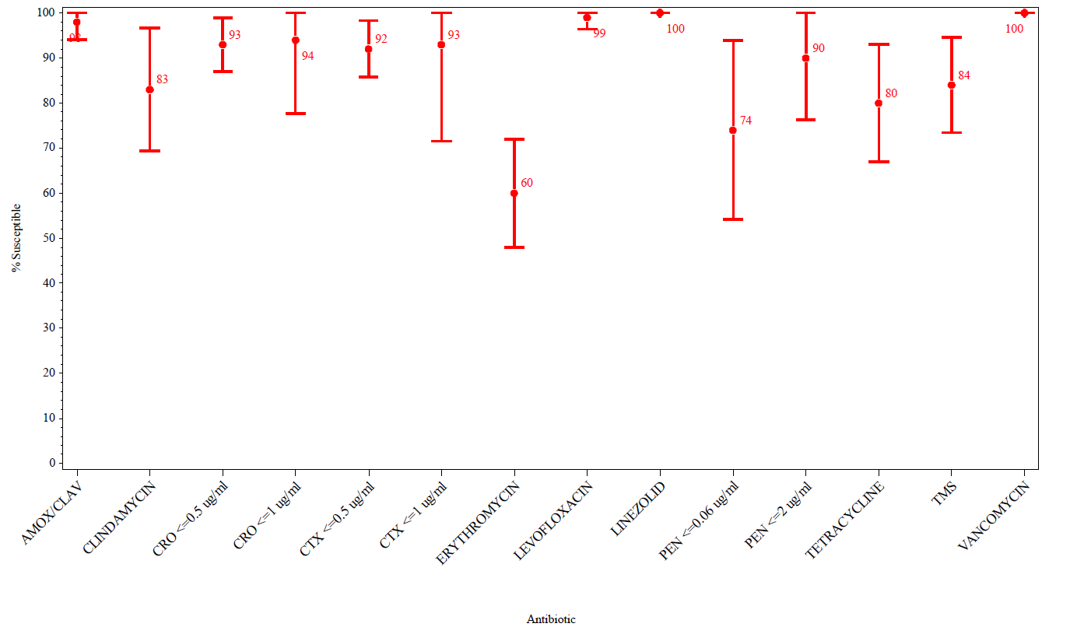

2018 Antibiogram Collection Form
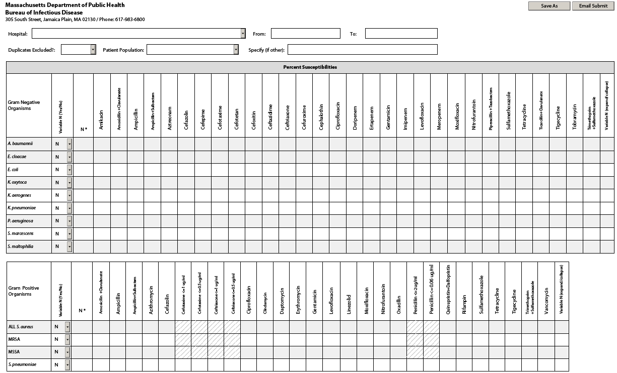

Hospitals that reported 2018 antibiogram data in accordance with regulations
(105 CMR 300.000) by reporting deadline
Anna Jaques Hospital | Hallmark Health System - Lawrence Memorial Hospital of Medford | North Shore Medical Center - Union Hospital
Athol Memorial Hospital | Hallmark Health System - Melrose-Wakefield Hospital | Saint Vincent Hospital
Baystate Franklin Medical Center | Harrington Memorial Hospital | Shriners Hospital for Children - Boston
Baystate Medical Center | Heywood Hospital | Signature Healthcare - Brockton Hospital
Baystate Noble Hospital | Holyoke Medical Center | South Shore Hospital
Baystate Wing Hospital | Lahey Health - Addison Gilbert Hospital | Southcoast Health - Charlton Memorial Hospital
Berkshire Health Systems - Berkshire Medical Center | Lahey Health – Beverly Hospital | Southcoast Health - St. Luke's Hospital
Berkshire Health Systems - Fairview Hospital | Lahey Health - Lahey Hospital & Medical Center (Burlington) | Southcoast Health - Tobey Hospital
Beth Israel Deaconess Hospital - Milton | Lahey Health – Lahey Medical Center, Peabody | Steward Health Care - Carney Hospital
Beth Israel Deaconess Hospital - Needham | Lahey Health – Winchester Hospital | Steward Health Care - Good Samaritan Medical Center
Beth Israel Deaconess Hospital - Plymouth | Lawrence General Hospital | Steward Health Care - Holy Family Hospital (Methuen)
Beth Israel Deaconess Medical Center | Lowell General Hospital - Main Campus | Steward Health Care - Holy Family Hospital at Merrimack Valley (Haverhill)
Boston Children's Hospital | Lowell General Hospital - Saints Campus | Steward Health Care - Morton Hospital
Boston Medical Center | Martha's Vineyard Hospital | Steward Health Care - Nashoba Valley Medical Center
Boston Medical Center - East Newton campus | Massachusetts Eye and Ear Infirmary | Steward Health Care - Norwood Hospital
Brigham and Women’s Faulkner Hospital | Massachusetts General Hospital | Steward Health Care - Saint Anne's Hospital
Brigham and Women's Hospital | Mercy Medical Center | Steward Health Care - St. Elizabeth's Medical Center
Cambridge Health Alliance - Cambridge Hospital | MetroWest Medical Center - Framingham Union Hospital | Sturdy Memorial Hospital
Cambridge Health Alliance - Everett Hospital | MetroWest Medical Center - Leonard Morse Hospital | The Veteran’s Administration Boston Healthcare System
Cambridge Health Alliance - Somerville Hospital | Milford Regional Medical Center | Tufts Medical Center
Cape Cod Healthcare - Cape Cod Hospital | Mount Auburn Hospital | UMass Memorial Health Care – Clinton Hospital
Cape Cod Healthcare - Falmouth Hospital | Nantucket Cottage Hospital | UMass Memorial Health Care – HealthAlliance Hospital Leominster
Cooley Dickinson Hospital | New England Baptist Hospital | UMass Memorial Health Care – Marlborough Hospital
Dana-Farber Cancer Institute | Newton-Wellesley Hospital | UMass Memorial Health Care – UMass Memorial Campus
Emerson Hospital | North Shore Medical Center - Salem Hospital | UMass Memorial Health Care – UMass University Campus

Antibiotic Susceptibility Testing Guidelines

Antibiotic susceptibility testing is conducted in microbiology laboratories. Microbiologists utilize standardized guidelines, such as those distributed by the Clinical and Laboratory Standards Institute (CLSI)* to determine whether a bacterial isolate is susceptible, intermediate, or resistant to an antibiotic. These guidelines are updated periodically. The extent to which clinical microbiology laboratories across Massachusetts are able to implement the most recently updated guidelines within a particular time period varies.

* Clinical and Laboratory Standards Institute (CLSI). Performance Standards for Antimicrobial Susceptibility Testing, 29th Edition. CLSI Supplement M100. Published July 2019.

