Commonwealth of Massachusetts

Department of Housing &

Community Development

# Charles D. Baker, Governor ◆ Karyn E. Polito, Lt. Governor ◆ Janelle Chan, Undersecretary

Massachusetts Seal.

DHCD logo.100 Cambridge Street, Suite 300 www.mass.gov/dhcd

Boston, Massachusetts 02114 617.573.1100xxx

**MASSACHUSETTS COMMUNITY DEVELOPMENT BLOCK GRANT (CDBG)**

**PROGRAM**

**FY 2019 Application Training**

The Department anticipates the availability of funding for the following Federal Fiscal Year 2019 Massachusetts Community Development Block Grant (MA CDBG) program components:

**Community Development Fund / Mini-Entitlement Program**

The MA CDBG program provides federal funds on a competitive basis to municipalities with a population of less than 50,000 that are not designated by HUD as entitlement areas. Communities may apply to the Community Development Fund or the Mini-Entitlement Program for a variety of projects including rehabilitation of housing stock, improvements to infrastructure, stabilization of neighborhoods, planning, public social services and downtown related projects.

Information sessions providing application guidance will be held at the following times and locations. Application guidance materials will be available online at [www.mass.gov/dhcd](http://www.mass.gov/dhcd) and will also be available at these sessions. Comments on the draft One Year Plan will also be accepted. An additional formal hearing on the Plan is anticipated in early 2019.

**Wednesday, December 5, 2018 10:00 am to 3:00 pm** at DHCD

100 Cambridge Street

Conference Room C, 2nd Floor

Boston, MA

**Thursday, December 13, 2018 10:00 am to 3:00 pm** at Pioneer Valley Planning Comm.

60 Congress Street, 2nd Floor

Springfield, MA 01104

We will need to provide you with a security ID badge in order for you to access **Conference Room C on the 2nd Floor** of 100 Cambridge Street. Please RSVP by December 3, 2018, via e-mail to Mark.Southard@mass.gov. if you plan to attend the Boston session.

***If you require an accommodation (materials in Braille/large print, sign language interpreters, etc.), please contact DHCD by November 26, 2018.***

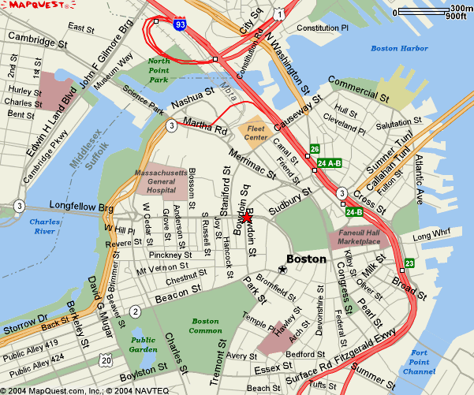**Directions to DHCD – 100 Cambridge St., Boston**

**Driving from the North**

From 93S take the Storrow Drive exit, at the bottom of the bridge turn off at Nashua Street. DO NOT GO

INTO THE TUNNEL. Turn right at end of ramp onto Nashua Street going towards the Fleet Center. Follow

Nashua Street around the Jail and past Spaulding Hospital. The street will make a right turn and come to a traffic light where you have to turn left. Turn left. Go to the next traffic light and go straight. This is Merrimac Street. Follow Merrimac to the next traffic light and turn as if going right. The entrance to the Government Center garage will be in front of you. If you are going to 100 Cambridge Street continue turning right (New Chardon Street). Follow New Chardon up the hill thru the pedestrian light and to the working traffic light at Cambridge Street. **100 Cambridge Street** is diagonally across on your left (a large **100** is in the window over the front entrance).

**Driving from the South**

Take Interstate 95N to Interstate 93N to Boston, enter new 93N Tunnel. Take Exit 26/Storrow Drive. After exiting you are on Martha Way, bear left on Merrimac Street. Government Center Parking Garage is straight

ahead at the end of Merrimac (across New Chardon).

**Driving from the West**

Take 90E (Mass Pike) to 93N to Boston, enter new 93N Tunnel. Take Exit 26/Storrow Drive. After exiting you are on Martha Way, bear left on Merrimac Street. Government Center Parking Garage is straight ahead at the end of Merrimac (across New Chardon).