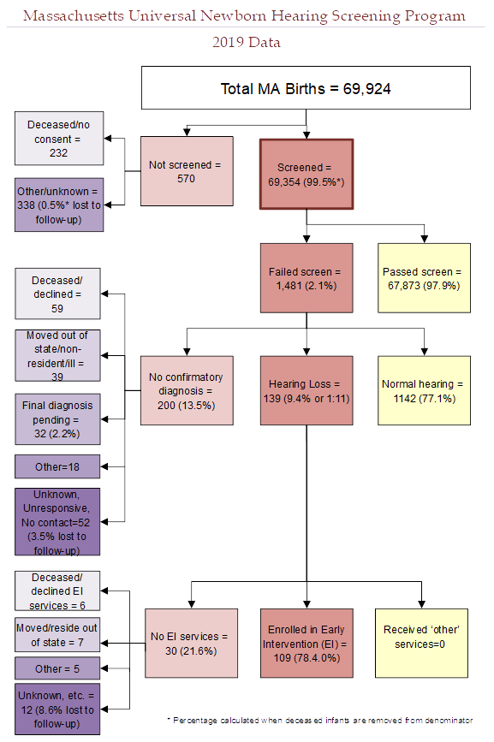

There were 69,924 total births in Massachusetts in 2019. 69,354 (99.5%*) of these infants received a hearing screen. 570 infants were not screened. Of the 570 infants that did not receive a screen:
- 232 died before a screen was performed or their parents/guardians did not provide consent to perform the screen
- 338 (0.5%*) had unknown screening status or did not receive a screen for unknown reasons (lost to screening follow-up)

Of the 69,354 infants that were screened:
- 67,873 (97.9%) passed the screen
- 1,481 (2.1%) failed the screen

Of the 1,481 infants that failed the hearing screen:
- 1142 (77.1%) were diagnosed with normal hearing
- 139 (9.4%) were diagnosed with hearing loss
- 200 (13.5%) did not have a final confirmatory diagnosis when the data were reported. Of these infants without a final confirmatory diagnosis:
  - 59 were deceased (n=2) or their parents/guardians declined follow-up diagnostic services (n=57)
  - 39 moved out of state or did not reside in Massachusetts
  - 32 received diagnostic testing but were pending a final diagnosis
  - 18 were not screened due to other reasons including illness or lack of pediatrician referral
  - 52 (3.5% of the 1,481 infants that failed the screen) were lost to documentation or diagnostic follow-up

Of the 139 infants with hearing loss:
- 109 (78.4%) were enrolled in Early Intervention (EI)
- The remaining 30 infants (21.6%) were not documented to be receiving EI services for the following reasons:
  - 6 were deceased (n=0) or declined EI services (n=6)
  - 7 moved out of state or did not reside in Massachusetts
  - 5 were too medically fragile to receive EI services or were deemed ineligible
  - 12 were not receiving EI services for unknown reasons (8.6% lost to EI follow-up)
* % screened is calculated when deceased children without a screen are not included in the denominator

