2022 Massachusetts Integrated HIV, STD, and Viral Hepatitis Surveillance Report,
Accessible Version, optimized for screen reader use
Please note that while the content of this report is the same as the pdf version, the format and pagination have been modified significantly to optimize use with screen readers to ensure access for blind or visually impaired audiences.
Massachusetts Department of Public Health
Bureau of Infectious Disease and Laboratory Sciences
December 2023
Suggested citation:
Massachusetts Department of Public Health, Bureau of Infectious Disease and Laboratory Sciences. 2022 Massachusetts Integrated HIV, STD and Viral Hepatitis Surveillance Report, https://www.mass.gov/doc/2022-integrated-hiv-std-and-viral-hepatitis-report-pdf/download Published December 2023. Accessed [date].
Bureau of Infectious Disease and Laboratory Sciences
Massachusetts Department of Public Health
Jamaica Plain Campus/State Public Health Laboratory
305 South Street
Jamaica Plain, MA 02130
Questions about this report
Tel: (617) 983-6560
To reach the Reporting and Partner Services Line
Tel: (617) 983-6999

To speak to the on-call epidemiologist
Tel: (617) 983-6800
Questions about infectious disease reporting
Tel: (617) 983-6801
Requests for additional data
https://www.mass.gov/lists/infectious-disease-data-reports-and-requests
Slide set for 2022 Integrated Report
https://www.mass.gov/lists/std-data-and-reports
For additional contact information see HIV, STD, and Viral Hepatitis Program Staff Contact Information

ACKNOWLEDGMENTS

We are grateful to healthcare providers and laboratories across the Commonwealth who report HIV, STI, and viral hepatitis diagnoses and corresponding clinical information to the Massachusetts Department of Health (MDPH), Bureau of Infectious Disease and Laboratory Sciences (BIDLS). These reports are essential to perform timely epidemiologic investigations and to inform an effective public health response. We also wish to acknowledge the contributions of the many program staff within BIDLS who collect, manage, maintain, and analyze this information and who reviewed draft sections relevant to their areas of expertise.

Contents
LIST OF COMMONLY USED ACRONYMS iv
KEY HIGHLIGHTS 1
CHLAMYDIA 5
CHLAMYDIA BY GENDER 5
CHLAMYDIA BY AGE 7
CHLAMYDIA BY AVERAGE AGE AND GENDER 8
CHLAMYDIA BY CITY/TOWN 9
SVI AMONG CHLAMYDIA CASES BY CITY/TOWN 11
GONORRHEA 13
GONORRHEA BY GENDER 13
GONORRHEA BY AGE 15
GONORRHEA BY CITY/TOWN 16
SVI AMONG GONORRHEA CASES BY CITY/TOWN 18
SYPHILIS 19
SYPHILIS BY GENDER 19
SYPHILIS BY AGE 21
SYPHILIS BY CITY/TOWN 22
SVI AMONG SYPHILIS CASES BY CITY/TOWN 24
HIV 25
HIV PREVALENCE 25
DIAGNOSES AND DEATHS FROM ANY CAUSE AMONG PERSONS REPORTED WITH HIV 26
HIV DIAGNOSES BY CITY/TOWN 27
HIV PREVALENCE BY CITY/TOWN 28
SVI AMONG HIV DIAGNOSES BY CITY/TOWN 29
HIV BY EXPOSURE MODE AND SEX ASSIGNED AT BIRTH 31
PERINATAL TRANSMISSION OF HIV 33
AGE AMONG PERSONS LIVING WITH HIV INFECTION 34
SURVIVAL AMONG INDIVIDUALS DIAGNOSED WITH HIV 35
VIRAL HEPATITIS 36
HEPATITIS A 36
HEPATITIS B 38
HEPATITIS B BY GENDER 40
ACUTE HEPATITIS B 41
HEPATITIS C 42
HEPATITIS C BY GENDER 43
HEPATITIS C BY AGE 44
HEPATITIS C BY AGE AND GENDER 45
CO-INFECTIONS- 46
HIV/SYPHILIS 46
HIV/GONORRHEA 47
HIV/HEPATITIS C 48
HIV/HEPATITIS C CO-INFECTIONS BY DEMOGRAPHICS 49
HIV/HEPATITIS C – PERCENTAGE CO-INFECTED 51
SPECIFIC POPULATIONS- ADOLESCENTS AND YOUNG ADULTS 52
STD DIAGNOSES BY AGE 52
STD DIAGNOSES BY AGE AND GENDER 53
HIV DIAGNOSES BY RACE/ETHNICITY AND EXPOSURE MODE 54
HEPATITIS C BY AGE AND GENDER 55
MASSACHUSETTS YOUTH RISK BEHAVIOR SURVEY 57
SPECIFIC POPULATIONS - MEN WHO HAVE SEX WITH MEN 58
HIV DIAGNOSIS RATE PER 100,000 58
MSM – SYPHILIS RATE PER 100,000 59
MSM – SYPHILIS/HIV CO-INFECTION 60
MSM - SYPHILIS BY COUNTY 61
MSM – RECENT HIV DIAGNOSES 62
MSM – SYPHILIS CASES 63
TRENDS IN HIV EXPOSURE MODE AMONG MALES 64
SPECIFIC POPULATIONS – PERSONS WHO INJECT DRUGS 65
PERSONS WHO INJECT DRUGS – RECENT HIV DIAGNOSES 66
DEATHS FROM ANY CAUSE AMONG INDIVIDUALS REPORTED WITH HIV BY EXPOSURE MODE 67
SPECIFIC POPULATIONS – RACIAL/ETHNIC MINORITIES 68
SYPHILIS BY RACE/ETHNICITY 69
HIV BY RACE/ETHNICITY 70
SPECIFIC POPULATIONS - WOMEN AND INFANTS 71
WOMEN AND INFANTS – CONGENITAL SYPHILIS 73
WOMEN - RECENT HIV DIAGNOSES 75
SPECIFIC POPULATIONS – OLDER INDIVIDUALS 76
STD DIAGNOSES BY AGE 76
STD DIAGNOSES BY AGE AND GENDER 77
SYPHILIS BY AGE, GENDER, RACE/ETHNICITY, AND RISK 78
OLDER INDIVIDUALS LIVING WITH HIV INFECTION 79
OLDER INDIVIDUALS RECENTLY DIAGNOSED WITH HIV INFECTION 83
STRENGTHS AND LIMITATIONS OF DATA 85
INTERPRETING HIV, STD, AND VIRAL HEPATITIS DATA 87
HIV, STD, AND VIRAL HEPATITIS CASE CLASSIFICATIONS 89
HIV infection 89
Sexually transmitted diseases (STD) 89
Viral Hepatitis 98
HIV, STD, AND VIRAL HEPATITIS PROGRAM STAFF CONTACT INFORMATION 106
HIV, STD, AND VIRAL HEPATITIS RESOURCES 108

LIST OF COMMONLY USED ACRONYMS
AFAB Assigned Female at Birth
AI/AN American Indian/Alaska Native
AIDS Acquired Immunodeficiency Syndrome
AMAB Assigned Male at Birth
API Asian/Pacific Islander
BIDLS Bureau of Infectious Disease and Laboratory Sciences
BRFSS Behavioral Risk Factor Surveillance System
CDC Centers for Disease Control and Prevention
CI Confidence Interval
COVID-19 Coronavirus Disease 2019
DOE Department of Education
HAV Hepatitis A Virus
HBV Hepatitis B Virus
HCV Hepatitis C Virus
HIV Human Immunodeficiency Virus
HSR Health Service Region
HTSX Heterosexual Sex
IDU Injection Drug Use
MDPH Massachusetts Department of Public Health
MSM Male-to-Male Sex or Men Who Have Sex with Men
N Number
NH Non-Hispanic
NIR No Identified Risk
PLWH Persons Living with HIV Infection
Pres. HTSX Presumed Heterosexual Sex
PR/USD Puerto Rico/United States Dependency
PWID Persons Who Inject Drugs
STD Sexually Transmitted Disease
STI Sexually Transmitted Infection

KEY HIGHLIGHTS
The 2022 Integrated HIV, STD, and Viral Hepatitis Surveillance Report provides data on infections reported to the Massachusetts Department of Public Health (MDPH), Bureau of Infectious Disease and Laboratory Sciences by healthcare providers and laboratories per regulation (105 CMR 300.000). This report focuses on a subset of these diseases:
- Chlamydia
- Gonorrhea
- Syphilis
- HIV
- Hepatitis A, B and C
The intended audience for this annual surveillance report includes the clinicians and laboratory professionals who report cases, community organizations, local public health departments, advocates, policymakers, and researchers who are interested in the health of Massachusetts residents.
Key Highlights in 2022
The coronavirus disease 2019 (COVID-19) pandemic has had a large impact on the screening, treatment, and surveillance of other infectious diseases in 2020 and 2021. Nationally, the Centers for Disease Control and Prevention (CDC) observed a sharp decline in reported STD cases from March-April 2020, compared to March-April 2019. Three factors were cited as likely contributing to the initial decrease in reported cases:
- Reduced screening – many health care clinics limited in-person visits to symptomatic cases or closed down
- Limited resources – many state and local health department STD staff were redirected from routine STD responsibilities to COVID-19 activities, which affected STD tracking capacity and reporting
- Social distancing measures – intended to reduce COVID-19 spread, they may have influenced sexual behaviors and reduced STD transmission.
After the initial decrease in 2020, an increase across STDs was observed nationally and in the Commonwealth in 2021 and 2022. Possible factors contributing to an increase in reported cases include:
- Increased service utilization after health care clinics re-opened
- Continued direction of services to patients most likely to be infected, increasing the number of cases identified
- Higher disease transmission - due to reduced access to care, those with an STD may have had their infections longer, providing more opportunities to transmit infection to their sexual partners. Additionally, following the initial shelter-in-place orders, sexual behaviors may have changed, including frequency of new sexual partners, leading to spread in sexual networks.
Although the official COVID-19 states of emergency are declared over, the effects of the pandemic continue to impact public health; its full effect on case detection and reporting and efforts to control the spread of infectious disease in the Commonwealth has yet to be determined. As such, please interpret infectious disease data from 2020 to 2022 with caution.
Chlamydia, Gonorrhea, and Syphilis:
- Chlamydia continues to be the most frequently reported STI, with over 28,000 cases reported in 2022.
- The total number of reported chlamydia cases increased by 33% from 23,789 in 2013 to a ten-year peak of 31,634 in 2019.With 28,384 cases reported in 2022, chlamydia incidence has not yet returned to pre-COVID levels.
- The overall average age of laboratory-confirmed chlamydia cases in Massachusetts increased from 24.1 years in 2013 to 26.3 years in 2022. This marks the fourth year that the average age has exceeded the CDC recommended screening age range of under 25 years for sexually active women.
- After a sharp 57% increase from 2016 (N=4,638) to 2017 (N=7,293), gonorrhea incidence remained relatively stable through 2020, and then increased 11% in 2021 (N=8,099) and an additional 13% in 2022 (N=9,129).
- The number of confirmed gonorrhea cases reported among males far exceeds cases reported among females. In 2022, 6,196 gonorrhea cases were reported among males, compared to 2,861 among females, and 68 among individuals of transgender experience and/or nonbinary individuals.
- The number of infectious syphilis cases (primary, secondary, and early non-primary non-secondary syphilis) increased to a ten-year high of 1,244 in 2019, decreased slightly to 1,159 in 2020, and then increased to a new high of 1,593 in 2022. Although cases among females have risen over the past decade, infectious syphilis continues to disproportionately affect males, reflecting an ongoing epidemic among men who have sex with men (MSM).
- Among the 49 states reporting in 2021, Massachusetts ranked 38th in chlamydia incidence rate and 40th in gonorrhea incidence rate.
- Massachusetts ranked 33rd in primary and secondary syphilis incidence rate in 2021 among the 49 states reporting syphilis incidence in 2021.
HIV:
- The number of persons living with HIV infection (PLWH) in Massachusetts increased by 11% from 21,347 at the end of 2013 to 23,597 at the end of 2022.,
- Because of effective HIV treatment, people diagnosed with HIV infection are living longer, healthier lives. Survival of individuals diagnosed with HIV infection has increased over time. In the earliest cohort of HIV infection diagnoses (1988–1992), estimated survival at five years after HIV infection diagnosis was 50%, compared to 95% in the three most recent cohorts (2018–2022, 2013–2017, and 2008–2012).
- After decreasing from 690 diagnoses in 2013 to approximately 640 diagnoses per year from 2014 to 2018 (five-year average = 637), the number of new HIV infection diagnoses declined to 537 in 2019. In 2020, the number of new HIV infection diagnoses further declined to 437 and then remained at this lower level in 2021 and 2022, when there were 449 and 444 diagnoses, respectively. However, caution should be used in the interpretation of this decline due to the impact of COVID-19 on access to HIV testing and care services, and case surveillance activities.
- The number of deaths due to any cause among individuals reported with HIV increased by 29% from 276 in 2013 to 355 in 2022.
- There were large disparities in age-adjusted HIV diagnosis rates by race/ethnicity: the average annual age-adjusted HIV diagnosis rates for 2020 to 2022 among black (non-Hispanic) individuals (29.7 per 100,000) and Hispanic/Latinx individuals (13.4 per 100,000) were nine and four times that of white (non-Hispanic) individuals (3.4 per 100,000), respectively.
- Male-to-male sex (MSM) remained the predominant exposure mode among individuals diagnosed with HIV infection from 2013 to 2022. Those reported with no identified risk (NIR) comprised the second largest exposure mode group, accounting for 26% of recent HIV infection diagnoses and consisting predominantly of individuals AMAB (69%), individuals born outside the US (58%), and individuals of black (non-Hispanic) (50%) and Hispanic/Latinx (24%) ethnicity.
- The total statewide number of reported cases with IDU as the primary exposure mode increased from 58 in 2019 to 81 in 2021. The increase was primarily due to a cluster of HIV infection identified in early 2019 in Boston among PWID who were experiencing or had experienced recent homelessness. Following a tailored public health response, the number of HIV infection diagnoses attributed to IDU decreased by 46% to 44 in 2022. As of December 31, 2022, a total of 188 cases diagnosed since November 2018 have been investigated and identified as part of the Boston cluster. As it is an active cluster of concern, additional cases will continue to be investigated and added. Emerging trends among those newly diagnosed in the Boston cluster (N=23 cases diagnosed in 2022) include an increase in polysubstance and methamphetamine use.
Hepatitis A, B, and C:
- Between 2018 and 2020, MDPH and local health departments investigated an outbreak of hepatitis A. The populations most affected by the outbreak were those with recent homelessness or unstable housing, and/or substance use disorder. Since spring of 2020, case counts have decreased to a pre-outbreak baseline, and very few cases have been reported among the populations most affected during the outbreak.
- From 2013 to 2022, an average of 1,720 cases of confirmed and probable chronic hepatitis B virus (HBV) infection were reported each year (with a low of 1,179 in 2020 and a high of 1,980 in 2017). Changes in testing behaviors and travel due to the COVID-19 pandemic likely influenced the number of reported cases and may contribute to the decrease in 2020, followed by the rebound in 2021 and 2022.
- The total number of confirmed acute HBV cases reported has decreased between 2017 (53 cases) and 2022 (21 cases).
- In 2022, 2,859 confirmed and probable cases of hepatitis C (HCV) were reported. Most reported cases are chronically infected and MDPH currently estimates that there are over 250,000 persons living with HCV infection in Massachusetts.
- The majority of HCV cases reported in 2022 were among young adults (age 20–39 years), reflecting ongoing transmission among young people who inject drugs.

CHLAMYDIA

CHLAMYDIA BY GENDER
Chlamydia is the most reported sexually transmitted infection in Massachusetts and nationally. Chlamydia is a bacterial sexually transmitted infection (STI) that can be spread through vaginal, anal, or oral sexual contact with an infected partner and from pregnant person to child during birth. While most people with chlamydia usually have no signs or symptoms, some may experience dysuria; vaginal, penile, or anal discharge; or irregular bleeding. Chlamydia is easily treated, but repeated infections are common. Women are at great risk of complications of repeated infections. For more information, see https://www.cdc.gov/std/chlamydia/stdfact-chlamydia-detailed.htm.

Figure 1. Number of laboratory-confirmed chlamydia cases reported by gender, Massachusetts 2013–2022

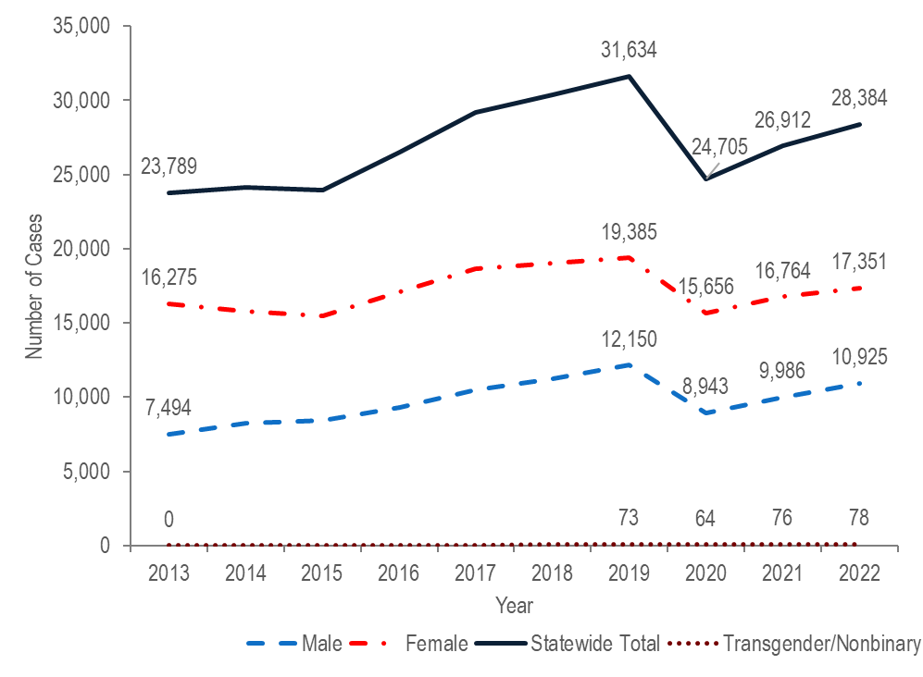
Note: Cases with no gender reported (2013–2022: N=422) are included in the statewide total but are not depicted in Figure 1 separately due to small numbers.
Data Source: Bureau of Infectious Disease and Laboratory Sciences, data are current as of 7/21/2023 and subject to change.

- The total number of reported chlamydia cases increased by 33% from 23,789 in 2013 to 31,634 in 2019, decreased to 24,705 in 2020, and then increased to 26,912 in 2021 and 28,384 in 2022. A decrease in reported chlamydia cases in 2020, followed by an increase in 2021 was also observed nationally. Case reporting could have been affected by a state of emergency that was declared in Massachusetts from March 10, 2020 until June 15, 2021 during which MDPH directed all hospitals and ambulatory surgical centers to postpone or cancel any nonessential elective procedures and limit in-person outpatient clinical encounters.
- Each year from 2013 to 2022, approximately twice as many chlamydia cases were reported among females as among males. In 2022, the ratio of female-to-male chlamydia cases was 1.6 (1.6 = 17,351/10,925).
- In 2022, 78 chlamydia cases were reported among individuals of transgender experience and/or individuals who are nonbinary. Please note reported numbers among individuals of transgender experience and individuals who are nonbinary are likely to be underestimates as there may be underreporting or misreporting of gender due to the absence of appropriate collection of gender options (e.g., individuals who are genderqueer, pangender, gender fluid, androgynous, etc.).

CHLAMYDIA BY AGE
Figure 2. Number of laboratory-confirmed chlamydia cases reported by age group (years), Massachusetts 2013–2022
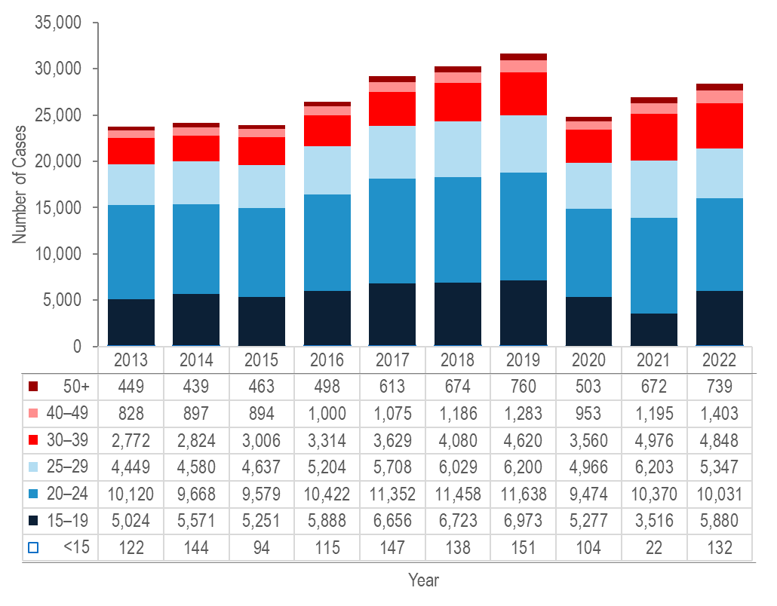
Note: Cases with no age reported (2013–2022: N=139) are not included in this figure
Data Source: Bureau of Infectious Disease and Laboratory Sciences, data are current as of 7/21/2023 and subject to change.

- Each year from 2013 to 2022, the greatest number of chlamydia cases was reported among 20–24 year-olds, followed by 15–19 year-olds, except for 2021. In 2021, the greatest number of chlamydia cases was still reported among 20–24 year-olds (N=10,370), but it was followed by 25–29 year-olds (N=6,203).
- The number of chlamydia cases reported among 15–19 year-olds decreased by 33% from 2020 to 2021 and then rebounded in 2022 increasing by 67% compared to 2021. Because a similar decrease was not seen in older age groups, this decrease should be interpreted with caution due to the decrease in routine care and STD screening experienced during the COVID-19 pandemic. In April of 2020, CDC made recommendations to defer routine screening visits until after the emergency response was over to minimize reductions in STD care and treatment.

CHLAMYDIA BY AVERAGE AGE AND GENDER
In 2021, the United States Preventive Services Task Force and the CDC recommended screening for chlamydia in sexually active women under 25 years of age, and in older women at increased risk for infection. Screening of sexually active young men is also recommended in higher prevalence clinical settings such as adolescent clinics, correctional facilities, and STD clinics, and among men who have sex with men.
Figure 3. Average age of laboratory-confirmed chlamydia cases reported by female and male gender, Massachusetts 2013–2022
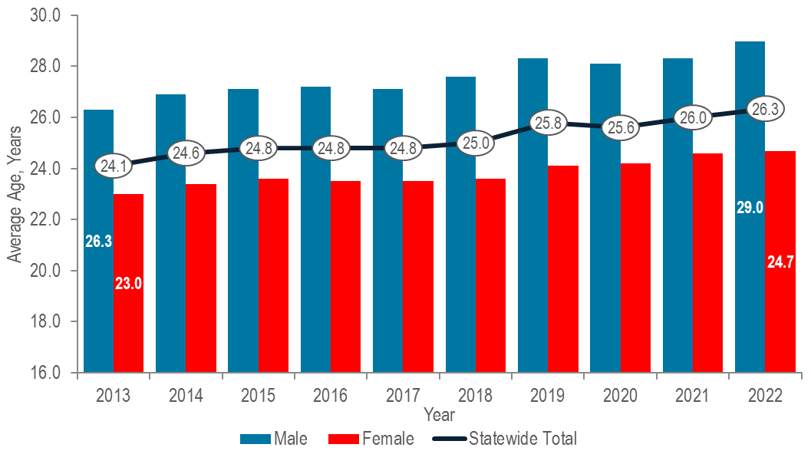
Note: Cases with no age reported (2013–2022: N=139) are not included in this analysis and cases reported as transgender, nonbinary, or missing gender (2013–2022: N=827) are included in the statewide total but not presented separately due to small numbers.
Data Source: Bureau of Infectious Disease and Laboratory Sciences, data are current as of 7/21/2023 and subject to change.
- The overall average age of laboratory-confirmed chlamydia cases in Massachusetts increased from 24.1 years in 2013 to 26.3 years in 2022.
- The increase in average age appeared to be driven mostly by male chlamydia cases. From 2013 to 2022, the proportion of chlamydia cases among males increased from 32% to 38% (See Figure 1, page 5). Additionally, the increase in average age of chlamydia cases reported among males was greater than the increase among females. From 2013 to 2022, the average age of chlamydia cases reported among males increased by 2.7 years compared to an increase of 1.7 years among females.

CHLAMYDIA BY CITY/TOWN
Figure 4. Incidence rate of confirmed chlamydia cases per 100,000 population reported by city/town, Massachusetts 2022

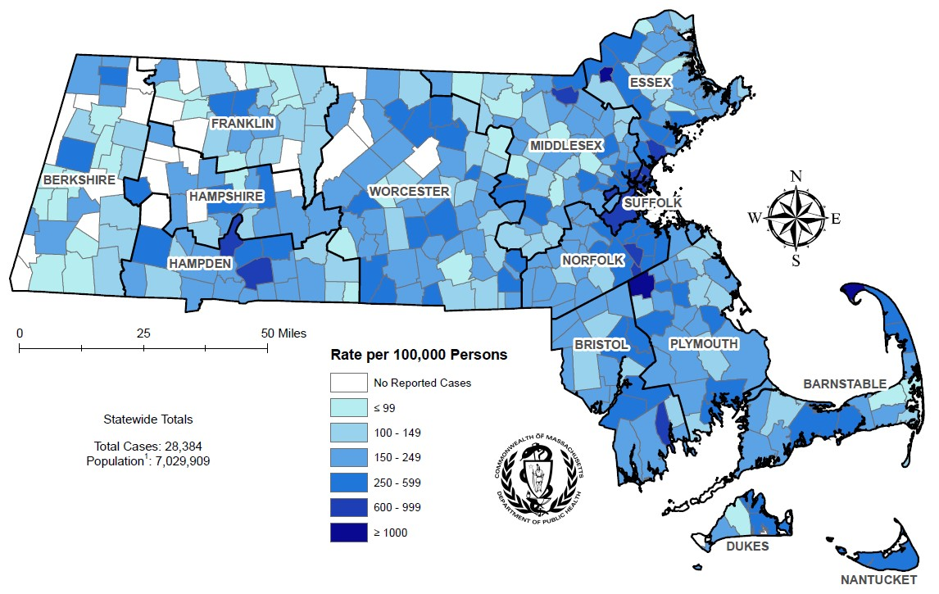

¹ Population based on University of Massachusetts Donahue Institute Estimates.
Note: regional data include individuals tested in a correctional facility.
There are no city/towns with <10 cases of chlamydia that fall within the top two rate categories (≥600 cases per 100,00).
Data Source: Bureau of Infectious Disease and Laboratory Sciences, data are current as of 7/18/2023 and subject to change.

- In 2022, the statewide chlamydia incidence rate of 403.8 per 100,000 population was lower than the 2021 national rate of 495.5 per 100,000.
  - Massachusetts ranked 38th in chlamydia incidence rate among the 49 states reporting chlamydia incidence in 2021, the last year for which these national data are publicly available.
- Chlamydia cases continue to be reported throughout Massachusetts, with concentrations in the most populated cities.
- The five cities with the highest chlamydia incidence rates in 2022 were Provincetown (2,074.2 per 100,000), Brockton (1,130.2 per 100,000), Lawrence (1,088.1 per 100,000), Springfield (972.9 per 100,000), and Boston (879.9 per 100,000).

SVI AMONG CHLAMYDIA CASES BY CITY/TOWN
The social vulnerability index (SVI) is a tool to identify socially vulnerable communities that was created by CDC and the Agency for Toxic Substances and Disease Registry (ATSDR). The CDC/ATSDR SVI uses U.S. Census data to determine the social vulnerability of every census tract. The SVI ranks each tract on 16 social factors, including poverty, lack of vehicle access, and crowded housing, and groups them into four related themes: socioeconomic status, household characteristics, racial and ethnic minority status, and housing type/transportation. Each census tract receives a separate ranking for each of the four themes, as well as an overall ranking. Originally developed to incorporate social determinants of health into emergency response and recovery efforts for environmental and natural disasters, more recently, higher SVI has been linked to higher HIV and STD diagnosis rates, COVID-19 mortality, and lower COVID-19 vaccination coverage. As such, the following maps of SVI by city/town in Massachusetts are provided as a comparison to the maps of HIV and STD diagnosis rates by city/town.

Figure 5. Median overall Social Vulnerability Index (SVI) by city/town for confirmed chlamydia cases, Massachusetts 2022
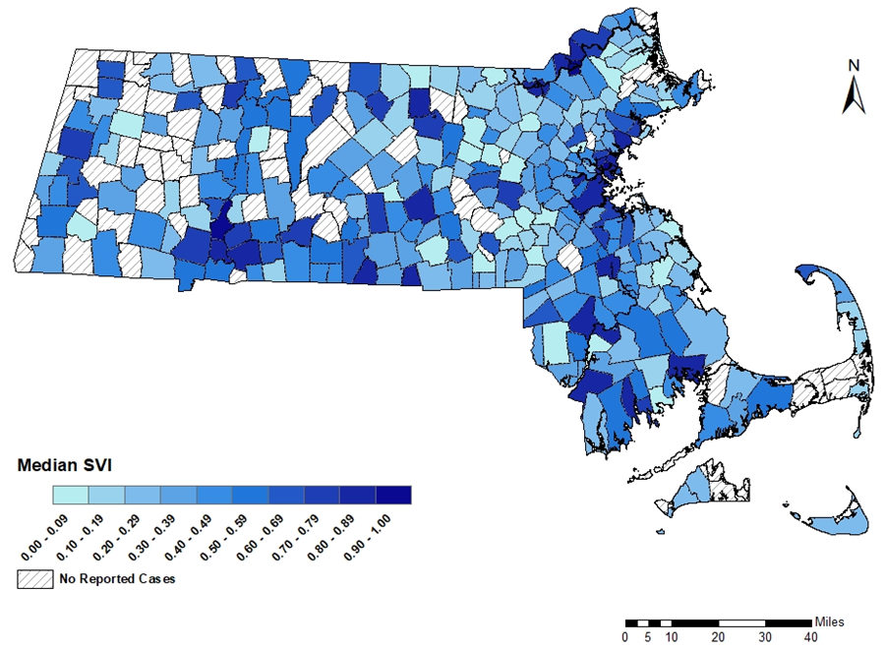
Note: Census tract level overall SVI values for 2020 were obtained from the CDC/Agency for Toxic Substance and Disease Registry and assigned to all cases based on their street address at diagnosis, 950 cases were excluded from this analysis because address was unknown or the individuals were homeless. City/Town level median is calculated from the median SVI score for that city/town among gonorrhea cases. Values range from 0 to 1, with higher values implying greater social vulnerability. Map should be interpreted with caution as it displays median SVI scores for cities/towns with one or more cases.
Data Sources: CDC/Agency for Toxic Substance and Disease, Bureau of Infectious Disease and Laboratory Sciences, data are current as of 7/21/2023 and subject to change.

- In 2022, the median SVI score among confirmed chlamydia cases in Massachusetts was 0.744, which would be categorized as moderately highly vulnerable.
- The five cities with the highest SVI scores (i.e., the most highly vulnerable) among confirmed chlamydia cases in 2022 were Lawrence (0.936), Holyoke (0.927), Chelsea (0.892), Springfield (0.889), and Lynn (0.870).

GONORRHEA

GONORRHEA BY GENDER
Gonorrhea is a common bacterial STI. It can be spread through vaginal, anal, or oral sexual contact with an infected partner or to an infant during birth. Symptoms of gonococcal infection can vary depending on the site of infection and may include dysuria; vaginal, penile, or anal discharge; irregular bleeding; abdominal or anal pain; and sore throat. Still, many infected individuals do not present with any symptoms of infection. Although gonorrhea infection is treatable, treatment has become more complex with increased antimicrobial non-susceptibility, including two cases of a novel strain of multidrug-non-susceptible gonorrhea that were detected in Massachusetts in 2022. For more information, see https://www.mass.gov/doc/clinical-alert-on-non-susceptible-gonorrhea-january-19-2023/download. For more general information, see https://www.cdc.gov/std/gonorrhea/stdfact-gonorrhea-detailed.htm

Figure 6. Number of laboratory-confirmed gonorrhea cases reported by gender, Massachusetts 2013–2022

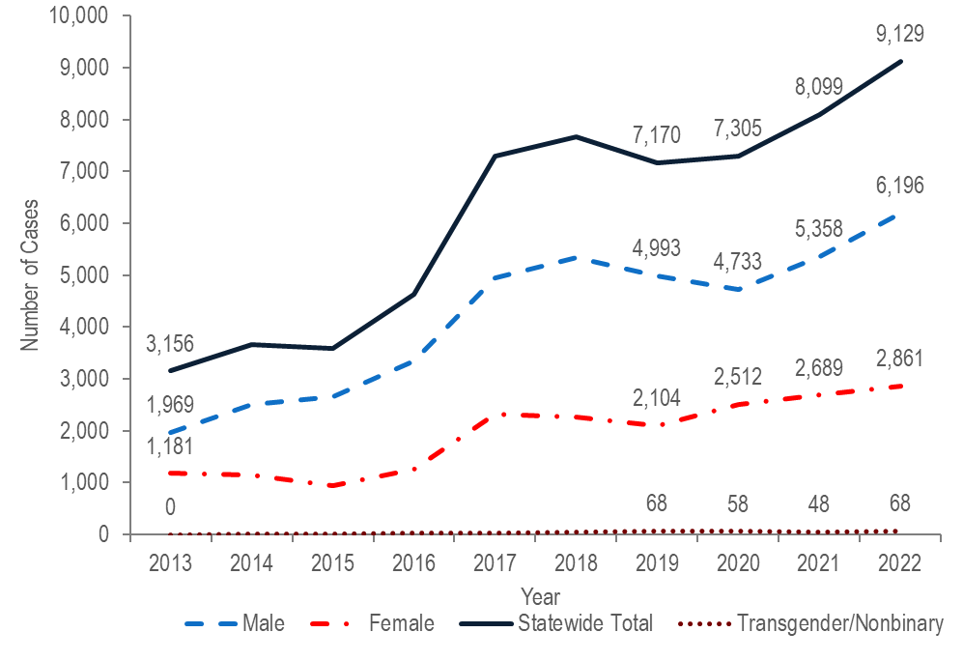

Note: Cases with no gender reported (2013–2022: N=37) are included in the statewide total but are not depicted in Figure 6 separately due to small numbers.
Data Source: Bureau of Infectious Disease and Laboratory Sciences, data are current as of 7/21/2023 and subject to change.

- After a sharp 57% increase from 2016 (N=4,638) to 2017 (N=7,293), gonorrhea incidence remained relatively stable through 2020, and then increased 11% in 2021 (N=8,099) and an additional 13% in 2022 (N=9,129).
- Between 2013 and 2022, the number of gonorrhea cases reported among males increased by 3.1 times (from 1,969 to 6,196, respectively). The number of gonorrhea cases among males in 2022 was more than double the number among females (2,861).
- The number of gonorrhea cases reported among females increased by 2.4 times from 1,181 in 2013 to 2,861 in 2022.
- In 2022, 68 gonorrhea cases were reported among individuals of transgender experience and/or nonbinary individuals. Please note reported numbers among individuals of transgender experience and individuals who are nonbinary are likely to be underestimates as there may be underreporting or misreporting of gender due to the absence of appropriate collection of gender options (e.g., individuals who are genderqueer, pangender, gender fluid, androgynous, etc.).

GONORRHEA BY AGE
Figure 7. Number of laboratory-confirmed gonorrhea cases reported by age group (years), Massachusetts 2013–2022

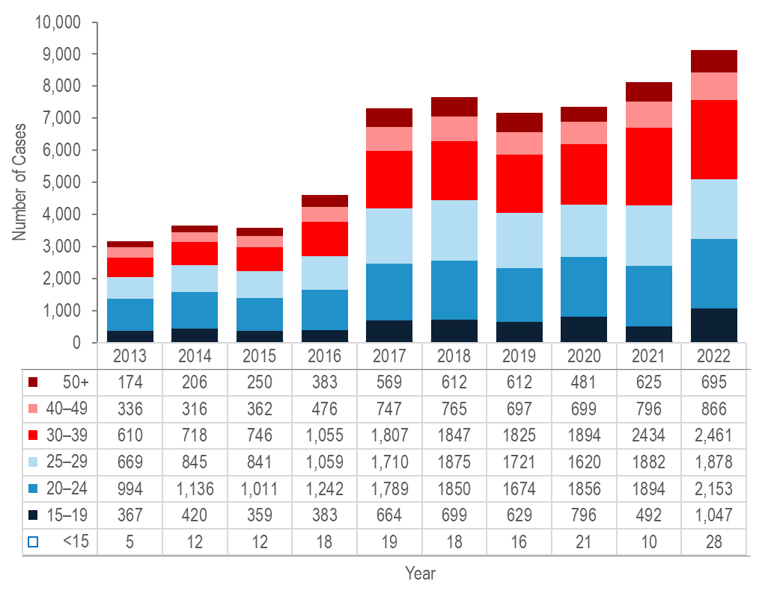
Note: Cases missing age (2013–2022: N=10) are not included in this figure
Data Source: Bureau of Infectious Disease and Laboratory Sciences, data are current as of 7/21/2023 and subject to change.
- Each year from 2013 to 2022, about half (44% to 54%) of gonorrhea cases were reported among individuals aged 20–24 or 25–29 years.
- From 2013 to 2022, the largest increases in the number of reported gonorrhea cases were among individuals aged 30–39 years (quadrupled from 610 to 2,461), and individuals aged 50 years and above (quadrupled from 174 to 695).

GONORRHEA BY CITY/TOWN
Figure 8. Incidence rate of confirmed gonorrhea cases per 100,000 population reported by city/town, Massachusetts 2022
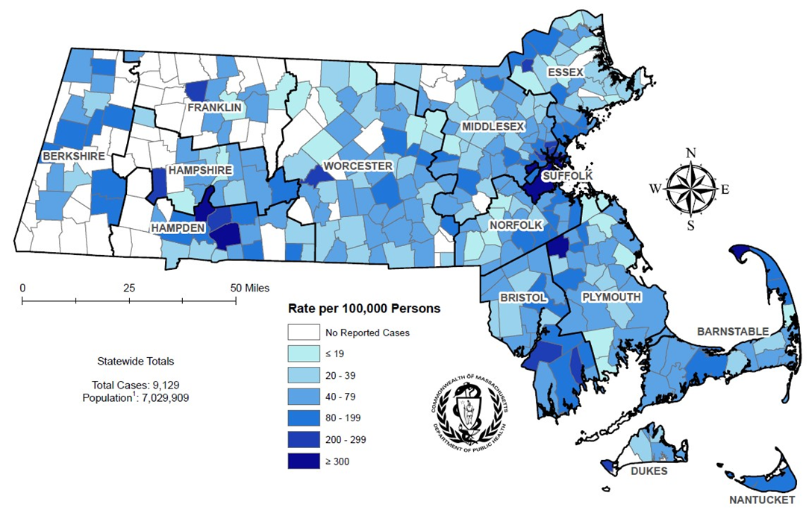
¹ Population based on University of Massachusetts Donahue Institute Estimates
There are four city/towns with <10 cases of gonorrhea that fall within the top two rate categories (≥200 cases per 100,000): Shelburne, Huntington, Aquinnah, and New Braintree.
Note: regional data include individuals tested in a correctional facility.
Data Source: Bureau of Infectious Disease and Laboratory Sciences, data are current as of 7/18/2023 and subject to change.
- In 2022, the statewide gonorrhea incidence rate of 129.9 per 100,000 population was lower than the 2021 national rate of 214.0 per 100,000.
  - Massachusetts ranked 40th in gonorrhea incidence rate among the 49 states reporting gonorrhea incidence in 2021, the last year for which these national data are publicly available.
- Gonorrhea cases continued to be clustered in the most populated cities in Massachusetts in 2022.
- The five cities with the highest gonorrhea incidence rates in 2022 were Provincetown (2,101.53 per 100,000), Springfield (389.9 per 100,000), Brockton (374.9 per 100,000), Boston (367.5 per 100,000), and Holyoke (324.3 per 100,000).

SVI AMONG GONORRHEA CASES BY CITY/TOWN
Figure 9. Median overall Social Vulnerability Index (SVI) by city/town for confirmed gonorrhea cases, Massachusetts 2022
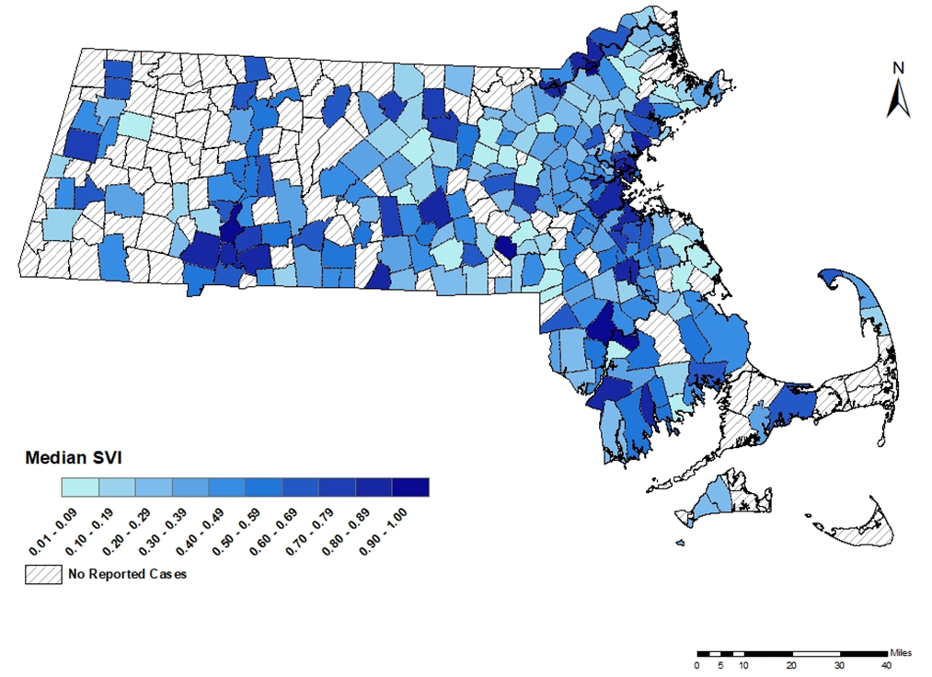
Note: Census tract level overall SVI values for 2020 were obtained from the CDC/Agency for Toxic Substance and Disease Registry and assigned to all cases based on their street address at diagnosis, 295 cases were excluded from this analysis because address was unknown or the individuals were homeless. City/Town level median is calculated from the median SVI score for that city/town among gonorrhea cases. Values range from 0 to 1, with higher values implying greater social vulnerability. Map should be interpreted with caution as it displays median SVI scores for cities/towns with one or more cases.
Data Sources: CDC/Agency for Toxic Substance and Disease, Bureau of Infectious Disease and Laboratory Sciences, data are current as of 7/21/2023 and subject to change.

- In 2022, the median SVI score among confirmed gonorrhea cases in Massachusetts was 0.753, which would be categorized as highly vulnerable.
- The five cities with the highest SVI scores (i.e., the most highly vulnerable) among confirmed gonorrhea cases in 2022 were Lawrence (0.960), Taunton (0.934), Holyoke (0.927), Milford (0.917), and Chelsea (0.892).

SYPHILIS

SYPHILIS BY GENDER
Syphilis is a sexually transmitted infection that can be spread through sexual contact with an infected person. The first symptom of syphilis infection is a sore or chancre at the site of inoculation that is usually firm, round, and painless. The most recognized symptom of the second stage of infection is a body rash which can be present on the palms of hands and soles of feet. As with primary syphilis symptoms, secondary symptoms also resolve with or without treatment. After the secondary stage of syphilis, untreated infected individuals enter a time of latent syphilis that can last for years. Individuals with syphilis are thought to be most infectious for the first year after acquisition. Syphilis infection can also be transmitted to an infant during pregnancy and birth. Syphilis transmission to an unborn baby is a serious complication of syphilis infection among pregnant individuals. From 2019 to 2022, the annual number of probable cases of congenital syphilis diagnosed in Massachusetts ranged from nine to eleven after remaining between zero and four from 2011 to 2018. Syphilis is treatable and it is possible to be re-infected with repeated exposure. For more information, see https://www.cdc.gov/std/syphilis/stdfact-syphilis-detailed.htm

Figure 10. Number of confirmed and probable infectious syphilis cases reported by gender, Massachusetts 2013–2022

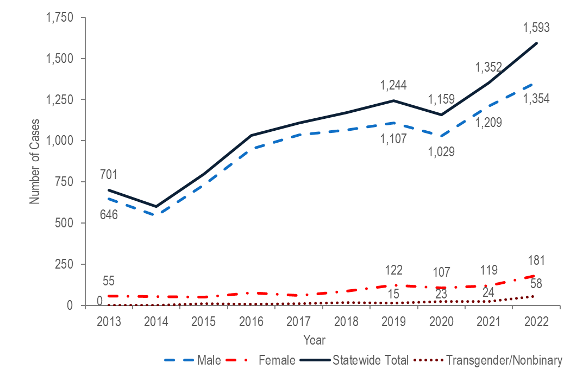

Note: Cases with no gender reported (2013–2022: N=3) are included in the statewide total but are not depicted in Figure 10 separately due to small numbers. Data Source: Bureau of Infectious Disease and Laboratory Sciences, data are current as of 7/21/2023 and subject to change.

- The total number of reported confirmed and probable infectious syphilis cases increased to a ten-year high of 1,244 in 2019, decreased slightly to 1,159 in 2020, and then increased to a new high of 1,593 in 2022. In 2022, the new ten-year high was observed among both males (N=1,354) and females (N=181).
- The total number of infectious syphilis cases increased by 2.3 times from 2013 (N=701) to 2022 (N=1,593). In the most recent five years from 2018 to 2022 the number of cases increased by 36% (from 1,170 to 1,593).
- Between 2013 and 2022, the proportion of syphilis cases among males remained between 85% and 94% each year. In 2022, there were 7.5 times as many syphilis cases reported among males (N=1,354) as among females (N=181).
- In 2022, 58 syphilis cases were reported among individuals of transgender experience and/or nonbinary individuals. Please note reported numbers among individuals of transgender experience and individuals who are nonbinary are likely to be underestimates as there may be underreporting or misreporting of gender due to the absence of appropriate collection of gender options (e.g., individuals who are genderqueer, pangender, gender fluid, androgynous, etc.).

SYPHILIS BY AGE
Figure 11. Number of confirmed and probable infectious syphilis cases reported by age group (years), Massachusetts 2013–2022

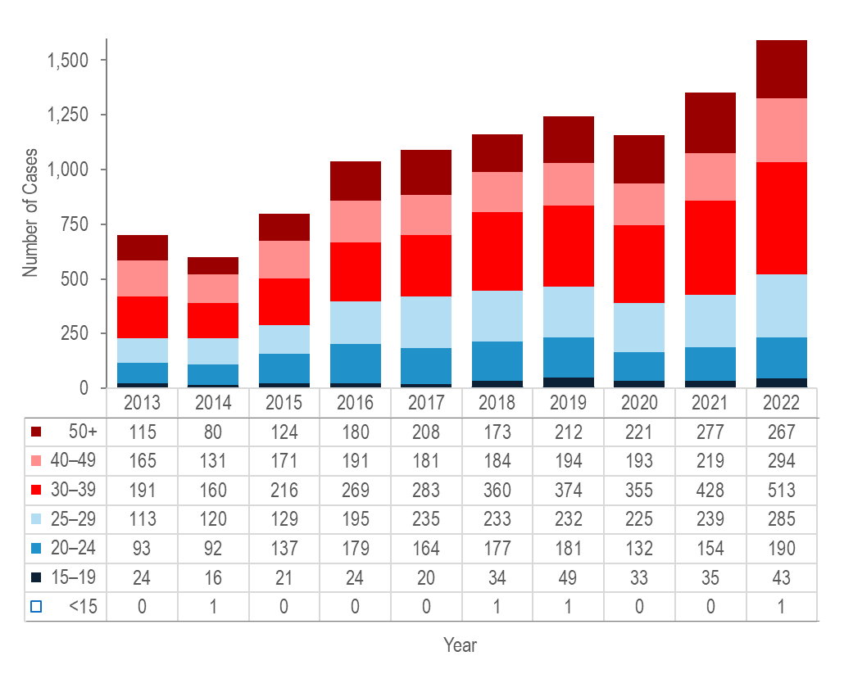

Note: All syphilis cases from 2013 to 2022 were reported with age, none were excluded from this figure
Data Source: Bureau of Infectious Disease and Laboratory Sciences, data are current as of 7/21/2023 and subject to change.

- From 2013 to 2022, the largest increases in the number of reported confirmed and probable infectious syphilis cases were among individuals aged 30–39 years (by 2.7 times from 191 to 513), and individuals aged 25–29 (by 2.5 times from 113 to 285).
- The largest number of reported confirmed and probable infectious syphilis cases was among 30–39 year-olds for the past decade.

SYPHILIS BY CITY/TOWN
Figure 12. Incidence rate of confirmed and probable infectious syphilis cases per 100,000 population reported by city/town, Massachusetts, 2022

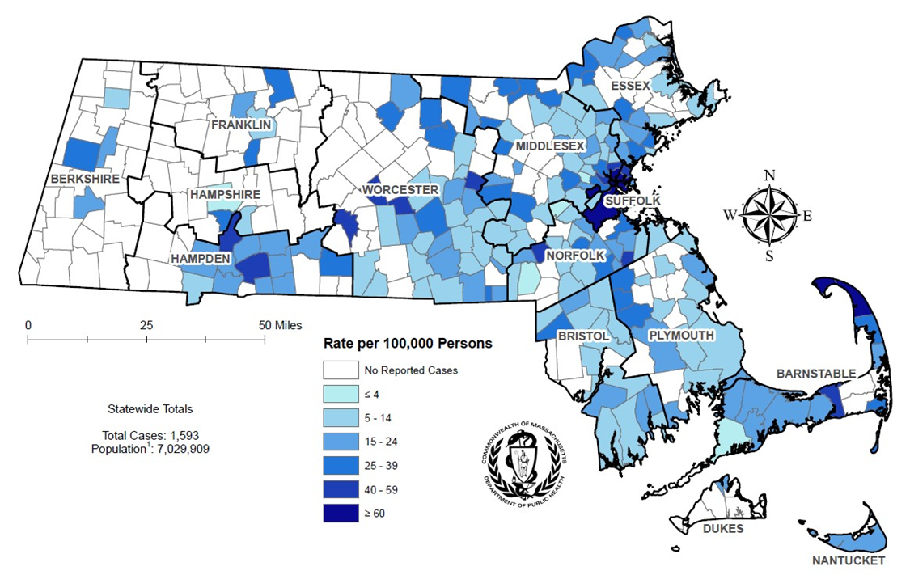

¹ Population based on University of Massachusetts Donahue Institute Estimates.
There are seven city/towns with <10 cases of syphilis that fall within the top two rate categories (≥40 cases per 100,00): Truro, Oakham, West Brookfield, Berlin, Millis, Holbrook, and Dennis.
Note: regional data include individuals tested in a correctional facility.
Data Source: Bureau of Infectious Disease and Laboratory Sciences, data are current as of 7/10/2023 and subject to change.
- The statewide infectious syphilis incidence rate increased over the past ten years to 17.7 per 100,000 in 2019, decreased to 16.6 per 100,000 in 2020, and then increased to a ten-year high of 22.7 in 2022.
  - Massachusetts ranked 33rd in primary and secondary syphilis incidence rate among the 49 states reporting syphilis incidence in 2021, the last year for which these national data are publicly available.
- The five cities with the highest infectious syphilis incidence rates were Provincetown (537.2 per 100,000), Chelsea (85.4 per 100,000), Everett (68.9 per 100,000), Boston (60.1 per 100,000), and Springfield (57.8 per 100,000).

SVI AMONG SYPHILIS CASES BY CITY/TOWN
Figure 13. Median overall Social Vulnerability Index (SVI) by city/town for infectious syphilis cases, Massachusetts 2022

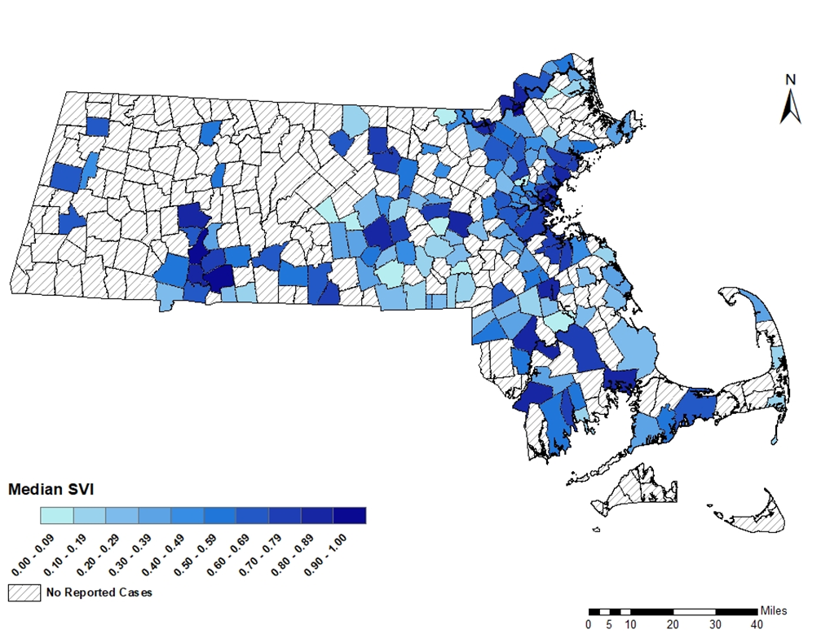
Note: Census tract level overall SVI values for 2020 were obtained from the CDC/Agency for Toxic Substance and Disease Registry and assigned to all cases based on their street address at diagnosis, 54 cases were excluded from this analysis because address was unknown or the individuals were homeless. City/Town level median is calculated from the median SVI score for that city/town among infectious syphilis cases. Values range from 0 to 1, with higher values implying greater social vulnerability. Map should be interpreted with caution as it displays median SVI scores for cities/towns with one or more cases.
Data Sources: CDC/Agency for Toxic Substance and Disease, Bureau of Infectious Disease and Laboratory Sciences, data are current as of 7/21/2023 and subject to change.
- In 2022, the median SVI score among infectious syphilis cases in Massachusetts was 0.722, which is moderately highly vulnerable.
- The five cities with the highest SVI scores (i.e., the most highly vulnerable) among infectious syphilis cases in 2022 were Lawrence (0.948), Holyoke (0.927), Springfield (0.908), Chelsea (0.892), and Lynn (0.888).

HIV

HIV PREVALENCE
Human immunodeficiency virus (HIV) is transmitted through exposure to blood, semen, vaginal secretions, or breast milk, most commonly through unprotected sex or through sharing injection drug equipment. HIV attacks the body’s immune system, specifically the CD4 cells. Without treatment, HIV can destroy so many of these cells that the body can’t fight off infections and can lead to acquired immunodeficiency syndrome (AIDS). But with proper medical care, HIV can be controlled. People with HIV who get effective HIV treatment can live long, healthy lives and protect their partners by reducing the risk for HIV transmission.
Figure 14. Number of persons living with HIV infection, Massachusetts 2013–2022
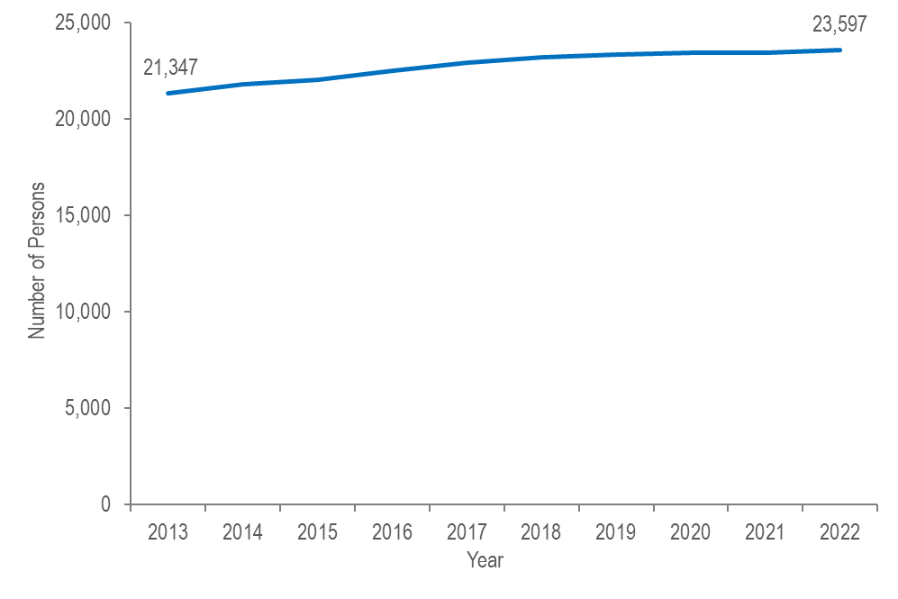
Data Source: Bureau of Infectious Disease and Laboratory Sciences, data are current as of 7/1/2023 and subject to change.

- The number of persons living with HIV infection (PLWH) in Massachusetts increased by 11% from 21,347 at the end of 2013 to 23,597 at the end of 2022.,

DIAGNOSES AND DEATHS FROM ANY CAUSE AMONG PERSONS REPORTED WITH HIV
Figure 15. Number of HIV infection diagnoses and deaths from any cause among persons with HIV, Massachusetts 2013–2022
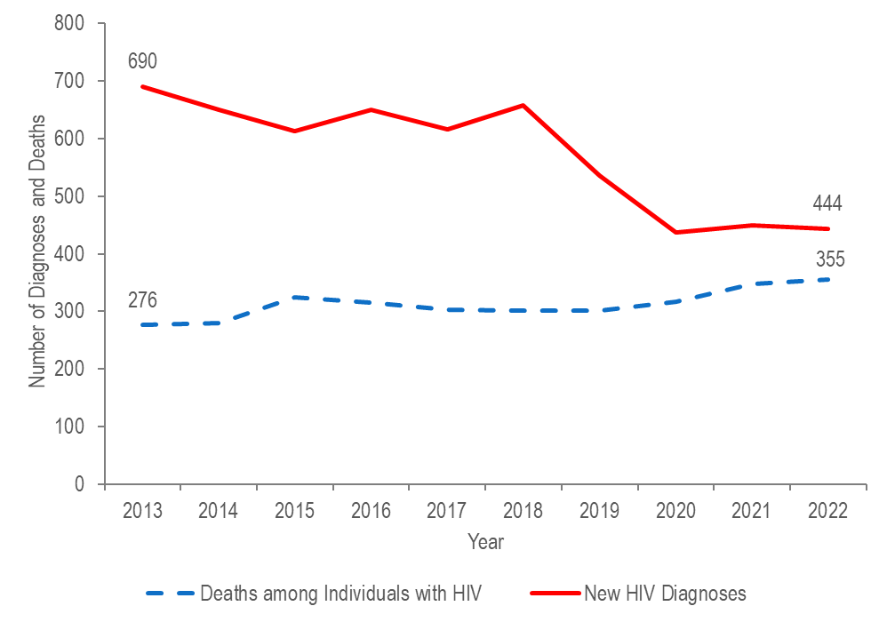
Data Source: Bureau of Infectious Disease and Laboratory Sciences, data are current as of 7/1/2023 and subject to change.
- After decreasing from 690 diagnoses in 2013 to approximately 640 diagnoses per year from 2014 to 2018 (five-year average = 637), the number of new HIV infection diagnoses declined to 537 in 2019. In 2020, the number of new HIV infection diagnoses further declined to 437 and then remained at this lower level in 2021 and 2022, when there were 449 and 444 diagnoses, respectively. However, caution should be used in the interpretation of this decline due to the impact of COVID-19 on access to HIV testing and care services, and case surveillance activities.
- The number of deaths due to any cause among individuals reported with HIV increased by 29% from 276 in 2013 to 355 in 2022.

HIV DIAGNOSES BY CITY/TOWN
Figure 16. Average annual rate of HIV diagnosis per 100,000 population by city/town, Massachusetts 2020–2022

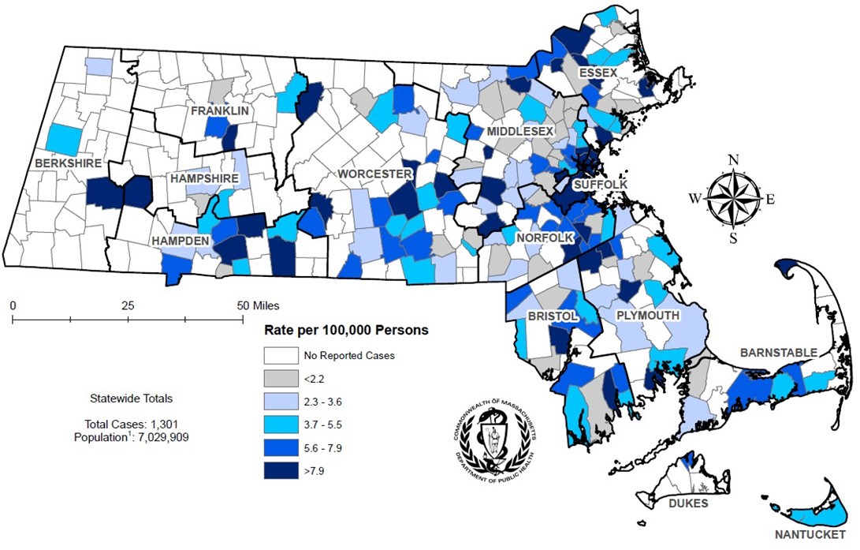

¹ Population based on University of Massachusetts Donahue Institute Estimates.
Note: regional HIV data exclude individuals diagnosed in a correctional facility.
Data Source: Bureau of Infectious Disease and Laboratory Sciences, data are current as of 7/1/2023 and subject to change.
- The cities and towns with the highest average annual rate of HIV infection diagnosis during 2020 to 2022 included Brockton (20.8 per 100,000), Boston (16.6), Malden (15.6), Chelsea (15.5), and Everett (15.5).
- Boston had the highest number of new HIV infection diagnoses from 2020–2022 (N=336), followed by Brockton (N=66).

HIV PREVALENCE BY CITY/TOWN
Figure 17. Prevalence rate of persons living with HIV infection (PLWH) per 100,000 population by city/town, Massachusetts 2022

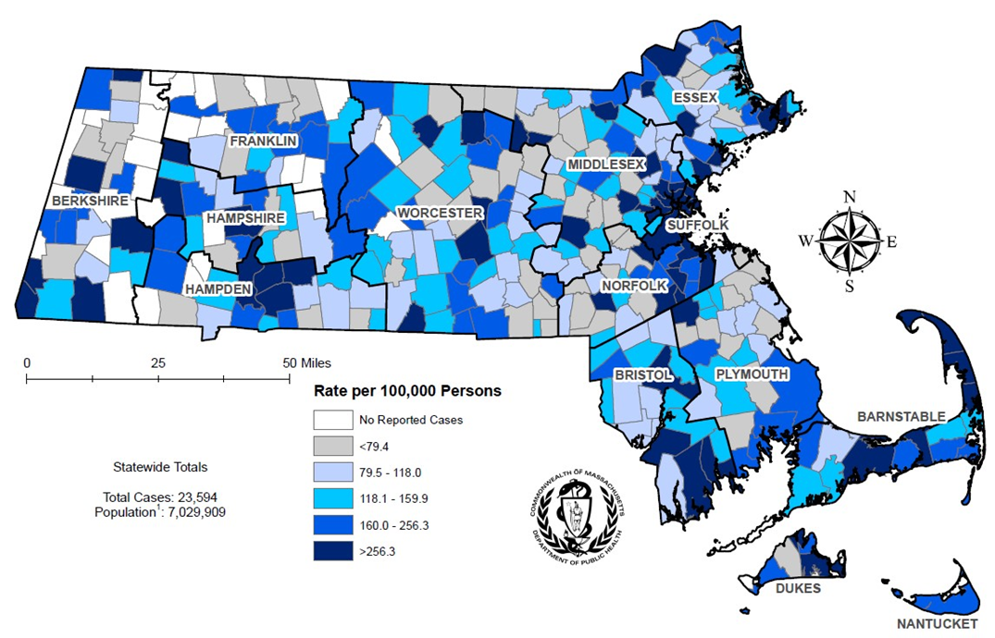

¹ Population based on University of Massachusetts Donahue Institute Estimates.
Note: regional HIV data exclude individuals diagnosed in a correctional facility.
Data Source: Bureau of Infectious Disease and Laboratory Sciences, data are current as of 7/1/2023 and subject to change.
- The cities and towns with the highest prevalence rate of PLWH in 2022 included Provincetown (11,767.6 per 100,000), Boston (832.4), Springfield (829.9), Shirley (794.0), and Chelsea (755.1).
- Boston and Springfield had the highest numbers of PLWH in 2022, at 5,624 and 1,294, respectively.

SVI AMONG HIV DIAGNOSES BY CITY/TOWN
Figure 18. Median overall Social Vulnerability Index (SVI) by city/town for HIV infection diagnoses, Massachusetts 2021
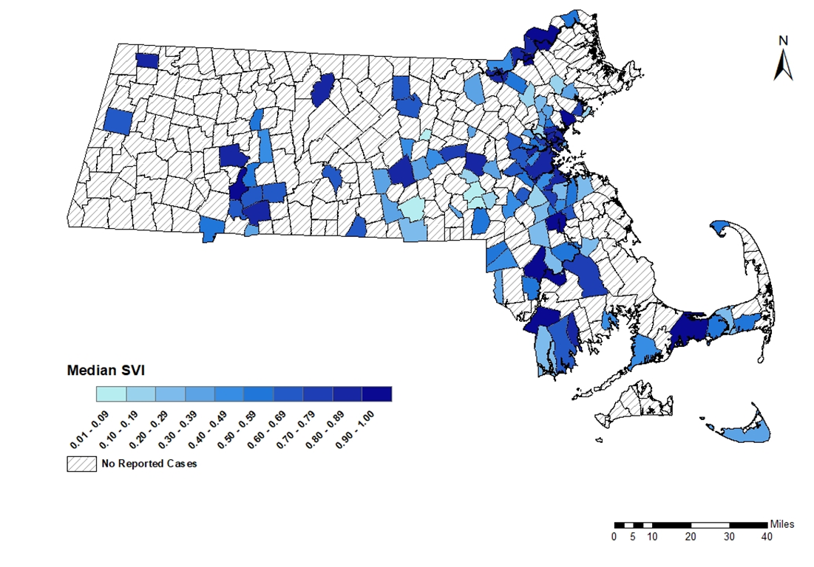
Note: Census tract level overall SVI values for 2020 were obtained from the CDC/Agency for Toxic Substance and Disease Registry and assigned to all cases based on their street address at diagnosis, 36 cases were excluded from this analysis because address was unknown or the individuals were homeless. City/Town level median is calculated from the median SVI score for that city/town among HIV infection diagnoses. Values range from 0 to 1, with higher values implying greater social vulnerability. Map should be interpreted with caution as it displays median SVI scores for cities/towns with one or more cases.
Data Sources: CDC/Agency for Toxic Substance and Disease, Bureau of Infectious Disease and Laboratory Sciences, data are current as of 7/1/2023 and subject to change.

- In 2021, the median SVI score among HIV infection diagnoses in Massachusetts was 0.744, which equates to moderately highly vulnerable.
- The five cities with the highest SVI scores (i.e., the most highly vulnerable) among HIV infection diagnoses in 2021 were Haverhill (0.982), Holyoke (0.970), Lawrence (0.960), Taunton (0.949), and Barnstable (0.931).

HIV BY EXPOSURE MODE AND SEX ASSIGNED AT BIRTH
Figure 19. Percentage of HIV infection diagnoses by sex assigned at birth and exposure mode, Massachusetts 2020–2022
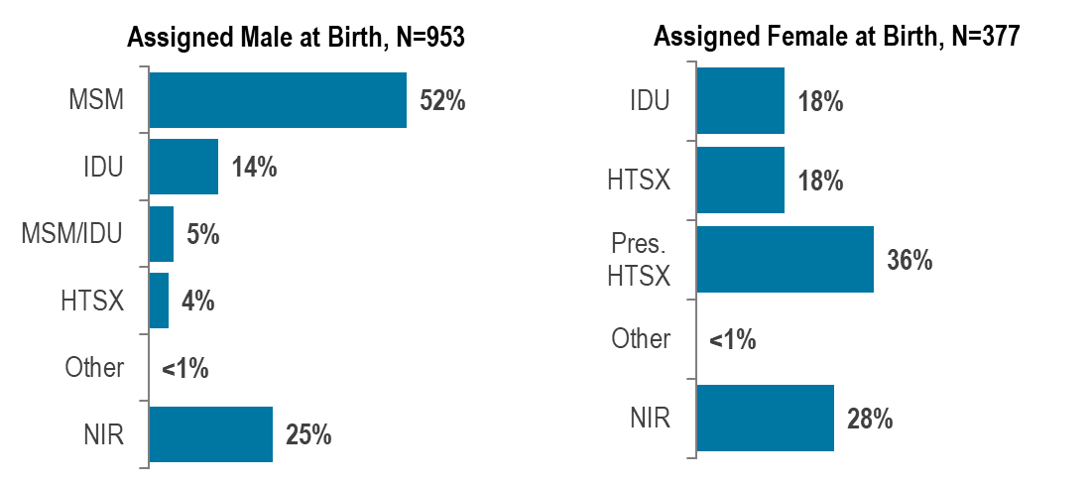
Data Source: Bureau of Infectious Disease and Laboratory Sciences, data are current as of 7/1/2023 and subject to change.
- From 2020 to 2022, of the 1,330 HIV infections newly diagnosed in Massachusetts, 953 (72%) were among individuals assigned male at birth (AMAB) and 377 (28%) were among individuals assigned female at birth (AFAB). Among the 1,330 HIV infections, 14 (1%) were among individuals of transgender experience, and 1,316 (99%) were among cisgender individuals.
- From 2020 to 2022, the most frequently reported known exposure mode among individuals AMAB was male-to-male sex (52%) and among individuals AFAB was presumed heterosexual sex (36%). A substantial proportion of diagnoses among both individuals AMAB and AFAB were reported with no identified risk (25% and 28%, respectively).

- Among individuals AMAB, the proportion of HIV infection diagnoses with injection drug use (IDU) exposure mode increased from a low of 4% (N=19/486) in 2014 to 17% (N=76/457) in 2017, decreased to 9% (N=34/396) in 2019, increased to 17% in 2021 (N=54/313), and then decreased again to 10% (N=32/325) in 2022.

- Among individuals AFAB, the proportion of HIV infection diagnoses with IDU exposure mode increased from a low of 7% (N=12/164) in 2014 to 25% (N=40/159) in 2017, decreased to 17% (N=24/140) in 2019, increased to 22% in 2020 (N=27/122), and then decreased again to 10% (N=12/119) in 2022.

PERINATAL TRANSMISSION OF HIV
Figure 20. Number of reported cases of perinatal transmission of HIV infection, by year of birth, Massachusetts 1985–2022
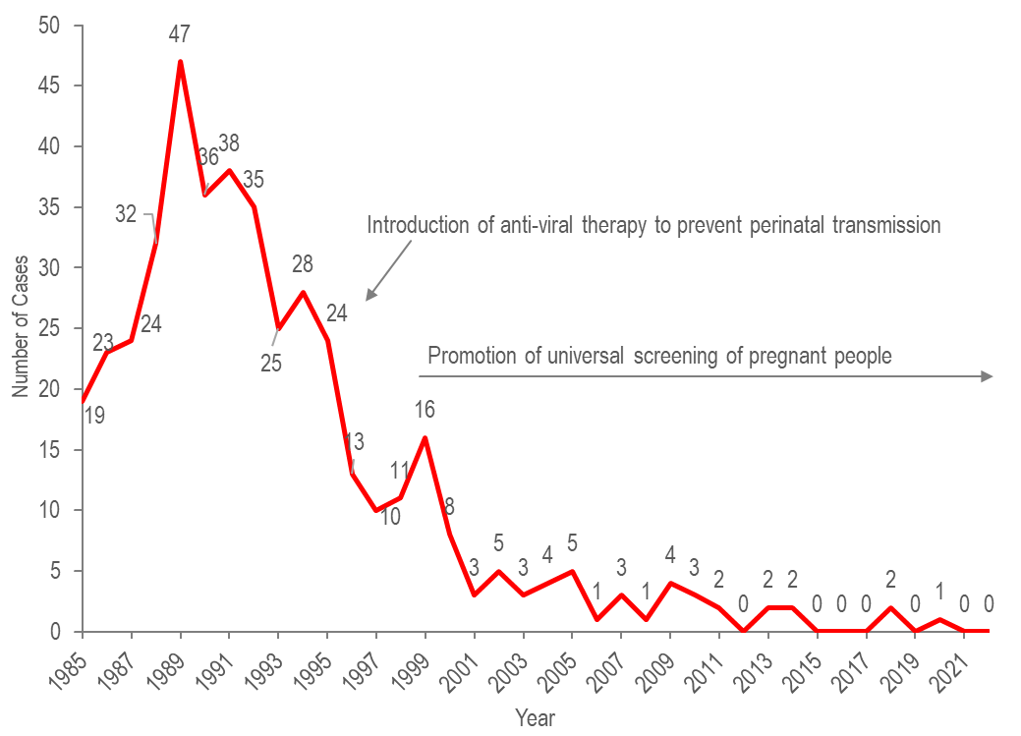
Data Source: Bureau of Infectious Disease and Laboratory Sciences, data are current as of 7/1/2023 and subject to change.

- Since the mid-1990s, there has been a dramatic reduction in perinatal transmission of HIV infection related to high rates of antiretroviral treatment of HIV positive people and promotion of HIV screening during pregnancy.
- There were only three cases identified in the past eight years (two in 2018 and one in 2020).

AGE AMONG PERSONS LIVING WITH HIV INFECTION
Figure 21. Percentage distribution of individuals living with HIV infection by age on December 31, Massachusetts 2013–2022

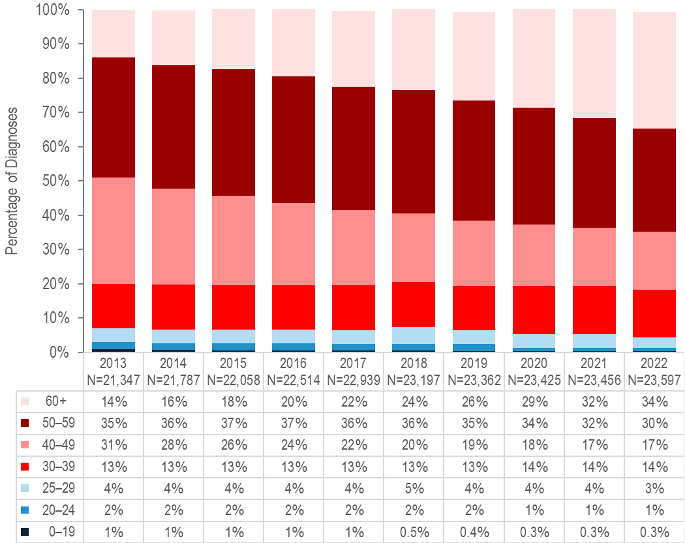

Data Source: Bureau of Infectious Disease and Laboratory Sciences, data are current as of 7/1/2023 and subject to change.
- Because of effective HIV treatment, people diagnosed with HIV infection are living longer, healthier lives. The proportion of people living with HIV infection who were aged 60 years or older increased from 14% on December 31, 2013 to 34% on December 31, 2022.,

SURVIVAL AMONG INDIVIDUALS DIAGNOSED WITH HIV
Figure 22. Five-year survival among with individuals with HIV infection by year of diagnosis, Massachusetts 1988–2022 (Total number of HIV diagnoses from 1988–2022, N=35,853)
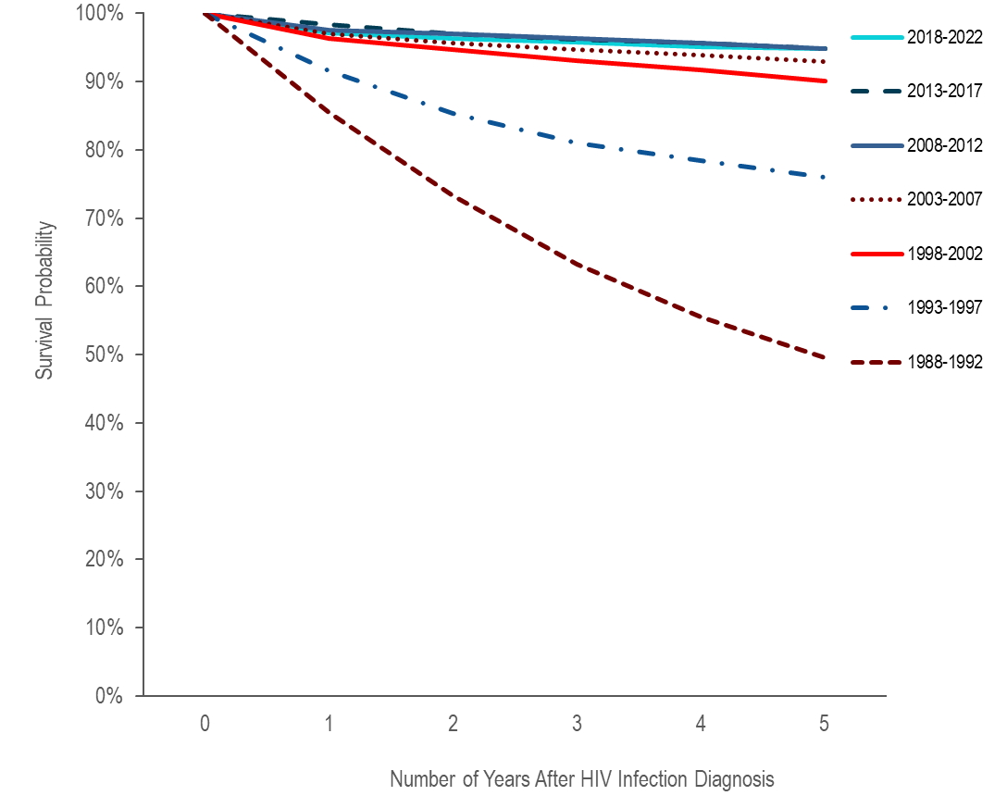
Data Source: Bureau of Infectious Disease and Laboratory Sciences, data are current as of 7/1/2023 and subject to change.

- Survival of individuals diagnosed with HIV infection has increased over time. In the earliest cohort of HIV infection diagnoses (1988–1992), estimated survival at five years after HIV infection diagnosis was 50%, compared to 95% in the three most recent cohorts (2018–2022, 2013–2017, and 2008–2012).

VIRAL HEPATITIS

HEPATITIS A
Hepatitis A is a vaccine-preventable, viral liver disease that can cause mild to severe illness. It is usually transmitted person-to-person through the fecal-oral route or through consumption of contaminated food or water. Hepatitis A is a self-limited disease that does not result in chronic infection.

Figure 23. Number of hepatitis A cases reported by year, housing status, and presence of substance use disorder, Massachusetts 2013–2022
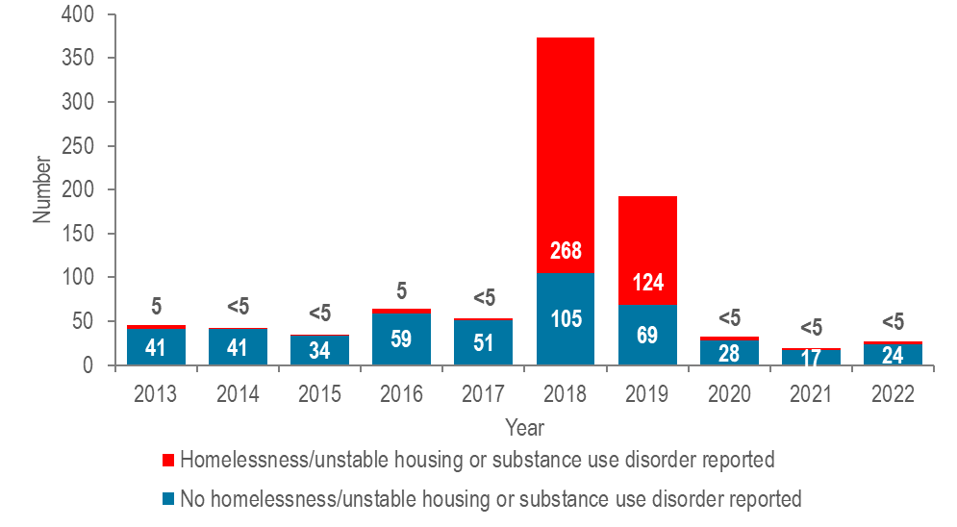
Data Source: Bureau of Infectious Disease and Laboratory Sciences, data are current as of 7/26/2023 and subject to change.

- Between 2018 and 2020, the Massachusetts Department of Public Health (MDPH) and local health departments investigated an outbreak of hepatitis A. The populations most affected by the outbreak were those reported with recent homelessness or unstable housing, and/or substance use disorder, accounting for 72% (N=268/373) and 64% (N=124/193) of cases in 2018 and 2019, respectively. MDPH partnered with clinical and community-based providers to implement a hepatitis A (HAV) vaccination response by deploying mobile vaccination providers to shelters, correctional facilities, harm reduction programs, and outreach venues. Since spring of 2020, case counts have decreased to a pre-outbreak baseline, and very few cases have been reported among the populations most affected by the outbreak. Fewer than five cases were reported among individuals with homelessness/unstable housing or substance use disorder each year from 2020 to 2022. MDPH encourages continued vaccination of vulnerable populations in accordance with recommendations from the Advisory Committee on Immunization Practices.

HEPATITIS B
Hepatitis B is a liver infection caused by the hepatitis B virus. Transmission occurs via contact with blood or other body fluids, including from mother to infant at birth, via sexual contact, and through sharing of drug injection equipment. Most people who get the disease recover from it and cannot be re-infected. However, about 10% of adults who get hepatitis B will go on to have chronic (long-term) infection and can pass it on to others. When it is chronic, it can be a serious disease that can lead to cirrhosis (scarring of the liver) and/or liver cancer. The younger a person is when infected, the more likely he or she is to go on to have chronic infection and to develop serious liver disease. There is a vaccine to prevent hepatitis B infection.

The impact of chronic hepatitis B in the US is greater among people born in regions of the world with high or moderate prevalence of chronic hepatitis B, including much of Asia and the Pacific Islands.

Figure 24. Number of confirmed and probable chronic hepatitis B cases reported by year, Massachusetts 2013–2022

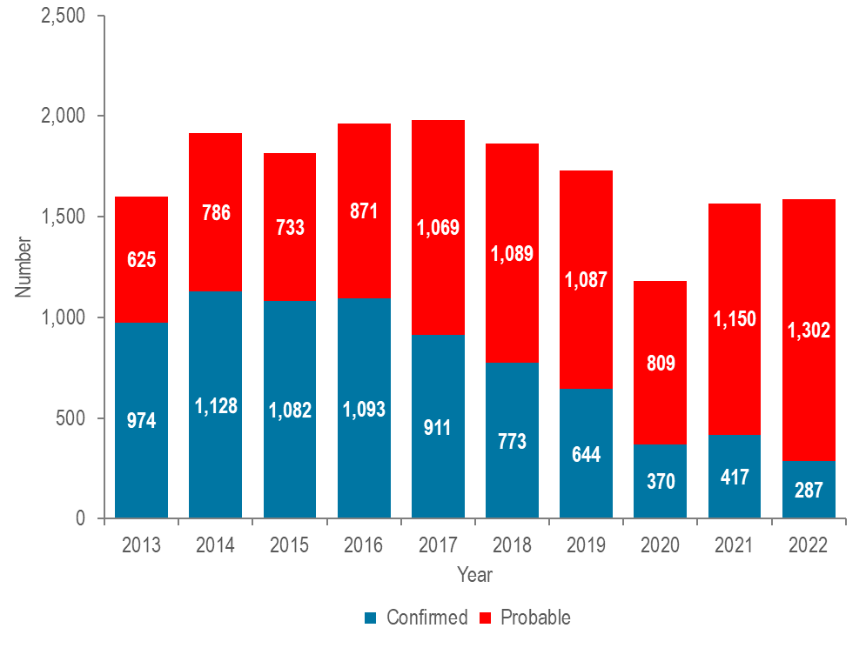
Data Source: Bureau of Infectious Disease and Laboratory Sciences, data are current as of 7/6/2023 and subject to change.
- From 2013 to 2022, an average of 1,720 cases of confirmed and probable chronic hepatitis B virus (HBV) infection were reported each year (with a low of 1,179 in 2020 and a high of 1,980 in 2017). Changes in testing behaviors and travel due to the COVID-19 pandemic likely influenced the number of reported cases and may contribute to the decrease in 2020, followed by the rebound in 2021 and 2022.
- The surveillance case definition for chronic HBV requires two positive tests; for certain test types, these two tests must be taken at least six months apart. Reported cases are classified as "probable" following the initial test result and are re-classified as "confirmed" if additional test results are received. During the most recent year of data, 2022, some cases currently reported as probable may be eventually confirmed in future reports as additional information is obtained.

HEPATITIS B BY GENDER
Figure 25. Number of confirmed and probable chronic hepatitis B cases reported by female and male gender, Massachusetts 2013–2022

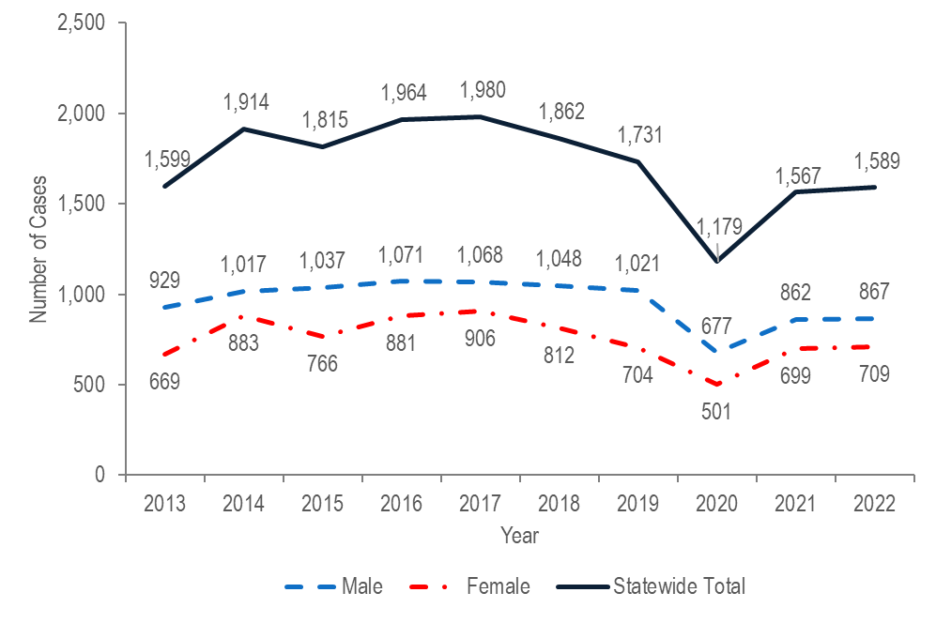

Note: Cases reported as transgender or missing gender (2013–2022: N=73) are included in the statewide total but are not depicted in Figure 25 separately due to small numbers.
Data Source: Bureau of Infectious Disease and Laboratory Sciences, data are current as of 7/6/2023 and subject to change.
- In 2022, 867 (55%) cases of confirmed and probable chronic HBV infection were newly reported among males, 709 (45%) were reported among females, and fewer than five were reported among individuals of transgender experience. Please note reported numbers among individuals of transgender experience are likely to be underestimates as there may be underreporting or misreporting of gender due to the absence of appropriate collection of gender options (e.g., individuals who are nonbinary, and women and men of transgender experience). Changes in testing behaviors due to the COVID-19 pandemic likely affected the numbers of reported cases from 2020 to 2022.
- Hepatitis B in people of childbearing age is of particular concern due to the risk of transmission from pregnant person to infant at birth. Perinatal HBV transmission can be prevented by identifying HBV-positive pregnant people and providing post-exposure prophylaxis (PEP) to their infants within 12 hours of birth. The MDPH Perinatal Hepatitis B Prevention Program provides case management to pregnant people who are HBV-positive and their infants to ensure appropriate PEP, vaccination, and post-vaccination serologic testing.
ACUTE HEPATITIS B
Figure 26. Number of confirmed and suspect acute hepatitis B cases reported by year, Massachusetts 2013–2022

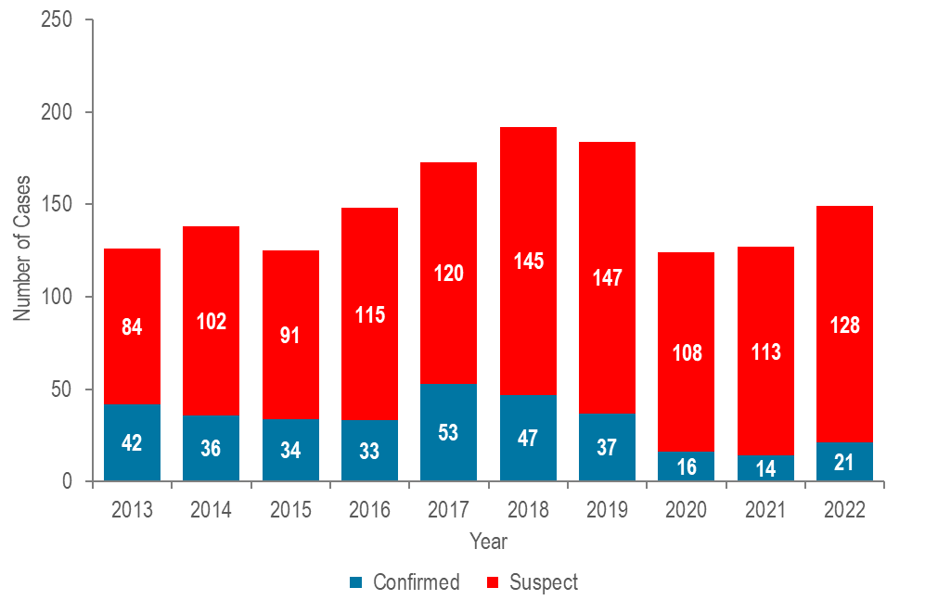
Data Source: Bureau of Infectious Disease and Laboratory Sciences, data are current as of 7/6/2023 and subject to change.
- In 2022, there were 21 confirmed acute and 128 suspect acute HBV cases for a total of 149 acute cases.
- The total number of confirmed acute HBV cases reported has decreased between 2017 (53 cases) and 2022 (21 cases).
- Injection drug use (IDU) is a significant, and increasingly important, risk factor for acquisition of acute HBV infection.

HEPATITIS C
Hepatitis C is a liver infection caused by the hepatitis C virus. The majority of infected individuals are asymptomatic, but symptoms, when present, can include fatigue, loss of appetite, nausea, vomiting, abdominal pain, and jaundice. Over time, liver damage can result, and complications can include cirrhosis and liver cancer. Hepatitis C infection is spread by direct contact with the blood of an infected person. Transmission mechanisms can include: sharing equipment used to inject drugs, blood transfusions and organ transplants (primarily prior to 1992 when widespread screening of the blood supply began), from gestational parent to child at birth, sharing personal items such as toothbrushes or razors, tattoos and piercings in non-sterile environments, infection control breaches in healthcare settings, and, rarely, through sexual contact (more likely with HIV co-infection). Most people who get the infection will go on to have chronic infection. With the advent of direct-acting antivirals, hepatitis C infection is curable with an 8-12 week course of treatment.

Figure 27. Number of confirmed and probable hepatitis C cases reported by year, Massachusetts 2013–2022
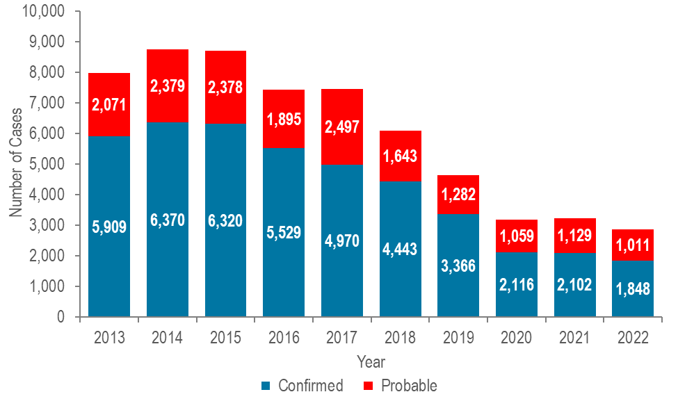
Data Source: Bureau of Infectious Disease and Laboratory Sciences, data are current as of 8/24/2023 and subject to change.
- The total number of reported confirmed and probable hepatitis C cases decreased from 7,980 in 2013 to 2,859 in 2022.
  - Most reported cases are chronically infected and MDPH currently estimates that there are over 250,000 people living with HCV infection in Massachusetts.
HEPATITIS C BY GENDER
Figure 28. Number of confirmed and probable hepatitis C cases reported by female and male gender, Massachusetts 2013–2022

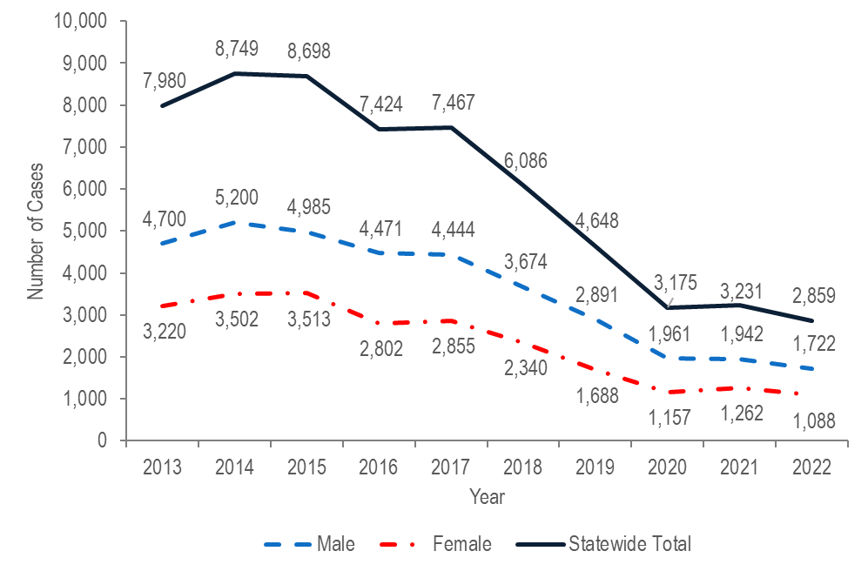
Note: Cases reported as transgender or missing gender (2013–2022: N=900) are included in the statewide total but are not depicted in Figure 28 separately due to small numbers.
Data Source: Bureau of Infectious Disease and Laboratory Sciences, data are current as of 8/24/2023 and subject to change.

- In 2022, 1,722 (60%) cases of confirmed and probable HCV infection were newly reported among males, 1,088 (38%) were reported among females, 45 (2%) were reported among individuals with unknown gender, and fewer than five were reported among individuals of transgender experience. Please note reported numbers among individuals of transgender experience are likely to be underestimates as there may be underreporting or misreporting of gender due to the absence of appropriate collection of gender options (e.g., individuals who are nonbinary, and women and men of transgender experience). Changes in testing behaviors due to the COVID-19 pandemic likely affected the numbers of reported cases from 2020 to 2022.

HEPATITIS C BY AGE
Figure 29. Distribution of confirmed and probable hepatitis C cases by age: 2007 versus 2022
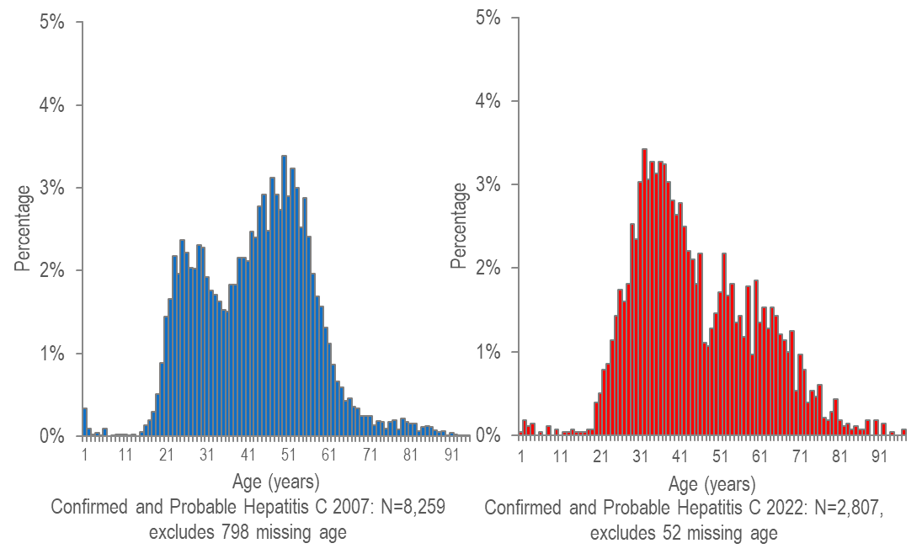

Data Source: Bureau of Infectious Disease and Laboratory Sciences, data are current as of 8/24/2023 and subject to change.

- In 2007, reported cases of hepatitis C were distributed in a curve with two age peaks, with the lower peak at age 24 years and the higher peak at age 49 years.
- In 2022, the reported cases were again distributed in a bimodal curve, but with the higher peak at age 31 years, reflecting a continuing shift in the age profile of newly reported cases.

HEPATITIS C BY AGE AND GENDER
Figure 30. Number of confirmed and probable hepatitis C cases reported by age, and female and male gender, Massachusetts 2022
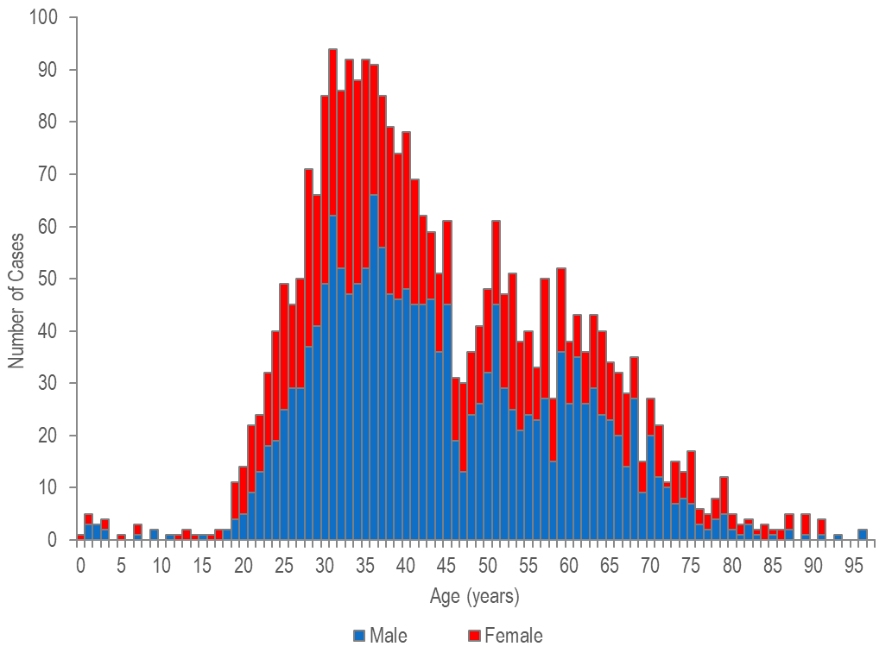
Note: Confirmed and Probable Hepatitis C 2022: N=2,807, excludes 52 missing age and/or gender. Cases reported as transgender are not depicted in Figure 30 separately due to small numbers. Data Source: Bureau of Infectious Disease and Laboratory Sciences, data are current as of 8/24/2023 and subject to change.
- In 2022, 1,722 (60%) confirmed and probable hepatitis C cases were reported among males, 1,088 (38%) were reported among females, and fewer than five were reported among individuals of transgender experience. Please note reported numbers among individuals of transgender experience are likely to be underestimates as there may be underreporting or misreporting of gender due to the absence of appropriate collection of gender options (e.g., individuals who are nonbinary, and women and men of transgender experience, etc.).
- Fifty-four percent (N=244/455) of confirmed and probable hepatitis C infection cases in those less than 30 years of age were reported among males, 46% (N=210/455) were reported among females, and less than 1% were reported among individuals of transgender experience.
  - For newly reported hepatitis C infections among persons less than 30 years of age with a known risk history, injection drug use was the most commonly reported risk factor for infection.

CO-INFECTIONS-

HIV/SYPHILIS
Table 1. Percentage of 2022 confirmed and probable infectious syphilis cases ever co-infected with HIV by gender, race/ethnicity, and age
 | HIV/Syphilis Co-infections | Syphilis  Cases | % of Syphilis Cases Co-infected with HIV
Total: | 397 | 1,593 | 25%
Gender:
Male | 378 | 1,354 | 28%
Female | 5 | 181 | 3%
Transgender | 14 | 58 | 24%
Race/Ethnicity:
White NH | 144 | 607 | 24%
Black NH | 83 | 270 | 31%
Hispanic/Latino | 136 | 493 | 28%
Other NH | 33 | 163 | 20%
Unreported | 1 | 60 | 2%
Age:
<15 years | 0 | 1 | 0%
15–19 years | 2 | 43 | 5%
20–24 years | 15 | 190 | 8%
25–29 years | 46 | 285 | 16%
30–39 years | 130 | 513 | 25%
40–49 years | 94 | 294 | 32%
50+ years | 110 | 267 | 41%
Data Source: Bureau of Infectious Disease and Laboratory Sciences, data are current as of 7/21/2023 and subject to change.
- In 2022, among 1,593 reported cases of infectious syphilis, 25% (N=397/1,593) were co-infected with HIV.
- Among infectious syphilis cases reported in 2022, higher than average (25%) proportions of HIV co-infection were observed in males, black (non-Hispanic) and Hispanic/Latinx individuals, and individuals aged 40 years and above.
- Seventy-four percent (N=999/1,347) of infectious syphilis cases among males reported same sex contact. Of those who reported male-to-male sex, 33% (N=325/999) were co-infected with HIV, compared to 15% (N=53/358) of males with unknown risk.

HIV/GONORRHEA
Table 2. Percentage of 2022 laboratory-confirmed gonorrhea cases ever co-infected with HIV by gender, race/ethnicity, and age
 | HIV/Gonorrhea  Co-infections | Gonorrhea Cases | % of Gonorrhea Cases Co-infected with HIV
Total: | 701 | 9,129 | 8%
Gender:
Male | 665 | 6,196 | 11%
Female | 21 | 2,861 | 1%
Transgender | 15 | 68 | 22%
Race/Ethnicity: | 0 | 4 | 0%
White NH
Black NH | 213 | 2,023 | 11%
Hispanic/Latino | 92 | 1,462 | 6%
Other NH | 142 | 1,528 | 9%
Unreported | 57 | 724 | 8%
Age: | 197 | 3,392 | 6%
<15 years
15–19 years | 0 | 28 | 0%
20–24 years | 6 | 1,047 | 1%
25–29 years | 58 | 2,153 | 3%
30–39 years | 104 | 1,878 | 6%
40–49 years | 255 | 2,461 | 10%
50+ years | 137 | 866 | 16%
Data Source: Bureau of Infectious Disease and Laboratory Sciences, data are current as of 7/21/2023 and subject to change.
- In 2022, among 9,129 reported cases of gonorrhea, 8% (N=701/9,129) were ever co-infected with HIV.
- Among laboratory-confirmed gonorrhea cases reported in 2022, higher than average proportions of HIV co-infection were observed in individuals of transgender experience, males, white (non-Hispanic individuals, and individuals aged 40 years or older. However, caution should be used in the interpretation of co-infection rates by race/ethnicity as a large percentage of cases had unreported race/ethnicity (37%).

HIV/HEPATITIS C
Figure 25. Number of individuals diagnosed with HIV infection only, and ever co-infected with hepatitis C (HCV) by year of HIV infection diagnosis, Massachusetts 2013–2022

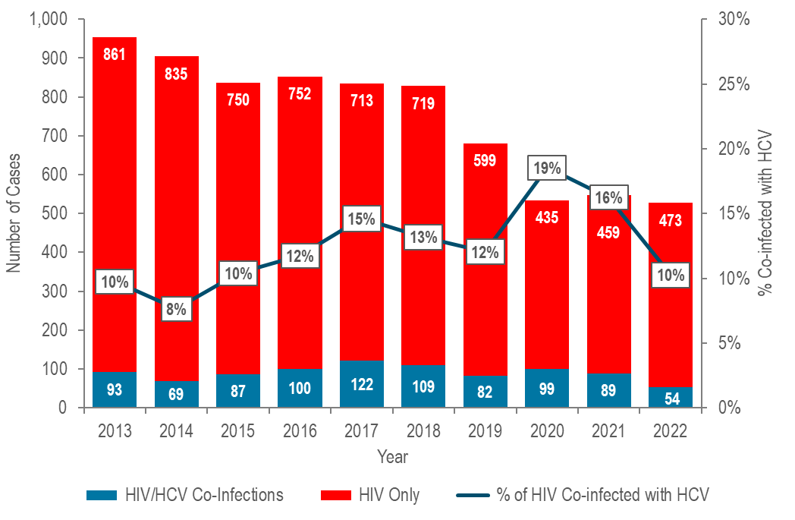
Data Source: Bureau of Infectious Disease and Laboratory Sciences, data are current as of 8/2/2023 and subject to change.
- The percentage of individuals diagnosed with HIV infection who were co-infected with hepatitis C increased from 8% (N=69/904) in 2014 to 15% (N=122/835) in 2017, decreased to 12% in 2019 (N=82/681), increased again to a ten-year high of 19% (N=99/534) in 2020 and then decreased to 10% (N=54/527) in 2022., This trend mirrors that among HIV infection diagnoses with a primary exposure mode of injection drug use and is likely related to two outbreaks of HIV infection among persons who inject drugs. The first outbreak occurred from 2016 to 2018 in the northeastern part of the state and the second was identified in 2019 in the Boston area and is still ongoing (see Specific Populations – Persons Who Inject Drugs for more information).

HIV/HEPATITIS C CO-INFECTIONS BY DEMOGRAPHICS
Table 3. Individuals diagnosed with HIV infection ever co-infected with hepatitis C virus (HCV) by year of HIV infection diagnosis and selected demographics, 2018–2022
 | 2018  N | 2018 % | 2019  N | 2019  % | 2020  N | 2020  % | 2021  N | 2021  % | 2022  N | 2022  %
Sex Assigned at Birth:
Male | 70 | 64% | 55 | 67% | 71 | 72% | 60 | 67% | 41 | 76%
Female | 39 | 36% | 27 | 33% | 28 | 28% | 29 | 33% | 13 | 24%
Race/Ethnicity:
White NH | 66 | 61% | 48 | 59% | 74 | 75% | 60 | 67% | 36 | 67%
Black NH | 11 | 10% | 14 | 17% | 10 | 10% | 10 | 11% | 2 | 4%
Hispanic/Latino | 32 | 29% | 15 | 18% | 15 | 15% | 18 | 20% | 14 | 26%
Asian/Pacific Islander NH | 0 | 0% | 2 | 2% | 0 | 0% | 0 | 0% | 0 | 0%
Other NH/Unknown | 0 | 0% | 3 | 4% | 0 | 0% | 1 | 1% | 2 | 4%
Age:
13-19 years | 1 | 1% | 0 | 0% | 0 | 0% | 0 | 0% | 0 | 0%
20-29 years | 29 | 27% | 21 | 26% | 19 | 19% | 8 | 9% | 9 | 17%
30-39 years | 39 | 36% | 35 | 43% | 54 | 55% | 45 | 51% | 26 | 48%
40-49 years | 24 | 22% | 17 | 21% | 15 | 15% | 17 | 19% | 8 | 15%
50+ years | 16 | 15% | 9 | 11% | 11 | 11% | 19 | 21% | 11 | 20%
HIV Exposure Mode:
MSM | 9 | 8% | 6 | 7% | 10 | 10% | <5 | N/A | <5 | N/A
IDU | 79 | 72% | 52 | 63% | 73 | 74% | 75 | 84% | 38 | 70%
MSM/IDU | 7 | 6% | 11 | 13% | 11 | 11% | <5 | N/A | 8 | 15%
HTSX | 6 | 6% | <5 | N/A | 0 | 0% | <5 | N/A | <5 | N/A
Pres. HTSX | <5 | N/A* | <5 | N/A | <5 | N/A | <5 | N/A | 0 | 0%
NIR | ≥5 | N/A | 10 | 12% | <5 | N/A | 6 | 7% | <5 | N/A
Total: | 109 | 100% | 82 | 100% | 99 | 100% | 89 | 100% | 54 | 100%
MSM=Male-to-Male Sex, IDU=Injection Drug Use, HTSX=Heterosexual Sex, Pres.=Presumed, NIR=No Identified Risk. For more information, see HIV primary exposure mode definitions in Interpreting HIV, STD, and Viral Hepatitis Data, on page 72.
*Values one through four are suppressed for denominator populations less than 50,000 or for unknown population sizes. Additional values of zero and greater than or equal to five may be suppressed to prevent back calculation. Data Source: Bureau of Infectious Disease and Laboratory Sciences, data are current as of 8/2/2023 and subject to change.
- From 2018 to 2022,, the proportion of individuals co-infected with HIV/HCV who were assigned male at birth increased from 64% to 76%. During the same period, the proportion of 30-39 year-olds increased from 36% to 48%, while the proportion of 20-29 year-olds decreased from 27% to 17%, and the proportion of 40-49 year-olds decreased from 22% to 15%. The proportion of individuals co-infected with HIV/HCV with IDU exposure mode likely reflected two separate HIV outbreaks among persons who inject drugs (PWID), decreasing from 72% in 2018 to 63% in 2019, increasing to 84% in 2021 and then decreasing again to 70% in 2022.
- The distribution of individuals co-infected with HIV/HCV infection by race/ethnicity remained relatively stable from 2018 to 2022, with white (non-Hispanic) individuals accounting for the majority of cases each year (59-67%).

HIV/HEPATITIS C – PERCENTAGE CO-INFECTED
Table 4. Percentage of 2022 HIV infection diagnoses ever co-infected with HCV by gender, race/ethnicity, age, and HIV exposure mode
 | HIV/HCV Co-infections | HIV Diagnoses | % of HIV Diagnoses  Co-infected with HCV
Total | 54 | 527 | 10%
Assigned Sex at Birth:
Male | 41 | 386 | 11%
Female | 13 | 141 | 9%
Race/Ethnicity:
White NH | 36 | 149 | 24%
Black NH | 2 | 180 | N/A
Hispanic/Latino | 14 | 169 | 8%
Asian/Pacific Islander NH | 0 | 16 | 0%
Other NH/Unknown | 2 | 13 | N/A
Age:
13–19 years | 0 | 5 | 0%
20–29 years | 9 | 140 | 6%
30–39 years | 26 | 189 | 14%
40–49 years | 8 | 89 | 9%
50+ years | 11 | 103 | 11%
HIV Exposure Mode:
MSM | <5 | 209 | N/A*
IDU | 38 | 46 | 83%
MSM/IDU | 8 | 18 | 44%
HTSX | <5 | 26 | N/A
Pres. HTSX | 0 | 69 | 0%
NIR | <5 | 158 | N/A
MSM=Male-to-Male Sex and Men Who Have Sex with Men, IDU=Injection Drug Use, HTSX=Heterosexual Sex, Pres.=Presumed, NIR=No Identified Risk. *Values one through four are suppressed for denominator populations less than 50,000 or for unknown population sizes. Additional values of zero and greater than or equal to five may be suppressed to prevent back calculation.
Data Source: Bureau of Infectious Disease and Laboratory Sciences, data are current as of 7/1/2023 and subject to change.
- In 2022, among 527 individuals diagnosed with HIV infection, 10% (N=54/527) were ever co-infected with HCV.
- Among individuals diagnosed with HIV infection in 2022, higher rates of HCV co-infection were observed in white (non-Hispanic) individuals (24%), individuals aged 30–39 years (14%), and individuals with IDU exposure mode (83%), or MSM/IDU exposure mode (44%). Co-infection rates were similar for individuals assigned male at birth and individuals assigned female at birth.

SPECIFIC POPULATIONS- ADOLESCENTS AND YOUNG ADULTS

STD DIAGNOSES BY AGE
Figure 32. Distribution of confirmed chlamydia and gonorrhea cases reported by age group (years), Massachusetts 2022
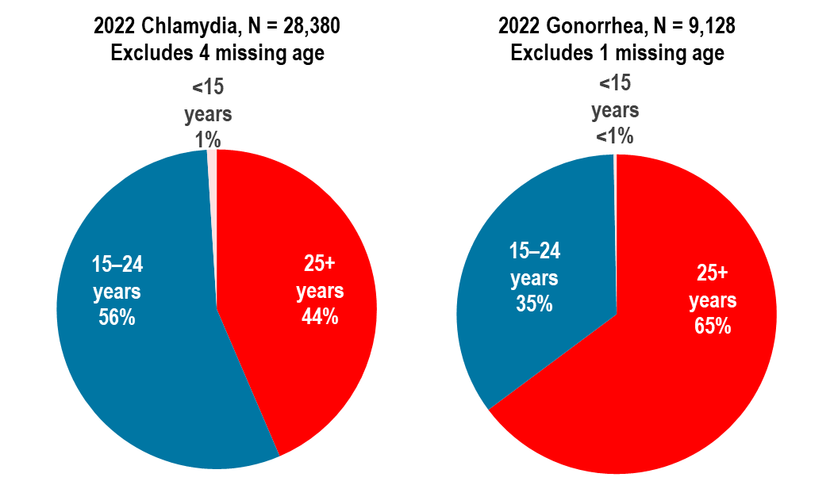
Data Source: Bureau of Infectious Disease and Laboratory Sciences, data are current as of 7/21/2023 and subject to change.
- In 2022, in Massachusetts, 56% of chlamydia cases and 35% of gonorrhea cases were reported among adolescents and young adults aged 15–24 years.
- Nationally, 59% of chlamydia cases and 41% of gonorrhea cases were reported among adolescents and young adults aged 15–24 years in 2021.

STD DIAGNOSES BY AGE AND GENDER
Figure 33. Distribution of confirmed chlamydia and gonorrhea cases reported by age group (years) and gender, Massachusetts 2022
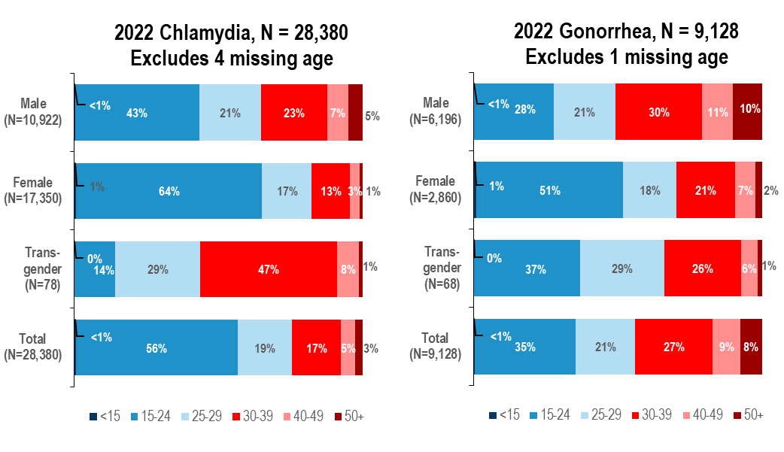
Data Source: Bureau of Infectious Disease and Laboratory Sciences, data are current as of 7/21/2023 and subject to change.
- In 2022, in Massachusetts, 43% of chlamydia cases reported among males, 64% among females, 29% among individuals of transgender experience, and 56% of total cases were reported among adolescents and young adults aged 15–24 years.
  - Nationally in 2021, 47% of chlamydia cases reported among males, 65% among females, and 59% of total cases were reported among adolescents and young adults aged 15–24 years.
- In 2022, in Massachusetts, 28% of gonorrhea cases reported among males, 51% among females, 37% among individuals of transgender experience, and 35% of total cases were reported among adolescents and young adults aged 15–24 years.
  - Nationally in 2021, 32% of gonorrhea cases reported among males, 52% among females, and 41% of total cases were reported among adolescents and young adults aged 15–24 years.

HIV DIAGNOSES BY RACE/ETHNICITY AND EXPOSURE MODE
Figure 34. Distribution of HIV infection diagnoses in adolescents and young adults (aged 15–24 years) by race/ethnicity, exposure mode, place of birth, and sex assigned at birth, Massachusetts 2020–2022, N=142
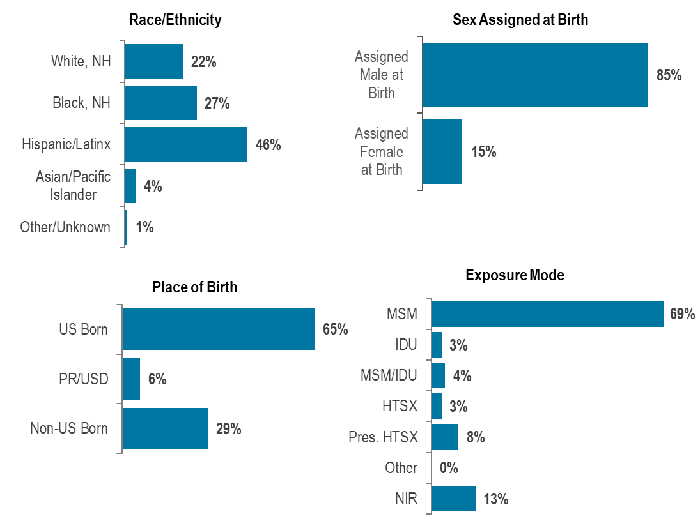
Data Source: Bureau of Infectious Disease and Laboratory Sciences, data are current as of 7/1/2023 and subject to change.
- During 2020 to 2022, 11% (N=142/1,330) of HIV infection diagnoses were reported among adolescents and young adults aged 15–24 years.
- Adolescent and young adults aged 15–24 years newly diagnosed with HIV infection in Massachusetts during 2020 to 2022 were predominantly Hispanic/Latinx (46%) or black (non-Hispanic) (27%), assigned male at birth (85%), and US born (65%), with an exposure mode of male-to-male sex (69%).

HEPATITIS C BY AGE AND GENDER
Figure 35. Number of confirmed and probable hepatitis C cases reported by age and female and male gender, Massachusetts 2002, 2007, 2022
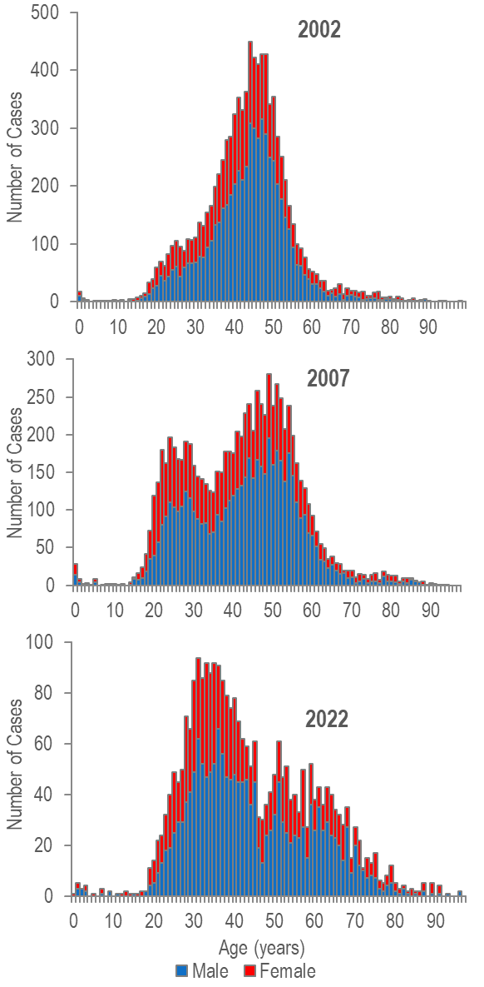
- The age distribution of hepatitis C virus (HCV) cases reported in Massachusetts changed between 2002 and 2022 with a significant increase in cases among young persons who inject drugs.
- In 2002, reported HCV cases were distributed in a curve with one age peak at 44 years.
- In 2007, reported cases of hepatitis C were distributed in a curve with two age peaks, with the lower peak at age 24 years and the higher peak at age 49 years.
- In 2022, HCV cases among young adults who inject drugs outnumbered newly reported cases among the older (“baby boomer”) age cohort.
- The proportion of cases among young adults (aged 20-39 years) was higher in 2007 (38%, N=3,178/8,259) and 2022 (46%, N=1,282/2,807) compared to 2002 (31%, N=2,802/9,039).
- The primary risk for hepatitis C infection in younger adults is injection drug use. While the primary exposure mode for HIV infection in younger adults is male-to-male sex, recent increases in the number of HIV infections attributed to injection drug use have been observed, particularly among young adults (aged 13-29 years).

MASSACHUSETTS YOUTH RISK BEHAVIOR SURVEY
Table 5. Reported sexual behaviors among Massachusetts high school students, 2013–2021
 | 2013 | 2015 | 2017 | 2019 | 2021
Percentage who reported: | %  (95% CI)  n | %  (95% CI)  n | %  (95% CI)  n | %  (95% CI)  n | %  (95% CI)  n
Ever having sexual intercourse | 38.1%  (34.3–42.0)  2,516 | 36.4%  (32.4–40.6)  2,779 | 35.3%  (31.8–39.1)  2,889 | 36.9%  (32.8–41.3)  1,946 | NA
Having sexual intercourse before age 13 | 3.0%  (2.4–3.8)  2,506 | 2.9%  (2.2–3.8)  2,793 | 2.4%  (1.6–3.4)  2,886 | 2.5%  (1.7–3.4)  1,951 | 2.7%  (2.1–3.3)  2,897
Having had sexual intercourse with 4+ partners during their life | 9.3%  (8.0–10.8)  2,508 | 7.9%  (6.2–10.0)  2,781 | 6.7%  (5.4–8.2)  2,886 | 7.8%  (6.3–9.5)  1,938 | 4.3%  (3.4–5.3)  2,883
Using a condom at last sexual intercourse | 57.6%  (52.9–62.2)  667 | 62.5%  (58.9–65.9)  766 | 57.8%  (53.1–62.3)  719 | 51.4%  (45.3–57.4)  427 | 58.0%  (52.8–63.3)  468
Drinking alcohol or using drugs before last sexual intercourse | 23.5%  (19.9–27.5)  679 | 21.8%  (18.1–26.0)  782 | 18.2%  (15.8–21.0)  631 | 23.4%  (19.5–27.9)  434 | 20.7%  (17.6–23.7)  432
Ever tested for HIV | 11.0%  (9.0–13.4)  2,659 | 9.9%  (8.0–12.2)  3,010 | 10.5%  (9.0–12.1)  3,125 | 12.6%  (10.4–15.3)  2,085 | NA
Data Source: Massachusetts Department of Elementary and Secondary Education and Massachusetts Department of Public Health, Office of Data Management and Outcomes Assessment

- The Massachusetts Youth Risk Behavior Survey (MYRBS) is performed biennially among a sample of ninth to twelfth grade students.
- From 2013 to 2021, the proportion of respondents reporting having had sexual intercourse with four or more partners during their life decreased from 9.3% to 4.3%. However, caution should be used in the interpretation of 2021 YRBS data due to the effect of the COVID-19 pandemic. COVID-19 precautions might have reduced school and student participation, although more schools were sampled in 2021 than in previous cycles. Additionally, COVID-19 may have also affected student behavior.

SPECIFIC POPULATIONS - MEN WHO HAVE SEX WITH MEN

HIV DIAGNOSIS RATE PER 100,000
Figure 36. Estimated average annual HIV diagnosis rate per 100,000 population: MSM (men who have sex with men) compared to non-MSM (males) ages 18–64 years: Massachusetts 2020–2022
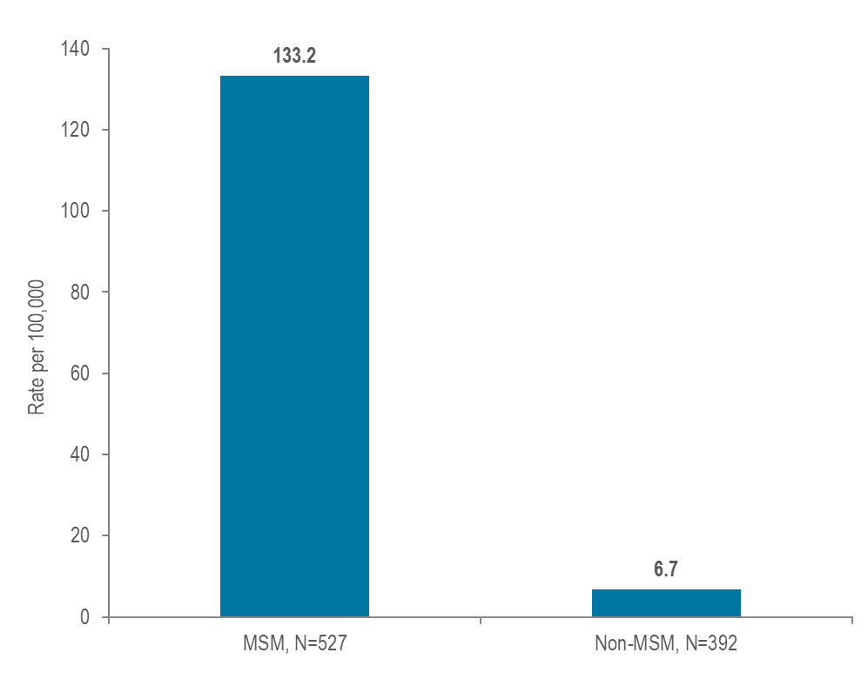

- At 133.2 per 100,000 population (95% confidence interval [CI]: 110.4–171.3 per 100,000), the estimated average rate of HIV diagnosis from 2020 to 2022 among MSM (ages 18–64 years) was 20 times the rate of infection in men who did not report sex with men (6.7 per 100,000 [95% CI: 6.6–6.8 per 100,000]).

MSM – SYPHILIS RATE PER 100,000
Figure 37. Estimated infectious syphilis rate per 100,000 population: MSM compared to non-MSM (males) ages 18–64 years: Massachusetts 2022
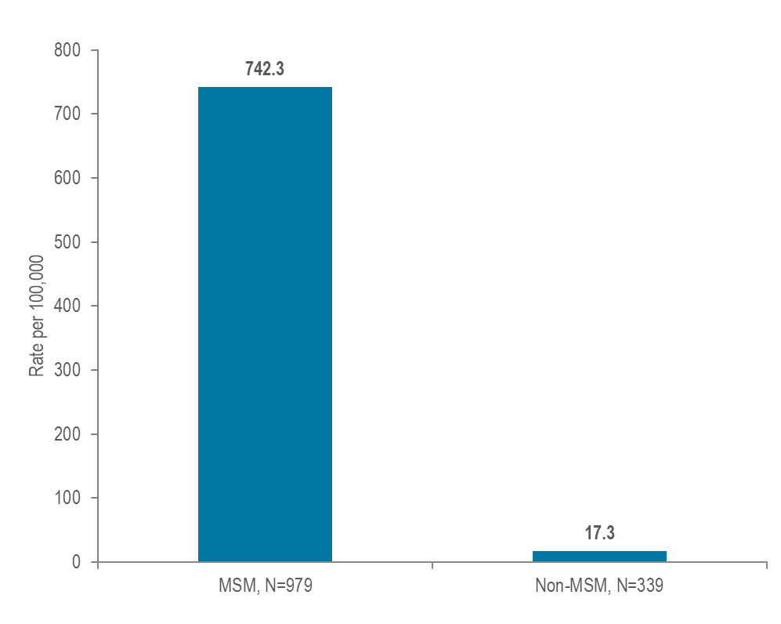
- At 742.3 per 100,000 population (95% confidence interval [CI]: 615.4–954.4 per 100,000), the estimated infectious syphilis rate in 2022³ among MSM (ages 18–64) was 43 times the rate of infection in men who did not report sex with men (17.3 per 100,000 [95% CI: 17.0–17.5 per 100,000]).

MSM – SYPHILIS/HIV CO-INFECTION
Figure 38. Number of confirmed and probable infectious syphilis cases among MSM and the percent of cases among MSM known to ever be co-infected with HIV, Massachusetts 2018–2022

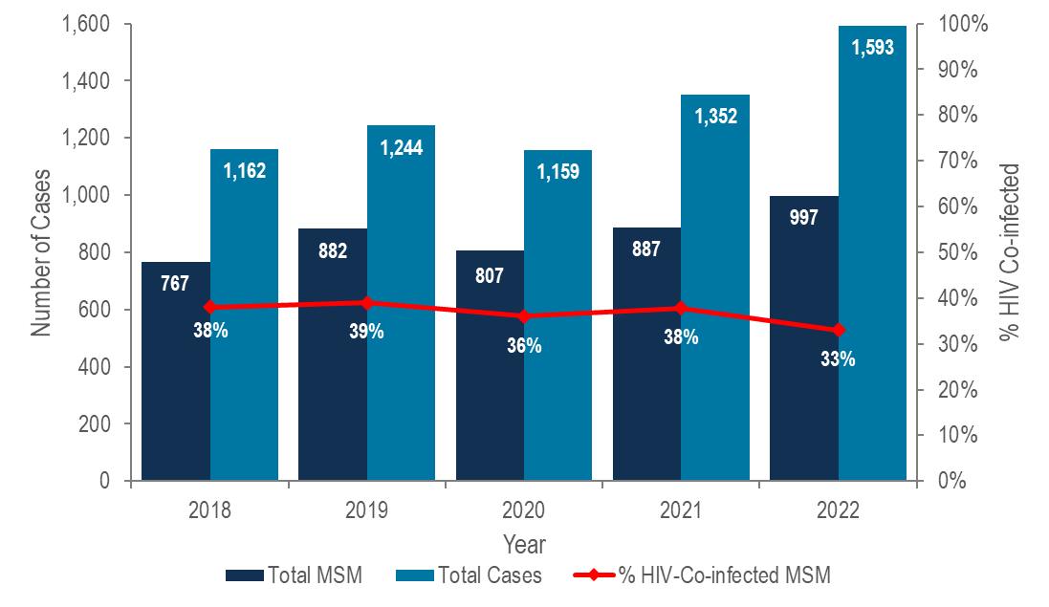

Data Source: Bureau of Infectious Disease and Laboratory Sciences, data are current as of 7/21/2023 and subject to change.

- The incidence of syphilis in Massachusetts increased by 36% in the past five years; men who have sex with men represented the majority of cases (63% in 2022).
- In 2022, 33% (N=330/997) of infectious syphilis cases among men reporting sex with men also self-reported co-infection with HIV.

MSM - SYPHILIS BY COUNTY
Figure 39. Total number of confirmed and probable infectious syphilis cases and number among MSM by county, Massachusetts 2022
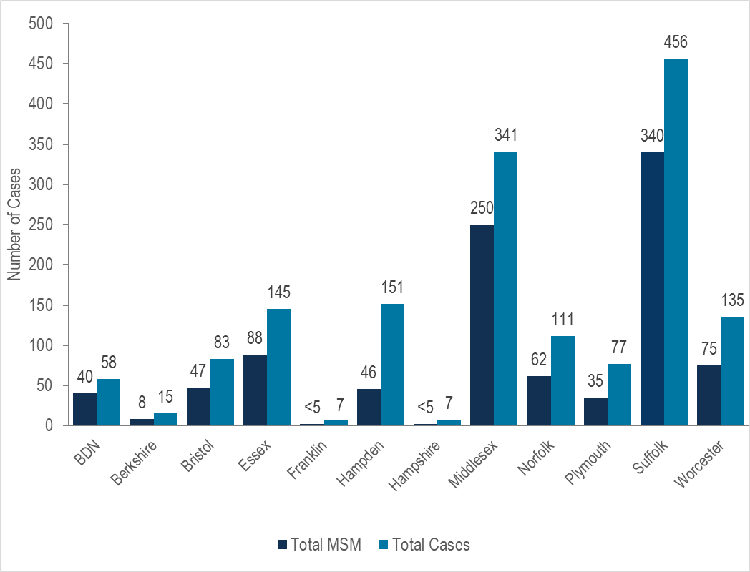
Note: MSM N=997, Other risk N=24, missing risk information N=126, total cases N=1,593 and excludes three cases with no reported county of residence.
Data Source: Bureau of Infectious Disease and Laboratory Sciences, data are current as of 7/21/2023 and subject to change.
BDN=Barnstable, Dukes and Nantucket; Counties are combined because of small numbers.

- In 2022, the largest proportions of MSM among infectious syphilis cases were reported in Suffolk (75%, N=340/456) and Middlesex (73%, N=250/341) counties.

MSM – RECENT HIV DIAGNOSES
Figure 40. HIV infection diagnoses among men reporting sex with men by race/ethnicity, age at diagnosis, and place of birth, Massachusetts 2020–2022 (N=492)
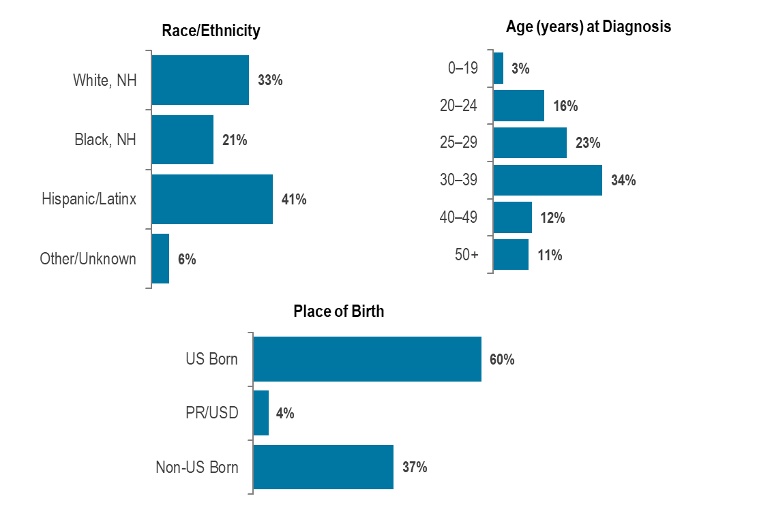
Data Source: Bureau of Infectious Disease and Laboratory Sciences, data are current as of 7/1/2023 and subject to change.
- Black (non-Hispanic) and Hispanic/Latinx individuals represented 7% and 13% of men in Massachusetts, compared to 21% and 41%, respectively, of men recently diagnosed with HIV infection with MSM exposure mode.
- Individuals with MSM exposure mode newly diagnosed with HIV infection in Massachusetts during 2020 to 2022 were predominantly in their twenties or thirties (39% 20–29 year-olds, 34% 30–39 year-olds), Hispanic/Latinx (41%) or white (non-Hispanic) (33%), and US born (60%).

MSM – SYPHILIS CASES
Figure 41. Confirmed and probable infectious syphilis cases among men reporting sex with men, by race/ethnicity and age, Massachusetts 2022 (N=997)
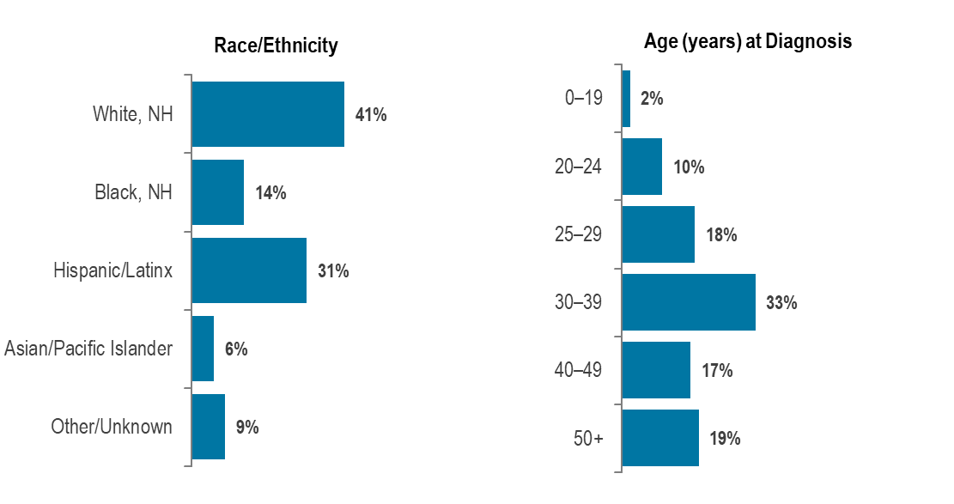
Data Source: Bureau of Infectious Disease and Laboratory Sciences, data are current as of 7/21/2023 and subject to change.
- Black (non-Hispanic) and Hispanic/Latinx individuals represented 7% and 13% of men in Massachusetts, compared to 14% and 31%, respectively, of infectious syphilis cases among men reporting sex with men in 2022.
- In 2022, infectious syphilis cases among men reporting sex with men were predominantly white (non-Hispanic) (41%), and age 30 years and above (69% 30+ year-olds).

TRENDS IN HIV EXPOSURE MODE AMONG MALES
Figure 42. Percentage distribution of individuals assigned male at birth (AMAB) diagnosed with HIV infection by exposure mode, Massachusetts 2013–2022
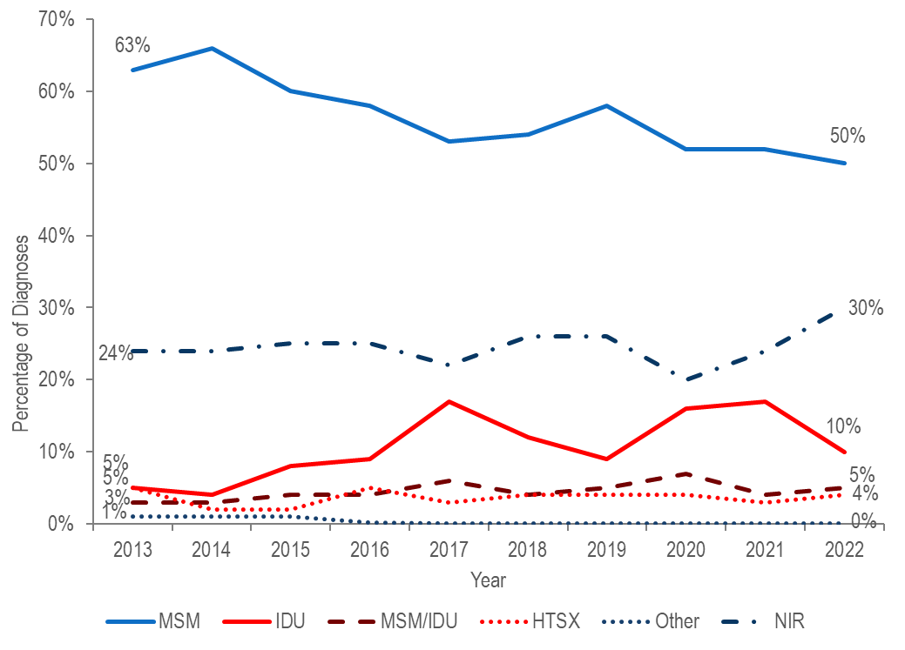
Data Source: Bureau of Infectious Disease and Laboratory Sciences, data are current as of 7/1/2023 and subject to change.
- Among individuals AMAB, the proportion of HIV infection diagnoses with male-to-male sex as the reported mode of exposure remained between 50% and 66% from 2013 to 2022. During the same time period, the proportion reported with no identified risk remained between 20% and 30%.
- The proportion of cases among individuals AMAB attributed to injection drug use increased from 4% in 2014 to a peak of 17% in 2017 and then decreased to 9% in 2019. The increase was primarily due to an outbreak among persons who inject drugs in the northeast part of the state between 2016 and 2018. Following a focused public health response, the number of HIV infection diagnoses attributed to IDU in the northeast decreased. However, in early 2019, a new cluster of HIV infection was identified in Boston among PWID who were experiencing or had experienced recent homelessness, and the proportion of HIV infection diagnoses among AMAB with IDU as the primary exposure increased again to 17% in 2021, and then decreased to 10% in 2022.

SPECIFIC POPULATIONS – PERSONS WHO INJECT DRUGS
Figure 43. Individuals diagnosed with HIV infection by exposure mode, Massachusetts 2013–2022
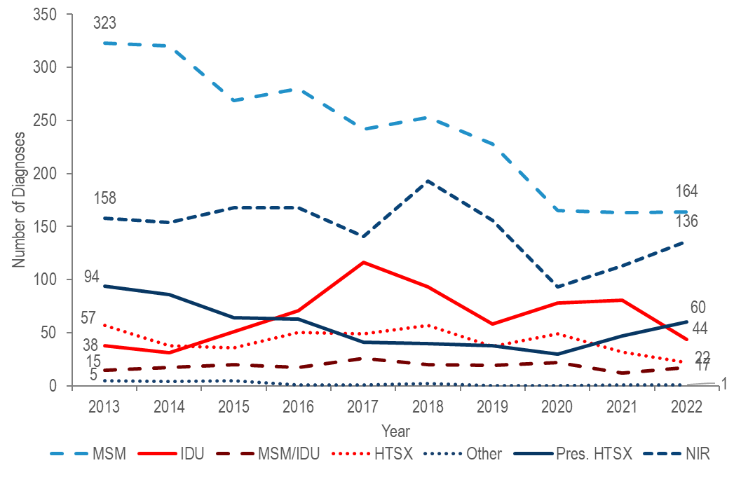
Data Source: Bureau of Infectious Disease and Laboratory Sciences, data are current as of 7/1/2023 and subject to change.
- After declining by 18% from 2013 (N=38) to 2014 (N=31), the number of reported cases with injection drug use (IDU) as the primary exposure mode peaked at 116 in 2017 then decreased to 58 in 2019. The increase was primarily due to an outbreak among persons who inject drugs (PWID) in the northeast part of the state between 2016 and 2018. Following a focused public health response, the number of HIV infection diagnoses attributed to IDU in the northeast has decreased.
- However, in early 2019, a new cluster of HIV infection was identified in Boston among PWID who were experiencing or had experienced recent homelessness, and the total statewide number of reported cases with IDU as the primary exposure increased to 81 in 2021. Following another focused public health response, the number of HIV infection diagnoses attributed to IDU decreased by 46% to 44 in 2022. As of December 31, 2022, a total of 188 cases diagnosed since November 2018 have been investigated and identified as part of the Boston cluster. As it is an active cluster of concern, additional cases will continue to be investigated and added. Emerging trends among those newly diagnosed in the Boston cluster (N=23 cases diagnosed in 2022) include an increase in polysubstance and methamphetamine use

PERSONS WHO INJECT DRUGS – RECENT HIV DIAGNOSES
Figure 44. Percentage of individuals with IDU exposure mode diagnosed with HIV infection by race/ethnicity, age, place of birth and current gender, Massachusetts 2020–2022 (N=203)
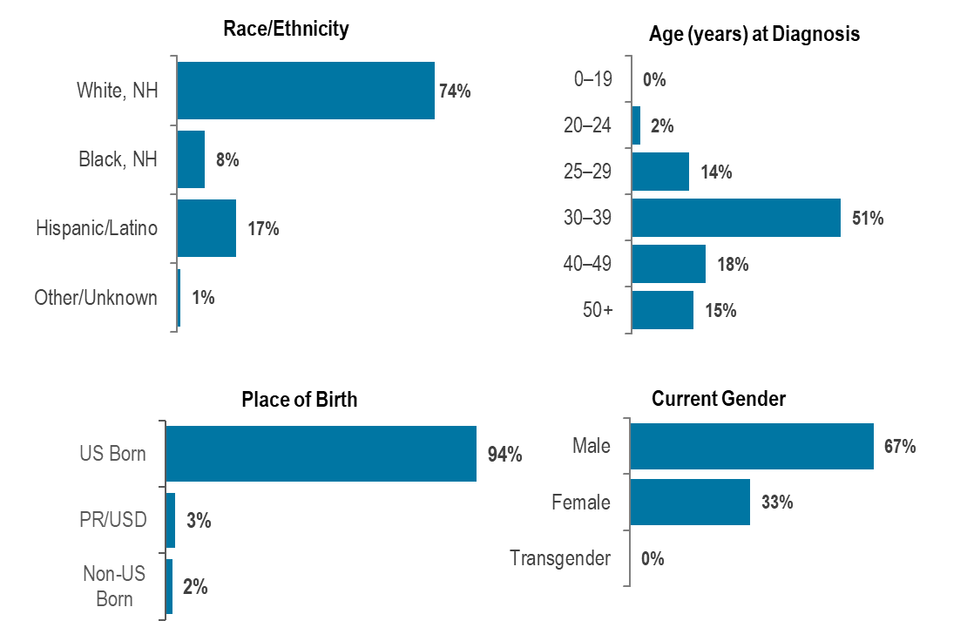
Data Source: Bureau of Infectious Disease and Laboratory Sciences, data are current as of 7/1/2023 and subject to change.

- Individuals with IDU exposure mode newly diagnosed with HIV infection in Massachusetts during 2020 to 2022 were predominantly white (non-Hispanic) (74%), between 30 and 39 years of age (51%), US born (94%), and male (67%).

DEATHS FROM ANY CAUSE AMONG INDIVIDUALS REPORTED WITH HIV BY EXPOSURE MODE
Figure 45. Deaths from any cause among individuals reported with HIV by exposure mode, Massachusetts 2022 (N=355)
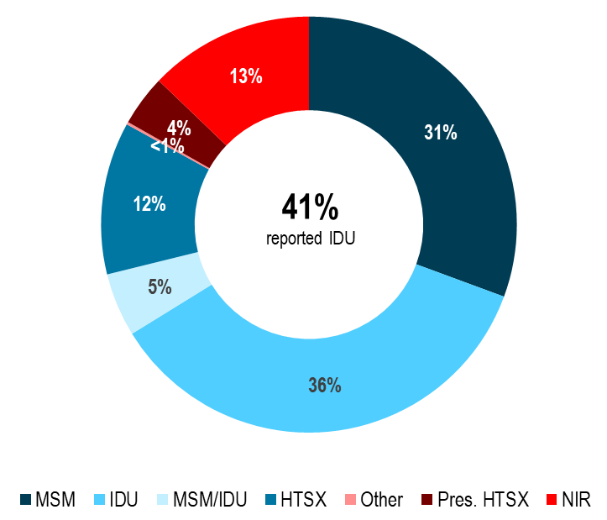
Data Source: Bureau of Infectious Disease and Laboratory Sciences, data are current as of 7/1/2023 and subject to change.

- The proportion of deaths from any cause among individuals with HIV with IDU exposure mode decreased from 42% in 2013 to 36% in 2022. At 36%, the proportion among IDU remained the largest among exposure modes in 2022, with an additional 5% reported with an exposure mode of MSM/IDU, compared to 10% and 4%, respectively, of new HIV diagnoses.

SPECIFIC POPULATIONS – RACIAL/ETHNIC MINORITIES
Figure 46. Distribution of the general population and of individuals diagnosed with confirmed and probable infectious syphilis in 2022, and HIV infection during 2020–2022 by race/ethnicity, Massachusetts

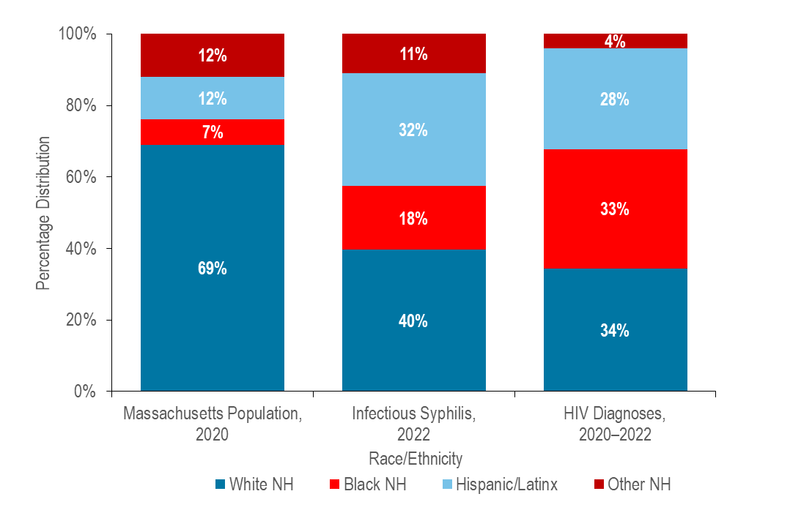Confirmed and Probable Infectious Syphilis 2022, N=1,533 and excludes 60 (4%) cases missing race/ethnicity; HIV Diagnoses 2020-2022, N=1,330
Data Source: Bureau of Infectious Disease and Laboratory Sciences, HIV data are current as of 7/1/2023, STD data are current as of 7/21/2023 and subject to change.
- In 2022, black (non-Hispanic) and Hispanic/Latinx individuals represented 7% and 12% of the total Massachusetts population and 18% and 32% of infectious syphilis cases (with known race/ethnicity), respectively.
- During 2020 to 2022, black (non-Hispanic) and Hispanic/Latinx individuals represented 33% and 28% of individuals diagnosed with HIV infection in Massachusetts, respectively.

SYPHILIS BY RACE/ETHNICITY
Figure 47. Number of confirmed and probable infectious syphilis cases reported by race/ethnicity, Massachusetts 2013–2022

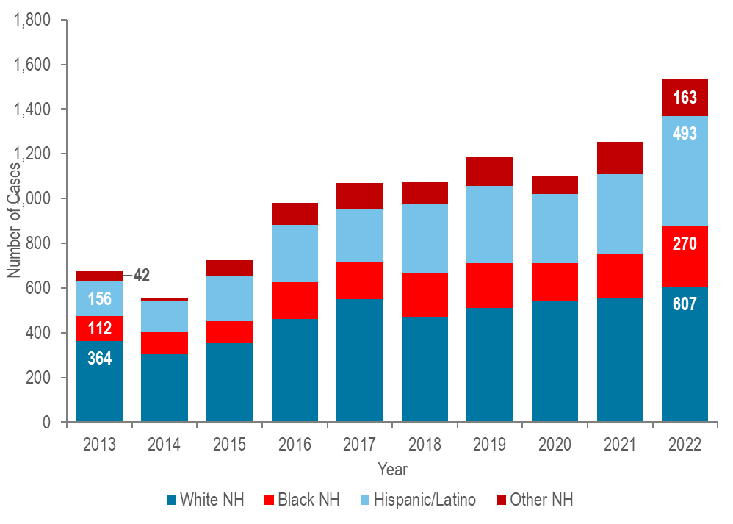

Confirmed and Probable Syphilis 2013-2022 Total N=10,155; 582 (6%) cases missing race/ethnicity are not included in this figure
Data Source: Bureau of Infectious Disease and Laboratory Sciences, data are current as of 7/21/2023 and subject to change.

- The greatest number of infectious syphilis cases was among white (non-Hispanic) individuals each year from 2013 to 2022.
- From 2013 to 2022, the greatest proportionate increase in the number of infectious syphilis cases was reported among Hispanic/Latinx individuals (more than tripled from 156 to 493), followed by black (non-Hispanic) individuals (more than doubled from 112 to 270), and white (non-Hispanic) (increased by 67% from 364 to 607).

- In 2022, the age-adjusted infectious syphilis incidence rate among black (non-Hispanic) individuals (17.5 per 100,000) and Hispanic/Latinx individuals (17.3 per 100.000) were both four times that of white (non-Hispanic) individuals (4.3 per 100,000).

HIV BY RACE/ETHNICITY
Figure 48. Average annual age-adjusted HIV diagnosis rate per 100,000 population by sex assigned at birth and race/ethnicity, Massachusetts 2020–2022 (N=1,330)
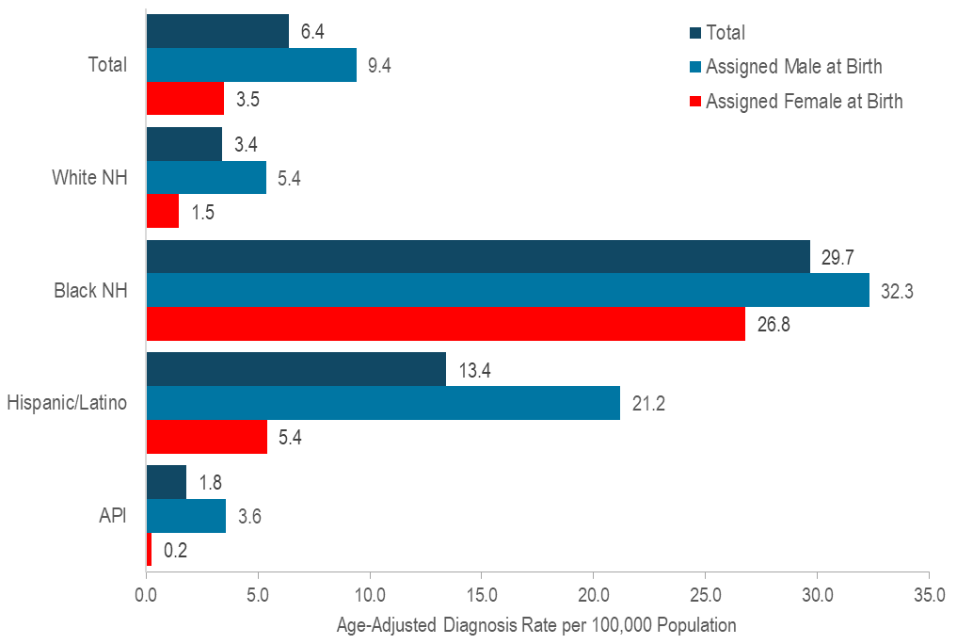
Data Source: Bureau of Infectious Disease and Laboratory Sciences, data are current as of 7/1/2023 and subject to change.
- In 2020–2022, the average annual age-adjusted HIV diagnosis rate per 100,000 population of individuals assigned male at birth (AMAB) was three times that of individuals assigned female at birth (AFAB). There were large disparities in age-adjusted HIV diagnosis rates by race/ethnicity, the average annual age-adjusted HIV diagnosis rates among:
  - black (non-Hispanic) individuals was nine times that of white (non-Hispanic) individuals,
  - Hispanic/Latinx individuals was four times that of white (non-Hispanic) individuals,
  - black (non-Hispanic) individuals AMAB, was six times that of white (non-Hispanic) individuals AMAB,
  - Hispanic/Latinx individuals AMAB was four times that of white (non-Hispanic) individuals AMAB,
  - black (non-Hispanic) individuals AFAB was 18 times that of white (non-Hispanic) individuals AFAB, and
  - Hispanic/Latinx individuals AFAB was four times that of white (non-Hispanic) individuals AFAB.

SPECIFIC POPULATIONS - WOMEN AND INFANTS
Figure 49. Distribution of confirmed chlamydia and gonorrhea cases reported by gender, Massachusetts 2022

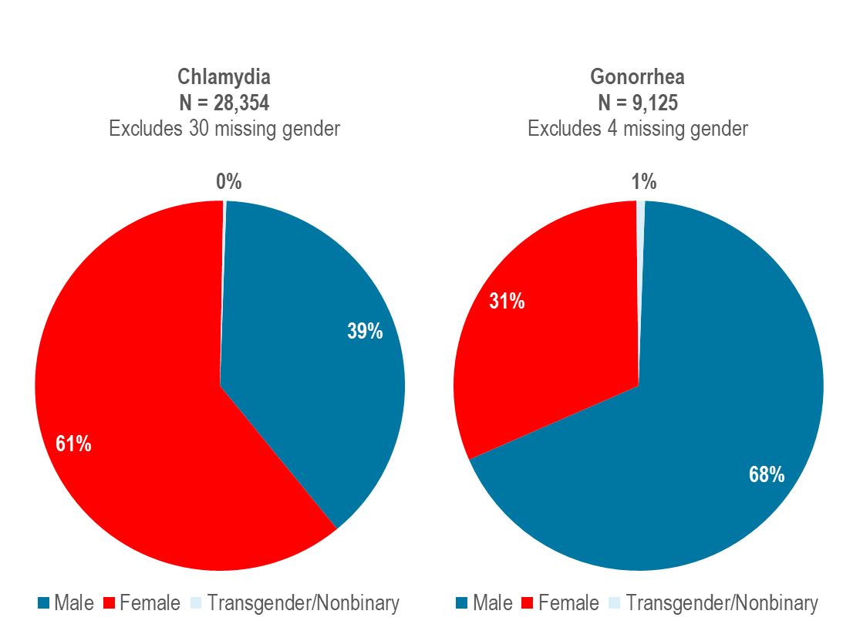

Data Source: Bureau of Infectious Disease and Laboratory Sciences, data are current as of 7/21/2023 and subject to change.

- In 2022, 61% of reported chlamydia cases were among females (N=17,351), 39% were among males (N=10,925), less than one percent (N=77) was among individuals of transgender experience, and less than one percent was reported among individuals who are nonbinary (N<5). Please note reported numbers among individuals of transgender experience and individuals who are nonbinary are likely to be underestimates as there may be underreporting or misreporting of gender due to the absence of appropriate collection of gender options (e.g., individuals who are genderqueer, pangender, gender fluid, androgynous, etc.).
In 2022, 31% of reported gonorrhea cases were among females (N=2,861), 68% were among males (N=6,196), one percent (N=66) was among individuals of transgender experience, and less than one percent was reported among individuals who are nonbinary (N<5).

WOMEN AND INFANTS – CONGENITAL SYPHILIS
Despite close follow-up of cases of syphilis in pregnant patients and their partners, breakthrough cases of congenital syphilis have increased in Massachusetts. Two syphilitic stillbirths and nine presumptive reportable cases were reported to MDPH in 2022. In 2020, MDPH released a recommendation for universal syphilis screening early in the 3rd trimester (around 27–28 weeks gestation), in addition to routine syphilis screening performed at the first prenatal visit. For more information see, Congenital Syphilis Clinical Alert, June 30, 2020, available at https://www.mass.gov/doc/congenital-syphilis-clinical-alert-6-30-2020/download
Figure 50. Number of confirmed and probable congenital syphilis cases reported by year of birth and rate of infectious syphilis per 100,000 among individuals assigned female at birth (AFAB) of child-bearing age (15–44 years), Massachusetts 2013–2022
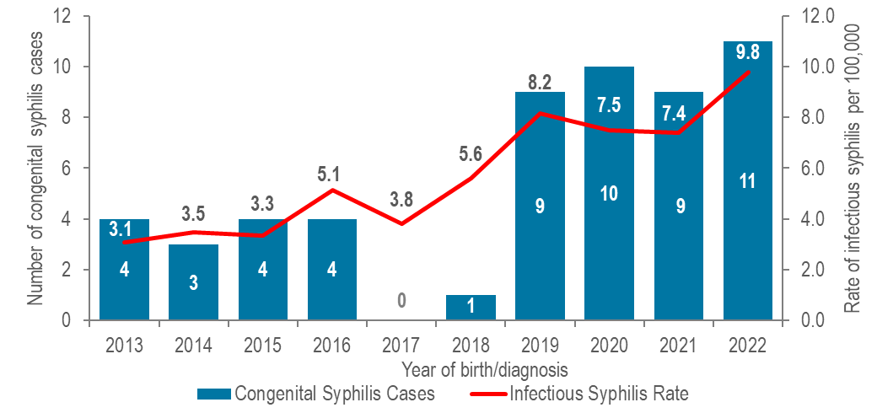
Data Source: Bureau of Infectious Disease and Laboratory Sciences, data are current as of 7/21/2023 and subject to change.
- Trends in congenital syphilis typically mirror trends in infectious syphilis among individuals AFAB of child-bearing age. In Massachusetts, as the rate of infectious syphilis among individuals AFAB of child-bearing age increased to 9.8 per 100,000 in 2022, so too did the number of probable cases of congenital syphilis (N=11).
- Nationally, the number of congenital syphilis cases reached 2,855 in 2021, with a rate of 77.9 cases per 100,000 live births, the highest rate reported since 1994. Massachusetts ranked 42nd in congenital syphilis incidence rate among the 49 states reporting congenital syphilis incidence in 2021.

WOMEN - RECENT HIV DIAGNOSES
Figure 51. Percentage of individuals assigned female at birth and diagnosed with HIV infection by race/ethnicity, age, place of birth, and exposure mode, Massachusetts 2020–2022 (N=377)
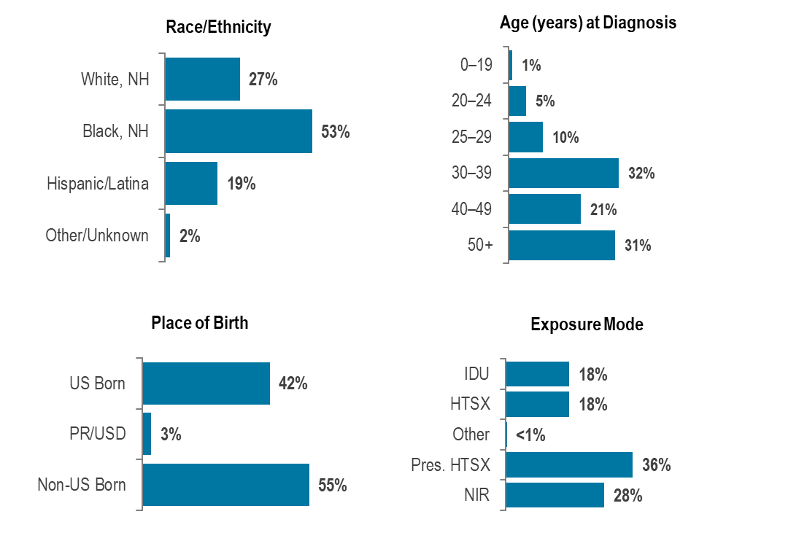
Data Source: Bureau of Infectious Disease and Laboratory Sciences, data are current as of 7/1/2023 and subject to change.
- Individuals assigned female at birth (AFAB) and newly diagnosed with HIV infection in Massachusetts during 2020–2022 were predominantly black (non-Hispanic) (53%), 30 years of age or older (32% 30–39 year-olds, 21% 40–49 year-olds, 31% 50+ year-olds), with an exposure mode of presumed heterosexual sex (36%). While presumed heterosexual sex was the leading reported exposure mode, a large percentage of new HIV diagnoses were reported with no identified risk (NIR) (28%).
- Among individuals AFAB, the proportion of HIV infection diagnoses with IDU exposure mode increased from 7% (N=12/164) in 2014 to 25% (N=40/159) in 2017, remained between 17% (2019, N=24/140) and 22% (2020, N=27/122) from 2018 through 2021, and then decreased to 10% (N=12/119) in 2022.

SPECIFIC POPULATIONS – OLDER INDIVIDUALS

STD DIAGNOSES BY AGE
Figure 52. Distribution of confirmed chlamydia, gonorrhea, and syphilis cases reported by age group (years), Massachusetts 2022
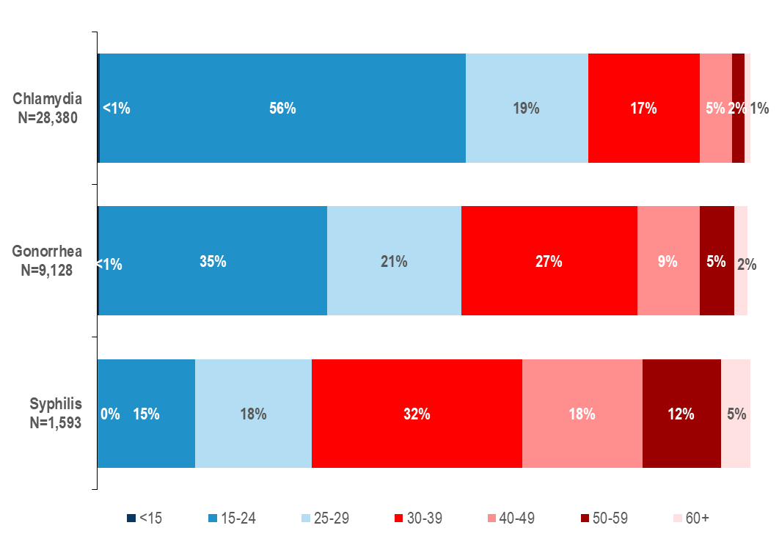
Data Source: Bureau of Infectious Disease and Laboratory Sciences, data are current as of 7/21/2023 and subject to change.
- In 2022, in Massachusetts, 1% of chlamydia cases, 2% of gonorrhea cases, and 5% of infectious syphilis cases were reported among individuals aged 60+ years. An additional 2% of chlamydia cases, 5% of gonorrhea cases, and 12% of infectious syphilis cases were reported among individuals aged 50–59 years.

STD DIAGNOSES BY AGE AND GENDER
Figure 53. Percentage of confirmed chlamydia and gonorrhea cases by age at diagnosis (<60 years vs. 60+ years) and gender, Massachusetts 2022

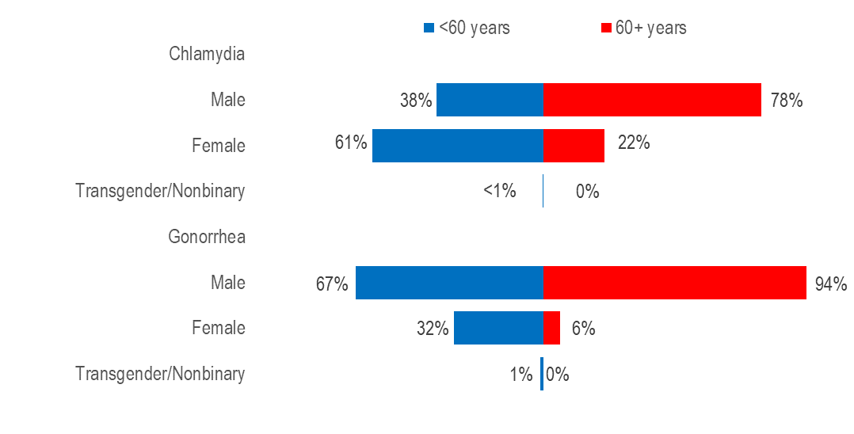
Note: 2022 chlamydia N=28,350 (<60 N=28,144; 60+ N=206) and excludes cases missing gender and/or age (N=34). 2022 gonorrhea N=9,124 (<60 N=8,919; 60+ N=205) and excludes cases missing gender and/or age (N=5).
Data Source: Bureau of Infectious Disease and Laboratory Sciences, data are current as of 7/21/2023 and subject to change.

- In 2022, a much larger proportion of chlamydia cases among individuals aged 60 years or older (78%) than aged less than 60 years (38%) was male.
- Similarly in 2022, a much larger proportion of gonorrhea cases among individuals aged 60 years or older (94%) than aged less than 60 years (67%) was male.

SYPHILIS BY AGE, GENDER, RACE/ETHNICITY, AND RISK
Figure 54. Percentage of infectious syphilis cases by age at diagnosis (<60 years vs. 60+ years), gender, race/ethnicity, and risk, Massachusetts 2022

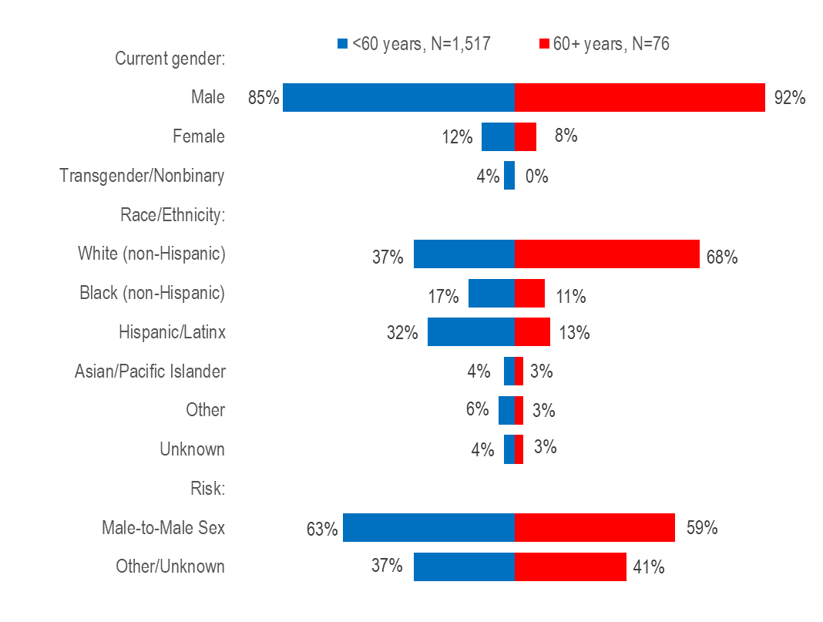
Data Source: Bureau of Infectious Disease and Laboratory Sciences, data are current as of 7/21/2023 and subject to change.
- In 2022, a slightly larger proportion of infectious syphilis cases among individuals aged 60 years or older (92%) than aged less than 60 years (85%) was male.
- A much larger proportion of infectious syphilis cases among individuals aged 60 years or older (68%) than aged less than 60 years (37%) was white non-Hispanic.
- A similar proportion of infectious syphilis cases among individuals aged 60 years or older (59%) and aged less than 60 years (63%) reported male-to-male sex.

OLDER INDIVIDUALS LIVING WITH HIV INFECTION
Figure 55. Persons living with HIV infection by expanded age category, Massachusetts 2022 (N=23,597)

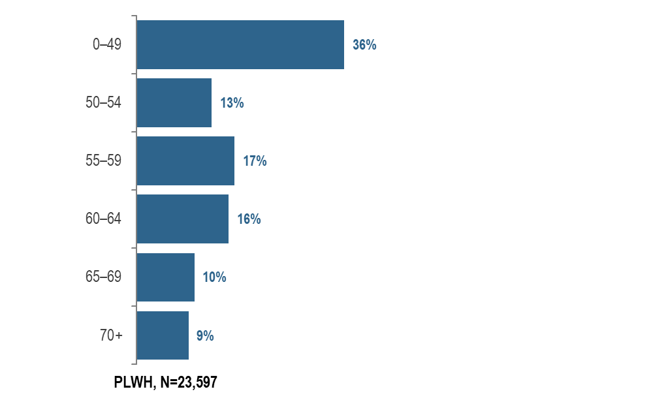

Data Source: Bureau of Infectious Disease and Laboratory Sciences, data are current as of 7/1/2023 and subject to change.

- In 2022, 19% (N=4,362) of PLWH were aged 65 years or older, the age of eligibility for Medicare for individuals without a disability.

OLDER INDIVIDUALS LIVING WITH HIV INFECTION

Figure 56. Number of years since HIV infection diagnosis among individuals aged 60 years and older living with HIV infection, Massachusetts 2022 (N=8,018)

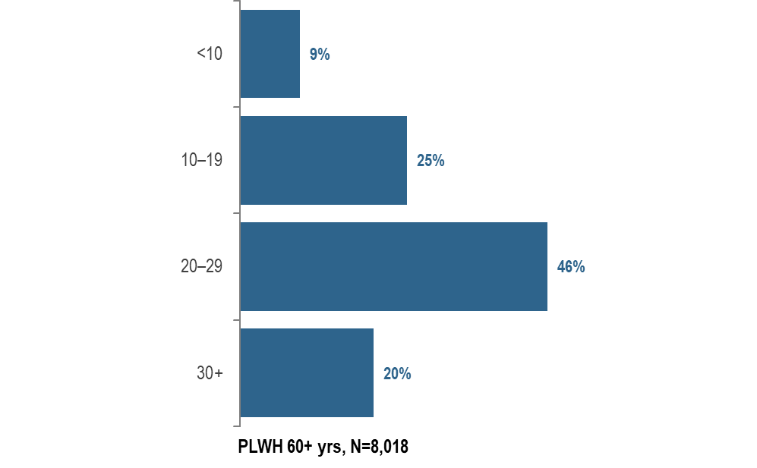
Data Source: Bureau of Infectious Disease and Laboratory Sciences, data are current as of 7/1/2023 and subject to change.

- In 2022, the majority (66%) of PLWH aged 60 years and older were diagnosed with HIV infection at least 20 years ago. The average number of years since HIV infection diagnosis among PLWH aged 60 years and older was 22.1 years.

OLDER INDIVIDUALS LIVING WITH HIV INFECTION

Figure 57. People aged 60 years and older living with HIV infection compared to people aged under 60 years by selected characteristics, Massachusetts 2022
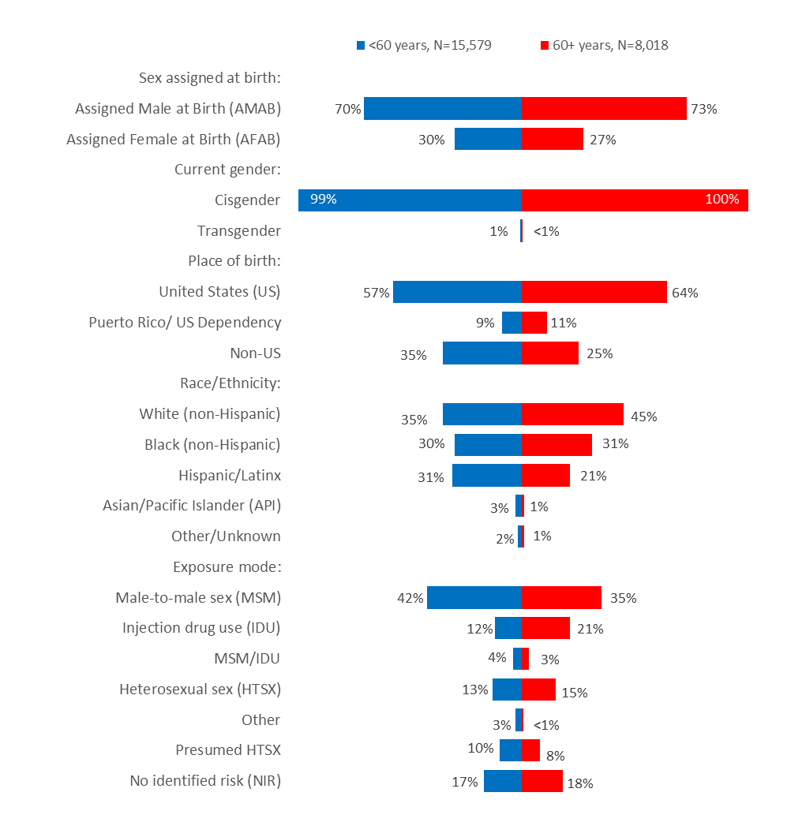

Data Source: Bureau of Infectious Disease and Laboratory Sciences, data are current as of 7/1/2023 and subject to change.

- In 2022, the distributions of people living with HIV infection by place of birth, race/ethnicity, and exposure mode varied by age:
  - A larger proportion of individuals aged 60+ years (64%) than <60 years (57%) was born in the US.
  - A larger proportion of individuals aged 60+ years (45%) than <60 years (35%) was white (non-Hispanic), and a smaller proportion was Hispanic/Latinx (21% vs. 31%).
  - A larger proportion of individuals aged 60+ years (21%) than <60 years (12%) had injection drug use exposure mode and a smaller proportion had MSM exposure mode (35% vs. 42%). However, MSM was still the most frequently reported exposure mode for both age groups.
  - The distributions of people living with HIV infection by sex assigned at birth and current gender identity were similar for both age groups in 2022.

OLDER INDIVIDUALS RECENTLY DIAGNOSED WITH HIV INFECTION
Figure 58. People aged 60 years and older diagnosed with HIV infection compared to people aged under 60 years by selected characteristics, Massachusetts 2020–2022
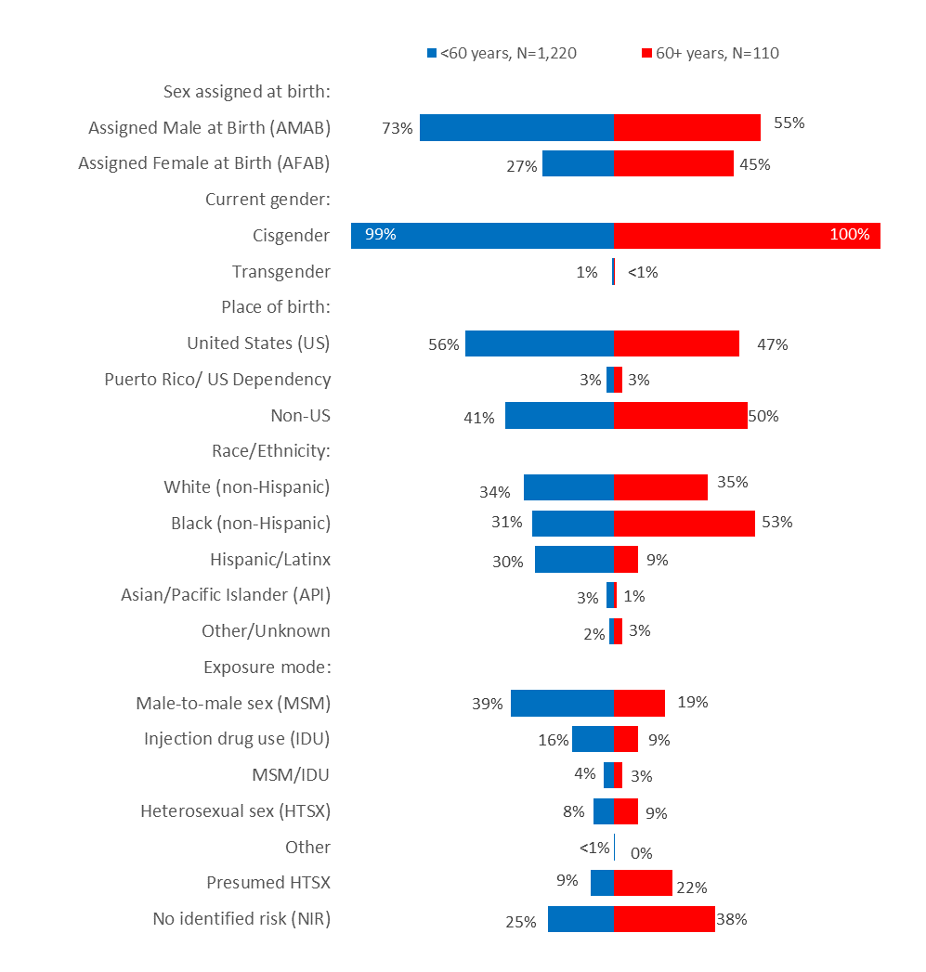

Data Source: Bureau of Infectious Disease and Laboratory Sciences, data are current as of 7/1/2023 and subject to change.

When reviewing the data presentations on people diagnosed with HIV infection at age 60+ years, please note that the ascertainment of accurate initial diagnosis date/age is often more difficult for individuals born outside the United States than those born in the United States or Puerto Rico. This is due to limited access to clinical documentation and/or less access to testing in the patient’s country of origin. Differences between younger (<60) and older (60+) individuals diagnosed with HIV infection displayed in this report may be an artefact of this data quality discrepancy rather than actual age at diagnosis.
- During 2020 to 2022, the distributions of individuals diagnosed with HIV infection by sex assigned at birth, place of birth, race/ethnicity, and exposure mode varied by age:
- A larger proportion of individuals aged 60+ years (46%) than <60 years (26%) was assigned female at birth.
- A larger proportion of individuals aged 60+ years (50%) than <60 years (41%) was born outside the US.
- A larger proportion of individuals aged 60+ years (53%) than <60 years (31%) was black (non-Hispanic).
- A larger proportion of individuals aged 60+ years (38%) than <60 years (25%) did not have exposure mode information reported that met CDC-defined categories.

STRENGTHS AND LIMITATIONS OF DATA
 | HIV/AIDS | STD | Viral Hepatitis
Description | - Collected by MDPH Bureau of Infectious Disease and Laboratory Sciences  - Reported statewide  - All laboratories and healthcare providers are required by state law to report New HIV diagnoses include only individuals who were first diagnosed in Massachusetts.  - HIV prevalence data include all individuals who were reported as residing in Massachusetts regardless of where they were first diagnosed. | - Collected by MDPH Bureau of Infectious Disease and Laboratory Sciences  - Reported statewide  - All laboratories and healthcare providers are required by state law to report.  - Includes individuals first reported as living in MA. | - Collected by MDPH Bureau of Infectious Disease and Laboratory Sciences  - Reported statewide  - All laboratories and healthcare providers are required by state law to report.  - Includes individuals first reported as living in MA.
Strengths | - Completeness of race/ethnicity data is high.  - All clinical laboratories in MA report electronically resulting in more complete and timely reporting of disease.  - Data are estimated to be 99% complete. | - All clinical laboratories in MA report electronically resulting in more complete and timely reporting of disease.  - Most infectious syphilis cases agree to interview, resulting in reasonably complete race/ethnicity and sex of sex partner data. | - All clinical laboratories in MA report electronically resulting in more complete and timely reporting of disease.
Limitations | - 2022 HIV prevalence data as of 7/1/2023 are preliminary. | - Race/ethnicity data are incomplete for gonorrhea (missing for 37% of 2022 cases) and chlamydia (missing for 46% of 2022 cases).  - Sex of sex partner is not routinely collected for gonorrhea and chlamydia cases.  - Bias is introduced for some STDs, such as chlamydia infection, where screening of asymptomatic persons occurs more frequently among women than among men. | - Race/ethnicity data are incomplete.  - Risk history data are not collected on chronic HBV cases.

Massachusetts Youth Risk Behavior Survey

Description | The Massachusetts Youth Risk Behavior Survey (MYRBS) is conducted every two years through a collaborative effort between the Massachusetts Department of Elementary and Secondary Education (ESE) and Department of Public Health (DPH) to monitor health indicators, behaviors, and risk factors contributing to the leading causes of morbidity, mortality, and social and academic problems among adolescents. For more information see https://www.mass.gov/lists/massachusetts-youth-health-survey-myhs
Strengths | A two-stage sampling method is used to produce representative samples of students in grades 9 – 12. Response rates are high.
Limitations | All data collected for the MYRBS and the MYHS are based on self-report from students. Self-reported data may be subject to error for several reasons, including inaccurate recall of events.

INTERPRETING HIV, STD, AND VIRAL HEPATITIS DATA
Hepatitis A and hepatitis B surveillance data are current as of July 6, 2023, hepatitis C data are as of August 24, 2023, HIV data are as of July 1, 2023, and STD data are as of July 21, 2023. All data are subject to change.
I. HIV Primary Exposure Mode Definitions
The HIV primary exposure mode indicates the most probable exposure associated with HIV infection. Assignment of primary exposure mode is done in accordance with Centers for Disease Control and Prevention (CDC) guidelines when multiple exposure modes are reported. Although the reported primary exposure mode is the most likely mode of transmission, there is always the possibility that it is not the actual mode of transmission. Following is a description of the exposure mode categories:
- MSM (Male-to-Male Sex): Includes all individuals assigned male at birth who report any sexual contact with other individuals that identify as male. Please note that in accordance with CDC guidelines, this category is defined by an individual’s assigned sex at birth and not an individual’s current gender identity.
  - Sex with Men: This exposure mode category is used by the Bureau of Infectious Disease and Laboratory Sciences (BIDLS) to categorize sexual risk in transgender women reporting sex with men only. For the purposes of official reporting in the MA HIV Surveillance System and to CDC, exposure mode for transgender women is based on sex assigned at birth, and therefore would be reported as male-to-male sex.
- IDU (Injection Drug Use): Cases among persons who report injection drug use.
- MSM/IDU: Includes all individuals assigned male at birth who report both injection drug use and any sexual contact with other individuals that identify as male.
  - Sex with Men/IDU: This exposure mode category is used by BIDLS to categorize sexual risk in transgender women reporting both sex with men and injection drug use. For the purposes of official reporting in the MA HIV Surveillance System and to CDC, exposure mode for transgender women is based on sex assigned at birth, and therefore would be reported as MSM/IDU.
- Heterosexual Sex: Cases among persons who report heterosexual sex with a person diagnosed with, or at increased risk for, HIV infection (e.g., a PWID). The sub-categories for this mode of transmission are listed below.
  - Heterosexual Sex w/ a person who injects drugs
  - Heterosexual Sex w/ a person diagnosed w/ HIV infection or AIDS
  - Heterosexual Sex w/ a bisexual male
  - Other Heterosexual Sex: Includes all other sub-categories of heterosexual risk, such as heterosexual contact with a person infected through a blood transfusion.
- Other: Cases among persons with other known exposure modes, including receipt of clotting factor, receipt of transfusion or transplant, and person-to-child transmission through pregnancy, childbirth, or breastfeeding (perinatal transmission).
- Presumed Heterosexual: The presumed heterosexual risk category is used by BIDLS exclusively for individuals assigned female at birth to identify HIV exposure mode when sex with individuals that identify as male was the only reported risk factor, there was no evidence of current or past injection drug use (IDU), and behavioral risk and HIV status information about sexual partners that identify as male was unknown. The rationale for the application of the presumed heterosexual risk category to individuals assigned female at birth only has been addressed in the MDPH Office of HIV report “Intersecting Risks: HIV Infection among Heterosexual Women and Men in Massachusetts” (2010).
- NIR (No Identified Risk): Cases among persons with no reported history of exposure to HIV through any of the listed exposure categories. Follow-up is conducted to determine exposure for those cases that are initially reported without an exposure mode identified. Includes cases among individuals assigned male at birth who were previously categorized in Massachusetts as Presumed Heterosexual.
II. References to Newly Diagnosed HIV Infections
Due to the extensive follow up required to verify accurate date of diagnosis, all HIV data reflect HIV infections diagnosed through 2022. Newly diagnosed HIV infections/cases include all persons diagnosed with HIV from 2020-2022, including those who were concurrently or subsequently diagnosed with AIDS. All HIV data are presented by the year of diagnosis, not the year of report.
III. Race/Ethnicity of STD and HIV Cases
Race/ethnicity references to white residents and black residents represent persons who are white (non-Hispanic) and black (non-Hispanic), respectively. All references to Hispanic/Latino for race/ethnicity represent persons of Hispanic/Latinx heritage regardless of race.
IV. STD Case Reports and Analyses
All information on STD cases reflects year of report. As of 1/1/2020, BIDLS calculates rates per 100,000 population using denominators estimated by the University of Massachusetts Donahue Institute using a modified Hamilton-Perry model. 2020 population estimates were used for single-year rates; for pooled year rates (i.e., 2020-2022), the 2020 population estimates were multiplied by three. For more information, see: Strate S, et al. Small Area Population Estimates for 2011 through 2020, report published Oct 2016, and http://www.donahue.umassp.edu/business-groups/economic-public-policy-research/massachusetts-population-estimates-program. When the proportion of STD cases with unknown values is greater than or equal to 30%, incidence trends are not presented by that variable. For instance, race/ethnicity is unknown for 46% of confirmed chlamydia cases and 37% of confirmed gonorrhea cases reported in 2022. Therefore, the number of confirmed chlamydia and gonorrhea cases by race/ethnicity are not presented in this report.
V. Cell suppression methodology:
Values one through four are suppressed for denominator populations less than 50,000 or for unknown population sizes. Additional values of zero and greater than or equal to five may be suppressed to prevent back calculation. Values less than five are not suppressed for compound categories (categories containing two or more subcategories, such as other/undetermined) because the exact population value of each subcategory cannot be determined.

HIV, STD, AND VIRAL HEPATITIS CASE CLASSIFICATIONS
In the time period of the data in this report

HIV infection
Clinical description: HIV (human immunodeficiency virus) is a retrovirus with two serologically and geographically distinct species: HIV-1 and HIV-2. It is spread via person-to-person transmission through: sexual contact, the use of HIV-contaminated needles and syringes, vertical transmission from mother to infant, or the transfusion of contaminated blood or its components. HIV attacks the body’s immune system, making the individual more likely to acquire infections or develop infection-related cancers. These opportunistic infections or cancers take advantage of the “opportunity” of a weakened immune system and may be one signal that the person has an AIDS diagnosis (acquired immunodeficiency syndrome), the advanced stage of HIV infection.
Case Classification
Confirmed: Positive HIV-1, Positive HIV-2, or Positive (Undifferentiated) HIV result from a differentiating immunoassay, Western Blot, IFA, or culture; Positive/Detected Qualitative HIV NAT (DNA or RNA); Quantitative HIV NAT (detectable viral load assay) or physician verified diagnosis.

Sexually transmitted diseases (STD)
Chlamydia trachomatis Infection (2010)
Clinical description
Infection with Chlamydia trachomatis may result in urethritis, epididymitis, cervicitis, acute salpingitis, or other syndromes when sexually transmitted; however, the infection is often asymptomatic in women. Perinatal infections may result in inclusion conjunctivitis and pneumonia in newborns. Other syndromes caused by C. trachomatis include lymphogranuloma venereum (see Lymphogranuloma Venereum) and trachoma.
Laboratory criteria for diagnosis
Isolation of C. trachomatis by culture or
Demonstration of C. trachomatis in a clinical specimen by detection of antigen or nucleic acid
Case classification
Confirmed: a case that is laboratory confirmed.
Chlamydia trachomatis Infection (2022)
Clinical Description
Chlamydia is a sexually transmitted infection that has a variable clinical course based on the serotype causing infection. Serovars D-K of C. trachomatis are the typical cause of chlamydial infections in the United States, and infection with C. trachomatis can result in urethritis, epididymitis, cervicitis, acute salpingitis, or other syndromes when sexually transmitted; however, the infection is often asymptomatic. Perinatal infections may result in inclusion conjunctivitis and pneumonia in newborns. Other syndromes caused by C. trachomatis include LGV and trachoma.
LGV is a specific type of chlamydial infection, caused by the serovars L1, L2, and L3 of C. trachomatis. Symptomatic LGV can be divided into three stages. The primary stage can include a small ulcer or lesion at the site of inoculation (genital, rectal, or oral/oropharyngeal sites). The secondary stage can include a syndrome featuring cervical, inguinal, and/or femoral lymphadenopathy that may rupture or an anorectal syndrome featuring proctocolitis (including mucoid or hemorrhagic rectal discharge, anal pain, constipation, fever, and/or tenesmus). Late stage LGV typically involves sequelae, such as genital elephantiasis, lymph node scarring, chronic colorectal fistulas and strictures, perirectal abscesses, and/or anal fissures. LGV may also be asymptomatic.
Laboratory Criteria
Demonstration of C. trachomatis in a clinical specimen by detection of antigen or nucleic acid, OR
Detection of LGV-specific antigen or nucleic acid in a clinical specimen, OR
Isolation of C. trachomatis by culture
Criteria to Distinguish a New Case from an Existing Case
For surveillance purposes, a new case of C. trachomatis infection (caused by either non-LGV or LGV serotypes) meets the following criteria:
There is no evidence of a prior C. trachomatis infection that has been reported as a case;
OR
There is evidence of a prior C. trachomatis infection that has been reported as a case, but the prior infection’s specimen collection date or treatment date was >30 days before the current infection’s specimen collection date;
OR
There is evidence of a prior C. trachomatis infection that has been reported as a case with a specimen collection date or treatment date ≤30 days from the current infection’s specimen collection date, but there is evidence of re-infection.
Case Classification
Confirmed
A case that meets laboratory evidence.
Case Classification Comments
The following provides guidance for health departments to use for the classification and notification of cases of C. trachomatis infection caused by serovars L1, L2, and L3 (also known as lymphogranuloma venereum, or LGV). Cases should be reported to the Centers for Disease Control and Prevention (CDC) through voluntary notification as C. trachomatis infection and should be marked as LGV in the CDC case report data, as defined below.
Classification of C. trachomatis infection cases to identify LGV.
Verified: a person with detection of LGV-specific antigen or nucleic acid in a clinical specimen. This includes asymptomatic cases.
Likely: a person with demonstration of C. trachomatis in a clinical specimen by detection of antigen or nucleic acid OR isolation of C. trachomatis by culture; AND who demonstrates clinical symptoms or signs consistent with LGV; AND has no negative test for LGV-specific antigen or nucleic acid in a clinical specimen.
Gonorrhea (2014)
Clinical description
A sexually transmitted infection commonly manifested by urethritis, cervicitis, proctitis, salpingitis, or pharyngitis. Infection may be asymptomatic.
Laboratory criteria for diagnosis
Observation of gram-negative intracellular diplococci in a urethral smear obtained from a male or an endocervical smear obtained from a female, or
Isolation of typical gram-negative, oxidase-positive diplococci by culture (presumptive Neisseria gonorrhoeae) from a clinical specimen, or
Demonstration of N. gonorrhoeae in a clinical specimen by detection of antigen or nucleic acid
Case classification
Probable: demonstration of gram-negative intracellular diplococci in a urethral smear obtained from a male or an endocervical smear obtained from a female.
Confirmed: a person with laboratory isolation of typical gram-negative, oxidase-positive diplococci by culture (presumptive N. gonorrhoeae) from a clinical specimen, or demonstration of N. gonorrhoeae in a clinical specimen by detection of antigen or detection of nucleic acid via nucleic acid amplification (e.g., polymerase chain reaction [PCR]) or hybridization with a nucleic acid probe.
Syphilis
Syphilis is a complex sexually transmitted disease that has a highly variable clinical course. Adherence to the following surveillance case definitions will facilitate understanding the epidemiology of this disease across the US.
Syphilis, primary (2014)
Clinical description
A stage of infection with Treponema pallidum characterized by one or more ulcerative lesions (e.g. chancre), which might differ considerably in clinical appearance.
Laboratory criteria for diagnosis
Demonstration of T. pallidum in clinical specimens by darkfield microscopy, or by PCR or equivalent direct molecular methods.
Case classification
Probable: a case that meets the clinical description of primary syphilis with a reactive serologic test (nontreponemal: Venereal Disease Research Laboratory [VDRL], rapid plasma reagin [RPR], or equivalent serologic methods; treponemal: fluorescent treponemal antibody absorbed [FTA-ABS], T. pallidum particle agglutination [TP-PA], enzyme immunoassay [EIA], chemiluminescence immunoassay [CIA], or equivalent serologic methods). These treponemal tests supersede older testing technologies, including microhemagglutination assay for antibody to T. pallidum [MHA-TP].
Confirmed: a case that meets the clinical description of primary syphilis that is laboratory confirmed.
Syphilis, primary (2018)
Clinical description
A stage of infection with Treponema pallidum characterized by one or more ulcerative lesions (e.g. chancre), which might differ considerably in clinical appearance.
Laboratory criteria for diagnosis
Confirmatory:
- Demonstration of T. pallidum by darkfield microscopy in a clinical specimen that was not obtained from the oropharynx and is not potentially contaminated by stool, OR
- Demonstration of T. pallidum by polymerase chain reaction (PCR) or equivalent direct molecular methods in any clinical specimen.
Supportive:
- A reactive nontreponemal serologic test VDRL, RPR, or equivalent serologic methods), OR
- A reactive treponemal serologic test (TP-PA, EIA, CIA], or equivalent serologic methods).*
* These treponemal tests supersede older testing technologies, including MHA-TP.
Case classification
Probable: A case that meets the clinical description of primary syphilis and the supportive laboratory criteria.
Confirmed: A case that meets the clinical description of primary syphilis and the confirmatory laboratory criteria.
Syphilis, secondary (2014)
Clinical description
A stage of infection caused by T. pallidum characterized by localized or diffuse mucocutaneous lesions (e.g., rash – such as non-pruritic macular, maculopapular, popular, or pustular lesions), often with generalized lymphadenopathy. Other symptoms can include mucous patches, condyloma lata, and alopecia. The primary ulcerative lesion may still be present. Because of the wide array of symptoms possibly indicating secondary syphilis, serologic tests for syphilis and a thorough sexual history and physical examination are crucial to determining if a case should be classified as secondary syphilis.
Laboratory criteria for diagnosis
Demonstration of T. pallidum in clinical specimens by darkfield microscopy, or by PCR or equivalent direct molecular methods.
Case classification
Probable: a case that meets the clinical description of secondary syphilis with a nontreponemal (VDRL, RPR, or equivalent serologic methods) titer ≥4 and a reactive treponemal test (FTA-ABS, TP-PA, EIA, CIA, or equivalent serologic methods).
Confirmed: a case that meets the clinical description of secondary syphilis (with at least one sign or symptom) that is laboratory confirmed.
Syphilis, secondary (2018)
Clinical description
A stage of infection caused by T. pallidum characterized by localized or diffuse mucocutaneous lesions (e.g., rash – such as non-pruritic macular, maculopapular, papular, or pustular lesions), often with generalized lymphadenopathy. Other signs can include mucous patches, condyloma lata, and alopecia. The primary ulcerative lesion may still be present.*
*Because of the wide array of symptoms and signs possibly indicating secondary syphilis, serologic tests for syphilis and a physical examination are crucial to determining if a case should be classified as secondary syphilis.
Laboratory criteria for diagnosis
Confirmatory:
- Demonstration of T. pallidum by darkfield microscopy in a clinical specimen that was not obtained from the oropharynx and is not potentially contaminated by stool, OR
- Demonstration of T. pallidum by polymerase chain reaction (PCR) or equivalent direct molecular methods in any clinical specimen.
Supportive:
- A reactive nontreponemal serologic test VDRL, RPR, or equivalent serologic methods), AND
- A reactive treponemal serologic test (TP-PA, EIA], CIA, or equivalent serologic methods).
Case classification
Probable: A case that meets the clinical description of secondary syphilis and the supportive laboratory criteria.
Confirmed: A case that meets the clinical description of secondary syphilis and the confirmatory laboratory criteria.
Syphilis, early latent (2014)
Clinical description
A subcategory of latent syphilis (a stage of infection caused by T. pallidum in which organisms persist in the body of the infected person without causing symptoms or signs) when initial infection has occurred within the previous 12 months.
Case classification
Probable: A person with no clinical signs or symptoms of syphilis who has one of the following:
- No past diagnosis of syphilis, and a reactive nontreponemal test (e.g., VDRL, RPR, or equivalent serologic methods), and a reactive treponemal test (e.g., FTA-ABS, TP-PA, EIA, CIA, or equivalent serologic methods), or
- A current nontreponemal test titer demonstrating fourfold or greater increase from the last nontreponemal test titer
AND evidence of having acquired the infection within the previous 12 months based on one or more of the following criteria:
- Documented seroconversion or fourfold or greater increase in titer of a nontreponemal test during the previous 12 months
- Documented seroconversion of a treponemal test during the previous 12 months
- A history of symptoms consistent with primary or secondary syphilis during the previous 12 months
- A history of sexual exposure to a partner within the previous 12 months who had primary, secondary, or early latent syphilis (documented independently as duration <12 months)
- Only sexual contact was within the last 12 months (sexual debut).
There is no confirmed case classification for early latent syphilis.
Syphilis, early non-primary non-secondary (2018)
Clinical description
A stage of infection caused by T. pallidum in which initial infection has occurred within the previous 12 months, but there are no signs or symptoms of primary or secondary syphilis.
Laboratory criteria for diagnosis
Supportive:
- A current nontreponemal test titer demonstrating fourfold or greater increase from the last nontreponemal test titer, unless there is evidence that this increase was not sustained for >2 weeks.
Case classification
Probable
- A person with no clinical signs or symptoms of primary or secondary syphilis who has one of the following:
- No prior history of syphilis, AND a current reactive nontreponemal test (e.g., VDRL, RPR, or equivalent serologic methods), AND a current reactive treponemal test (e.g., TP-PA, EIA, CIA, or equivalent serologic methods), OR
- A prior history of syphilis and meets the supportive laboratory criteria.
AND evidence of having acquired the infection within the previous 12 months based on one or more of the following criteria:
- Documented seroconversion or fourfold or greater increase in titer of a nontreponemal test during the previous 12 months, unless there is evidence that this increase was not sustained for >2 weeks
- Documented seroconversion of a treponemal test during the previous 12 months
- A history of symptoms consistent with primary or secondary syphilis during the previous 12 months
- Meets epidemiologic criteria
Epidemiological Criteria:
- A history of sexual exposure to a partner within the previous 12 months who had primary, secondary, or early non-primary non-secondary syphilis (documented independently as duration <12 months).
- Only sexual contact (sexual debut) was within the previous 12 months.
Syphilis, late latent (2014)
Clinical description
A subcategory of latent syphilis (a stage of infection caused by T. pallidum in which organisms persist in the body of the infected person without causing symptoms or signs) when initial infection has occurred >12 months previously.
Case classification
Probable: a person with no clinical signs or symptoms of syphilis who has one of the following:
- No past diagnosis of syphilis, and a reactive nontreponemal test (e.g., VDRL, RPR, or equivalent serologic methods), and a reactive treponemal test (e.g., FTA-ABS, TP-PA, EIA, CIA, or equivalent serologic methods), or
- A past history of syphilis therapy and a current nontreponemal test titer demonstrating fourfold or greater increase from the last nontreponemal test titer.
AND who has no evidence of having acquired the disease within the preceding 12 months (see Syphilis, early latent).
There is no confirmed case classification for late latent syphilis.
Syphilis, unknown duration or late (2018)
Clinical description
A stage of infection caused by T. pallidum in which initial infection has occurred >12 months previously or in which there is insufficient evidence to conclude that infection was acquired during the previous 12 months.
Case classification
Probable
A person with no clinical signs or symptoms of primary or secondary syphilis who meets one of the following sets of criteria:
- No prior history of syphilis, and a current reactive nontreponemal test (e.g., VDRL, RPR, or equivalent serologic methods), and a current reactive treponemal test (e.g., TP-PA, EIA, CIA, or equivalent serologic methods), OR
- A prior history of syphilis, and a current nontreponemal test titer demonstrating fourfold or greater increase from the last nontreponemal test titer, unless there is evidence that this increase was not sustained for >2 weeks, OR
- Clinical signs or symptoms and laboratory results that meet the likely or verified criteria for neurologic, ocular, otic, or late clinical manifestations syphilis (see below)
AND who has no evidence of having acquired the disease within the preceding 12 months (see Syphilis, early non-primary non-secondary)
Comments
Although cases of syphilis of unknown duration are grouped together with late syphilis for the purposes of surveillance, the conservative clinical and public health responses to these cases will differ when there is uncertainty about the duration of infection. When faced with uncertainty, clinicians should act conservatively and treat unknown duration syphilis as if it were late infection, with three doses of benzathine penicillin. In contrast, the most conservative approach for STD control programs would be to manage cases of syphilis of unknown duration as early non-primary non-secondary infections and search for partners who may have been recently infected. Because this would not be feasible for most STD control programs, programs should consider prioritizing cases of syphilis of unknown duration with higher nontreponemal titers (e.g., 1:32 or higher) for investigation and partner services. Although nontreponemal titers cannot reliably distinguish between early infection (<12 months duration) and late infection (>12 months duration), nontreponemal titers usually are higher early in the course of syphilis infection.
Syphilis, Congenital (2015)
Clinical description
A condition caused by infection in utero with T. pallidum. A wide spectrum of severity exists, from inapparent infection to severe cases that are clinically apparent at birth. An infant or child (aged less than 2 years) may have signs such as hepatosplenomegaly, rash, condyloma lata, snuffles, jaundice (nonviral hepatitis),
pseudoparalysis, anemia, or edema (nephrotic syndrome and/or malnutrition). An older child may have stigmata (e.g., interstitial keratitis, nerve deafness, anterior bowing of shins, frontal bossing, mulberry molars, Hutchinson teeth, saddle nose, rhagades, or Clutton joints).
Laboratory criteria for diagnosis
- Demonstration of T. pallidum by darkfield microscopy of lesions, body fluids, or neonatal nasal discharge, or
- PCR or other equivalent direct molecular methods of lesions, placenta, umbilical cord, or autopsy material, or
- Immunohistochemistry (IHC), or special stains (e.g., silver staining) of specimens from lesions, neonatal nasal discharge, placenta, umbilical cord, or autopsy material.
Case classification
Probable: a condition affecting an infant whose mother had untreated or inadequately treated* syphilis at delivery, regardless of signs in the infant, or an infant or child who has a reactive non-treponemal test for syphilis (VDRL, RPR, or equivalent serologic methods) AND any one of the following:
- Any evidence of congenital syphilis on physical examination (see Clinical description)
- Any evidence of congenital syphilis on radiographs of long bones
- A reactive cerebrospinal fluid (CSF) VDRL test
- In a nontraumatic lumbar puncture, an elevated CSF leukocyte (white blood cell [WBC]) count or protein (without other cause):
* Adequate treatment is defined as completion of a penicillin-based regimen, in accordance with CDC treatment guidelines, appropriate for stage of infection, initiated 30 or more days before delivery.
Suggested parameters for abnormal CSF WBC and protein values:
- During the first 30 days of life, a CSF WBC count of >15 WBC/mm3 or a CSF protein >120 mg/dL.
- After the first 30 days of life, a CSF WBC count of >5 WBC mm3 or a CSF protein >40 mg/dL, regardless of CSF serology.
- The treating clinician should be consulted to interpret the CSF values for the specific patient.
Confirmed: a case that is laboratory confirmed.
Syphilis, Congenital (2018)
Clinical Description
A condition caused by infection in utero with Treponema pallidum. A wide spectrum of severity exists, from inapparent infection to severe cases that are clinically apparent at birth. An infant or child (aged less than 2 years) may have signs such as hepatosplenomegaly, rash, condyloma lata, snuffles, jaundice (nonviral hepatitis), pseudoparalysis, anemia, or edema (nephrotic syndrome and/or malnutrition). An older child may have stigmata (e.g., interstitial keratitis, nerve deafness, anterior bowing of shins, frontal bossing, mulberry molars, Hutchinson teeth, saddle nose, rhagades, or Clutton joints).
Laboratory Criteria for Diagnosis
Demonstration of Treponema pallidum by:
- Darkfield microscopy of lesions, body fluids, or neonatal nasal discharge, OR
- PCR or other equivalent direct molecular methods of lesions, neonatal nasal discharge, placenta, umbilical cord, or autopsy material, OR
- IHC, or special stains (e.g., silver staining) of specimens from lesions, placenta, umbilical cord, or autopsy material.
Case Classification
Probable
A condition affecting an infant whose mother had untreated or inadequately treated* syphilis at delivery, regardless of signs in the infant, OR an infant or child who has a reactive non-treponemal test for syphilis (VDRL, RPR, OR equivalent serologic methods) AND any one of the following:
- Any evidence of congenital syphilis on physical examination (see Clinical description)
- Any evidence of congenital syphilis on radiographs of long bones
- A reactive CSF venereal disease research laboratory test (VDRL) test
- In a non-traumatic lumbar puncture, an elevated CSF leukocyte (white blood cell, WBC) count or protein (without other cause):
- Suggested parameters for abnormal CSF WBC and protein values:
- During the first 30 days of life, a CSF WBC count of >15 WBC/mm3 or a CSF protein >120 mg/dl is abnormal.
- After the first 30 days of life, a CSF WBC count of >5 WBC/mm3 or a CSF protein >40 mg/dl, regardless of CSF serology.
The treating clinician should be consulted to interpret the CSF values for the specific patient.
*Adequate treatment is defined as completion of a penicillin-based regimen, in accordance with CDC treatment guidelines, appropriate for stage of infection, initiated 30 or more days before delivery.
Confirmed
A case that is laboratory confirmed.
Comments
Congenital and acquired syphilis may be difficult to distinguish when a child is seropositive after infancy. Signs of congenital syphilis may not be obvious, and stigmata may not yet have developed. Abnormal values for CSF VDRL, WBC count, and protein may be found in either congenital or acquired syphilis. Findings on radiographs of long bones may help because radiographic changes in the metaphysis and epiphysis are considered classic signs of congenitally acquired syphilis. While maternal antibodies can complicate interpretation of serologic tests in an infant, reactive tests past 18 months of age are considered to reflect the status of the child. The decision may ultimately be based on maternal history and clinical judgment. In a young child, the possibility of sexual abuse should be considered as a cause of acquired rather than congenital syphilis, depending on the clinical picture. For reporting purposes, congenital syphilis includes cases of congenitally acquired syphilis among infants and children as well as syphilitic stillbirths.

Viral Hepatitis
Hepatitis is inflammation of the liver. It can impair vital liver functions such as processing nutrients, filtering the blood and fighting infection. Viral hepatitis is inflammation of the liver caused by infection with a virus. In Massachusetts, the most common types of viral hepatitis are hepatitis A, hepatitis B and hepatitis C. Non-viral hepatitis can also result from heavy alcohol use, toxins, some medications, and certain medical conditions.
Hepatitis A, Acute (2019)
Clinical Criteria - An acute illness with a discrete onset of any sign or symptom consistent with acute viral hepatitis (e.g., fever, headache, malaise, anorexia, nausea, vomiting, diarrhea, abdominal pain, or dark urine)
AND
a) jaundice or elevated total bilirubin levels ≥ 3.0 mg/dL, OR
b) elevated serum alanine aminotransferase (ALT) levels >200 IU/L,
AND
c) the absence of a more likely diagnosis
Laboratory Criteria for Diagnosis
Confirmatory laboratory evidence:
- Immunoglobulin M (IgM) antibody to hepatitis A virus (anti-HAV) positive,
OR
- Nucleic acid amplification test (NAAT; such as Polymerase Chain Reaction [PCR] or genotyping) for hepatitis A virus RNA positive
Epidemiologic Linkage
Contact (e.g., household or sexual) with a laboratory-confirmed hepatitis A case 15-50 days prior to onset of symptoms.
Criteria to Distinguish a New Case from an Existing Case
Hepatitis A is usually self-limiting and does not result in chronic infection. However, up to 10% of persons with hepatitis A may experience a relapse during the 6 months after acute illnesses. Cases of relapsing hepatitis A should not be enumerated as new cases. In addition, a case should not be counted as a hepatitis A case if there is an alternate, more likely diagnosis.
Case Classification
Confirmed:
- A case that meets the clinical criteria and is IgM anti-HAV positive §, OR
- A case that has hepatitis A virus RNA detected by NAAT (such as PCR or genotyping), OR
- A case that meets the clinical criteria and occurs in a person who had contact (e.g., household or sexual) with a laboratory-confirmed hepatitis A case 15-50 days prior to onset of symptoms.
§ And not otherwise ruled out by IgM anti-HAV or NAAT for hepatitis A virus testing performed in a public health laboratory.
Hepatitis B, Chronic (2012)
Confirmed:
IgM antibodies to hepatitis B core antigen (IgM anti-HBc) negative
AND
A positive result on one of the following tests: hepatitis B surface antigen (HBsAg), hepatitis B e antigen (HBeAg), or nucleic acid test for hepatitis B virus DNA (including qualitative, quantitative and genotype testing),
OR
HBsAg positive or nucleic acid test for hepatitis B virus DNA (including qualitative, quantitative and genotype testing), or HBeAg positive two times at least 6 months apart (Any combination of these tests performed 6 months apart is acceptable.)
Probable:
A case with a single HBsAg positive or HBV DNA positive (including qualitative, quantitative and genotype testing), or HBeAg positive lab result when no IgM anti-HBc results are available
Hepatitis B, Acute (2012)
Clinical Presentation: An acute illness with a discrete onset of symptoms consistent with acute viral hepatitis (e.g., fever, headache, malaise, anorexia, nausea, vomiting, diarrhea, and abdominal pain) and either a) jaundice or b) elevated serum alanine aminotransferase levels > 100 IU/L
Confirmed:
Clinically compatible case* not known to have chronic hepatitis B and
HBsAg positive
AND
IgM antibody to hepatitis B core antigen (IgM anti– HBc) positive, if done *
A documented negative hepatitis B surface antigen (HBsAg) laboratory test result within 6 months prior to a positive test (either HBsAg, Hepatitis B “e” antigen (HBeAg), or hepatitis B virus nucleic acid testing (HBV NAT) including genotype) result does NOT require an acute clinical presentation to meet the surveillance case definition.
Suspect:
Positive IgM antibody to hepatitis B core antigen (IgM anti-HBc) that does not meet the clinical definition
Note that the year into which a case is categorized is based upon the case’s “Event Date”, which is assigned by the following case characteristics, in decreasing order of specificity, dependent on availability of information: symptom onset date, specimen collection date, diagnosis date, or case report date
Hepatitis C, Acute (2012)
Clinical description – An acute illness with a discrete onset of any sign or symptom consistent with acute viral hepatitis (e.g. fever, headache, malaise, anorexia, nausea, vomiting, diarrhea, and abdominal pain), and either a) jaundice, or b) elevated ALT levels >400 IU/L. A documented negative HCV antibody laboratory test result followed within 6 months by a positive test result does not require an acute clinical presentation to meet the surveillance case definition.
Laboratory criteria for diagnosis – One or more of the following three criteria (except in persons less than 18 months of age, for whom only the third criterion would meet the case classification criteria):
- Anti-HCV screening-test-positive with a signal to cut-off ratio predictive of a true positive as determined for the particular assay as defined by CDC, or
- HCV recombinant immunoblot assay positive, or
- Nucleic acid test (NAT) for HCV RNA positive (including qualitative, quantitative, or genotype testing) and, if done meets the following two criteria:
- Absence of IgM antibody to hepatitis A virus
- Absence of IgM antibody to hepatitis B core antigen
Confirmed – A case that meets the clinical case definition, is laboratory confirmed, and is not known to have chronic hepatitis C.
Hepatitis C, Past or Present (2012)
Laboratory criteria for diagnosis – One or more of the following three criteria (except in persons less than 18 months of age, for whom only the third criterion would meet the case classification criteria):
- Anti-HCV screening-test-positive with a signal to cut-off ratio predictive of a true positive as determined for the particular assay as defined by CDC, or
- HCV recombinant immunoblot assay positive, or
- NAT for HCV RNA positive (including qualitative, quantitative, or genotype testing)
Probable – A case that does not meet the case definition for acute hepatitis C, is anti-HCV positive (repeat reactive) by EIA, and has ALT values above the upper limit of normal, but the anti-HCV EIA result has not been verified by an additional more specific assay or the signal to cut-off ratio is unknown.
Confirmed – A case that is laboratory confirmed and does not meet the case definition for acute hepatitis C.
Hepatitis C, Acute (2016)
Clinical criteria – An illness with discrete onset of any sign or symptom consistent with viral hepatitis (e.g. fever, headache, malaise, anorexia, nausea, vomiting, diarrhea, and abdominal pain) and a) jaundice or b) a peak elevated serum ALT level >200 IU/L during the period of acute illness.
Laboratory criteria for diagnosis
- A positive test for antibodies to HCV
- HCV detection test: NAT for HCV RNA positive, including qualitative, quantitative, or genotype testing
- A positive test indicating presence of HCV antigen when and if a test for HCV antigen is approved by FDA and available
Probable – A case that meets clinical criteria and has a positive anti-HCV antibody test, but has no reports of a positive HCV NAT or positive HCV antigen tests and does not have test seroconversion within 12 months or has no report of test conversion.
Confirmed – A case that meets clinical criteria and has a positive HCV NAT or HCV antigen, or a documented negative HCV antibody, HCV antigen or NAT laboratory test result followed within 12 months by a positive result of any of these tests (test conversion).
Hepatitis C, Chronic (2016)
Laboratory criteria for diagnosis
- A positive test for antibodies to HCV
- HCV detection test: NAT for HCV RNA positive, including qualitative, quantitative, or genotype testing
- A positive test indicating presence of HCV antigen when and if a test for HCV antigen is approved by FDA and available
Probable – A case that does not meet clinical criteria or has no report of clinical criteria, and does not have test conversion within 12 months or has no report of test conversion, and has a positive anti-HCV antibody test, but no report of a positive HCV NAT or positive HCV antigen test.
Confirmed – A case that does not meet clinical criteria or has no report of clinical criteria, and does not have test conversion within 12 months or has no report of test conversion, and has a positive HCV NAT or HCV antigen test.
Hepatitis C, Acute (2020)
Clinical Criteria

All hepatitis C virus cases in each classification category should be > 36 months of age, unless known to have been exposed non-perinatally.
One or more of the following:
- Jaundice, OR
- Peak elevated total bilirubin levels ≥ 3.0 mg/dL, OR
- Peak elevated serum ALT levels >200 IU/L,
AND
The absence of a more likely diagnosis (which may include evidence of acute liver disease due to other causes or advanced liver disease due to pre-existing chronic Hepatitis C virus (HCV) infection or other causes, such as alcohol exposure, other viral hepatitis, hemochromatosis, etc.)

Laboratory Criteria

Confirmatory laboratory evidence:
- Positive hepatitis C virus detection test: NAT for HCV RNA positive (including qualitative, quantitative, or genotype testing), OR
- A positive test indicating presence of hepatitis C viral antigen(s) (HCV antigen)
Presumptive laboratory evidence:
- A positive test for antibodies to hepatitis C virus (anti-HCV)

Epidemiologic Linkage

No epidemiologic linkage is required for case classification.

Criteria to Distinguish a New Case from an Existing Case

A new acute case is an incident case that is over the age of 36 months and has not previously been reported meeting case criteria for chronic hepatitis C or for whom there is laboratory evidence of re-infection. Cases under the age of 36 months should be classified under the Perinatal HCV Position Statement (17-ID-08) unless the exposure mode is not perinatal (e.g., healthcare acquired).
All jurisdictions are encouraged to track negative HCV viral detection tests to document both spontaneous clearance of infection or sustained viral response to HCV treatment. Cases that have evidence of having cleared the infection at time of initial report or are considered false positive should not be reported to CDC.

Acute cases determined via anti-HCV test conversion do not need to have a positive HCV viral detection test reported to be considered confirmed acute cases.

A new probable acute case may be reclassified as confirmed acute if a positive HCV viral detection test is reported in the same reporting year (e.g. prior to CDC closing reporting for the calendar year).
Collection of risk history data is recommended for probable and confirmed acute HCV cases. Timing of risk history data to collect ranges from 2 weeks to 12 months prior to symptom onset or diagnosis. The time frame to employ depends on the method of classification (e.g. if a case meets clinical criteria and has a positive HCV detection test, a risk history time frame of 2 weeks to 6 months prior to onset should be used; for a case classified via anti-HCV test conversion or HCV RNA test conversion, 2 weeks to 12 months prior to onset should be considered).

If evidence indicating resolution of infection is received after a confirmed acute case has been reported to CDC, the case report does not need to be modified as it was a confirmed case at the time of initial report. However, negative HCV viral detection test results received on confirmed acute case, subsequent to an initial positive result, should be appended to case reports, as feasible, and considered for the purpose of data analysis by each jurisdiction.
For probable acute cases, the presence of a negative HCV viral detection test result, in the absence of criteria that would allow for confirmation, indicates that a case should not be classified as probable acute and should not be reported to CDC.

A confirmed acute case may be classified as a confirmed chronic case if a positive HCV viral detection test is reported one year or longer after acute case onset. A confirmed acute case may not be reported as a probable chronic case (i.e. HCV antibody positive, but with an unknown HCV viral detection test). For purposes of incidence and prevalence calculations, confirmed acute and chronic HCV cases should be counted.

Case Classification

Probable
- A case that meets clinical criteria and has presumptive laboratory evidence,
AND
- Does not have a hepatitis C virus detection test reported,
AND
- Has no documentation of anti-HCV or HCV RNA test conversion within 12 months,
Confirmed
- A case that meets clinical criteria and has confirmatory laboratory evidence,
OR
- A documented negative HCV antibody followed within 12 months by a positive HCV antibody test (anti-HCV test conversion) in the absence of a more likely diagnosis,
OR
- A documented negative HCV antibody OR negative hepatitis C virus detection test (in someone without a prior diagnosis of HCV infection) followed within 12 months by a positive hepatitis C virus detection test (HCV RNA test conversion) in the absence of a more likely diagnosis.

Hepatitis C, Chronic (2020)
Clinical Criteria - All hepatitis C virus cases in each classification category should be > 36 months of age, unless known to have been exposed non-perinatally.
One or more of the following:
•Jaundice, OR
•Peak elevated total bilirubin levels ≥ 3.0 mg/dL, OR
•Peak elevated serum ALT levels >200 IU/L,
AND
The absence of a more likely diagnosis (which may include evidence of acute liver disease due to other causes or advanced liver disease due to pre-existing chronic Hepatitis C virus (HCV) infection or other causes, such as alcohol exposure, other viral hepatitis, hemochromatosis, etc.)
Laboratory Criteria
Confirmatory laboratory evidence:
•Positive hepatitis C virus detection test: NAT for HCV RNA positive (including qualitative, quantitative, or genotype testing), OR
•A positive test indicating presence of hepatitis C viral antigen(s) (HCV antigen)
Presumptive laboratory evidence:
•A positive test for antibodies to hepatitis C virus (anti-HCV)
Epidemiologic Linkage - No epidemiologic linkage is required for case classification.
Criteria to Distinguish a New Case from an Existing Case
All jurisdictions are encouraged to track negative HCV viral detection tests to document both spontaneous clearance of infection or sustained viral response to HCV treatment. Cases that have evidence of having cleared the infection at time of initial report or are considered false positive should not be reported to CDC.

If evidence indicating resolution of infection is received after a confirmed chronic case has been reported to CDC, the case report does not need to be modified as it was a confirmed case at the time of initial report. However, negative HCV viral detection test results received on confirmed chronic cases, subsequent to an initial positive result, should be appended to case reports, as feasible, and considered for the purpose of data analysis by each jurisdiction.

Evidence for re-infection may include a case of confirmed chronic HCV infection that has at least two sequential negative HCV viral detection tests reported, indicative of treatment initiation and sustained virologic response, followed by a positive HCV viral detection test. Under current treatment recommendations, those two negative tests should be at least three months apart, however, the timing may change as standard of care for HCV treatment evolves. Other evidence of reinfection should be considered, including a report of a new genotype on a case that has previously cleared a different genotype. Jurisdictions are encouraged to ensure that cases of HCV treatment failure are not classified as new cases of HCV infection to the extent that it can be determined. Jurisdictions tracking re-infection should also consider collecting data on prior treatment completion (when relevant and possible to document), treatment failure, change in reported genotype if that applies, and the known time frame for reinfection.

For probable chronic cases, the presence of a negative HCV viral detection test result, in the absence of criteria that would allow for confirmation, indicates that a case should not be classified as probable chronic and should not be reported to CDC.

A new chronic case is a newly reported case that does not have evidence of being an acute case of HCV infection. A confirmed acute case may be classified as a confirmed chronic case if a positive HCV viral detection test is reported one year or longer after acute case onset. A confirmed acute case may not be reported as a probable chronic case (i.e. HCV antibody positive, but with an unknown HCV viral detection test). For purposes of incidence and prevalence calculations, confirmed chronic HCV cases should be counted.

Jurisdictions are also encouraged to track and classify possible re-infection cases that may have been previously submitted to CDC as a confirmed or probable chronic HCV infection case. Jurisdictions tracking re-infection should also consider collecting data on prior treatment completion (when relevant and possible to document), treatment failure, change in reported genotype if that applies, and the known time frame for reinfection.

Case Classification
Suspect
NUL
Probable
•A case that does not meet OR has no report of clinical criteria,
AND
•Has presumptive laboratory evidence,
AND
•Has no documentation of anti-HCV or RNA test conversion within 12 months,
AND
•Does not have an HCV RNA detection test reported.
Confirmed
•A case that does not meet OR has no report of clinical criteria,
AND
•Has confirmatory laboratory evidence,
AND
•Has no documentation of anti-HCV or HCV RNA test conversion within 12 months.

HIV, STD, AND VIRAL HEPATITIS PROGRAM STAFF CONTACT INFORMATION
Table 1. Division of STD Prevention & HIV/AIDS Surveillance, and Ratelle STD/HIV Prevention Training Center
Topic | Contact | Email | Phone
Policy Development and Administration | Brenda Hernandez (Director, Division of STD Prevention) | Brenda.Hernandez@mass.gov | 617-983-6943
Sylvie Ratelle STD/HIV Prevention Training Center | Katherine Hsu (Medical Director)  Janine Dyer (Deputy Director) | Katherine.Hsu@mass.gov  Janine.Dyer@mass.gov | 617-983-6948  617-983-6964
STD/HIV Surveillance and Epidemiology | Betsey John (Director, HIV/AIDS and STD Surveillance) | Betsey.John@mass.gov | 617-983-6570
STD Clinical Services | Katherine Hsu (Medical Director)  Kaitlin Nichols(Public Health Nurse) | Katherine.Hsu@mass.gov  Kaitlin.Nichols@mass.gov | 617-983-6948  617-983-6959

Table 2. Office of HIV/AIDS
Topic | Contact | Email | Phone
HIV/AIDS Resource Allocation, Policy, and Programs | Linda Goldman (Director, Office of HIV/AIDS) | Linda.Goldman@mass.gov | 617-624-5347
Health Promotion and Disease Prevention Services | Linda Goldman (Director, Office of HIV/AIDS) | Linda.Goldman@mass.gov | 617-624-5347
Behavioral Health and Community Engagement | Barry Callis  (Director of Behavioral Health and Infectious Disease Prevention | Barry.Callis@mass.gov | 617-624-5316

Table 3. Viral Hepatitis Program
Topic | Contact | Email | Phone
Viral Hepatitis Surveillance and Epidemiology | Lindsay Bouton (Programmatic epidemiologist for hepatitis A and B)  Anthony Osinski (Programmatic epidemiologist for hepatitis C)  Susan Soliva (Surveillance epidemiologist for viral hepatitis) | Lindsay.Bouton@mass.gov  Anthony.Osinski@mass.gov  Susan.Soliva@mass.gov | 617-983-6800  617-983-6800  617-983-6801

HIV, STD, AND VIRAL HEPATITIS RESOURCES
Training
Professional training to community based organizations, local public health departments, and medical providers can be requested and is free of charge.
Type of Training | Contact Information and Website
STD Education, STD Partner Notification, and  STD Reporting | 617-983-6940  www.mass.gov/dph/cdc/std
HIV Reporting and Surveillance Projects | 617-983-6560  www.mass.gov/dph/cdc/aids
HIV Provider Trainings | 617-624-5338  www.mass.gov/dph/aids
Viral Hepatitis Education | 617-983-6800  https://www.mass.gov/lists/hepatitis-b-educational-materials-and-other-resources  https://www.mass.gov/lists/hepatitis-c-educational-materials-and-other-resources
STD Diagnosis, Treatment, and Management | 617-983-6945  www.RatellePTC.org
Material and Clinical Toolkits
Health education materials and clinical toolkits can be requested free of charge.
Type of Material | Contact Information and Website
Massachusetts HIV Epidemiologic Profile | 617-983-6560  https://www.mass.gov/lists/hivaids-epidemiologic-profiles
HIV Reporting for Health Care Providers | 617-983-6560  https://www.mass.gov/infectious-disease-surveillance-reporting-and-control
STD, and HIV Posters and Brochures | 617-983-6800  https://massclearinghouse.ehs.state.ma.us/
STD Diagnosis, Treatment, and  Management Toolkits | 617-983-9645  www.RatellePTC.org
Partner Services Program Information | 617-983-6999  https://www.mass.gov/partner-services-program-psp

MDPH and MDPH Funded Websites
Bureau of Infectious Disease and Laboratory Sciences www.mass.gov/orgs/bureau-of-infectious-disease-
and-laboratory-sciences
Office of HIV/AIDS www.mass.gov/dph/aids
Viral Hepatitis Programs www.mass.gov//hepatitis-a
www.mass.gov/hepatitis-b-hbv
www.mass.gov/hepatitis-c-hcv
Sylvie Ratelle STD/HIV Prevention Training Center www.RatellePTC.org
Division of STD Prevention www.mass.gov/dph/cdc/std
National Websites
Centers for Disease Control and Prevention www.cdc.gov
Division of STD Prevention www.cdc.gov/std
Division of HIV Prevention www.cdc.gov/hiv
Division of Viral Hepatitis www.cdc.gov/hepatitis
National Network of STD/HIV Prevention www.nnptc.org
Training Centers

Providers may use this number to report individuals newly diagnosed with a notifiable sexually transmitted infection, including HIV, or request partner services. Partner services is a free and confidential service for individuals recently diagnosed with a priority infection. The client-centered program offers counseling, linkage to other health and social services, anonymous notification of partners who were exposed and assistance with getting testing and treatment. For more information, see: https://www.mass.gov/service-details/partner-services-program-information-for-healthcare-providers)
Source: CDC Press Release, July 16, 2021: Trends in STD case reports during the U.S. COVID-19 pandemic, January-December 2020 available at: https://www.cdc.gov/nchhstp/newsroom/2021/2020-std-trend-report.html
CDC. Preliminary 2021 STD Surveillance Data. https://www.cdc.gov/std/statistics/2021/default.htm#:~:text=Preliminary%20data%20show%202.5%20million,%2C%20syphilis%2C%20and%20congenital%20syphilis.
CDC. Impact of COVID-19 on STDs. https://www.cdc.gov/std/statistics/2020/impact.htm
Please consider the impact of the COVID-19 pandemic on infectious disease screening, treatment, and surveillance in the interpretation of data from 2020 to 2022.
Please note reported numbers among individuals of transgender experience and individuals who are nonbinary are likely to be underestimates as there may be underreporting or misreporting of gender due to the absence of appropriate collection of gender options (e.g., individuals who are genderqueer, pangender, gender fluid, androgynous, etc.).
Centers for Disease Control and Prevention. Sexually Transmitted Disease Surveillance 2021 Atlanta: U.S. Department of Health and Human Services; 2023. Please note, 2021 state rankings are presented because 2022 rankings were not yet available at the time of this publication. Additionally, due to a network security incident in December 2021, the Maryland Department of Health could not finalize their 2021 STD case notification data. Although 2021 data from Maryland were included in the national case counts, state-specific data have been suppressed and are therefore not included in the rates ranked by state.
HIV prevalence data are preliminary and subject to change.
Please consider the impact of the COVID-19 pandemic on infectious disease screening, treatment, and surveillance in the interpretation of data from 2020 to 2022.
For more information, see: Joint MDPH and BPHC Clinical Advisory: Increase in newly diagnosed HIV infections among persons who inject drugs in Boston, March 15, 2021, available at: https://www.mass.gov/doc/joint-mdph-and-bphc-clinical-advisory-hiv-transmission-through-injection-drug-use-in-boston-march-15-2021/download
Please consider the impact of the COVID-19 pandemic on infectious disease screening, treatment, and surveillance in the interpretation of data from 2020 to 2022.
Please consider the impact of the COVID-19 pandemic on infectious disease screening, treatment, and surveillance in the interpretation of data from 2020 to 2022.
CDC, Trends in Reported Cases and Rates of Reported Cases for Nationally Notifiable STDs, United States, 2017-2021*, available at https://www.cdc.gov/std/statistics/2021/default.htm Pagaoa, Melissa MPH; Grey, Jeremy PhD; Torrone, Elizabeth PhD; Kreisel, Kristen PhD; Stenger, Mark MA; Weinstock, Hillard MD Trends in Nationally Notifiable Sexually Transmitted Disease Case Reports During the US COVID-19 Pandemic, January to December 2020, Sexually Transmitted Diseases: October 2021 - Volume 48 - Issue 10 - p 798-804
For more information, see COVID-19 State of Emergency https://www.mass.gov/info-details/covid-19-state-of-emergency#health-care-delivery-(archive)-
Please consider the impact of the COVID-19 pandemic on infectious disease screening, treatment, and surveillance in the interpretation of data from 2020 to 2022.
For more information, see STD Treatment Options | 2020 | Dear Colleague Letters | NCHHSTP | CDC. Published April 6, 2020. Accessed November 11, 2022. https://www.cdc.gov/nchhstp/dear_colleague/2020/dcl-040620-std-treatment-options.html
Source: Final Recommendation Statement: Chlamydia and Gonorrhea: Screening. U.S. Preventive Services Task Force. September 2021. https://www.uspreventiveservicestaskforce.org/uspstf/recommendation/chlamydia-and-gonorrhea-screening#fullrecommendationstart .
For more information, see MDPH Chlamydia Screening Advisory (2022) https://www.mass.gov/doc/chlamydia-screening-advisory-2022/download
Please consider the impact of the COVID-19 pandemic on infectious disease screening, treatment, and surveillance in the interpretation of data from 2020 to 2022.
Please consider the impact of the COVID-19 pandemic on infectious disease screening, treatment, and surveillance in the interpretation of data from 2020 to 2022.
Centers for Disease Control and Prevention, Sexually Transmitted Disease Surveillance 2021, available at https://www.cdc.gov/std/statistics/2021/default.htm
Centers for Disease Control and Prevention. Sexually Transmitted Disease Surveillance 2021 Atlanta: U.S. Department of Health and Human Services; 2023. Please note, 2021 state rankings are presented because 2022 rankings were not yet available at the time of this publication. Additionally, due to a network security incident in December 2021, the Maryland Department of Health could not finalize their 2021 STD case notification data. Although 2021 data from Maryland were included in the national case counts, state-specific data have been suppressed and are therefore not included in the rates ranked by state.
Among cities that reported at least 12 confirmed chlamydia cases in 2022.
Please consider the impact of the COVID-19 pandemic on infectious disease screening, treatment, and surveillance in the interpretation of data from 2020 to 2022.
The chlamydia incidence rate for Provincetown is high because of small population size (2,583), as opposed to the number of cases (76).
For more information, see: https://www.atsdr.cdc.gov/placeandhealth/svi/index.html
Gant, Z., Dailey, A., Hu, X. et al. A Census Tract–Level Examination of Diagnosed HIV Infection and Social Vulnerability among Black/African American, Hispanic/Latinx, and White Adults, 2018: United States. J. Racial and Ethnic Health Disparities (2022). https://doi.org/10.1007/s40615-022-01456-7
Copen CE, Haderxhanaj LT, Renfro KJ, Loosier PS. County-Level Chlamydia and Gonorrhea Rates by Social Vulnerability, United States, 2014-2018. Sex Transm Dis. 2022 Dec 1;49(12):822-825.
Dasgupta S, Bowen VB, Leidner A, et al. Association Between Social Vulnerability and a County’s Risk for Becoming a COVID-19 Hotspot — United States, June 1–July 25, 2020. MMWR Morb Mortal Wkly Rep 2020;69:1535–1541. DOI: http://dx.doi.org/10.15585/mmwr.mm6942a3
Please consider the impact of the COVID-19 pandemic on infectious disease screening, treatment, and surveillance in the interpretation of data from 2020 to 2022.
Please consider the impact of the COVID-19 pandemic on infectious disease screening, treatment, and surveillance in the interpretation of data from 2020 to 2022.
Please consider the impact of the COVID-19 pandemic on infectious disease screening, treatment, and surveillance in the interpretation of data from 2020 to 2022.
Please consider the impact of the COVID-19 pandemic on infectious disease screening, treatment, and surveillance in the interpretation of data from 2020 to 2022.
Centers for Disease Control and Prevention, Trends in Reported Cases and Rates of Reported Cases for Nationally Notifiable STDs, United States, 2017-2021*, available at https://www.cdc.gov/std/statistics/2021/default.htm
Centers for Disease Control and Prevention. Sexually Transmitted Disease Surveillance 2021 Atlanta: U.S. Department of Health and Human Services; 2023. Please note, 2021 state rankings are presented because 2022 rankings were not yet available at the time of this publication. Additionally, due to a network security incident in December 2021, the Maryland Department of Health could not finalize their 2021 STD case notification data. Although 2021 data from Maryland were included in the national case counts, state-specific data have been suppressed and are therefore not included in the rates ranked by state.
Among cities that reported at least 12 confirmed gonorrhea cases in 2022.
The gonorrhea incidence rate for Provincetown is high because of small population size (2,583), as opposed to the number of cases (77).
Please consider the impact of the COVID-19 pandemic on infectious disease screening, treatment, and surveillance in the interpretation of data from 2020 to 2022.
Infectious syphilis includes diagnoses made in the primary, secondary, and early non-primary non-secondary stages of infection (latent asymptomatic syphilis where infection occurred in the past 12 months).
Please consider the impact of the COVID-19 pandemic on infectious disease screening, treatment, and surveillance in the interpretation of data from 2020 to 2022.
Infectious syphilis includes diagnoses made in the primary, secondary, and early non-primary non-secondary stages of infection (latent asymptomatic syphilis where infection occurred in the past 12 months).
Please consider the impact of the COVID-19 pandemic on infectious disease screening, treatment, and surveillance in the interpretation of data from 2020 to 2022.
Infectious syphilis includes diagnoses made in the primary, secondary, and early non-primary non-secondary stages of infection (latent asymptomatic syphilis where infection occurred in the past 12 months).
Please consider the impact of the COVID-19 pandemic on infectious disease screening, treatment, and surveillance in the interpretation of data from 2020 to 2022.
Centers for Disease Control and Prevention. Sexually Transmitted Disease Surveillance 2021 Atlanta: U.S. Department of Health and Human Services; 2023. Please note, 2021 state rankings are presented because 2022 rankings were not yet available at the time of this publication. Additionally, due to a network security incident in December 2021, the Maryland Department of Health could not finalize their 2021 STD case notification data. Although 2021 data from Maryland were included in the national case counts, state-specific data have been suppressed and are therefore not included in the rates ranked by state.
Among cities that reported at least 12 confirmed syphilis cases in 2022.
The syphilis incidence rate for Provincetown is high because of small population size (2,583), as opposed to the number of cases (20).
Please consider the impact of the COVID-19 pandemic on infectious disease screening, treatment, and surveillance in the interpretation of data from 2020 to 2022.
For more information, see Centers for Disease Control and Prevention. Diagnose and Treat to Save Lives: Decreasing Deaths Among People with HIV. Atlanta: U.S. Department of Health and Human Services; 2020, available at: https://www.cdc.gov/hiv/statistics/deaths/index.html
Please consider the impact of the COVID-19 pandemic on infectious disease screening, treatment, and surveillance in the interpretation of data from 2020 to 2022.
2022 HIV prevalence data are preliminary and subject to change.
Please consider the impact of the COVID-19 pandemic on infectious disease screening, treatment, and surveillance in the interpretation of data from 2020 to 2022.
Among cities that reported at least 12 HIV infections during 2020-2022. City/town is based on residence at HIV infection diagnosis and excludes individuals diagnosed in a correctional facility.
Please consider the impact of the COVID-19 pandemic on infectious disease screening, treatment, and surveillance in the interpretation of data from 2020 to 2022.
Among cities that reported at least 50 PLWH in 2022. City/town is based on residence at HIV infection diagnosis and excludes individuals diagnosed in a correctional facility.
Please consider the impact of the COVID-19 pandemic on infectious disease screening, treatment, and surveillance in the interpretation of data from 2020 to 2022.
The rate of HIV prevalence for Provincetown is very high because of small population size (3,663), as opposed to the number of cases (431). The same is true for Shirley (population N = 7,431; case N = 59) and to a lesser extent also for Chelsea (population N = 40,787; case N = 308).
2021 data are used for this analysis because geocoded 2022 HIV diagnoses data were not available at the time of publication. Please consider the impact of the COVID-19 pandemic on infectious disease screening, treatment, and surveillance in the interpretation of data from 2020 to 2022.
Data reflect sex assigned at birth and therefore not gender identity or gender expression of transgender individuals.
Please consider the impact of the COVID-19 pandemic on infectious disease screening, treatment, and surveillance in the interpretation of data from 2020 to 2022.
Please note reported numbers among individuals of transgender experience are likely to be underestimates as there may be underreporting or misreporting of gender due to the absence of appropriate collection of gender options (e.g., individuals who are nonbinary, and women and men of transgender experience, etc.)
Persons whose current gender identity corresponds with their sex assigned at birth.
Presumed heterosexual exposure includes individuals assigned female at birth with a negative history of injection drug use who report having sex with an individual that identifies as male of unknown HIV status and risk
Please consider the impact of the COVID-19 pandemic on infectious disease screening, treatment, and surveillance in the interpretation of data from 2020 to 2022.
Please consider the impact of the COVID-19 pandemic on infectious disease screening, treatment, and surveillance in the interpretation of data from 2020 to 2022.
2022 HIV prevalence data are preliminary and subject to change.
Please consider the impact of the COVID-19 pandemic on infectious disease screening, treatment, and surveillance in the interpretation of data from 2020 to 2022.
Please consider the impact of the COVID-19 pandemic on infectious disease screening, treatment, and surveillance in the interpretation of data from 2020 to 2022.
Nelson NP, Weng MK, Hofmeister MG, et al. Prevention of Hepatitis A Virus Infection in the United States: Recommendations of the Advisory Committee on Immunization Practices, 2020. MMWR Recomm Rep 2020;69(No. RR-5):1–38. DOI: http://dx.doi.org/10.15585/mmwr.rr6905a1
Please consider the impact of the COVID-19 pandemic on infectious disease screening, treatment, and surveillance in the interpretation of data from 2020 to 2022.
For more information, see HIV, STD, and Viral Hepatitis Case Classifications.
Please consider the impact of the COVID-19 pandemic on infectious disease screening, treatment, and surveillance in the interpretation of data from 2020 to 2022.
Please consider the impact of the COVID-19 pandemic on infectious disease screening, treatment, and surveillance in the interpretation of data from 2020 to 2022.
Case definitions and classifications can be found in the Technical Notes.
Please consider the impact of the COVID-19 pandemic on infectious disease screening, treatment, and surveillance in the interpretation of data from 2020 to 2022. Please note, in 2016, revised case definitions for acute and chronic HCV infection were implemented that contain significant changes from the case definitions for 2012 to 2015. For further information see https://wwwn.cdc.gov/nndss/conditions/
Please consider the impact of the COVID-19 pandemic on infectious disease screening, treatment, and surveillance in the interpretation of data from 2020 to 2022. Please note, in 2016, revised case definitions for acute and chronic HCV infection were implemented that contain significant changes from the case definitions for 2012 to 2015. For further information see https://wwwn.cdc.gov/nndss/conditions/
Please consider the impact of the COVID-19 pandemic on infectious disease screening, treatment, and surveillance in the interpretation of data from 2020 to 2022.
Please consider the impact of the COVID-19 pandemic on infectious disease screening, treatment, and surveillance in the interpretation of data from 2020 to 2022.
Infectious syphilis includes diagnoses made in the primary, secondary, and early non-primary non-secondary stages of infection (latent asymptomatic syphilis where infection occurred in the past 12 months).
HIV/syphilis co-infections include all infectious syphilis cases reported in 2022 that were ever diagnosed with HIV infection.
Please consider the impact of the COVID-19 pandemic on infectious disease screening, treatment, and surveillance in the interpretation of data from 2020 to 2022.
Case counts are based on current gender and include individuals of transgender experience who currently identify as male.
HIV/gonorrhea co-infections include all laboratory-confirmed gonorrhea cases reported in 2022 that were ever diagnosed with HIV infection.
Please consider the impact of the COVID-19 pandemic on infectious disease screening, treatment, and surveillance in the interpretation of data from 2020 to 2022.
Total number of annual HIV diagnoses presented here is larger than totals presented elsewhere in the report because all HIV diagnoses, including those first made in another state, were included in the co-infection analysis.
Please consider the impact of the COVID-19 pandemic on infectious disease screening, treatment, and surveillance in the interpretation of data from 2020 to 2022.
HIV/HCV co-infections include all HIV infection diagnoses reported from 2018 - 2022 that were ever diagnosed with HCV infection. Total number of annual HIV diagnoses presented here is larger than totals presented elsewhere in the report because all HIV diagnoses, including those first made in another state, were included in the co-infection analysis.
Please consider the impact of the COVID-19 pandemic on infectious disease screening, treatment, and surveillance in the interpretation of data from 2020 to 2022.
HIV/HCV co-infections include all HIV infection diagnoses reported in 2022 that were ever diagnosed with HCV infection. Total number of annual HIV diagnoses presented here is larger than totals presented elsewhere in the report because all HIV diagnoses, including those first made in another state, were included in the co-infection analysis.
Please consider the impact of the COVID-19 pandemic on infectious disease screening, treatment, and surveillance in the interpretation of data from 2020 to 2022.
Please consider the impact of the COVID-19 pandemic on infectious disease screening, treatment, and surveillance in the interpretation of data from 2020 to 2022.
Centers for Disease Control and Prevention. Sexually Transmitted Disease Surveillance 2021. Atlanta: U.S. Department of Health and Human Services; 2023. National percentages among 15-24 year-olds also exclude cases of unknown age for comparability with Massachusetts percentages. Please note, 2021 percentages are presented because 2022 percentages by age were not yet available at the time of this publication.
Please consider the impact of the COVID-19 pandemic on infectious disease screening, treatment, and surveillance in the interpretation of data from 2020 to 2022.
Centers for Disease Control and Prevention. Sexually Transmitted Disease Surveillance 2021. Atlanta: U.S. Department of Health and Human Services; 2023. National percentages among 15-24 year-olds also exclude cases of unknown age for comparability with Massachusetts percentages. Please note, 2021 national data are presented because 2022 data by age and gender were not yet available at the time of this publication.
Please consider the impact of the COVID-19 pandemic on infectious disease screening, treatment, and surveillance in the interpretation of data from 2020 to 2022.
Probable and Confirmed Hepatitis C 2002, N=9,039 (excludes 160 with missing age and/or gender), 2007 N=8,259 (excludes 798 with missing age and/or gender), 2022 N=2,807 (excludes 52 with missing age and/or gender). Cases reported as transgender are not depicted in Figure 35 separately due to small numbers. Data Source: Bureau of Infectious Disease and Laboratory Sciences, data are current as of 8/24/2023 and subject to change.
Please consider the impact of the COVID-19 pandemic on infectious disease screening, treatment, and surveillance in the interpretation of data from 2020 to 2022.
The number of respondents (unweighted) varied for each question because participants may not answer all questions.
Not asked. Some questions were removed from the YRBS in 2021 to allow for the addition questions related to COVID-19 and adverse childhood experiences.
Among youth reporting sexual intercourse in the past three months
Among youth reporting sexual intercourse in the past three months
For more information, see: Mpofu JJ, Underwood JM, Thornton JE, Brener ND, Rico A, Kilmer G, Harris WA, Leon-Nguyen M, Chyen D, Lim C, Mbaka CK, Smith-Grant J, Whittle L, Jones SE, Krause KH, Li J, Shanklin SL, McKinnon I, Arrey L, Queen BE, Roberts AM. Overview and Methods for the Youth Risk Behavior Surveillance System - United States, 2021. MMWR Suppl. 2023 Apr 28;72(1):1-12. doi: 10.15585/mmwr.su7201a1. PMID: 37104281; PMCID: PMC10156160.
Multiple source estimation method for MSM rate (2020–2022 BRFSS, UMDI Interim 2020 Population Estimates by Age, Sex, Race, and Municipality, UMass Donahue Institute Population Estimates Program, March 1, 2022; and MDPH Bureau of Infectious Disease and Laboratory Sciences, data as of 7/1/2023)
Please consider the impact of the COVID-19 pandemic on infectious disease screening, treatment, and surveillance in the interpretation of data from 2020 to 2022.
Multiple source estimation method for MSM rate (2020–2022 BRFSS, UMDI Interim 2020 Population Estimates by Age, Sex, Race, and Municipality, UMass Donahue Institute Population Estimates Program, March 1, 2022, and MDPH Bureau of Infectious Disease and Laboratory Sciences, data as of 7/21/2023)
Infectious syphilis includes diagnoses made in the primary, secondary, and early non-primary non-secondary stages of infection (latent asymptomatic syphilis where infection occurred in the past 12 months).
Infectious syphilis includes diagnoses made in the primary, secondary, and early non-primary non-secondary stages of infection (latent asymptomatic syphilis where infection occurred in the past 12 months).
Please consider the impact of the COVID-19 pandemic on infectious disease screening, treatment, and surveillance in the interpretation of data from 2020 to 2022.
Please note that the syphilis/HIV co-infection rate among MSM is based on self-report; not database matching analyses, which were used to calculate HIV/syphilis co-infection rates elsewhere in this report.
Infectious syphilis includes diagnoses made in the primary, secondary, and early non-primary non-secondary stages of infection (latent asymptomatic syphilis where infection occurred in the past 12 months).
Please consider the impact of the COVID-19 pandemic on infectious disease screening, treatment, and surveillance in the interpretation of data from 2020 to 2022.
Please consider the impact of the COVID-19 pandemic on infectious disease screening, treatment, and surveillance in the interpretation of data from 2020 to 2022.
Infectious syphilis includes diagnoses made in the primary, secondary, and early non-primary non-secondary stages of infection (latent asymptomatic syphilis where infection occurred in the past 12 months).
Please consider the impact of the COVID-19 pandemic on infectious disease screening, treatment, and surveillance in the interpretation of data from 2020 to 2022.
Please consider the impact of the COVID-19 pandemic on infectious disease screening, treatment, and surveillance in the interpretation of data from 2020 to 2022.
For more information see: Charles Alpren et al. “Opioid Use Fueling HIV Transmission in an Urban Setting: An Outbreak of HIV Infection Among People Who Inject Drugs—Massachusetts, 2015–2018”, American Journal of Public Health 110, no. 1 (January 1, 2020): pp. 37-44.https://doi.org/10.2105/AJPH.2019.305366
For more information, see: Joint MDPH and BPHC Clinical Advisory: Increase in newly diagnosed HIV infections among persons who inject drugs in Boston, March 15, 2021, available at: https://www.mass.gov/doc/joint-mdph-and-bphc-clinical-advisory-hiv-transmission-through-injection-drug-use-in-boston-march-15-2021/download
For more information, see: Charles Alpren et al. “Opioid Use Fueling HIV Transmission in an Urban Setting: An Outbreak of HIV Infection Among People Who Inject Drugs—Massachusetts, 2015–2018”, American Journal of Public Health 110, no. 1 (January 1, 2020): pp. 37-44. https://doi.org/10.2105/AJPH.2019.305366
Please consider the impact of the COVID-19 pandemic on infectious disease screening, treatment, and surveillance in the interpretation of data from 2020 to 2022.
For more information, see: Joint MDPH and BPHC Clinical Advisory: Increase in newly diagnosed HIV infections among persons who inject drugs in Boston, March 15, 2021, available at: https://www.mass.gov/doc/joint-mdph-and-bphc-clinical-advisory-hiv-transmission-through-injection-drug-use-in-boston-march-15-2021/download
Please consider the impact of the COVID-19 pandemic on infectious disease screening, treatment, and surveillance in the interpretation of data from 2020 to 2022.
Please consider the impact of the COVID-19 pandemic on infectious disease screening, treatment, and surveillance in the interpretation of data from 2020 to 2022.
Population Data Source: UMDI Interim 2020 Population Estimates by Age, Sex, Race, and Municipality, UMass Donahue Institute Population Estimates Program, March 1, 2022;
Infectious syphilis includes diagnoses made in the primary, secondary, and early non-primary non-secondary stages of infection (latent asymptomatic syphilis where infection occurred in the past 12 months).
Please consider the impact of the COVID-19 pandemic on infectious disease screening, treatment, and surveillance in the interpretation of data from 2020 to 2022.
Infectious syphilis includes diagnoses made in the primary, secondary, and early non-primary non-secondary stages of infection (latent asymptomatic syphilis where infection occurred in the past 12 months).
Please consider the impact of the COVID-19 pandemic on infectious disease screening, treatment, and surveillance in the interpretation of data from 2020 to 2022.
As of 01/01/2020, BIDLS calculates rates per 100,000 population using denominators estimated by the University of Massachusetts Donahue Institute: UMDI Interim 2020 Population Estimates by Age, Sex, Race, and Municipality, UMass Donahue Institute Population Estimates Program, March 1, 2022; Note that rates and trends calculated using previous methods cannot be compared to these. All rates are age-adjusted using the 2000 US standard population.
Please consider the impact of the COVID-19 pandemic on infectious disease screening, treatment, and surveillance in the interpretation of data from 2020 to 2022.
Please consider the impact of the COVID-19 pandemic on infectious disease screening, treatment, and surveillance in the interpretation of data from 2020 to 2022.
A condition caused by infection in utero with Treponema pallidum. A wide spectrum of severity exists, from inapparent infection to severe cases that are clinically apparent at birth. For more information see http://www.cdc.gov/std/stats/congenitalsyphilisdef-rev-jan-2015.pdf
On January 1, 2015, the congenital case definition was updated to better define treatment and laboratory parameters for classifying cases. From 2019 through 2021, one confirmed cases of congenital syphilis and 6 syphilitic stillbirths were reported. All other reportable cases from 2015 to 2021 met the case definition of probable congenital syphilis which uses the birthing person’s treatment adequacy and timing as the primary criteria for this classification status.
Please consider the impact of the COVID-19 pandemic on infectious disease screening, treatment, and surveillance in the interpretation of data from 2020 to 2022.
Centers for Disease Control and Prevention. Sexually Transmitted Disease Surveillance 2021 Atlanta: U.S. Department of Health and Human Services; 2023. Please note, 2021 state rankings are presented because 2022 rankings were not yet available at the time of this publication. Additionally, due to a network security incident in December 2021, the Maryland Department of Health could not finalize their 2021 STD case notification data. Although 2021 data from Maryland were included in the national case counts, state-specific data have been suppressed and are therefore not included in the rates ranked by state.
Recent HIV diagnoses among women include 377 individuals assigned female sex at birth. Data included reflect sex assigned at birth and therefore not gender identity or gender expression of transgender individuals (N=14 transgender individuals diagnosed with HIV infection from 2020 – 2022).
Please consider the impact of the COVID-19 pandemic on infectious disease screening, treatment, and surveillance in the interpretation of data from 2020 to 2022.
Please consider the impact of the COVID-19 pandemic on infectious disease screening, treatment, and surveillance in the interpretation of data from 2020 to 2022.
Please consider the impact of the COVID-19 pandemic on infectious disease screening, treatment, and surveillance in the interpretation of data from 2020 to 2022.
Please consider the impact of the COVID-19 pandemic on infectious disease screening, treatment, and surveillance in the interpretation of data from 2020 to 2022.
Please consider the impact of the COVID-19 pandemic on infectious disease screening, treatment, and surveillance in the interpretation of data from 2020 to 2022.
Please consider the impact of the COVID-19 pandemic on infectious disease screening, treatment, and surveillance in the interpretation of data from 2020 to 2022.
Please consider the impact of the COVID-19 pandemic on infectious disease screening, treatment, and surveillance in the interpretation of data from 2020 to 2022.
Please consider the impact of the COVID-19 pandemic on infectious disease screening, treatment, and surveillance in the interpretation of data from 2020 to 2022.

