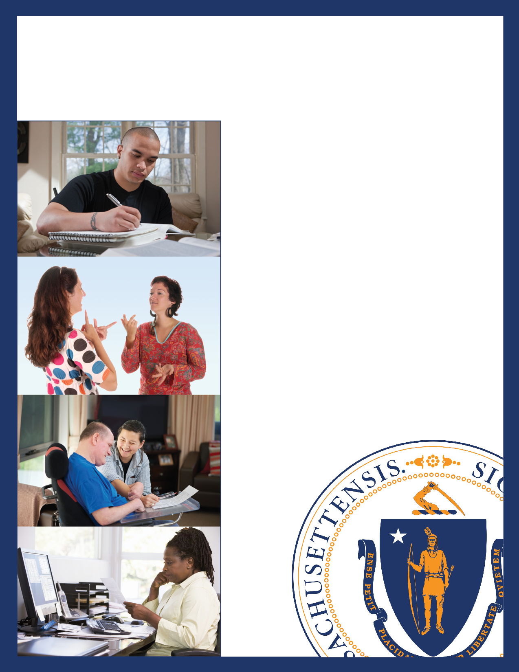
Annual Report

State Rehabilitation Council
of the
MA Rehabilitation Commission

Fiscal Year 2019

Table of Contents
Letter from the Chairperson 3
Governmental Organizational Structure for Funding and Oversight 4
State Rehabilitation Council Organizational Structure 5
MA State Rehabilitation Council Members 6
Gubernatorial Appointed Members 6
SRC Committees 7
Executive Committee 7
Comprehensive Statewide Needs Assessment Committee & Consumer Satisfaction Committee 7
Business and Employment Opportunity Committee 8
Policy Committee 9
Joint Committee State Plan Committee & Interagency Relations Committee 10
State Rehabilitation Council Recommendations for Fiscal Year 2020 11
Recommendation 1: Employment Outcomes 11
Recommendation 2: Transportation 12
Recommendation 3: Training and Opportunities 14
Recommendation 4: Autism 14
Recommendation 5: Procurement 15
Recommendation 6: Outreach to Unserved/Underserved 16
Recommendation 7: College Liaisons 18
Final MRC Note Regarding Recommendations: 18
The Massachusetts Rehabilitation Commission 19
The Massachusetts Rehabilitation Commission Accomplishments 20
MRC Fiscal Year 2019 in Review 22
Appendix 24
Community Living Division 24
Disability Determination Services 24
Join the MA State Rehab Council 25

Letter from the Chairperson
The Massachusetts State Rehabilitation Council (SRC) partners with the Massachusetts Rehabilitation Commission (MRC) to enhance its provision of employment services for residents with disabilities. The SRC is a legislatively mandated, volunteer body, and all its meetings are open to the public. The Council is comprised of twenty-one (21) gubernatorial appointees. The Council does not have staff nor does it provide services; it does, however, provide recommendations to MRC and, jointly with MRC, develops state vocational rehabilitation program goals among other duties. We hold four quarterly meetings in various communities around the state throughout the year.
The good news is that with increased funding from the state and significant effort of MRC staff, MRC did not go into "Priority for Service" (MRC refers to Order of Selection as Priority for Services) this year. Thus, everyone that was eligible was served, leaving the SRC the space to offer recommendations that would enhance service rather than maintain service.
Because the Council spent significant time on Priority for Services, a vote was taken to continue working on Federal Fiscal Year 2018 recommendations into Federal Fiscal Year 2019 plus the Priority for Services recommendation. These are the recommendations addressed in this report.
Another highlight was the approval of the initial draft of the MRC portion of the Workforce Innovation and Opportunity Act (WIOA) Combined State Plan that will be sent to MRC's federal funding agency, the Rehabilitative Services Administration (RSA). The entire plan will include the goals of workforce partners, including, but not limited to, Mass Hire, the Department of Labor, and the Department of Elementary & Secondary Education.
The Council has seen a number of resignations and appointments this year. The Executive Committee is using this time of transition to focus on clarifying the organization’s policies and procedures, including expectations of members, to further the SRC's mission. In doing so, we hope to actively embrace the skills SRC members bring to the table.
Also, the Executive Committee wants to see members of the public participate more in recommending ideas and addressing concerns that will enhance MRC's service to participants. I challenge members of the public to get involved by assisting the SRC to offer recommendations to MRC that will increase the ability to have new, diverse, and robust services for people with disabilities in Massachusetts.
In closing, I want to thank MRC staff for the tremendous support you have given the Council this year and the Council members for the trust you have placed in me to move us forward.
Again this year, it has been my honor and pleasure to serve the Governor and the people of Massachusetts as we work together to ensure that needed and deserved employment services are provided for our people with disabilities.
Respectfully submitted,
Dawn Clark
Dawn E. Clark, D. Min.
SRC Chairperson

Government Organizational Structure for Funding and Oversight

State Rehabilitation Council Organizational Structure

MA State Rehabilitation Council Members

Gubernatorial Appointed Members

Member | Seat
Rosanna Woodmansee | Business/Labor/Industries 1
Ellie Starr | Business/Labor/Industries 2
Barbara Cipriani | Business/Labor/Industries 3
Katherine O'Neil | Business/Labor/Industries 4
Vacant | Workforce Investment Board (WIB) Rep
Stephen Aalto | Community Rehab Services Provider Rep
Naomi Goldberg | Client Assistance Program (CAP)
Bonnie Jones | Statewide Independent Living Council (SILC) Rep
Dawn Clark | Disabilities Rep 1
Youcef J. Bellil | Disabilities Rep 2
Richard Colantonio | Disabilities Rep 3
Matthew Bander | Disabilities Rep 4
Lisa Chiango | Disabilities Rep 5
Heather Wood | Disabilities Rep 6
Inez Canada | Disabilities Rep 7
Vacant | Higher Education Rep 1
Dr. Lusa Lo | Higher Education Rep 2
Vacant | Parent Training/Info Center Rep
Katherine Queally | Unserved/Underserved Rep 1
Vacant | Ex-Officio Vocational Rehabilitation Counselor

SRC Committees

Executive Committee
Chairperson: Dawn Clark
Mission: The Executive Committee ensures the Council acts in accordance with federal and state vocational rehabilitation regulations; manages the affairs of the Council in the interim between meetings; reviews the appointment categories the Council has vacant and maintains a list of potential candidates to fill the vacancies; and submits selected candidates for the following year to the Governor for consideration.
Past Fiscal Year Activities: The Committee has worked to build a solid framework upon which the SRC can build a sustainable structure for growth and change without reinventing the wheel each time. It challenged the Committees to rethink their missions and priorities, to help the SRC run more efficiently. The work of Fiscal Year (FY) 19 included getting current members more involved in the Committees (the driving forces of the SRC), and seeking motivated new members to fill vacancies.
The Executive Committee also began looking into the recommendation regarding Autism training for vocational rehabilitation (VR) staff. Originally, this recommendation was assigned to the Unserved/Underserved Committee. The Committee began the process of gathering information on current trainings from MRC designated contacts as well as speaking to former SRC members who worked on a similar effort for consumers with learning disabilities. The Committee hopes these initial efforts will reveal what exists and where there may be gaps. Going forward, the Committee continues to work with MRC in order to identify current and future agency and community partners with whom MRC can develop targeted, quality training that will better equip counselors to serve this growing population of consumers.

Comprehensive Statewide Needs Assessment Committee & Consumer Satisfaction Committee
(Note: for Fiscal Year 2019, these two committees were combined)
Chairperson: Richard Colantonio
Mission: The Comprehensive Statewide Needs Assessment Committee and Consumer Satisfaction Committee ensures consumer perspectives are included in the process of evaluating MRC VR services. MRC and SRC jointly conduct an annual needs assessment; resultant information and findings are incorporated into the MRC VR section of the Massachusetts WIOA Combined State Plan, MRC strategic planning efforts, and the agency’s quality assurance activities. The Committee provides the agency with detailed information regarding the needs of the consumers served by MRC VR, and fulfills the federal requirements that the agency and the SRC jointly conduct a needs assessment at least every three years. As part of this process, a Consumer Satisfaction Survey is sent annually to consumers with closed cases to gauge their satisfaction with MRC’s VR services.
Past Fiscal Year Activities: The Committee had many notable accomplishments. The Committee collaborated with MRC to enhance and refine the Comprehensive Statewide Needs Assessment (CSNA) process and survey questions to ensure that it best captured the needs of individuals with disabilities served by MRC. Also, the Committee recommended the development of a short-form version of the Needs Assessment survey that can be distributed through area offices to consumers who do not have emails in the MRCIS (case management database) system. MRC has developed this survey and is working on strategies to implement this during FY2020. Likewise, with the annual Consumer Satisfaction Survey and the Consumer Satisfaction Survey report, the Committee provided input to MRC to further enhance the effectiveness and efficiency of the survey and make best use of its findings.
The Committee made recommendations to MRC on transportation and outreach to the Asian community. Finally, the Committee assisted with planning a focus group at the Lowell MRC office in FY2019 and will work with MRC to conduct a focus group in the Braintree office during FY2020 to assist with outreach to the Asian community.

Business and Employment Opportunity Committee
Chairperson: Steve Aalto
Mission: The SRC Employment and Business Development Committee is responsible for reviewing, analyzing, and providing guidance to the MRC on methods and best practices for employment and employment services.
Past Fiscal Year Activities: The Committee focused on the progress of their four assigned FY2019 recommendations. The first was related to the 'Gig Economy.' The SRC recommended that MRC create a career pathway and provide support for MRC consumers to enter these types of businesses. The second recommendation was that MRC should create a partnership with State Rehabilitation Councils in other New England states to gather new ideas surrounding VR programming, identify employment opportunities, and share best practices with the Council. The third recommendation focused on the Commonwealth passing an “Employment Bill” that would require the Supplier Diversity Office (SDO) to consult with the Massachusetts Office on Disability (MOD) to establish goals for participation of individuals with disabilities in all areas of state procurement contracting. The SRC recommended that MRC be actively involved with this endeavor. The fourth recommendation was for MRC to increase social media usage to attract consumers and communicate initiatives with the general public. This included revisiting the MRC Mass.gov website and exploring strategies to make the MRC website more user-friendly and accessible to all people with disabilities. Distinct from the four FY2019 recommendations, the Committee also discussed how to increase the number of SRC members that attend the Committee meetings.

Policy Committee
Chairperson: Naomi Goldberg
Mission: The Policy Committee reviews and analyzes Vocational Rehabilitation (VR) policies and procedures to ensure service delivery aligns with federal and state VR regulations and policy guidance. The Committee recommends revisions to and the development of policies that help consumers better understand the VR process and what is necessary to attain competitive integrated employment. Also, it recommends changes to policies to fix systemic matters as appropriate. Finally, the Committee periodically reviews and recommends updates to the Council Bylaws.
Past Fiscal Year Activities: During FY19, the SRC Policy Committee refined its purpose and methods to better support the SRC’s partnership with MRC. The Committee positioned itself to actively participate in the development and revision of VR policies, provide meaningful feedback on VR service delivery methods and practices, and recommend changes when it notes systemic concerns. This new approach allows the Policy Committee to prioritize the work it executes to implement the mission of the SRC.
Using the new approach, the Policy Committee got involved in several initiatives. First, the Committee reviewed the FFY17 RSA Monitoring Report and MRC’s response to the RSA-proposed corrective action. We noted Monitoring Report concerns that fell under the Committee’s purpose, namely concerns with timeliness of eligibility decisions and of development of IPEs, and with the age of engagement and the implementation of Pre-employment Transition Services. The Committee sought to understand MRC’s policies and procedures in these service areas in order to offer feedback on ways to address the noncompliance noted by the RSA.
Also, the Committee checked for compliance with the federal regulations that allow the SRC access to the information it needs to partner with MRC. This review revealed that the SRC had no regular access to VR policies or Hearing Decisions as required by federal regulations. The Committee asked MRC to provide both. MRC has provided the SRC with access to its written policies and procedures. Subsequently, MRC conducted a review of its VR policies and procedures to ensure centralized, consistent operations across area offices. Upon the Committee’s request, MRC provided copies of its existing written policies to the Committee for review, comment and proposed edits. This work is ongoing.
Finally, the Committee took ownership of two recommendations submitted for FFY20 State Plan goals; procuring state contractors to fill services gaps (e.g., math tutors), and adding a dedicated college liaison to MRC staff to increase the number of consumers who choose post-secondary training. This work is ongoing.

Joint Committee State Plan Committee & Interagency Relations Committee
  - (Note: In Fiscal Year 2019, these two committees were combined.)
Chairperson: Joe Bellil
Mission: The mission of this Committee is to ensure the SRC meets its obligations regarding input from consumers in the development of both the MRC public VR State Plan and the Workforce Innovation and Opportunity Act (WIOA) Combined State Plan.
Past Fiscal Year Activities: The Committee reviewed progress made with 2019 SRC Recommendations and reviewed and edited the SRC 2018 Annual Report. Working with all the SRC Committees, the Committee developed the 2020 SRC Recommendations timeline and process. The SRC approved seven recommendations for 2020. Each recommendation has been assigned to a SRC Committee in order for its members to provide advice to MRC on an ongoing basis. SRC members developed, agreed to, and reviewed state goals and priorities in the VR services portion of the Massachusetts Workforce Innovation and Opportunity Act (WIOA) Combined State Plan. This plan identifies the goals and priorities of the state in carrying out the VR program.

State Rehabilitation Council Recommendations for Fiscal Year 2020 with Massachusetts Rehabilitation Commission Responses

Recommendation 1: Employment Outcomes
Increase and improve the quality of employment outcomes for MRC consumers.
- Develop a self-employment curriculum for those consumers whose interests and/or disabilities are better suited for working independently. For example, MCB has a Small Business Enterprise Program that may serve as a model. The SRC is also requesting data on self-employment outcomes, i.e., what percentage of consumers with IPEs with self-employment goals exited with self-employment and maintained that self-employment in the second quarter after exit.
- Ensure Competitive Integrated Employment Services (CIES) vendors are complying with their MRC contracts and the MRC/EOHHS RFR (e.g., vendors are conducting outreach and developing relationships with prospective employers to understand MRC’s CIES quality control process and data).
- Restore MRC's Individual Consumer Consultant program (ICC) and provide the SRC with the percentage of participants employed upon completing the program during ICC’s last two years of existence.
- The SRC Business & Employment Opportunity Committee working with Bill Allen and his team to understand the team's goals, processes, and barriers to accomplishing those goals, and, where possible, assist with addressing those barriers.

Assigned to: Business and Employment Opportunity Committee

MRC Response
MRC is committed to continuing to improve the quality of employment outcomes for its consumers. MRC places consumers into a wide variety of jobs based on each individual’s interests, needs, skills, and choices. MRC has an existing process that counselors can utilize to develop a self-employment business plan in collaboration with the consumer. MRC can provide data on the number of individuals who have self-employment as an employment goal and outcome data for consumers successfully exiting with self-employment. Self-employment information at 2nd quarter after exit is not available as it is not included in the UI wage data provided to MRC.
MRC has a quality assurance monitoring process for CIES contracts to ensure that CIES vendors comply with RFR and MRC requirements, and to evaluate the quality of services provided under the RFR. Providers report key performance indicator results to MRC on a monthly basis including both performance data and individual progress reports on consumers. Providers also meet with MRC staff to discuss performance on a quarterly basis. MRC will have three program monitoring staff in place to provide oversight on CIES, specifically dedicated to managing vendor relationships. Additionally, the Department of Analytics and Quality Assurance will provide regular performance reports and conduct a performance evaluation.
MRC recommends that consumers be placed into permanent competitive integrated employment. The ICC program does not currently exist, and past outcome data is not available. MRC is developing a new consumer engagement office/program to outreach to consumers. This program is currently under development.
MRC will continue to closely work with the SRC Business and Employment Opportunity Committee to discuss goals, processes, and work on solutions to overcome barriers to employment for people with disabilities. MRC’s Job Placement Director will continue to meet with the SRC committee as part of this process.

Recommendation 2: Transportation
Continue to increase consumer awareness of transportation options and explore efforts to assist consumers with transportation.
- Needs Assessment Committee determined that transportation remains a significant need for many MRC consumers.
- MRC should refine and update its transportation fact sheets on MRC's website as needed and incorporate these into trainings and informational materials based upon its research.
- Development of other informational materials and training should be considered to assist consumers in learning about other available resources including:
  - Local Councils on Aging
  - EOHHS Human Service Transportation (HST) office
  - MBTA pilot project with Uber and Lyft
    - MRC should request for more information
- MRC should continue to research collaboration with MassRides, MassMobility, the Massachusetts Department of Transportation, Career Centers, the HST office, local and regional planning boards, and other organizations on projects or programs that might be able to assist consumers with transportation, given that transportation is a systemic issue requiring collaboration on multiple levels.
  - Open a discussion on ideas to address the transportation issues facing MRC consumers and individuals with disabilities and how MRC can work together.
- MRC should also do a survey of its offices to find out more about how its local staff are connected to the local transportation regional coordinating councils.
- A plan should be formed to initiate a group of volunteers across the state to drive people to work and back.
- This task has many roadblocks, but it may be feasible with a co-coordinated effort on the part of many agencies. Regional data should be compiled to possibly have alternative choices based on the demographics of the people and area.
- Improve transportation access to consumers by one or more of the following options:
  - Establishing a petty cash/revolving fund at each area office for immediate transportation needs (e.g., cash for gas or a cab is cheaper than paying a vendor; North Carolina and South Carolina VR use such funds).
  - Putting a local registered taxi company on the state contract (Indiana VR does this).
  - Partnering with Uber/Lyft/other ride-share companies (Georgia VR does this).
  - Partnering with the entities that fill gas for state vehicles (that entity should already be on the state contract) to allow consumers to get gas from those entities (New Hampshire welfare does something similar).
  - Obtaining a credit card from a local gas station (or a state credit card) for each area office tied to a state account that can be used by staff to get gas to a consumer.

Assigned to: Comprehensive Statewide Needs Assessment Committee & Consumer Satisfaction Committee

MRC Response
MRC recognizes that transportation continues to be a significant need for some of our consumer population and can present a barrier to employment for individuals with disabilities. This need has been established through the Comprehensive Statewide Needs Assessment. This is a complex issue that goes beyond MRC and VR in general and requires collaboration on the local, state, and federal levels.
MRC would like to work with the SRC to determine if any marketing priorities exist in terms of transportation. MRC will update its transportation fact sheets, and MRC can research additional information that we can make available on our website for consumers, including information on councils of aging, the MBTA Ride Uber/Lyft pilot, and others. MRC will also reach out to the Independent Living Centers to discuss collaboration on transportation. MRC has also worked to obtain automatic eligibility for the Transportation Access Pass discount program for MRC consumers.
MRC would like to work with the SRC to open a discussion on collaboration with entities such as Mass Rides, MassMobility, the Massachusetts Department of Transportation, Career Centers, and other organizations on potential projects or programs to assist consumers with transportation. The SRC’s assistance in this process would be appreciated.
MRC’s Transportation Options Grant evaluated the strategy of volunteer rides and discovered a significant obstacle as volunteers would need commercial insurance to transport people in their vehicles and participate in ongoing training programs which would be cost prohibitive.
MRC can provide funds to consumers for short-term transportation needs through an existing maintenance resources working with their counselor. EOHHS Human Service Transportation which MRC utilizes has an array of vendors for transportation including taxi companies. MRC can reach out to Georgia VR to find out about their partnership with ride share companies and check with the MBTA on their Uber/Lyft pilot. MRC will continue to utilize its maintenance process which allows for monitoring of costs and internal controls.

Recommendation 3: Training and Opportunities
Increase the quantity and quality (i.e., wage outcomes) of on-the-job trainings (OJTs), on-the-job evaluations (OJEs), job driven trainings (JDTs), and apprenticeships by targeting employers who offer higher wages and targeting in-demand skill sets (e.g., Salesforce).
In addition to the annual Office of Federal Contract Compliance program (OFCCP) hiring event, MRC should also consider developing regionalized hiring events in collaboration with the regional employment advisory boards.

Assigned to: Business and Employment Opportunity Committee

MRC Response
The MRC Job Placement Team has developed a wide variety of employer partnerships. MRC has and will continue to utilize OJTs, OJEs, and Job Driven Trainings such as Home Depot, Human Service Worker, CVS, and other employers, and is developing a new JDT with Cisco. For the annual statewide OFCCP hiring event, MRC will continue to work with employer advisory boards on job placement efforts. MRC will develop key performance indicators and measure outcomes including wages for these efforts.

Recommendation 4: Autism
Given the increasing number of individuals diagnosed on the Autism Spectrum, MRC should identify and utilize resources that will expand staff and CIES vendor knowledge and understanding of Autism Spectrum Disorders and practical strategies for supporting VR consumers as they learn to live and work independently.
Examples of resources include: the Asperger/Autism Network (AANE), Federation for Children with Special Needs (FCSN), the Autism Commission, and Massachusetts Advocates for Children (MAC).

Assigned to: Executive Committee

MRC Response
MRC is committed to supporting vocational rehabilitation consumers with Autism Spectrum Disorders in their efforts to live and work independently. The MRC Commissioner is the co-chair of the MA Statewide Autism Commission, and MRC works closely with the Department of Developmental Services, which is the designated agency to provide services for individuals on the Autism Spectrum. MRC will continue to collaborate with AANE, FSCN, and other entities to improve services for individuals on the Autism Spectrum. MRC’s training department in collaboration with AANE will continue to develop and provide staff trainings related to assisting consumers on the Autism Spectrum.

Recommendation 5: Procurement
Procure other important services on the state contract (e.g., math tutors at each area office, standardized test registration) to avoid having consumers pay upfront for these services (or not receive them at all), especially when many consumers (e.g., clients on SSI and/or SSDI) are not obligated to contribute to the cost of their VR services.
The SRC Policy Committee is requesting a list of MRC services that are currently on the state contract to understand what MRC can already write purchase orders (POs) for and thereby also know what services MRC cannot pay via PO.
Meanwhile, the SRC Policy Committee would coordinate with the SRC Consumer Needs/ Satisfaction Committee to determine whether survey responses can also identify services needed on the state contract and will share its findings with MRC. The SRC recommends MRC conduct a survey of area offices asking counselors what services they believe are needed on the state contract and share survey results with the SRC Policy Committee.
Lastly, the SRC requests the following to better inform members on the procurement process: a) the job title and department of MRC staff who handle procuring services on the state contract, b) how MRC makes decisions on what services to procure including how often a review of needed services occurs, c) a brief description of the key steps and barriers to procuring services on the state contract including the approximate duration of the procurement process, and d) what the current remedy is for services needed by a consumer that are not on the state contract.

Assigned to: Policy Committee

MRC Response
MRC will make available a list of services utilizing contracts to the SRC. MRC can provide information from the Needs Assessment in terms of services identified by consumers as important and needed. MRC can utilize its counselor satisfaction survey to ask counselors about what services could be procured on a statewide basis. MRC is in the process of enhancing our Contracts Department including staffing, and will provide an update to the SRC on progress. MRC conducts an annual review of contracts that involves program and fiscal staff, and follows applicable state procurement rules and processes to procure services. MRC can have a fiscal staff person attend a SRC meeting to review the procurement process upon completion of MRC’s revamp of procurement process after March 2020.

Recommendation 6: Outreach to Unserved/Underserved
Continue outreach to communities of ethnic and diverse backgrounds on vocational rehabilitation and other MRC service offerings, especially in the Asian community.
- MRC has made a commitment to reach out to individuals with the most significant disabilities who are also ethnic and cultural minorities through its Diversity Committee and through its Language Access Plan.
- MRC should continue these outreach efforts to ethnic and cultural minorities, especially to the Asian community, which has been identified as slightly underserved by the VR program in Massachusetts.
- As growth in the Asian community continues to be seen in the state’s general population, it is recommended that MRC continues its outreach efforts to Asian communities in particular.
  - There was growth in the number of Asian consumers served by MRC during FY2018 but it still remains below the proportion in the overall state population.
- MRC conducted a focus group of Asian consumers in the Lowell office during Fall 2018.
- Information from this focus group and additional consultation with MRC's Diversity Committee yielded a wealth of information and suggestions on additional steps MRC can take in this area to further engage with the Asian community.
- It is recommended that MRC use the findings from this focus group to assist in developing strategies for outreach to this community.
- Several focus groups will be scheduled in the coming year.
- It was suggested that the first focus group be held in the Braintree office. Other possible sites are Boston and Cape Cod.
- MRC should continue to focus on how to reach out effectively to these communities, including but not limited to conducting outreach to local community agencies and organizations that serve ethnic and cultural minorities.
- MRC should continue to consult its Bi-Lingual Committee for recommendations on how to reach out more to minority communities.
  - MRC has been successfully increasing its numbers in terms of Hispanic community; best practices in this area may also assist with outreach to the Asian community.
  - Possible outreach strategies include collaborating with local public cable TV shows, radio programs, and having a presence at various functions such as conferences or community gatherings.
- The SRC Unserved/Underserved Committee should add reaching out to the Asian community to their agenda.
- Furthermore, it is recommended that the MRC's Diversity Committee, the SRC Needs Assessment Committee and Unserved/Underserved committee consider meeting jointly to come up with ideas for enhanced outreach to minority communities, including the Asian community.

Assigned to: Statewide Needs Assessment Committee & Consumer Satisfaction Committee

MRC Response
MRC is committed to serve communities of ethnic and diverse backgrounds across Massachusetts to assist consumers in obtaining competitive employment. MRC has identified through the Comprehensive Statewide Needs Assessment that Asian/Pacific Islanders are slightly underserved by the MRC VR program in comparison to their proportion in the statewide population.
MRC conducted a focus group of Asian consumers and community members in the Lowell office during Fall 2018. MRC is planning an additional focus group in the Braintree/Quincy area. The Lowell focus group revealed a number of possible strategies for outreach to the Asian community. A work plan was developed with local Area Office staff to follow up on the recommendations made in the focus group. These efforts could be replicated in other area offices as a strategy.
MRC is in the process of establishing a consumer engagement office/program to provide outreach to consumers. MRC will work with the new manager of this program and the Diversity/Bilingual Committee, and the SRC Executive Committee to develop a community outreach model and strategy for the Asian community, including a work plan to conduct outreach to local community agencies and organizations that serve ethnic and cultural minorities. The Commissioner met with the MRC Bilingual Committee in September and outreach to minorities will be discussed.

Recommendation 7: College Liaisons
Increasing post-secondary training outcomes by adding dedicated college liaisons to MRC staff who encourage VR consumers to seek postsecondary training, ensure consumer connections to college disability services, and research grants/scholarships.
In addition, the SRC is recommending MRC counselors refer consumers, as appropriate, to the American Student Assistance program for help finding grants/scholarships and navigating higher education.

Assigned to: Policy Committee

MRC Response
MRC counselors serve as liaisons and work closely with colleges and universities to refer consumers to college disability service offices. MRC staff and vendors work closely with post-secondary institutions on assisting consumers in obtaining post-secondary training. MRC will research information on the American Student Assistance program and can make it available to its counseling staff.

Final MRC Note Regarding Recommendations:
MRC will work closely with the SRC to establish a work plan to track progress on the recommendations and associated steps related to the recommendations.

The Massachusetts Rehabilitation Commission

Agency Overview

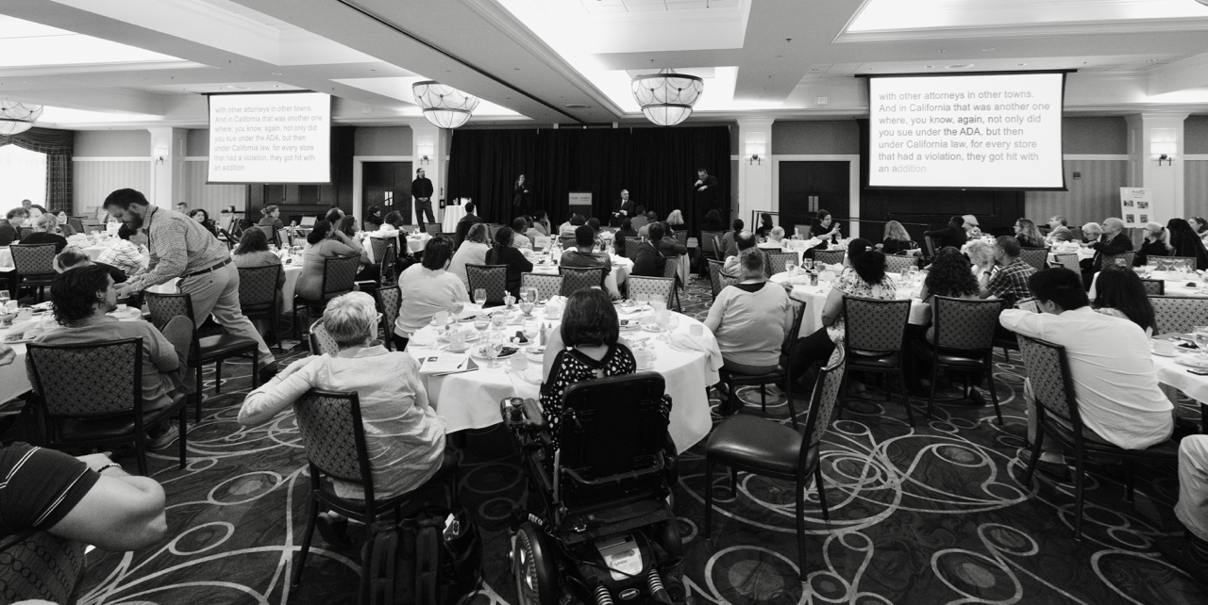
Mission:
The MRC promotes equality, empowerment, and independence of individuals with disabilities.
These goals are achieved through enhancing and encouraging personal choice and the right to succeed or fail in the pursuit of independence and employment in the community.

Vision:
The MRC provides comprehensive services to people with disabilities that maximize their quality of life and economic self-sufficiency in the community.

State Leadership:

Charles D. Baker | Karyn Polito | Marylou Sudders | Toni Wolf
Governor | Lt. Governor | Secretary of Health  and Human Services | Commissioner

The Massachusetts Rehabilitation Commission Accomplishments

Vocational Rehabilitation Services
The Vocational Rehabilitation Program assists individuals with physical, psychiatric, and/or learning disabilities in facing the challenges of the modern workplace. This may include identifying job goals based on individual interests and aptitudes, providing funds for college and vocational training, assessing work site accommodations, educating an employer about the Americans with Disabilities Act (ADA), or assisting an individual returning to work. Vocational Rehabilitation services can reduce or remove barriers to employment. Priority is given to those individuals who have the most significant disabilities in areas such as communication, learning disabilities, mobility, work tolerance, and work skills.

VR Year in Review
 | 2016 | 2017 | 2018 | 2019
Consumers actively receiving services: | 25,125 | 27,028 | 29,463 | 24,991
Consumers enrolled in training/education programs: | 16,513 | 17,685 | 18,471 | 13,174
Consumers with disabilities competitively employed: | 3,816 | 3,973 | 4,053 | 3,695
Consumers employed with medical insurance: | 95.9% | 96.6% | 98.7% | 99.0%
Consumers satisfied with services: | 84.0% | 86.0% | 88.0% | 78.0%
Average age of consumer: | 33.0 | 32.4 | 31.8 | 31.0
Average hourly wage: | $13.18 | $14.11 | $14.65 | $14.69
Average work hours weekly: | 26.8 | 26.7 | 27.3 | 27.4

Services for Youth and Young Adults in Transition
As a result of the Workforce Innovation and Opportunity Act’s (WIOA) mandate that 15% of all federal grants shall be spent on services for youth, MRC has shared the following statistics with the SRC:
- The Vocational Rehabilitation Program served 11,057 youth and young adults aged 14 to 24 during State Fiscal Year (SFY) 2018.
- 1,060 of these consumers were placed in employment, with an average hourly wage of $12.55.
- Employed young consumers worked an average of 26.5 hours per week.
- MRC served 5,588 high school and post-secondary education students with disabilities aged 14 to 22 through its VR Area Offices.
- MRC also operated Pre-Employment Transition Service (Pre-ETS) contracts with 34 vendors across the Commonwealth serving 1,061 students. These programs offer work-based learning experiences, job readiness and skills trainings, assistance with enrollment in post-secondary education and training programs, job exploration, and leadership/mentoring services to students with disabilities.

- MRC provided work-based learning experiences for 1,481 young consumers across the Commonwealth through its local Area Office internship program, CVS Health Summer Internship Program, Pre-ETS contracts, and Transitional Internship Program (TIP). These work-based learning experiences provide employment related skills and guidance, and references to facilitate permanent future employment opportunities.

Note: The Massachusetts Rehabilitation Commission includes three divisions: Vocational Rehabilitation, Community Living, and Disability Determination Services. The Community Living division and the Disability Determination Services division both intersect with vocational rehabilitation. A brief description and accomplishments of these areas are included in the Appendix.

MRC Fiscal Year 2019 in Review
  - The State Rehabilitation Council supported the Massachusetts Rehabilitation Commission with the following initiatives during fiscal year 2019.

Department of Mental Health Employment Initiative
In Fiscal Year 2017-2018, MRC and the Department of Mental Health (DMH) established partnership pilots in three geographic areas to develop and test a collaborative approach to engaging young adults (ages 18-26) who were DMH clients to access MRC’s vocational rehabilitation services. Lessons from the pilot were rolled into a formalized partnership between DMH and MRC, launched in July 2019. MRC now employs 15 specialized mental health vocational rehabilitation counselors across the Commonwealth to specifically serve DMH Adult Clinical and Community Services job seekers.

Department of Transitional Assistance “Empower to Employ” Initiative
Two years ago, the Department of Transitional Assistance (DTA) and MRC embarked on a journey to design and implement an innovative and integrated employment model, “Empower to Employ,” to maximize opportunities for individuals with disabilities receiving Transitional Aid to Families with Dependent Children (TAFDC). The shared vision of the partnership is to use a jointly funded model of engagement and co-case management to provide individualized and meaningful services leading to sustained employment, economic independence, and family stability for DTA clients with disabilities. Empower to Employ is operating in four Area Offices (Brockton, Lawrence, Quincy, and North Shore/Salem), with Fitchburg slated to join this fall. As of September 2019, 189 clients are participating in the program and receiving a range of specialized employment supports.

Eligibility Pilot
As part of MRC’s business redesign process, MRC embarked on a pilot project to explore strategies to streamline the VR eligibility process, and decrease the time from eligibility to service delivery. An Eligibility Unit was established in the West VR district, where a team of mobile counselors were responsible for working with consumers through the eligibility process. The Eligibility Unit pilot became operational on May 1, 2019. After six months, initial data and outcomes will be reviewed by agency and VR leadership, the Department of Analytics and Quality Assurance, and Eligibility Unit staff to identify lessons learned and next steps.

Priority for Service (Order of Selection)
In Fiscal Year 2019, MRC faced an emerging set of fiscal challenges, which required a significant overhaul of agency and fiscal practices across VR. Fiscal projections from early FY19 suggested MRC would not be able to meet existing obligations to current VR consumers and at the same time serve all incoming potential VR eligible individuals. As such, MRC and the SRC began a thorough and thoughtful process to consider entering an Order of Selection (which MRC calls Priority for Service). The SRC convened three specialty meetings over the summer of 2018 to better understand the implications of implementing Priority for Service. During these meetings SRC members met with the MRC CFO to review current and forecasted fiscal data, and learned from other states already in Order of Selection. Fortunately, thanks to significant support from the Governor, and the Secretary of Health and Human Services, MRC did not have to enter Priority for Service, and all priority categories remain open.

Appendix

Community Living Division
The Community Living Division is comprised of a variety of programs, supports, and services that address the diverse needs of adults and transition age youth and young adults with disabilities to support community integration, and participate fully in the community.
 | 2016 | 2017 | 2018
Total consumers actively receiving services: | 12,267 | 14,284 | 15,054
Total funds expended: | $49,640,740 | $50,116,672 | $48,186,551
Cost per consumer served: | $4,047 | $3,509 | $3,201

Disability Determination Services
The Disability Determination Services (DDS) Division is funded by the Social Security Administration (SSA) and determines applications and continued eligibility for federal Supplemental Security Income (SSI) and Social Security Disability Insurance (SSDI) benefits. Special outreach efforts are made to homeless clients, individuals with HIV/AIDS, and veterans injured during military service.
 | 2016 | 2017 | 2018
Total budget: | $50,350,907 | $47,645,563 | $47,765,219
Cost per case: | $549.34 | $571.63 | $568.79
Total disposition of SSI/SSDI cases: | 91,657 | 87,054 | 83,977
Accuracy of initial decisions: | 98.6% | 96.2% | 96.4%
Standard for Federal accuracy of decisions made by Disability Determination Offices: | 90.6% | 90.6% | 90.6%

Join the MA State Rehab Council

Make a difference in the world of disability employment!

The Massachusetts SRC provides individuals with disabilities and representatives from the community with a voice in the state's vocational rehabilitation program. We partner with MRC to realize the goal of "empowering individuals with disabilities to maximize employment, economic self-sufficiency, independence, inclusion and integration into society."
Click join if you are interested in the unique opportunity the SRC offers a person to use their talents and skills to influence and innovate the state’s vocational rehabilitation service delivery.
Send an email to: MRC.StateRehabCouncil@MassMail.State.MA.US

We want to hear YOUR voice!
We need YOUR help!

SRC Mission:
The primary goal of the SRC is to partner with MRC to ensure that people with disabilities are provided with an equal opportunity to receive the programs, services and supports needed to gain competitive integrated employment. The SRC provides a forum for consumer input resulting in recommendations and advice to the agency. We aim to provide a path to high quality, value-based, vocational rehabilitation services that lead to meaningful, sustainable, and competitive employment for consumers with disabilities.

SRC Vision:
Our vision is to break the historic bonds of poverty by providing a dynamic pathway to economic self-sufficiency for people with disabilities eligible for vocational rehabilitation services.

Read more about the SRC
600 Washington St; Second Floor | Boston, MA 02111| (617) 204-3665
MRC.StateRehabCouncil@MassMail.State.MA.US

