|  |  |  |
| --- | --- | --- |
| Massachusetts Youth Count | January 1  2019 | |
| A report from the Massachusetts Commission on Unaccompanied Homeless Youth on homelessness, housing instability, and access to services among youth and young adults under the age of 25 in the Commonwealth. | |  |

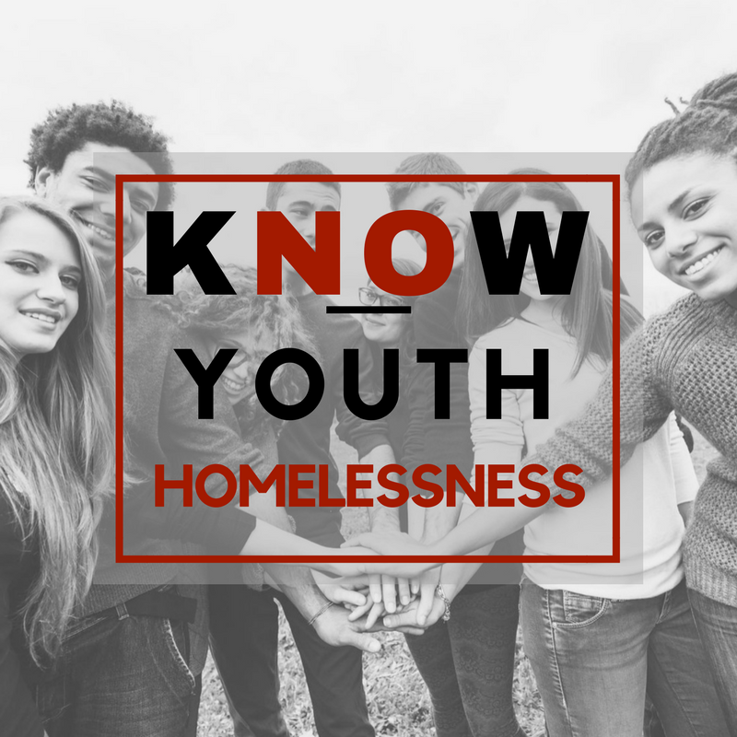

Contents[1]

1.0 The 2018 Massachusetts Youth Count Overview 2

2.0 The 2019 Youth Count Results and Analysis 3

2.1 Housing Status and Reasons for Homelessness 5

Where slept the night before taking the survey 5

Why respondents were no longer with parent or guardian 7

2.2 Education, Employment, and other Income sources 9

Education 9

Income Sources 10

2.3 Service Utilization 12

2.4 Vulnerable Subpopulations 16

2.4.1 Pregnant OR Parenting 16

2.4.2 Systems Involvement 18

2.4.3 Lesbian, Gay, Bisexual, Transgender, Queer/questioning+ (LGBTQ+) 21

2.4.4. UNDER 18 years old 22

2.5 Demographics 23

2.5.1 Age 23

2.5.2 Race/Ethnicity 24

2.5.3 Gender 24

2.5.4 Sexual Orientation 25

2.5.5 Place of Birth 25

3.0 Conclusion 26

4.0 Attachments 29

# 1.0 The 2018 Massachusetts Youth Count Overview

The Massachusetts Youth Count is an annual survey used to learn about the scope and needs of youth and young adults under the age of 25 who are unstably housed or experiencing homelessness[2]. The Massachusetts Commission on Unaccompanied Homeless Youth (Commission) provides oversight for the Count and is responsible for annual reports on its progress to the Governor’s Office, the Legislature, and the Office of the Child Advocate. The Commission defines an unaccompanied homeless youth or young adult (UHY) as a person who:

1. **Is 24 years of age or younger; and**
2. **Is not in the physical custody or care of a parent or legal guardian; and**
3. **Lacks a fixed, regular, and adequate nighttime residence.**

From April 12 through May 12, 2019, the Commission conducted the sixth annual Massachusetts Youth Count. The survey was administered online and by service providers, Youth Ambassadors[3] , and street outreach workers at drop-in centers, meal programs, programs for youth experiencing homelessness, and other places where young people congregate[4]. In 2019, a total of 3,176 surveys were collected. Of these surveys, 1,957 were included in the analysis and 529 survey respondents met the Commission’s definition of an unaccompanied young person experiencing homelessness.[5]

The 2019 Count continues to build on progress started with the groundbreaking 2014 Count, the first statewide effort of its kind in the United States, and the subsequent annual Counts. The 2014 Count established a baseline against which progress in addressing unaccompanied youth homelessness could be measured. The importance of having this baseline became even more significant when the Commission released the “Massachusetts State Plan to End Youth Homelessness” in 2018. The Massachusetts Plan responds to youth and young adult housing vulnerability and identifies needed program, policy, and system changes. The Massachusetts Plan also requires regions to undertake community needs assessments to analyze the drivers of youth homelessness. Youth Count data are an important component of the regional assessments.

***Please just help me get on my feet! I'm done not being somewhere where I can call home.***

**--19-year old Latinx cis-female* from Westfield**

**Highlights of the 2019 Count include:**

* 529 respondents (27.0%) met the Commission definition of UHY. An additional 501 were housed but had experienced homelessness in the past, and 121 were currently experiencing homelessness and were accompanied. In total, 1,151 2019 Youth Count respondents had experienced homelessness at some point in their life—either while being accompanied or not by a parent or guardian.
* 30.2% of respondents who met the Commission definition left home permanently before the age of 18; the average age of those who left home before 18 was 14.9 years old.
* 12.3% who met the Commission definition were unsheltered, meaning they were staying outside, in an abandoned building, in a car, or in another location not meant for human habitation.
* The use of Youth Ambassadors and street outreach were two of the most effective methods to reach youth under 18, as well as youth who were couch surfing or unsheltered through the Youth Count process.
* 55% of respondents who met the Commission definition had a high school diploma or equivalent; but 19.1% of them had no diploma and were not in school.
* Most respondents had access to income through employment or benefits; however, 13.4% relied on illegal or informal income sources.
* 84% of respondents reported having received some or all of the help they sought; however of the 63 respondents who said they did not seek help, 73% of them were doubled-up or unsheltered.

# 2.0 The 2019 Youth Count Results and Analysis

|  |  |
| --- | --- |
| Table One | 2019 State |
| Total # surveys | **1957** |
| Total # HUD definition | **422** |
| # currently housed but homeless in past | **501** |
| Total # Commission definition | **529** |
| # under 18 | **31** |
| # LGBTQ | **131** |
| # foster care | **165** |
| # juvenile/criminal justice | **133** |
| # parenting with custody/pregnant | **127** |
| # not in school/no diploma | **101** |

In 2019, a total of 1,957 surveys were included for analysis. These 1,957 responses were analyzed to determine the number that met the definition of unaccompanied youth and young adults experiencing homelessness (UHY) adopted by the Commission. A total of 529 survey respondents met the Commission’s definition, or 27.0% of all surveys collected in 2019. Table One presents the total number of included surveys and the total number meeting the Commission’s definition. All numbers below “Total # Commission definition” are in relation to the 529 who met the Commission definition; the numbers above refer to the whole sample.

In addition to UHY, 121 respondents were experiencing homelessness and living with a family member[6]. Of the housed youth, 501 of them reported experiencing homelessness at some point in the past. Eighteen (18) housed, unaccompanied respondents reported not having a safe place to stay for the next 14 days. These additional data points suggest a higher degree of homelessness and housing vulnerability than revealed by the numbers of youth and young adults meeting the Commission’s definition at the time of the Count. In fact, 1,151 respondents (58.8%) were either experiencing homelessness or had experienced it in the past. On average, UHY permanently left home at 17.5 years old. One hundred and sixty (160) or (30.2%) had left home permanently before the age of 18; their average age of leaving home permanently was 14.9 years old.

***On my campus other trans students of color like myself have to panic every summer/break because our only stable housing has been on the college campus.***

**--19-year old transgender Latinx youth from Amherst**

Surveys from the 826 respondents who had reported never experiencing homelessness were analyzed to provide a point of comparison for several variables of interest including education and employment status and history of systems involvement. These housed, never homeless respondents included 87 youth and young adults not living with parents or guardians. The remaining housed, never homeless respondents were still with family.

As a point of comparison, in 2018, 2,150 surveys were included in the analysis and of these 738 (34.3%) met the Commission definition (see Table Two). Rather than indicating a trend in the prevalence of youth and young adult homelessness, we believe the decrease could be a function of the shift in responsibility from the Continuums of Care (CoCs)[7] to ten regional lead youth homelessness service agencies[8] (“the Regions”) for administering the Count. The Regions were conducting their community needs assessments (CNAs) at the same time as the Count. This may have reduced the amount of outreach effort they could put into the 2019 Count.

|  |  |  |  |
| --- | --- | --- | --- |
| Table Two | 2019 State | 2018 State | 2017 State |
| Total # Surveys | 1957 | 2150 | 2711 |
| Total # Commission Definition | 529 | 738 | 501 |
| % | 27.0% | 34.3% | 18.5% |
| Under 18 | 5.9% (31) | 5.0% | 5.6% |
| LGBTQ | 24.7% (131) | 23.5% | 22.7% |
| Foster care | 31.2% (165) | 26.4% | 29.9% |
| Juvenile/ Criminal justice | 25.1% (133) | 33.6% | 26.4% |
| Parenting with custody/Pregnant | 24.0% (127) | 26.2% | 17% |
| Not in school/No diploma | 19.0% (101) | 22.4% | 23.8% |
| Left home before 18 | 30.2% (160) | 30.4% | N/A |

## 2.1 Housing Status and Reasons for Homelessness

### Where slept the night before taking the survey

In 2019, 300 out of the 529 (56.6%) UHY respondents had stayed at a shelter, transitional housing, or a hotel/motel on the night before the Count. It is noteworthy that there was a 43% increase in the number of youth and young adults in transitional housing.

As in the two prior years, the next most common response was staying with family, a partner, or a friend, with 164 or 31.0% of UHY respondents. Throughout the report we refer to this group as couch surfing or doubled-up. Eighty of the respondents who were couch surfing or doubled-up either knew that they did not have a safe place to stay for the next 14 days or were unsure whether or not they did.

Sixty-five (65) respondents reported being unsheltered, meaning they stayed outside or in another place not meant for human habitation. At 12.2% of respondents, this is several percentage points lower than last year’s count.

Chart One groups where respondents stayed the night before the survey into sheltered, couch surfing/doubled up or unsheltered and provides five-year trends. Chart Two provides more detailed information on where the 2019 respondents slept the night before taking the survey.

***We need more housing for homeless teens and I understand Mass is trying to help so keep up the good work.***

**--22-year old Black cis-female from Worcester**

|  |  |  |  |  |  |  |  |
| --- | --- | --- | --- | --- | --- | --- | --- |
| Table Three: Sheltered Status and Vulnerable Populations | UHY | Average Age | Pregnant/ Parenting | Foster system | Justice system | LGBTQ | Under 18 |
|  |  |  |  |  |  |  |  |
| Sheltered | 56.6% | 21.1 | 74.0% | 57.6% | 53.0% | 49.0% | 32.2% |
| Couch surfing/ doubled-up | 31.0% | 20.1 | 19.7% | 30.3% | 29.0% | 33.0% | 48.3% |
| Unsheltered | 12.2% | 20.9 | 6.3% | 12.1% | 17.0% | 18.0% | 19.3% |
|  |  |  |  |  |  |  |  |
| Total number in each group | 529 |  | 127 | 165 | 133 | 131 | 31 |

Pregnant and parenting UHY were most likely to be sheltered (74.0%). Youth under 18 were least likely to be sheltered (32.2%) and most likely to be couch surfing/doubled up (48.3%). Those most likely to be unsheltered were LGBTQ respondents (18%) and youth under 18 (19.3%). See Table Three for more details on where each population slept the night before the survey.

***I think there should a shelter for youths only in MA cause a lot of youths are out on the street with no place to put their head cause they got kicked out, abused, don’t feel safe etc.***

**--19-year old Black cis-male from Brockton**

### Why respondents were no longer with parent or guardian

In order to gain insight into young people’s paths to homelessness, the survey included a question about why the respondent was no longer with their parent or guardian. As presented in Chart Three, the survey provided 14 options and respondents could choose as many as were relevant to their situation.

Like in the past years, the top reasons UHY were not living with their families were related to family conflict. Fighting with a parent or guardian, being told to leave, and wanting to leave were among the top reasons young people were not with family. The following reasons increased in 2019: family lost their housing and the home was too small. Findings about why particular vulnerable populations were no longer with a parent or guardian are found in Section 2.4.

## 2.2 Education, Employment, and other Income sources

The survey included questions regarding school enrollment, educational attainment, employment, and income sources. These questions provide insight into challenges UHY may experience in achieving housing and economic stability in the future.

### Education

Table Four compares the education status of UHY with respondents who were housed and never experienced homelessness.

|  |  |  |
| --- | --- | --- |
| Table Four: Education Status | UHY (529) | Housed, never homeless (826) |
| High school diploma and currently in school | 68 (13%) | 170 (21%) |
| High school diploma, not currently in school | 226 (43%) | 57 (7%) |
| No diploma and currently in school | 113 (21%) | 497 (60%) |
| No diploma, not currently in school | 101 (19%) | 28 (3%) |
| Blank | 21 | 74 |
| Average age | 20.8 | 17.4 |

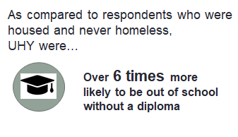Of the UHY, 294 (56%) of them had a high school diploma or equivalent and 68 of these young people were enrolled in some form of education program at the time of the survey. Twenty-one percent of UHY did not have a diploma, but were in school. Overall, 181 UHY were in school (i.e. either high school or post-secondary); indicating that in spite of housing instability, these young people were engaging in education. Yet, when compared to respondents who had never been homeless, we see a point of disparity for UHY. For UHY, 19% were not in school and did not have a diploma; only 3% of housed, never homeless youth were in this situation. Respondents who met the Commission definition were over six times more likely to be out of school without a diploma than housed, never homeless respondents, in spite of the fact that the UHY tended to be older.

Looking at educational level by type of homelessness young people were experiencing is also informative. Chart Four shows that unsheltered respondents were least likely to be in school and have a diploma. Couch surfing youth were more likely to still be in school but not yet have a diploma. Sheltered youth were more likely to have a diploma than couch surfing and unsheltered youth. These findings suggest that unsheltered youth may have had a path to homelessness that involved greater levels of disconnection from school and other formal supports. Identifying earlier points of intervention for these young people will be important to reduce their vulnerability to long-term homelessness and economic struggle.

### Income Sources

In 2019, respondents were asked about their current sources of income. They could choose as many as were relevant to them. Chart Five provides details about the number of respondents who reported receiving income from each source. Chart Six breaks down income source by shelter status (i.e. sheltered, couch surfing, or unsheltered).

Slightly less than one-third of the respondents reported working at a part-time job. This represented the largest source of income for unaccompanied youth and young adults experiencing homelessness and an 11% increase from last year. Cash assistance was the second most common response, at 20% of respondents. No income source was the third most common response at 16%. This represents a slight increase from last year. Full-time employment was the fourth most common response at 15%. Hustling or drug dealing represented 5% of reported income sources, sex work represented 3%, and panhandling represented 2%. Of the respondents relying on illegal or informal income sources, 12 of them also reported working at a full- or part-time job. These results indicate that many of the respondents reported being engaged in legal activities to earn money. However, 13.4% reported relying on illegal or informal income sources.

As Chart Six indicates, couch surfing and unsheltered respondents were most likely to be engaging in illegal or informal activities to earn money. While the percent of respondents relying on illegal or informal income sources decreased from last year, it is likely a function of fewer unsheltered respondents included in the sample this year than it is a trend in income sources for young people experiencing homelessness. The large numbers of sheltered respondents receiving cash assistance and child support is due to the high percentage of sheltered pregnant and parenting youth. Overall, sheltered youth access formal income sources at a higher rate, suggesting specific strategies are needed to engage disconnected and unconnected youth in order to ensure they have access to more stable and secure income sources.

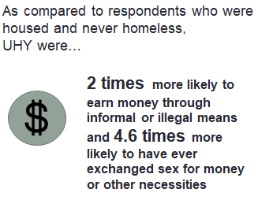Respondents were asked about past involvement in exchanging sex for money, housing, or other necessities. Sixty-three UHY (11.9%) responded yes to this question. This is a decrease from last year when 14.4% indicated having ever exchanged sex for money or other necessities. UHY were 4.6 times more likely to exchange sex for money or other necessities as compared to housed and never homeless respondents. Close to 10% of respondents who were not currently homeless, but who had experienced homelessness in the past reported having ever engaged in sex for money or other necessities. Of housed, never homeless respondents, 2.6% reported having ever exchanged sex for money or other necessities. This is the same rate as last year for this group.

Ten percent of sheltered respondents indicated having ever exchanged sex for money or other necessities, while 13% of couch surfing respondents and 17.9% of unsheltered respondents reported having ever exchanged sex for money or other necessities. Fifty-three percent of the UHY respondents who had exchanged sex for money or other necessities identified as LGBTQ. Of the UHY who identify as LGBTQ, 25.9% reported having ever exchanged sex for money or other necessities. This represents a 10 percentage point decrease from last year. Further, UHY who identified as LGBTQ were 4 times more likely than youth who meet the Commission definition but did not identify as LGBTQ to exchange sex for money or other necessities.

## 2.3 Service Utilization

A major goal of the Massachusetts Youth Count is to gain a better understanding of the kinds of services UHY need and the challenges they face accessing them. The survey tool included three questions related to service utilization. The first asked about the types of services respondents tried to access in the past year. The second asked if they got all, some, or none of the help they needed. The third asked about service barriers. Due to the way questions were asked, there is no way to determine youth’s ability to access any one particular service type.

***More resources like jobs. Yeah, they help us look for them but there are people who don't have money to go around applying for jobs.***

**--24-year old Black cis-female from Brockton**

Starting with service types, respondents could indicate services they had previously sought from a list of 14 service types (note that domestic violence and sexual assault services were divided into two categories in 2019). Respondents could also indicate they had not tried to access any help. Chart Seven shows the distribution of these responses. The four top most sought-out services remained the same in 2019 as compared to the prior years: housing (both shelter and long-term housing); nutritional assistance, and cash assistance. One of the larger increases in services sought was for family support. This increase is encouraging given the significant role family conflict has as a driver of youth and young adult homelessness. Childcare was also sought at a higher rate in 2019 as compared to 2018. The rate of youth not seeking help increased in 2019 to about 12% of respondents. Unsheltered respondents sought health care, family support, and substance abuse treatment at higher rates than other groups of young people based on shelter status. Couch surfing respondents were more likely to seek education support, mental health counseling, sexual assault counseling and no help than other groups.

Chart Eight shows that one-third of the UHY felt they received all the help they sought—this is a six percentage point increase from last year. Fifty-three percent received some of the help they sought and 16% reported receiving none of the help they sought. The percentage of respondents reporting that they received none of the help they sought was similar in 2018. Overall, 84% of the young people received all or some of the help they sought and more received all they sought than in prior years.

Unsurprisingly, there are variations in the extent to which different groups of young people experiencing homelessness felt they got the help they needed (See Chart Nine). For example, 40.6% of young people in shelter felt they received all the help they sought, while only 17.8% of couch surfing youth and 17.2% of unsheltered youth felt they received all the help they sought. Alternatively, only 10.3% of youth in shelter felt they got none of the help they sought as compared to 22.7% of couch surfing youth and 24.0% of unsheltered youth. Cis-males were less likely to report receiving some or all of the help they sought than cis-females.

***We really need places to go for males to have a place to stay at night* .**

**--20-year old Black cis-male from Springfield**

Chart Ten provides reasons young people reported that they did not get the help they needed. The top reasons remained the same from last year—waiting lists, transportation, and not having money. Not hearing back from the provider was in the top five reasons and was the only reason to increase as compared to 2018.

## 2.4 Vulnerable Subpopulations

The Commission was interested in learning more about the experiences of vulnerable subpopulations; therefore, the survey tool contained questions to determine the number of youth who were pregnant or parenting, who had history of systems involvement, those with veteran status, who identified as LGBTQ, and who were under 18 years old. Table Five presents an overview of these populations as compared to respondents who reported being housed and never homeless.

|  |  |  |
| --- | --- | --- |
| Met Commission Definition (529) | TABLE 5: VULNERABLE POPULATIONS  Population | Housed, Never Homeless (826) |
| 24% (127) | Pregnant/Parenting with custody  (234 total respondents) | 3.6% (30) |
| 31.2% (165) | Foster Care Involvement  (325 total respondents) | 4.4% (37) |
| 25.1% (133) | Juvenile or Criminal Justice Involvement  (279 total respondents) | 3.1% (26) |
| 24.7% (131) | LGBTQ  (500 total respondents) | 22.6% (187) |
| 5.9% (31) | Under 18  (672 total respondents) | 54% (445) |
| 2.3% (12) | Military  (41 total respondents) | 1.0% (9) |

As compared to respondents who were housed and never homeless, UHY were almost 7 times more likely to be pregnant or parenting; 7 times more likely to have had foster care involvement; 8 times more likely to have had justice system involvement; and 2 times more likely to have been in the military. UHY were only slightly more likely to report an LGBTQ identity. Alternatively, youth under 18 experiencing homelessness are just a fraction of the sample; yet, we include them in this section this year due to their current vulnerabilities and increased likelihood of experiencing chronic adult homelessness. In the following section, a closer examination is provided of each of these populations’ experiences with homelessness and service acquisition.

### 2.4.1 Pregnant OR Parenting

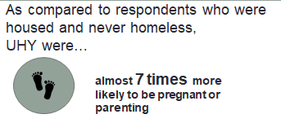Of the 529 youth who met the Commission definition, 127 (24%) were pregnant or parenting with custody of their children. Of the 127, 72.4% were parents with custody, 18.1% were pregnant, and 9.4% were both. Twenty parenting respondents identified as cis-male; 104 as cis-female; and two as transgender. Thirty (3.6%) of housed and never homeless youth and young adults were pregnant or parenting.

The night before the Youth Count survey was taken, 74% of pregnant/parenting respondents were in a shelter, transitional program, or hotel; 19.6% were couch surfing; and 6.2% were unsheltered. Pregnant/parenting respondents were much more likely to be sheltered as compared to UHY as a whole.

The reasons pregnant and parenting respondents were not living with their parents/guardians that differed most significantly from the UHY respondents as a whole were the house being too small and their pregnancy. Pregnant/parenting UHY were less likely than other respondents experiencing homelessness to have been told to leave or to have left due to abuse or neglect in their home.

Pregnant/parenting UHY sought most services at higher rates than UHY as a whole, with the following services being sought at a much higher rate: cash assistance, childcare, and nutritional assistance. They were much less likely to not seek help and to seek a substance use/alcohol treatment program.

These young people were also more likely to get the help they needed: 36% reported getting all the help they needed, and only 8% of them reported not getting any of the help they needed. This is likely due to the higher rate at which these young people were sheltered and therefore connected to services. While pregnant/parenting youth did get connected to services at a higher rate than other groups, the following barriers were more pronounced for them than UHY as a whole: being put on a waiting list, paperwork, and not hearing back. They were less likely to report not feeling safe or comfortable and not having needed identification.

In terms of income sources, the primary income source for pregnant/parenting UHY was cash assistance. These respondents were also more likely to be working a full or part time job than other UHY. There were much less likely to have no income, to be engaged in sex work, to receive money from family, and to be working under the table.

***Housing and general help for pregnant and parenting teens is needed. I slept in my car for two months.***

**--19-year old Multi-racial cis-female from Framingham**

***One agency can't do it all. More help and services are needed to help people in my situation at risk of or on way to being homeless with children.***

**--24-year old White cis-female from Pittsfield**

### 2.4.2 Systems Involvement

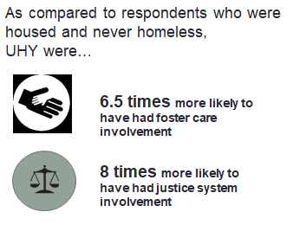In this section we discuss foster care, juvenile justice, and criminal justice involvement. We also highlight the experiences of ‘crossover youth’ or young people with both foster care and juvenile justice involvement.

#### Foster Care

Thirty-one percent of respondents meeting the Commission definition had ever been in foster care; this is five percentage points higher than last year. Only 4.4% of housed, never homeless youth and young adult respondents had ever been in foster care. Roughly 44% of respondents with foster care involvement identified as cis-male and 52% identified as cis-female. Twenty-eight percent of respondents with a history of foster care involvement identified as LGBTQ, which is roughly 3 percentage points higher than respondents as a whole. These respondents reported leaving home permanently at a younger age than UHY as a whole (16.9 versus 17.5).

UHY with involvement in the foster care system were as likely to have been in shelter or transitional housing the night before the survey as UHY as a whole. Of respondents who slept outside the night before the Count, 30.1% had previous foster care involvement. Twenty or 12% of all youth with foster care involvement were unsheltered the night before taking the survey. UHY with foster care system involvement were more likely to be staying with a friend than other UHY, but less likely to be staying with another relative.

UHY with foster care involvement were more likely to not be living with parents due to abuse or neglect or due to the death of a parent/caregiver. These young people were less likely than UHY as a whole to not be living with their family because the home was too small and because they wanted to leave.

UHY with foster care involvement were more likely to have sought short-term shelter, help for job skills, mental health counseling, long-term housing, and domestic violence counseling than UHY respondents as a whole. They were less likely to seek cash assistance and childcare than other UHY. They were slightly less likely to say they received both all and none of the help they sought than UHY respondents. In terms of barriers to receiving the help they needed, UHY with foster care involvement were more likely to report not hearing back, not knowing where to go, and being sent somewhere else than other UHY respondents. While not one of the top five service barriers mentioned, 12% of UHY with foster care involvement reported that not having proper identification was a service barrier as compared to 9.6% of UHY overall. Of all UHY who reported not having proper identification as a barrier, 39% were respondents with foster care involvement.

Twenty-six respondents with foster care involvement (15.8%) reported having ever exchanged sex for basic necessities. This is almost four percentage points higher than respondents who met the Commission definition as a whole.

#### Juvenile or Criminal Justice System

In the 2019 Count, 133 UHY had juvenile or criminal justice system involvement. This represents 25.1% of all UHY respondents and is a 25% decrease from last year. Of these, 40% had juvenile justice system involvement only, 22% had criminal justice system involvement only, and 38% had both (see Chart Eleven). Only 3.1% of housed, never homeless youth and young adult respondents had ever been detained.

Fifty-eight UHY respondents (11%) were ‘crossover youth,’ reporting both foster care and juvenile justice system involvement. This rate is one percentage point lower than last year.

In terms of gender, respondents with justice system involvement differed substantially from others who met the Commission definition in that 63.2% reported identifying as cis-male; 33.1% as cis-female; 3% as gender queer, gender non-conforming, or transgender (Commission definition: 50.5% cis-female and 42.2% cis-male; 4.5% as gender queer, gender non-conforming transgender, two-spirit; or 0.4% agender).

Young people with juvenile justice system involvement tended to have left home permanently at a younger age than UHY as a whole (see Table 6). The young people with justice system involvement had an elevated likelihood of having slept in a place not meant for habitation the night before the survey; 17% of them reported sleeping in a vehicle, outside, or in an abandoned building. This is 5 percentage points higher than respondents who met the Commission definition as a whole. These young people were much less likely to have been in shelter, transitional housing, or a relative’s or friend’s home. Young people with justice system involvement appear to have less connection to formal resources as well as social networks that can provide them with a place to stay.

***Please never be afraid to seek help…***

**--19-year old White cis-male from Worcester**

This picture looks slightly different for crossover youth with respect to the ability to stay with a friend. The fifty-eight respondents experiencing homelessness with both juvenile justice involvement and foster care system involvement were more likely to be staying with a friend than other UHY. They were much less likely to be in shelter, in a relative’s home, or transitional housing.

|  |  |  |  |  |  |
| --- | --- | --- | --- | --- | --- |
| Table Six: Justice System Involvement by Gender and Age | Juvenile only | Criminal only | Both | Crossover youth | UHY total |
| Average current age | 20.1 | 21.8 | 21.7 | 20.5 | 20.8 |
| Average age left home first time | 15.8 | 17.4 | 15.6 | 15.5 | 16.8 |
| Average age left home for good | 16.6 | 18 | 16.6 | 16.1 | 17.5 |

Respondents who met the Commission definition with justice system involvement were more likely to not be living with family due to being released from jail or detention, being told to leave, parental substance use, leaving foster care, and the death of parent or caregiver. They were less likely to report that they wanted to leave, that their house was too small, and their sexual orientation/gender identity as compared to UHY as a whole. Crossover youth were much more likely to report the reason they were not with a caregiver was due to leaving foster care, being abused or neglected, parent/guardian death, and being released from jail or detention. They also were more likely to report their parents’ use and their personal use of alcohol and drugs as reasons they are no longer with family. These young people were less likely to report wanting to leave and the house being too small.

As compared to all respondents meeting the Commission definition, youth with justice system involvement were more likely to have sought substance use/alcohol treatment services; family support; mental health counseling; and job skills/training services and were less likely to seek long-term housing support and childcare. For those who sought help, 23% reported that they received all of the help they sought, as compared to 31% of all UHY. In terms of barriers to receiving the help they needed, UHY with justice system involvement were more likely to report not having money, not qualifying for help, not having the needed identification, and not asking for help than other UHY respondents. They were less likely to report being sent somewhere else.

Crossover youth were more likely to seek shelter, job training, family support, health care, mental health care, and alcohol treatment services. They were less likely to seek nutrition assistance than other UHY. For those who sought help, 24% reported that they received all of the help they sought and 12% reported that they received none of the help they sought. In terms of barriers to receiving the help they needed, crossover youth were more likely to report not having needed identification, not having money, being put on a waiting list, and not hearing back than other UHY respondents. They were less likely to report that they did not follow through or return for services.

In terms of income sources, UHY with justice system involvement were more likely to have reported working under the table, having no income, receiving disability-based income, and hustling/selling drugs than all UHY. They were less likely to report having a part-time job and receiving cash assistance. Roughly 20% of respondents with justice system involvement reported having ever exchanged sex for basic necessities, which is roughly 8 percentage points higher than UHY as a whole.

***Horrible being homeless; not enough services or if service, not enough within the agency to help. Hard to find or available services in Berkshires, rural areas.***

***--22-year old White cis-male from North Adams***

### 2.4.3 Lesbian, Gay, Bisexual, Transgender, Queer/questioning+ (LGBTQ+)[9]

In total, 500 out of the 1,957 respondents reported an LGBTQ identity (25.5%). Of the 500, 131 met the Commission definition for an unaccompanied homeless youth (26.2%). For UHY youth who identified as LGBTQ, the average age they reported leaving their home permanently was 17.6 years old. This was slightly older than the average age when UHY respondents as a whole left home, which was 17.5 years old.

Young people who identified as LGBTQ were more likely to have slept outside or in a car the night before the survey than other respondents. They were much less likely to have slept in a shelter or in the home of a friend. UHY who identified as LGBTQ were more likely than other respondents to report abuse and neglect, not feeling safe in their home, fighting with caregivers and wanting to leave as reasons they were not living with their families. They were less likely to report being released from jail or detention and pregnancy as reasons they were not with family.

Respondents who identified as LGBTQ had a slightly different list of top services sought. In addition to shelter and nutrition assistance, LGBTQ respondents reported mental health services, health care, job training, nutrition assistance, long-term housing, substance use treatment, and sexual assault counseling more frequently than UHY as a whole. They were less likely to report not trying to access help than UHY as a whole. Rates of receiving the help they were seeking were similar to all respondents meeting the Commission definition. In terms of barriers to seeking help, LGBTQ respondents were more likely to report not knowing where to go, transportation issues, not following through with services, not qualifying for help, and not feeling safe as compared to all UHY.

LGBTQ respondents were more likely to report part-time employment, sex work, and no income than other UHY. Fifty-six percent of all UHY respondents who had exchanged sex for money or other necessities identified as LGBTQ. It is important to highlight that 34.5% of UHY who identified as LGBTQ reported having ever exchanged sex for money or other necessities. UHY who identified as LGBTQ were 4 times more likely than youth who meet the Commission definition but did not identify as LGBTQ to exchange sex for money or other necessities.

### 2.4.4. UNDER 18 years old

Only 31 respondents (5.8%) meeting the Commission definition were under the age of 18. On average, these respondents reported leaving home permanently at 14.5 years of age[10].

Roughly 48% of respondents under 18 identified as cis-female, 42% identified as cis-male, and roughly 10% identified as gender-queer/gender non-conforming or Two-Spirit. Twenty-nine percent of UHY respondents under 18 identified as LGBTQ, which is roughly 4 percentage points higher than respondents as a whole.

UHY under the age of 18 were more likely to be staying with a relative, a partner, or staying outside than UHY respondents as a whole. They were much less likely to be staying in a shelter, with a friend, or in transitional housing than other UHY respondents.

UHY under the age of 18 were more likely to not be living with parents due to caregiver substance use, fighting with parents, and personal use of alcohol and drugs. These young people were less likely than UHY as a whole to not be living with their family because the home was too small and because they were told to leave.

UHY under the age of 18 were much more likely to have not sought help than other UHY respondents. They were much less likely to seek shelter, long-term housing, nutritional assistance, or cash assistance. For those that did seek help, 40% said they received all the help they sought and 48% said they received some of the help they sought. In terms of barriers to receiving the help they needed, UHY under the 18 were much less likely to report being put on a waiting list, not qualifying for help, and not hearing back than other than other UHY respondents.

The most frequent income source responses for UHY under 18 were none and a part-time job and UHY under 18 were much more likely to report hustling/selling drugs and earning money from the under the table work than other UHY. They were much less likely have a part-time job, full-time job, and cash assistance. Four UHY under the age of 18 (12.9%) reported having ever exchanged sex for basic necessities.

## 2.5 Demographics

The Commission included several questions to understand demographic characteristics of unaccompanied youth and young adults who were experiencing homelessness. In this section, information about the age, race/ethnicity, gender identity, sexual orientation, and place of birth are provided.

### 2.5.1 Age

Similar to last year, the majority of survey respondents meeting the Commission’s definition of unaccompanied homeless youth were between the ages of 18 and 24. Roughly 6.0% of responses from those meeting the state’s definition for homelessness came from youth under the age of 18 (see Chart Twelve).

The average age unaccompanied homeless youth left home the first time was 16.8 and the average age these young people left home permanently was 17.5. One hundred and sixty (160) young people or 30.2% of UHY left home permanently before age 18. This is relatively the same rate as 2018.

***Make resources available before the age of 18 and make them well known in high schools and college/universities across the state.***

**--22-year old Latino cis-male from Westfield**

### 2.5.2 Race/Ethnicity

Respondents were able to select multiple options for race and ethnicity on the survey tool. Chart Thirteen indicates the distribution of those responses. Cumulatively, Black, Latinx, and Multiracial respondents constituted 65% of the respondents who met the Commission definition but were 58% of all young people surveyed. White respondents made up 30% of all young people surveyed and 28% of those that met the Commission definition. In contrast, the majority of Massachusetts residents are White (~82%) and 61% of students in Massachusetts schools are White. While only 7% of the Massachusetts population identifies as Black/African American, 20% of UHY respondents were Black/African American. Similarly, U.S Census data shows that only 10% of Massachusetts residents are Hispanic/Latino, but 29% of UHY respondents self-identified as Hispanic/Latino/Latina/Latinx.

### 2.5.3 Gender

Of the 529 UHY respondents, 52% identified as cis-female. Roughly 43% of respondents identified as cis-male. Of the remaining respondents, 2% identified as transgender (female and male); 2% as gender queer; 1% as agender; and 1% as two-spirit.

### 2.5.4 Sexual Orientation

In order to better understand the experiences of unaccompanied youth by sexual orientation, the survey tool included the following question: “What is your sexual orientation? Please check the answer that best describes you.” The phrasing and response categories were designed to be as inclusive as possible. Chart Fifteen shows the breakdown of responses. The most common response was straight, at 74% of responses. All responses for lesbian, gay, bisexual, queer, and questioning total 26%.

### 2.5.5 Place of Birth

Of the 529 respondents meeting the Commission’s definition, 64.5% were born in Massachusetts. Breaking this down further, 37.8% of respondents were born in the same city or town in which they took the survey. Roughly 20% were born in the United States but outside of Massachusetts and 13.6% were born outside of the United States (see Chart Sixteen).

# 3.0 Conclusion

Of the 1,957 young people under the age of 25 who responded to the Youth Count survey, 1,151 of them—***or*** ***nearly 60%***—had experienced homelessness at some point in their life. In this report, primary focus was put on the 529 respondents who were currently experiencing homelessness and were also unaccompanied. Thirty percent of these young people left home permanently before the age of 18. Twelve percent were unsheltered the night before taking the survey, meaning they slept outside, in an abandoned building, in a car, or in another location not meant for human habitation. As compared to respondents who were housed and never homeless, in 2019, UHY were almost 7 times more likely to be pregnant or parenting; 6.5 times more likely to have had foster care involvement; and 8 times more likely to have had justice system involvement. The vast majority of these young people sought and received at least some help, but many of them faced barriers accessing the resources they needed.

Nineteen percent (19%) of the UHY were not in school and did not have a diploma, but only 3% of housed, never homeless youth were in this situation. Unsheltered youth were even less likely to have a diploma, suggesting that they may have had a path to homelessness that involved greater levels of disconnection from school and other formal supports. Thirteen percent of the UHY relied on illegal or informal income sources; in some cases even while holding down a part–time or a full-time job. Youth under the age of 18 were much less likely to have stayed in a shelter the night before the survey. These young people were more likely to not be with their family due to family substance use, fighting with caregivers, and their own substance use.

Young people experiencing homelessness demonstrate a great deal of resilience. For example, 34% of the UHY were in either high school or post-secondary education, indicating that in spite of housing instability, many of these young people were engaging in education. Over one-third of the UHY had a part-time job or a full-time job. Eighty-eight percent of the UHY sought and received help over the past 12 months. In addition to basic needs of shelter and food, many young people wanted the type of help that could improve their situation, such as job training, health care, education, and mental health support. Their considerable resilience comes through even in a point-in-time survey.

Holding both their vulnerabilities and resilience in mind, we highlight several areas from the 2019 Count that can help guide future interventions.

1. **Focus on family situations.** There is a lot we can learn from examining the reasons that the young people were no longer with their families. The primary factors associated with unaccompanied youth homelessness continued to include family conflict and economic instability. Yet, certain factors took on more salience for the different sub-populations. For example, for youth with foster care involvement prominent factors included abuse or neglect and having a parent or caregiver die. For youth with justice system involvement, more salient factors included being released from jail or detention, being told to leave, and parental substance use. A noticeable reason for LGBTQ+ youth included not feeling safe in their home. What is also compelling is looking at the reasons that emerged as less important. For example, youth with foster system involvement or justice system involvement were less likely to not be living with their families because they wanted to leave.

***Educating schools and service providers about family dynamics that increase a young person’s likelihood of not being able to stay with family could allow for earlier intervention and more effective housing stabilization.***

1. **Social networks matter.** Thirty-one percent (31%) of the UHY stayed with a friend, a relative, or a partner the night before the survey. Being doubled-up or couch surfing can expose young people to additional risks and increase the likelihood they may have to exchange sex for a place to stay. Yet, we can also understand these social networks as a valuable resource that many youth possess that can help them when they cannot or prefer not to access more formal housing resources. What is also interesting to look at are patterns within the UHY group in terms of being doubled-up. For example, young people with foster care involvement were more likely to being staying with a friend than other UHY, but less likely to be staying with a relative. Young people with justice system involvement were much less likely to have been in shelter, transitional housing, or a relative’s or friend’s home. Respondents with justice system involvement appeared to have less connection to formal resources as well as social networks that could provide them with a place to stay.

***Case workers from the Department of Children and Families (DCF) and the Department of Youth Services (DYS) could help system-involved youth to understand their social networks as a strategy to avoid transitioning into homelessness and/or staying in risky or dangerous situations.***

1. **Taking a deeper look at unconnected and disconnected youth.** There were some interesting data points in the 2019 Youth Count results that illustrate dynamics of connection and disconnection. For example, we saw a 43% increase in the number of youth and young adults in transitional housing. Pregnant and parenting UHY were much more likely than the UHY as a whole to be sheltered. Sheltered youth were considerably more likely to get some or all of them help they sought as compared to unsheltered and couch surfing youth. These data suggest encouraging movement in youth getting connected to formal services and the positive outcomes associated with connection.

Yet, we also saw ways that lack of connection increases youth’s vulnerability. For example, unsheltered and couch surfing youth were much more likely to rely on hustling, drug dealing, sex work, and panhandling than sheltered youth. Unsheltered respondents were least likely to be in school and have a diploma. We found that 12% of UHY did not seek help over the past 12 months. Of those that did not seek help, 73% were doubled-up or unsheltered.

For those that did seek help, we saw interesting differences in what they were looking for. Unsheltered respondents sought health care, family support, and substance use treatment at higher rates than other groups of young people based on shelter status. Couch surfing respondents were more likely to seek education support, mental health counseling, sexual assault counseling, and no help than other groups. These young people’s service needs reinforce the idea that they are experiencing significant life challenges on top of being homeless, such as sexual assault and substance use. Youth under 18 also were much less likely to sheltered. These young people were also less likely to report seeking help, which helps to explain the challenges providers face trying to connect with them during the Youth Count.

***The Youth Count provides important insight into the situations of unconnected and disconnected youth. It is important to highlight that these young people tended to be recruited to take the survey through Youth Ambassadors, service providers, street outreach workers, and education programs. Meeting these young people where they are at appears to be an important connection strategy. Solely relying on shelter counts would decrease our ability to understand and intervene in the situations of these very vulnerable young people.***

After conducting the Youth Count for six years, we have learned a great deal about the scope of the problem and service needs of unaccompanied youth and young adults experiencing homelessness. Yet, we continue to have at least three gaps in our knowledge base. One, there are many cities and towns from which we receive no surveys (See Attachment Six). There is likely a correlation between these places and availability of services for young people experiencing homelessness. Two, while we have made great strides in developing robust Youth Ambassador and street outreach procedures, these lessons have not been applied across the state, decreasing our connection to young people who are doubled-up, couch surfing, unsheltered youth, or under 18 years old. Finally, the MA Youth Count process has been largely unsuccessful connecting with unaccompanied youth under the age of 18. While 23% of all surveys collected are from youth under 18, in 2019 only 6% of them met the Commission definition. The data tell us that the average age UHY left home permanently was 17.5 years old and that over 30% of youth left home permanently before the age of 18; yet our Count strategies are not reaching youth under 18 who meet the Commission definition. Specific strategies will be needed to address these three gaps.

Massachusetts remains committed to ending youth and young adult homelessness. As the MA State Plan to End Youth Homelessness rolls out, we are already seeing improvements in young peoples’ ability to access supports, services, and resources such as transitional housing. It is clear that young people connected to formal housing resources also get connected to services and other supports that increase their ability to exit homelessness permanently. The Youth Count makes visible the situation of less connected youth. Vigilance will be needed to connect with these young people so that we can achieve our goal of ending youth homelessness in the Commonwealth.

***Hope to continue receiving help, I'm crying for help and hate the situation I am in.***

**--21-year old Multi-racial cis-female from Worcester**

# 4.0 Attachments[11]

1. Methodology
2. Members of the Commission on Unaccompanied Homeless Youth
3. Final 2019 Uniform Survey Tool (English Version)
4. State level data table
5. Open-ended responses
6. Cities and towns where surveys were and were not collected

**Attachment One: Methodology**

#### Structure of the Massachusetts Youth Count

Three organizing entities support the Massachusetts Youth Count: the Massachusetts Commission on Unaccompanied Homeless Youth (the Commission), the Identification and Connection Working Group (the Working Group) of the Commission, and a network of ten regional providers often with the support of the local Continuums of Care (CoCs).[12]

The ***Massachusetts Commission on Unaccompanied Homeless Youth*** provides oversight for the Count and is responsible for reporting on its progress annually to the Governor’s Office, the Legislature, and the Office of the Child Advocate. The Executive Office of Health and Human Services chairs the Commission, and at the time of the 2019 Count, the Commission included 29 members, representing youth, state government, service providers, and advocates (see Attachment Two for members of the Commission).

The ***Identification and Connection Working Group*** of the Commission organized and facilitated the Massachusetts Youth Count on behalf of the Commission. For the 2019 Count, its primary responsibilities were to convene interested stakeholders to prepare for the Count, update the Count methodology, make needed modifications to the uniform survey tool, develop print and social media materials for stakeholders to prepare for the Count, and implement the Count in partnership with Regional Providers. The Working Group is chaired by Gordie Calkins of the Department of Housing Community Development and Kelly Turley of the Massachusetts Coalition for the Homeless.

The ***Regional Providers*** implemented and coordinated the Youth Count at the local and regional level. Each Regional Provider had a unique geographic area to cover, a mix of resources and providers, and high demand for homeless services.

#### Youth Count Methodology

The Commission, through the Working Group, provided technical assistance to the network of regional providers that executed the Youth Count survey in 2019. The Count’s uniform survey tool was administered during a 4-week period from April 12 through May 12,2019. The Working Group developed guidelines for regional partners to work with diverse partners to identify young people who may or may not be connected to schools, employment or social services and to engage youth volunteers, also known as “Youth Ambassadors,” to assist with implementation.

The Youth Count is aligned with lessons learned through Chapin Hall’s Voices of Youth Count process[13]. The Working Group formulated a set of guidelines based on best practices to conduct a youth count (See Pergamit et al., 2013). Recommended practices included forming a local planning committee, providing stipends to youth volunteers, conducting focused youth outreach and marketing of the count, training all volunteers, engaging diverse partners, providing day-of coordination and quality control, and seeking creative ways to engage youth under 18 years old.

##### Refinement of the Uniform Survey Tool

To develop the 2019 uniform survey tool, the Working Group started with the 2018 survey tool and worked to further address limitations, reduce confusion, and encourage completion of each question by survey participants. In 2019, the one modification made to the tool was to separate sexual assault and domestic violence support into two questions. In 2019, we continued to use the Google Form to capture responses. The survey was also administered through a paper version. The paper survey was available in English, Spanish, Haitian Creole, Cape Verdean Creole, Khmer/Cambodian, and Brazilian Portuguese. The electronic Google Form was available in English and Spanish. See Attachment Three for the final English version of the 2019 Uniform Survey Tool.

##### Regional Provider Engagement

Once the methodology and updated survey tool were complete, the Working Group worked with the Regional Providers to develop the outreach strategies. Engagement with the Regional Providers during this phase included email and telephone conversations providing basic information about what the Working Group was hoping to accomplish, grant information, and a webinar on April 4th 2019 that described the proposed methodology. Additionally, each Provider had the opportunity to apply for a capacity-building grant in the amount of up to $3,500 from the Commission to help with financial costs of conducting the Youth Count.

**Attachment Two: Members of the Commission on Unaccompanied Youth**

|  |  |
| --- | --- |
| **Role** | **Name** |
| House Minority Leader Representative | Kate Campanale |
| Senate Minority Leader | Maureen Flatley |
| Member of the House | Representative James O’Day |
| Member of the Senate | Senator Harriette Chandler |
| Member of the Senate | Senator Katherine Clark |
| Boston Alliance of GLBT Youth | Grace Sterling-Stowell |
| Department of Children and Families | Amy Mullen |
| Department of Children and Families | Linda Spears |
| Department of Elementary and Secondary Education | Jeffery Wulfson, Sarah Slautterback |
| Department of Housing and  Community Development | Chrystal Kornegay, Gordie Calkins |
| Department of Mental Health | Joan Mikula |
| Department of Public Health | Dr. Monica Bharel |
| Department of Transitional Assistance | Jeffrey McCue |
| Department of Youth Services | Rebecca Moore |
| Direct Service Provider, Appointed by the Governor | Lisa Goldblatt-Grace, My Life My Choice |
| Direct Service Provider, Appointed by the Governor | Lisa Goldsmith, DIAL/SELF |
| Direct Service Provider, Appointed by the Governor | Kevin Lilly, Samaritan Steps |
| House Chair, Committee on Children, Families Persons with Disabilities | Representative Kay Khan |
| ICHH (staff) | Linn Torto |
| MA Appleseed Center for Law and Justice | Joan Meschino |
| MA Coalition for the Homeless | Kelly Turley |
| MA Housing and Shelter Alliance | Caitlin Golden |
| MA Task Force on Youth Aging Out of DCF | Danielle Ferrier |
| MA Transgender Political Coalition | Gunner Scott |
| MassEquality.Org | Carly Button |
| Office of Medicaid | Lauren Almquist |
| Secretary of Health and Human Services | Secretary Marylou Sudders, (Chair) |
| Youth | Jamila Bradley |
| Youth | Lauren Leonardis |
| Youth | Kitty Zen |

**Attachment Three: Final 2019 Uniform Survey Tool**

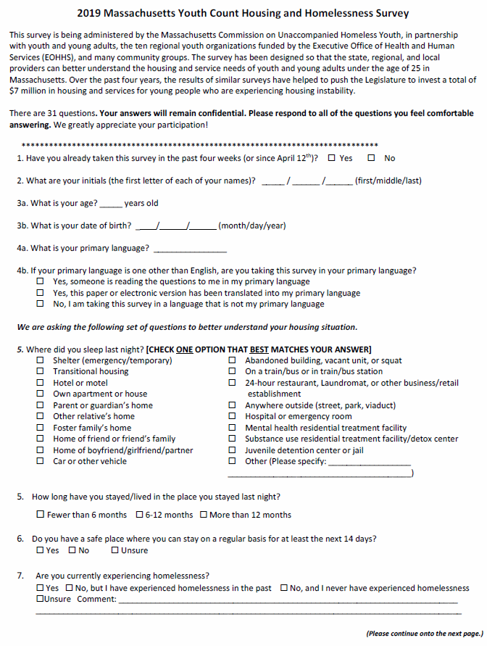

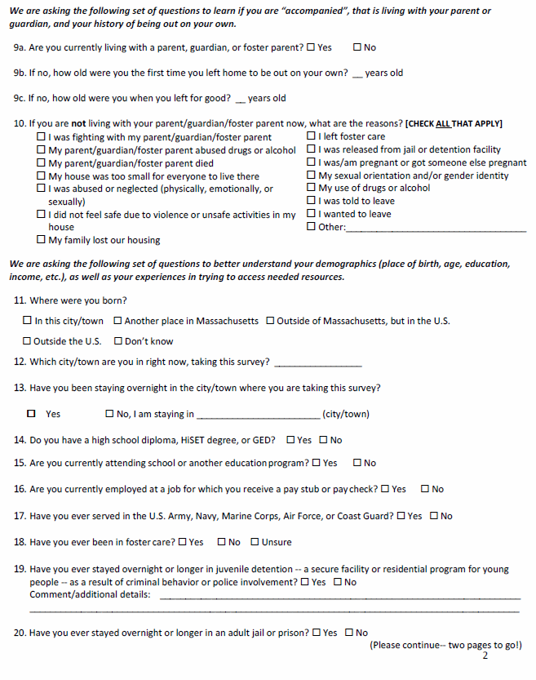

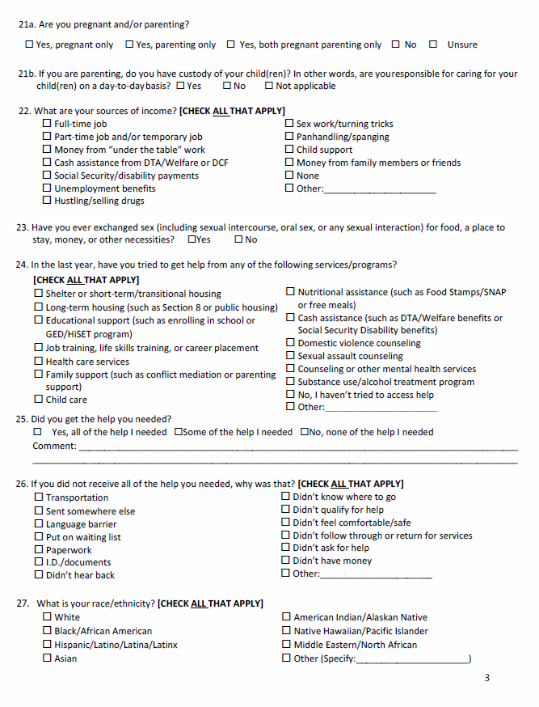

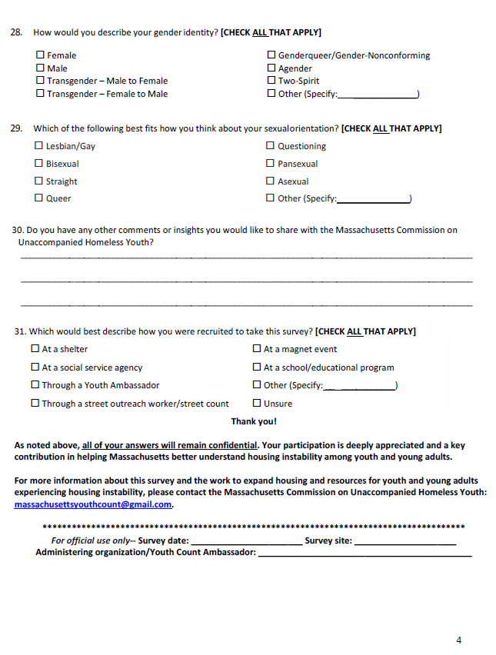

**Attachment Four: State Level Data Table**

|  |  |  |  |  |
| --- | --- | --- | --- | --- |
| Individual Characteristics | Total number | % Total | # 2019  Commission Definition | % 2019  Commission Definition |
| Total | 1957 | NA | 529 | 27% |
| Under 18 Years Old | 672 | 34.3% | 31 | 5.9% |
| Average age (current) | 18.8 | 1.0% | 20.8 |  |
| Asian | 58 | 3.0% | 7 | 1.3% |
| Black / African American | 390 | 19.9% | 108 | 20.4% |
| Hispanic / Latino / Latina | 427 | 21.8% | 153 | 28.9% |
| Middle Eastern / North African | 16 | 0.8% | 3 | 0.6% |
| Multiracial | 317 | 16.2% | 85 | 16.1% |
| Native American / Pacific Islander / Native Hawaiian | 10 | 0.5% | 3 | 0.6% |
| White | 585 | 29.9% | 149 | 28.2% |
| Other | 4 | 0.2% | 2 | 0.4% |
| Cis-Female | 928 | 47.4% | 267 | 50.5% |
| Cis-Male | 797 | 40.7% | 223 | 42.2% |
| Agender | 6 | 0.3% | 2 | 0.4% |
| Genderqueer | 37 | 1.9% | 8 | 1.5% |
| Transgender | 44 | 2.2% | 11 | 2.1% |
| Two-Spirit | 10 | 0.5% | 2 | 0.4% |
| Straight | 1289 | 65.9% | 369 | 69.8% |
| Gay / Lesbian | 101 | 5.2% | 27 | 5.1% |
| Queer | 22 | 1.1% | 8 | 1.5% |
| Bisexual | 249 | 12.7% | 71 | 13.4% |
| Asexual | 14 | 0.7% | 3 | 0.6% |
| Pansexual | 69 | 3.5% | 11 | 2.1% |
| Questioning / Don't Know /Other | 38 | 1.9% | 9 | 1.7% |
| Pregnant/Parenting *has custody* | 234 | 12.0% | 127 | 24.0% |
| Foster care involvement | 325 | 16.6% | 165 | 31.2% |
| Juvenile or criminal justice involvement | 279 | 14.3% | 133 | 25.1% |
| Not in school, no diploma or equivalent | 181 | 9.2% | 101 | 19.1% |
| Ever exchanged sex for money, housing | 143 | 7.3% | 63 | 11.9% |
| Average age left home first time |  | 0.0% | 16.8 |  |
| Average age left for good |  | 0.0% | 17.5 |  |
| # ever in military | 41 | 2.1% | 12 | 2.3% |

**Attachment Five: Open-ended Responses on 2018 Youth Count Survey**

The following themes emerged from an analysis of the open-ended response to the final question on the 2019 Youth Count Survey, **“Do you have any comments or insights you would like to share with the MA Commission on Unaccompanied Homeless Youth?”** Quotations follow each theme. Quotations were also integrated throughout the report.

**Under 18**

* Transportation can be really hard. It would be nice if there was a safe place for 16 yo's to go.
* They should try and let kids under 18 get housing while still going to school and working
* There needs to be homeless shelters for the youth
* Make resources available before the age of 18 and make them well known in high schools and college/universities across the state
* I think there should be a shelter for youths only in MA cause a lot of youths are out on the street with no place to put their head cause they got kicked out, abused, don’t feel safe etc.
* Homelessness in Massachusetts along with many other states is a huge problem. Elderly homeless, but they can try to help their situation. There are way too many children and teens that don't get the help they need.
* Mas ayuda para los jovenes imigrantes

**Teen parent**

* You should help more with finding apartment because not all parents are able to work but need a stable apartment because of the living conditions here especially with a newborn.
* One agency can't do it all. More help and services are needed to help people in my situation at risk of or on way to being homeless with children.
* More options for pregnant/single mom housing
* I believe there should be more affordable housing for young single moms
* Housing and general help for pregnant and parenting teens is needed. I slept in my car for 2 months
* Be more open on prioritizing young parents for Section 8 list, housing, or entering shelter

**Services for males**

* We really need places to go for males to have a place to stay at night
* Massachusetts needs more resources for young men

**DCF/Foster Care**

* DCF will not provide childcare for me until my daughter is 3 months old, but I want to complete my high school education.
* Get more foster homes for the many kids in foster care...too many to count.

**Housing**

* Nothing other than what's already in place. We need more housing for homeless teens and I understand MA is trying to help so keep up the good work.
* More options for emergency housing
* More housing, less yearly waits
* More affordable housing
* Lowell housing should do more
* We need more affordable housing that doesn’t take years to get! Bringing back rent control would help so many from homeless. The cost of living for one person is extremely expensive and more people will become homeless because of it.
* To help younger people with housing
* Rent is too high. A room is $700. If rent was lower I could swing it.
* Make housing more affordable
* Just making more housing available for working youth
* Finding low income housing has been difficult
* Can you help me find a cheap apartment please?
* A need for more affordable housing

**Family issues**

* Mom died/ dad kicked me out at 17 yrs old
* Family is complicated my dad wants all my $ if I live w/him. My mom has no room and we bug each other all the time
* My mother lost housing after domestic violence and corruption in court. Cape is a who knows who crooked place. My youngest brother’s relatives work in the courts and have police/ agency ties here. I was denied a shelter placement on Cape a few yrs ago. My mom finally got a home after being homeless for 3 1/2 yrs in hotels and a campground. Now the town says the room sizes are a few inches too small to house the 5 of us. We have been through hell by men in Power on Cape Cod. They used DCF to destroy us. Elizabeth Warren has had a case about us for 3 yrs. Lower Cape Outreach helped us. Trying to rebuild what was illegally stolen from my family has been hard. 3 states involved. MA, AZ, and IL.
* I was always a good child to my parents than my dad started being abusive and I started to be bad and stuff I kept running away due to him trying hit me and I also ran away due to my uncle sexual assaulting me. I went to court when they found me told them what happen and they haven't done anything about me being sexual assaulted by my uncle and when I go to court the judge never listens to me only my dad and sometimes I feel like killing myself because they’re trying to send me back with my dad and my uncle. At court I said that and they judge to the police to tell me to cut that crap and stuff and I forgot a phone password because I’ve been at the house for 7 months now and I haven’t been on the phone since were not allowed to and the judge mad be stay until I figured it out so I work with my DCF tryna to fight out what it was I gave him some numbers the judge said if it was wrong for my dad to call them and I will go to DYS which I never been there .so now I’m feel like killing myself because I don’t feel safe going back with my dad and my uncle .and think they shouldn’t because this is how teen suicide happens because they don’t listen and send kids back to their family and that how they be killing them self. All I want is to go into a foster home finish school and go to pre independent living when I’m 16 and live my life
* I was adopted by my parents and then after all the services went away and my parents don't understand me (they are white and I am black)

**Advice**

* Visit High Schools. Offer a life skills class to prevent homelessness/ money management
* Yes, when applying for shelter if the young adult is attending college, training, or work related programs, DHCD should not move the person away from home! Especially a young adult that is a parent!
* Please work directly with those looking to transition into independent living (own apartment/with roommates) and out of transitional programs like Somerville village. One on one help and focusing on personalized action plans with follow through from supports

**Service quality (positive)**

* SMOC housing and my caseworker helped me in the best way that they could, I can't be more thankful for their help. Only been at the shelter for one day.
* Francis House in Fall River has helped me a lot, I received my Hi-Set and am now enrolled at BCC
* Should have more resources like Job Corps for young adults closer to where they live
* Please never be afraid to seek help, one of the best places you can go to in your time of need is Grafton Job Corps, free food, free housing, and a free education

**Service quality (negative)**

* You guys need to learn better people skills. Stop using getting kicked out as a threat. Treat us like people not like animals or someone less than yourself.
* Yes, been moved around shelter to shelter in MA with my wife and son. Shouldn't place married families with single families. They should get their own space.
* Y'all suck at your job, there's always been people out here hurting.
* Was too scared to go to a shelter, heard some scary rumors so never seeked out shelter services & stayed at friends instead since Jan.2019
* There needs to be more communication respect understanding and structure cause it's bad enough were homeless so just show respect
* The shelter system needs to be changed and advocated for more. More programs need to be made for them to help stabilize their life.
* The local shelters place youths in sober living homes. Exposing them to drug related problems
* Shouldn't have to be hard for youth to go into shelter, youth is the future
* More help for people and less employees are needed-Louison House in North Adams Ten people live there, 7 staff. Like WTF???
* I have friends who are struggling with where to go after this. There are great resources for youth at risk for homelessness, but not for adults.

**Gaps in rural areas**

* Horrible being homeless; not enough services or if service, not enough w/in the agency to help; hard to find or available services in Berkshires, rural areas
* Being homeless in Pittsfield, North Adams and Adams is hard because there is hardly any services and places are always full

**LGBTQ service gaps**

* We need more LGBT+ specific services in Berkshire County, or a youth-centered shelter

**Domestic violence**

* More help with domestic violence healing would be an awesome addition to services

**Need help**

* We need help!!
* There’s too many of us to be so overlooked.
* There need to be more services available to help us
* Please just help me get on my feet! I'm done not being somewhere where I can call home.
* It’s hard being a struggling homeless youth
* I think all homeless youth should have a place to stay
* Hope to continue receiving help, I'm crying for help and hate the situation I am in

**Attachment Six: Where surveys were and were not collected**

In 2019, surveys were collected in 107 out of the 351 cities and towns of Massachusetts (30%). Respondents who met the Commission definition were surveyed in 51 of these cities and towns. The following table is organized by Regions and provides a list of all cities and towns where surveys were collected, the number of surveys collected in each, and the number that met the Commission definition. Total numbers of surveys collected and meeting the Commission definition do not add up to 1,957 and 529 respectively due to missing information about where the young person was staying.

|  |  |  |
| --- | --- | --- |
| **Region/Cities & Towns** | **Sum of Total** | **Sum of Commission** |
| **Region 1 - Tri-County** | **136** | **47** |
| Adams | 2 | 2 |
| Alford | 0 | 0 |
| Amherst | 3 | 1 |
| Ashfield | 0 | 0 |
| Becket | 0 | 0 |
| Belchertown | 0 | 0 |
| Bernardston | 0 | 0 |
| Buckland | 0 | 0 |
| Charlemont | 0 | 0 |
| Cheshire | 0 | 0 |
| Chesterfield | 0 | 0 |
| Clarksburg | 0 | 0 |
| Colrain | 0 | 0 |
| Conway | 1 | 1 |
| Cummington | 0 | 0 |
| Dalton | 0 | 0 |
| Deerfield | 0 | 0 |
| Easthampton | 2 | 1 |
| Egremont | 0 | 0 |
| Erving | 0 | 0 |
| Florida | 0 | 0 |
| Gill | 0 | 0 |
| Goshen | 0 | 0 |
| Granby | 0 | 0 |
| Great Barrington | 0 | 0 |
| Greenfield | 37 | 9 |
| Hadley | 0 | 0 |
| Hancock | 0 | 0 |
| Hatfield | 0 | 0 |
| Hawley | 0 | 0 |
| Heath | 0 | 0 |
| Hinsdale | 0 | 0 |
| Huntington | 0 | 0 |
| Lanesborough | 0 | 0 |
| Lee | 0 | 0 |
| Lenox | 0 | 0 |
| Leverett | 0 | 0 |
| Leyden | 0 | 0 |
| Middlefield | 0 | 0 |
| Monroe | 0 | 0 |
| Montague | 19 | 3 |
| Monterey | 0 | 0 |
| Mount Washington | 0 | 0 |
| New Ashford | 0 | 0 |
| New Marlborough | 0 | 0 |
| New Salem | 0 | 0 |
| North Adams | 16 | 6 |
| Northampton | 17 | 7 |
| Northfield | 0 | 0 |
| Orange | 5 | 1 |
| Otis | 0 | 0 |
| Pelham | 0 | 0 |
| Peru | 0 | 0 |
| Pittsfield | 26 | 15 |
| Plainfield | 0 | 0 |
| Richmond | 0 | 0 |
| Rowe | 0 | 0 |
| Sandisfield | 0 | 0 |
| Savoy | 0 | 0 |
| Sheffield | 0 | 0 |
| Shelburne | 1 | 0 |
| Shutesbury | 0 | 0 |
| South Hadley | 2 | 0 |
| Southampton | 0 | 0 |
| Stockbridge | 0 | 0 |
| Sunderland | 0 | 0 |
| Tyringham | 0 | 0 |
| Ware | 0 | 0 |
| Warwick | 0 | 0 |
| Washington | 0 | 0 |
| Wendell | 0 | 0 |
| West Stockbridge | 0 | 0 |
| Westhampton | 0 | 0 |
| Whately | 4 | 1 |
| Williamsburg | 0 | 0 |
| Williamstown | 0 | 0 |
| Windsor | 0 | 0 |
| Worthington | 1 | 0 |

|  |  |  |
| --- | --- | --- |
| **Region/Cities & Towns** | **Sum of Total** | **Sum of Commission** |
| **Region 2 - Hampden County** | **173** | **99** |
| Agawam | 1 | 0 |
| Blandford | 0 | 0 |
| Brimfield | 1 | 0 |
| Chester | 0 | 0 |
| Chicopee | 13 | 1 |
| East Longmeadow | 0 | 0 |
| Granville | 0 | 0 |
| Hampden | 0 | 0 |
| Holland | 0 | 0 |
| Holyoke | 20 | 13 |
| Longmeadow | 0 | 0 |
| Ludlow | 2 | 0 |
| Monson | 0 | 0 |
| Montgomery | 0 | 0 |
| Palmer | 1 | 0 |
| Russell | 0 | 0 |
| Southwick | 1 | 0 |
| Springfield | 102 | 63 |
| Tolland | 0 | 0 |
| Wales | 0 | 0 |
| West Springfield | 18 | 10 |
| Westfield | 14 | 12 |
| Wilbraham | 0 | 0 |
| **Region/Cities & Towns** | **Sum of Total** | **Sum of Commission** |
| **Region 3 - Worcester County** | **340** | **77** |
| Ashburnham | 0 | 0 |
| Athol | 3 | 1 |
| Auburn | 0 | 0 |
| Barre | 0 | 0 |
| Berlin | 0 | 0 |
| Blackstone | 0 | 0 |
| Bolton | 1 | 1 |
| Boylston | 1 | 0 |
| Brookfield | 1 | 0 |
| Charlton | 1 | 0 |
| Clinton | 1 | 0 |
| Douglas | 0 | 0 |
| Dudley | 3 | 0 |
| East Brookfield | 0 | 0 |
| Fitchburg | 24 | 9 |
| Gardner | 1 | 0 |
| Grafton | 1 | 0 |
| Hardwick | 0 | 0 |
| Harvard | 1 | 0 |
| Holden | 1 | 1 |
| Hopedale | 0 | 0 |
| Hubbardston | 0 | 0 |
| Lancaster | 0 | 0 |
| Leicester | 0 | 0 |
| Leominster | 1 | 0 |
| Lunenburg | 0 | 0 |
| Mendon | 0 | 0 |
| Milford | 0 | 0 |
| Millbury | 0 | 0 |
| Millville | 0 | 0 |
| New Braintree | 0 | 0 |
| North Brookfield | 0 | 0 |
| Northborough | 0 | 0 |
| Northbridge | 1 | 0 |
| Oakham | 0 | 0 |
| Oxford | 0 | 0 |
| Paxton | 1 | 0 |
| Petersham | 0 | 0 |
| Phillipston | 0 | 0 |
| Princeton | 0 | 0 |
| Royalston | 0 | 0 |
| Rutland | 0 | 0 |
| Shrewsbury | 0 | 0 |
| Southborough | 0 | 0 |
| Southbridge | 0 | 0 |
| Spencer | 0 | 0 |
| Sterling | 0 | 0 |
| Sturbridge | 16 | 0 |
| Sutton | 0 | 0 |
| Templeton | 0 | 0 |
| Upton | 0 | 0 |
| Uxbridge | 0 | 0 |
| Warren | 0 | 0 |
| Webster | 0 | 0 |
| West Boylston | 0 | 0 |
| West Brookfield | 0 | 0 |
| Westborough | 0 | 0 |
| Westminster | 1 | 0 |
| Winchendon | 1 | 0 |
| Worcester | 280 | 65 |

|  |  |  |
| --- | --- | --- |
| **Region/Cities & Towns** | **Sum of Total** | **Sum of Commission** |
| **Region 4 - Bristol County** | **37** | **10** |
| Acushnet | 0 | 0 |
| Attleboro | 2 | 0 |
| Berkley | 0 | 0 |
| Dartmouth | 0 | 0 |
| Dighton | 0 | 0 |
| Easton | 0 | 0 |
| Fairhaven | 0 | 0 |
| Fall River | 21 | 2 |
| Freetown | 0 | 0 |
| Mansfield | 0 | 0 |
| New Bedford | 13 | 8 |
| North Attleborough | 0 | 0 |
| Norton | 0 | 0 |
| Raynham | 0 | 0 |
| Rehoboth | 0 | 0 |
| Seekonk | 0 | 0 |
| Somerset | 0 | 0 |
| Swansea | 1 | 0 |
| Taunton | 0 | 0 |
| Westport | 0 | 0 |

|  |  |  |
| --- | --- | --- |
| **Region/Cities & Towns** | **Sum of Total** | **Sum of Commission** |
| **Region 5 - Cape Cod & Islands (Barnstable, Dukes & Nantucket counties)** | **86** | **15** |
| Aquinnah | 1 | 0 |
| Barnstable | 61 | 4 |
| Bourne | 0 | 0 |
| Brewster | 1 | 0 |
| Chatham | 1 | 1 |
| Chilmark | 0 | 0 |
| Dennis | 3 | 2 |
| Eastham | 1 | 1 |
| Edgartown | 3 | 1 |
| Falmouth | 4 | 3 |
| Gosnold | 0 | 0 |
| Harwich | 0 | 0 |
| Mashpee | 1 | 1 |
| Nantucket | 1 | 0 |
| Oak Bluffs | 3 | 2 |
| Orleans | 0 | 0 |
| Provincetown | 1 | 0 |
| Sandwich | 1 | 0 |
| Tisbury | 1 | 0 |
| Truro | 0 | 0 |
| Wellfleet | 1 | 0 |
| West Tisbury | 0 | 0 |
| Yarmouth | 2 | 0 |

|  |  |  |
| --- | --- | --- |
| **Region/Cities & Towns** | **Sum of Total** | **Sum of Commission** |
| **Region 6 - Plymouth & East Norfolk counties** | **41** | **25** |
| Abington | 0 | 0 |
| Braintree | 0 | 0 |
| Bridgewater | 0 | 0 |
| Brockton | 35 | 23 |
| Carver | 0 | 0 |
| Cohasset | 0 | 0 |
| Duxbury | 0 | 0 |
| East Bridgewater | 0 | 0 |
| Halifax | 0 | 0 |
| Hanover | 0 | 0 |
| Hanson | 0 | 0 |
| Hingham | 0 | 0 |
| Holbrook | 0 | 0 |
| Hull | 0 | 0 |
| Kingston | 0 | 0 |
| Lakeville | 0 | 0 |
| Marion | 0 | 0 |
| Marshfield | 0 | 0 |
| Mattapoisett | 0 | 0 |
| Middleborough | 0 | 0 |
| Norwell | 1 | 1 |
| Pembroke | 0 | 0 |
| Plymouth | 2 | 0 |
| Plympton | 0 | 0 |
| Quincy | 2 | 1 |
| Rochester | 0 | 0 |
| Rockland | 0 | 0 |
| Scituate | 0 | 0 |
| Wareham | 0 | 0 |
| West Bridgewater | 0 | 0 |
| Weymouth | 1 | 0 |
| Whitman | 0 | 0 |

|  |  |  |
| --- | --- | --- |
| **Region/Cities & Towns** | **Sum of Total** | **Sum of Commission** |
| **Region 7 - Essex County** | **43** | **12** |
| Amesbury | 1 | 0 |
| Andover | 0 | 0 |
| Beverly | 0 | 0 |
| Boxford | 0 | 0 |
| Danvers | 0 | 0 |
| Essex | 1 | 0 |
| Georgetown | 0 | 0 |
| Gloucester | 1 | 1 |
| Groveland | 0 | 0 |
| Hamilton | 0 | 0 |
| Haverhill | 3 | 3 |
| Ipswich | 0 | 0 |
| Lawrence | 3 | 2 |
| Lynn | 18 | 3 |
| Lynnfield | 0 | 0 |
| Manchester | 0 | 0 |
| Marblehead | 0 | 0 |
| Merrimac | 0 | 0 |
| Methuen | 0 | 0 |
| Middleton | 0 | 0 |
| Nahant | 0 | 0 |
| Newbury | 0 | 0 |
| Newburyport | 2 | 0 |
| North Andover | 0 | 0 |
| Peabody | 1 | 0 |
| Rockport | 0 | 0 |
| Rowley | 0 | 0 |
| Salem | 9 | 3 |
| Salisbury | 0 | 0 |
| Saugus | 3 | 0 |
| Swampscott | 0 | 0 |
| Topsfield | 0 | 0 |
| Wenham | 0 | 0 |
| West Newbury | 1 | 0 |

|  |  |  |
| --- | --- | --- |
| **Region/Cities & Towns** | **Sum of Total** | **Sum of Commission** |
| **Region 8 - North Middlesex County** | **183** | **48** |
| Acton | 0 | 0 |
| Ashby | 0 | 0 |
| Ayer | 0 | 0 |
| Bedford | 1 | 0 |
| Billerica | 0 | 0 |
| Boxborough | 0 | 0 |
| Burlington | 0 | 0 |
| Carlisle | 0 | 0 |
| Chelmsford | 0 | 0 |
| Concord | 1 | 0 |
| Dracut | 0 | 0 |
| Dunstable | 0 | 0 |
| Groton | 0 | 0 |
| Hudson | 0 | 0 |
| Lexington | 0 | 0 |
| Lincoln | 32 | 0 |
| Littleton | 0 | 0 |
| Lowell | 113 | 46 |
| Marlborough | 1 | 0 |
| Maynard | 0 | 0 |
| North Reading | 0 | 0 |
| Pepperell | 0 | 0 |
| Reading | 0 | 0 |
| Shirley | 0 | 0 |
| Stoneham | 1 | 0 |
| Stow | 0 | 0 |
| Sudbury | 32 | 2 |
| Tewksbury | 0 | 0 |
| Townsend | 0 | 0 |
| Tyngsborough | 0 | 0 |
| Wakefield | 1 | 0 |
| Wayland | 0 | 0 |
| Westford | 0 | 0 |
| Weston | 1 | 0 |
| Wilmington | 0 | 0 |
| Winchester | 0 | 0 |
| Woburn | 0 | 0 |

|  |  |  |
| --- | --- | --- |
| **Region/Cities & Towns** | **Sum of Total** | **Sum of Commission** |
| **Region 9 - Metro West**  **(South Middlesex & West Norfolk counties)** | **63** | **31** |
| Ashland | 0 | 0 |
| Avon | 1 | 1 |
| Bellingham | 0 | 0 |
| Canton | 0 | 0 |
| Dedham | 0 | 0 |
| Dover | 0 | 0 |
| Foxborough | 0 | 0 |
| Framingham | 56 | 27 |
| Franklin | 0 | 0 |
| Holliston | 0 | 0 |
| Hopkinton | 1 | 1 |
| Medfield | 0 | 0 |
| Medway | 0 | 0 |
| Millis | 1 | 0 |
| Natick | 0 | 0 |
| Needham | 0 | 0 |
| Norfolk | 0 | 0 |
| Norwood | 1 | 0 |
| Plainville | 0 | 0 |
| Randolph | 0 | 0 |
| Sharon | 1 | 1 |
| Sherborn | 0 | 0 |
| Stoughton | 2 | 1 |
| Walpole | 0 | 0 |
| Wellesley | 0 | 0 |
| Westwood | 0 | 0 |
| Wrentham | 0 | 0 |

|  |  |  |
| --- | --- | --- |
| **Region/Cities & Towns** | **Sum of Total** | **Sum of Commission** |
| **Region 10 - Metro Boston** | **723** | **149** |
| Arlington | 0 | 0 |
| Belmont | 0 | 0 |
| Boston | 643 | 125 |
| Brookline | 1 | 0 |
| Cambridge | 45 | 14 |
| Chelsea | 2 | 1 |
| Everett | 0 | 0 |
| Malden | 0 | 0 |
| Medford | 0 | 0 |
| Melrose | 1 | 0 |
| Milton | 0 | 0 |
| Newton | 4 | 0 |
| Revere | 1 | 0 |
| Somerville | 12 | 9 |
| Waltham | 12 | 0 |
| Watertown | 1 | 0 |
| Winthrop | 1 | 0 |

1. Note: The Massachusetts Youth Count involves extensive collaboration, including in the development of this report. Analysis and writing of this report was completed by Laurie Ross, PhD, Professor of Community Development and Planning at Clark University, with consultation and involvement from the network of regional youth homelessness service providers, Continuums of Care (CoCs), Massachusetts Commission on Unaccompanied Homeless Youth (Commission), and the Commission’s Identification and Connection Working Group.
2. The Executive Office of Health and Human Services allocated $150,000 from its FY’19 administrative line item (4000-0300) to continue the state’s commitment to understand the scope of homelessness among unaccompanied youth. This report is submitted as part of those efforts.
3. Youth Ambassadors are young people who have experienced homelessness or housing vulnerability and who are trained to assist the regional partners with administering the Count. Youth Ambassadors contribute their knowledge about homelessness and their communities so that the results of the Youth Count reflect the full breadth and depth of youth in diverse communities across the Commonwealth.
4. See Attachment One for the Youth Count methodology.
5. Surveys from respondents over the age of 24, duplicates, and surveys with missing housing status were removed. We If it was not clear whether a survey was a duplicate, it was included in the analysis. We also received roughly 1100 surveys that did not adhere to the approved methodology. We did not include these surveys in the analysis.

   * Throughout this report, cis refers to a person whose [gender identity](https://www.merriam-webster.com/dictionary/gender%20identity) corresponds with the sex the person had or was identified as having at birth (Merriam Webster Dictionary).
6. Last year, 77 respondents were homeless and living with family. This increase in surveys from accompanied youth experiencing homelessness could be an indication that regions relied on organizations that provide services to homeless families as a connecting strategy.
7. A Continuum of Care (CoC) is a regional or local planning body under HUD that coordinates housing and services funding for homeless families and individuals.
8. Regional leads receive funding from the Executive Office of Health and Human Services to provide state-wide coverage for supports and services for young adults experiencing homelessness and housing instability. 
9. A breakdown of gender identity and sexual orientation is provided in the Demographics section (Section 2.5).
10. In total, there were 672 respondents who were under 18 years old, indicating that the Youth Count is reaching youth under 18 but not those who meet the Commission definition. The low number of younger respondents meeting the definition likely has more to do with challenges connecting with youth under 18 experiencing homelessness than the rate of homelessness among individuals under the age of 18 (e.g. over 30% of the sample experiencing homelessness had left their homes permanently before the age of 18).
11. Numbering of Tables, Charts, and Figures restart in the Attachments section.
12. A Continuum of Care (CoC) is a regional or local planning body that coordinates housing and services funding for homeless families and individuals.
13. Dworsky, A., Horwitz, B., (2018). Missed opportunities: Counting Youth Experiencing Homelessness in America. Chicago, IL: Chapin Hall at the University of Chicago