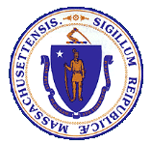

Health Information Technology Council
Report to the Massachusetts Legislature

Reporting Period: January 2020 to December 2020

Submitted in February 2021
by the Health Information Technology Council

Contents
I. Executive Summary 1
II. Introduction 1
III. Mass HIway COVID-19 Response Support 2
(A) Clinical Gateway Nodes 2
IV. Mass HIway Operations 3
(A) Connection Requirement 3
(B) Mass HIway Development Activity 5
(C) Outreach and Account Management 7
(D) 2020 HAUS Program Update 9
(E) Statewide Event Notification Service Framework 10
V. Federal developments 11
(A) Interoperability Rules 11
(B) Privacy Rules 12
VI. Future initiatives 13
(A) ePOLST 13
(B) FHIR API 13

Executive Summary
The Massachusetts Health Information Highway (Mass HIway) is a health information exchange program within the Commonwealth of Massachusetts’ Executive Office of Health and Human Services and advised by the Health Information Technology Council composed of consumer, provider, legal, policy, and technology stakeholders.

In 2020, the Mass HIway continued to pursue its primary goal of improving provider interoperability throughout the state during the COVID-19 pandemic. It supported the state’s need for data to track COVID-19 through electronic data exchange technologies developed and operated since 2013.

The Mass HIway continued its operations seamlessly throughout the pandemic. It conducted its annual attestation process to measure provider connections and utilization of HIway Direct Messaging. The first set of Mass HIway services, including the attestation system and Direct Messaging system, migrated to Amazon Web Services cloud servers, with other service migrations in progress. Provider outreach and use case implementation efforts continued throughout the pandemic to help providers increase interoperability. The Event Notification Service Initiative is moving closer to certification of vendors by the State in early 2021.

The U.S. Department of Health and Human Services set national standards for providers and payers to adopt, which would improve interoperability. The Office of the National Coordinator for Health Information Technology finalized rules that require vendors to adhere to national standards for certification to remove barriers that result in information blocking. The Centers for Medicare and Medicaid Services finalized its rules to require MassHealth and its contracted Managed Care Organizations to develop those standardized technologies. In addition, the Substance Abuse and Mental Health Services Administration and the Office of Civil Rights updated rules and guidance that promote increased provider data sharing.

The Mass HIway continued to explore potential future services to provide to the Massachusetts healthcare community to further enhance interoperability and health information exchange. The Mass HIway joined a cross-agency initiative to develop a registry for Physician Orders for Life Sustaining Treatment forms, which capture patient preferences for end-of-life care. With the setting of federal standards, including Application Programming Interfaces that use Fast Healthcare Interoperable Resources, the Mass HIway is exploring ways to leverage the aligned technical infrastructure.

Introduction
Pursuant to M.G.L. c. 118I, the Massachusetts Legislature authorized Executive Office of Health and Human Services (EOHHS) to coordinate and promote the development of a statewide health information exchange (HIE). EOHHS created the Massachusetts Health Information Highway (Mass HIway) program to embody those HIE coordination and promotion efforts. The same enabling statute also created the Health Information Technology Council (HIT Council) to serve as an advisory body to EOHHS and the Mass HIway program.

This HIT Council Report to the Massachusetts Legislature fulfills the statutory requirement under M.G.L. Chapter 118I, Section 15, for the HIT Council to file an annual report that: (a) describes the activities of the HIT Council; and (b) describes the progress made in developing the statewide health information exchange and recommending legislative action, if deemed appropriate.

This report provides an update on notable accomplishments and activities related to the state’s HIE that occurred between January 1, 2020 and December 31, 2020. This report follows the previous report, which covered activities through December 31, 2019.

The Mass HIway promotes the adoption of HIE through a variety of policy and technical levers. Currently, it operates a Direct Messaging network (HIway Direct Messaging) that offers healthcare entities the ability to securely and seamlessly transmit vital health data electronically, regardless of affiliation, location, or differences in technology. The Mass HIway also has a health information technology change management consulting service, HIway Adoption Utilization and Support (HAUS), to help MassHealth providers make their systems interoperable by assessing a client’s technology and workflow, developing a plan to meaningfully exchange health data, and supporting the implementation of that plan. The Mass HIway is currently working to implement a Statewide Event Notification Service (ENS) Framework to leverage existing market-based solutions to provide ENS to providers throughout the Commonwealth. The Mass HIway’s activities aim to increase the Commonwealth’s adoption of health information exchange and technology to improve care coordination, quality, patient satisfaction, and public health reporting, while containing costs.

Mass HIway COVID-19 Response Support
In 2020, the rapid spread of severe acute respiratory syndrome coronavirus 2 (SARS-CoV2) causing 2019 Coronavirus Disease (COVID-19) required the need for the state to quickly and effectively respond. The Commonwealth declared a public health emergency on March 10, 2020 to respond to COVID-19. As part of this response, the COVID-19 Response Command Center (Command Center), led by Secretary of Health and Human Services Marylou Sudders, was created to coordinate Massachusetts’ pandemic response across different areas – from building up testing and tracing, monitoring data and trends on a daily basis, advising on guidance, and to ensuring we have sufficient PPE.

In its emergency response efforts, the Command Center relies on data to track COVID-19 infection rates, among many things, to make evidence-based public health and policy decisions. The Command Center in coordination with the Department of Public Health and the State Public Health Laboratory (State Lab) continues to use the data submitted for Syndromic Surveillance (Syndromic) and Electronic Lab Reporting (ELR) to produce the public daily dashboard. In 2021, the state expects to track COVID-19 vaccinations through the Massachusetts Immunization Information System (MIIS) system. The Mass HIway operates technology enabling providers to electronically transmit data to those public health systems through HIway Direct Messaging and Clinical Gateway Nodes (CG Nodes).

Clinical Gateway Nodes
Public health reporting is a key use case for HIway Direct Messaging. The public health reporting process via HIway Direct Messaging is mature, with monthly transaction volumes exhibiting some gradual growth year to year and some seasonal variability, especially in reports of immunizations. In 2013, the Mass HIway created CG Nodes to reduce the burdens for providers to submit public health reporting. These CG Nodes are designed to accept data submitted by the provider through HIway Direct Messaging and technically transform the data into a format that the state’s public health systems can accept and analyze. This use case was an early success, with widespread, robust use by providers across Massachusetts. Every Massachusetts hospital and many other providers implemented HIway Direct Messaging for public health reporting purposes.

Relative to the state’s COVID-19 response, the Mass HIway supports the Command Center and DPH through its previously established CG nodes for Syndromic and ELR reporting. The Syndromic CG node receives data from hospitals, transforms the data, and submits data to the US Center for Disease Control’s BioSense Platform for national syndromic surveillance. BioSense aggregates the data from Massachusetts hospitals and sends the curated data to the State Lab. The State Lab then analyzes the data to identify COVID-19 cases. The ELR CG node allows hospitals to send COVID-19 test results to the State Lab through an automated process. Approximately 60% of Massachusetts Hospitals submit their electronic lab results, including their COVID-19 test results, through HIway Direct Messaging and the CG nodes.

As COVID-19 vaccinations became available, DPH collected – and will continue to collect – immunization data using its existing provider connections through the Mass HIway’s MIIS CG node. MIIS is the state system that holds records of all immunizations provided as well as additional functions like vaccination reminders that will be critical to ensure individuals receive a second dose (booster shot) of the COVID-19 vaccine. In anticipation of increased immunizations due to COVID-19 vaccinations, the Mass HIway team coordinated closely with the MIIS application team at DPH to increase the message capacity and throughput of both systems. The Mass HIway, in this initial increase, tripled capacity of the systems to transmit data for tracking vaccinations in support of the Commonwealth’s COVID-19 response efforts.

Mass HIway Operations
In 2020, Mass HIway operations included important improvements to provider usage, technical infrastructure, and adoption of services. The Mass HIway continued to track connections and began efforts to create new services offerings, such as the Statewide ENS Framework (anticipated in early 2021).

Connection Requirement
As set forth in M.G.L. Chapter 118I, Section 7, and as detailed in the Mass HIway Regulations (101 CMR 20.00), certain healthcare providers in the Commonwealth are required to connect to and utilize HIway Direct Messaging. This requirement is phased in over a four-year period, which is intended to incrementally promote the use of HIway Direct Messaging for provider-to-provider communications to achieve bi-directional exchange of health information.

Every organization subject to the connection requirement is required to submit an annual attestation form (see Figure 1) indicating how it met the annual requirement to connect to HIway Direct Messaging. During the 2020 attestation period, Acute Care Hospitals were required to submit a Year 4 Attestation Form; Medium/Large Medical Ambulatory Practices and Large Community Health Centers were required to submit a Year 3 Attestation Form; and Small Community Health Centers were required to submit a Year 2 Attestation Form. If an organization had not fulfilled the connection requirement, it was required to submit a Health Information Exchange Exception Form stating why it did not meet the connection requirement and explaining the organization’s plans to comply prospectively.
Figure 1
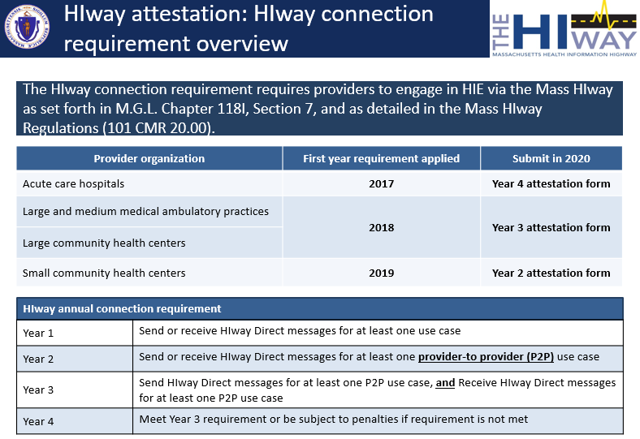

In early 2020, the Mass HIway considered how to improve the process through which organizations declare to the Commonwealth whether they have fulfilled the connection requirement. To improve the process, the Mass HIway clarified language on the attestation forms and added a section to the forms regarding the state’s ENS Initiative. Additionally, the Mass HIway developed a list of unique IDs for every organization subject to the connection requirement. The Mass HIway will leverage this list to more accurately measure the connection rates of medium/large medical ambulatory practices in the Commonwealth and to engage practices that have not made an attestation submission.

In early spring 2020, the Mass HIway began outreach and education efforts, holding regular educational webinars and sending reminder emails to organizations subscribed to the Mass HIway’s updates. Additionally, to facilitate attestation submissions among the medical ambulatory practice cohort, the Mass HIway held coordination calls with several of the largest practice groups in the state.

Recognizing the impact of COVID-19, EOHHS extended the 2020 attestation deadline from August 31, 2020 to December 31, 2020. In addition, the EOHHS waived any penalties for failure to submit a 2020 attestation form to allow providers to focus on the COVID-19 response. Organizations began to submit their attestation forms on August 1, 2020.

As of January 6, 2021, the Mass HIway had received 111 Attestation Forms and 53 HIE Exception Forms, for a total of 164 forms (95 of which were submitted in December). As of that date, the HIway had received submissions from 65 of the Commonwealth’s 67 Acute Care Hospitals, 19 of 40 Community Health Centers, and about 60% of Medium and Large Medical Ambulatory Practice entities.

The HIway analyzes these submissions to identify trends and potential opportunities for outreach to provider organizations to improve HIE. After the December 31, 2020 deadline passed, the HIway focused outreach on organizations subject to the connection requirement that had not completed an attestation submission. In January 2021, the Mass HIway sent a mass email reminder to all provider organizations that had not yet submitted forms; and followed up with a direct reply email from the organization’s HIway account manager. In late January, the Mass HIway called organizations that still had not submitted. Finally, in mid-February, the Mass HIway sent reminder letters to organizations that had not submitted. Based on prior experience where multiple follow-up communications substantially increased the submissions received, the Mass HIway is confident that this outreach will result in many more submissions.

Mass HIway Development Activity
The Mass HIway development team focused on consolidating the CG nodes into a single, consolidated application and migrating that core application and a suite of supporting applications and tools to Amazon Web Services (AWS) cloud-based servers. While critical changes and fixes were addressed as needed, most functional changes requested by the backend application teams have either been incorporated into the new Consolidated Clinical Gateway application (CCG) (described below) or deferred until after the migration is complete.

Background
The CG nodes are Mass HIway software applications that connect providers securely to DPH and other state agencies for public health reporting. Providers send public health reports via Direct Message to the CG nodes, which transform the message into a format useable by the agency’s systems. The CG node transformation processes include decryption of the original message, validation that the data is correctly submitted, and transformation of the message into a format acceptable to the receiving system. Reporting providers and state agencies benefit by allowing each group to keep their existing technology infrastructure while the CG node does the transformative work to allow for the seamless exchange of information.

Each of the following CG nodes is a separate application that supports a corresponding public health reporting back-end application:

- Children’s Behavioral Health Initiative (CBHI)
- Childhood Lead Poison Prevention Program (CLPPP)
- Electronic Lab Reporting (ELR)
- Opioid Treatment and TB Reporting Programs (I-EATS)
- Massachusetts Cancer Registry (MCR)
- Massachusetts Immunization Information System (MIIS)
- Syndromic Surveillance Program (Syndromic)

The architecture for the existing CG nodes was developed in 2013 with the launch of HIway Direct Messaging. The CG nodes were scaled up by copying the first CG node and recoding it as a separate application to be able to connect to a respective DPH system. The multiple CG nodes will continue to run in the EOHHS Private Cloud Data Center, LogicWorks Virtual Gateway (VG4), until the CCG implementation in the AWS cloud is complete.

Migration of CG Nodes to AWS
The Mass HIway conducted a business and architectural review of the CG nodes in 2019 that identified current and future needs and challenges of the CG nodes, including affiliated applications and operational tools. The comprehensive review identified the following challenges:

- Infrastructure not positioned to meet emerging FHIR-based API standards.
- Infrastructure not easily scalable or extensible.
- Infrastructure requires a long turnaround time to update nodes including routine software updates.

As a result, the Mass HIway team began a program in October 2019 to implement the recommended architecture (see Figure 2). Arrangements for use of a cloud infrastructure, hosted by AWS, were made through the Executive Office of Technology Services and Security and development environments were established. As work progressed through 2020, additional AWS environments for testing and production were added.
Figure 2

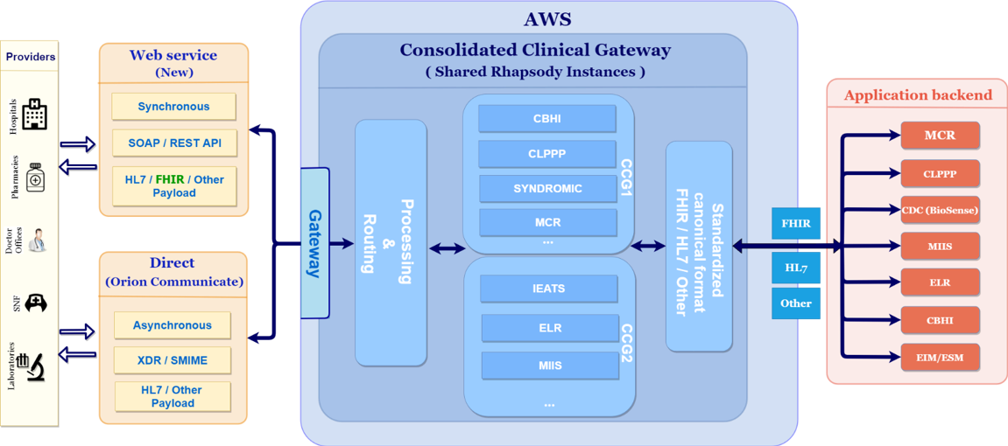

Consolidation of CG Nodes
Also starting in October 2019, and continuing throughout 2020 and into 2021, the Mass HIway team is transforming the current set of CG nodes into a CCG, as depicted in Figure 2 above. The CCG will allow the Mass HIway to address the challenges identified in the business and architectural review completed in 2019, as described above.

The CCG implements a technical shift from the previous approach, consolidating multiple independent applications into a single application for all public health reporting needs. This shift will improve scalability for future changes impacting all nodes, as the Mass HIway will only need to update a single module within the CCG, rather than making individual updates for each of the seven CG node applications. In addition, implementing new nodes will be faster and easier as they can be implemented as an add-on to the existing CCG application.

In general, business functionality will remain the same as before, however several enhancements requested by the DPH application teams are being included in the new CCG as part of the implementation.

Maintenance and Enhancement of CCG Functionality
The CCG follows the developing national trends and the latest guidance from the Centers for Medicare & Medicaid Services (CMS) and the Office of the National Coordinator for Health Information Technology (ONC) by creating a new web service link to DPH using FHIR APIs. Fast Healthcare Interoperability Resources (FHIR) is a standard describing data formats and elements and an application programming interface (API) for exchanging Electronic Health Records (EHR). This new option will allow providers whose systems offer FHIR API-capable public health reporting to take advantage of the associated benefits as soon as possible, even if the backend public health system has not been upgraded to directly handle FHIR API transactions; the CCG will transform the message accordingly. Meanwhile, the Mass HIway anticipates it will begin to recognize the costs savings that come from gradually reducing the annual maintenance fees for provider on-site devices and services as the transitions from Direct Messaging to FHIR are implemented.

Other Applications Moving to AWS
The development team moved other Mass HIway applications from VG4 to AWS. The other Mass HIway applications moved include the 1) online attestation form, 2) customer relationship manager (CRM) software and database, and 3) public website. The development team activated the 2020 attestation forms on AWS in August 2020. In December 2020, the CRM software and database were migrated to AWS with enhancements to improve data analytical abilities. The Mass HIway’s public website was updated and went live on AWS in January 2021.

Outreach and Account Management
The Mass HIway continued to build on efforts to raise awareness and educate Massachusetts providers on the importance of interoperability. The outreach team educates providers, clinicians, and administrative staff on the value of HIE and its ability to improve care coordination. They leverage several channels to educate providers and increase awareness. These can include live monthly webinars, recorded on-demand webinars, and HIE “Spotlight Stories” highlighting organizations that have utilized HIE to advance its care coordination objectives. The team also organizes HIE learning collaboratives; however, due to COVID-19, these in-person events were cancelled for 2020. A virtual one-day learning collaborative was held in the fall of 2020 to share Telehealth-related best practices among clinicians and administrative staff. This event was organized to investigate the potential of EHR and HIE solutions in Telehealth activities, and as a test case to prepare for organizing HIE-related virtual learning collaboratives in 2021.

Live Monthly and On-Demand Webinars
The Mass HIway Account Management team hosted eight webinars in 2020. All webinars are recorded and posted on the new Mass HIway website and the website of its outreach vendor, the Massachusetts eHealth Institute (MeHI).

The following webinars were prepared and presented by the team:
- Four HIway connection requirement and attestation webinars (total of 140 attendees)
- One HIway Webmail webinar (34 attendees)
- Three Provider Directory Webinars (114 attendees)

HIE Case Studies and Spotlight Stories
The team published four spotlight stories illustrating how provider organizations are using the Mass HIway to improve care coordination. These organizations include: Family Doctors VNA, Merrimack Valley ACO, Family Doctors LLC, and Tufts Children's Hospital. Spotlight summaries of these stories were included in the monthly Mass HIway newsletters. An additional story was written and will be published in early 2021 for a successful HIE implementation at HealthFirst, and several more stories are in development for publication throughout 2021.

Mass HIway Newsletters and Bulletins
The team drafted the content for monthly HIway newsletters, including Spotlight story summaries, attestation reminders, HAUS promotion, ENS progress announcements, and workshop and webinar invitations. Numerous bulletins were created with targeted announcements and reminders for these same topics.

Workshops and Learning Collaboratives
A two-day “Change Management and Process Improvement” workshop was presented by the team in January 2020. To practice the teachings of the workshops, the participants engaged in mapping out various health information exchange processes as experienced in their own practices. Throughout the workshop, providers were better able to identify opportunities for process improvement, roadblocks, inefficiencies, and other barriers to implement health information exchange. The maps created by the participants were documented in Visio and added to the new Process Improvement Toolkit.

The team is currently in the process of organizing four virtual learning collaboratives for 2021, including:
- Cures Act provisions about information blocking
- Hospital referrals
- HIE patient education, consent, sensitive health info
- Telehealth workgroups

New Mass HIway Website
A new informational/educational Mass HIway website was developed and released in January 2021. During the technical development of the new Mass HIway website, all information was posted onto the MeHI website. Upon launch of the new Mass HIway website, all content was updated, reorganized, and incorporated.

The following information on the MeHI website were updated and posted to the new Mass HIway website:

- HAUS, PD 2.0, Mass HIway, and Regulation & Attestation pages.
- Query HIE Toolkit, with enhancements based on input from the API/Query HIE project.
- HIE Use Case Toolkit, with improved tools and new use cases linked to spotlight stories.
- Spotlight Story Library, expanded with recently developed stories.
- Webinar Library, with closed captioning added to all Mass HIway webinar recordings.

2020 HAUS Program Update

Background
The primary goal of the HAUS program is to improve patient transitions of care among MassHealth provider organizations through increased electronic provider-to-provider communication. A secondary goal of this program is to help providers achieve Meaningful Use measures through integration of electronic exchange of information.

The HAUS program is aimed at offering high-touch, hands-on change management consulting services to eligible provider organizations to ensure use cases are fully implemented by sending and receiving organizations. Typical use cases and the reasoning behind them include the following:

- Sending a referral to a specialist with patient information such as current condition, reason for consultation, and expected outcome of consultation. The use case goal is for specialist treatment to be more effective; the expectations of the primary care provider (PCP) are clear at the outset and the specialist has all patient information at hand (therefore does not have to engage in duplicative testing to understand the presenting illness).
- Sending a discharge summary from a hospital to a skilled nursing facility (SNF). Discharge summaries are often lost in transit when given as a paper copy; SNFs need Discharge Summaries to ensure continuity of care.
- Exchanging care plans between behavioral health community partners (CP) and PCPs in an Accountable Care environment.

The following are examples of typical activities performed during a HAUS engagement:

- Creating cross-functional teams between participants to enhance coordination. These teams may include clinical, information technology, and business leadership to ensure that the needs of all stakeholders (clinicians, clinical staff, etc.) are addressed and that the information exchange approach genuinely improves patient care rather than merely complying with information exchange regulations.
- Facilitating communication between multiple provider organizations to define clinical information exchange requirements and protocols through Zoom meetings, emails, and calls.
- Documenting agreed-upon clinical protocols, including the content of clinical documents to be exchanged and release triggers for an exchange.
- Creating workflows reflecting clinical protocols to ensure the right information is available when and where it is needed to accomplish goals such as streamlined discharges from a hospital to a SNF.

HAUS Progress
The HAUS program completed nine engagements in 2020, and there are another 55 active engagements underway with a variety of organizations including Visiting Nurse Associations, ACOs, CPs, Community Health Centers, large ambulatory practices, and large Acute Care Hospitals.

The HAUS program currently focuses on MassHealth ACO organizations and CP organizations. Bi-directional communication between ACOs and multiple behavioral health and long-term services and supports CPs remains a critical function to ACO implementation. Inquiries about the HAUS program have increased as organizations begin to turn their attention toward the need for improved communication and secure exchange of health information among these entities. The HAUS team is working with several community health centers that participate in the MassHealth ACO program. Specifically, there are efforts to increase the use of Direct Messaging to support successful closed-loop referrals between primary care providers and specialists.

Also, the team has provided HAUS services to all providers who have been unable to meet the Mass HIway connection requirement. The HAUS team is supporting organizations experiencing challenges meeting the requirement due to a lack of a trading partner, workflow challenges, or other issues. The team has seen an increase in the number of organizations contacting the HAUS Account Management team for assistance meeting the connection requirement.

Statewide Event Notification Service Framework
ENS is a tool used in healthcare to provide real-time electronic notification regarding a patient’s transitions of care. ENS can be used for many healthcare purposes. One common example is notifying providers of a patient’s admission to, transfer from, or discharge from, a hospital (ADT). These notifications help providers improve care coordination by receiving notice that they should follow up with that patient.

ENS Background
The Mass HIway and HIT Council have long recognized the benefits of expanding ENS availability to all providers to best serve patients across the healthcare continuum. As part of its efforts to promote health information exchange, EOHHS seeks to develop timely ENS in order to improve health care delivery, quality, and care coordination between providers of all sizes. EOHHS promulgated regulations and issued a procurement in 2019 to develop a Statewide ENS Framework. The Statewide ENS Framework will consist of ENS Vendors certified by EOHHS who will be responsible for collecting ADTs from acute care hospitals, sharing ADTs, and providing notifications to providers. State Certified ENS Vendors will be required to share the ADTs they collect with all other State Certified ENS Vendors, pursuant to the submission requirements from the state’s acute care hospitals.

Thus, the Statewide ENS Framework will generate a universal data set of acute care hospital ADTs. This will allow ENS recipient providers such as primary care providers, behavioral health providers, and care coordinators to subscribe to a single Certified ENS Vendor and receive notifications from any acute care hospital in the state. The Certified ENS Vendors will be required to run matching algorithms on the ADT data they receive to generate notifications to ENS Recipients for the ENS Recipient’s patient panel. Patient privacy will be protected, as the Certified ENS Vendors will be required to delete ADTs where there is no match as well as, maintain security standards in compliance with applicable privacy laws and standards. By enabling more providers, including small and medium-sized providers, to receive notifications, EOHHS will make it easier for all providers to collaborate and coordinate care for their patients. Below is a graphical representation of the framework (see Figure 3).

Figure 3
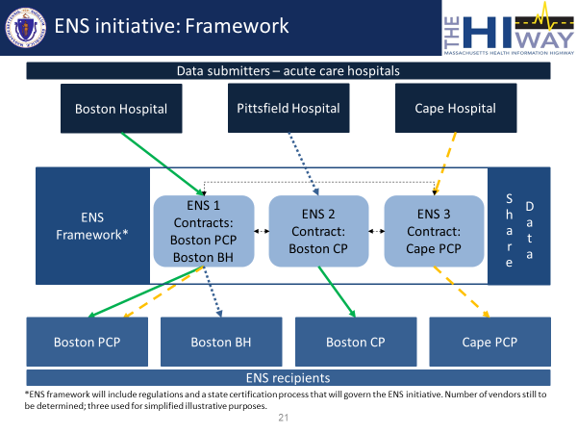

ENS Vendor Certification Process
In November 2019, EOHHS issued a Request for Applications for the certification of ENS vendors to participate in the Statewide ENS Framework. The ENS vendors submitted certification materials in January 2020 with award letters sent in July 2020. Contracts for certification are expected to be completed in early 2021. The Statewide ENS Framework is expected to become fully operational in April 2021.

Federal developments
In 2020, the federal government finalized the proposed rules highlighted in the 2019 HIT Council Annual Report. CMS and ONC finalized rules around the adoption of FHIR data standards and API for transporting data. The Substance Abuse and Mental Health Services Administration (SAMHSA) also finalized updates to privacy rules on the release of Substance Use Disorder-related patient information to expand sharing among providers. The Mass HIway and HIT Council have been exploring the interoperability potential around industry adoption of these new technical standards. (see FHIR API)

Interoperability Rules
The Department of Health and Human Services finalized the ONC Cures Act Final Rule (ONC Cures Rule) and the CMS Interoperability and Patient Access Final Rule (CMS Interoperability Rule) to put patients in charge of their own healthcare records. The ONC Cures Rule sets standards for providers, vendors, and HIEs to achieve uniformity in the 1) healthcare data fields, 2) information within those data fields, and 3) data transfer mechanism. The CMS Interoperability Rule requires providers and CMS-regulated payers (e.g., MassHealth FFS, MassHealth MCOs, and Medicare Advantage) to implement those standards set in the ONC Cures Rule.

The ONC Cures Rule adopted internationally recognized standards for the storage and transport of healthcare data. Vendors that want their EHRs systems certified need to meet these new standards. Specifically, ONC set FHIR as the uniform data fields standard due to its ability to store and send without the need for technical transformation. Information in those data fields will be standardized by ONC’s adoption of the United States Core Data for Interoperability (USCDI). Finally, ONC set APIs, a widely used transport mechanism, as the mechanism for transporting healthcare data.

The CMS Interoperability Rule leverages the standards defined by ONC as requirements for CMS-regulated payers. Payers are required to implement FHIR APIs on their claims data and payer-held clinical data to allow patient access. In addition to payer regulations, CMS’s annual provider payment rules (e.g., Hospital Inpatient Prospective Payment System, Hospital Outpatient Prospective Payment System, and the Physician Fee Schedule) calculate quality-based payments based on a provider’s adoption of an ONC-certified EHR. Providers that do not implement ONC-certified EHRs have the potential to lose quality-based incentive payments for their reimbursable services.

With the enactment of these rules, the federal government made an important stride in interoperability by setting new standards that all providers, payers, and vendors should implement in their IT systems. The federal government created these standards for the purpose of allowing patient access to the information. However, the technology being implemented has the potential to be leveraged for provider-to-provider data exchange. Throughout the next year, the Mass HIway will continue to track the adoption of FHIR APIs by providers and payers and explore additional provider-to-provider use cases that could be adopted statewide in furtherance of these rules.

Privacy Rules

42 CFR Part 2 Substance Use Disorder – Substance Abuse and Mental Health Services Administration
In July 2020, SAMHSA finalized a rule containing amendments to the substance use disorder (SUD) patient confidentiality rule, 42 CFR Part 2 (Part 2). Part 2 covers the disclosure of health information for patients receiving SUD treatment provided by federally supported providers (i.e., providers that receive federal funding including, but not limited to, Medicare and Medicaid reimbursements). SAMHSA’s final rule attempted to align its privacy policies closer to HIPAA by reducing Part 2 barriers around sharing SUD data among a patient’s providers. One notable change was SAMHSA easing requirements around needing patient consent to name a specific individual provider to allowing the patient to name a practice group for disclosure of her information. The final rule did not incorporate newly created statutory authority under the CARES Act that would allow it to further align Part 2 with HIPAA consent policies.

Health Insurance Portability and Accountability Act – Office of Civil Rights
The Office of Civil Rights (OCR) within the U.S. Department of Health and Human Services is responsible for the enforcement of HIPAA privacy rules. OCR published a Notice of Proposed Rulemaking (proposed rule) in December 2020 to reduce barriers for patients to access their health data and for patients to direct their data to third parties (e.g., mobile apps, other providers, other payers). The proposed rule would ban certain types of identification that OCR finds overly burdensome, including notarized documentation to release data to that patient. It also proposes to clarify the definitions around care coordination to expand the ability of providers and payers to disclose health data of a shared patient/member without requiring affirmative patient consent.

Future initiatives

ePOLST
In 2020, EOHHS embarked on a cross-agency effort to support patient preferences for end-of-life care through technology that improves care coordination. The project is a combination of policy and technical development. First, the state will update the state’s Medical Order for Life Sustaining Treatment (MOLST) form to align with the national paradigm for Physician Order for Life Sustaining Treatment (POLST) form for transferability between states. Then the state will procure and implement an electronic POLST registry to serve as the single source of truth across all care settings. The Mass HIway will develop an integration and implementation strategy with EHR to gain efficiency in its usage. EOHHS is in the process of finalizing its receipt of a grant from the Massachusetts Coalition for Serious Illness Care, made possible by Blue Cross Blue Shield of Massachusetts to support the ePOLST registry’s development.

Background
The POLST (Physician Orders for Life Sustaining Treatment) form was developed in Oregon in the 1990s, after a group of clinicians and medical ethicists realized that current advance directive documents were inadequate for those with serious, advanced illness. These patients frequently require emergency care, but it can be challenging to both locate and then subsequently honor their wishes for limited care (e.g., EMS is often required to transfer to hospital). The MOLST (Medical Orders for Life Sustaining Treatment) program in Massachusetts started with the passage of Chapter 305 of the Acts of 2008, which authorized EOHHS to establish a MOLST program in the Commonwealth. In 2010, the state began a MOLST demonstration program in Central Massachusetts and expanded it statewide two years later.

Planned 2021 Activities
The Mass HIway, along with the Executive Office of Elder Affairs, will hired an ePOLST project management team in January 2021 to conduct stakeholder outreach. The project manager will work with government stakeholders and external stakeholders like the Coalition on Serious Illness Care. That outreach will include community stakeholders such as providers, payers, and patient advocacy groups. The goal of the initial outreach is to identify the gaps that exist with documentation, information flow, and version control of the current MOLST form and recommendations on how to fill the gaps to ultimately create an ePOLST registry for the state. Mid-2021 activities are anticipated to include vendor procurement and development of an ePOLST registry implementation strategy.

FHIR API
The Mass HIway and the HIT Council recognize the increasing interest and adoption of FHIR APIs as a tool to improve health information exchange and interoperability. ONC’s adoption estimates indicate that stakeholders are utilizing FHIR standards and FHIR-based specifications to support a range of Health IT interoperability needs and a large share of specialized HIE services.

The ONC Cures Rule made several changes to the existing 2015 Edition Health IT Certification Criteria, which is leading EHR vendors to expose new and more data on FHIR and enable enhanced data access and exchange capabilities. FHIR resources may be pushed or pulled in accordance with purpose-built profiles or discrete data, and in response to more specific data requests beyond document-based query exchange.

National, state, and regional HIEs are enabling new and existing services with FHIR-based APIs, with most networks reporting active FHIR implementations or FHIR-enabled services as a near-term development priority (see Figure 4). For the Mass HIway, the architecture being developed to support the new Consolidated Clinical Gateway plans to extend web services to include FHIR API capability and provide FHIR-HL7 message transformation services to and from the source registry systems. The technical components (e.g., Amazon Web Services, Rhapsody engine) and new FHIR capabilities of the Consolidated Clinical Gateway development could be leveraged to support other FHIR API initiatives and a range of FHIR-enabled HIE services. A proof of concept for FHIR API enhancement development is currently planned for the third quarter of 2021.
Figure 4
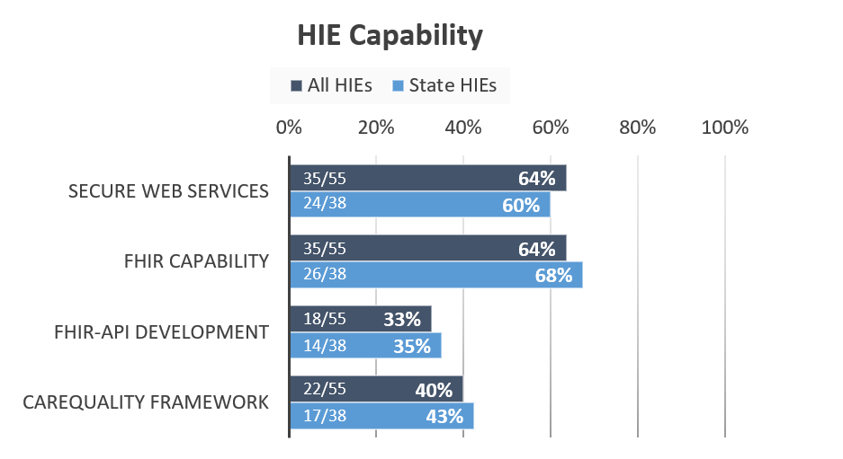

Statewide EHR Scan and FHIR Readiness
Earlier in the year, the Mass HIway completed a review of the EHR market in Massachusetts to better understand market share, as well as capabilities related to FHIR and USCDI exchange. A similar methodology to one used in the ONC analysis on the FHIR capabilities of Certified EHR Technologies (CEHRT) was utilized, which combined data available from ONC Certified Health IT Product List and summarized Medicare EHR Incentive Program and Medicare Physician Utilization and Payment data.

The Mass HIway team conducted an analysis of the major EHR vendors and their adoption of FHIR APIs (see Figure 5). The analysis revealed that nationally, approximately 25-40% of EHR developers have FHIR API capability. However, this EHR cohort represents almost 70% of the US provider offices market share and approximately 83% of the US hospital market share. In Massachusetts, the top EHR vendors in the state have FHIR API capability and represent approximately 85% of the provider offices market and 100% of the hospital EHR market. In addition to standardization for FHIR APIs, many of the developers adopted the principal authentication standard, OAuth 2.0, to allow providers to share data securely.

Figure 5
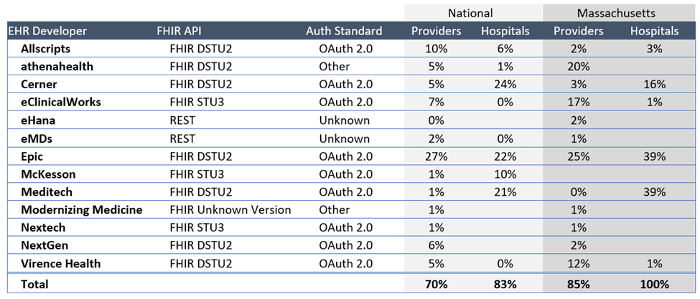
FHIR APIs have been primarily oriented to meet the patient access requirements and clinical decision support tools. ONC’s regulations only require that EHRs have APIs that enable other systems to read or extract information. Write access is not currently required. Although provider-to-provider exchanges are not specified, increasingly FHIR resources may be pushed/pulled in accordance with purpose-built profiles or discrete data and in response to more specific data requests beyond document-based query exchange.

The Mass HIway FHIR API Initiatives
As previously mentioned, the architecture being developed to support the new CCG plans to extend web services to include FHIR API capability and provide FHIR-HL7 message transformation services to and from the source registry systems (see Maintenance and Enhancement of CCG Functionality). The enhancement development work is currently planned for the third quarter of 2021. This development will allow hospitals to send with the emerging technical standards and allow state agencies to continue to receive data in its current format with the Mass HIway performing the transformation work.

The technical components (eg., Amazon Web Services, Rhapsody engine) and new FHIR capabilities of the Consolidated Clinical Gateway development could be leveraged to support other FHIR API initiatives and a range of FHIR-enabled HIE services. Service options being considered include a FHIR API to Provider Directory, FHIR Exchange and Routing Services and FHIR-HL7 Broker and Message Transformation Services.

The Mass HIway will continue to gather and consolidate stakeholder feedback related to FHIR HIE services to inform direction and planning. The Mass HIway will identify interested provider-organizations and define use cases for proposed FHIR HIE Services, beginning with the FHIR API to Consolidated Clinical Gateway and FHIR API to Provider Directory.

Once use cases have been defined, the proposed FHIR API solutions will be scoped and an assessment of the Mass HIway technology and capability gaps will be conducted to determine change areas necessary to support development. Additionally, a framework of options and opportunities to align proposed FHIR API solution(s) with the CMS and ONC requirements on regulated entities will be developed.

85 FR 25642
85 FR 25510
APIs are used by large Internet organizations for their mobile applications, including but not limited to social media, banking, and entertainment.
85 FR 42986
Data pushes are data movements that are initiated by a sender. An example is when you send an email with information to another person.
Data pulls are data movements that are initiated by the recipient. An example is when you conduct a search on a website and the search engine generates the matches for your request.

