COME JOIN US
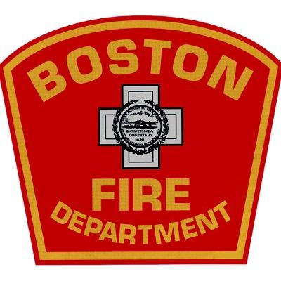
Boston Fire Information Session
The Commonwealth of Massachusetts Human Resources Division in conjunction with the Boston Fire Department will be hosting an Information Session for applicants interested in taking the March 21st , 2020 Civil Service Exam for Entry-Level Firefighter for Cities and Towns. The Information Session will take place at the following dates and locations*:
Jan 27th, 2020- MAMLEO 61 Columbia Rd. Dorchester, MA 6pm-8pm
Jan 31st ,2020- Tobin Community Center 1481 Tremont Street, Roxbury,6pm-8pm
Feb 1st, 2020 – KAYPAM 6 Livingstone St, Dorchester, MA 12pm -2 pm
Feb 4th, 2020 – AACA, 87 Tyler street, Chinatown, MA 5;30pm – 8pm
If you have any question regarding the Info Session or the upcoming Civil Service exam, please email JoinBostonFire@Boston.gov or call the Boston Fire Department 617-343-2939 or the Massachusetts Human Resources Division at 617-878-9700.
Helpful links:
https://www.boston.gov/departments/fire-operations/how-become-firefighter
https://www.mass.gov/service-details/2020-municipal-firefighter-exam
*Future dates and locations will be added

