Your Letterhead

For Immediate Release: <DATE>
Contact: <NAME>, <Tel>
www.mass.gov/cookingsafety

Chief <Name> and State Fire Marshal Ostroskey Urge Residents to Help Prevent Cooking Fires and Injuries

<Community> Fire Department Promotes Cooking Safety Tips

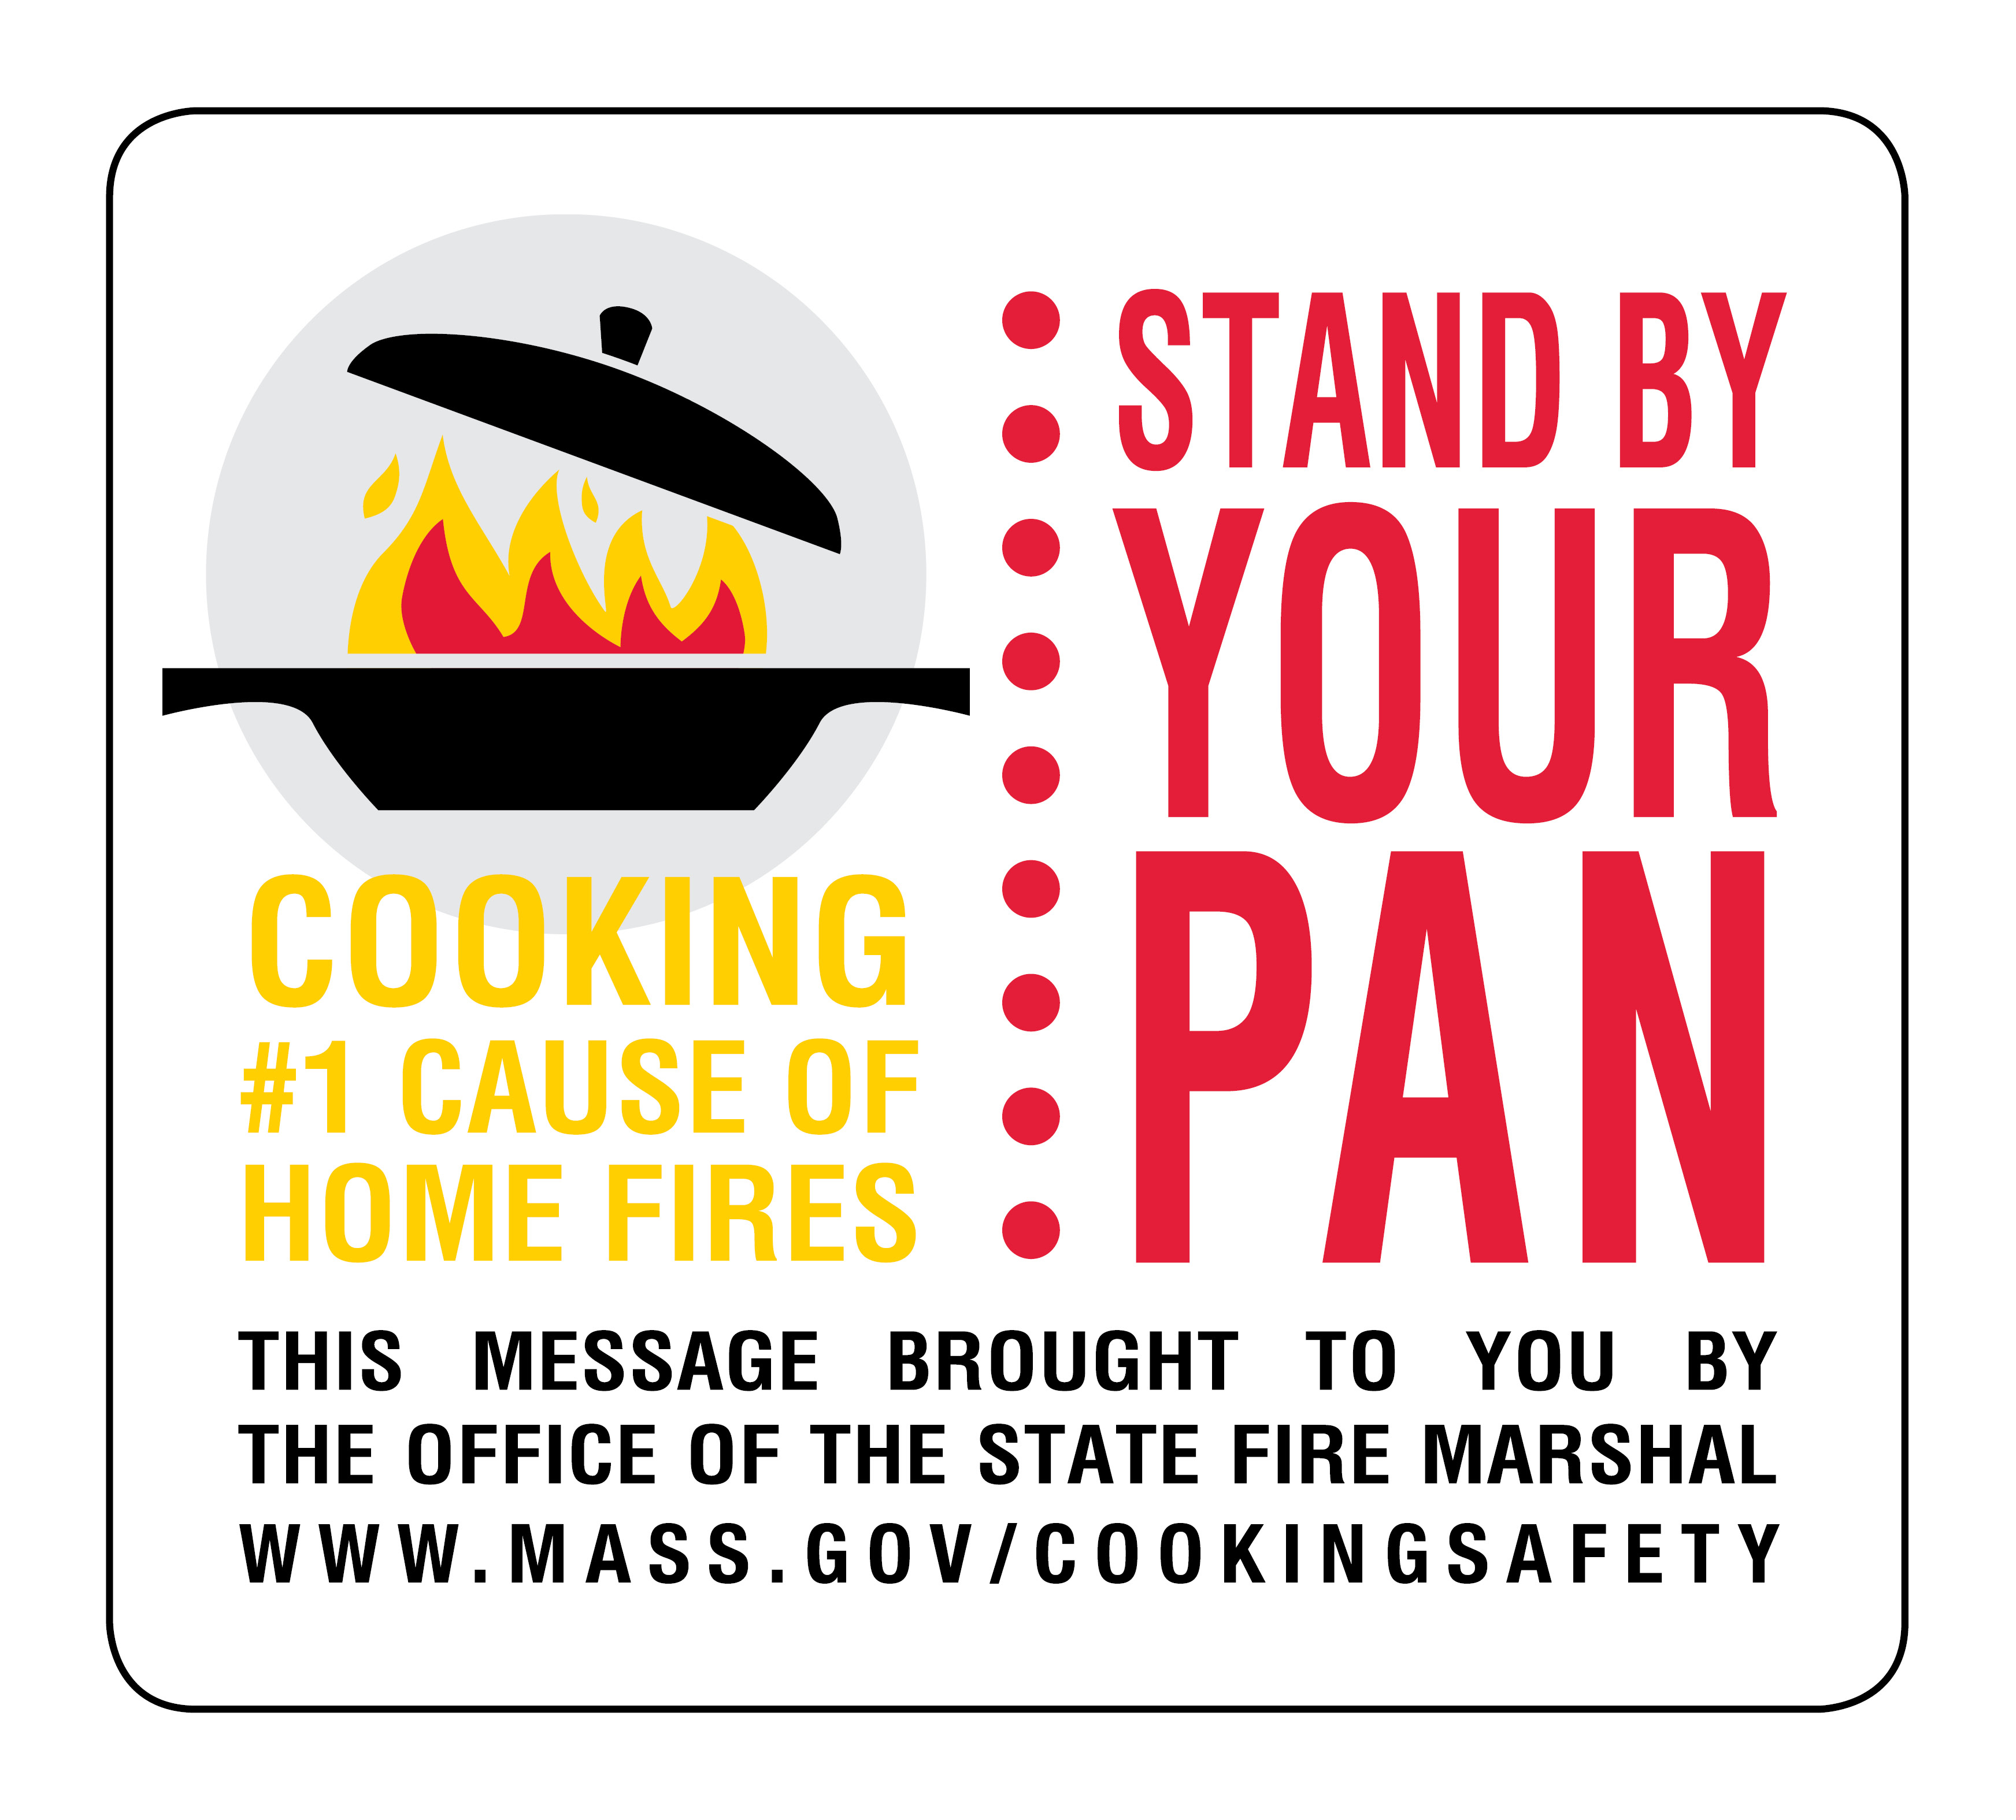
<COMMUNITY> -- Cooking is the leading cause for home fires and injuries, and so <Community> Fire Chief <Full Name> and State Fire Marshal Peter J. Ostroskey are urging residents to use caution while cooking in a statewide cooking fire safety public awareness campaign. This campaign has two main messages to prevent home fires: Stand by Your Pan to prevent cooking fires and Put a Lid on It to put grease fires out safely.

“Cooking is the #1 cause of fires in our community,” said Chief <Last Name>. “Leaving pots and pans unattended can be a recipe for disaster. So it is important to always stay in the kitchen when cooking.”

The Department of Fire Services has developed PSA’s to educate the public on the importance of standing by your pan in the kitchen. They feature firehouse chefs from Holyoke and Methuen talking about cooking safety and sharing their favorite recipes. Lt. Maria Pelchar from Holyoke provides us with her recipe in Spanish. The PSA’s serve up two key messages on cooking safety in these television and radio spots: “Stand by Your Pan” to prevent fires and “Put a Lid on It” to put out a stovetop fire.

“Safety is the key ingredient in any recipe. The leading cause of fire injuries to everyone and especially to seniors is cooking,” said State Fire Marshal Ostroskey, “which is why it is important to put a lid on a stovetop fire.”

Important cooking safety tips:
- Stand by your pan, when cooking. Never leave food, grease or oils cooking on the stovetop unattended.
- Put a lid on it. In the case of a pan fire, slide the lid on it to smother the fire, and then turn off the heat. Do not move the pan until it has cooled off.
- Water or fire extinguishers will not work. They will only spread the fire.
- Never move a burning pan. You can be badly burned or spread the fire.
- Wear short or tight-fitting sleeves when cooking, because loose fitting clothing can easily catch on fire.
- If your clothing catches fire, Stop, Drop, Cover and Roll to put out the flames.

According to the Massachusetts Fire Incident Reporting System (MFIRS), there were 9,879 residential fires in Massachusetts involving cooking in 2019, which resulted in three civilian deaths, 49 civilian injuries, 20 firefighter injuries and an estimated $6.7 million in property damage. Cooking is also the leading cause of injuries to older adults (people over the age of 65).

For more information, please visit www.mass.gov/cookingsafety.

