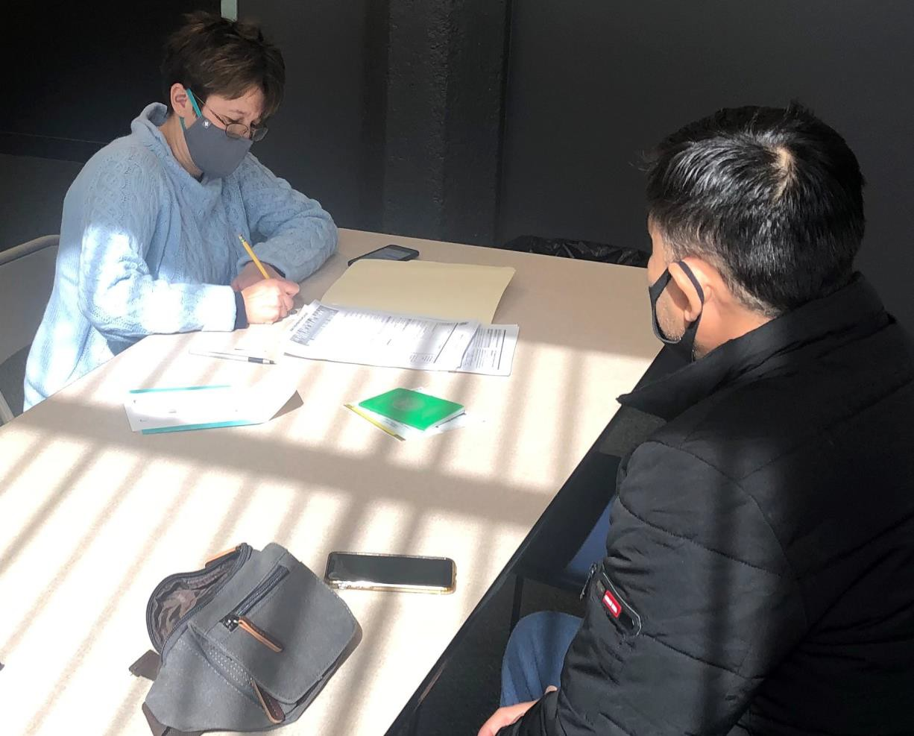

ANNUAL REPORT 2020

The Massachusetts O
ffice for Refugees and Immigrants

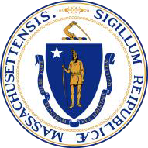 Charles D. Baker
Governor

Karyn Polito
Lieutenant Governor
Marylou Sudders
Secretary of Health & Human Services

M ary Truong
Executive Director

Cover Photo Courtesy of the New American Association of Massachusetts

OUR MISSION
Promote the full participation of refugees and immigrants as
self-sufficient individuals and families in the economic, social, and civic life of the Commonwealth.

About ORI
The Massachusetts Office for Refugees and Immigrants (ORI) administers programs that provide direct services to clients through a network of community partners including sister agencies, resettlement agencies, faith-based and ethnically grounded organizations, all of which cooperate to meet the needs of our culturally and linguistically diverse newcomer populations.

Welcome from Massachusetts Governor Charlie D. Baker
The Baker-Polito Administration values the immigrant community’s role in making Massachusetts a vibrant and competitive commonwealth.
“
Massachusetts has long benefited from the significant contributions that persons who come to the United States from other countries make to our economy
and our communities.”

CONTENTS
Mission 3 About ORI 3 Welcome from Governor Charlie D. Baker 3 Contents 4 Message from the Executive Director 5 Executive Summary 6 Refugee Population Demographics 7 Employment Services 9 Educational Training Programs 10 Children and Youth Services 13 Community and Elders Services 16 Health Services 18 Citizenship Services 20 Town Hall Meetings 21 Success Stories 23 Community Partnership 27 Financials 29 Acknowledgment 30

MESSAGE FROM THE EXECUTIVE DIRECTOR

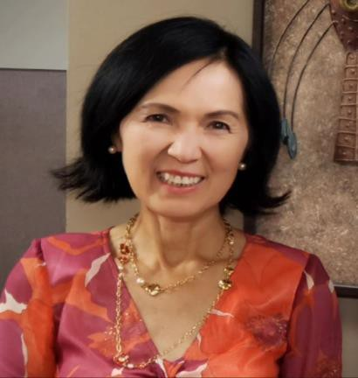
D ear Friends,

This year presented an unprecedented challenge for families around the world. Inequities have always been prominent in refugee and immigrant communities and were highlighted during the COVID-19 pandemic.
When the country shut down in March, many refugee and immigrants faced unique challenges that the Office for Refugees and Immigrants (ORI) sought to address.

For many families, the pandemic meant lost wages, unemployment, or adjusting to working from home. The increase in the cost of utilities and need for technology added to the uncertainty for those already living paycheck to paycheck who suddenly lost the means to provide for their families. Non-naturalized essential workers who kept their jobs were burdened with the stress of arranging childcare, staying safe when the PPE supply chain was challenged, and protecting their families. Those who suddenly qualified for unemployment had to navigate a quickly changing unemployment system. Furthermore, parents with limited educational or English-speaking backgrounds often could not provide adequate educational support for their children’s remote learning.

Service providers for refugees and immigrants also pivoted to new technology and trained their clients to use it to continue their work virtually.
Although each service provider ‘stepped up’ to carry out crucial work while navigating an unpredictable landscape, some struggled to find ways to safely implement a hybrid model of service.

The Office for Refugees and Immigrants (ORI) was here to support service providers and refugees and immigrants, and to help them navigate these challenges.

While some of ORI’s operations were paused in March during the stay-at-home advisory, we were able to resume most of our operations very quickly, and resumed other in-person services when it was safe to do so. Through virtual
environments, ORI’s Financial Literacy for
Newcomers (FLN) program managed to reach

Mary Truong
Executive Director
more clients from September to December in FFY2020 than during the same time frame in FFY2019.

ORI also received a $400,000 grant from the Department of Health and Human Services Administration for Children and Families–Office of Refugee Resettlement (ORR) to fund the first-year activities of the Family Integration Program (FIP). This new program aims to fill service gaps by providing foundational case management services; remote foundational case management services, as needed in the southeastern portion of the state below the Boston metropolitan area and eastwards into the Cape & the Islands; customized employment services in Springfield; and customized resources to support self-sufficiency and community integration. ORI remains passionate about embracing diversity and promoting sustainable support for the most vulnerable members of our community.

Going forward, we hope to continue growing and finding new partnerships and grant opportunities to further our impact. We would like to thank Governor Baker, Massachusetts Legislature, community leaders, and the readers of our 2020 Annual Report for their continued support for our efforts and the refugee and immigrant communities. The commitment to advocacy for refugees and immigrants, even in these unprecedented times, inspires us to create a better Massachusetts for all.

EXECUTIVE SUMMARY
While COVID-19 left a profound impact on our operations, over the past year, ORI continued to work diligently to expand and strengthen its partnerships with service providers and stakeholders to ensure continued delivery of high quality and locally accessible services to its refugee and immigrant populations. In brief:
- Fifty-two (52) workshops were delivered in 5 regions of the state to equip 314 participants with the education necessary for them to take control of their finances.
- Two thousand six hundred seventy-two (2,672) Massachusetts lawful permanent residents enrolled in the ORI Citizenship for New Americans Program.
- Seven hundred six (706) refugees participated in various employment programs. Of those, sixty five percent (457) obtained employment, with an average hourly wage of
$14.38 per hour.

- ORI successfully assisted 169 unaccompanied minors into appropriate housing and care
- Youth Adjustment Services helped 57 young newcomers through their transition into living in Massachusetts communities.
- One hundred twenty-fived (125) refugee and immigrant elders received ORI’s services
for refugee elders.

- Seven hundred twenty-three (723) refugees with were provided community assistance with accessing and understanding mainstream service systems and local resources.
- ORI’s health promotion services reached out to 691 individuals to address their medical
needs.

- The health assessment program conducted 413 medical screening service visits to newly-arrived refugees and immigrants, and more than 97% successfully transitioned to primary care.
- More than 640 students and 162 parents throughout the state were served to promote academic achievement for children from refugee families.
- One hundred seventy (170) refugees and immigrants participated in ORI’s Online
Refugee Town Hall meetings.

- In 2020, sixty-six (66) young newcomers were matched with mentors in their communities to help them define and work towards their individual vocational and educational goals.
- ORI enrolled 39 individuals into its new English Language Training for integration (ELT) program.

REFUGEE POPULATION DEMOGRAPHICS

D
espite the challenges that arose during the COVID-19

pandemic, in FFY2020 Massachusetts welcomed 646 individuals from more than 29 countries. The largest
populations came from Afghanistan, Democratic
Republic of the Congo, El Salvador, Haiti, Moldova, and
Ukraine. The following infographics represent our
newcomers’ nationalities, age distribution, and
resettlement locations in the last year.

❖ Refugee Resettlement Regions by Percentage (%)
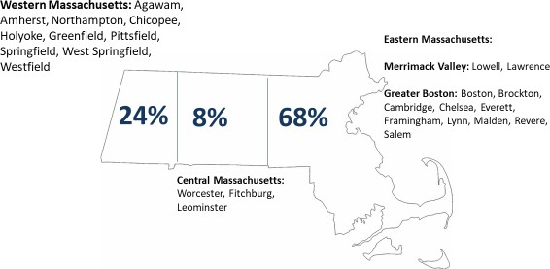

Arrival by Immigration Status
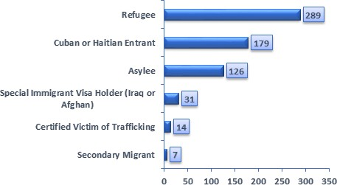

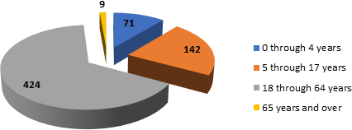
- New Enrollees by Age Distribution

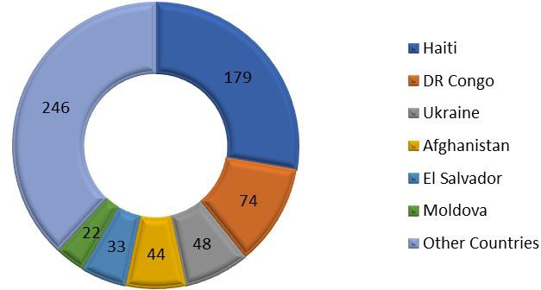
New Enrollees by Country of Origin

“With support from RIAC’s Youth Adjustment program, I adapted quickly to life in the U.S. I started the program in my first year of high school in 2012, and […] they helped me to apply for my first job as a Personal Care Aid, advised me, and believed in me. They also helped me to deal with situations beyond my years, such as applying for visas for my brothers, supporting my mother emotionally, physically, mentally, and making referrals to other agencies and services.
Though I am the oldest and the anchor that supports my mother, I can now study out of state and succeed because of the support I received from RIAC. […] I would not be where I am today without the Youth Adjustment program at RIAC.”
-Hibaq, Somalia

EMPLOYMENT SERVICES

Employment services help all employable individuals obtain their first job, retain employment, and identify career laddering opportunities. Bilingual and bicultural employment staff provide intensive counseling and mentorship to support economic independence and reduce welfare dependence of refugees and other eligible populations.
Available services include: Integrated English for employment, résumé building, interview preparation and coaching, computer literacy, and online job application guidance. Once employed, participants are provided first job assistance, post- employment follow-up, retention assistance, suggestions for upgrades, career laddering, career path opportunities, trainings, and networking.
ORI’s employment partners maintain strong connections with employers to provide cultural competency support both during the hiring and training processes, as well as the months following employment. Furthermore, ORI, in partnership with employers, conducts Vocational Skills Training (VST) to ensure that employment services meet local market demands and take advantage of job opportunities.

Employee Outcomes  Cash Assistance Terminations
and Reductions

11%
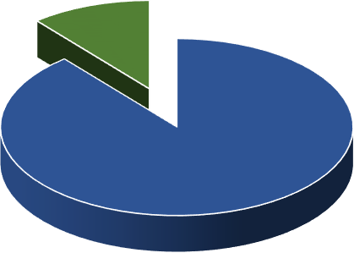(61
individuals obtained 1st employment)

89%
(493
individuals obtained job upgrades)

Cash Assistance Terminations
Cash Assistance Reductions
8%
18%
74%
Continued on Cash Assistance (TAFDC)

Vocational Skills Trainings

Customer Service (f/Retail and Health Centers) Driver's Education Training (Class D & CDL)
Health Sciences/Elder Care (C.N.A., H.H.A., P.C.A. &…
Hospitality & Culinary Arts Financial/Banking Industry Training
Medical Interpretation
Trades (Electricians, Construccion, Green Indutries,…

EDUCATIONAL TRAINING PROGRAMS

Financial Literacy for Newcomers
The Financial Literacy for Newcomers Program (FLN) supports refugees, immigrants, and some Puerto Rican evacuees by working in close cooperation with financial institutions, government agencies, community-based organizations, and other stakeholders. The FLN

targets the specific needs of newcomers as they learn to manage their personal finances. The program explains American credit and banking systems in ways that can be easily understood. The information presented is culturally and linguistically appropriate, while being thorough and practical, covering the basics of banking, budgeting, credit scores, credit reports, loans, and buying a home.
Photo: FLN Banking workshop for AFAB clients-Boston

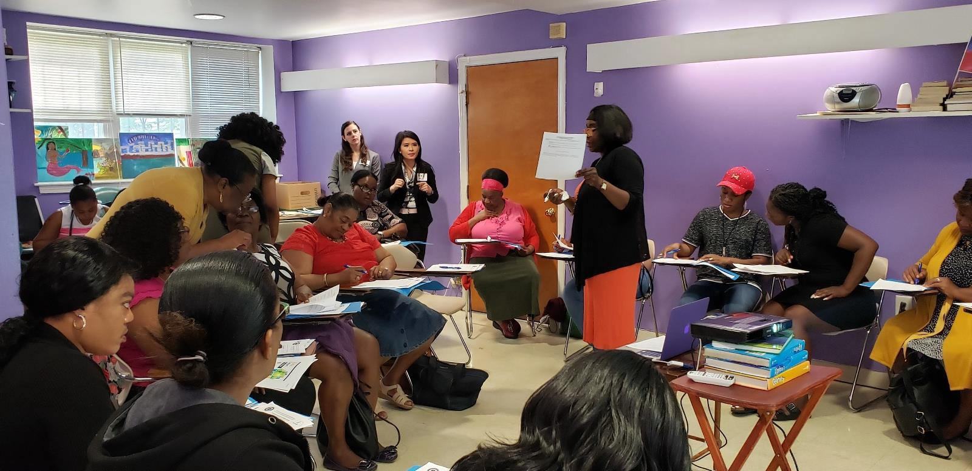

In 2020, ORI provided financial education training to 314 participants through 52 workshops conducted in Greater Boston, Merrimack Valley, and Central and Western Massachusetts. This year’s 13 workshop series
were delivered in 6 languages: Arabic, Haitian Creole, Kinyarwanda, Russian, Spanish, and Swahili.

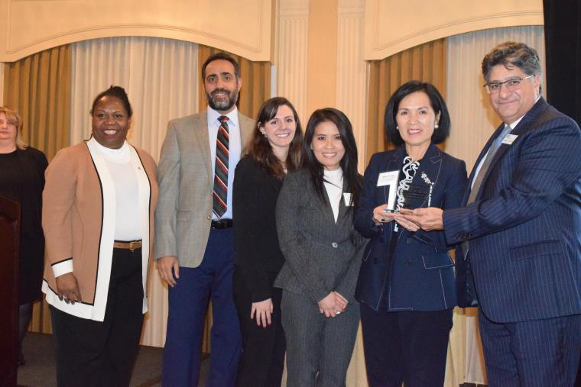
Our dedication to delivering quality financial literacy training to the low-income populations in Massachusetts was demonstrated by receiving an acknowledgement from MassHousing for our outstanding commitment to homebuyer education at their second Annual Award Ceremony on November 20, 2019.

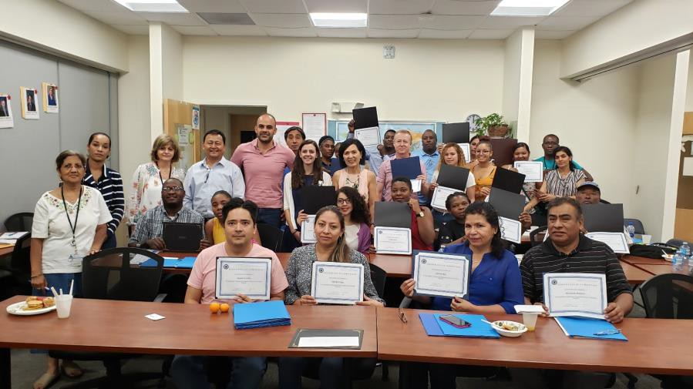
“I am happy to have the opportunity to participate in the budget class. I learned a lot about how budget works. Now I feel I know how to manage my budget.
Congratulations to

the whole team”
-Florence Cange, FLN participant

Top: Receiving MassHousing Recognition
Bottom: FLN Graduation-Worcester

English Language Training

This training supports the English language learning needs of refugee newcomers who struggle to integrate into their new communities. Three distinct models of ELT provision tailored to meet needs of specific refugee populations, ages, learning styles, and personal interests, all with the goal of integrating English language acquisition with life skills, greater familiarity with community resources (libraries, civic centers, public transit), and understanding of civics and financial literacy.

“I like all three
classes Yoga, Music

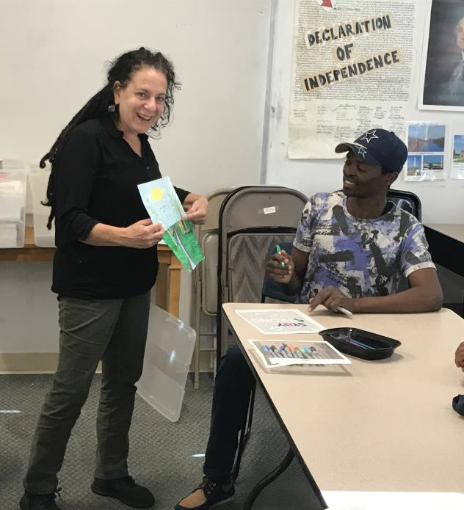
Photo: English Language Training

and Singing. I’m comfortable learning English in the class because it is small, and I have some people who speak the same language like me and they help me. The teachers are good the speak slow and have me repeat and learn to write English.”
-Papa Kinwa, Congo
The target populations for ELT services includes stay-at- home women/caregivers, older refugees that previously lacked opportunities to attend English courses, and employed refugees who still had not attained the level of English proficiency that they need to advance in their jobs or careers. These populations have very different needs and skill levels as well as optimal learning styles. By end of FFY2020, 39 eligible clients had enrolled into the three programs.

During the COVID-19 pandemic, the two ELT-I providers quickly transitioned to an all-remote learning model.
Both providers ensured that ELT-I enrollees had access to tablets and internet service as needed. As a result, both enrollment and class attendance increased. The all-remote learning model enabled the ELT-I target population (elders, disabled and largely home-bound caregivers) to be able to more regularly attend classes and feel more confident to speak and participate with their peers.

CHILDREN AND YOUTH SERVICES

Youth Adjustment Services

Youth Adjustment Services (YAS) is dedicated to helping refugee youth find community and autonomy, facilitating integration, and teaching skills for independent living. The program provides young refugees with vocational and educational exploration and support, referral to short term job training and internship opportunities, life skills coaching, recreation, cultural enrichment, and intergenerational opportunities. In FFY 2020, YAS was able to help 57 young newcomers transition to life in Massachusetts and begin to feel themselves, fully and freely, as members of their communities.

Photo: Youth Soccer

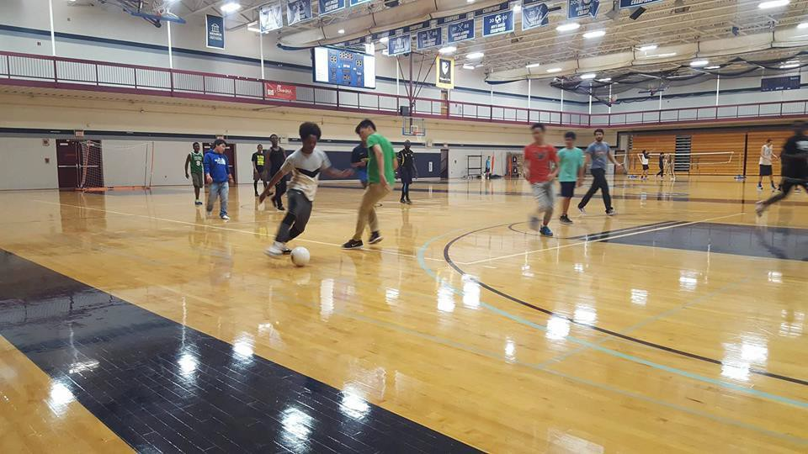

Refugee Youth Mentoring
The Refugee Youth Mentoring (RYM)
s ervices are designed to contribute to the achievement of vocational, educational, and social adjustment goals for youth through personalized strategies, such as developing individualized plans for each youth and on-site English Language classes. RYM recruits, trains, and maintains a volunteer corps to provide mentoring for refugee youth and help supporting youth’s physical and mental well-being, employability, integration/ acculturation, and financial literacy.

In 2020, RYM enrolled 66 young newcomers to be matched with mentors in their communities and to help them to define and work toward their individual vocational and educational goals. Providers held 33 workshops focused on building goal setting, independent living, financial literacy, confidence, and leadership skills amongst refugee youth. They also held numerous online discussions regarding COVID-19 to help youth cope with the stress of the pandemic and find ways to financially support their families during this trying time.

Unaccompanied Refugee Minors Program
In FFY2020, the Unaccompanied Refugee Minors Program (URMP) nurtured 169 refugee minors with health, housing, education, community engagement, and other forms of support. In partnership with the Department of Children and Families, ORI’s URMP helps children and adolescent refugees who are without parents or guardians. These minors need support adjusting to new caregivers, communities, and
schools. Their emotional and behavioral health is often at risk. Children and adolescents are placed in a range of environments, from licensed foster homes to group homes, residential treatment centers, independent living homes, or therapeutic foster care.

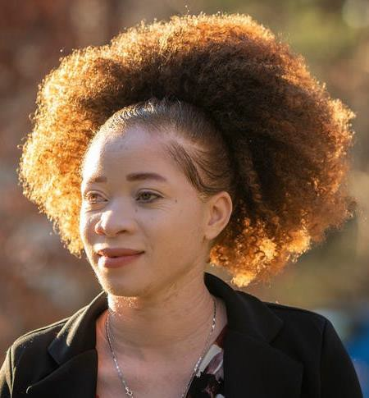
ORI is very excited to share an inspiring successful story for one of our URMP clients. Chantale Zuzi’s remarkable refugee journey started from her home country, the Democratic Republic of Congo (DRC), to Worcester where she lives at a foster home. Chantale
overcame many obstacles, including pale skin from Albinism that put her at danger at the DRC, language barriers, and her disability as a legally blind person, to become a successful young woman who excelled at her school where she finished the four- year high school education in only three. She interns as a mentor to refugee girls at RefuSHE through
zoom and phone calls. In recognition of Chatale's commitment and dedication to leadership and volunteering in her community and beyond, the Women's lnitiative of the United Way of Central Massachusetts presented her with the Meridith D. Wesby Young Leader Award in November 2020. Read the full story at the Telegram & Gazette.
Photo: Chantele Zuzi

Refugee School Impact Program
The Refugee School Impact (RSI)
program supports effective local partnerships between refugee providers and local public schools/school districts to address gaps in services for refugee school- age children and provides individualized services for each refugee child entering the public- school system.

Service providers work with their families to foster understanding of elementary and secondary education in the United States so that parents can encourage in academic achievement and social integration. The Refugee School Impact Program enabled more than 640 students and 162 parents to better connect with their school systems, learn needed skills to increase academic success, and adjust to learning during the challenge of the COVID-19 pandemic.

COMMUNITY AND ELDERS SERVICES

Refugee Community Services
Refugee Community Services (RCS) introduces refugee populations to the diverse range of social services available in Massachusetts, and helps them understand and access state and local resources. These include family support to promote economic self-sufficiency, help with housing issues, fuel assistance, educational supports, child care, and referrals to mental health, medical, and legal services.
Providers use ethnic TV, radio, newspapers, and local events to reach out to refugee populations and help them as they adjust to their new communities.

In FFY 2020, RCS directly supported 723 refugees with assistance to accessing and understanding mainstream service systems and local resources.

This year we share with you a success story for clients served through one of our RCS service providers. T.J. is a Congolese single mother who came to the U.S. in March 2019 with two young children while expecting a baby. With limited English ability and no specific job skills, she began attending classes and participated in other programs at the New American Association of Massachusetts (NAAM). Her 11-year-old daughter attends NAAM’s Refugee School Impact after-school program. Her RCS case manager helped find child care for her 3-year-old son, so she could attend ESL classes.

NAAM staff also helped T.J. make child care plans for the time she was in the hospital delivering her baby and communicated with her health care providers to ensure
they understood the family’s challenges. To accommodate the new addition to her family and improve her family living conditions, NAAM found T.J. a well-maintained, affordable apartment where she and her children will be safe and worked with the new landlord to ensure the apartment is de-leaded. T.J. moved into the new place with a roommate from the same rural neighborhood in Congo.
NAAM staff and ORI are optimistic that this living arrangement will help both families.

Program to Enhance Elder Refugee Services
Through partnership with the Massachusetts Department of Public Health, ORI makes refugee health assessment services available to all newly-arrived refugees. The Refugee Health Assessment Program facilitates follow-up care for these patients, as referral and linkage to primary care or specialty care is a key component of services. For FFY 2020, 413 health assessments consisting of two visits each were conducted, with 97% of individuals linked to primary care. Over 88% maintained primary care at the same site where they received health assessment services.

HEALTH SERVICES

Refugee Health Assessment Services

Through partnership with the Massachusetts Department of Public Health, ORI makes refugee health assessment services available to all newly-arrived refugees. The Refugee Health Assessment Program facilitates follow-up care for these patients, as referral and linkage to primary care or specialty care is a key component of services. For FFY 2020, 413 health assessments consisting of two visits each were conducted, with 97% of individuals linked to primary care. Over 88% maintained primary care at the same site where they received health assessment services.

Image Credit: Shutterstock / didesign021

Refugee Health Promotion
ORI’s Refugee Health Promotion Program (RHPP) provides ongoing individual healthcare access assistance to the newest refugee arrivals and preventive health information to refugee communities. It also works to heighten cultural competence within mainstream agencies. In 2020, ORI’s health promotion program assisted more than 691 individuals to address emergent needs and access health and behavioral health services in their communities. All 691 individuals received direct support in accessing health and behavioral health services. Additionally, more than 30 health forums or classes were held on a variety of issues to build the health literacy of newcomers.
Numerous online trainings were also held to address prevention of COVID-19. One hundred and seventy- one (171) non-ORI service health and social service providers received orientation about the culture and customs of refugee populations to better understand how they may present as patients and how they may regard healers and health professionals.

One story to highlight some of RHPP service providers’ work helping clients through pandemic is about a family that arrived to the U.S. in August of 2019 from Rwanda, originally from the Democratic Republic of Congo. During the pandemic, the family had a difficult time. The parents were preliterate and could not navigate online systems. They did not have access to technology and did not understand how to use it. Their case manager took the time to counsel them repeatedly about COVID-19 precautions and provided them with masks. As Massachusetts gradually reopened, she called them consistently to remind them the pandemic was not over. She helped them book several appointments with Caring Health Center, their RHAP, and their primary care provider. She assisted them with accessing care using their cell phones – not an easy feat when their resettlement provider, Jewish Family Service of Western Massachusetts, staff were also working remotely, and they could not sit down together. The clients leaned on RHPP to keep them up to date and give them the latest information on the pandemic, as well as help them navigate a new and foreign way of navigating U.S. services.

CITIZENSHIP SERVICES

ORI’s Citizenship for New Americans Program (CNAP) enables low-income, lawful permanent residents in Massachusetts to become naturalized citizens of the United States. Services
provided under CNAP include: ESOL (English for Speakers of Other Languages)/civics classes, citizenship application assistance, interview preparation and supportive services including, interpretation and referral services. This year, 2,672 individuals enrolled in CNAP and a total of 640 applicants were successfully naturalized.

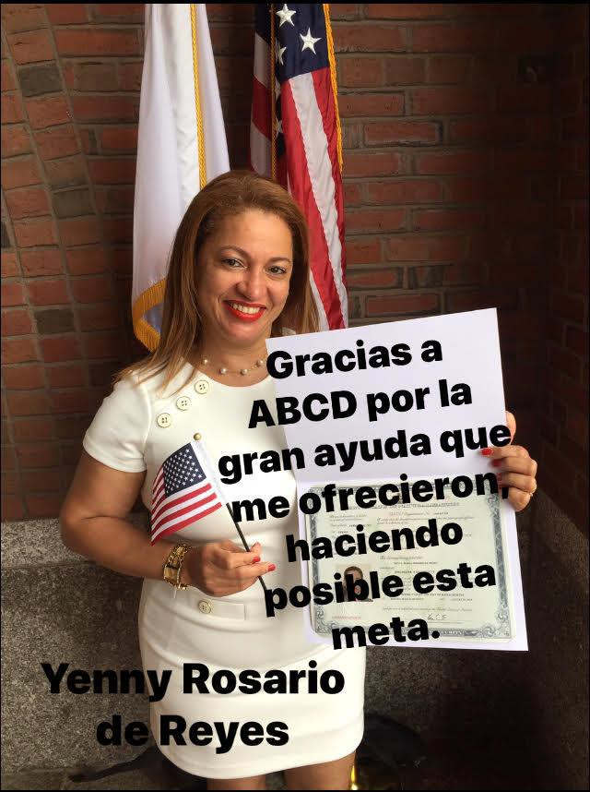
Yenny Rosario moved to Texas with her husband when later he left her behind with her children. Yenny was forced to move to Boston with her brother since she did not have any support in Texas but later Yenny became homeless and unemployed. Yenny checked in to a shelter with her children where she was able to find employment.

Photo: Yenny Rosario

TOWN HALL MEETINGS

O RI’s fifth annual statewide refugee town hall meetings in
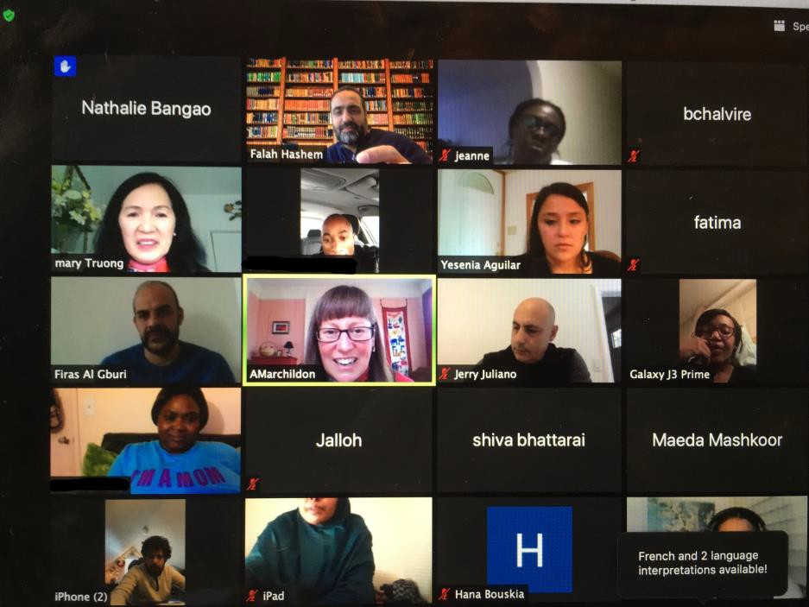
2020 brought together 170 refugees and immigrants living mainly in 5 cities including Boston, Lowell, Lynn, Springfield & West Springfield, and Worcester. Participants came from different countries of origin including Afghanistan, Algeria, Cameroon, Democratic Republic of Congo, Dominican Republic, El Salvador, Eritrea, Guatemala, Haiti, Iraq, Morocco, Russia, and Ukraine. Due to the pandemic, this year’s Town Hall Meetings were conducted online via Zoom. Live interpretation in Arabic, Dari, French, Haitian Creole, Russian, Spanish, Swahili, and Tigrinya were provided during each meeting.

Refugee Town Hall meetings provide an inclusive approach to highlighting clients’ concerns and provide durable responses over the long term, whether in the shape of emerging programming, increased public and private partnership, or policy development.
Main topics discussed during the Refugee Town Hall Meetings include housing, access to healthcare, English language acquisition, public safety, and employment. ORI’s key partners, including representatives from the Department of Mental Health, Department of Public Health, and the United States Citizenship and Immigration Services (USCIS), talk to participants about the services provided by their agencies and answer important questions regarding mental health services, and self-care during the pandemic, and immigration.

All participants expressed eagerness to integrate into their new communities, spoke of the obstacles they faced, and sought additional support. The discussions were honest, frank and interactive. Based on these exchanges, ORI will explore ways to better support and improve our services.

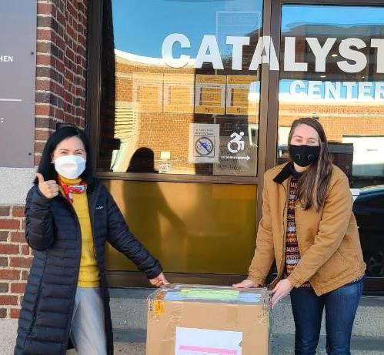

ORI also delivered donated items from Converse Company to refugees and immigrants that attended these Refugee Town Hall meetings.

Top: Refugee Town hall Meeting in Boston
Bottom: delivering donations

“I really like it here and I like
my work where I have a

flexible schedule”
-Nesterchuk, a refugee from
Ukraine who participated in ORI’s online Refugee Town Hall Meeting for Western Massachusetts

SUCCESS STORIES

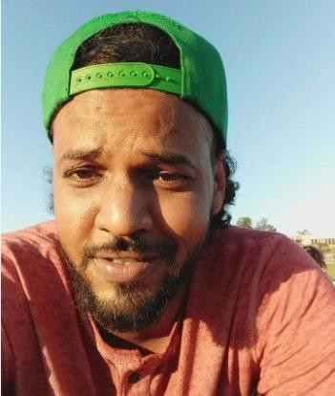
Hassan Sharif Mohammed
Originally from Somalia, Hassan came to the USA through the refugee resettlement program in December 2019 and was resettled in Worcester by RIAC, who provided his initial Case Management Services and referred him to Ascentria for Employment and Education services.
Though he started with limited English- speaking skills, he attended English language classes in Ascentria. Within two months, his English skills had drastically
improved, and he passed the learner’s permit test in English on his first attempt. He then took driving lessons and received his driver’s license within three months of his arrival to the U.S.

Within two months of arriving to the US, Hassan started working FT at a gas station and successfully maintained his first job for 90 days. He opened checking and savings accounts and managed them so efficiently, he successfully bought a car within a month and a half of being employed. To build a better future, Hassan began vocational training through the free VST service. On August 22, 2020, Hassan moved to Texas to join his friends and build a better future by learning trades. He recently passed the entrance test and currently attends Dyer Appliance Repair Academy while simultaneously working. Hassan will become a certified Appliances and Refrigeration technician by the end of the December.

Photo: Hassan Sharif

Lina Issa

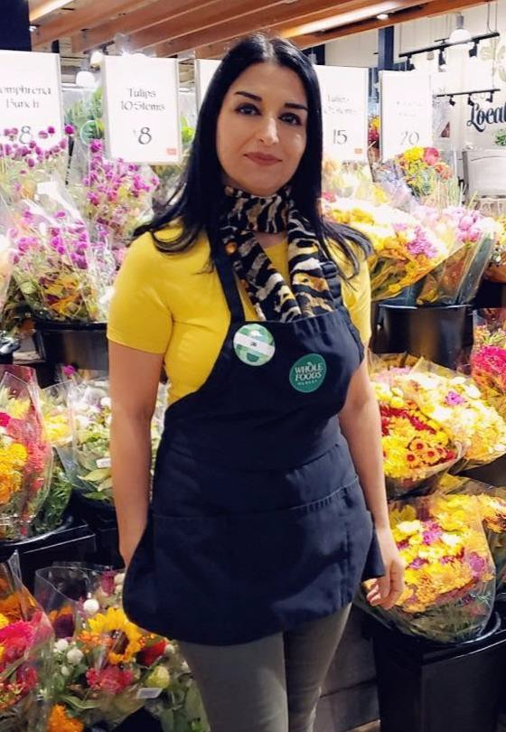Lina and her husband, adult daughter, and teenage son, came to the US as refugees in April 2020 after fleeing the war and violence targeting Iraqi Christians. They were referred by IINE to JVS’ CRES program for Vocational ESOL classes to build job readiness skills and receive job search support. Her family was the first newly-arrived refugees to enroll in JVS services after the COVID-19 pandemic began. Despite the significant barriers to adjusting to their new life in the US compounded by the pandemic, they were extremely motivated. They quickly learned how to use Zoom to attend remote Vocational ESOL classes and meet virtually with their coach and volunteers. With their

career coach’s guidance, they searched for employment, often developing their own ideas of new opportunities to pursue.

Lina’s career coach connected her with
JVS’ employer partner Whole Foods where she was quickly invited for an interview for a position at their West Roxbury store. JVS helped her practice interviewing and, when she was nervous, reminded her of the value that she would bring to the company. Her hard work and preparation paid off. She was immediately hired after impressing the hiring manager with her skills, dedication, and friendly attitude. When Lina continued feeling anxious after being hired, her coach provided continued support. Soon after her employment began, Lina developed more confidence and enjoyed her new job, telling JVS, “You are right I can do this!” Recently, her husband was also offered a job at Saver thrift store and her daughter already has interviews lined up.

We are so proud of Lina’s accomplishments, especially in the midst of the public health crisis, and we are excited to see the next steps she and her family will take as they build their lives and careers in the US.

Photo: Lina at her work

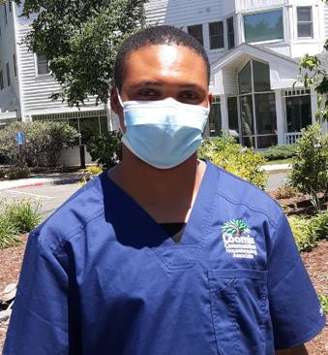Rasi

Photo: Rasi in his work uniform outside of the Loomis Lakeside senior facility

After spending nearly his entire life in a Tanzanian refugee camp, in March 2020, Rasi arrived in Springfield with his wife and two young children under five years old. Though they were given assistance through DTA, it was insufficient to pay their rent and utilities, especially as jobs disappeared while the pandemic spread. Through the guidance of Tatyana, the employment coordinator for the Jewish Family Service of Western Massachusetts, Rasi earned a housekeeping position at Loomis Lakeside at Reeds Landing, an assisted living facility. Obtaining required medical records and a TB for the job was challenging due to the pandemic. JFSWM staff coordinated with the local health center to provide documents even though its medical records office was closed. They also prepared Rasi for his job responsibilities as well as and how to take necessary precautions to keep his family and the elders at the facility safe. He had just an hour before his orientation would start when he was finally cleared for work on day in early May.

After 3 weeks of training, Rasi learned his shift would end after the bus stopped running. Tatyana reached out to JFSWM’s wider network. In just one day, she located a bicycle and delivered it to his house. Five months after hiring him, his manager praises his determination and dedication to his job. Rasi is an essential
part of the team. Reflecting on the time spent interviewing, training, and guiding Rasi, his manager says that every minute he spent in Rasi had been paid back tenfold.

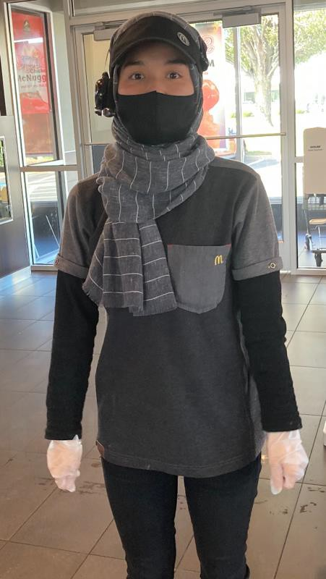Zafa

“Zafa,” a refugee originally from Afghanistan, came from Turkey to the US with her family in December 2019. At 21, she dreamed of receiving an education at an American university, but because her parents were unable to work and her brother was still in high school, Zafa became responsible for supporting her family. She enrolled in JFSWM’s World of Work class and was ready to find a job just as the pandemic hit. JFSWM helped her attain a position at a McDonald’s within walking distance of her home, as well as a part-time job at Safeway Grocery Store. She worked long hours at both jobs, juggling home responsibilities, safety concerns, and a complicated work schedule. Working at McDonald’s allowed Zafa to support her family through the pandemic and gain skills to start her career. She was recently promoted to supervisor for her hard work during the COVID-19 pandemic.

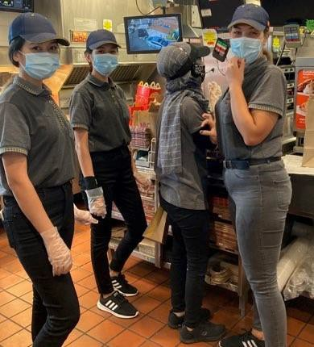
Today, as a trusted employee and supervisor, Zafa connects fellow refugees with work opportunities – under a year after she arrived herself. She advocates for, hires, and trains refugee clients, connecting the refugee community with opportunities for first-time employment. She has become a leader in her community and is on a management track at
McDonald’s. She and her fellow Afghan refugee employees get to work riding bicycles obtained by JFSWM in partnership with RAD Springfield.
Zafa’s dedication demonstrated courage and leadership in a new country in the midst of global crisis. Her dream of continuing her education at an American college is also coming true as she
began classes at a local community college in the fall.
Top: Zafa at her MacDonald’s in her uniform ready for work
Bottom: Zafa (faced away) and the three young Afghan women she helped hire and train

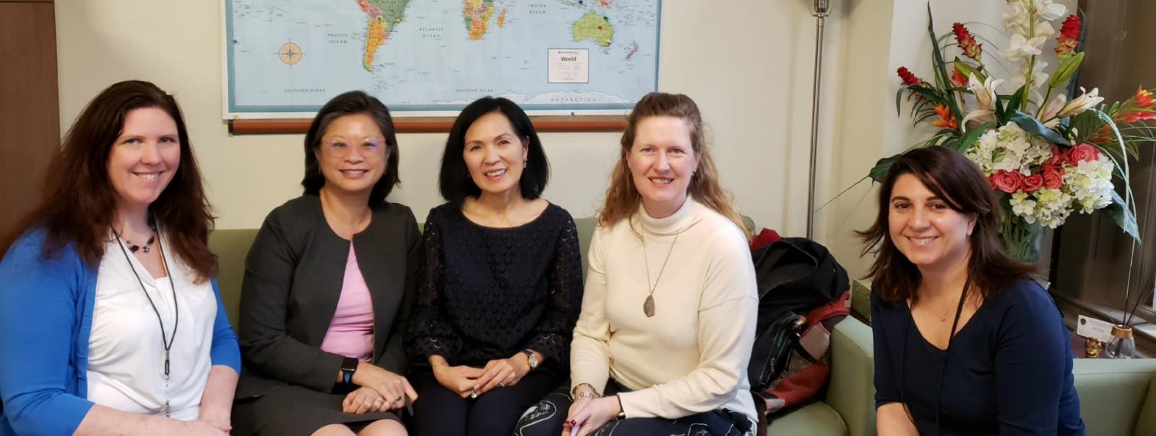

COMMUNITY PARTNERSHIPS
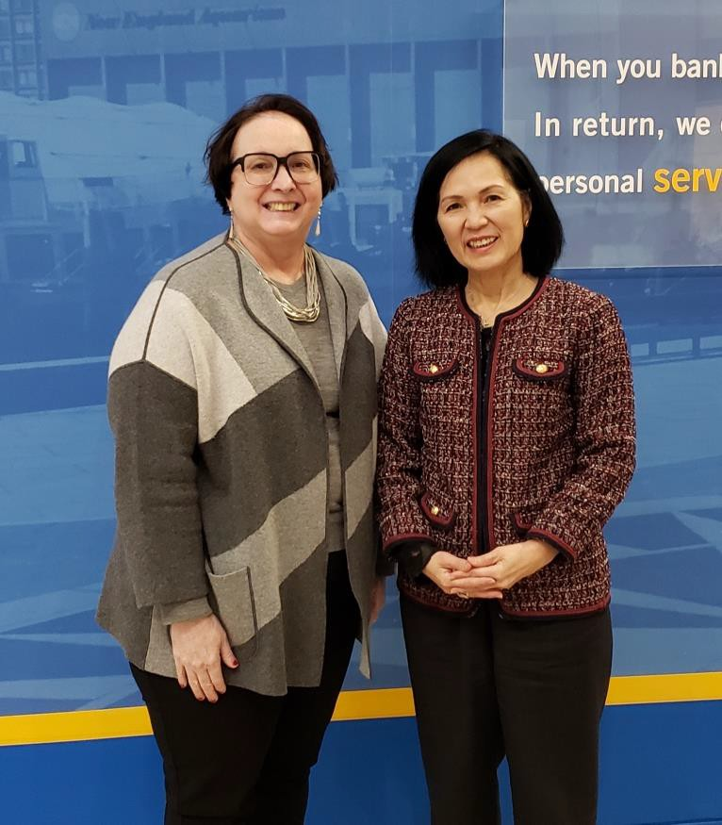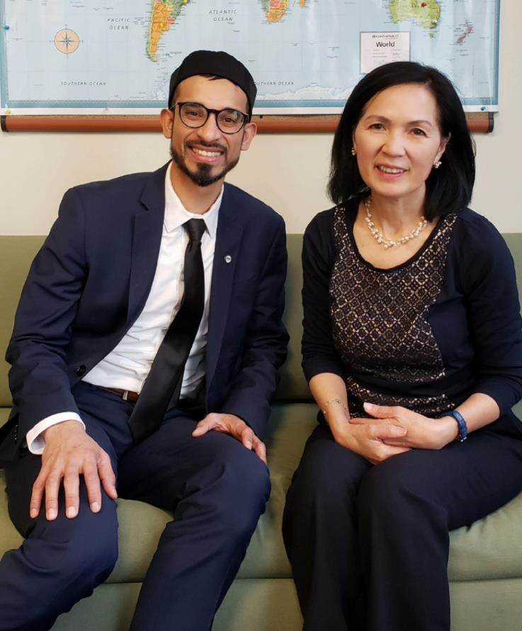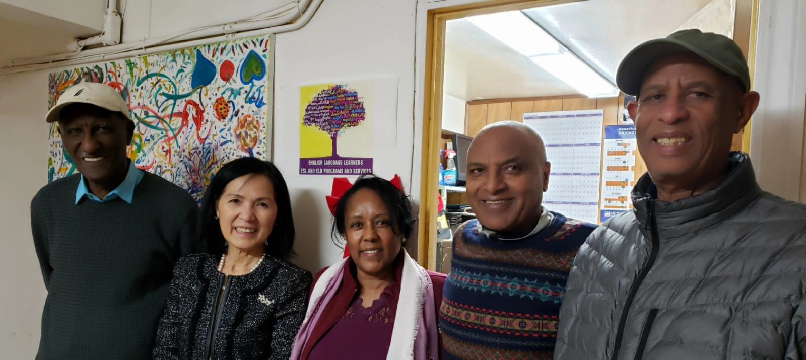

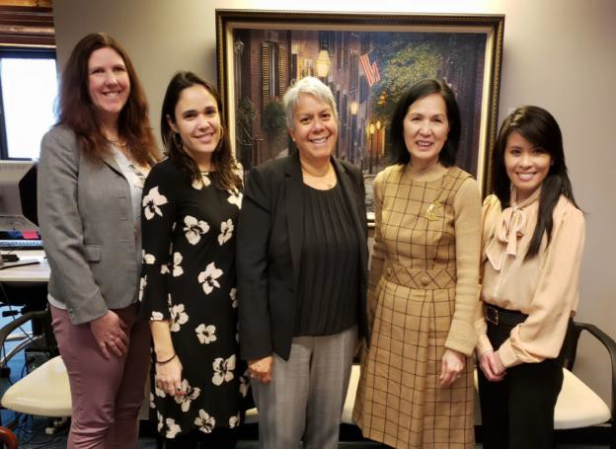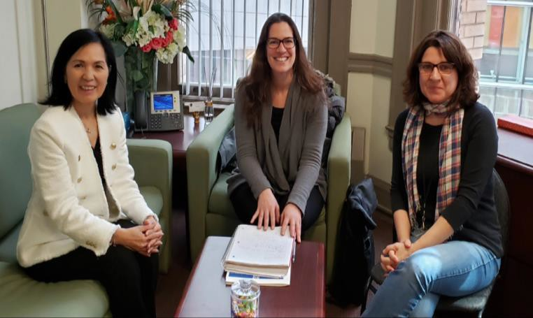

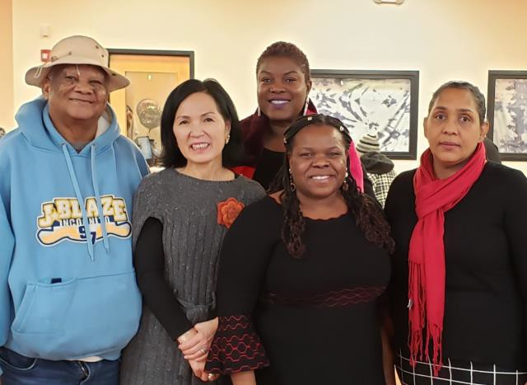
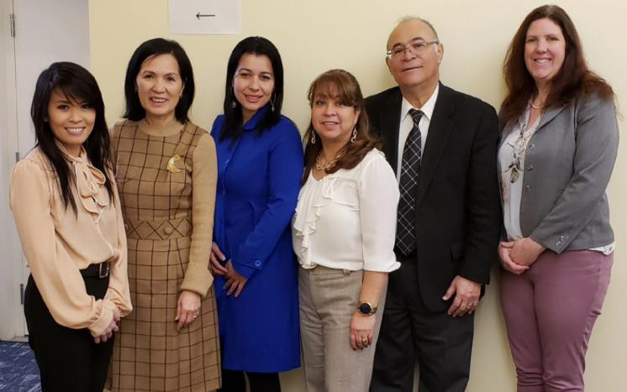

To ensure a successful integration for refugees and immigrants into their new communities, ORI continued its tireless efforts to strengthen existing partnership and create new ones. Above are pictures for some of the partners ORI met with during this year.

Top page (top row from left): Meeting with Elizabeth Chen, Secretary of the Massachusetts Executive Office of Elder Affairs; Webster Bank; Meeting with Director of Immigrant Advancement; Meeting with Eritrean Community Center Team

Bottom page (top row from left): Meeting with Project Citizenship Team; Meeting with Fish Foundation Representative; Haitian Adult Day Center; Meeting with Director of Immigrant Advancement; Community Partners Meeting

FINANCIALS

ORI is 86% federally-funded through the U.S. Department of Health &
Human Services Office of Refugee Resettlement (ORR). In addition, it is 13% state-funded to support citizenship and employment services for
refugees and immigrants living in the Commonwealth. ORI also received 1% of its total funds from private funding to support its Financial
Literacy for Newcomers Program.

In FFY2020, the ORI overall budget was $16.9M, with $14.7M funded through federal grants,
$2.2M from state dollars, and $50K through private donors. ORI continues to develop public- private partnerships to sustain and enhance its mission, strengthen collaborations with key stakeholders, and further empower refugees and immigrants as they successfully integrate into their new communities.

ORI is grateful to all partners and key stakeholders who support its programs. ORI sincerely welcomes all who would like to help by contributing monetary and/or in-kind support to make 2021 an even more successful year for both newcomers and the Commonwealth. If interested, please call us at (617) 727 - 7888 or send an email to Mary.truong@mass.gov.

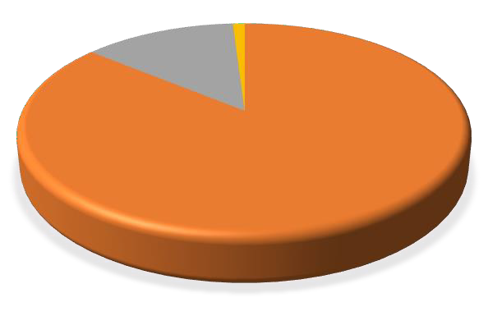
State
13%
Other
1%
Federal
86%
❖ FY20 Direct
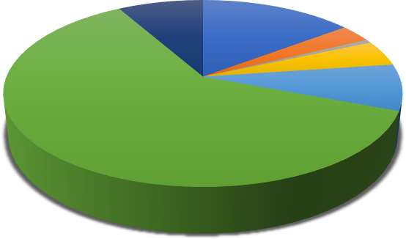
Services Funding
Employment Related Services 15% Social Adjustment Services 3% Case Management 1% Cash Assistance 4%
Health Assessment 8% Unaccompanied Minors 61%
Other 8%
- FY20 ORI Funding

ACKNOWLEDGMENT
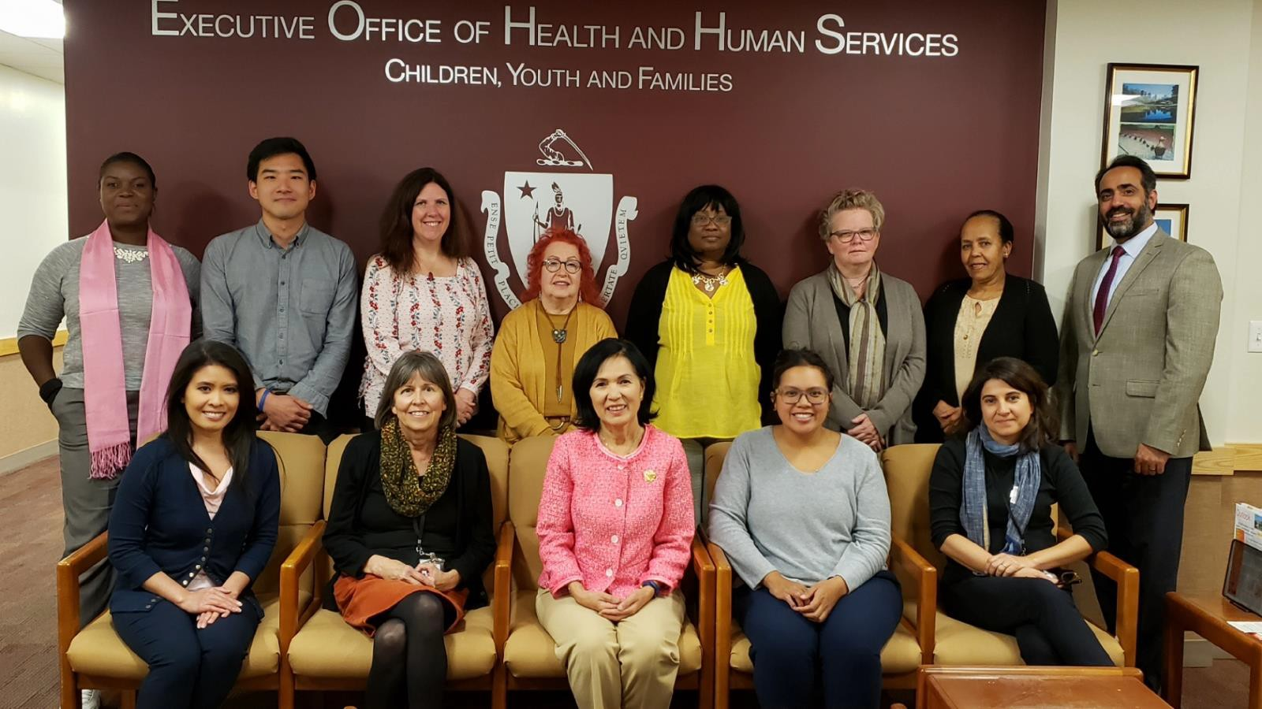
ORI would like to thank the following partners in support of our work.
  - Governor Charles Baker
  - Lieutenant Governor Karyn Polito
  - Executive Office of Health and Human Services (EOHHS) Secretary Marylou Sudders

  - Governor’s Advisory Council on Refugees and Immigrants
  - Office of Refugee Resettlement
  - MA Department of Children and Families
  - MA Department of Public Health
  - MA Department of Transitional Assistance
  - MassHealth
  - Interns, volunteers, supporters and service providers
  - United States Citizenship and Immigration Services
  - Generation Fund
  - CONVERSE

Special thanks to:
Stephanie Yu for her generous help in producing this report

CONTACT US
Massachusetts Office for Refugees and Immigrants
600 Washington Street, 4th Floor Boston, MA 02111

For more information, or to download this report, please visit:
617-727-7888 | www.mass.gov/ORI | @ORIMassState

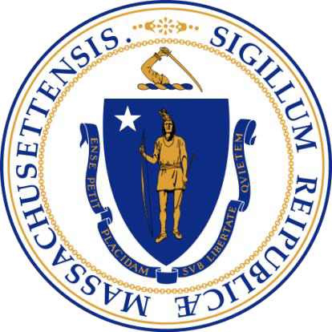

Charles D. Baker, Governor
Karyn Polito, Lieutenant Governor Marylou Sudders, Secretary

Mary Truong, Executive Director

MASSACHUSETTS OFFICE FOR REFUGEES AND
IMMIGRANTS
600 Washington St. 4th floor, Boston, MA 02111, Phone: 617-727-7888
For more information or to download this provider directory – visit
www.mass.gov/ORI
@ORIMassState

