|  |  |  |
| --- | --- | --- |
| **Special Report to the MA Unaccompanied Homeless Youth Commission** | 2020 | |
| The purpose of the Commission is to study and make recommendations regarding services for unaccompanied youth and young adults experiencing homelessness in Massachusetts, to ultimately provide comprehensive and effective responses to the unique needs of this population. | | https://lh5.googleusercontent.com/YJVp5WDBgE45-yTD9MK5WoiKNdZWhApqmxMG9SJVhOfBnEmYC_pTy1TK1aS06W3a1rJgwLYZWw=w800 |

Laurie Ross, Ph.D.

MA YOUth Count Consultant

Clark University

2/18/21

Contents

Purpose of this Report 2

A Glimpse into the Situation of Youth and Young Adults Facing Homelessness in 2020 3

Efforts to expand the current spectrum of accountable and evidence-informed models of housing and services: A Focus on Flexible Funding 5

Efforts to enhance early identification, connection, and outreach systems to improve young people’s connection to existing resources: A Focus on Referrals and Partnership Development 6

Referrals 6

Partnership Development 7

Create a structure to support authentic youth and young adult involvement statewide: A Focus on Youth Action Boards (YABs) 7

Setting the Stage for 2021 YOUth Count Survey 8

The Massachusetts Commission on Unaccompanied Homeless Youth defines an unaccompanied homeless youth or young adult as a person who:

1. **Is 24 years of age or younger; and**
2. **Is not in the physical custody or care of a parent or legal guardian; and**
3. **Lacks a fixed, regular, and adequate nighttime residence.**

# **Purpose of this Report**

“The Commonwealth of Massachusetts envisions a future where we end homelessness among youth and young adults (YYA) by making homelessness rare, brief, and non-recurring, and where every YYA is safe, supported, and able to use their strengths fully. We acknowledge that YYA will continue to face life’s challenges; however, we can create systems that will catch them when they fall. Our goal is to build a system in which every community in the Commonwealth has coordinated, developmentally appropriate, and trauma-informed resources that are effective, regionally accessible, and reliably funded”—Vision Statement in the Massachusetts State Plan To End Youth Homelessness

“It needs to be easier to enroll in the program than to stay homeless.” (Youth respondent)

Amidst a global pandemic, the Commonwealth of Massachusetts’ systems and safety nets for youth and young adults (YYA) experiencing homelessness and housing instability have been tested and stretched. The MA Commission on Unaccompanied Homeless Youth could not have anticipated that the robustness of the Massachusetts Plan to End Youth Homelessness would be challenged by a force such as COVID-19. Yet, in large part due to the inclusive process to develop and implement the Plan, regional providers had already been adopting new ways of thinking and powerful tools such as Flex Funding, the College Pilot, Winter/Emergency Response Protocols, and newly activated partnerships. As a result, providers were able to respond rapidly as young people’s situations became more precarious. Regions were prepared to rethink service delivery when in-person programming and tried and true street outreach methods were temporarily not possible. The Plan’s basis in eight evidence-based principles[1] helped to ensure that while systems were stretched, they did not break.

One practice that was suspended in 2020 was the annual MA Youth Count. It had been scheduled for April and May; yet, with shutdowns impending and safety concerns, it was determined to be too risky and resource intensive to implement. Over the years, the Count has played an important role in understanding the situation of a diverse range of young people facing homelessness and housing instability, as well as informing resource allocation and strategy development. For this reason, the MA Commission did not want this historic year to go by without a report that could signal areas for action and investment. By reviewing quarterly provider reports, other surveys[2], and relevant data sources, this brief report focuses on progress being made on three recommendation areas in the MA Plan to End Youth Homelessness as well as areas of unmet need.

A theme that emerges from a review of available data is that of **vulnerability**. The pandemic has revealed just how deep inequities are to access the social determinants of health (SDOH), rendering many of the state’s subpopulations of young people vulnerable to homelessness. Indeed, providers expressed concern that the pandemic has pushed more YYA into homelessness. Networks that had once kept young people out of literal homelessness, such as couch surfing and staying with family and friends, became less available due to safety concerns related to COVID-19. Procedures to de-densify shelters limited young people’s access to emergency resources and in some cases caused longer wait lists to get help. Motel regulations prohibiting housing young people under 21 years old proved to be a barrier to providing rapid shelter. Providers have seen increases in referrals for services and expressed worry that demand will continue to increase as the eviction moratorium comes to an end. The Commission has always been concerned about the unconnected and disconnected young people in the state who are particularly vulnerable to becoming homeless. This ongoing concern, coupled with deepening inequities, make it more important than ever to connect with every city and town in the Commonwealth and exercise deep intentionality engaging with subpopulations that face barriers in accessing housing and related services.

**Resilience** can be thought of as the flip side of vulnerability. In the context of a global pandemic, the resilience of youth and providers working in the context of an increasingly resilient system clearly emerges from the data. For example, as providers were distributing PPE and flex funding so that young people could be as safe and stable as possible, they were also examining their practices and policies through an anti-racist lens. They expanded the number beds and extended the operations of shelters to meet pandemic-related demand. They demonstrated concerted effort to elevate their visibility to young people and other providers to ensure young people knew where to go to get help. They initiated learning communities to increase communitywide understanding and capacity to be responsive to young people experiencing homelessness. The ability to work at these very different levels—from crisis response to long-term planning through an anti-racist lens simultaneously is a testament of providers’ commitment and readiness to do the best they can by the young people.

# A Glimpse into the Situation of Youth and Young Adults Facing Homelessness in 2020

Based on the Regional Providers’ quarterly reports, in FY 2020, 2,470 unduplicated YYA were served. This was a 38.9% increase from FY 19 when 1,778 YYA were served. As a point of comparison, since 2017, there has been a 3% increase in the number of unaccompanied youth experiencing homelessness being reported by the Department of Elementary and Secondary Education[3]. While the number reported by DESE is limited to a population attending school and the Regions serve youth and young adults up to age 25, the large increase in youth served by Regional Providers compared to the relatively small increase in the number of unaccompanied youth experiencing homelessness in the schools raises interesting questions. Is it the case that services for young people have become more visible and accessible and therefore service usage is increasing even if the incidence of youth homelessness is relatively stable? Is the increase a function of the significant prevention work the Regions have been undertaking (i.e. while more youth are being served, they are being served prior to becoming homeless and therefore avoiding the risks associated with homelessness)?

A look at patterns of case management provision would suggest that while numbers served increased, more youth are being diverted from becoming homeless. Indeed, 353 YYA served maintained stable housing for at least 90 days following receiving case management. Of these, 213 received case management to prevent becoming homeless and 140 received case management after being rehoused due to homelessness. In Quarter One of FY 21, 669 have been served. If this pace continues over the course of the year, the state is on track to serve at least 400 more young people in FY21-with very promising indications that a higher number will be diverted from homelessness[4]. Table 1 provides a demographic overview of those served in FY20.

|  |  |
| --- | --- |
| Table 1: Demographic Overview | FY20year |
| Total | 2470 |
| Under 18 | 3% |
| Male | 44% |
| Female | 52% |
| Other | 3% |
| White | 44% |
| Black | 35% |
| Asian | 1% |
| Other | 18% |
| Hispanic | 31% |
| Pregnant/Parenting | 12% |
| LGBTQ | 12% |
| Complete HS | 33% |
| State Agency involvement | 23% |
| Has insurance | 56% |

A brief survey was administered in April and May 2020 to get a snapshot of how young people were faring at the outset of the pandemic. Encouragingly, most of the YYA reported that they were socially distancing (78%) at that time. Several important insights can be gleaned from this survey of roughly 90 young people:

* 87% were experiencing homelessness and 23 who were not homeless were worried about their ability to pay rent.
* 50% had no income source and were struggling to find employment.
* Supports most desired but least able to access included: rental assistance, public benefits, unemployment benefits, utility assistance, phone assistance, food assistance, laundry, free online classes, and transportation.
  + The biggest barriers the respondents reported were: not knowing who to ask, no in-person meetings, transportation, staff not being available, and limited program hours.
* Their top reported concerns during COVID-19 were getting sick, employment, their ability to cope mentally, the health of family and friends, and food access.

Efforts to expand the current spectrum of accountable and evidence-informed models of housing and services: A Focus on Flexible Funding

|  |  |
| --- | --- |
| **Table 2: Flex Fund Usage (numbers indicate % of YYA served)** | **FY 2020** |
| **Total YYA receiving flex funds** | **741** |
| **Transportation** | **54%** |
| **Food/groceries** | **45%** |
| **Move-in costs** | **28%** |
| **Other** | **23%** |
| **Rent** | **17%** |
| **Work-related costs** | **11%** |
| **Education-related costs** | **9%** |
| **Rent arrears** | **9%** |
| **Cell phone** | **8%** |
| **Utilities** | **5%** |
| **Medical** | **4%** |
| **Legal** | **2%** |
| **Child care** | **0%** |

Acknowledging that young people often do not need large sums of money to increase their housing stability, the MA Plan developed a mechanism to provide flexible funding to youth (Flex Funds). As COVID-19 hit during the last quarter of 2020 (April-June), Flex Funds were critical in helping YYA facing homelessness and housing instability with basic needs, staying connected, and achieving a semblance of stability. Flex Funds played an important role fostering the stability of vulnerable sub-populations such as pregnant and parenting young adults as well as young people involved in the foster care system. In the face of COVID-19, Flex Funds became critical for young people who were laid off or otherwise lost employment income to cover housing and basic needs as well as transportation and education costs. Table 2 shows the use of Flex Funds in FY 20.

Cumulatively, in 2020 the top uses of Flex Funds as measured by the number of YYA needing Flex Funds, were for transportation, food/groceries, move-in costs, and rent. Preliminary analysis of FY21 data indicates that in addition to the four top uses in 2020, use of Flex Funds for cell phones increased. As the pandemic persisted, youth and providers increasingly recognized the importance of having a working phone as a primary way to stay connected to case managers, other community supports, and potential employers and landlords. The bulleted list below summarizes Region’s use of flex funds.

* Flex funds covered young people’s **basic needs** including maternity clothes for pregnant YYA, food, hygiene products/PPE, and laundry. Some providers used flex funds to provide gift cards for YYA who were couch surfing for groceries and other necessities to divert them from shelter.
* Use of flex funds for **cell phone activation and paying back phone bills** helped to ensure connection with case management and other services.
* Flex funds enhanced housing stability by covering **rent, rent arrears, move-in costs, and important household items** needed for leasing new apartments, such as beds and refrigerators. Providers reported working with discount furniture stores to help young adults furnish their apartments. Flex Funds accelerated providers’ ability to house youth because having immediate access to these funds was appealing to landlords.
* To reduce the amount of time YYA are unsheltered, flex funds allowed providers to work directly with local hotels to **bolster emergency shelter** options for YYA during the pandemic.
* Flex funds allowed for creativity in support **transportation**. For example, YYA purchased bicycles, bought new tires for a car, and fixed a scooter to facilitate access to employment. Providers used flex funds to purchase bus passes, train passes, and uber cards.

One creative way we were able to use flex funding this quarter was to help a young adult get new tires for their car. They had lost their job due to the COVID crisis and wanted to start driving for rideshare of food delivery services. Unfortunately, their car was due for an annual inspection and the tires were bald. We were able to use flex funds to help this young adult purchase new tires. They have been driving for a food delivery service ever since full time and making enough to support themselves and pay all their bills.

Efforts to enhance early identification, connection, and outreach systems to improve young people’s connection to existing resources: A Focus on Referrals and Partnership Development

One of the recommendations in the Plan was to enhance early identification, connection, and outreach systems to improve young people’s connection to existing resources. This section examines patterns in referrals as evidence of ‘connection to existing resources’. This section also examines Region’s work forging partnership as evidence of regional system development.

## Referrals

In FY 20, providers received 934 referrals for YYA experiencing homelessness and 744 YYA at-risk of homelessness. In FY 20, providers made 983 referrals to other providers—this represents 39.7% of YYA served. Table 3 presents data on referrals made out in FY 20.

|  |  |
| --- | --- |
| **Table 3: Referrals Out** | **FY 20** |
| Total number of YYA who received referrals to other providers | 983 |
| Housing supports | 41% |
| Employment & job training services | 34% |
| Mental health services | 23% |
| Other services or activities | 22% |
| Health services (excluding mental health) | 19% |
| Life skills/ financial literacy services | 19% |
| Benefits (excluding health insurance) | 18% |
| Education services | 15% |
| State agencies | 12% |
| Substance use services | 7% |
| Parenting resources | 7% |
| Health insurance providers | 7% |
| Language-related resources | 6% |
| Cultural/ recreation activities | 6% |
| Domestic violence-related services | 5% |
| Legal services | 4% |

While the first quarter of FY 21 shows a slight decrease in the percent of youth served receiving referrals out, there are some interesting trends—some encouraging and some concerning. Two areas that showed an increase were referrals for housing supports and for mental health services. Of concern was a large decrease in referrals for health services.

## Partnership Development

Many providers reported that the partnerships they had cultivated prior to COVID-19 as part of the Plan to End YYA Homelessness enhanced their preparedness to respond quickly to youth need. Several providers highlighted improved coordination and responsiveness with DCF, DMH, and DYS. Yet, as the pandemic continued over the summer and into the fall, some regions were finding it difficult to foster or maintain community partnerships. The challenges were in part due to changes in operations that decreased organizational accessibility. Regions also reported needing to enhance their capacity to do outreach to particular communities, including LGBTQ YYA, indigenous communities, and YYA with limited English proficiency. Regional providers discussed attempts to reengage community supports and get an up- to-date understanding of their program capacity. In spite of the challenges, there is ample evidence that partnerships were critical in keeping young people housed and resourced. Providers continued to work on coordinated entry and shared data tracking systems. The bulleted list below highlights some of the partnership development work reported by Regional Providers.

**Housing:** Providers developed partnerships with hotels to meet the immediate housing needs of YYA with no safe place to stay.

**COVID-19 coordination:** Regions partnered with public health departments to coordinate COVID screenings in shelters and develop plans to ensure YYA had a safe place to stay while quarantining or waiting results of COVID testing.

**Partnerships aimed at increasing young people’s ability to access education and employment:** One innovative example included partnering with an area driving school to increase YYA access to driver education.

**Partnerships with DCF and other systems:** Some regions reported deepened partnership with DCF to provide more protection to young people at risk for commercial sexual exploitation.

**Partnerships in towns and rural areas:** Regional providers reported developing relationships with services in smaller, rural parts of their catchment areas.

Create a structure to support authentic youth and young adult involvement statewide: A Focus on Youth Action Boards (YABs)

Of the 10 regions, YABs were active in five of them in FY 20. Many regions placed meetings on hold at the outset of the pandemic. Regions that continued their YABs reported some challenges due to disruptions caused by not being able to meet in person and college shutdowns. Many regions shifted to virtual meetings and used zoom functions to maximize participation. Several YABs instituted safety practices that allowed in person meetings to resume. Now, in FY 21, there are active YABs in eight of the ten regions. Many regions used the pause in meetings to rework aspects of the YABs that were not effective and to institute new practices and renewed energy.

Below is a bulleted list of the types of work YABs took on during the last quarter of 2020 and into 2021:

* Fortified the identity of the group by creating a YAB logo
* Planned events and programs in conjunction with regional planning work, including input into Homeless YYA Race Equity Plans; website design; presentations to local legislators, educators, and homeless service providers; forums with landlords, providers and other young adults to discuss stigma and other renting challenges; participation in NIS Racial Equity focus groups
* Conducted focus groups with other young people to get feedback on service quality
* Held regional meetings with other YABs
* Engaged in community service, including food distribution, COVID-19 care package/PPE distribution

YAB Members rose to answer the calls for volunteers continued in our food pantry as the number daily visitor numbers went from 50 in the second quarter to over a hundred and fifty in the third, to over 388 in the fourth quarter. Our YAB members wanted to do more and requested donations from School On Wheels to put together COVID Care Packages filled with toiletries including hand sanitizer, soap, towels, gloves and masks. Marketing materials were designed by the YAB members and approved, and received and are ready to be disseminated with more COVID Care Packages throughout all three Coc’s at more food pop up locations.

# Setting the Stage for 2021 YOUth Count Survey

The resilience and vulnerabilities of young people, providers and systems have been on full view this year. Providers have developed new partnerships and models. Flex funds have made it possible to address emergent needs in the context of a pandemic. Yet, at same time, the inequities in SDOH have proven formidable. Providers are reporting that while it is possible get youth housed, it is challenging to maintain housing given limitations in employment and public transportation. Rents are high and landlords are hesitant to rent to young people, who may lack life skills needed to maintain housing and support services for mental health and substance use.

It is now more important than ever to be sure that young people are not falling through the cracks and that we have the right resources to support them. The Massachusetts YOUth Count is an important tool to reveal the scope and needs of youth and young adults under the age of 25 who are unstably housed or experiencing homelessness. We intentionally emphasize the “YOU” in “youth” because we want to make it clear that the YOUth Count is not just about the data. It is an opportunity to connect with vulnerable youth to share resources with them and hear their voices.

For 2021, the groundwork has been laid to focus on areas that have been challenging in prior years of the Count, including expanding the geographical coverage and surveying a sample that includes more young people experiencing housing instability, particularly youth who are under 18, LGBTQ+, and disconnected/unconnected from services and supports. The Count will be including questions about how young people are managing after a year of a pandemic. Regional Providers and members of the Identification and Connecting Subcommittee of the Commission have expressed excitement in bringing back the Count. Here are some reasons expressed at recent Count planning meetings:

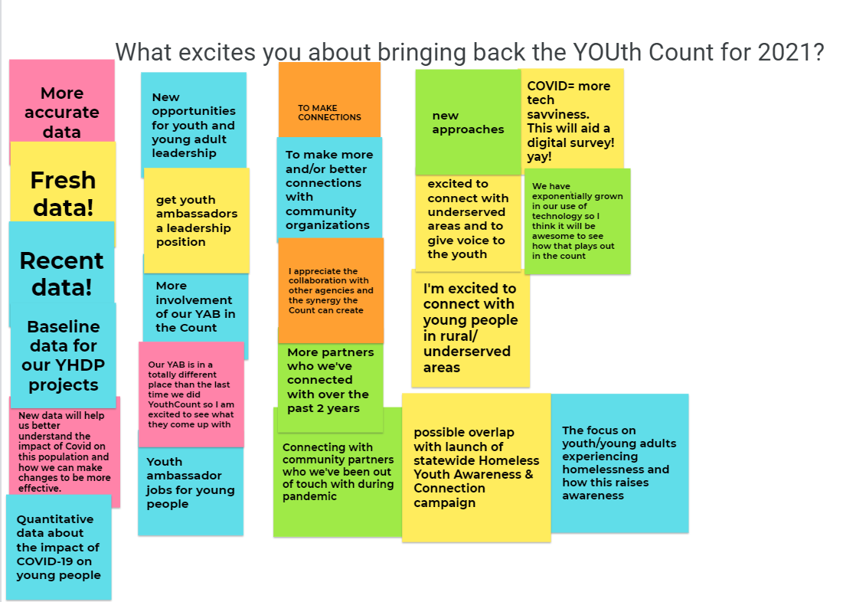

This year’s count may look a little different than in the past. Yet, the capacity built in the context of the Massachusetts Plan to End Youth Homelessness and in response to COVID-19 will ensure that the information collected is actionable and that the connections forged are authentic bringing us steps closer to ending youth homelessness in Massachusetts.

1. Trauma-informed Care, Positive Youth Development, Housing First, Culturally Responsive Services, Racial Equity, Authentic Youth and Young Adult Engagement, and Multi-system Approaches
2. COPING-19 Survey with 87 respondents from 9 of the regions administered in April 2020.
3. 860 of unaccompanied youth experiencing homelessness were over 18 years old.
4. De-duplication of total number of youth served in FY21 is not complete. For this reason, when discussing total numbers of youth served, this report only includes quarter one data. Program narratives from FY21 Quarters One and Two are used to describe service utilization.