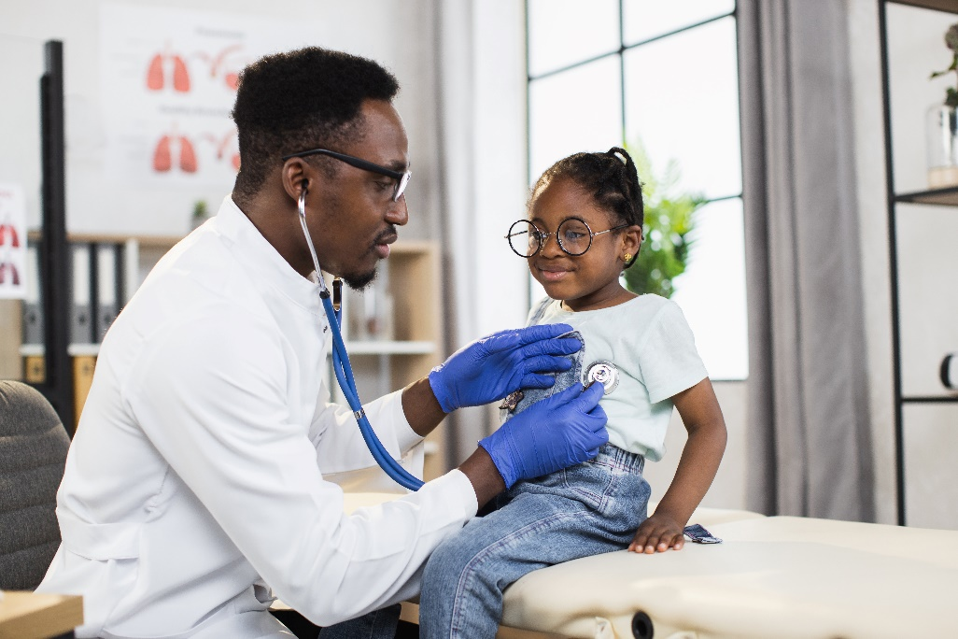
For more information on MDPH-funded SBHCs, including a directory of sites and their sponsoring agencies, go to mass.gov/school-based-health-centers-here-for-the-kids

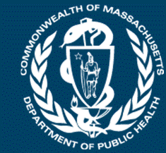
Commonwealth of Massachusetts
School-Based Health Center Program
2021-2022 Annual Report
About School-Based Health Centers

School-Based Health Centers in Massachusetts
School-Based Health Centers (SBHCs) are health centers that offer a variety of health care services, including primary and behavioral health care, where children and adolescents can most easily access them—school.
Since 1989, the Massachusetts Department of Public Health (MDPH)’s SBHC Program has been providing comprehensive health care to children and adolescents across the Commonwealth.

Funded SBHCs
Every child and adolescent deserves to have access to health care and the resources that they need to succeed; yet, where we live, grow, and learn impacts our ability to access the resources that we need.
The 33 SBHCs funded by MDPH’s SBHC Program in the 2021-2022 school year are strategically located where they can make the greatest impact in the lives of the youth they serve. These centers develop nurturing, stable, therapeutic relationships with populations that have historically experienced structural and physical barriers to comprehensive health care.
SBHCs Funded in the 2021-2022 School Year
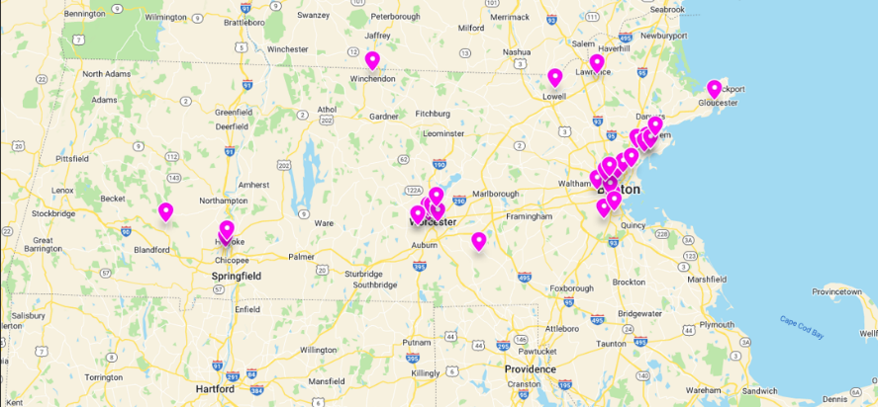
Map created using Padlet

Use this hyperlink Map of SBHCs funded in FY22 to interact with the above map of SBHCs funded by MDPH in the 2021-2022 school year. The full list of SBHCs (some of which support multiple schools) and their sponsors is in Appendix I.
SBHC Program Partners
Funded SBHCs are run by community health centers, hospitals, behavioral health agencies, and local public health agencies. The 15 sponsoring agencies were selected with intentionality based on:
For more information on MDPH-funded SBHCs, including a directory of sites and their sponsoring agencies, go to mass.gov/school-based-health-centers-here-for-the-kids
Their ability to bring community organizations together to build hope and health.

The shared value that all kids deserve the resources that they need to be healthy and well.

SBHC Services and Programming

Services and Programming
SBHCs provide a variety of services to meet the needs of students and their communities. In the 2021-2022 school year, some of the common services provided by SBHCs included primary care, vaccinations, behavioral health care, COVID-19 testing, dental care, collaborative care planning/case management, sexual and reproductive health care, and community engagement.

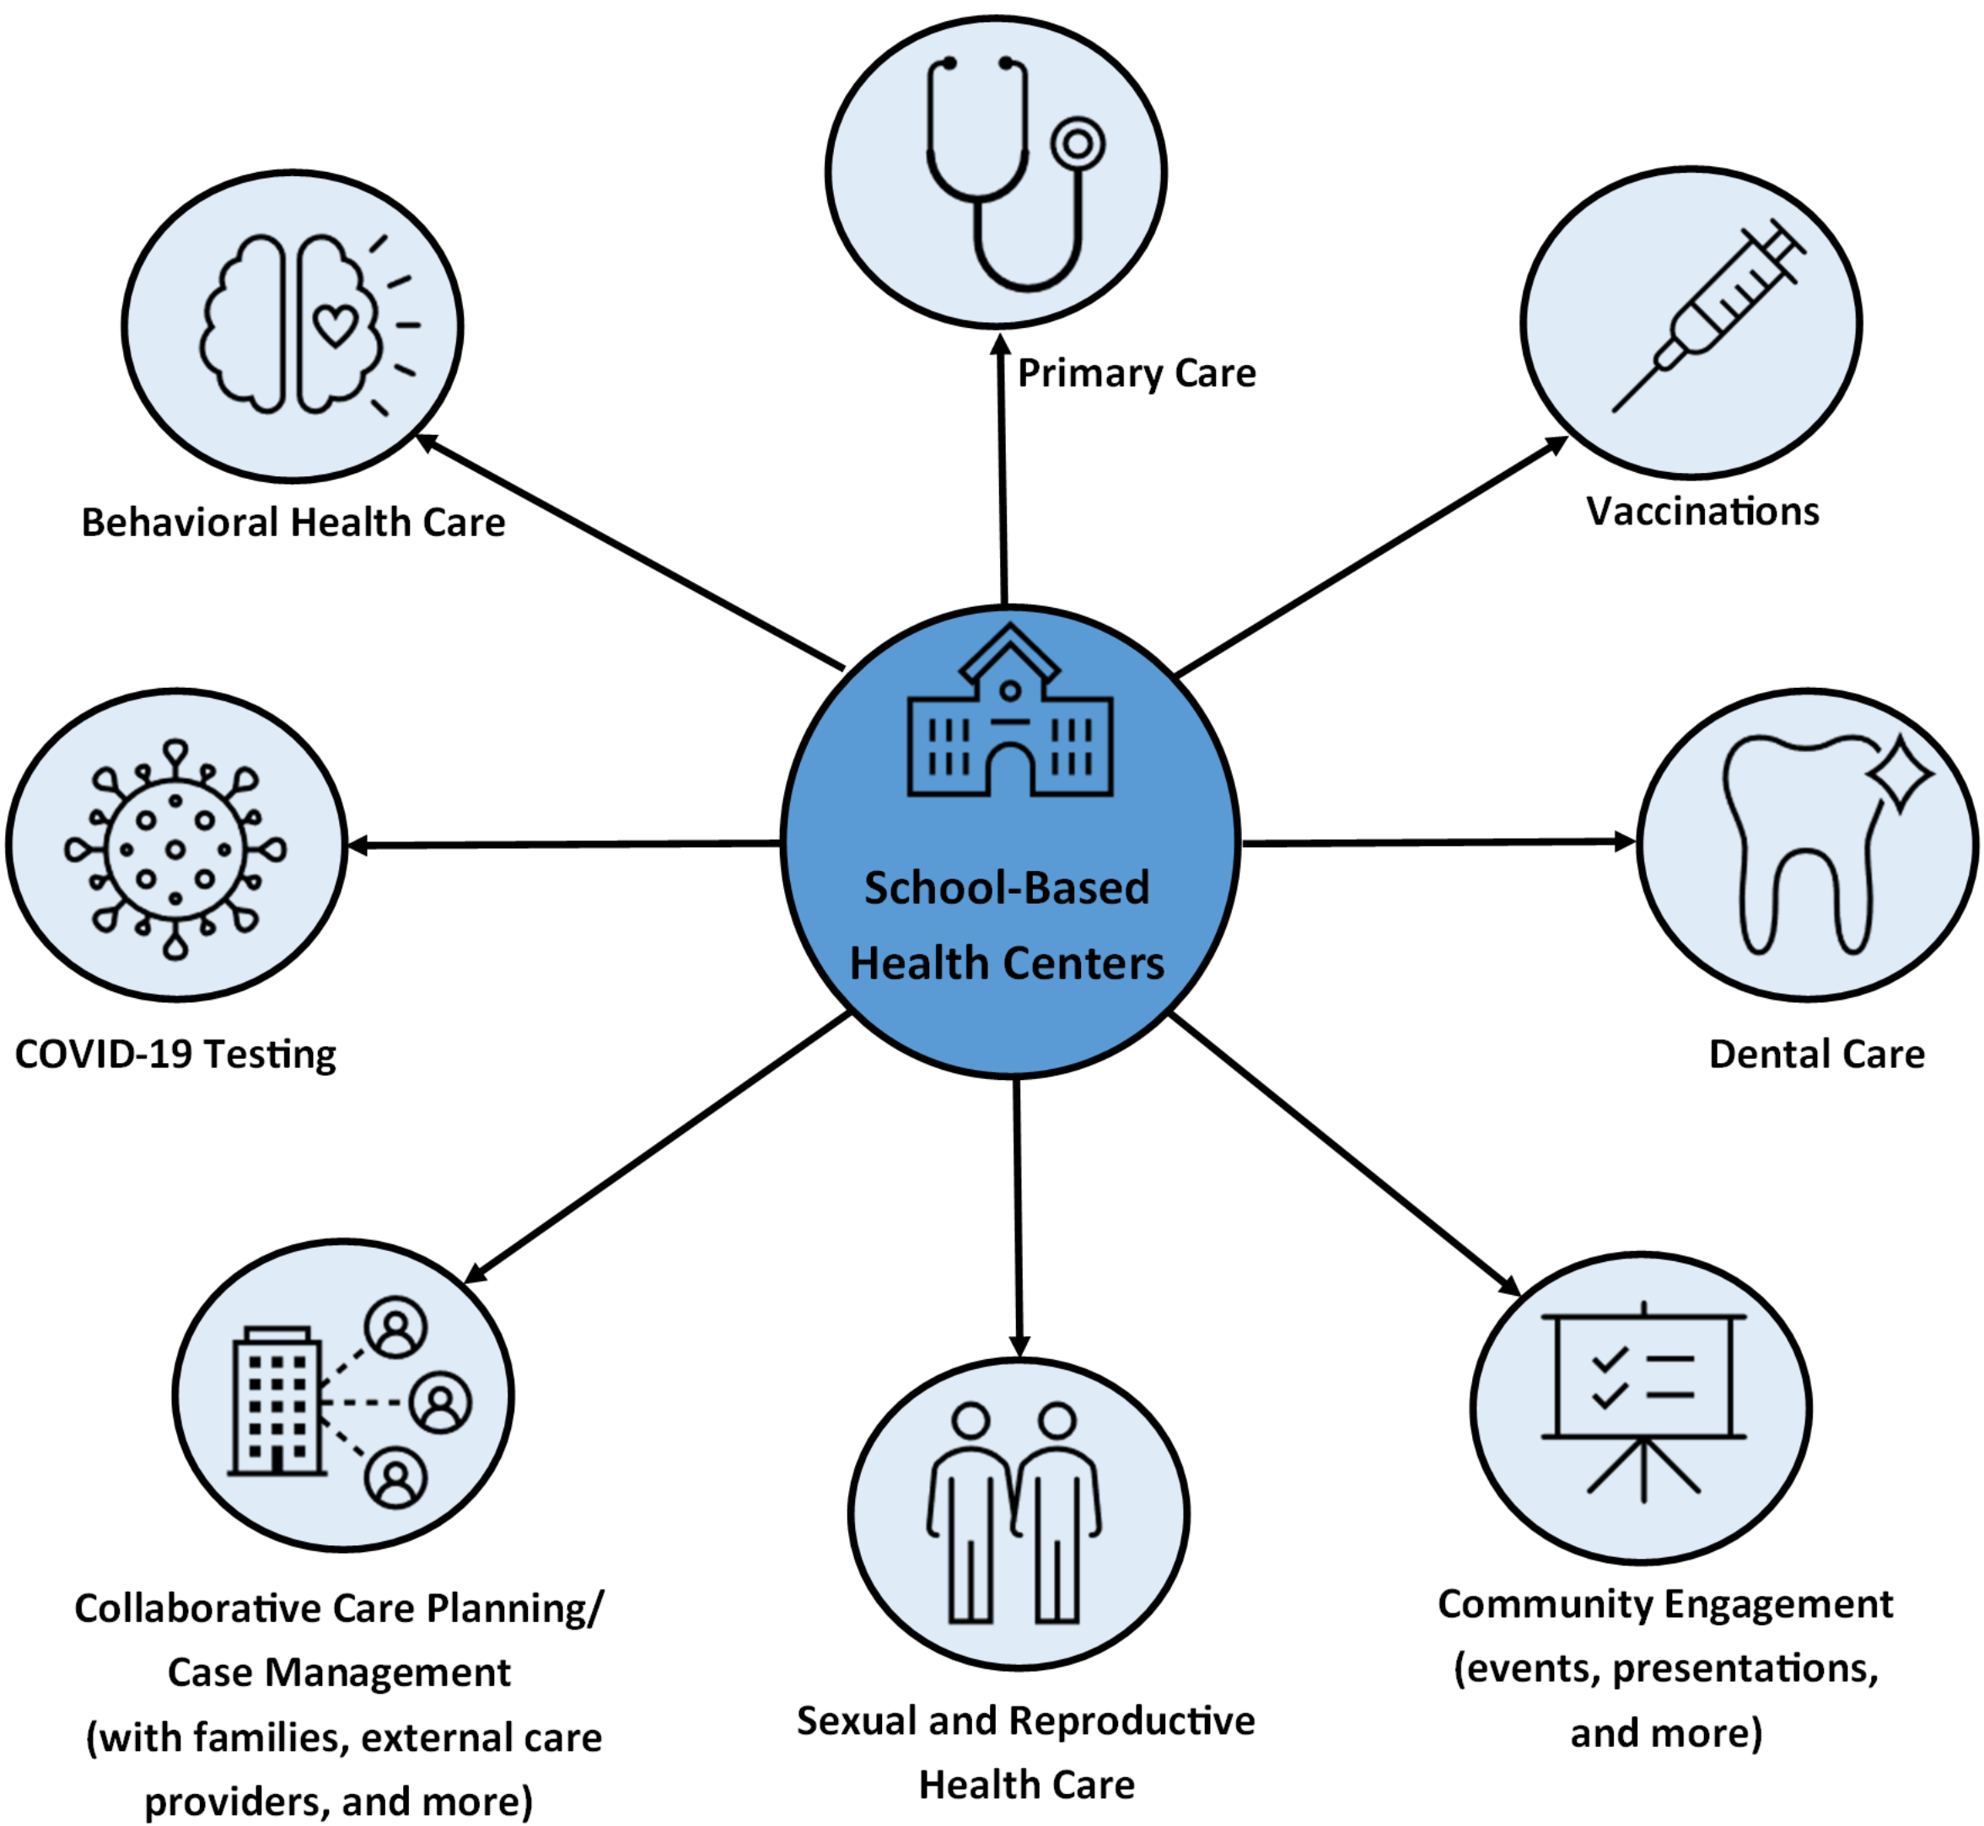
For more information on MDPH-funded SBHCs, including a directory of sites and their sponsoring agencies, go to mass.gov/school-based-health-centers-here-for-the-kids

SBHC Impact in 2021-2022

2021-2022 School Year: A Year of Transitions
In the 2021-2022 school year, students transitioned back to full-time in-person learning after remote and hybrid learning during previous school years due to the COVID-19 pandemic. As noted by the American Academy of Pediatrics (AAP), “The pandemic has exacerbated preexisting disparities in morbidity and mortality, access to health care, quality education, digital access, affordable housing and safe environments, which create more challenges and stressors for many families and communities. It also highlights the inequities that result from structural racism, which increase vulnerability to emergency situations.”¹ Funded SBHCs were well positioned to respond to these exacerbated and pre-existing needs that were highlighted by the COVID-19 pandemic.
Services Provided
SBHCs remain flexible to meet the needs of their communities while also providing core services. They provide accessible and comprehensive health care (including behavioral health care and comprehensive sexual and reproductive health care) and wraparound services (including support navigating student health care needs outside of the SBHC).
SBHCs are key partners in supporting students, families, and the school community by providing accessible primary care, behavioral health care, and community outreach and engagement services in a welcoming and convenient setting. In the 2021-2022 school year, MDPH-funded SBHC partners had:
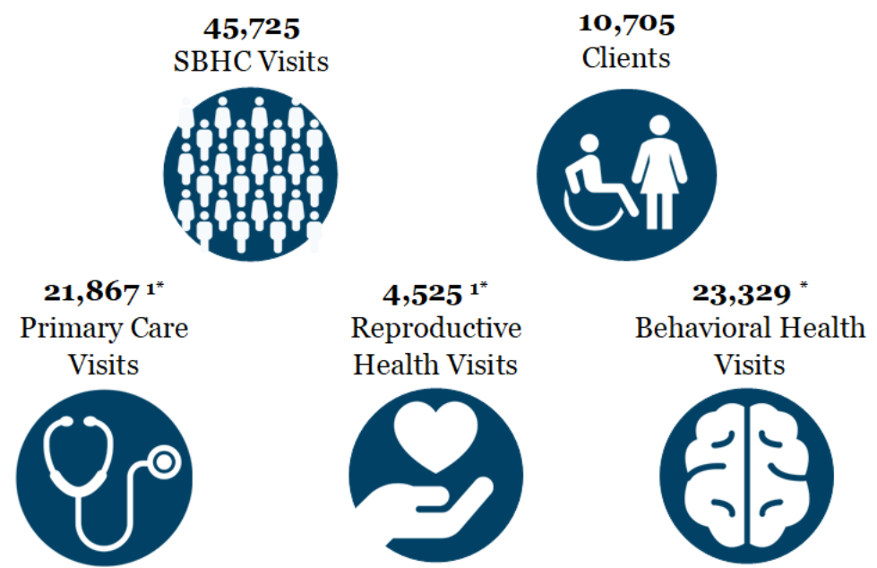
* Visit count categories are based on the Primary International Classification of Diseases (ICD) Code assigned to the visit by the SBHC.
¹ Primary Care Visits include Reproductive Health Visits.
For more information on MDPH-funded SBHCs, including a directory of sites and their sponsoring agencies, go to mass.gov/school-based-health-centers-here-for-the-kids

SBHC Patient Population

Centering Racial Equity
The AAP states that “Racism…has a profound impact on the health status of children, adolescents, emerging adults, and their families. Although progress has been made toward racial equality and equity, the evidence to support the continued negative impact of racism on health and well-being through implicit and explicit biases, institutional structures, and interpersonal relationships is clear. Failure to address racism will continue to undermine health equity for all children, adolescents, emerging adults, and their families.”² A first step in centering racial equity for SBHCs has been to ensure equitable access to health care services across all racial/ethnic groups.
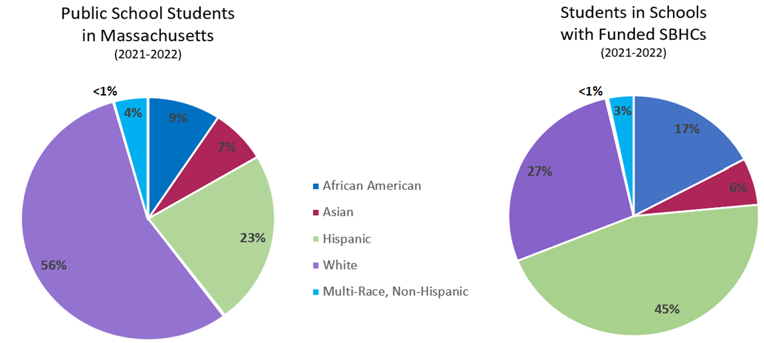
The percentage of students identified by the Massachusetts Department of Elementary and Secondary Education (DESE) as Native American (0.2% in all schools and 0.22% in SBHC schools) as well as the percentage identified as Native Hawaiian/Pacific Islander (0.1% in both K-12 public schools and SBHC schools) are not visible wedges in these pie charts given the scale, and so are represented as <1% in the pie charts above.³
The students counted as “Public School Students in Massachusetts” are in grades K-12. The students counted as
“Students in Schools with Funded SBHCs” are also in grades K-12 and include all students in schools that have SBHCs that are funded by MDPH’s SBHC Program.

The pie charts above show the racial/ethnic demographic characteristics of students in Public Schools in Massachusetts from 2021-2022 as compared to those in schools with MDPH SBHC Program-funded SBHCs. There are racial/ethnic inequities in access to medical care for youth in the United States.⁴ MDPH’s SBHC Program prioritizes serving youth and children in communities and populations that have been disproportionately affected by health inequities, including those most affected by racism and poverty. The SBHC Program uses data to identify communities with the greatest need for SBHCs. Some of the many factors considered in making decisions about which SBHCs to fund include: chronic absenteeism, dropout rate, percentage of students whose first language is not English, percent of children living below the federal poverty level, and municipalities where housing costs are higher than 30% of income.⁵
For more information on MDPH-funded SBHCs, including a directory of sites and their sponsoring agencies, go to mass.gov/school-based-health-centers-here-for-the-kids

A Meaningful Impact

These three stories come from MDPH’s SBHC partners that used their unique position to meet the needs of students and their families. All names and identifying details have been changed to protect patient privacy. Additional edits have been made to improve clarity.

One day at the SBHC, a high school student came in asking to speak with me. This took me by surprise, as I had only met the student once before. When I sat down to talk with the student, he explained to me that he was very worried about his father (his sole care giver), who was reported to be experiencing chest pain over the last few days. The student described his father as being unable to walk down the two flights of stairs to leave his home due to shortness of beath. The student also shared that his father did not have health insurance and was “terrified” of seeking medical care due to the potential bills and financial implications. The student requested I help get his father to accept an appointment at the SBHC host agency saying, “please, he is the only person I have, I can’t lose him”.
I picked up the phone and called the student’s father using a Spanish interpreter. The father was polite, but would not schedule an appointment, again expressed concern about the bill, and hung up abruptly. After the phone call, I couldn’t stop thinking about this gentleman and his son, but I struggled with how to get him care. How do I get him to come into the health center? I then thought of the SBHC’s community health worker, who has a gentle, sympathetic approach to care and has the cultural and language fluency that would likely help support the patient in an even more meaningful way.
The next day the CHW called the father and was able to ease his concerns about the health center, explaining how she would facilitate support at the SBHC host agency to link him to insurance. The CHW got the father into an appointment to see a provider the next day at 8AM. At the appointment, the father was determined to need higher level of care and was subsequently sent to the ER and admitted into the hospital, where he stayed for two weeks.
The father is now home and stable. The SBHC received multiple calls from the student’s family thanking us for saving this man’s life. This story highlights the importance of fostering trusted relationships between students and SBHC medical and behavioral health providers, and SBHC community health workers’ ability to deeply support our students and their families.*

For more information on MDPH-funded SBHCs, including a directory of sites and their sponsoring agencies, go to mass.gov/school-based-health-centers-here-for-the-kids

A Meaningful Impact (continued)

One young woman found our health center in a curious way. Early one morning, before school began, our Community Health Worker was taking a walk around our building and came across a student, Amy*, who was quite pregnant. She didn't recognize Amy as someone who had been seen this school year at the SBHC, so she struck up a conversation and they communicated through a language barrier. Our Community Health Worker introduced Amy to our services so that we could offer her support with her pregnancy, parenthood, and graduation.
Our team ensured that Amy was aware of her rights and of how to obtain leave from school as her delivery approached. We have been able to support her through the paperwork and hoops required to get her baby into daycare and obtain a voucher to get back to school. She is now all up to date on the school immunizations that she was unable to get during pregnancy and she has a stroller, diapers, and clothes thanks to the diligent work of our Community Health Worker. We look forward to supporting Amy and her baby through the coming years!*

In my first year of working in the SBHC, I met Ryan*, a student who loved video games, anime, and had a long history of mental health hospitalizations and challenges. This student was introduced to me due to school staff concerns about extensive missing class time and extremely frequent visits to the school nurse with chief complaints related to his physical health (pain, discomfort, illness, etc.). To help reengage Ryan in the classroom, without dismissing his health concerns, we set up scheduled weekly visits to the SBHC for wellness check-ins. During these check-ins, I learned that Ryan was struggling to feel accepted both at school and at home since transitioning from female to male identity. Ryan uses “he/him” pronouns, but his parents continued to use “she/her” and his birth name, which upset Ryan.
Through establishing our therapeutic relationship and identifying Ryan’s need for support, he began to trust me, and allowed me to introduce him to a behavioral health provider who could provide more tailored supports. Throughout the collaboration with this student, the behavioral provider, and myself, we were able to engage the parents in some therapeutic sessions at the SBHC. By the end of the year, the parents began to use the correct pronouns/name and agreed to develop a plan with the Primary Care Provider and Gender Affirming care team at the SBHC sponsor agency. By the end of the year, we saw Ryan more engaged in school (with less missed class time), making new friends, and expressing increased self-confidence. The incredible transformation in the mental well-being of this student and the acceptance of his parents is a testament to the importance of our school-based team. Ryan was given access to care that allowed improved relationships and understanding of his gender identity by both his parents and the school, allowing him to feel true belonging.*

*All names and identifying details have been changed to protect patient privacy. Additional edits have been made to improve clarity.
For more information on MDPH-funded SBHCs, including a directory of sites and their sponsoring agencies, go to mass.gov/school-based-health-centers-here-for-the-kids

Appendix I

The 33 SBHCs funded by MDPH during the 2021-2022 School Year
Sponsoring Agencies and their SBHCs | Address
BOSTON PUBLIC HEALTH COMMISSION
Boston Latin Academy | 205 Townsend Street, Boston, MA
Brighton High School | 25 Warren Street, Brighton, MA
Jeremiah E. Burke High School | 60 Washington Street, Dorchester, Boston, MA
Madison Park High School | 75 Malcolm X Boulevard, Lower Roxbury, Boston, MA
Boston Community Leadership Academy and New Mission High School | 655 Metropolitan Avenue, Hyde Park, MA
CAMBRIDGE PUBLIC HEALTH COMMISSION d.b.a. Cambridge Health Alliance
Cambridge Rindge & Latin High School | 459 Broadway, Cambridge, MA
Somerville High School | 81 Highland Avenue, Somerville, MA
CODMAN SQUARE COMMUNITY HEALTH CENTER
TechBoston Academy | 9 Peacevale Road, Dorchester, Boston, MA 02124
EDWARD M. KENNEDY COMMUNITY HEALTH CENTER
Burncoat Middle/High School | 135 Burncoat Street, Worcester, MA
FAMILY HEALTH CENTER OF WORCESTER, INC.
Academy Health: Woodland Academy and Claremont Academy | 15 Claremont Street, Worcester, MA
Doherty Memorial High | 299 Highland Street, Worcester, MA
Elm Park Community School | 23 North Ashland Street, Worcester, MA
South High Community School | 170 Apricot Street, Worcester, MA
Sullivan Middle School | 140 Apricot Street, Worcester, MA
Worcester East Middle School | 420 Grafton Street, Worcester, MA
GREATER LAWRENCE FAMILY HEALTH CENTER
Lawrence High School Campus | 70-71 North Parish Road, Lawrence, MA
HENRY HEYWOOD MEMORIAL HOSPITAL
Murdock: Murdock Middle High School and Memorial Elementary School | 3 Memorial Drive, Winchendon, MA
HILLTOWN COMMUNITY HEALTH CENTERS, INC.
Gateway: Gateway Regional Middle/High and Littleville Elementary | 12 Littleville Road, Huntington, MA
LOWELL COMMUNITY HEALTH CENTER
Lowell High School | 50 Father Morissette Boulevard, Lowell, MA
For more information on MDPH-funded SBHCs, including a directory of sites and their sponsoring agencies, go to mass.gov/school-based-health-centers-here-for-the-kids

Appendix I (continued)

LYNN COMMUNITY HEALTH CENTER
Breed Middle School | 90 O'Callaghan Way, Lynn, MA
Ingalls School | 1 Collins Street Terrace, Lynn, MA
Lynn English High School | 50 Goodridge Street, Lynn, MA
Lynn Voc. Tech. Institute | 80 Neptune Boulevard, Lynn, MA
Marshall Middle School | 100 Brookline Street, Lynn, MA
MILFORD REGIONAL MEDICAL CENTER
Blackstone Valley Reg. Voc. Tech. High School | 65 Pleasant Street, Upton, MA
NORTH SHORE COMMUNITY HEALTH, INC.
Salem High School | 77 Willson Street, Salem, MA
NORTHEAST HOSPITAL CORPORATION
Gloucester High School | 32 Leslie O Johnson Road, Gloucester, MA
RIVER VALLEY COUNSELING CENTER, INC.
Holyoke High School – Dean Campus and Holyoke STEM Academy | 1045 Main Street, Holyoke, MA
Holyoke High School – North Campus | 500 Beech Street, Holyoke, MA
Peck Full Service Community School and Veritas Prep Holyoke | 1916 Northampton Street, Holyoke, MA
THE GENERAL HOSPITAL CORPORATION d.b.a. MGH Community Health Associates
Charlestown High School | 240 Medford Street, Charlestown, MA
Chelsea High School | 299 Everett Avenue, Chelsea, MA
Revere High School | 101 School Street, Revere, MA

For more information on MDPH-funded SBHCs, including a directory of sites and their sponsoring agencies, go to mass.gov/school-based-health-centers-here-for-the-kids

References

1. (2022, September 10). Interim Guidance on Supporting the Emotional and Behavioral Health Needs of Children, Adolescents, and Families During the COVID-19 Pandemic. American Academy of Pediatrics. Retrieved December 21, 2022, from https://www.aap.org/en/pages/2019-novel-coronavirus-covid-19-infections/clinical-guidance/interim-guidance-on-supporting-the-emotional-and-behavioral-health-needs-of-children-adolescents-and-families-during-the-covid-19-pandemic/
2. Trent M, Dooley DG, Dougé J, AAP SECTION ON ADOLESCENT HEALTH, AAP COUNCIL ON COMMUNITY PEDIATRICS, AAP COMMITTEE ON ADOLESCENCE. The Impact of Racism on Child and Adolescent Health. Pediatrics. 2019;144(2):e20191765 The Impact of Racism on Child and Adolescent Health | Pediatrics | American Academy of Pediatrics (aap.org)
3. (2022). Massachusetts Department of Elementary and Secondary Education. DESE. https://profiles.doe.mass.edu/search/search.aspx
4. Weller, B. E., Faubert, S. J., & Ault, A. K. (2020). Youth Access to Medical Homes and Medical Home Components by Race and Ethnicity. Maternal and child health journal, 24(2), 241–249. https://doi.org/10.1007/s10995-019-02831-3
5. (2022). Bid Solicitation: BD-22-1031-BCHAP-BCH01-69440. Commbuys Operational Services Division. Retrieved December 21, 2022, from https://www.commbuys.com/bso/external/bidDetail.sdo?docId=BD-22-1031-BCHAP-BCH01-69440&external=true&parentUrl=close
For more information on MDPH-funded SBHCs, including a directory of sites and their sponsoring agencies, go to mass.gov/school-based-health-centers-here-for-the-kids

