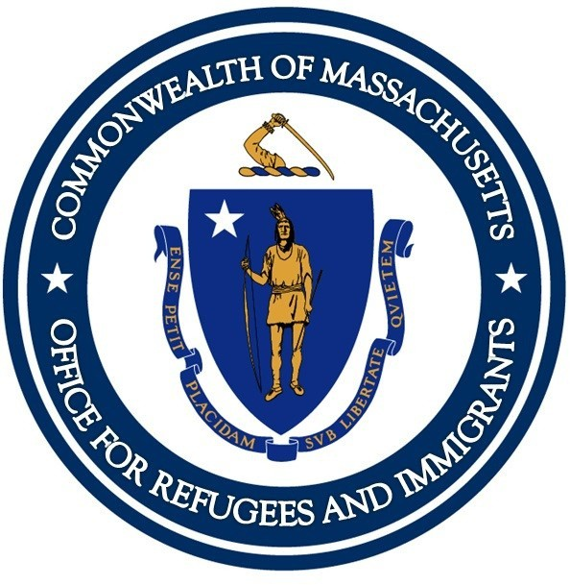THE MASSACHUSETTS OFFICE FOR REFUGEES AND IMMIGRANTS

## ANNUAL REPORT

2021

CONTENTS

table of

1. Message from the Executive Director
2. Impact Summary
3. Refugees Population Demographics

4

Employment Services

Educational Training Programs

5

6 Child and Youth Services Community and Elders Services

8

Health Services Citizenship Services Community Partnerships

9

10

11

Refugee Town Hall Meetings Financials

12

13

14 Acknowledgements

###### MESSAGE FROM THE

The Massachusetts Office for refugees and Immigrants - Annual Report 2021 - PAGE 1

###### EXECUTIVE DIRECTOR

DDear Friends,

In 2021, the continued challenges posed by the COVID-19 pandemic gave way to a new normalfor Massachusetts refugee and immigrant families by year’s end. The gradual lifting of restrictions marked a return to some essential in-person services and new employment opportunities for vulnerable newcomersstruggling to rebuildtheir lives in a new homeland under unprecedented circumstances. The year also saw a gradual uptick in new refugee arrivals to the US (albeit in small numbers),culminating in the arrival of Afghan humanitarian parolees displaced after US troop withdrawal from Afghanistan in the waning months of the year. At the same time, Haitian nationals were arriving in large numbers from the US southern border seeking refuge and asylum from the ravagesof natural disasters and political turmoil in their homeland. The Office for Refugeesand Immigrants (ORI)joined with federal and state partners, legislative and community leaders to marshal the funding, resources and emergency responseneeded to welcomeour newest arrivals.

While the focus for much of the year was on maintaining our service system due to the pandemic, the latter part of the year was focused on rebuilding to meet the overwhelming and immediate needs of Afghan and Haitian families.Service providers for refugees and immigrants across the Commonwealth sought to recruit new staff and worked feverishly to reestablish relationships withlandlords and employersonce relied upon to providerefugees with housingand work.

While programs were able to return to some essential in-person services,they leaned into the new technologies and remote learning strategies implemented under the pandemic shutdown to continue enhanced hybrid service models, as appropriate. Service providers also forged new alliances to expand the reach of services to far corners of the state welcoming Afghan evacuees. ORI was here to support service providers and refugees and immigrants, and to help them navigate a quickly changing landscape.

As we look forward to the year ahead, we are energized and inspired to continue growing and finding new partnerships and grant opportunities to better serve the thousands of newcomers who have arrived in Massachusetts in recent months and will continue to arrive daily. We are grateful to Governor Baker, the Massachusetts Legislature, community leaders, and the readers of our 2021 Annual Report for their continued support for our efforts and the refugee and immigrant communities we serve. In this time of uncertainty and unrest across the globe, our commitment to advocacy for refugees and immigrants has never been stronger.

Mary Truong

The Massachusetts Office for refugees and Immigrants - Annual Report 2021 - PAGE 2

THE MA O **F**ICE FOR REFUG **E**S AND IMMIGRANTS

2021 SUMMARY IMPACT

#### 453

FLN workshop participants

**954**

assessed health and behavioral health

**765**

refugees served for employment

#### 3,687

enrolled in the Citizenship Program

#### 2,119

naturalization applications filed via our Citizenship Services

**160**

participants in our Refugee Town Hall meetings

#### 579

individuals were assisted with issues arising from COVID-19 pandemic via our RCS Program

#### 1,018

new refugees arrivals

**438**

participated in individual, family, or community orientation via Refugee Community Services

**541**

accessed mainstream health care services Refugee Health Assessment Services

The Massachusetts Office for refugees and Immigrants - Annual Report 2021 - PAGE 3

RDEEMFUOGGEREAPpH0ICPSulation

In FFY2021 Massachusetts welcomed 1,018 individuals. The largest populations came from Haiti, DR Congo, Ukraine, Afghanistan, El Salvador, Uganda and Burma. The following infographics represent our newcomers’ nationalities, age distribution, and immigration status in the last year.

NEW ENROLEES BY AGE DISTRIBUTION NEW ENROLEES BY COUNTRY OF ORIGIN

0 to 4 years



5 to 17 years

18 to 64 years

65 years and over

0 250 500 750

Haiti DR Congo Ukraine Afeghanistan

Uganda Others

0 250 500 750

ARRIVAL BY IMMIGRATION STATUS

## 1,018

Refugee Secondary migrant

Asylee Special Visa Holder (Iraq or Afghan) Certfied Victim of Trafficking Cuban/Haiti Entrant

23%

2%

7%

3%

2%

62%

NEW ARRIVALS IN 2021

The Massachusetts Office for refugees and Immigrants - Annual Report 2021 - PAGE 4

Employment services help all employable individuals obtain their first job, retain employment, and identify opportunities for career mobilities. Bilingual and bicultural employment staff provide intensive counseling and mentorship to support socio-economic independence of refugees and other eligible populations.

ORI EMPLOYMENT SERVICES



%

employment

s entered for

7

6

Refugee

employment

Re7fuge6es se5rved for

VOCATIONAL SKI **L**S TRAINING OUTCOMES

Accessed Vocational Skill Trainings

Medical Interpretation Banking, Accounting and Finance Trades (HVAC, Electrician, etc.)



Food Service Hospitality

Driver's Ed Training, including CDL Health Sciences/Elder Care

Customer Service Digital Literacy for Office Use

0 25 50 75 100 125

SUCCESS STORY : Jeanne olive

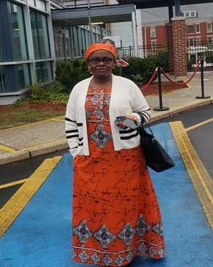Jeanne Olive is from Cameroon, her asylum case was granted in the end of June 2020 after passing few months in detention center. She was enrolled in the Massachusetts Refugee Resettlement Program on 7/14/2020.

Jeanne was enrolled in Comprehensive Refugee Employment Program(CRES) and she was referred to the ESL class.

She took Hospitality classes via our Employment Center(EC) She received assistance through COVID-19 relief funds

She started working at FedEx as part time position at the end of January 2021 In May 2021 she was able to get her Driver’s License

Recently she bought a car and was able to find a new full time job at DHL Company with good hourly wages.

The Massachusetts Office for refugees and Immigrants - Annual Report 2021 - PAGE 5

ETDURCAAITNIOINNAGL

ENGLISH LANGUAGE TRAINING

English Language Training (ELT) served

71 individuals during FFY2021. ELT supports the English language learning needs of newcomers who want to integrate into their new communities. Three distinct models of ELT are designed to meet the needs of specific refugee populations. However, they all aim to foster the use of English language in acquiring life skills, understanding of civics and financial literacy, and greater familiarity with community resources.

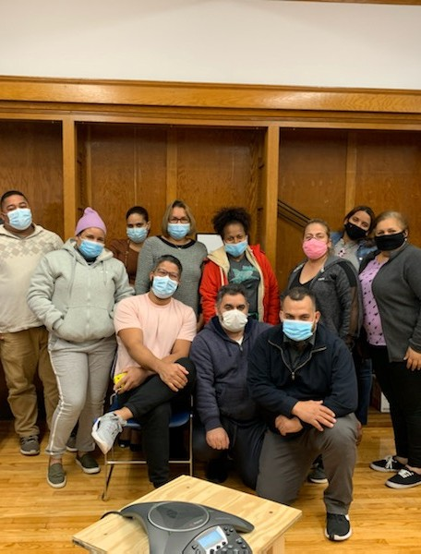

PROGRAMS

FINANCIAL LITERACY FOR NEWCOMERS

The Financial Literacy for Newcomers Program (FLN) cooperates with financial institutions, government agencies, and community-based organizations to equip immigrants to manage their personal finances. The basics of banking, budgeting, credit scores, and buying a home are presented in a practical yet culturally appropriate manner.

93%

OF 453 FLN PARTICIPANTS

HAVE GRADUATED

IN 92 WORKSOPS

ACROSS THE STATE

The Massachusetts Office for refugees and Immigrants - Annual Report 2021 - PAGE 6

# CHILDREN AND YOUTH

##### SERVICES

**Youth Adjustment Services (YAS)**

YAS helped **68 young newcomers from 18 different countries** to build skills needed to adjust to living in their new Massachusetts communities, and to deal with the COVID-19 pandemic and the subsequent challenges faced by their families.

YAS is dedicated to helping refugee youth find community and autonomy, and teaching skills for independent living. YAS provides young refugees with vocational and educational support, referrals to short term job training and internship opportunities, recreation, and cultural enrichment.

**Refugee School Impact Program (RSI)**

The Refugee School Impact Program enabled more than **494 students and 182 parents** to better connect with their school systems, learn needed skills to increase academic success, and adjust to learning during the challenge of the COVID-19 pandemic. **407 of these students demonstrated measured academic improvement.** All RSI students progressed to the next grade level at the end of the 2020-21 school year.

The Refugee School Impact (RSI) program fosters effective local partnerships between refugee providers and local public schools to address gaps in services for refugee school-age children, in addition to providing individualized services for refugee children entering the public school system, families gain understanding of the United States school system so they can encourage academic achievement and social integration.

**Refugee Youth Mentoring (RYM)**

In 2021, RYM enrolled **88 young newcomers originating from 19 different countries** to be matched with mentors in their communities and to help them to define and work toward their individual vocational and educational goals. 18% were aged 14-18, and 72% were aged 18-24.

RYM services contribute to the achievement of vocational, educational, and social adjustment for youth through personalized strategies, such as developing individualized plans and on-site English Language classes. RYM recruits, trains, and maintains a volunteer corps that mentors refugee youth and helps support their physical and mental well-being, employability, integration, and financial literacy.

**Unaccompanied Refugee Minors Program (URMP)**

Unaccompanied Refugee Minors Program in FFY2021, the Unaccompanied Refugee Minors Program (URMP) **nurtured 174 refugee minors** with health, housing, education, community engagement, and other forms of support. In partnership with the Department of Children and Families, ORI’s URMP helps children and adolescent refugees who are without parents or guardians. These minors need support adjusting to new caregivers, communities, and schools. Their emotional and behavioral health is often at risk. Children and adolescents are placed in a range of environments, from licensed foster homes to group homes, residential treatment centers, independent living homes, or therapeutic foster care.

The Massachusetts Office for refugees and Immigrants - Annual Report 2021 - PAGE 7

# CHILDREN AND YOUTH

##### SERVICES

**Success Story : Mariam and Ousmane**

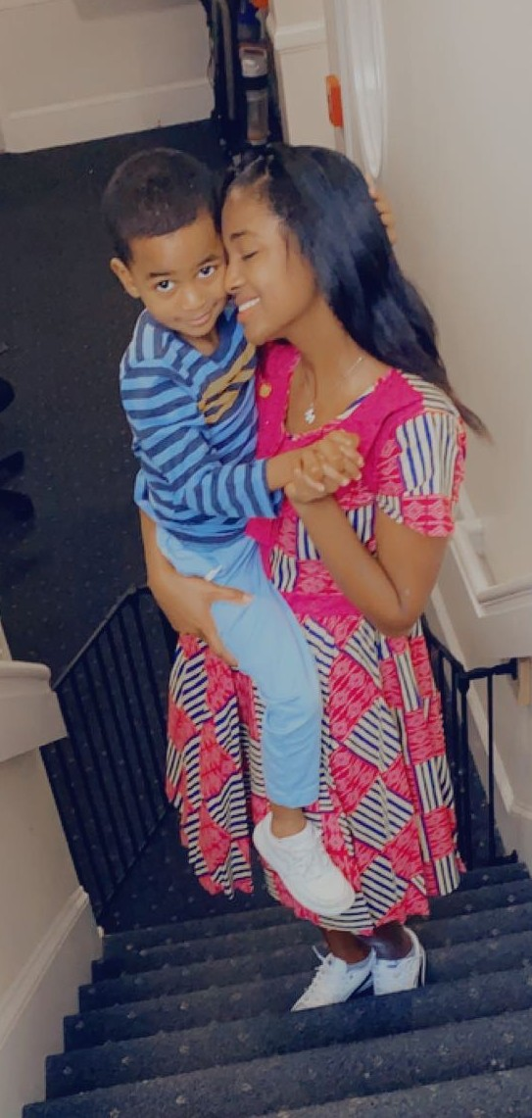Mariam and her son Ousmane arrived to Massachusetts in November 2017, when Mariam was 17 years old and Ousmane was 1. Upon arriving to Massachusetts, Mariam, who is originally from Guinea, entered Ascentria’s Unaccompanied Refugee Minors (URM) Program, and she and Ousmane were placed at a teen parenting program. While in this placement, Mariam received support in developing her parenting and independent living skills, as well as working towards her educational and vocational goals. In 2019, Mariam and Ousmane met a family through the URM Program, with whom they developed a very close, supportive relationship. Over the past two years, Mariam and Ousmane have spent holidays and taken vacations with this family. The family also threw Mariam a graduation party, after she graduated high school with honors. This past June, Mariam began renting an apartment owned by this family. Mariam is currently enrolled in community college and Ousmane is enrolled in the local kindergarten. Mariam is working part-time and is on the waiting list for a Section 8 voucher, which she hopes to apply to her current apartment. In the future, Mariam hopes to become a Medical Assistant and a US citizen, and to eventually help Ousmane’s father resettle to the US. The URM Program is very impressed by all that Mariam has accomplish and has offered Mariam a year- long extension to continue working towards her goals with the support of the Program until December 2023.

The Massachusetts Office for refugees and Immigrants - Annual Report 2021 - PAGE 8

ANCDOEMLMDEURNSITSYERVICES 

**Refugee Community Services (RCS)**

Refugee Community Services (RCS) introduces refugee populations to the diverse range of social services available at the state and local level in Massachusetts. These include family support to promote economic self-sufficiency, help with housing issues, fuel assistance, educational support, medical referrals, and legal services. Providers use ethnic TV, radio, newspapers, and local events to reach out to refugee populations and help them as they adjust to their new communities.

**Program to Enhance Elder Refugee Services (PEERS)**

ORI’s Program to Enhance Elder Refugee Services (PEERS) aims to improve elder refugees’ access to needed services through strengthened coordination between refugees, elder services, Council on Aging, and the provision of naturalization services. Due to the COVID-19 pandemic, many elders and their families needed extra support to understand how to prevent infection, connect with health care when sick, and communicate with hospital staff when families were not able to visit their elders when sick.

RCS AND P **E**RS OUTCOMES

Refugee Community Services (RCS) provided 847 refugees with assistance to access and understand mainstream service systems and local resources. Clients came from 47 countries.

438 individuals participated in individual, family, or community orientation. 498 individuals were assisted to access mainstream and family supports.

137 mainstream human services agency staff attended cultural competency workshops or provided with consultation

154 online or in person events were undertaken to outreach to the refugees and/or the greater community.

1,916 hours of interpreter services were provided to consumers.

579 individuals were assisted with issues arising from COVID-19 pandemic.

Program to Enhance Elder Refugee Services (PEERS):

134 refugee elders received PEERS services 60 home visits were conducted during the year

108 elders educated about COVID-19 vaccine and 75 elders assisted with receiving the COVID-19 vaccine

18 elders assisted with the naturalization process

13 elders participated in leadership and volunteer positions, and employment services 450 times case workers provided elders with translation and interpreting services

525 hours of pro-bono service were secured to assist the elders

The Massachusetts Office for refugees and Immigrants - Annual Report 2021 - PAGE 9

SHEERALVTIHCES 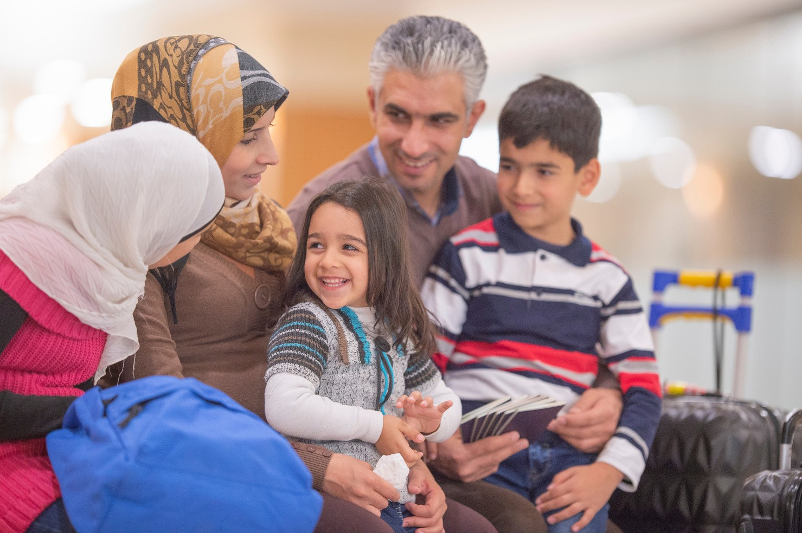

Refugee Health Promotion Refugee Health Assessment Program

ORI’s Refugee Health Promotion Program (RHPP) provides ongoing individual healthcare information and access assistance to the newest refugee arrivals. RHPP aims to heighten cultural competence within mainstream agencies. RHPP also organized online health trainings on how to prevention the spread of COVID-19.

|  |
| --- |
| ORI'S HEALTH PROMOTION PROGRAM |
| ASSISTED MORE THAN  954 |
|  |
| TO ADDRESS EMERGENT N **E**DS |
| AND ACCESS HEALTH |
| AND BEHAVIORAL HEALTH SERVICES |
| IN THEIR COMMUNITIES. |

**541**

**Individuals were assisted to access**

**mainstream health care services via RHPP**

**676**

**individuals were assisted with COVID-19- related supports via RHPP**

**91**

**participated in virtual and in-person health forums or classes via RHPP**

**404**

**Total number of recipients referred to primary care via RHPP**

ORI, through partnership with the Department of Public Health, makes refugee health assessment services available to all newly-arrived refugees. In FFY2021, 297 refugees started the two encounter health assessment and 97% (289/297) completed both visits

The Massachusetts Office for refugees and Immigrants - Annual Report 2021 - PAGE 10

ORI’s Citizenship for New Americans Program (CNAP) enables low-income, lawful permanent residents in Massachusetts to become naturalized citizens of the United States. Services provided under CNAP include English for Speakers of Other Languages (ESOL) classes, citizenship application assistance, interview preparation and other services including, interpretation and referral services.

CITIZENSHIP SERVICES

3,687

2021 ORI CNAP SERVICES

2020 2021

Clients Enrolled in 2021

Client Enrolled

Naturalization applications

2

filled in 2021

,

**1**

9

1,356

Clients naturalized in 2021

Naturalization application

Naturalization Exam

Client Naturalized

0 2,500 5,000 7,500

MVIEC SUCCESS STORY : LOAN

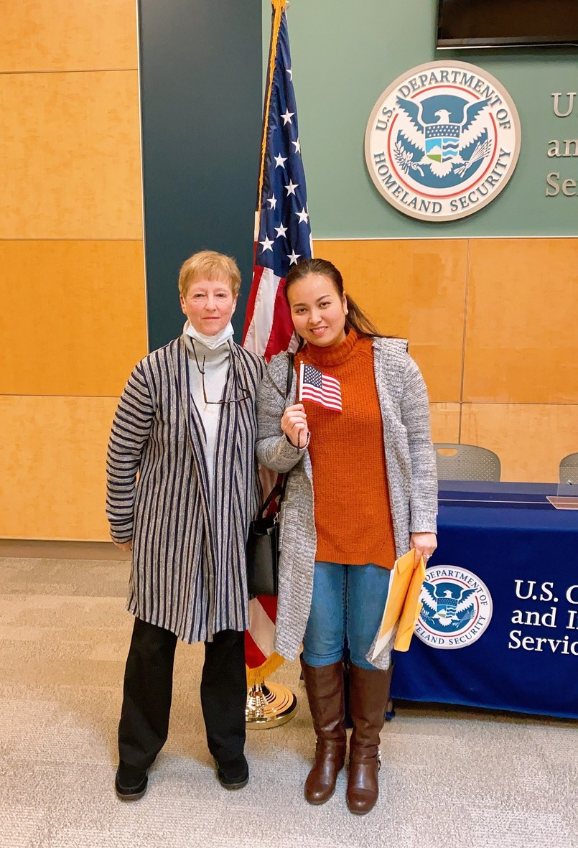Loan, age 35, is an American success story of hard work and persistence. She came to the U.S. from Vietnam in 2014. She is married with 4 children and works full-time as a nail technician. She studied English and took citizenship classes at Merrimack Valley Immigration Education Center (MVIEC, ORI’s CNAP partner in Lawrence). To MVIEC’s surprise, Loan failed the English understanding portion of the naturalization test. Loan did very well in the mock interview and confidently answered the questions on the 20- page application in a soft, but understandable voice during that session.

Even though Loan was crestfallen, she reapplied for another N-400, paid another $725 fee, signed up for another session of citizenship preparation classes and tutoring. During the January 2021 naturalization interview, MVIEC staff accompanied her for the naturalization test as her accredited representative. She passed with flying colors! MVIEC staff was able to attend her oath ceremony as well at that very day and celebrated her crowning achievement as a role model for her children.

The Massachusetts Office for refugees and Immigrants - Annual Report 2021 - PAGE 11

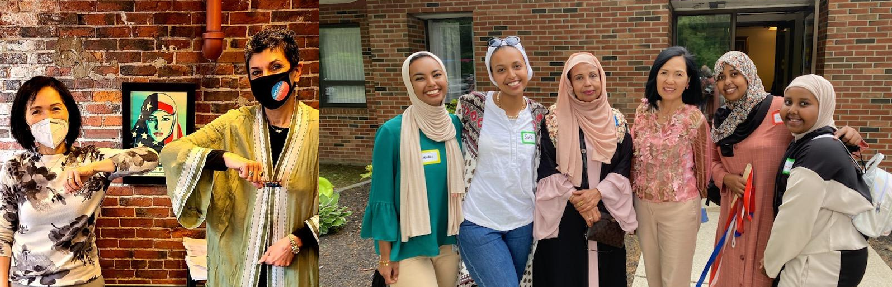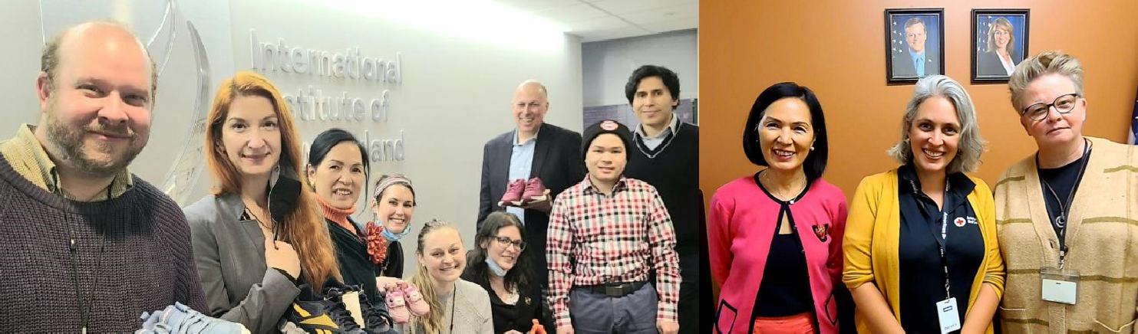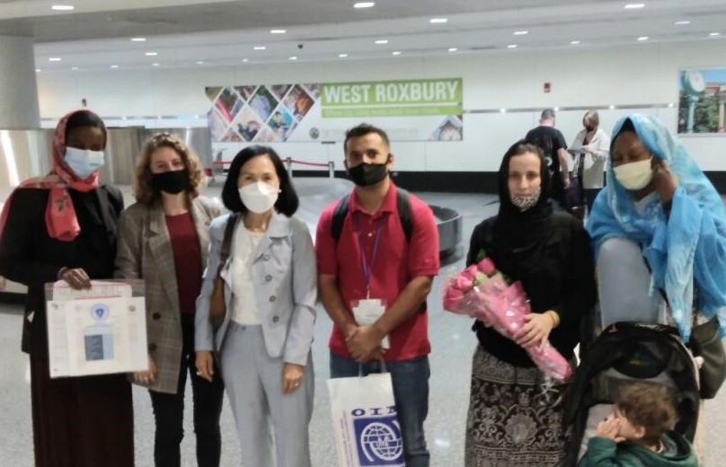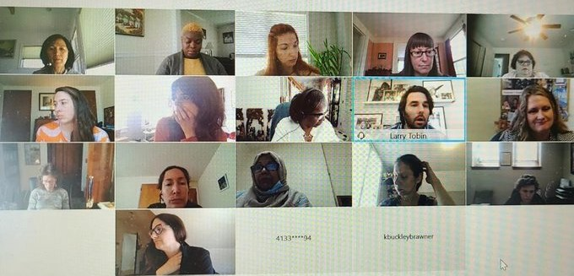

### COMMUNITY PARTNERSHIPS

*PROJECT*

***CITIZENSHIP***

*REEBOK*

***WORLD REFUGGE DAY***

***RIAC***

***AMERICAN***

***RED CROSS***

***ARRIVALS FROM***

***AFGHAN ISTAN***

***SHAPIRO***

***FOUNDATION***

**To ensure a successful integration for refugees and immigrants into their new communities, ORI continued its tireless efforts to strengthen existing partnership and create new ones. Above are pictures for some of the partners ORI met with during this year.**

The Massachusetts Office for refugees and Immigrants - Annual Report 2021 - PAGE 12

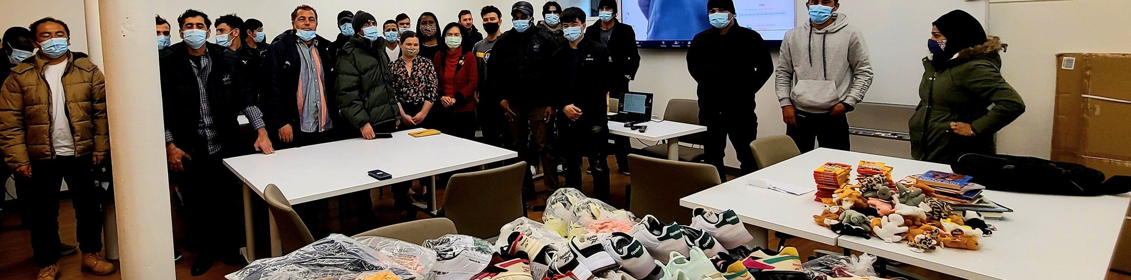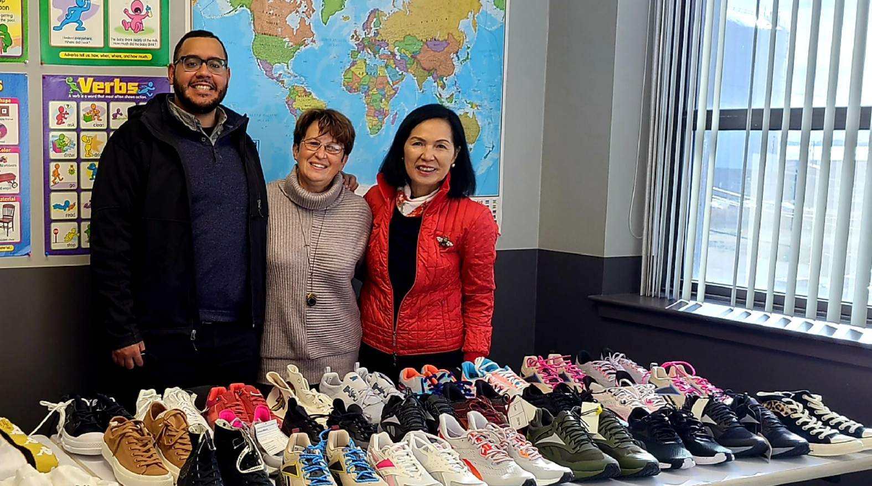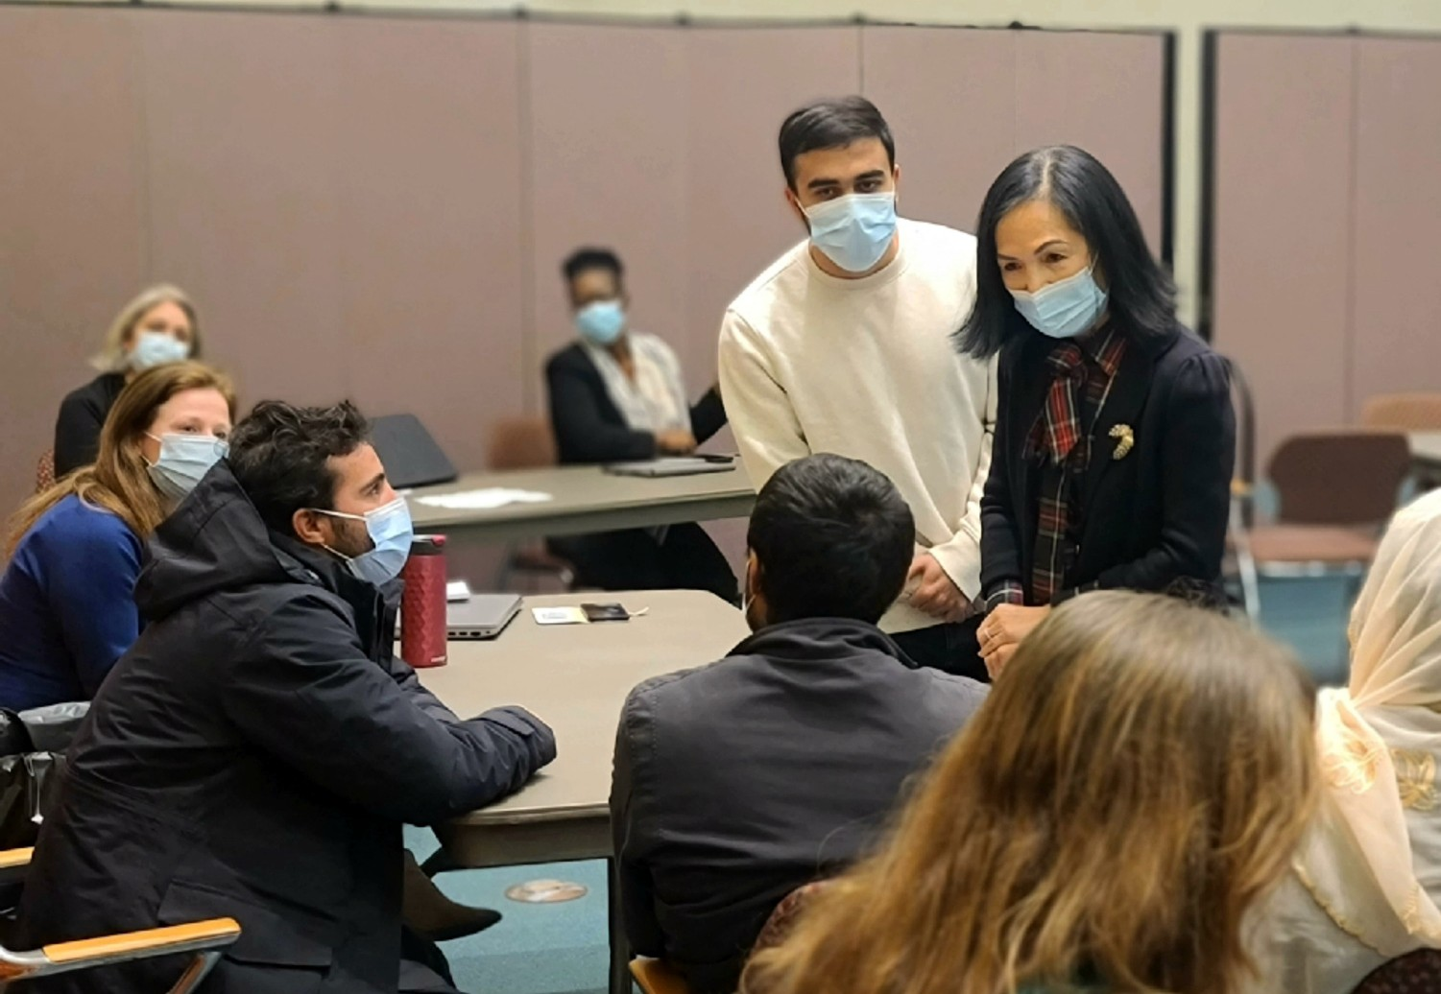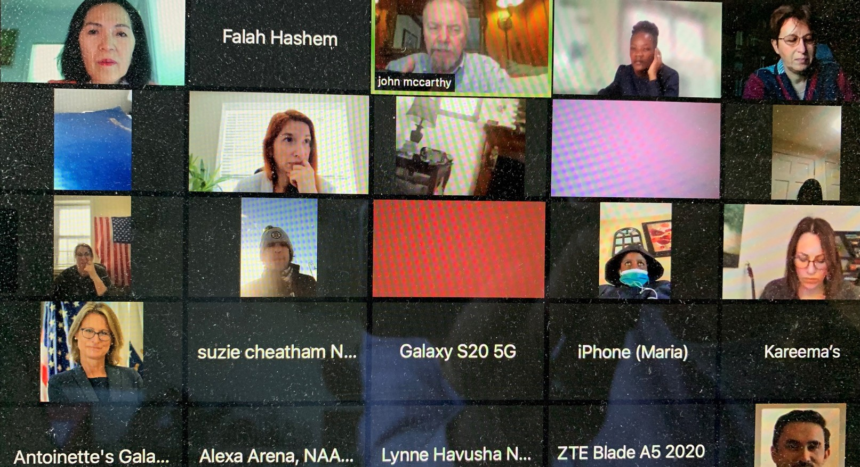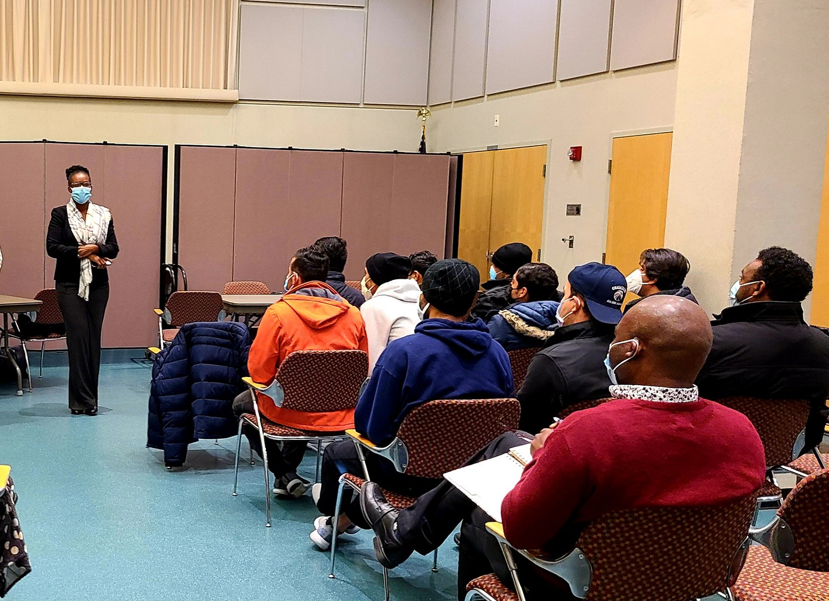

### town hall meetings

*LOWELL*

***REFUGEE TOWN HALL***

*WORCESTER*

***REFUGEE TOWN HALL***

*WORCESTER*

***REFUGEE TOWN HALL***

***BOSTON***

***REFUGEE TOWN HALL***

***DONATIONS AT***

***REFUGEE TOWN HALL***

**Refugee Town Hall brought together 160 refugees and immigrants. These meetings provide an inclusive approach to highlighting clients’ concerns and provide durable responses over the long term, whether in the shape of emerging programming, increased public and private partnership, or policy development.**

The Massachusetts Office for refugees and Immigrants - Annual Report 2021 - PAGE 13

FINANCIALS

ORI is 85% federally-funded through the U.S. Department of Health & Human Services’ Office of Refugee Resettlement (ORR). In addition, it is 15% state-funded to support citizenship, Financial Literacy for Newcomers and employment services for refugees and immigrants living in the Commonwealth.

$3M

FUNDED THROUGH STATE GRANTS

$16.4M

FUNDED THROUGH FEDERAL GRANTS

$19.4M

ORI OVERALL BUDGET

In FFY2021, the ORI overall budget was $19.4M, with

$16.4M funded through federal grants, and $3M from state dollars. ORI continues to develop public-private partnerships to sustain and enhance its mission, strengthen collaborations with key stakeholders, and further empower refugees and immigrants as they successfully integrate into their new communities.

ORI is grateful to all partners and key stakeholders who support its programs. ORI sincerely welcomes all who would like to help by contributing monetary and/or in- kind support to make 2022 an even more successful year for both newcomers and the Commonwealth. If interested, please call us at (617) 727 - 7888 or send an email to [Mary.truong@mass.gov.](mailto:Mary.truong@mass.gov)

FUNDING PERCENTAGE FUNDING TO REFUGEE SERVICES BY CATEGORY (%)

STATE

15% EMPLOYMENT RELATED SERVICES SOCIAL ADJUSTMENT SERVICES

CASE MANAGEMENT CASH ASSISTANCE HEALTH ASSESSMENT

UNACCOMPANIED MINORS

15%

2%

1%

4%

7%

61%

FEDERAL 85%

OTHER

10%

The Massachusetts Office for refugees and Immigrants - Annual Report 2021 - PAGE 14

Governor **Charles Baker**

Lieutenant Governor **Karyn Polito**

**The Massachusetts Office for Refugees and Immigrants**

600 Washington St. 4th Floor

ACKNOWLEDGEMENTS

Boston, MA 02111 [www.mass.gov/ori](http://www.mass.gov/ori) T: 617-727-7888

TTY: 617-727-8147

Twitter: @ORIMassState

Executive Office of Health and Human Services (EOHHS) Secretary **Marylou Sudders**

Governor’s Advisory Council on Refugees and Immigrants Office of Refugee Resettlement

MA Department of Children and Families MA Department of Public Health

MA Department of Transitional Assistance MassHealth

Interns, volunteers, supporters and service providers United States Citizenship and Immigration Services Generation Fund

REEBOK

Museum of Science, Boston

We wish to recognize the participation of:

Mary Truong, ORI Executive Director Falah Hashem, ORI Chief of Staff

ORI Staff (Katie Nye, Leticia Morales-Ripalda, Mohan Sunuwar, Kierra Ho, Robin Carmona, Deni Ozan-George, and Kelvin Pham)

*Special thanks to:*

***Fabio Leandro Pereira Freire*** *for his generous help in producing this report*

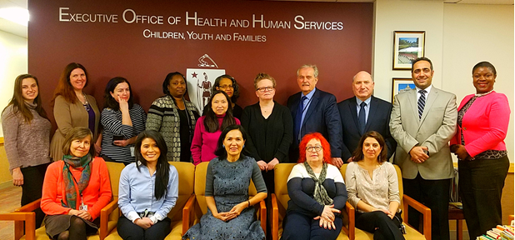WE THANK YOU FOR YOUR CONTINUED SUPPORT IN OUR PROGRAMS