Blue Hills
STATE RESERVATION

White-Tailed Deer Management Program
2021 Program Overview & Results

The Massachusetts Department of Conservation and Recreation (DCR) and the Massachusetts Division of Fisheries and Wildlife (MassWildlife) have legislative mandates and missions to protect and manage a myriad of natural resources including forests, wildlife, and the habitats upon which a diversity of wildlife depends. From the canopy to the understory, healthy forest ecosystems are made up of trees and plants of multiple species and age classes. Tree regeneration is critical to the long-term survival of forests and their ability to recover from natural disturbances exasperated by climate change. Forests that contain high deer population densities are vulnerable to deer over-browsing young trees, which can prevent forest regeneration.

The DCR’s management of the Blue Hills Reservation is guided by a comprehensive Resource Management Plan (RMP) approved by the DCR Stewardship Council in April 2011. The DCR has become increasingly concerned with the long-term health of the Reservation’s Forest and the ecological impacts of sustained high deer densities on this natural resource.

In 2015, the DCR introduced the Blue Hills Deer Management Plan. The primary objective and rationale for developing and implementing a deer management program is to maintain an ecologically sustainable deer density that allows for the continuous growth and development of forest regeneration. Managing deer populations is a complex and dynamic process. The DCR’s program for white-tailed deer management is not intended to provide a new recreational opportunity in the Blue Hills. Rather, the program provides a concrete, practical, and workable solution intended to deal with a critical environmental problem.

Since 2015, the DCR has allowed controlled deer hunting within the reservation. Prior to DCR’s initiation of controlled deer hunting in the Blue Hills Reservation, several private property owners near or adjacent to the Blue Hills have voluntarily allowed archery hunters onto their land to hunt deer using archery. This informal program has been successful in harvesting several deer each year and highlighted the importance of cooperation between landowners and deer hunters.

In 2021, limited archery hunting was permitted in certain designated areas of the Blue Hills Reservation for a total of eleven (11) days on Mondays through Thursdays only between November 15th and December 2nd. Hunting was not allowed on Thursday, November 25th in observance of the Thanksgiving holiday. In accordance with state hunting regulations, hunters were allowed to hunt one-half hour before sunrise to one-half hour after sunset.

Licensed hunters were offered the opportunity to apply on-line using a web-based form. The application process was open from October 8 through October 18, 2021. A total of 250 hunters submitted applications for the permitted archery hunt. Following a planned review by the Massachusetts Environmental Police, 230 eligible hunters were provided the opportunity to complete an online orientation to obtain a permit to participate in the Blue Hills managed hunt.

In total, 193 access permits were issued. Access permits were valid for all eleven days in which archery hunting was allowed.

The table below provides archery hunt applicants and permittees according to state of residence:

 | State of Residence | Number of Applicants | Number of Permittees
 | Massachusetts | 226 | 189
 | New Hampshire | 3 | 3
 | Rhode Island | 1 | 1
 | TOTAL | 230 | 193

Archery hunting was limited to the areas outlined on the map below. A total of 2,622 acres of the Reservation’s 7,000 acres were opened to permitted archery hunting across ten (10) management areas. Archery hunters were separated into two groups and each group was assigned to one of two archery zones. Each zone included several management areas. Hunters assigned to Zone 1 were permitted to hunt in any of the management areas listed within that zone. Hunters assigned to Zone 2 were permitted to hunt in any of the management areas listed within that zone.

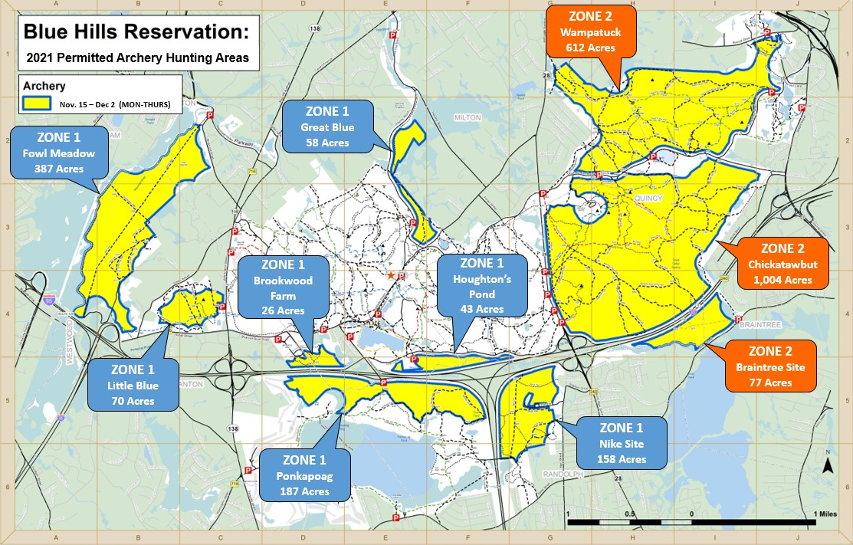

2021 Harvest Results

A total of 19 deer were harvested from approximately 4.1 mi² of forest land opened to hunting. The table below provides more detailed information and deer harvest results for each of the management zones:

 | Management Zone | Square Miles Hunted | Male | Female | Total
 | Fowl Meadow | 0.60 | 2 | 1 | 3
 | Great Blue | 0.10 | 1 | 0 | 1
 | Houghton’s Pond | 0.07 | 0 | 1 | 1
 | Chickatawbut | 1.57 | 1 | 1 | 2
 | Wampatuck | 0.96 | 2 | 2 | 4
 | Ponkapoag | 0.30 | 2 | 1 | 3
 | Braintree Site | 0.12 | 2 | 0 | 2
 | Zone 1 (management area not reported) |  | 0 | 1 | 1
 | Zone 2 (management area not reported) |  | 2 | 0 | 2
 | TOTAL | 4.12 | 12 | 7 | 19

DCR and MassWildlife are pleased with the results and smooth operational implementation of the 2021 Blue Hills Reservation permitted archery hunt. Harvest results from this year’s archery hunt (19 deer) were on par with 2020 results (19 deer) and slightly higher than the archery harvest in 2019 (17 deer). The chart below provides annual harvest results (by sex) for each of the six controlled hunts conducted thus far:

Synopsis of the 2021 Deer Management Program

As was acknowledged in the initial Blue Hills Deer Management Plan, effective deer management programs must incorporate and maintain a good degree of flexibility in order to make modifications and adjustments that are grounded in experience and ongoing assessment.

The 2021 permitted archery hunt represents continued progress toward addressing deer overabundance and its impacts in the Reservation.

From the perspective of public safety, all agencies involved in the coordination and implementation of the 2021 controlled hunt were satisfied. Considerable time was spent assessing a myriad of operational aspects associated with conducting controlled hunting within the Reservation and developing a plan that addressed these operational concerns. The successful execution of this plan and support from permitted hunters for the overall goal of safety represents a significant achievement. Like the previous five controlled hunting programs, the 2021 program demonstrated that hunting can be safely conducted in a suburban/urban setting.

