Special Emphasis Report:
Falls in Older Adults

Massachusetts: 2017-2021 Data

This document was produced by the Council of State and Territorial Epidemiologists, Injury Surveillance Workgroup with support from the Centers for Disease Control and Prevention (CDC) Cooperative Agreement Number NU38OT000297-03-00.

UNDERSTANDING FALLS IN OLDER ADULTS
Each year in the U.S., more than one out of four adults 65 years of age and older has a fall. Falls are the leading cause of fatal and nonfatal injuries in older adults and can lead to a spiraling decline in health and a loss of independence. Falling is not a normal part of aging. These events can often be prevented through the implementation of public health interventions by health care providers and community organizations, and through actions that can be taken by older adults and their families to reduce fall risk.

Impact and Magnitude of Falls in Older Adults
During 2021, there were 1,027 fall deaths among Massachusetts older adults (90 per 100,000 persons). There were 19,244 hospital stays (1,745 per 100,000 persons), and 52,112 emergency department (E.D.) visits (4,764 per 100,000 persons) associated with a fall injury(*) in 2021. Total charges in 2021 for hospital stays and E.D. visits associated with these events were $964 million. Medicare was the primary payer for 86% of these injuries. Fall injuries and deaths are increasing in older adults, both nationally and in Massachusetts, even after adjusting for an aging population. Figure 1 shows the five-year trend in age-adjusted death rates, which have increased 42% during this period.

*Refer to page 4 for Massachusetts technical notes.

Figure 1: Number and Age-Adjusted Fall Injury Death Rate per 100,000 Massachusetts Adults 65+ Years, 2017-2021

Risk Factors for Falls in Older Adults
There are many factors that can contribute to falling. These include lower body weakness, vision problems, vitamin D deficiency, medicines that affect balance, home hazards such as uneven steps, throw rugs, and clutter, walking and balance difficulty, foot pain and poor footwear, (see footnote 1) disability (see footnote 2), and other conditions. Most falls are caused by a combination of these factors and the more a person has, the greater their chances of falling. Many risk factors can be changed or modified to help prevent falls. Healthcare providers can help reduce a person’s risk of fall injury by screening for these risks and addressing them with their patients (see footnote 1).

Footnote 1. Source: https://www.cdc.gov/falls/facts.html.
Footnote 2. Massachusetts, Adults 65+ with a disability (physical, cognitive, or emotional) are significantly more likely to experience a fall and fall-injury than those with none (Massachusetts Behavioral Risk Factor Surveillance Survey, 2023).

Falls in Older Adults by Age and Sex
Fatal and nonfatal fall injury rates increase exponentially with age. In 2021, the age-adjusted fall injury death rate among adults aged 85 years and older was 1.5 times that of those aged 75-84 years, and 4.2 times that of residents aged 65-74 years. In 2021, males had a higher rate of fall injury deaths than females (111 and 93 per 100,000 persons respectively). Females, however, had higher rates of nonfatal fall-related injury hospital stays and E.D. visits than males (2,224 vs. 1,426 hospital stays per 100,000 persons respectively and 5,668 vs. 4,205 E.D. visits per 100,000 persons respectively).

Figure 2: Percentage of Older Adult Fall-related E.D. Visits, Hospital Stays, and Deaths Associated with a Hip Fracture or Traumatic Brain Injury (TBI), 2021
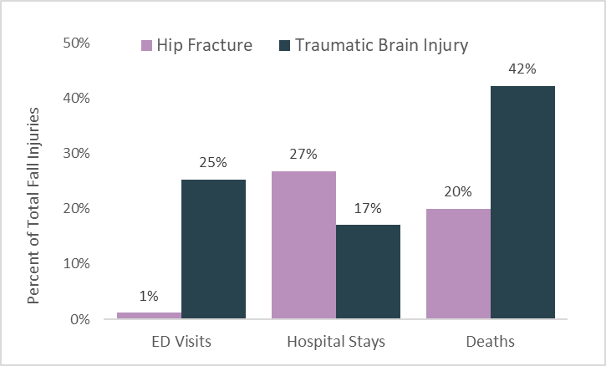

Fall-related Injury Hospital Stays in Older Adults by Race and Ethnicity
Certain racial and ethnic populations have higher rates of older adult falls. In Massachusetts, White, Non-Hispanic/Non-Latino residents had the highest 5-year age-adjusted rates for deaths, hospital stays, and E.D. visits. The table below shows 5-year average annual counts and rates of hospital stays associated with fall injury per 100,000 residents by race and ethnicity.

Table 1. Number and Age-Adjusted Rate of Fall-related Injury Hospital Stays by Race and Ethnicity among Massachusetts Adults 65 and Older, During the 5-Year Period: 2017-2021

Count and Rate by Race and Ethnicity
Asian/Pacific Islander, Non-Hispanic/Latino | Count= | 350 | Rate= | 799 | per 100,000 population
American Indian/Alaska Native, Non-Hispanic/Latino | Count= | 15 | Rate= | 858 | per 100,000 population
Black, Non-Hispanic/Latino | Count= | 425 | Rate= | 871 | per 100,000 population
Hispanic/Latino | Count= | 504 | Rate= | 991 | per 100,000 population
White, Non-Hispanic/Latino | Count= | 17,466 | Rate= | 1,696 | per 100,000 population

Falls in Older Adults Prevention Strategies
CDC's National Center for Injury Prevention and Control (Injury Center) is committed to protecting people against preventable older adult falls by putting science into action.

For Healthcare Providers: Make CDC’s STEADI Part of Every Medical Practice.
Still Going Strong is a new campaign to educate adults aged 65 and older, and those who care for them, about common injuries (e.g., falls, motor vehicle crashes, brain injuries) that can be prevented as they age and specific steps they can take to reduce their risk of injury. Still Going Strong empowers older adults to stay safe without sacrificing their favorite hobbies and activities. It is possible to age without injury and maintain a good quality of life. Campaign resources are available for older adults, caregivers, healthcare providers, and fall prevention partners at www.cdc.gov/stillgoingstrong

For Older Adults and Caregivers: Learn how to age without injury with CDC’s Still Going Strong campaign.
STEADI (Stopping Elderly Accidents, Deaths, and Injuries) is an initiative to encourage healthcare providers to screen older adults for fall risk at least once a year, assess at risk patients for modifiable fall risk factors, and to intervene to reduce identified risk using effective clinical and community strategies (e.g., physical therapy, medication management, and tai chi). STEADI resources are available for inpatient, outpatient, and pharmacy settings. Learn more at www.cdc.gov/STEADI

Older Adults Fall Prevention Activities in Massachusetts
Massachusetts is taking a multi-pronged approach to addressing this serious public health problem through the following activities and initiatives:

The Massachusetts Senior Care Association and the Home Care Alliance of Massachusetts lead an active state Falls Prevention Coalition with an engaged and diverse group of over 150 members. With coordination from the Massachusetts Department of Public Health, the coalition convenes twice a year and fosters collaboration and information-sharing across sectors. Coalition members promote Falls Prevention Awareness Week and related activities every September as part of a national effort sponsored by the National Council on Aging.

The Massachusetts Department of Public Health convenes the Massachusetts Commission on Falls Prevention, a statutory body comprising stakeholder and state agency members that is charged with recommending strategies to reduce older adult falls and associated health care costs within Massachusetts that informs key state policy makers. Since 2013, the Commission has issued biennial reports to the state legislature with extensive recommendations for preventing falls in the Commonwealth, including allocating resources for evidence-based falls prevention programming, enhancing falls risk screening and assessment in primary care settings, and developing continuing education requirements around older adult falls for health care workers.

Community-based organizations in Massachusetts implement a range of evidence-based falls prevention programs Area agencies on aging, state-designated aging service access points, local councils on aging, and local branches of organizations like the YMCA offer single and multi-factorial interventions across the Commonwealth.

The Massachusetts Department of Public Health also oversees the Mobile Integrated Health and Community EMS programs, which educate older adults about falls prevention at the community level. These programs allow emergency providers and other clinicians to provide falls prevention services like fall risk assessments and safety checks for older adults within their own home settings to reduce the risk of falls and related injuries. The programs also refer older adults to other community-based organizations to help them age safely in place.

Note: Falls in older adults-related cases were identified by first limiting the datasets to injury cases based on external cause of injury (deaths), primary diagnosis (hospital stays) or both (emergency department visits). All fields were then searched for diagnostic ICD-10-CM codes. For confidentiality and data stability purposes, small counts are suppressed. Suppression rules vary by state and territory, and across datasets. Reference to any commercial entity or product or service on this page should not be construed as an endorsement by the Government or the company or its products or services.

Massachusetts Technical Notes: Fatal data are based on a calendar year. Nonfatal data (hospital stays and E.D. Visits) are based on a federal fiscal year (October 1 to September 30). Hospital Stays combine Mass. Inpatient hospitalizations and Mass. Observation Stays databases from the Center for Health Information and Analysis. TBI data definition includes unspecified head injuries (S09.90) if no other TBI code was assigned.

Massachusetts Department of Public Health
Bureau of Community and Health Prevention
Injury Surveillance Program
Injury Prevention and Control Program
Updated: August 2024
