Executive Summary

Background
The Blueprint for Public Health Excellence, released in 2019 by the Special Commission on Local and Regional Public Health, provided six interlocking recommendations for modernizing Massachusetts’ local public health system. The recommendations center around public health standards, sharing services, data reporting and analysis, workforce credentials, adequate resources, and partner engagement.

To implement the recommendations, it was necessary to better understand the existing capacity of Massachusetts’ local public health system. Thus, in the fall of 2022, two major first-time initiatives were undertaken to obtain this foundational information. A capacity assessment was developed to evaluate local public health’s current ability to provide basic public health services based on their available resources, including staffing levels, funding, and training. The first-ever Massachusetts Local Public Health Performance Standards, which define basic levels of services and workforce credentials and training, framed the assessment. The Performance Standards outline expectations for local boards of health to support the delivery of consistent public health services across the Commonwealth. For this initial rollout, the Performance Standards are a compilation of all existing responsibilities delegated to local public health by Massachusetts regulation.

Out of the 351 municipalities in Massachusetts, a Capacity Assessment was conducted among the 305 municipalities participating in the Public Health Excellence Shared Services Grant Program. The goal of this grant program is to improve the efficiency and effectiveness of local public health by establishing Shared Services Arrangements. These arrangements involve groups of municipalities committed to pooling resources and benefits to offer more comprehensive services to their populations. These newly formed Shared Services Arrangements mark a significant milestone in shared services initiatives, both in terms of their scale and scope.

The Shared Services Arrangements participated in the first-ever Capacity Assessment in Massachusetts for local public health, which entailed three distinct phases:
- Phase 1: Baseline Capacity Assessment
  - A municipal self-report survey to evaluate local public health’s ability to meet the Performance Standards. The survey questions were divided into seven subject areas: Administration, Community Sanitation, Disease Control and Prevention, Environmental Protection, Food Protection, Housing, and Tobacco Use Prevention.
- Phase 2: Workforce Assessment
  - An individual self-report survey to evaluate the local public health workforce in relation to education, credentialing, and training standards outlined in the Performance Standards.
- Phase 3: Backup Documentation Submission
  - A document request to review the proficiency of existing practices of local public health in delivering services.

Analysis and Observations
The Capacity Assessment provided a comprehensive overview of local public health’s current capacity and proficiency as analyzed and reported by Shared Services Arrangement groupings. Analysis from Phase 1 revealed that Shared Services Arrangements are meeting, on average, 78% of applicable Performance Standards, with a significant range in performance from as low as 46% to as high as 93%. Rural municipalities are, on average, meeting 3-10% points less of the Performance Standards compared to urban municipalities, largely as a result of staffing needs. Housing and Administration are the areas with the greatest training needs among all Shared Services Arrangements. Phase 2, the Workforce Assessment, revealed gaps in the education, training, and credentialing requirements across all local public health staffing positions. Out of municipalities that submitted documentation for Phase 3, 34% met the proficiency standard, meaning documents contained the critical elements. The assessment also identified a lack of standardized inspection and report forms across all document categories and a consistent lack of follow-up activities after required inspections.

Next Steps
For the first time, Massachusetts is using Performance Standards to help assess local health department capacities, providing local health departments with the data they want and need. Local health departments collaborated with the Massachusetts Department of Public Health on the Capacity Assessment, which provides critically useful information. The assessment revealed considerable gaps in Shared Services Arrangements’ abilities to meet minimum legal requirements. The three phases provide a baseline measure for the Massachusetts Department of Public Health to identify areas of opportunity and create measurable achievement pathways for the Performance Standards using quality improvement best practices. Significant investment is necessary to improve local public health’s capacity to meet the first iteration of the Performance Standards and ultimately achieve the Foundational Public Health Services as directed in the Blueprint for Public Health Excellence. The Foundational Public Health Services are a nationally recognized set of standards that outline the responsibilities of governmental public health and will be the last iteration of a multi-step approach to elevating the Performance Standards.
The Performance Standards are also an important step toward achieving equity in public health service delivery across Massachusetts. When local public health meets these standards statewide, it will mean that people in all cities and towns in Massachusetts can expect the same high-quality public health services. To get there, Massachusetts’ investment in local public health must be multifaceted and consider varying resource needs across the state. The Massachusetts Department of Public Health is working alongside local public health to address the identified gaps and modernize the local public health system by using data to inform action, setting measurable goals, expanding and strengthening the workforce, collaborating with internal and external partners, and ensuring that equity remains a central component of all work. The Public Health Excellence Shared Services Grant Program is vital in building a robust public health infrastructure that can meet the needs of all Commonwealth municipalities.

Local public health professionals are tireless advocates for their municipalities, and the local public health workforce is committed to providing the highest quality local health services to all residents across the Commonwealth. The Massachusetts Department of Public Health, through its Office of Local and Regional Health, is dedicated to collaborating with local public health to build, improve, and measure the progress of local public health to provide essential and equitable public health services to all people in Massachusetts.

Key Findings
- The self-report Baseline Capacity Assessment revealed that Shared Services Arrangements are meeting an average of 78% of the applicable Performance Standards, with a range of 46% to 93%.
- The Workforce Assessment highlighted considerable gaps in education, training, and credentialing across all position categories in local public health.
- Subject matter experts found that 34% of the documents from participating municipalities met the proficiency standards. Identified areas for improvement include the absence of standardized inspection and report forms, as well as a consistent failure to follow-up on required inspections.
- The Public Health Excellence Shared Services Grant Program plays a vital role in building a robust public health infrastructure to meet the needs of all municipalities in Massachusetts. The Massachusetts Department of Public Health is actively working with local public health to address gaps identified during the Capacity Assessment and modernize the local public health system, including using data to inform action, setting measurable goals, expanding and strengthening the workforce, and collaborating with internal and external partners.

Table of Contents
List of Acronyms 5
Glossary of Terms 6
Background 8
Methodology 11
Baseline Capacity Assessment (BCA) 11
Workforce Assessment 12
Backup Documentation 12
Analysis and Observations 14
Phase 1: Baseline Capacity Assessment 14
Statewide BCA Score Distribution - SSA Level 14
Lack of Awareness and Training Needs 15
Antiquated Laws 16
Rurality 17
Funding & Staffing 18
Additional Programs & Services 21
Additional Considerations 22
Standard-Specific Findings 23
11 Largest Cities 27
Phase 2: Workforce Assessment 28
Workforce Standards 28
Demographics 32
Salary 34
Phase 3: Backup Documentation 34
Summary / Distribution of Backup Documentation Scores by SSA 34
Document Proficiency 35
MAVEN Data 39
Additional Considerations 40
Themes 41
What’s Next 42
Acknowledgments 45
Appendix 47

List of Acronyms
BCA | Baseline Capacity Assessment
Blueprint | Blueprint for Public Health Excellence Report
CHO | Certified Health Officer
CMR | Code of Massachusetts Regulations
DEP | Massachusetts Department of Environmental Protection
DPH | Massachusetts Department of Public Health
FTE | Full-Time Equivalent
FTH | Field Training Hub
HACCP | Hazard Analysis and Critical Control Point
LPH | Local Public Health
MAVEN | Massachusetts Virtual Epidemiologic Network
MGL | Massachusetts General Laws
OLRH | Office of Local and Regional Health, DPH
PHE | Public Health Excellence Shared Services Grant Program
PHN | Public Health Nurse
QI | Quality Improvement
RS | Registered Sanitarian
SME | Subject Matter Expert
SSA | Shared Services Arrangement

Glossary of Terms
Data Interpretation Terminology

Aggregate - Data gathered and expressed in a summary form.

Bias - Any systematic errors or distortions in the data collection, analysis, or interpretation that may lead to incorrect or incomplete conclusions.

Distribution - The arrangement of data by the values of one variable in order from low to high.

Frequency - The number of times a particular value occurs in the data.

Maximum - Refers to the largest value that exists in a dataset.

Mean - Also known as the “average” and represents the average value of a set of numbers. The mean is calculated by adding all the values in a dataset and then dividing by the numbers of values in that dataset.

Median - The “middle” value in a list of numbers that are in numerical order from smallest to largest.

Minimum - The smallest value that exists in a dataset.

Outlier - A data point that falls far outside the range of the other data points. It is often shown as a small circle or dot and can indicate unusual or extreme values in the data.

Variability - The extent to which data points are spread out from the average (mean) of a dataset.

Report-Specific Language

Baseline Capacity Assessment Subject Areas - The Baseline Capacity Assessment collected data via survey questions that covered several subject areas, explained here in more detail:

Administration - The Administration subject area encompasses various responsibilities related to the management, organizational, and regulatory functions of the local health department/board of health. Such administrative responsibilities include publishing hazardous chemical lists, notifying applicants of subdivision plan approval/disapproval, making and enforcing local regulations and policies, etc.

Community Sanitation - The Community Sanitation subject area involves a broad spectrum of activities to protect public health and maintain sanitary conditions within municipalities. Key areas covered under the Community Sanitation subject area include enforcing the chapters of the State Sanitary Code, medical waste management and control, swimming pool inspection and safety, bathing water quality control, nuisance complaints, etc.

Environmental Protection - The Environmental Protection subject area encompasses the role of the local health department/board of health in protecting public health related to various environmental factors. This includes enforcing laws and regulations related to industrial establishments, assigning sites for hazardous waste facilities, overseeing and regulating solid waste facilities and transfer stations, conducting soil evaluations for septic systems, issuing permits for the removal and transportation of garbage, etc.

Food Protection - The Food Protection subject area includes a comprehensive range of the local health department/board of health responsibilities to ensure the safety of food establishments within a municipality. Key aspects of this category include regular inspection of all retail food establishments, conducting food plan reviews for new food establishments, licensing frozen dessert manufacturers, issuing variances for different food processes, enforcing statutes and regulations related to the adulteration and misbranding of food, etc.

Housing - The Housing subject area includes a range of activities and responsibilities carried out by the local health department/board of health related to the inspection, licensing, maintenance, and enforcement of health and safety standards in various types of housing facilities.

Tobacco Use Prevention - The Tobacco Use Prevention subject area focuses on the activities carried out by the local health department/board of health regarding the regulation of tobacco products within their jurisdiction.

Board of Health - Board of health shall mean the appropriate and legally designated health authority of a city, town, or other legally constituted governmental unit within the Commonwealth having the usual powers and duties of the board of health or health department of a city or town.

Local Health Department - The staff who carry out day-to-day public health responsibilities. In most municipalities, the local health department reports directly to the board of health.

Local Public Health - The greater local public health system in Massachusetts.

Background
Massachusetts is known for its unique public health system, with all 351 cities and towns each having their own public health budget and authority. The decentralized approach to delivering public health services in Massachusetts offers advantages such as tailored interventions and efficient implementation. However, it also presents challenges related to coordinated statewide efforts as well as equitable access and consistent service delivery.
As part of the state action for the Public Health Excellence (PHE) Shared Services Grant Program being established by the Department of Public Health pursuant to M.G.L. c. 111 § 27D(b), the Office of Local and Regional Health created the first ever Performance Standards that will elevate over time to improve the municipal and regional public health system. One of the six recommendations in the 2019 Blueprint for Public Health Excellence report released by the Special Commission on Local and Regional Public Health called for actions to “elevate the standards for and improve the performance of local public health departments.” These recommendations offer new ways to organize and support local public health to raise standards and improve performance, strengthen efficiency and collaboration, better use technology, enhance skills, and sustain adequate resources.
Clear and measurable performance standards set minimum expectations for local boards of health around services and staffing and support the delivery of a consistent set of public health services across all Commonwealth municipalities (see Appendix A for the Performance Standards). Elevating the delivery of these minimum services across Massachusetts will ensure a more equitable LPH system for residents. The Performance Standards will evolve over time, ultimately resulting in the expectation that all people in Massachusetts have access to the Foundational Public Health Services^{[1]}.

For the initial rollout of the Performance Standards, the Office of Local and Regional Health (OLRH) of the Department of Public Health (DPH) compiled the existing statutory and state-level regulatory mandated obligations for local boards of health, as well as the Workforce Standards recommended in the Blueprint. These standards were shared with internal and external partners for accuracy, clarity, applicability, and content, including a three-week open review and comment period for LPH at large. It is important to know the current capacity of LPH in providing services to make the best use of available resources and guide transformational activities. Massachusetts does not have a comprehensive data collection system for local health performance, and therefore has historically had limited ability to evaluate, measure, and improve local public health system capacity.

Beginning in the fall of 2022, OLRH conducted a Capacity Assessment of local health departments in Massachusetts in order to establish a baseline to measure improvement. This initial step was needed for DPH and LPH partners to move forward together and modernize the public health system in the Commonwealth. By understanding and documenting LPH’s current capacity to meet these minimum obligations, DPH will also be able to use these data to allocate available resources, develop trainings, provide support for implementing the Blueprint’s recommendations, and address identified capacity gaps.

Of the 351 municipalities in Massachusetts, 305 municipalities were part of the PHE Shared Services Grant Program^{[2]} in the fall of 2022, via 50 Shared Services Arrangements (SSAs) (Figure 1). All 50 SSAs participated in the three phases of the Capacity Assessment as described in the following page. The tenure and comprehensiveness of the services shared within these SSAs varies considerably — a few SSAs were created nearly a century ago, and many other SSAs were established within the past several years, some as recently as the fall of 2022 (see Appendix B for a list of all Shared Services Arrangements and Appendix C for a spectrum of sharing arrangements).

Figure 1: Public Health Excellence Shared Services Grant Program Map
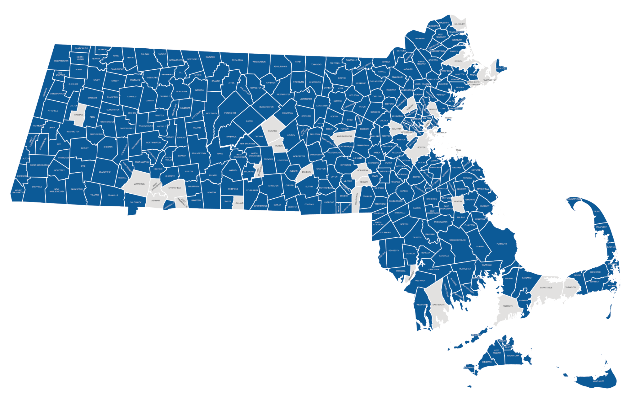

*Please note that this map represents current program participation at time of publication, and not all municipalities represented in the map participated in the fall of 2022 Capacity Assessment.

Phase 1 of the Capacity Assessment, the Baseline Capacity Assessment (BCA), was completed as one 179-question survey for each municipality (or group of municipalities in select cases), with a 98% completion rate (see Appendix D for the Baseline Capacity Assessment survey questions). This survey asked local health departments to report their ability to meet existing mandatory statutes and regulations — the Performance Standards. It is important to note that the survey questions in the BCA, which were benchmarked to the Massachusetts General Laws (MGLs) and Code of Massachusetts Regulations (CMRs), do not nearly include the full breadth of services delivered by local health departments. However, the Blueprint suggested the assessment as a first step to support LPH to reach all of the existing mandated obligations before eventually expanding to include the complete Foundational Public Health Services.

Phase 2, the Workforce Assessment, was open to anyone doing public health work (paid or unpaid) for a municipality or in an SSA. This assessment was based on the Blueprint’s Workforce Standards and aimed to collect information about the training, education, and credentials of the Commonwealth’s LPH workforce.

Finally, Phase 3, Backup Documentation, was tailored to each municipality (or group of municipalities) based on their responses to the BCA. If a municipality self-reported that they were able to meet a particular standard, Phase 3 asked for samples of relevant documentation. Subject matter experts (SMEs) then reviewed the documents to determine whether they contained all critical elements.
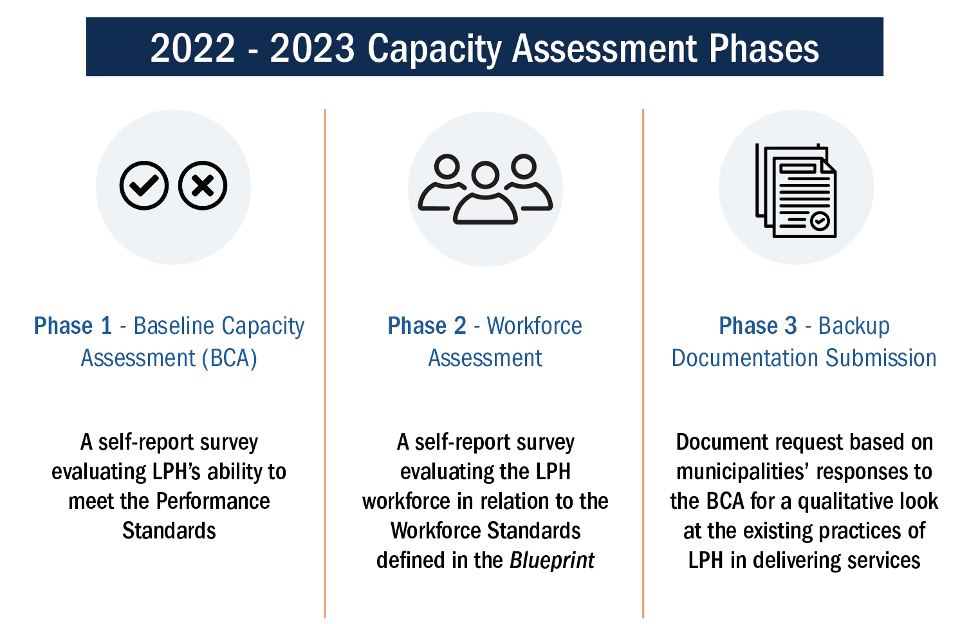
The data collected by this assessment were reported back to communities in aggregated form, at the SSA level, so that groups could look at their needs as a whole, determine strengths and areas for improvement, and work together to share resources, improve efficiency, and raise their service levels.
^{[1]} The Foundational Public Health Services are recognized as the minimum set of skills, programs, and activities a health department must have to function well.
^{[2]} As of report release, the Public Health Excellence Shared Services Grant Program has expanded to include 319 municipalities in 51 SSAs.

Methodology

Baseline Capacity Assessment (BCA)
A collaborative group developed the Baseline Capacity Assessment. This group included OLRH, BME Strategies, Massachusetts Health Officers Association, Public Consulting Group, and selected local and state public health SMEs. To create the survey questions, the team thoroughly reviewed all Massachusetts General Laws (MGLs) and Code of Massachusetts Regulations (CMRs) outlined in the Performance Standards. The objective was to identify existing statutory and state-level regulatory mandated obligations for local boards of health and create survey questions based on these established benchmarks.

Following the initial survey draft, the team collaborated to review and finalize the phrasing, content, and answer options for all proposed survey questions. The final version of the BCA had 25 survey questions related to budget, grant, and staffing information, and 134 survey questions related to the MGLs and CMRs. The questions relating to the Performance Standards were then categorized into seven subject areas (Administration, Community Sanitation, Disease Control and Prevention, Environmental Protection, Food Protection, Housing, and Tobacco Use Prevention).

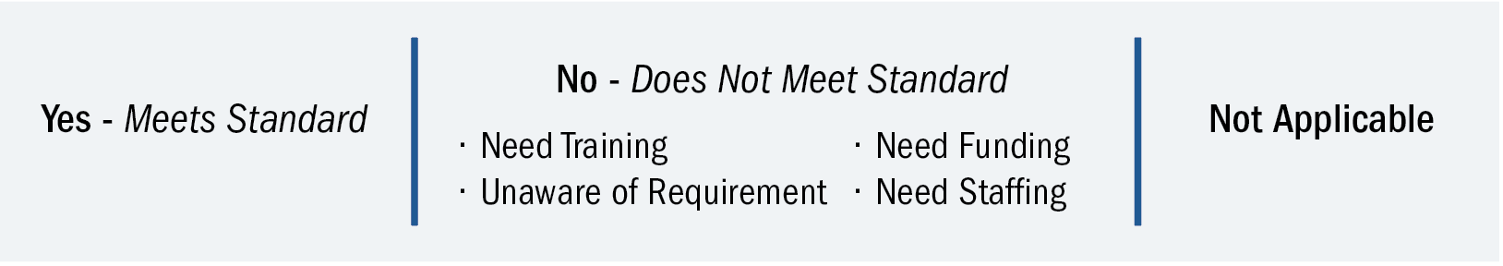
Municipalities could only include one response option from the following list and were encouraged to choose the option that best applies:
In September of 2022, the online BCA self-report survey was sent to all 305 municipalities that were participating in the PHE Shared Services Grant Program. Municipalities that encountered technical difficulties or needed to garner information from multiple sources to answer all of the questions were provided a fillable PDF version of the BCA upon request. Similar support structures were integrated into the entire process to improve equity and accessibility, ensure a high response rate, and limit potential bias created by less-resourced health departments being unable to respond due to very limited capacity.

To ensure the BCA included as many municipalities as possible, OLRH engaged in multiple outreach attempts to ensure all municipalities had the support they needed to participate. For example, OLRH hosted a total of 50 office hours, attended by 41 LPH participants. Additionally, based on feedback from municipalities, the deadline for the BCA was extended.

Each municipality was instructed to submit one BCA completed by their lead board of health or local health department employee, with assistance from colleagues as needed. The survey took municipalities an average of one and a half hours to complete. The BCA closed at the beginning of November 2022 and achieved a response rate of 98% (300 of 305 municipalities).

Workforce Assessment
The Workforce Assessment survey was developed based on the recommended Workforce Standards outlined in the Blueprint and are now part of the Performance Standards (see Appendix E for survey questions). The Workforce Assessment aimed to determine which Workforce Standards were met “At Hire” and “After Hire” by position type and to supplement these data with workforce demographic information.

Survey questions relating to education, training, and credentials were position-specific to match the Blueprint’s recommendations for the local public health workforce. At the beginning of the survey, respondents selected their position from the following options: Management, Management/Agent (agents of the board of health that have administrative and managerial duties), Inspector/Sanitarian, Public Health Nurse, Clerical Staff, Board of Health Member, and Community Public Health Specialist. The Community Public Health Specialist category was added to gather information for positions not explicitly outlined in the Workforce Standards (e.g., Community Health Worker, Epidemiologist, Grant Coordinator, Social Worker, and others). If an individual held multiple positions within a health department, they could complete the survey for all relevant positions. The survey did not collect any identifying information to preserve respondent anonymity.

In October of 2022, the online Workforce Assessment was sent to personnel from municipalities participating in the PHE Shared Services Grant Program. The following personnel were encouraged to complete the survey: all LPH staff, other municipal staff that provide public health services, regional public health staff, board of health members, and independent contractors supporting LPH. The survey closed in early November of 2022 and took individuals approximately 15 to 30 minutes to complete. A total of 1,020 people responded to the Workforce Assessment, representing a wide range of positions across the LPH workforce and geographic diversity.

Backup Documentation
The same group of key partners who developed the BCA also collaborated to determine the categories and types of documents (e.g., Food Inspection Reports, Bathing Beaches Lab Results, Housing Condemnation Orders, etc.) to collect from municipalities. The documents were qualitatively reviewed to evaluate the implementation of the Performance Standards. In creating the backup documentation request, the team aimed to minimize the burden on local public health to locate and submit documents. Therefore, documents were only requested from municipalities that self-reported meeting specific statutory requirements in the BCA that were then reviewed for proficiency (whether or not the documents contained all critical elements).

Using an online documentation collection system, BME Strategies sent individualized document requests to municipalities based on their BCA responses. For some categories, such as Food Establishments or Swimming Pools, requests specified which particular location a municipality should submit documents for to limit self-selection bias. The SMEs randomly selected these specific location requests. All municipalities had the opportunity to explain any special circumstances that prevented them from submitting requested documentation. For example, if a municipality reported that a requested food establishment closed in 2019, the missing documents for 2021 would not affect their backup documentation score. In addition, SMEs were available to provide on-site assistance and support if a municipality had challenges interpreting the documentation requests, locating requested documents, or using the online documentation-upload system.

Municipalities submitted documents for a total of 198 backup documentation requests, and 55 municipalities were considered non-contributing (meaning <5% of requested documents were submitted).

OLRH, BME Strategies, Massachusetts Health Officers Association, and the SMEs collaborated to determine the scoring criteria for each category (e.g., Recreational Camps for Children, Swimming Pools, Food Protection). Then, a group of 10 geographically diverse SMEs, each with at least 25 years of experience in local public health, reviewed and scored the submitted documents.

After piloting several methods to reduce variability in scoring, consistency was best achieved when SMEs scored documents for only one subject area. Additionally, the SMEs did not score documents from municipalities where they previously worked to minimize bias.

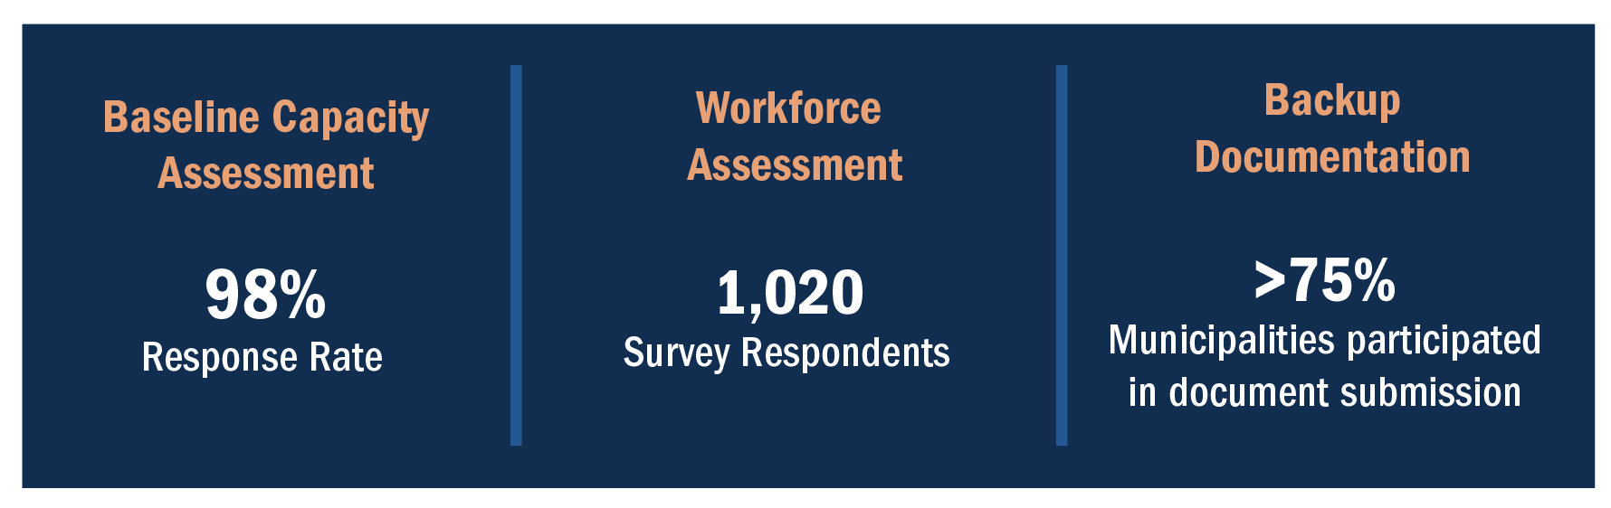
SMEs could assign documents the following scores: “Meets Standard,” “Does Not Meet Standard,” or “No Document for Review/Incorrect Document Submitted.” When SMEs scored a document as "Does Not Meet Standard," they were able to select more descriptive reasons to explain their score determination (e.g., follow-up action not completed or documented). The backup documentation review began in November of 2022 and concluded in April of 2023. The SMEs scored a total of 5,506 documents.

Analysis and Observations

Phase 1: Baseline Capacity Assessment

Statewide BCA Score Distribution - SSA Level
The Baseline Capacity Assessment demonstrated a clear and consistent need to strengthen the local public health system in Massachusetts to meet the current 94 Performance Standards. Figure 2 illustrates the wide variation in self-reported ability to meet the Performance Standards at the SSA level.

The scores reflect the percentage of applicable Performance Standards that all municipalities in an SSA reported meeting in the BCA. Among the 50 SSAs, the highest BCA score was 93%, while the lowest was 46%. Half of all SSAs self-reported meeting between 76% and 84% of the applicable Performance Standards. The median score was 80%, with a slightly lower average of 78%. Thirty-eight out of 50 SSAs (76%) had SSA BCA scores of 75% or above. The outliers refer to the specific SSA BCA scores that deviate significantly from the overall trend observed in the dataset.

As a reminder, the Performance Standards represent the current minimum statutory and regulatory requirements for local health departments. These BCA scores demonstrate a need for further investment and improvement in local public health to be able to meet the minimum requirements and, in the future, provide the more extensive Foundational Public Health Services.

Figure 2: SSA Reported Ability to Meet Performance Standards (PS) Frequency

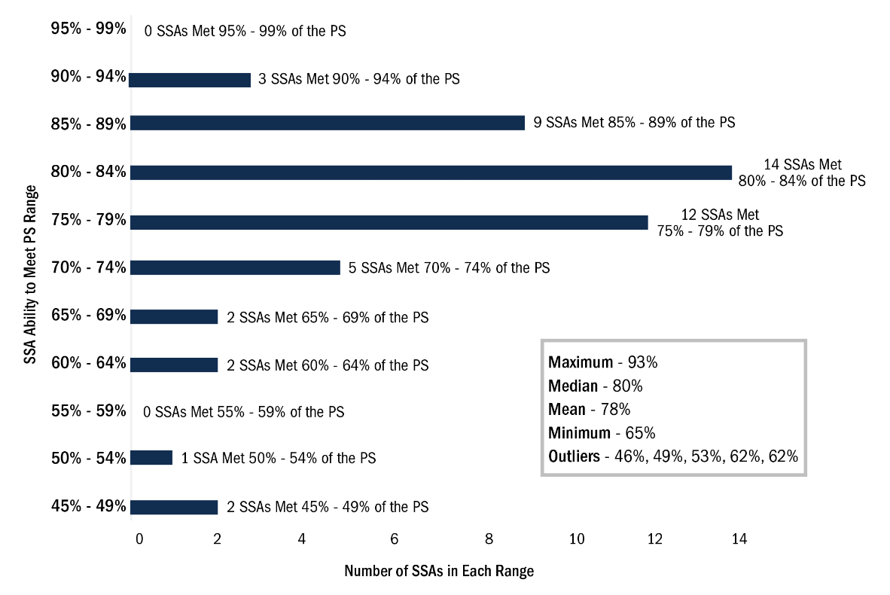

In looking at the gaps in meeting the Performance Standards, the BCA demonstrated that the most frequently reported reason for not meeting the Performance Standards was being Unaware of the requirements (10%), followed by needing Staffing (7%), needing Training (4%), and needing Funding (1%) (Figure 3). It is important to take note of the four outliers and maximum observed in the Staffing column as they represent the five lowest SSA BCA scores.

Figure 3: SSA BCA Reason for Not Meeting Performance Standards

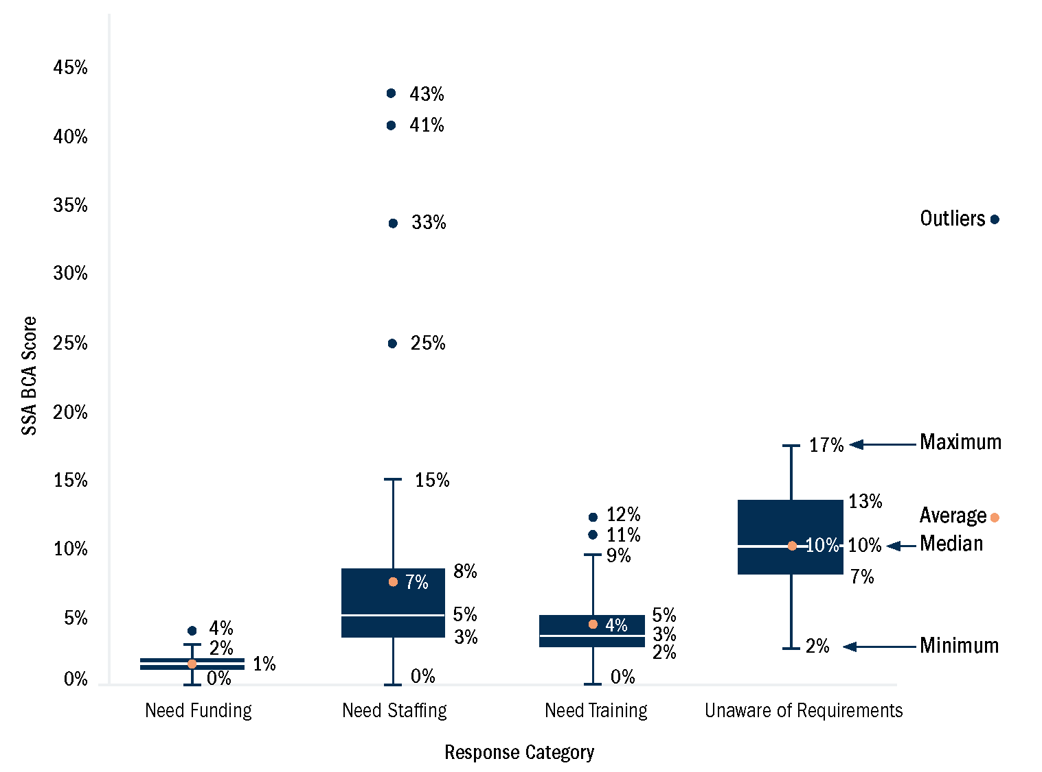

Lack of Awareness and Training Needs
Unawareness had the highest average by response category which highlights that across the board, the largest issue facing SSAs is a lack of awareness of the Performance Standards. The data show the greatest need for training across all SSAs is in Housing and Administration, where SSAs reported needing training to meet 7% and 5% of the Performance Standards in those subject areas, respectively. In addition, the subject areas where the most SSAs reported being unaware of requirements were Disease Control and Prevention (17%), Environmental Protection (14%), and Administration (13%) (Figure 4). However, it is important to note that the Disease Control and Prevention category did include several standards that LPH identified as antiquated. Please see the “Antiquated Laws” section for a more detailed description of these regulations. Overall, raising awareness of the various statutory and regulatory requirements for local health departments is crucial to ensure full compliance with the Performance Standards.

To address training needs, DPH is establishing 10 Field Training Hubs (FTHs) across the state to provide standardized training for local public health environmental health inspectional staff (see Appendix F). The FTHs will provide hands-on proficiency training on Community Sanitation, Food Protection, and Environmental Health-related regulatory compliance. The results of this assessment and subsequent assessments, particularly the training and unawareness needs identified across SSAs, will help to develop training curricula tailored to the unique needs of each FTH geographical region. Additionally, the release of the Performance Standards should inherently increase awareness of the minimum legal and regulatory requirements which will be quantified in the next Capacity Assessment. Following widespread awareness of the Performance Standards, further Capacity Assessments will be able to better identify the resource-oriented root cause of not being able to meet Performance Standards.

Figure 4: Training Needs and Unawareness Needs Overall
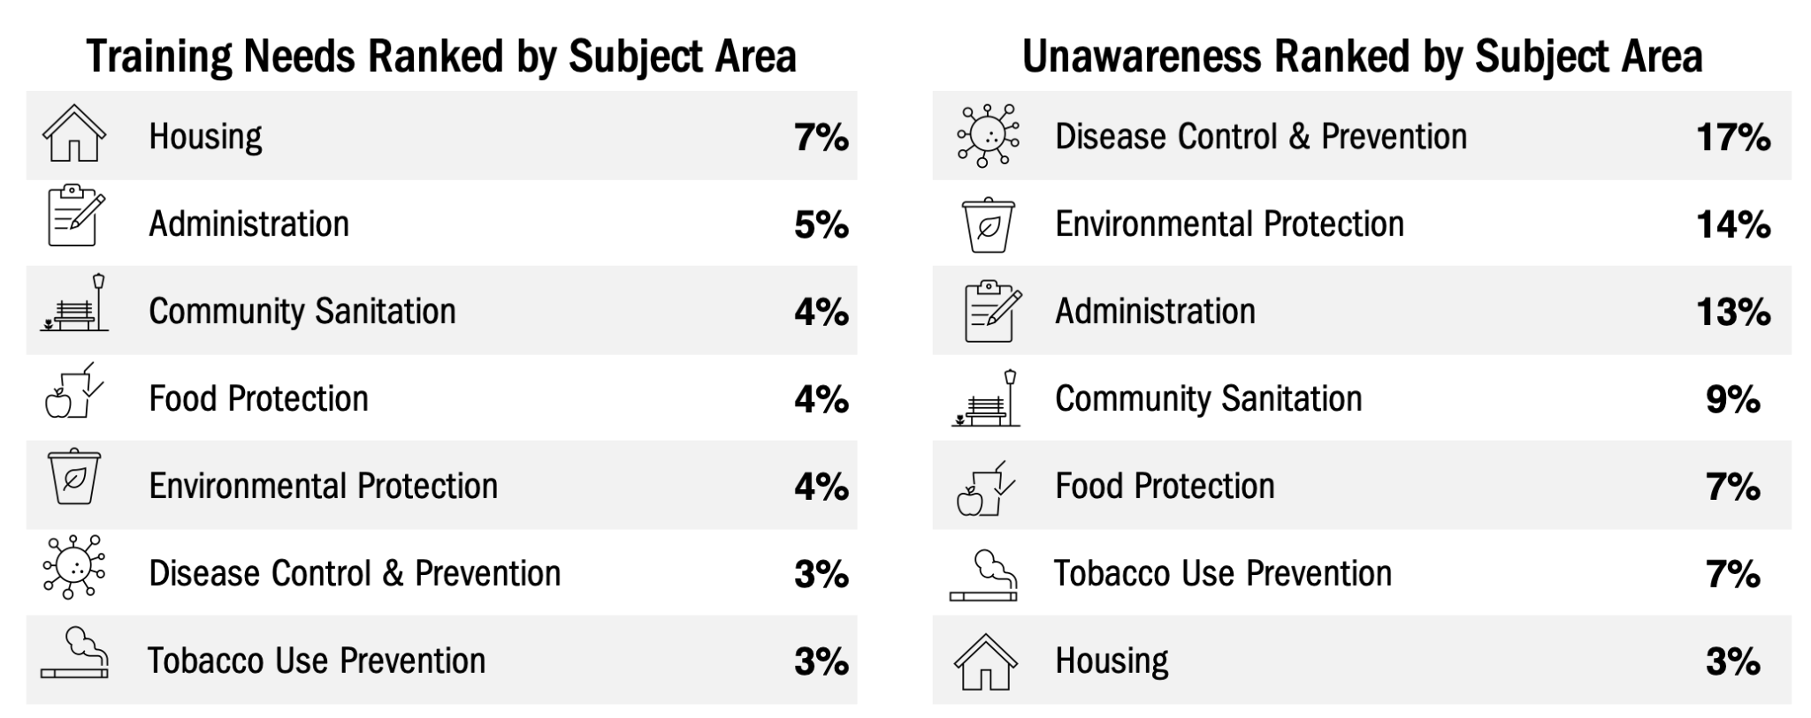

Antiquated Laws
Although Disease Control and Prevention had the highest percentage of SSAs reporting being Unaware of requirements, statewide partners and LPH identified several of the 13 Disease Control and Prevention Standards as antiquated. Two of these antiquated standards pertain to reporting cerebral palsy cases and deaths from diseases dangerous to public health to DPH (M.G.L c. 111, s. 111A and M.G.L. c. 111, s. 29). Notably, these two standards had the second and third highest number of BCA respondents that reported being Unaware of the requirements.

The reason these two particular standards are considered antiquated is that modern systems have altered the reporting process. For example, the Massachusetts Virtual Epidemiologic Network (MAVEN), now serves as a comprehensive platform for efficient and streamlined infectious disease reporting directly to DPH. Quantitative findings of this BCA analysis support the categorization of these laws as antiquated and may be considered for repeal or amendment.

Rurality
In 2002, DPH’s State Office of Rural Health created a definition of rurality that categorizes municipalities across the Commonwealth into three categories: Rural Level 1, Rural Level 2, and Urban. Rural municipalities are concentrated in distinct regions across the state (Western and Central Massachusetts, the Islands, and the Outer Cape) and face unique barriers to delivering comprehensive public health services.

Figure 5 compares the ability to meet the Performance Standards between municipalities in these three distinct categories. The results demonstrate that, on average, Rural Level 2 municipalities, considered the most rural, met on average, 10% points less of the applicable Performance Standards than Urban municipalities, and Rural Level 1 municipalities met on average 3% points less of the applicable Performance Standards compared to Urban municipalities (Figure 5).

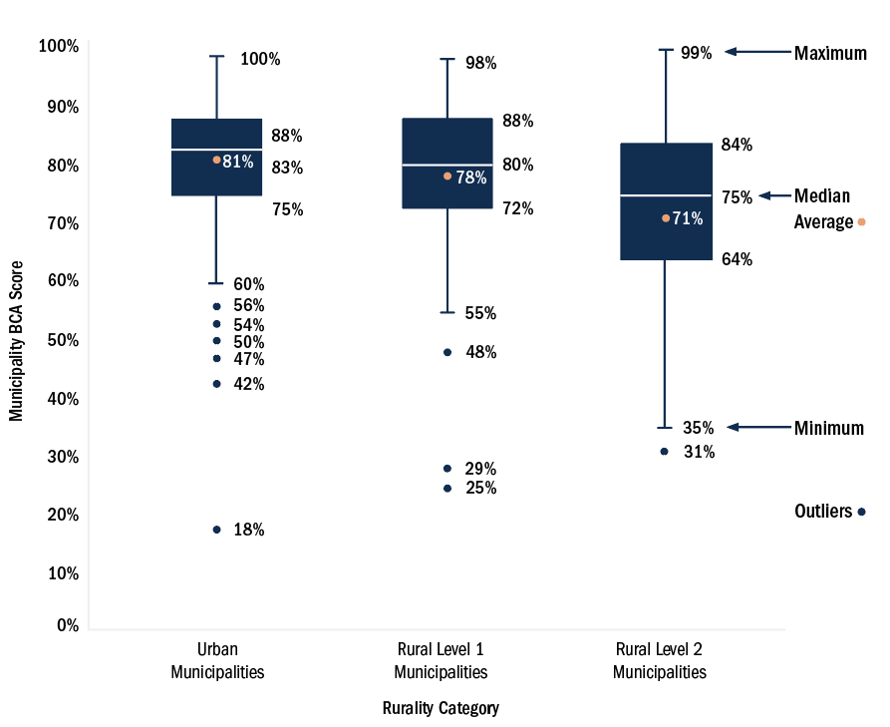
Figure 5: BCA Score by Municipality Rurality

The disparity in scores is largely attributed to a greater reported need for Staffing (12% for Rural Level 2, 8% for Rural Level 1, and 5% for Urban) across the applicable Performance Standards (Figure 6). Staffing needs accounted for the majority (79%) of the discrepancy between Urban and Rural municipalities' reported ability to meet the Performance Standards.
While Unawareness was 3% points higher, on average, for municipalities in Rural Level 2 than Rural Level 1 and Urban, the reported needs for Funding and Training were consistent across all three categories. Please note that three group BCA submissions encompassing 27 municipalities are not included in this rurality analysis as they included municipalities in both the Rural and Urban categories.

These findings highlight the need to strengthen and substantially increase the LPH workforce, particularly for Rural Level 2 municipalities in regions such as Western and Central Massachusetts, the Islands, and the Outer Cape. Rural LPH will require additional resources to enhance its workforce capacity in both staffing levels and awareness. Utilizing the shared services model can significantly boost efficiency and help municipalities leverage economies of scale to meet the minimum Performance Standards.

Figure 6: Response Categories by Rurality
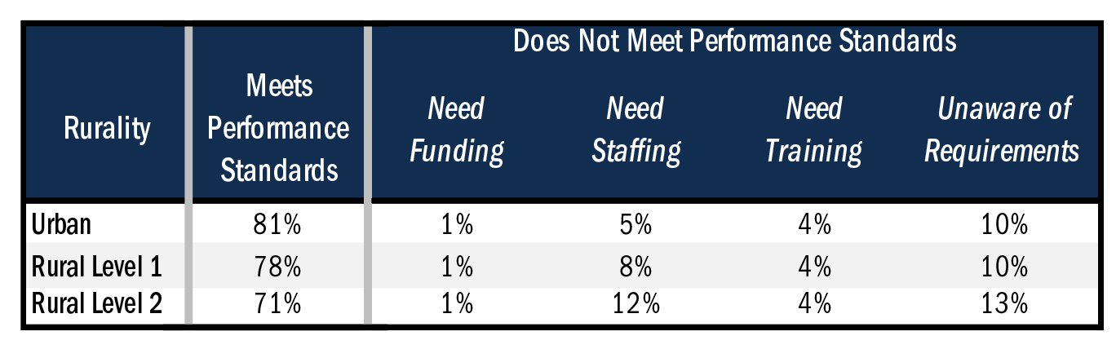

Funding & Staffing
Funding
To understand the variability of financial resources of local health departments across the Commonwealth, budget and grant information was collected from each municipality and then aggregated to the SSA level. Reporting back funding information at the SSA level aims to emphasize the role of SSAs in sharing and pooling resources. The shared services model allows municipalities to leverage combined efficiencies and resources as well as achieve economies of scale. However, a limitation of reporting funding information at the SSA level is that it does not capture the nuances and disparities that exist within the SSA and can obscure the specific needs of each participating municipality.
Consider a hypothetical SSA consisting of four municipalities. If one municipality reported a substantial grant amount for a specific program, the municipal and grant funding per capita average could create a distorted perception that the overall funding situation is more equally distributed within the SSA than it is in actuality. Factors such as population size, demographics, geographic location, and specific challenges faced by each SSA and its member municipalities must be considered. Failing to account for such variations could lead to a misallocation of resources, leaving some municipalities underserved and exacerbating health inequities even within the SSA structure.
Analysis revealed a significant disparity in funding, with self-reported combined municipal and grant budgets for SSAs ranging from $76,111 to $8,135,480, with an average of $2,521,940. This disparity also persists when standardized by population served as local health departments reported municipal and grant funding ranging from $1.57 to $137.41 per capita, with an average of $26.61 per capita. Although all municipalities are required to meet the same statutory and regulatory requirements, most municipalities have inadequate financial resources to support their residents effectively. These findings highlight the urgent need to create commensurate financing among local health departments to ensure equitable and comprehensive public health services are delivered across the Commonwealth.
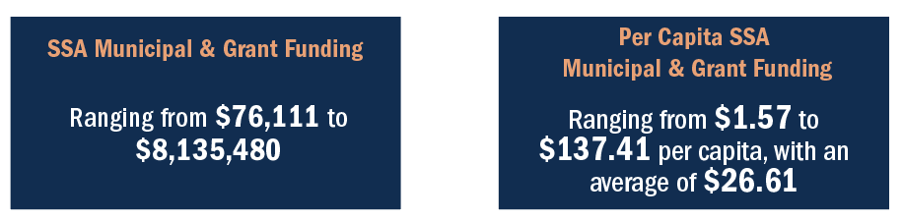

According to current research, local health departments’ municipal budgets should be at least $36.98 per capita (estimates adjusted for inflation) to establish even the basic public health capacities within an SSA. This assessment demonstrated that out of the 50 SSAs, only two SSAs reported funding that exceeded the $36.98 per capita. Figure 7 shows the distribution of municipal budgets per capita with an average of $17.56 per capita and 50% of SSAs fall between $11.88 and $20.45 per capita.

Determining the precise financial and staffing thresholds that would enable a clear correlation between funding/staffing and the ability to meet Performance Standards is challenging, particularly due to Massachusetts's unique decentralized public health system. The multitude of factors at play, such as varying local priorities, resource allocations related to the Performance Standards, and operational constraints, make it difficult to visualize a straightforward relationship between resources and self-reported BCA scores.

By recognizing these complexities and engaging in discussions and analysis, stakeholders can work towards developing tailored solutions that enhance the resourcing levels of local health departments to ensure that all municipalities across the state can achieve 100% of the Performance Standards and safeguard the health and well-being of their constituents.
Figure 7: SSA Distribution of Municipal Budget Per Capita

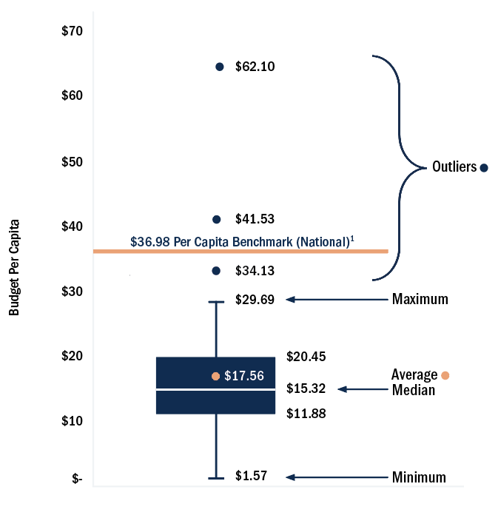

Shared Staffing
Investing in LPH staff is crucial to ensure municipalities have the necessary resources and expertise to respond to public health emergencies, prevent morbidity and mortality, provide critical health services, and promote overall wellness for residents. As such, SSAs have been utilizing PHE Shared Services Grant Program funds to build shared capacity among their member municipalities. Sharing public health services and functions across municipalities also improves efficiency and benefits from economies of scale, and integrating shared services is a major goal and contractual requirement of the PHE Shared Services Grant Program. Many SSAs have taken the first step toward achieving this goal by hiring shared staff to allocate resources where needed. As of the fall of 2022, the 50 SSAs reported having 93.92 FTE shared staff funded by the PHE Shared Services Grant Program. The top five position types and their associated FTE are displayed in Figure 8.

Figure 8: Fall of 2022 Shared Staff - PHE Shared Services Grant Program Funded
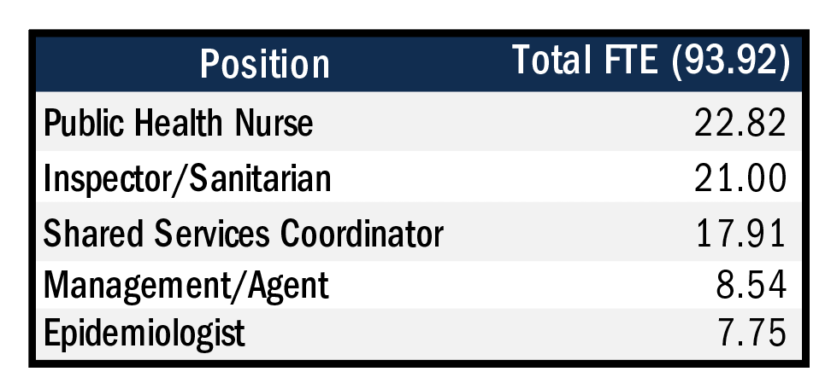
An additional PHE Shared Services Grant Program requirement is to hire a Shared Services Coordinator (SSC). The SSC plays a vital role in bringing the member municipalities together to develop and execute their workplan, facilitate SSA meetings, manage the PHE Shared Services Grant Program budget, and identify opportunities for additional grants and professional development for the SSA. Of the 50 SSAs, 29 (58%) have hired an SSC. During the data review meetings where the SSA-specific Capacity Assessment results were shared with SSAs, it was recommended that all SSAs without an SSC hire one in the next six months to meet the existing contractual requirements of the PHE Shared Services Grant and to help coordinate and expand the sharing of services across participating municipalities.

Additional Programs & Services
Although the primary goal of the BCA was to evaluate local health departments’ capacity to fulfill the Performance Standards, it also sought to gather information on the wide range of additional programs and activities that local health departments engage in beyond these minimum requirements. This was partly to discern which of the other Foundational Public Health Services are already being implemented across Massachusetts, and to highlight the breadth of work that local health departments carry out beyond the minimum legally obligated requirements. While not mandated, these important programs require prioritization and adequate allocation of funds from already limited budgets to ensure the health and well-being of residents.

As part of this effort, the BCA requested municipalities to provide five examples of additional programs or activities in which their departments are involved. Notably, the most frequently reported programs were associated with substance use (66), COVID-19 response (44), emergency and disaster response (41), community health and safety (41), and immunization (33). Several other notable programs were identified, including wellness and safety programs for older adults, mental health, housing and safety (beyond the housing-related Performance Standards), chronic disease management, and food insecurity. It is important to highlight that public health nurses, despite having limited representation in the existing mandated state regulations and statutes, play a crucial role in spearheading numerous programs and delivering vital services and resources that uphold the welfare of communities.

Figure 9 illustrates the most prominent responses throughout the state, with the size of the boxes indicating the frequency of provided programs and services.

Figure 9: Statewide Additional Public Health Programs & Services
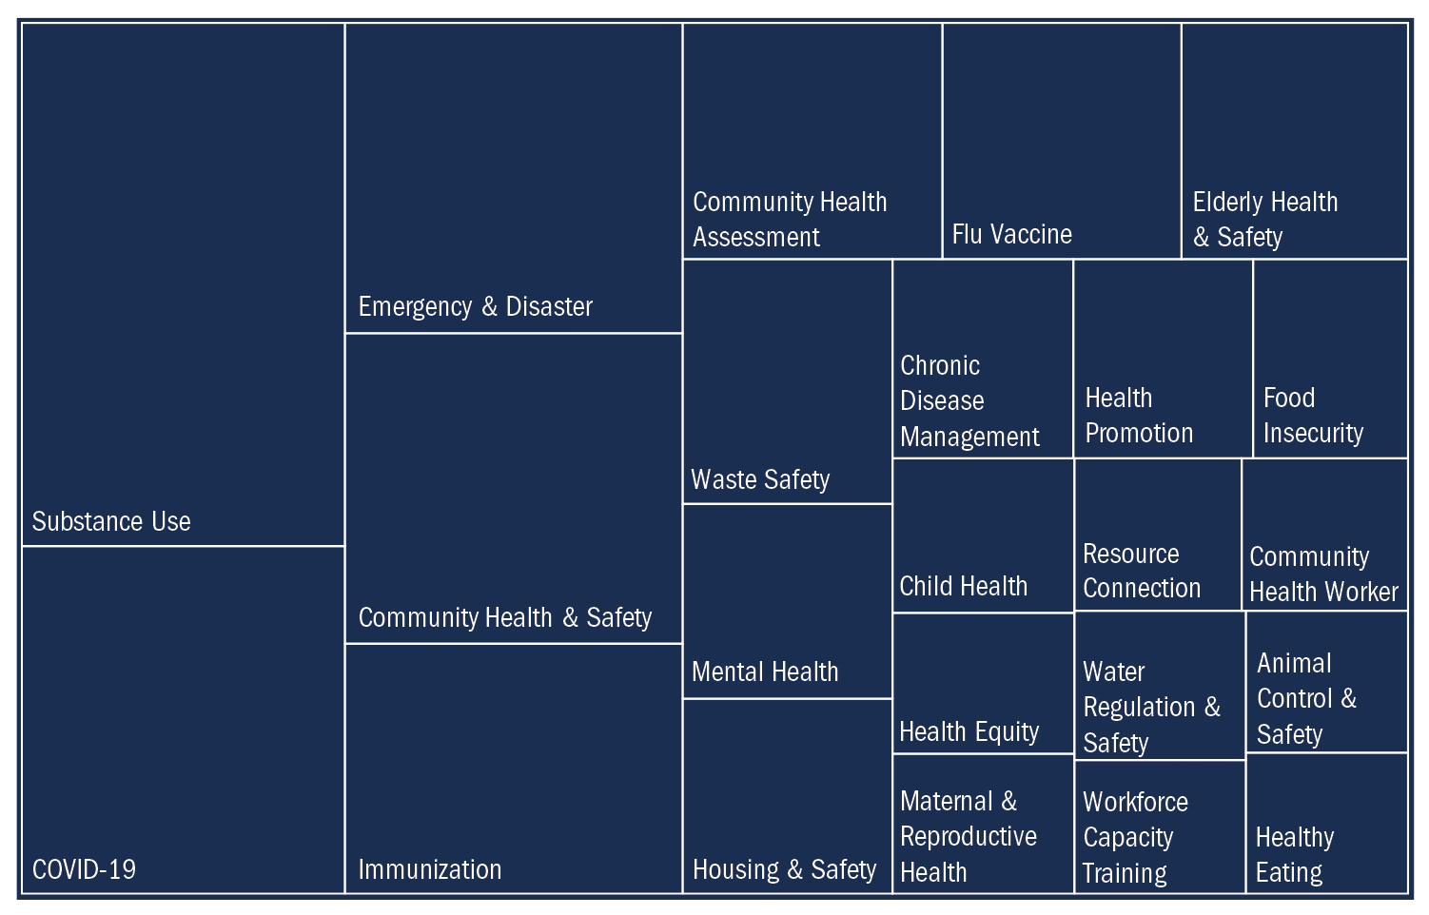

Additional Considerations
Given that the Performance Standards are based on lengthy legal text, survey respondents may have misunderstood the underlying requirements being assessed. For example, in response to a question about frozen dessert manufacturers (any retail establishment operating a frozen dessert freezing/dispensing machine), an unexpectedly high percentage (63%) of respondents selected Not Applicable. Specific BCA questions will be reworded for clarity in the future to ensure that survey responses are more accurate. However, it is important to note that the questions marked as Not Applicable were not factored into the BCA scores. If municipalities answer these questions as applicable in future surveys, they will be added to their BCA scores, potentially impacting the overall score.

The timeframe of "in the last five years" which served as the question stem for some BCA survey questions may have also allowed for respondents to select Not Applicable when the time frame did not align with their tenure in that municipality, but the Performance Standard was still applicable to their municipality. Thus, the BCA scores may overrepresent municipalities’ current ability to meet the existing Performance Standards. During the course of the assessment, OLRH did clarify with municipalities via office hours and a Frequently Asked Questions (FAQ) document to respond to applicable BCA questions based on their current capacity even if they fell outside of a five-year timeframe; however, not all municipalities may have received this instruction before completing their BCA. When completing the BCA, LPH expressed that it was challenging to distinguish between reasons for not meeting Performance Standards, specifically in relation to the need for Funding, Staffing, or Training. This feedback highlights the importance of acknowledging the interconnected nature of Funding, Staffing, or Training and the need for additional clarity in future surveys.

Standard-Specific Findings
The tables below outline the Performance Standards with the highest needs by response group (Staffing, Funding, Training, and Unaware of Requirement). Please note that the denominator (256) is the number of BCA respondents, not the total number of individual municipalities (300) included in this analysis since a few group BCA submissions included multiple municipalities. There were 10 BCA group submissions, representing 54 individual municipalities. On average, the group submissions had lower BCA scores. Therefore, this may underestimate the number of municipalities that need additional resources to meet the specific Performance Standards outlined below.
Staffing
Administration
Regulation Enforcement
- 31/256 (12%) respondents need additional staffing to enforce any local regulations, policies, procedures, etc. passed by their Board of Health.
Community Sanitation
Nuisances (M.G.L. c. 111, s. 122)
- 39/256 (15%) respondents need additional staffing to log all complaints received related to nuisances, sources of filth, and causes of sickness.
Lead (105 CMR 460)
- 39/256 (15%) respondents need additional staff who have completed a specialized code enforcement lead determination inspector training program.
- 29/256 (11%) respondents need additional staffing to perform lead determinations if a house was built before 1978 and there is a child under six living in the house.
Housing Court (105 CMR 410)
- 31/256 (12%) respondents need additional staffing to feel competent taking all uncorrected housing code violations to the Massachusetts Housing Court for legal actions.
Radiation (105 CMR 123)
- 28/256 (11%) respondents need additional staffing to inspect tanning facilities prior to opening and every six months thereafter.
Environmental Protection
Title 5: Failed System Compliance (310 CMR 15)
- 37/256 (14%) respondents need additional staffing to follow up and ensure compliance (within two years) of failed systems upon receipt of a Title 5 inspection report that indicates the system failed the inspection.
Food Protection
Food Inspections (105 CMR 590)
- 52/256 (20%) respondents need additional staffing to inspect all food establishments once every six months or on a risk-based schedule AND at least once per year for temporary or seasonal establishments.
Tobacco Use Prevention
Inspections and Compliance Checks (105 CMR 665)
- 32/256 (13%) respondents need additional staffing to conduct inspections and compliance checks of tobacco retailers.

Funding
Community Sanitation
Pool Inspection Equipment (105 CMR 435)
- 25/256 (10%) respondents need additional funding for the appropriate equipment needed to conduct a pool inspection.
Disease Control and Prevention
Anti-Rabic Vaccine and Treatment (M.G.L. c.140, s. 145A)
- 18/256 (7%) respondents need additional funding to provide access to an anti-rabic vaccine and anti-rabic treatment free of charge to any uninsured resident who had or may have been exposed to rabies.

Training
Administration
Sanitary Code Filing (M.G.L. c. 111, s. 31)
- 20/256 (8%) respondents need additional training to file attested copies of sanitary codes, all rules, regulations, and standards which have been adopted, and any amendments and additions for the maintenance of a central register in accordance with section eight of chapter 21A AND can provide documentation of submittal with DEP.
Hazardous Chemical Publishing (M.G.L. c. 111, s. 26F)
- 18/256 (7%) respondents need additional training to annually publish a list of hazardous chemicals present in the municipal water supply in concentrations greater than fifty percent of the suggested action guidelines AND post the list in a town or city hall and at the offices of the Water Department.
Community Sanitation
Housing Court (105 CMR 410)
- 73/256 (29%) respondents need additional training to feel competent taking all uncorrected housing code violations to the Massachusetts Housing Court for legal actions.
Lead Determination Training (105 CMR 460)
- 56/256 (22%) respondents need additional training for an employee or agent to complete a specialized code enforcement lead determination inspector training program.
- 20/256 (8%) respondents need additional training to perform a lead determination if the house was built before 1978 and there is a child under six living in the house.
Food Protection
Misbranded/Adulterated Food Testing (M.G.L. c. 94, ss. 186-195)
- 15/256 (6%) respondents need additional training on how to take samples of food believed to be misbranded or adulterated.

Unaware of Requirement
Administration
Hazardous Chemicals - List (M.G.L. c. 111, s. 26F)
- 83/256 (32%) respondents were unaware of the requirement to annually publish a list of hazardous chemicals present in the municipal water supply in concentrations greater than 50% percent of the suggested action guidelines and post the list in a town or city hall and at the offices of the Water Department.
Agricultural Commission - Copy of Proposed Regulation/Review Period (M.G.L. c. 111, s. 31)
- 52/256 (20%) respondents were unaware of the Standard to provide their municipal Agricultural Commission with a copy of the proposed regulation and a 45-day review period (regulation that impacts (i) farmers markets; (ii) farms; (iii) the non-commercial keeping of poultry, livestock or bees; or (iv) the non-commercial production of fruit, vegetables or horticultural plants).
Residential and Non-Residential Subdivision Plan Review (M.G.L. c. 41, s. 81S)
- 39/256 (15%) respondents were unaware of the Standard to notify the applicant and the town or city clerk by certified mail or directly by hand with a certificate of whether the service plan (residential and nonresidential subdivisions) has been approved or disapproved.
Environmental Protection
Air Pollution Issues/Complaints (310 CMR 7)
- 187/256 (73%) respondents were unaware of the Standard to hold a public hearing as a result of air pollution issues/complaints that resulted in assisting DEP or the EPA to address the issue.
Enacted Rules/Regulations - Garbage, Offal, or Other Offensive Substances (M.G.L. c. 111, s. 31B)
- 44/256 (17%) respondents were unaware of how to enact rules and regulations for the control of the removal, transportation, or disposal of garbage, offal, or other offensive substances.
Solid Waste Facilities/Transfer Stations (310 CMR 19)
- 42/256 (16%) respondents were unaware of how to license, inspect, and regulate solid waste facilities and/or transfer stations.
Community Sanitation
Funeral Director Licenses (M.G.L. c. 114, s. 49)
- 74/256 (29%) respondents were unaware of the Standard to send the names and addresses of licensed Funeral Directors to the Board of Registration in Embalming and Funeral Directing.
Tobacco Use Prevention
Annual Report - DPH Commissioner (M.G.L. c. 270, s. 22)
- 63/256 (25%) respondents were unaware of the requirement to provide an annual report to the DPH Commissioner on enforcement of smoking in public places law (e.g., citations issued, workplaces issued citation, amount each workplace has been fined, etc).

11 Largest Cities
Out of the 14 largest cities designated by the Massachusetts Large Cities Health Coalition, 11 participated in the BCA. The cities of Boston, Cambridge, and Springfield were not part of the Public Health Excellence Shared Services Grant Program during the first phase of the Capacity Assessment. Cambridge has since joined the PHE Shared Services Grant Program, and OLRH is currently working with Boston and Springfield to support them to better achieve the Performance Standards.

On average, the 11 largest cities that participated in the BCA are meeting 1% more of the applicable Performance Standards than the rest of the municipalities in the PHE Shared Services Grant Program (Figure 10). No specific response group or subject area was identified as the cause of this minor discrepancy between the 11 largest cities and the rest of participating municipalities. In terms of specific Performance Standards subject areas, Food Protection has the most considerable discrepancy in the “Meets'' category, with 72% for the 11 largest cities and 83% for the rest of the municipalities. This difference is mostly attributed to the 11 largest cities needing more staffing and being less aware of the Performance Standards in this category.

Figure 10: 11 Largest Cities - Baseline Capacity Assessment Scores
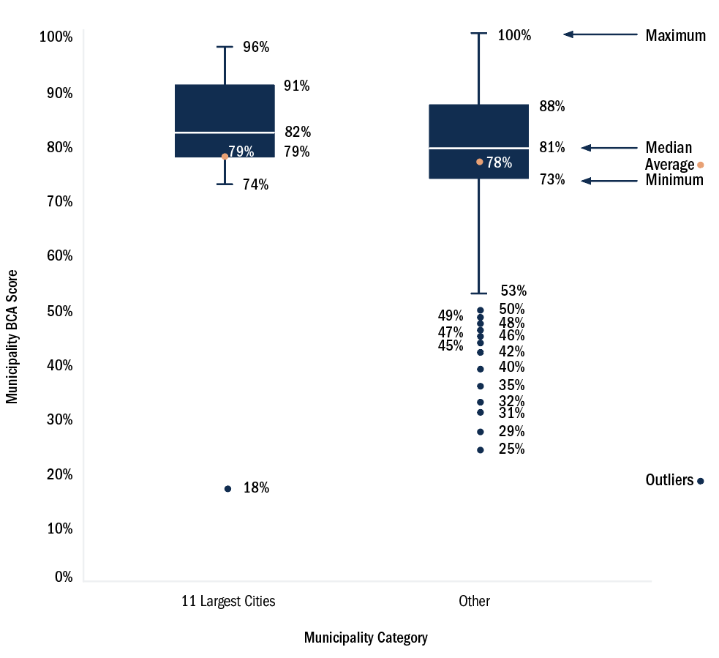

Key Findings
- Shared Services Arrangements meet an average of 78% of the applicable Performance Standards, ranging from 46% to 93%. The assessment highlights critical areas for improvement to meet the existing Performance Standards and ultimately achieve the more comprehensive Foundational Public Health Services — the final iteration of the Performance Standards.
- On average, municipalities designated as Rural Level 2 and Rural Level 1 met 10% and 3% points less of the applicable Performance Standards than Urban municipalities. This discrepancy was largely due to staffing differences — Rural municipalities were more likely than Urban municipalities to report Staffing as the reason for not meeting a standard. Quantifying this difference is a step forward in equitably addressing the variable staffing needs of municipalities in the PHE Shared Services Grant Program.
- Housing and Administration were reported as the greatest training needs across Shared Services Arrangements. Identifying these focus areas of training will allow the 10 Field Training Hubs to prioritize initial training and course offerings.
- While all municipalities are required to meet the same statutory and regulatory requirements, some municipalities have fewer financial resources to support their residents effectively. To create more equity in LPH funding, increased and tailored investment is needed at all levels — federal, state, and local.
- Lack of awareness is the major issue impeding Shared Services Arrangements’ adherence to the Performance Standards. The release of these Performance Standards is anticipated to improve awareness and facilitate identification of underlying resource-related challenges in the next Capacity Assessment.

Phase 2: Workforce Assessment

Workforce Standards
The Blueprint outlined the educational, training, and credentialing Workforce Standards set by the Special Commission for Massachusetts' LPH workforce. Before the 2019 release of the Blueprint, municipalities lacked any guidance pertaining to the education, training, or credentialing standards to utilize when hiring LPH staff. With the compilation of the Performance Standards, which include the Workforce Standards, there are now clear benchmarks for LPH to work towards.

The 2022 Workforce Assessment attempted to investigate the proportion of the LPH workforce that is currently meeting “Required At Hire” and “Required After Hire” standards. Figure 11 shows these results broken down by individual positions within LPH. These data suggest a considerable investment is required to elevate the current education, training, and credentialing of the LPH in Massachusetts to the Blueprint standards. The dark blue bars outline the percent of individuals that meet all of the “Required At Hire” or “Required After Hire” criteria.

Upon closer examination of the “Required At Hire” standards, it is evident that the majority of Inspectors/Sanitarians, Public Health Nurses, Clerical Staff, and Board of Health Members have achieved them. However, the Management and Management/Agent positions fall short of the standards “Required At Hire,” meeting 45% and 36%, respectively. The disparity becomes more pronounced when considering the “Required After Hire” standards, with Management meeting 4%, Management/Agent and Board of Health Members less than 1%, Inspector/Sanitarians at 6%, and Public Health Nurses at 45%.

It is important to note that of the 242 Board of Health Members that responded to the Workforce Assessment, 34 (14%) indicated that they conduct inspections. Among these 34 respondents, 91% are located in the Central and Western regions of the state. This further demonstrates the need for increased training and certification for both Board of Health Members and professional staff who conduct work related to the Performance Standards.

Figure 11: Statewide Workforce Assessment Education, Training, and Credentialing Requirements
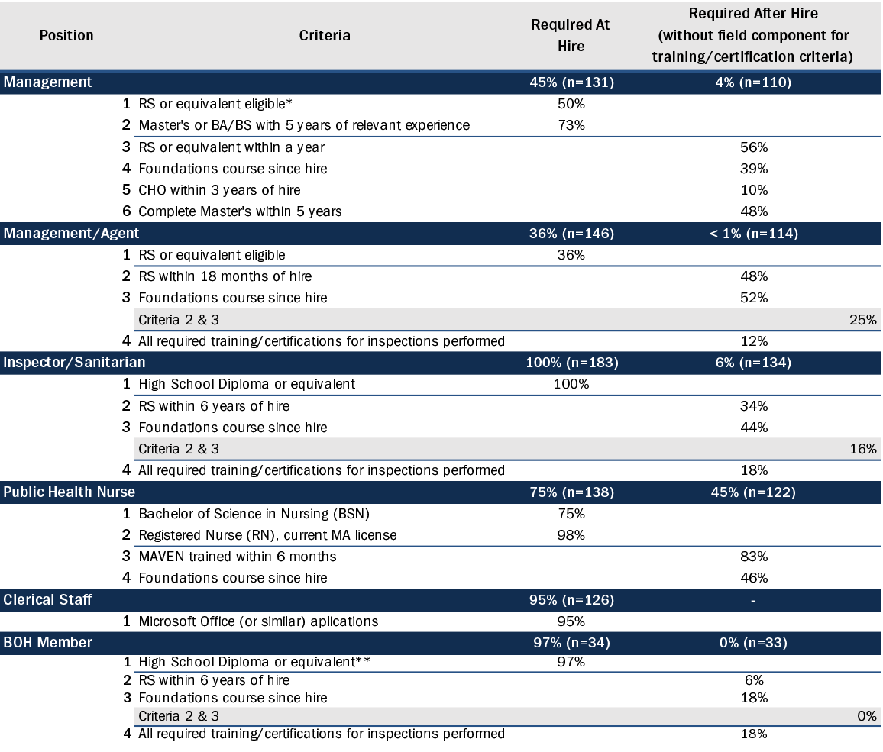
*The health department has a management position and a separate full-time environmental health director; the environmental health director has an RS, oversees the inspectors, and reports to the management position.

The reasons for such a large gap between the current education and training of the LPH workforce and these standards are multifaceted. The ability to take time from daily duties to train, the availability of funds to pay for the training, and the availability and proximity of the training were all commonly cited in SSA data review meetings as reasons from LPH for not meeting these standards. However, even when these particular barriers are addressed, the Workforce Assessment still showed training gaps within LPH. For example, Figure 12 offers insight into the ability of Workforce Assessment respondents to meet the Incident Command System (ICS) and National Incident Management System (NIMS) training requirements. These free, web-based, short courses provide a standardized approach to incident management and response, yet the vast majority of Workforce Assessment respondents fell short of meeting these ICS/NIMS training requirements.

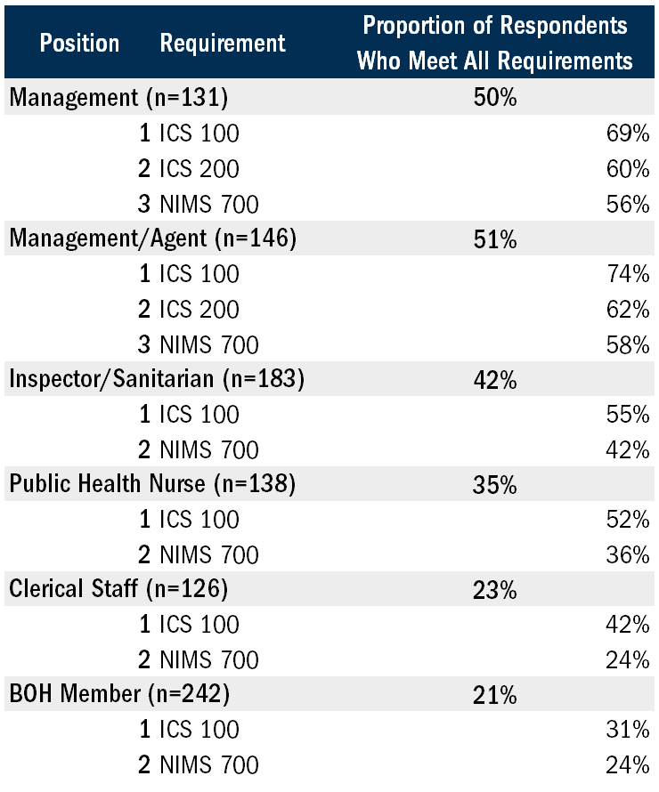
Figure 12: Statewide Workforce Assessment Respondents’ Ability to Meet ICS/NIMS Training Requirements

It is clear from the results of the Workforce Assessment that a significant investment in supporting the training, credentialing, and professional development of the LPH workforce is essential to meeting the Workforce Standards, the overall Performance Standards, and other critical functions of LPH, such as emergency preparedness and response.

The Workforce Assessment also further investigated the training and certifications held by Workforce Assessment respondents in two key positions focused on inspectional services: Management/Agent and Inspector/Sanitarian (Figure 13). The survey data highlight a concerning trend across all inspection categories: many respondents lack the required and recommended certifications and training.

The Local Public Health Institute of Massachusetts (LPHI) modules are a valuable resource for public health professionals, and their online and self-paced nature makes them widely accessible (see Appendix G). However, their low utilization rate is a cause for concern, with less than 50% of workforce respondents taking advantage of the online trainings. The LPHI modules present a promising starting point for the local public health workforce to gain basic knowledge and fulfill training requirements specific to their position.

On the other hand, there were some particular areas of achievement within these results. For example, out of the 112 individuals in Management/Agent roles who reported they conduct Food Protection inspections, 90% held the required ServSafe or equivalent certification.

Similarly, of the 143 respondents in Inspector/Sanitarian positions who reported they conduct Food Protection inspections, 88% had completed the necessary ServSafe training. Additionally, the majority of respondents had completed the Certified Pool Operator or Inspector training.

Figure 13: Statewide Certifications and Trainings by Inspection Type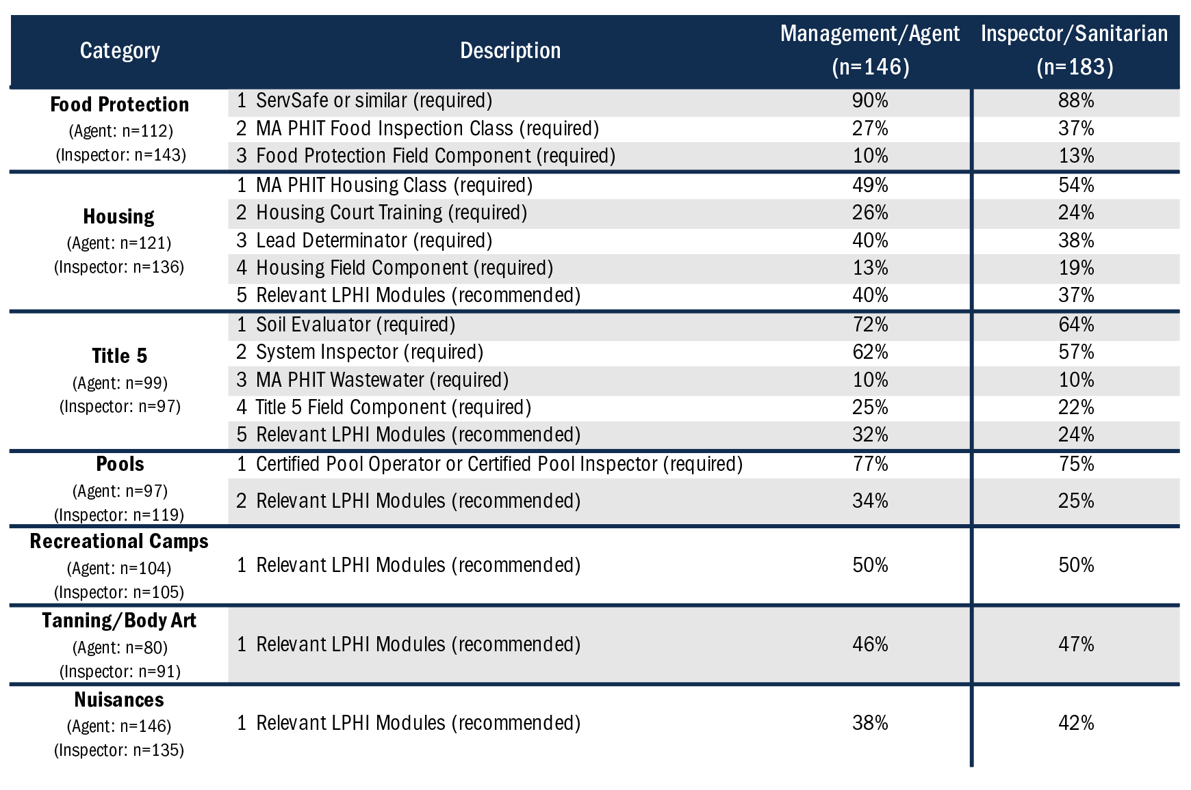

Demographics
Figure 14 presents a comprehensive breakdown of the demographic information collected by 1,020 Workforce Assessment respondents as compared to the Shared Services Arrangement constituency, including gender, age, and race/ethnicity. The results reveal that a higher proportion of female respondents (68%) than male respondents (28%) participated in the assessment (1% nonbinary and/or transgender and 4% prefer not to answer). Respondents' ages span a wide range, with 2% aged 18-24 and 18% over the age of 65. The largest age group among the respondents was those aged 55-64, comprising 23% of the total respondents. The White workforce is overrepresented compared to constituents served, comprising 86% of Workforce Assessment respondents compared to 72% of the SSA constituency. Notably, respondents who identify as Asian, two or more, and “other” races are underrepresented in the workforce related to their respective Shared Services Arrangement constituency served. Specifically, the percentage of respondents who identified as Asian, two or more, and “other” races were 2%, 1%, and 0%, respectively, compared to the SSA constituency of 7%, 8%, and 7%, respectively (see Figure 14).

The survey results reveal notable patterns across different demographic categories for the various positions surveyed. Public Health Nurses and Clerical Staff are predominantly female, with 93% and 88% respectively identifying as female, while 4% and 5% respectively identify as male. Board of Health Members who responded are mostly in the 65+ age category, with the workforce as a whole displaying much more age diversity. Additionally, the results indicate the highest racial diversity is among respondents in Management and Inspector/Sanitarian positions. In contrast, the lowest racial diversity is among Public Health Nurses and Board of Health Members. These findings offer valuable insight into the demographic composition of the LPH workforce and can be utilized to inform inclusive recruitment and retention strategies, aiming to foster increased diversity that is representative of the municipalities served.

Figure 14: Workforce Assessment Demographic Information
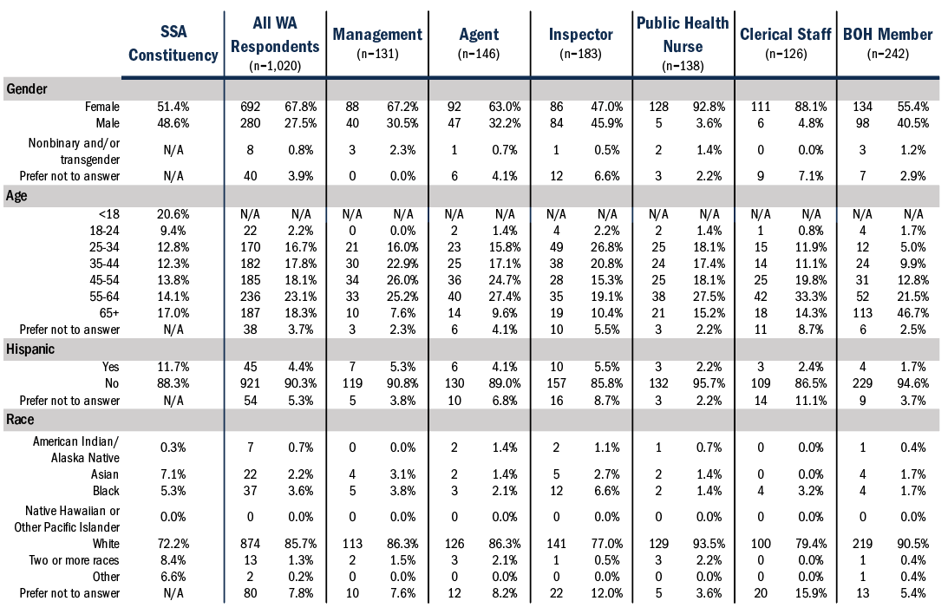

Salary
One of the objectives of the Workforce Assessment was to gather LPH salary data to determine salary ranges across various positions statewide. However, the assessment encountered challenges, such as a significant number of respondents across all position types who chose “Prefer Not to Answer” on the salary questions. As a result, this limitation hindered the ability to extract meaningful insights from the data. Rethinking how to collect this information in subsequent assessments is crucial to achieving an accurate and comprehensive understanding of position-specific salary information.

Key Findings
- The majority of Management and Management/Agent respondents are not meeting the standards “Required At Hire” and the majority of the workforce is not meeting the standards “Required After Hire.” This demonstrates a shortfall between the current practice and the newly sought standard, which is a core focus of OLRH’s strategic priorities and action.
- The complex reasons behind the substantial gap in education, training, and credentialing within the LPH workforce require a diverse set of solutions, such as increasing the availability of training programs, expanding access to courses through geographical proximity or distance learning options, and providing funding for course fees and back-fill staff support to facilitate attendance at educational opportunities.
- Local public health staff who report their race as Asian, two or more races, and “other” are underrepresented in the workforce when compared to the racial demographics of the people in their communities. Given the importance of a diverse and representative local public health workforce, recruiting, hiring, and retaining more people from underrepresented populations should be a focus for local public health.

Phase 3: Backup Documentation

Summary / Distribution of Backup Documentation Scores by SSA
An online documentation collection system was utilized to request backup documentation from 253 municipalities (or groups of municipalities). These requests varied in size, ranging from three to 80 requested documents, with an average of 50 documents requested per municipality. A total of 55 municipalities were considered non-contributing (the municipality submitted less than 5% of their requested documents) to the backup documentation request process. Of the 198/253 municipalities that participated in submitting documents, 34% (3,337) of submitted documents met the standard, while 22% (2,169) fell short, and 44% (4,349) were missing or incorrect. On average, contributing municipalities submitted 56% of the requested documentation.

The requested documents spanned various subject areas, including Bathing Beaches, Community Planning, Food Protection, Housing, Lead, Nuisances, Radiation Control Program, Recreational Camps for Children, Swimming Pools, Title 5, Tobacco Use Prevention, and Family Type Campgrounds. The unique backup documentation requests were based on each municipality's response to the BCA. It is important to note that documents were only requested if a municipality reported they were meeting a particular Performance Standard. Two municipalities that completed the BCA did not receive a backup documentation request because they indicated either that they were not meeting the Performance Standards for any of the backup document subject areas or the related Performance Standards did not apply.

Backup documentation scores for each SSA ranged from 0% to 69%, with an average score of 34%. The SSA backup documentation score was calculated by dividing the number of documents all municipalities in a specific SSA submitted that met the required standard by the difference between the total number of documents requested and the number of documents associated with non-contributing municipalities. This low average score indicates a considerable gap between the reported ability to achieve the Performance Standards and the proficiency of documents submitted. This discrepancy points to a potential overestimate of the capacity of LPH, as self-reported in the BCA, which had an average BCA score of 78%. The low average SSA backup documentation score underscores the importance of enhancing documentation expertise, capability, and capacity to achieve the Performance Standards.

Document Proficiency
The following figures outline the proficiency of documents submitted during Phase 3 of the Capacity Assessment by participating municipalities. The requested documents were grouped into four categories from the subject areas mentioned above: Food Protection, Housing, Recreation Settings, and Other. Figures 15, 16, 17, and 18 demonstrate the percentage of documents requested from contributing municipalities, along with an evaluation of the proficiency of submitted documents.

Figure 15 presents the percentage of documents submitted in the Food Protection category and the proficiency of those documents. For example, 263 documents were requested for food establishments with Hazard Analysis and Critical Control Point (HACCP) plans, and 187 were submitted. Of those 187 submitted documents, 61 (33%) were considered by the SMEs to have met proficiency standards.

The data suggests that while HACCP plans and food establishment/school inspections had the highest submission percentage within the category, they had the lowest proficiency among all Food Protection-related documents, with 33% and 39% meeting the proficiency standard. The SME qualitative scoring data indicated that many food establishment and school inspections did not meet the standard due to failing to conduct inspections every six months as mandated or not conducting the necessary reinspections. This finding highlights a significant Food Protection capacity issue.

As for HACCP plan documentation, the top reason for not meeting the proficiency requirements was not properly addressing an issue that may put consumers at risk. This finding could suggest either a need to prioritize training or staffing, or both, depending on the root cause of why HACCP plan issues are not being subsequently addressed. Thus, further investigation on the part of local municipalities with their inspectors is required.

Although frozen dessert and variance reviews had the lowest submission percentage, the submitted documents had a high proficiency standard, with 86% meeting the established criteria.

Food plan reviews had a submission rate of 53%; however, many documents were excluded from review due to insufficient or incorrect submissions. The most significant issue with food plan review submissions was that critical fields were often incomplete. Due to the variability of food plan reviews, SMEs encountered difficulties scoring the submitted documents, reinforcing the potential benefits of adopting a statewide standardized form to ensure that municipalities can review all necessary information in a plan review efficiently.

Figure 15: Food Protection - Number of Documents Requested, Submitted, and Proficient

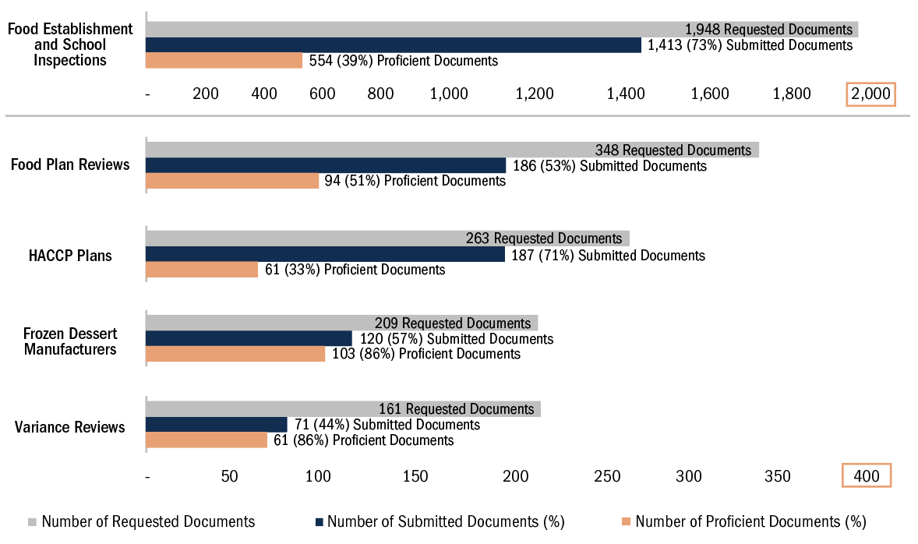
Figure 16 presents the percentage of submitted documents and their proficiency for the Housing category. The most significant issue for Housing overall was the absence of a corrective order or an incomplete one, followed by a missing or insufficient reinspection.

During the review process, it became apparent that not all municipalities utilized formal housing inspection forms. This issue led to the removal of many housing inspection documents from review if they were not in an acceptable format. For example, if a municipality only submitted a corrective order with a list of violations but not a housing inspection form, it was deemed an incorrect document and removed from review. This removal occurred to ensure that the SMEs were scoring the same type of document for each document request, which is crucial to ensure the validity of the proficiency score comparison.

Figure 16: Housing - Number of Documents Requested, Submitted, and Proficient
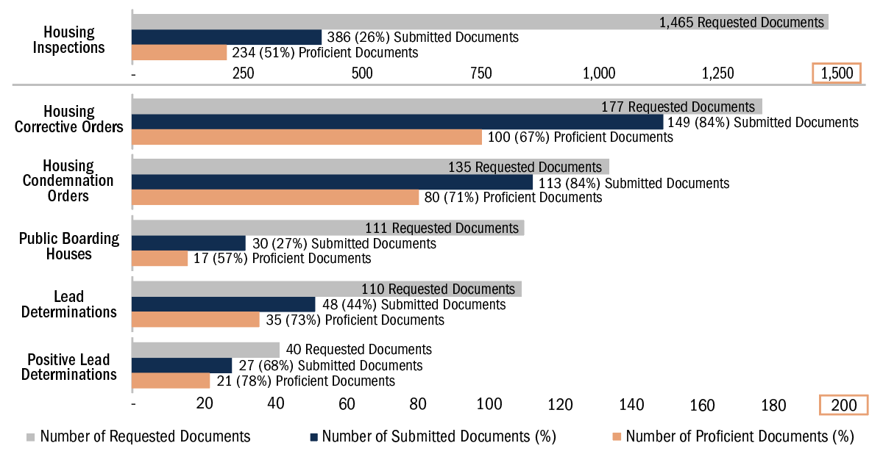

Referencing Figure 17, bathing beaches opening inspections and family type campgrounds tied for the second-lowest proportion of submitted documents across all document types (14%). The low submission rates suggest a capacity and potentially a proficiency issue, although not enough documents were reviewed to determine this distinction. Recreational camps are another area with possible capacity issues as 55% of the requested documents were submitted. Additionally, of the submitted documents, 64% met the proficiency standard with the most frequently reported issue being critical fields being left incomplete on the inspection form. Providing targeted training regarding completing recreational camp inspection forms could help increase the proficiency of these documents.

For swimming pools, 31% of inspections did not meet the standard. Issues that could be addressed with additional training were critical fields left incomplete and missing or insufficient follow-up action. As a result of these issues, SMEs concluded that these inspections could put participants at risk and contribute to illness or hazardous conditions.

Figure 17: Recreation Settings - Number of Documents Requested, Submitted, and Proficient

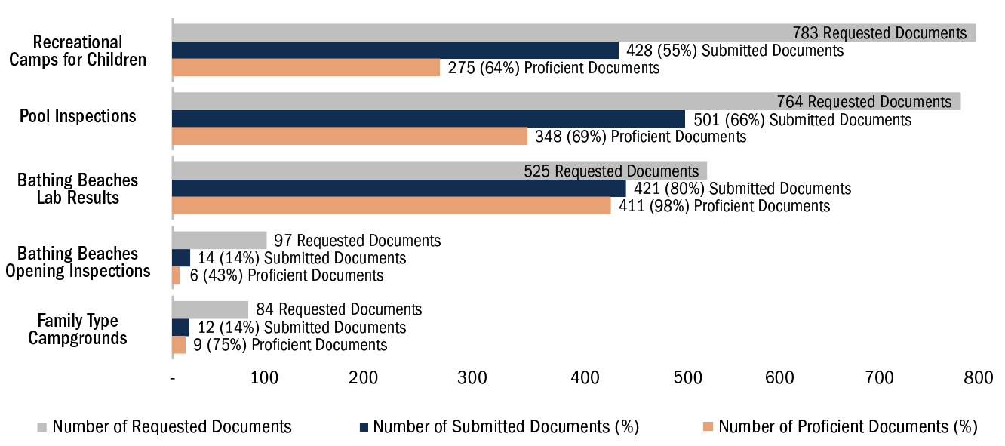

Based on the data in Figure 18, the radiation control program category had a low document submission rate of 41%. Of those documents submitted, 14% met the proficiency standards, largely due to the considerable number of municipalities that failed to submit the required two inspections. The valuable feedback provided by the SMEs highlights that, overall, while the number of inspections did not meet the standards, the submitted documents were completed proficiently, indicating that the issue is a need for staffing more than training.

The nuisances submissions showed more significant variation in the documents reviewed than in any other category. This finding illustrates the need for standard documentation and follow-up procedures that all municipalities could implement.

The community planning review letters achieved a high level of proficiency (95%) because the scoring criteria used to evaluate these documents were less strict. This scoring methodology was influenced by the diverse approaches observed among local health departments in providing feedback on planning projects. For the submitted Tobacco Use Prevention documentation, the majority of the proficiency issues were due to missing or insufficient follow-up action and violations without enforcement or follow-up actions.

Figure 18: Other - Number of Documents Requested, Submitted, and Proficient

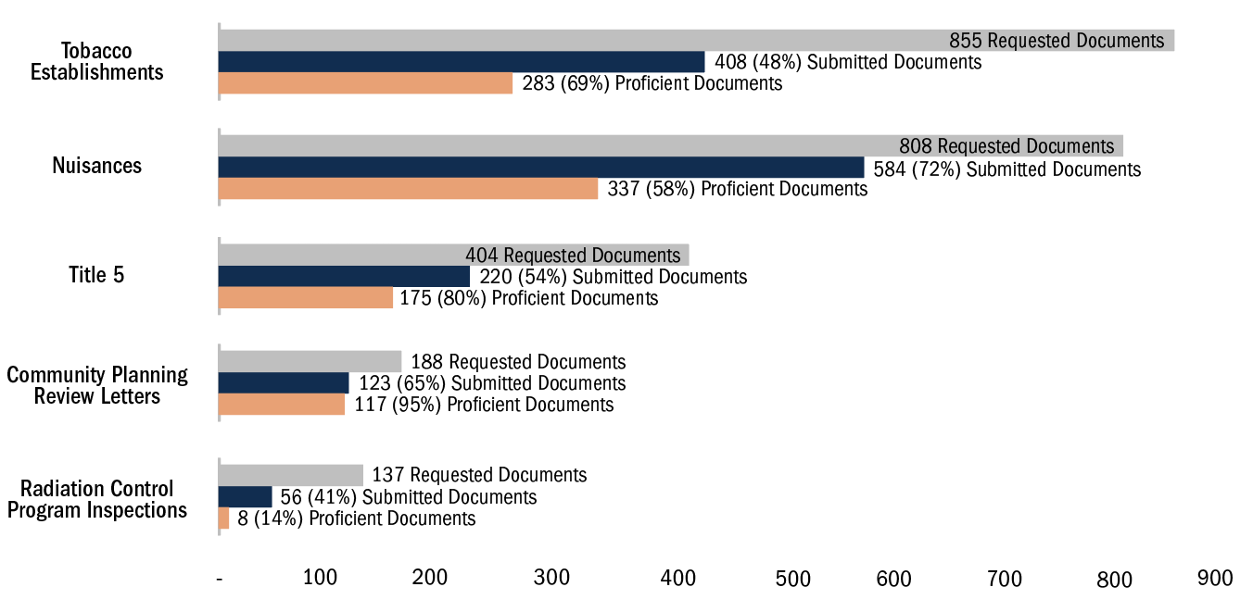

MAVEN Data
In an effort to bolster backup documentation regarding Disease Control and Prevention related Performance Standards, DPH provided municipal-level data representing how quickly immediate and routine infectious disease cases are acknowledged (accepting a case that has been assigned to your municipality) in MAVEN during 2019 and 2021, excluding all COVID-19 cases.

These data were then aggregated for all municipalities in each of the 50 SSAs, with 15 SSAs classified as “Need Improvement,” 32 as “Good,” and three as “Excellent.” For an SSA to receive an “Excellent” classification, all municipalities in that SSA must have received an “Excellent” rating for their follow-up time for both immediate and routine diseases. “Excellent” is the ideal timeframe for immediate and routine follow-up. See Figure 19 for the interpretations of the designations attributed to the SSAs based on their MAVEN acknowledgement time.

Figure 19: 2019 & 2021 SSA MAVEN Acknowledgment Time

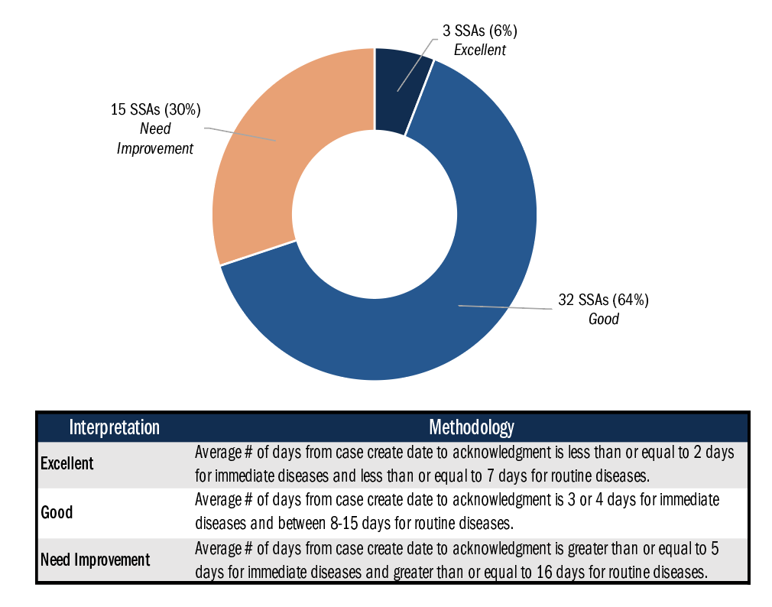

Additional Considerations
It is imperative to acknowledge that the number of documents requested varies greatly from municipality to municipality. For instance, one SSA may have submitted 20 of the total requested documents, of which 10 met the standard (BCA Score: 50%), while another SSA may have submitted 150 of the total requested documents, of which 60 met the standard (BCA Score: 40%).

Regarding the high percentage of documents that were scored as “No document for review/Incorrect document submitted,” we cannot pinpoint the reasons for this discrepancy. We speculate that municipalities did not submit certain requested documents for various reasons, including not having the documents requested, a lack of capacity to locate and upload documents, difficulty locating documents within their current storage systems, or accidental omission of a document when uploading all documents. It is difficult to determine if the absence of document submissions is due to proficiency or capacity issues. Additional qualitative data from LPH is required to understand why municipalities did not submit some requested documents for Phase 3 of the Capacity Assessment.

Themes
During the qualitative review of documents by the SMEs, it was noted that the lack of standardized forms led to significant variation in the documents submitted and the associated proficiency of those documents. A consistent issue across all backup documentation categories, where applicable, appears to be a lack of follow-up or failure to complete the required number of inspections, which suggests a need for increased inspectional staffing across the state. Based on this finding and the work of the SMEs in identifying examples of documents that they believed included all necessary criteria, OLRH, the Field Training Hubs, and other partners are beginning to work on creating a repository of documents that LPH can access. This repository will include examples of “best-in-practice” documents that the SMEs flagged as meeting all the identified criteria. In addition, these documents will help DPH and other partners create standardized forms that can be utilized by all municipalities (e.g., Housing Corrective Order). Furthermore, OLRH is currently developing a unified data collection system that will assist local health departments in meeting the Performance Standards. This system will include various features, including a uniform inspectional software system and document storage capabilities.

Key Findings
- Despite self-reported ability, of the 198/253 municipalities that participated in submitting documents, 34% of submitted documents met the standard, while 22% fell short, and 44% were missing or incorrect. This reveals a significant disparity between municipalities' self-reported capacity to meet Performance Standards and their demonstrated ability to do so.
- Municipalities' non-submission of requested documents appears to be influenced by factors such as document unavailability, limited capacity to locate and upload documents, challenges in accessing documents within current storage systems, or accidental omission during the uploading process. This could point to a need for greater investment in digitization and record-keeping practices within LPH.
- A lack of standardized forms was observed across all document categories. This highlights a need for greater consistency in the content and structure of forms to decrease errors and omissions and increase efficiency.
- The findings indicate a prevailing deficiency in adhering to subsequent procedures or fulfilling the mandated quota of inspections, where applicable. This observed occurrence can be attributed, in all likelihood, to insufficiencies in personnel resources. Nevertheless, further inquiry is imperative to ascertain and validate this correlation.

What’s Next
The data resulting from the Capacity Assessment provides valuable insights into the strengths and areas for improvement within the LPH system. It is evident that there is room for progress as SSAs currently meet an average of 78% of the Performance Standards, which are the minimum statutory and regulatory requirements for local health departments. DPH recognizes that all people in Massachusetts deserve equitable access to the same high-level resources and quality services no matter where they live. This report details where to focus attention to meet that goal and outlines the resources, funding, and programs available to help local health departments.

The data and results from this assessment will be used to strengthen initiatives supporting local public health and to inform future planning for OLRH. These strategies include using data to inform action, setting measurable goals, expanding and strengthening the workforce, and collaborating with internal and external partners, all while maintaining equity as a central component in all areas of work.

Shared Services Infrastructure
The Public Health Excellence Shared Services Grant Program is an essential component in building and maintaining an equitable, state-of-the-art local public health system. This grant program is an ongoing initiative that provides the infrastructure for municipalities to work together to meet the Performance Standards.

Moving Data to Action
SSA-specific Capacity Assessment results and their data-driven recommendations are currently being used to inform workplans for Public Health Excellence Shared Services grantees. Beginning in February of 2023, OLRH and BME Strategies hosted individual meetings with all 50 SSAs over eight weeks to present and discuss each SSA’s assessment results. This resulted in approximately 75 hours of dynamic and complex conversations.

The 2019 Blueprint identified that the lack of data at the LPH level is a massive barrier to determining areas for targeted improvement. The Performance Standards provide the first-ever opportunity to have a set of standards, and the Capacity Assessment provides the opportunity to measure LPH’s current ability to meet those standards. OLRH will use these baseline measurements and quality improvement (QI) best practices to identify areas of opportunity and create measurable pathways of achievement.

Increased Funding
Within the past few years, DPH has made a substantial investment in local public health, providing more than $23M to over 300 communities since the PHE Shared Services Grant Program was first launched in FY21. An anticipated multi-million-dollar expansion of the program will be rolled out in FY24 as well. Every SSA will be level-funded for FY24, and each SSA will be eligible for additional funding. This additional funding will be distributed based on a comprehensive funding mechanism informed by the results of the Capacity Assessment, population size, and level of need utilizing the Community Resilience Estimate (CRE) dataset. As with this assessment, future Capacity Assessments will inform funding levels for the PHE Shared Services Grant Program.

Local Public Health Data System
OLRH is currently developing a data system that will meet the complex needs of LPH and significantly expand the consistency, reliability, and availability of local public health data in practice. The initial rounds of the Capacity Assessment will help to inform what data will be needed to develop a fully comprehensive system. Future Capacity Assessments will be able to draw information directly from the data system, alleviating the burden from LPH.

Workforce Development
OLRH is dedicated to growing and strengthening the public health workforce. The Office has a multi-pronged approach to pipeline, recruitment, and retention efforts. This includes the Academic Public Health Corps. This paid internship program annually teaches over 100 community college, undergraduate, and graduate students about the unique world of Massachusetts LPH. The students complete 1,600 hours of local public health projects and professional development and gain insight into what LPH jobs entail.

OLRH is also expanding classroom and on-site training for local public health professionals, including a model for ten Field Training Hubs that offer hands-on training for environmental health inspections. Data from the Capacity Assessment will be used to determine which trainings are most needed in specific areas across the state.

Partner Engagement
OLRH is actively working to better engage existing and new partners, including municipal leaders and municipal inspectional services departments, to help better communicate and advocate for the role and needs of LPH. OLRH is also conducting more frequent outreach to LPH, including bimonthly webinars and hosting office hours where program-specific staff are available to answer questions from LPH partners.

Conclusion
This Capacity Assessment is only the beginning. Baseline data are useful to make a path toward setting and achieving goals and continuing to measure the work of LPH. The second round of the Capacity Assessment will begin in the Fall of 2024. OLRH will work closely with internal and external partners to measure progress made, and identify the LPH readiness to elevate the Performance Standards and move closer toward meeting the Foundational Public Health Services. OLRH will ensure all areas of the multi-pronged approach to transforming public health are rooted in sound QI best practices and processes.

The Capacity Assessment is limited in telling the story of all that LPH does. This effort was a first step in quantifying and increasing awareness of the incredibly varied public health services that local health departments are called upon to deliver with minimal funding and staff. The scope of this baseline assessment was intentionally limited to assess SSAs’ ability to meet existing required statutes and regulations, although LPH provides many services beyond these minimum requirements.

Future rounds of the Capacity Assessment will strive to incorporate other foundational services provided by LPH, such as public health nursing, substance use prevention and recovery services, emergency preparedness, mental health, community support, and more. This expansion aims to paint a more comprehensive and precise picture of the extensive work carried out by LPH, which often goes unnoticed. The development of the Performance Standards and the process of completing the Capacity Assessment have already begun to raise awareness of this work, and efforts to increase this awareness must continue.

DPH actively supports local public health initiatives statewide through diverse initiatives and collaborations across bureaus and offices. These include a long-standing relationship with the Massachusetts Tobacco Cessation and Prevention Program and Mass in Motion. Additionally, there are added communicable disease surveillance and control initiatives and a new position, Senior Epidemiology Advisor to Local Health, geared directly at providing a link for LPH to epidemiological resources and support. These are just a few examples of how DPH as a whole is committed to working alongside local public health.

OLRH recognizes and greatly appreciates the amount of time and effort that LPH invested in the various phases of this assessment. Many LPH members equally expressed their appreciation for the work that OLRH is doing with the Capacity Assessment:
- “Really appreciate this. The Capacity Assessment itself was a lot of work, but this is valuable feedback and ideas. Not just useful for our group, but also useful for me to take back to the town and use all this data. Very much appreciated.”
- “These recommendations resonate with me coming out of this foggy haze of post-COVID and trying to figure out where to go next now that we have people’s ears. I have my budget meeting tomorrow and will go in with this data-driven information with your hands on my shoulders.”
- “We appreciate that the State recognizes how much is on Local Public Healths’ shoulders and is starting to address it.”
We at OLRH hope that this report will serve as a starting place on which we can work in tandem with LPH to build, improve, and measure the progress of LPH to provide essential public health services in an equitable way, to all people in Massachusetts. The local public health workforce is remarkably dedicated and resilient and demonstrates extraordinary commitment to their residents. We must ensure they are supported and uplifted with the necessary resources, funding, and programs to help all local health departments across the Commonwealth receive the necessary support to provide the breadth of services our communities need and deserve.

Acknowledgments
We would like to acknowledge the pivotal role played by the Legislature and the Massachusetts Municipal Association in the formation of the Special Commission on Local and Regional Public Health, the subsequent passage of the legislation to strengthen the local public health system, and the utilization of American Rescue Plan Act (ARPA) funds.

These initiatives have been vital in laying the groundwork for a stronger and more effective public health infrastructure, allowing us to address the evolving needs of municipalities with greater efficiency and effectiveness. Their commitment and countless hours of effort have been instrumental in fostering the advancement and sustainability of local public health across the Commonwealth.

Thank you to our 319 municipal leaders for acknowledging the strain their health department staff were under before, during, and after the COVID-19 pandemic and agreeing to participate in an SSA, as well as attending the Capacity Assessment data review sessions to explore ways to provide their residents with public health services in a more equitably and efficiently. Without their leadership, the shared services program and this capacity improvement initiative would not be possible.
We want to thank our statewide partners including the Coalition for Local Public Health (Massachusetts Association of Health Boards, Massachusetts Association of Public Health Nurses, Massachusetts Environmental Health Association, Massachusetts Health Officers Association, Massachusetts Public Health Association, Western Massachusetts Public Health Association, and the Massachusetts Large Cities Health Coalition).

Lastly, we would like to express our gratitude to all the individuals involved in local public health in Massachusetts for their invaluable contributions to this Capacity Assessment process. Your unwavering commitment and collaborative efforts have greatly contributed to the success of this assessment, and we are truly grateful for your support.
Office of Local and Regional Health (OLRH)
Aimee Petrosky, Director of Performance Standards and Data Systems, aimee.petrosky@mass.gov
Michelle Surdyk, CDC Foundation Program Manager, michelle.k.surdyk@mass.gov

Thank you to all other OLRH staff that contributed to this Capacity Assessment process.

DPH Intra-Agency Working Group
Thank you to the programs and bureaus across DPH that interact with local public health on a daily basis, including the Office of Local and Regional Health, Office of Population Health, Office of Health Equity, Bureau of Community Health and Prevention, Bureau of Climate and Environmental Health, Bureau of Infectious Disease and Laboratory Sciences, Bureau of Substance Addiction Services, Office of Preparedness and Emergency Management, Registry of Vital Records and Statistics, Bureau of Family Health and Nutrition, Bureau of Health Care Safety and Quality, and Bureau of Health Professions Licensure.

BME Strategies
Bryan Murphy-Eustis, Executive Director, beustis@bmestrategies.com
Alyssa Loskill, Public Health Data Analyst Consultant, aloskill@bmestrategies.com
Jessica Sorcher, Public Health Associate Consultant, jsorcher@bmestrategies.com
Rebekah McCosby, Public Health Associate Consultant, rmccosby@bmestrategies.com
Karen Contador, Associate Principal, kcontador@bmestrategies.com
Anna Wielgosz, Emergency Preparedness Consultant, awielgosz@bmestrategies.com
Meghan Russell, Public Health Associate Consultant, mrussell@bmestrategies.com

Massachusetts Health Officers Association (MHOA)
Teresa Wood Kett, Executive Director, tkett@mhoa.com
Dawn Sibor, Consultant & Former MHOA Executive Director, dsibor@mhoa.com

Public Consulting Group (PCG)
Tim Yaecker, Senior Consultant, tyaecker@pcgus.com
Lillian Shirley, Public Health Systems Consultant, lshirley@pcgus.com
Sophie Brown, Business Analyst Human Services, sopbrown@pcgus.com

Subject Matter Experts (SMEs)
Amanda Stone
Bri Dupras
Brian Chapdelaine
Cathy Cardinale
Doug Halley
Doug Kress
Glen Ayers
Jim White
Lynn Mulkeen
Nancy Ellis-Ice
Pat Maloney
Paul Halfmann
Robin Chapell
Ruth Clay
Steve Ward
Susan Sawyer
Terry Hayes
Valerie Nelson

Appendix
Appendix A - Performance Standards
Appendix B - Public Health Excellence Shared Services Grant Program Shared Services Arrangements
Appendix C - Roadmap to Developing Sharing Initiatives in Public Health
Appendix D - Baseline Capacity Assessment Survey Questions & Groupings
Appendix E - Workforce Assessment Survey Questions
Appendix F - Field Training Hub List
Appendix G - Local Public Health Institute

State Office of Rural Health Rural Definition
DeSalvo, K., Parekh, A., Hoagland, G. W., Dilley, A., Kaiman, S., Hines, M., & Levi, J. (2019). Developing a Financing System to Support Public Health Infrastructure. American Journal of Public Health, 109(10), 1358–1361. https://doi.org/10.2105/AJPH.2019.305214

