2022
Massachusetts Department of Public Health
Bureau of Environmental Health
Environmental Toxicology Program
250 Washington Street
Boston, MA 02108
Email : dph-beach@mass.gov
Phone: (617) 624-5757

Massachusetts Beach Testing Results:
Annual Report
Nahant Beach, Nahant, MA
Photo by Logan Bailey
Executive Summary
Swimming is one of the most popular recreational activities in Massachusetts (EOEEA, 2017), with over 111 million individual trips to coastal beaches annually (EOEEA, 2007). Each year, the Massachusetts Department of Public Health (DPH), Bureau of Environmental Health’s Environmental Toxicology Program collects beach water quality data from local health departments and the Massachusetts Department of Conservation and Recreation. This report provides a description and summary of that information.
- Water quality: In 2022, a total of 16,124 water samples were collected from 592 marine and 576 freshwater beach sampling locations. These locations represent 569 marine and 529 freshwater beaches statewide, with 100% of marine and 99% of freshwater beach communities reporting water quality information to DPH. Approximately 5.3% and 4.6% of samples exceeded the Massachusetts bacterial water quality standards for marine and freshwater beaches, respectively, higher than in previous years. While exceedances were slightly above average in 2022, the overall low historical exceedance rates indicate that Massachusetts beaches generally have high water quality. Elevated bacteria accounted for 88% of beach posting days for poor water quality; additional reasons for notifications included cyanobacterial harmful algae blooms, rainfall (typically associated with elevated bacteria), and combined sewer overflows.

- Field data: In 2022, a majority (99%) of water samples submitted to DPH had accompanying field data. Recent rainfall was identified as the most important factor contributing to elevated bacteria levels at recreational waterbodies. As in previous years, the exceedance rate was greatest in the 24 hours following rainfall. Pollution sources, particularly the presence of larger numbers of birds at marine and freshwater beaches, were also associated with higher levels of bacteria.

- Public notification: DPH’s marine beaches website (https://ma-beaches.healthinspections.us) provides near real-time information on bacteria levels at public marine beaches during the beach season, as well as information on historical bacteria levels. In 2022, approximately 9,559 users visited the website with peak usage occurring during the month of July. Individuals are also notified of unsafe conditions at beaches by physical signage that beach operators are required to post. In 2022, 99% of marine and 92% of freshwater beaches were in compliance with the public notification requirements.

Introduction
Health risks to swimmers associated with poor water quality have been documented in numerous studies (Marion et al., 2010; Wade et al., 2003). Beachgoers may be exposed to pathogens through recreational activities in and around polluted waterbodies (Hlavsa et al., 2015). In the United States, most swimming-associated illnesses are caused by a variety of pathogens associated with fecal contamination (Cabelli et al., 1982; USEPA, 2012). Fecal matter can enter beach water in a variety of ways: sewage treatment system failures, combined sewer overflows, discharge of sewage by boats, re-suspension of sediments, and rainfall with resulting surface runoff (Galfi et al., 2016; Rodrigues et al., 2016).

To minimize swimming-associated illness and injury and to notify the public about the quality of beach water, DPH regulations require regular water quality monitoring and public notification of unsafe conditions. All public and semi-public bathing beaches in Massachusetts are monitored for fecal indicator bacteria (FIB), and on occasion, harmful algae. Monitoring occurs during the beach season which generally begins when the school year finishes in mid-June and ends during the weekend of Labor Day.

DPH adopted the U.S. Environmental Protection Agency (USEPA) criteria for enterococci and E. coli in marine- and fresh-waters in 2001. These criteria consist of both a single sample and geometric mean (geomean) value reported as colony forming units per 100 milliliters of water (CFU/100 mL) (see Table 1). When beach water exceeds these water quality standards, DPH requires that the beach be posted with a notice alerting the public to the possible risk of swimming.

At a majority of beaches in Massachusetts, water quality is considered to be unacceptable when two samples collected on consecutive days exceed the water quality standards. This approach is consistent with DPH regulations and has helped to minimize the impact of beach closures on vulnerable socio-economic populations, whose local beach may be the only accessible means of recreation during the summer.

Some of the highest use beaches operated by the state are in the urban areas of Boston, Lynn, Quincy, and Revere. Beaches with a history of multi-day elevated bacteria levels are required to post after a single exceedance. Posting is also required when the geomean of the five most recent samples exceeds the geomean standard.

Beach Type | Indicator | Single Sample | Geomean
Marine | Enterococci | >104 | >35
Freshwater | Enterococci | >61 | >33
 | E. coli | >235 | >126
Table 1. DPH recreational water quality criteria (CFU/100 mL)

In addition to water samples, field data such as days since rainfall and potential pollution sources are required to be recorded at the time of sample collection. Field data help facilitate the interpretation of bacteria data and can improve the understanding of water quality at the local and state level.

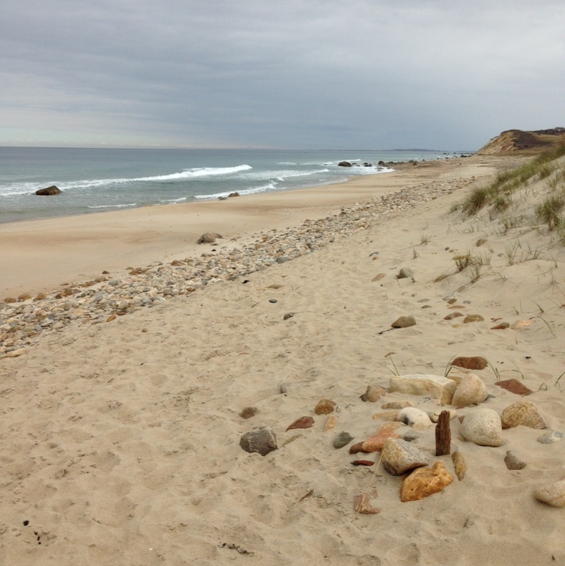
Philbin Beach, Aquinnah, MA
Photo by Irena Draksic

Water Quality
Marine beach exceedances During the 2022 beach season, 8,463 samples were collected and analyzed from 592 marine sampling locations in the 61 communities with marine beaches. Of these 592 locations, 195 (33%) had at least one bacterial exceedance. A total of 662 out of the 8,463 samples exceeded the 104 CFU/100 mL standard bringing the percentage of exceedances for marine waters to 5.3%. The 2022 exceedance rate is slightly higher than the historic average (5.1%) but represents a sharp decline from the 7.9% exceedance rate recorded in 2021 (Figure 1).
Figure 1. Marine beach exceedance rate (2001 – 2022)
Freshwater beach exceedances During the 2022 beach season, 7,661 samples from 576 freshwater sampling locations were collected and analyzed for the approved fecal indicator bacteria. Most freshwater beaches (90%) used E. coli as the indicator. Among the 576 freshwater locations, 148 (26%) in the 176 communities reporting beach data had at least one bacterial exceedance. A total of 356 out of 7,661 samples (4.6%) exceeded the single sample standard, which represents an exceedance rate slightly above average the historic average exceedance rate of 4.1% (Figure 2).

Figure 2. Freshwater beach exceedance rate (2001 – 2022)
Posting beaches In 2022, beaches were posted for 2,690 days, advising individuals to not swim in the water. The majority of posting days were due to the exceedance or expected exceedance (e.g., rainfall) of a water quality standard. For marine beaches, there were 1,079 total posting days due to either elevated bacteria (97% of days), rainfall (1%), or combined sewer overflows (2%) (Figure 3). For freshwater beaches (Figure 3), there were 1,611 posting days, 82% of which were due to elevated bacteria, 16% due to cyanobacterial harmful algae blooms, and 2 % due to other reasons, such as chemical treatments being applied to the waterbody.

Figure 3. Posting details for marine and freshwater beaches in 2022

Rainfall Rainfall is recognized as one of the major drivers of bacterial exceedances in beach water (Harder-Lauridsen et al., 2013). Historically, overall exceedances at both marine and freshwater beaches generally rise and fall with the total amount of summer rainfall, with some exceptions. In 2022, this pattern was observed in both marine and freshwater results (Figure 4). The rainfall data were obtained from the National Oceanic and Atmospheric Administration (NOAA, 2022). Data sets from two coastal communities, Boston and Chatham, were used to represent monthly rainfall amounts at marine beaches; for rainfall at freshwater beaches data sets from Amherst and Ashburnham, along with those from Boston and Chatham, were used to represent monthly rainfall across the state.

Figure 4. The historical relationship between rainfall amounts and exceedance rates at (A) marine and (B) freshwater beaches
Occurrences of exceedances will typically drop as time between rainfall and sample collection increases. For both marine and freshwater beaches in 2022, samples collected in the 24 hours following rainfall were most likely to exceed the state standard (Figure 5).

Figure 5. Relationship between the exceedance rate and days since rainfall in 2022

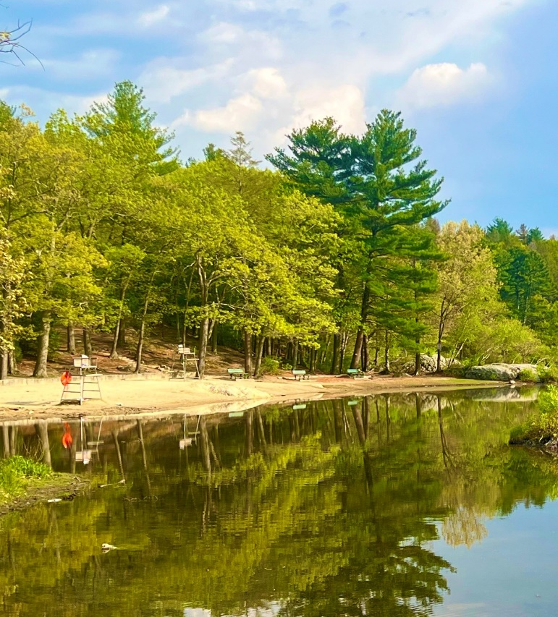
Breakheart Reservation, Saugus, MA
Photo by Logan Bailey

Potential pollution sources Starting in 2017, beach operators were asked to report the number of swimmers, birds, and dogs present in the water when a sample was collected. Figure 6 shows the mean bacteria levels of samples at marine and freshwater beach locations in 2022 compared to the number of reported swimmers, birds, and dogs. The data indicate that the presence of larger numbers of birds was associated with increases in bacteria levels at marine and freshwater beaches. The very high mean bacterial level when more than ten birds were present at freshwater beaches is a result of one outlier sample (>70,000 cfu/100 ml). No clear relationship was observed between bacteria levels and the number of humans or dogs present. Enterococci results at freshwater beaches were not included in this analysis due to the low number of samples.

Figure 6. Mean bacteria levels and numbers of birds, dogs, and humans at marine (top) and freshwater (bottom) beaches in 2022

Environmental Justice Communities Beach access and water quality are particularly important in environmental justice (EJ) communities, as these communities are disproportionally affected by the increased presence of environmental hazards and poor health outcomes (DPH, 2017). For example, EJ communities have high population densities, low income, and high levels of non-vehicle ownership. This means that more individuals in these communities, compared to other areas in the state, will tend to frequent a local public beach for cooling off or enjoying summer recreation. As rainfall is a significant factor in flushing enteric bacteria into beach water, any increase in rain near a population-dense EJ area will lead to an increase in exceedances.
Town EJ population data from the Massachusetts Executive Office of Energy and Environmental Affairs (EOEEA 2020) were used to evaluate water quality of beaches located near EJ communities. In 2022, beaches located in municipalities with more than 25% of the population living in EJ areas had a higher exceedance rate than other beaches (Figure 7).

Figure 7. Relationship between beach exceedance rate and municipal EJ population data
Public Notification
Beach website The DPH beach monitoring website (https://ma-beaches.healthinspections.us/) provides the public with up-to-date marine beach testing and posting information and presents the data in an easy-to-use format. In 2022, 9,559 users visited the website during the beach season (this includes both new and returning users). An analysis of weekly usage data demonstrated a sudden increase in the number of users at the halfway point of the beach season (Figure 8), with a maximum number of users (n=1,628) occurring in the week of July 18th. For two weeks during August 2022, the website was unavailable to the public due to outages with the website server.

Figure 8. Number of DPH marine beach website users per week during the 2022 beach season

Beach postings When water quality standards are exceeded or other safety concerns exist, beach operators are required to post signage at the beach advising individuals of the hazard and recommending they stay out of the water. This is an essential part of the public notification system. Marine and freshwater beaches were posted properly 99% and 92% of the time, respectively.

Conclusions
In 2022, the exceedance rates at both marine and freshwater beaches were slightly above the historical average. However, average historical exceedance rates of 5.1% or less indicate that the state has beaches with generally high water quality. Elevated bacteria levels, rainfall events, and cyanobacterial harmful algal blooms were the primary drivers of beach posting days for poor water quality. Public notification of marine results and postings via DPH’s marine beaches website continued to be a highly utilized means of communicating with the public.

Acknowledgements
This work was partially supported by a US EPA Beaches Environmental Assessment and Coastal Health grant. DPH received assistance from local, regional, and state partners, including Massachusetts boards of health, regional health networks, and the Massachusetts Department of Conservation and Recreation, to ensure that bathing beaches were tested, and data was submitted appropriately.

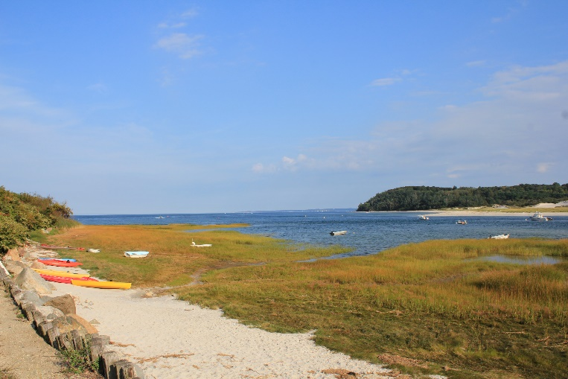
Little Neck Beach, Ipswich, MA
Photo by Michael Beattie

References
Cabelli, V.J., Dufour, A.P., McCabe, L.J., Levin, M.A. 1982. Swimming-associated gastroenteritis and water quality. American Journal of Epidemiology 115, 606-616.

Galfi, H., Österlund, H., Marsalek, J., Viklander, M. 2016. Indicator bacteria and associated water quality constituents in stormwater and snowmelt from four urban catchments. Journal of Hydrology 539, 125-140.

Harder-Lauridsen, N.M., Kuhn, K.G., Erichsen, A.C., Mølbak, K., Ethelberg, S. 2013. Gastrointestinal Illness among Triathletes Swimming in Non-Polluted versus Polluted Seawater Affected by Heavy Rainfall, Denmark, 2010-2011. PLOS ONE 8, e78371.
Hlavsa, M., Roberts, V., Kahler, A., Hilborn, E., Mecher, T., Beach, M., Wade, T., Yoder, J. 2015. Outbreaks of Illness Associated with Recreational Water - United States, 2011–2012. Morbidity and Mortality Weekly Report, Center for Disease Control and Prevention 64, 668-672.

Marion, J.W., Lee, J., Lemeshow, S., Buckley, T.J. 2010. Association of gastrointestinal illness and recreational water exposure at an inland U.S. beach. Water Research 44, 4796-4804.

MA Department of Public Health (DPH). October 2017. Massachusetts State Health Assessment. https://www.mass.gov/doc/2017-massachusetts-state-health-assessment/download

MA Executive Office of Energy and Environmental Affairs (EOEEA). 2007. Massachusetts Outdoors 2006: Statewide Comprehensive Outdoor Recreation Plan. http://archives.lib.state.ma.us/handle/2452/335705

MA Executive Office of Energy and Environmental Affairs (EOEEA). 2017. Massachusetts Statewide Comprehensive Outdoor Recreation Plan 2017.
https://www.mass.gov/files/massachusetts-scorp-2017-for-submission.pdf

MA Executive Office of Energy and Environmental Affairs (EOEEA). 2021. Massachusetts Cities & Towns with Environmental Justice Populations.
https://www.mass.gov/doc/massachusetts-cities-towns-with-environmental-justice-populations

National Oceanic and Atmospheric Administration (NOAA). 2021. National Weather Service NOWData-Online Weather Data. https://w2.weather.gov/climate/xmacis.php?wfo=box

Rodrigues, V.F.V., Rivera, I.N.G., Lim, K.-Y., Jiang, S.C. 2016. Detection and risk assessment of diarrheagenic E. coli in recreational beaches of Brazil. Marine Pollution Bulletin 109, 163-170

U.S. Environmental Protection Agency (US EPA), 2012. 2012 Recreational Water Quality Criteria USEPA 820-F-12-058, Office of Water.

Wade, T.J., Pai, N., Eisenberg, J.N., Colford, J.M.J. 2003. Do U.S. Environmental Protection Agency Water Quality Guidelines for Recreational Waters Prevent Gastrointestinal Illness? A Systematic Review and Meta-analysis. Environmental Health Perspectives 111.

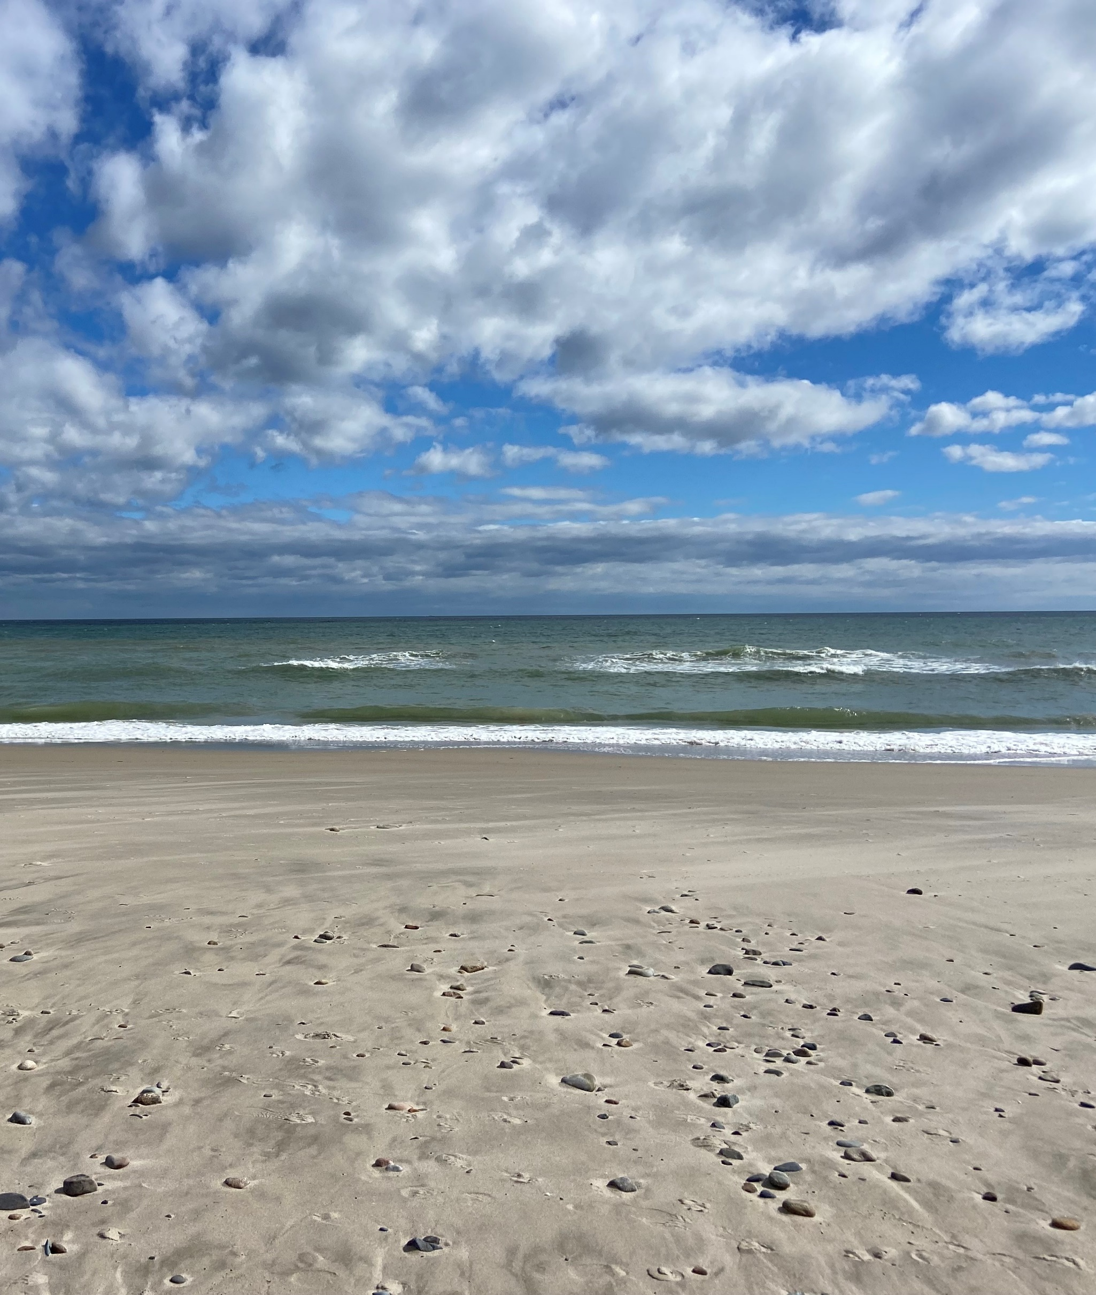

For more information, please visit:
DPH Beaches website: http://www.mass.gov/beaches

DPH Algae website: http://www.mass.gov/dph/algae

Or contact:
Massachusetts Department of Public Health
Bureau of Environmental Health
Environmental Toxicology Program
250 Washington Street
Boston, MA 02108
Email: dph-beach@mass.gov
Phone: (617) 624-5757
Fax: (617) 624-5183

Rexhame Beach, Marshfield, MA
Photo by Mandy McNeill

