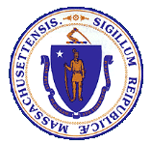

Health Information Technology Council
Report to the Massachusetts Legislature

Reporting Period: January 2022 to December 2022

Submitted in February 2023
by the Health Information Technology Council

Table of Contents
Executive Summary 1
A. Introduction 2
B. Mass HIway Operations 3
B.1 Connection Requirement 3
B.2 Attestation Data 5
C. Mass HIway Clinical Gateway 5
C.1 CG Background 6
C.2 CG Maintenance and Enhancement Activities 8
D. Mass HIway Account Management 9
D.1 Provider Directory, PD API and DirectTrust 10
D.2 Provider Engagement 10
E. Statewide Event Notification Service Framework 11
E.1 ENS Program 2022 Activity Update 12
E.2 ENS/ADT Landscape Improvement Efforts 13
F. Federal Developments 14
F.1 ONC Trusted Exchange Framework and Common Agreement (TEFCA) 15
F.2 CMS Advancing Interoperability & Improving Prior Authorization Processes 15
G. In Flight Initiatives 16
H. POLST Program 16
H.1 ePOLST Registry 2022 Update 17
I. Clinical Gateway API & FHIR Integration 19
I.1 CG API-FHIR Project Background 19
I.2 CG API-FHIR 2022 Technical Update 19
I.3 CG API-FHIR 2022 Provider Engagement Update 20
J. Budget 21
J.1 Background & Funding Rates 21
J.2 Budget Management 22
K. Conclusion 22

Executive Summary
The Massachusetts Health Information Highway (Mass HIway) is a health information exchange program within the Executive Office of Health and Human Services (EOHHS) and is advised by the Health Information Technology (HIT) Council. The HIT Council is composed of consumer, provider, legal, policy, and technology stakeholders.
The Mass HIway's main objective is to promote and coordinate health information exchange (HIE) throughout Massachusetts. To achieve this, the Mass HIway utilizes various policy and technical tools and provides a range of services and resources that help care providers and healthcare stakeholders in the state to utilize health information exchange. The Mass HIway has over 1,400 participants and processes over 36 million transactions per month which enable public health reporting, COVID-19 queries, provider-to-provider exchanges, and quality data reporting.
Below are the Mass HIway program activity highlights for 2022:
- The Mass HIway continued to operate and support the use of Direct Messaging and the Provider Directory to facilitate care coordination exchanges and enable Public Health Reporting through the Clinical Gateway to seven of the state's public health registries.
- The Mass HIway played a key role in the state's COVID-19 response by enabling providers to electronically transmit data to the Department of Public Health and State Public Health Laboratory systems and allowing payers and large provider groups access to retrieve patient vaccination status.
- The Statewide Event Notification Service (ENS) Framework is fully operational with the certified ENS vendors collecting admission, discharge and transfer (ADT) messages from all acute care hospitals within the state and sharing these messages with each other’s subscribers.
- The Mass HIway continued engagement on a cross-agency initiative to develop an electronic registry for Portable Orders for Life Sustaining Treatment (POLST) forms, which captures patient preferences for end-of-life care. An ePOLST Registry Request for Responses (RFR) to procure a statewide registry was developed, approved by CMS and officially posted in January 2023.
- The Mass HIway team successfully migrated the Clinical Gateway nodes and Mass HIway business applications into a consolidated environment hosted by Amazon Web Services. And, the development of new application programming interface (API) capabilities for the Clinical Gateway were completed and participant onboarding was initiated.
- The Mass HIway provider engagement activities focused on improving the health information exchange environment, implementing new, enhanced connections to public health registries, and increasing interoperability among healthcare stakeholders.
- Finally, the Mass HIway continues to explore policy and service needs to further enhance interoperability and health information exchange in the Commonwealth.
EOHHS has a multi-disciplinary and dedicated team to manage the policy, business, operational and strategic direction of the Mass HIway and other technology programming to support EOHHS objectives. EOHHS currently utilizes a combination of staff and vendor contracts to operate and maintain the Mass HIway programs and Clinical Gateway services.
EOHHS and the Mass HIway would like to acknowledge our partners, Orion Health and the Massachusetts eHealth Institute (MeHI), for their valuable contributions and efforts to support the Mass HIway operations and other EOHHS initiatives.

Introduction
Pursuant to M.G.L. c. 118I, the Massachusetts Legislature authorized the Executive Office of Health and Human Services (EOHHS) to coordinate and promote the development of a statewide health information exchange (HIE). EOHHS created the Massachusetts Health Information Highway (Mass HIway) program to embody those HIE coordination and promotion efforts. The same enabling statute also created the Health Information Technology Council (HIT Council) to serve as an advisory body to EOHHS and the Mass HIway program.
This HIT Council Report to the Massachusetts Legislature fulfills the statutory requirement under M.G.L. Chapter 118I, Section 15, for the HIT Council to file an annual report that: (a) describes the activities of the HIT Council; and (b) describes the progress made in developing the statewide health information exchange and recommending legislative action, if deemed appropriate.
This report provides an update on notable accomplishments and activities of the HIT Council related to the state’s HIE that occurred between January 1, 2022 and December 31, 2022. This report follows the HIT Council’s previous report, which covered activities through December 31, 2021.
Under the advisement of the HIT Council, the Mass HIway promotes the adoption of HIE through a variety of policy and technical levers. The Mass HIway’s activities aim to increase the Commonwealth’s adoption of health information exchange and technology to improve care coordination, quality, patient satisfaction, and public health reporting, while containing costs. Currently, it operates a Direct Messaging network (HIway Direct Messaging) and Provider Directory to enable the exchange of vital health data electronically in a secure and seamless fashion, regardless of differences in affiliation, location, or technology across users. The Mass HIway operates a Clinical Gateway designed to accept and transform Public Health Reporting data submitted by providers to seven (7) of the state’s public health registries. Additionally, the Mass HIway facilitates a Statewide Event Notification Service (ENS) Framework, leveraging existing market-based solutions to deliver admit, discharge and transfer notifications to providers throughout the Commonwealth.

Mass HIway Operations
In 2022, the Mass HIway implemented important developments to the technical infrastructure to improve public health reporting access and data processing and various engagement activities to address provider health information exchange needs and improve utilization. The Mass HIway maintained critical operations and continued to monitor and support connections, enhance services and improve programs, such as the Statewide ENS Framework.

Connection Requirement
As set forth in M.G.L. Chapter 118I, Section 7, and as detailed in the Mass HIway Regulations (101 CMR 20.00), certain healthcare providers in the Commonwealth are required to connect to and utilize HIway Direct Messaging. As outlined in Figure 1 below, this requirement for each provider is phased in over a four-year period, which is intended to incrementally promote the use of HIway Direct Messaging for provider-to-provider communications and to achieve bi-directional exchange of health information.
Every provider organization subject to the connection requirement is required to submit an annual attestation indicating how it met the annual requirement to connect to HIway Direct Messaging. If a provider organization could not fulfill the connection requirement, it was required to submit a Health Information Exchange Exception Form stating why it did not meet the connection requirement and explaining the organization’s plans to comply prospectively.
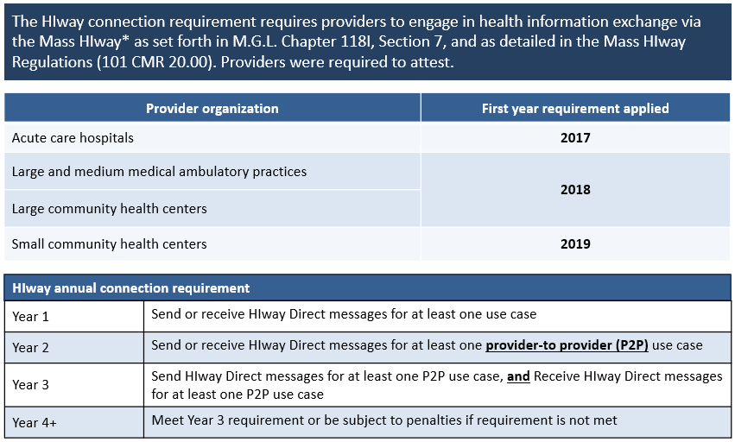
Figure-1
*Through sub-regulatory guidance the Mass HIway accepts DirectTrust HISP-to-HISP (Health Information Service Provider) exchange as an additional method to meet the HIway connection requirement.
In 2022, the timetable for the HIway connection requirement had been met for the regulated organizations (Acute care hospitals, Community health centers, Medical ambulatory practices). As of July 31, 2022, consistent with the timetable set forth in 101 CMR 20.09, providers were no longer required to submit an annual attestation under the regulations. Over 550 Provider Organizations have completed the attestation process over the last five years and many providers have integrated direct messaging within their daily workflows. It is expected that use of direct messaging will continue to persist for the foreseeable future as many providers rely upon it every day to coordinate patient care.
The Mass HIway will continue to monitor and report on the utilization of direct messaging. Changes in transaction volume will be reviewed and any notable observations and findings will be reported to the HIT Council. Any future regulations for new use cases or new provider type connection requirements will include a new attestation web-form and process.

Attestation Data
Attestations received for the final reporting year (CY 2021) surpassed submissions received in previous years. More provider organizations are meeting the Mass HIway connection requirement through DirectTrust HISP-to-HISP exchanges. As a result, more provider organizations submitted attestation forms and fewer organizations requested exceptions.
The graphic below shows the number of exceptions received by year for each of the regulated organization groups. The table below indicates the overall numbers of attestations and exceptions by year and group.
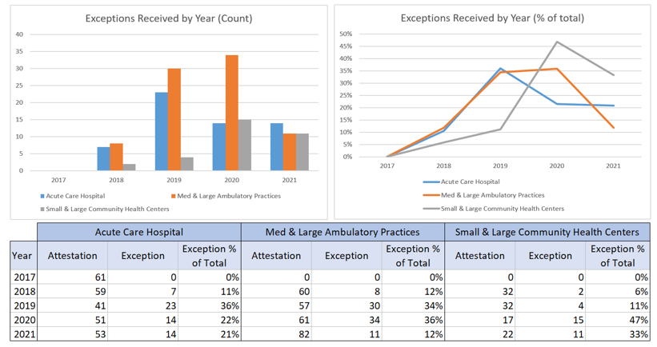
Figure-2

Mass HIway Clinical Gateway
The Mass HIway development team completed merging the Clinical Gateway (CG) nodes into a single, consolidated application. The core application and a suite of supporting applications and tools were migrated to Amazon Web Services (AWS) cloud-based servers from 2020-2022. All critical components and changes were addressed as needed, and additional functional changes and enhancements requested by the backend application teams were prioritized and have been incorporated into the new Consolidated Clinical Gateway application (CCG).
The Mass HIway continued to support the state’s COVID-19 response and data needs, operating technology which enables providers to electronically transmit data to the Department of Public Health (DPH) and the State Public Health Laboratory (State Lab) systems through Mass HIway Direct Messaging and the Clinical Gateway Nodes (CG Nodes). Data submitted via the Syndromic Surveillance (Syndromic) and Electronic Lab Reporting (ELR) CG nodes is used by DPH and the State Lab to produce public daily dashboards and data sets. COVID-19 vaccinations are tracked through the Massachusetts Immunization Information System (MIIS) and the MIIS Query by Parameter (MIIS QBP) CG Node allows payers and large provider groups access to retrieve patient vaccination status to help facilitate efforts aimed at increasing vaccination rates. Throughout 2022, MIIS QBP averaged over 10 million transactions per month.

CG Background
The Mass HIway Consolidated Clinical Gateway (CCG) is comprised of unique software applications referred to as Clinical Gateway (CG) nodes, which connect providers securely to the Department of Public Health (DPH) and other state agencies for public health reporting. Providers send public health reports via Direct Message to the CG nodes, where messages are transformed into a format useable by the agency’s systems. The CG node transformation processes include decryption of the original message, validation that the data is correctly submitted, and transformation of the message into a format acceptable to the receiving system. Reporting providers and state agencies benefit by allowing each group to keep their existing technology infrastructure while the CG node does the transformation work to allow for the seamless exchange of information.
Each of the following Clinical Gateway nodes is a separate application that supports a corresponding public health reporting back-end application:
- Syndromic Surveillance (Syndromic): A secure, automated mechanism for detecting, evaluating, and reporting suspicious events that may signify disease outbreak.
- Massachusetts Immunization Information System (MIIS): A state-wide immunization registry and vaccine management system. Includes the MIIS Query by Parameter (QBP) & MIIS Demographic Nodes to support COVID related data exchange, allowing payers and large provider groups access to retrieve patient vaccination status to help facilitate efforts aimed at increasing vaccination rates.
- Electronic Lab Reporting (ELR): A secure, automated mechanism for the reporting of laboratory and patient information by hospitals and commercial laboratories.
- Children’s Behavioral Health Initiative (CBHI): A secure, automated mechanism for the reporting of a standardized assessment tool (Child Adolescent Needs and Strengths (CANS)) to enable primary care providers to screen for behavioral health conditions and best develop and implement treatment plans.
- Childhood Lead Poisoning Prevention Program (CLPPP) and the Occupational Lead Poisoning Program (Adult Lead): A secure, automated means to collect and analyze lead exposure data in order to help prevent exposure and improve prevention and intervention programs.
- Intake Enrollment and Assessment Transfer Service (IEATS) for Opioid Treatment Program (OTP): A secure, automated means to collect provider data to evaluate client outcomes and assure program effectiveness for opioid treatment services.
- Massachusetts Cancer Registry (MCR): A secure, automated means to collect information on all newly diagnosed cases of cancer in the state to monitor the impact of environmental and occupational hazards as well as inform the design and evaluation of prevention and control programs.
The figure below depicts the architecture of the Mass HIway Clinical Gateway services environment which provides processing and routing to the public health registry systems.
Figure-3
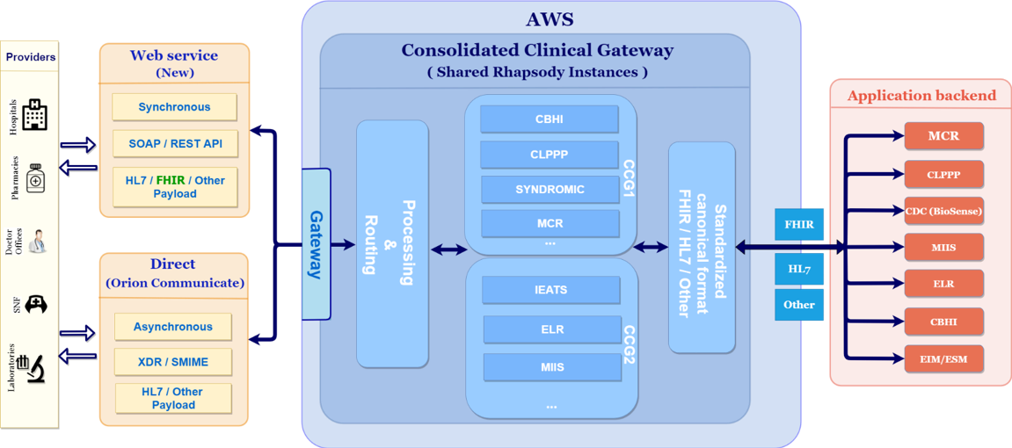

CG Maintenance and Enhancement Activities
In 2022, the Mass HIway Technical Maintenance and Enhancement (M&E) team continued to support all activities to host, operate, maintain, and enhance the Mass HIway Clinical Gateway (CG) nodes that connect seven registries and applications to providers state-wide and enables submission of required public health reporting data. The M&E team provides database administration, manages deployment of security patches, certificate updates and the new releases for the Mass HIway’s CG nodes in the AWS hosted environment and serves as the primary point of contact (24x7x365) for any infrastructure or security incidents.
Mass HIway technical project managers, analysts, developers, and testers worked closely with the business and technical teams supporting each of the Mass HIway connected registries and applications. As fixes, enhancements, or architectural upgrades are made to any of the seven back-end applications, or whenever new connections are proposed, this team identifies the impacts to the related CG node and designs, develops, tests, and implements the corresponding CG node changes. Coordinating documentation and process compliance reviews with a project management office and arranging for support from the release management team, this team shepherds each change through environments from Development to QA, to Certification, and finally to Production. All activities follow stringent Software Development Life Cycle (SDLC) processes.
The maintenance and enhancement activities ensure the smooth functioning of the applications, while allowing the new enhancements that are requested by the Department of Public Health (DPH) and MassHealth to be included into scheduled software releases. Enhancements ranged from minor fixes to major updates which include new features or functions, such as the building of a new node to support the Massachusetts My Vax Records program, allowing the retrieval of a citizen’s vaccination record.
The M&E team also maintains and enhances the Mass HIway business applications, including a customer relationship manager (CRM) system, the Mass HIway website, and the attestation application that is used to record provider attestations of compliance with the Mass HIway Regulations. In addition, several monitoring and tracking tools used internally by the Mass HIway operations team are maintained and frequently enhanced by the M&E team.
In addition to the seven (7) Clinical Gateway nodes for public health reporting, the Mass HIway includes the following applications to support business functions:
- Customer relationship manager (CRM) software and database
- The Mass HIway public website
- Online attestation form for connection requirement
- Audit and Reporting application
- Monitoring application
- Dashboards to support the DPH message submission integrity
Below are the number of Maintenance and Enhancement projects and activities that were completed during the calendar year 2022 for each Mass HIway application.
CG Node / Application | Projects & Major Enhancements | Maintenance & Support Activities
Childhood Lead Poisoning Prevention Program (CLPPP) | 2 | 5
Syndromic Surveillance (Syndromic) | 2 | 5
Children’s Behavioral Health Initiative (CBHI) | 1 | 5
Massachusetts Cancer Registry (MCR) | 1
Electronic Lab Reporting (ELR) | 1 | 7
Massachusetts Immunization Information System (MIIS) | 3 | 8
Intake Enrollment and Assessment Transfer Service (IEATS) for Opioid Treatment Program (OTP) | 4 | 5
Mass HIway CRM (Sugar CRM) | 5 | 7
Mass HIway Web | 4 | 9
Health Check Application |  | 1
Infrastructure (including Gateway updates) |  | 6
CG Node Common Changes & Report Generation |  | 12
Total | 23 | 70

Mass HIway Account Management
A core function of the Mass HIway program is to support health information exchange (HIE) and advance care coordination objectives among Massachusetts providers and the healthcare system more broadly. Engagement and account management activities are oriented to improve the HIE operating environment and address barriers and gaps for providers, state agencies and other healthcare stakeholders.

Provider Directory, PD API and DirectTrust
Accurate and up to date provider directory listings ensure providers and other care team members can exchange patient information for care coordination purposes. It is a foundational element of any health information exchange. The Mass HIway Account Management team worked closely with Orion Health on the creation of onboarding and testing documentation for a new Provider Directory (PD) Application Programming Interface (APl). The team facilitated testing of the PD API with Mass General Brigham, as a pilot organization, and engaged with Reliant Medical Group on operationalizing the PD API for their organization.
The Mass HIway Account Management team actively participated in the DirectTrust Provider Directory workgroups to develop the v2.8 User Guide to align the directory with FHIR (Fast Health Interoperability Resources), particularly regarding the workflow-associated Direct addresses being listed in the directory and to understand and minimize the impact to Mass HIway users. To that end, the team worked closely with Mass General Brigham to move their 10,000+ providers into sub-organizations in the Provider Directory to support more enhanced searching, as well as align with DirectTrust. The team also worked closely with Beth Israel Deaconess Medical Center (BIDMC) to incrementally add 980 providers to the Provider Directory and facilitated the update of Reliant Medical Group’s directory data which had not been updated in three years.
Lastly, the team worked with Orion Health and Mass General Brigham to develop a new workflow for Mass General Brigham to manage their own changes to the Provider Directory through the Mass HIway Provider Directory portal to ensure timely updates to their data. The Account Management team also facilitated Provider Directory 2.0 clean-up work including the removal of 19 workflow addresses with no users tied to them and the addition of missing National Provider Identifier (NPI) numbers and other inconsistencies that made it difficult to find providers in the Directory.

Provider Engagement
The Account Management Team enrolled 10 new provider organizations onto the Mass HIway over the last year. This includes three organizations that enrolled for care coordination purposes, and seven organizations that will utilize the Mass HIway for Department of Public Health (DPH) reporting. The team also continued to manage a steady volume of daily incoming email and telephone inquiries from current and future participants of the Mass HIway.

Some notable onboarding accomplishments over the past year include:
- Community Technology Cooperative (CTC): Twelve FQHCs that are part of the Medicaid ACO, Community Care Cooperative (C3), came together to form Community Technology Cooperative (CTC). These health centers combined resources to migrate onto one Epic EHR instance and chose the Mass HIway as their HISP for care coordination. The HIway worked with these organizations throughout most of 2022 to implement a test connection, evaluate DPH reporting needs and organize and publish their providers in the Provider Directory. They were live in Production in October 2022, and their Epic EHR went live 12/1/22.
- Tufts Medicine: Tufts Medicine completed an EHR migration in March 2022, bringing together three large hospitals to a single Mass HIway connection for DPH reporting. The Mass HIway team worked closely with the Tufts Medicine team, in addition to resources at each hospital, to move their six disparate connections to two new connections.
- Massachusetts Cancer Registry (MCR): MCR recently stopped accepting paper submissions for case reporting. The Mass HIway Account Management Team has worked closely with DPH and reporting providers to establish a new connection for providers to submit their backlog. The team also worked with the development team to scope enhancements to the Clinical Gateway node so that non-structured documents could be sent by pathology laboratories and other organizations without a certified EHR.
The Mass HIway Account Management team continued to manage the provider organization invoicing on behalf of EOHHS. The team supported provider organizations with the final annual attestation submissions for the Mass HIway Connection Requirement. Also in 2022, the team initiated a system cleanup of the Mass HIway customer relationship management (CRM) database by ensuring the accuracy of all connection types and engaging inactive users. The team contacted 152 organizations with inactive Webmail users leading to 33 accounts and 153 users to be deactivated, providing over $21,000 in annual savings to EOHHS.

Statewide Event Notification Service Framework
Event Notification Services (ENS) are a mechanism for hospitals to notify Health Care Providers of events (admissions, discharges, transfers – ADTs) related to their patients. The Massachusetts Statewide ENS Framework developed by EOHHS and the Mass HIway in 2021 constitutes an interoperable ENS network consisting of Certified ENS Vendors who have interconnected their ENS systems to serve care providers in Massachusetts. Prior to the implementation of the statewide system, Providers only received notifications if they subscribed to the same ENS vendor as the hospital sending the event.
The Statewide ENS Framework was implemented by regulations that require all Acute Care Hospitals in Massachusetts to subscribe to at least one Certified ENS Vendor (see 101 CMR 20.08(4)). The framework thereby ensures that all Massachusetts care providers who subscribe to any of the Certified ENS Vendors can receive ADT alert notifications from all Acute Care Hospitals in the Commonwealth. In addition, the statewide system requires MA state certified vendors to share notifications with other certified vendors so that vendors who do not directly receive the original notification can transmit it to their subscribers as needed.
Certified ENS Vendors were certified by the Mass HIway to meet specific functional, data security, data sharing, and business criteria focused on ensuring Statewide ENS access, delivery, reliability, and integrity. Vendors are required to submit quarterly reports to the Mass HIway pursuant to the reporting obligations set forth in the contracts between EOHHS and the Certified ENS Vendors. The Statewide ENS Framework went live on April 1, 2021.
As stated in the prior report, the goal and guiding principles for the Statewide ENS Framework are as follows:
Statewide ENS Framework Goal: Supporting timely statewide Event Notification Services (ENS) across the Commonwealth to improve health care delivery, quality, and coordination.
Statewide ENS Framework Guiding Principles
- Universal access - Promoting data sharing within an ENS framework to increase accessibility to ENS for providers of all sizes.
- Streamline provider experience - Crafting ENS framework to allow single point of submission and single point of reception of ADT data.
- Improve notification timing - Improving timing for flow of data (real/near-real time)

ENS Program 2022 Activity Update
The Statewide ENS Framework has been in operation for two years, utilizing services from two Certified ENS Vendors. The Certified ENS Vendor contracts had an initial term of two years, commencing on January 30, 2021. In early 2023, EOHHS extended contracts to both certified vendors for the EOHHS Market-Based ENS Initiative for an additional one-year term. EOHHS and the vendors have negotiated similar terms and conditions as the initial contract with some modifications to improve the reporting criteria and elements.
Additional ENS Program Activity that was completed by the Mass HIway ENS program team in 2022 included:
- Reviewed attestation materials indicating trends in HIE, compliance and waiver requests of Acute Care Hospitals, Large and Medium Medical Ambulatory Practices, and Small Community Health Centers.
- Provided progress updates of the ENS project at quarterly meetings of the Health information Technology Council (HIT Council) and posted updates for public review on the State’s website.
- Communicated the end of the attestation process for all required provider organizations via newsletters and other targeted communications.

ENS/ADT Landscape Improvement Efforts
The Mass HIway solicited feedback from MassHealth ACOs, providers and the certified ENS vendors about challenges within the current ADT landscape in Massachusetts to inform measures for improvement. The issues identified included duplicate ADTs, missing diagnosis codes, and technical workflow issues. To address these matters, the Mass HIway team has been engaging stakeholders, including MassHealth, MassHealth ACOs, providers and certified ENS vendors to better understand these reported challenges with the current ADT/ENS landscape in Massachusetts.
The Mass HIway Account Management team facilitated discovery sessions and created documentation regarding how the certified ENS vendors are receiving ADTs from hospitals, their data processing techniques, how they send notifications to subscribers, and how the ENS initiative relates to CMS’s Conditions of Participation ADT requirements. The Mass HIway Account Management team also provided in-depth analysis of the certified ENS vendors quarterly reporting, gathered insight from vendors, and highlighted areas for improvement, as well as tracked needed changes to contracts and reporting requirements for the certified ENS vendors.
The HIway Account Management team worked with several provider organizations to understand their technical and workflow issues with receiving ENS notifications. They additionally provided investigative work and facilitated the resolution of issues with the certified ENS vendors and any provider organizations who reported them.
In 2022 the HIway Account Management Team also introduced two surveys to better understand the capabilities and challenges providers face within the current ADT landscape. Findings from the surveys will enable the team and EOHHS to target improvement areas and support opportunities, such as developing educational materials, documentation, webinars and other resources to support providers and stakeholders.
Psychiatric Hospital Survey: Sent to all freestanding psychiatric hospitals and inpatient psychiatric units within the state to understand the facilities’ EHR and ADT capabilities, as well as the barriers for psychiatric hospitals to send or receive ADTs. The Mass HIway partnered with the Department of Mental Health (DMH) to coordinate and distribute this survey.
Federally Qualified Health Center (FQHC) Survey: Sent to all Federally Qualified Health Centers (FQHCs) in the state, to understand workflow challenges related to the use of ADTs. The Mass HIway partnered with the Massachusetts League of Community Health Centers as a component of a larger, annual HIT survey sent to their member organizations.

Federal Developments
The Mass HIway continues to monitor federal developments to understand and evaluate the potential intersection with Mass HIway services and operations and any impact to the health information exchange landscape in Massachusetts.
In 2022, policies under the CMS Interoperability and Patient Access and the ONC Cures Act Final Rules were in full effect requiring expanded access to information for patients, providers and payers. The Mass HIway and HIT Council continue to monitor compliance efforts from the regulated payers, such as Mass Health, as well as the industry adoption of the new technical standards to identify barriers and assess areas of need and support.
Other important federal updates in 2022 include new developments for the ONC Trusted Exchange Framework and Common Agreement (TEFCA) and a new notice of proposed rule and request for information from CMS called Advancing Interoperability & Improving Prior Authorization Processes. Each are discussed in more detail below.

ONC Trusted Exchange Framework and Common Agreement (TEFCA)
Supported by the Office of the National Coordinator for Health Information Technology (ONC) of the U.S. Department of Health and Human Services (HHS), the Trusted Exchange Framework and Common Agreement (TEFCA) outlines a common set of principles, terms, and conditions to support the development of a Common Agreement that would help enable nationwide exchange of electronic health information (EHI) across disparate health information networks (HINs).
The TEFCA is designed to scale EHI exchange nationwide and help ensure that HINs, health care providers, health plans, individuals, and many more stakeholders have secure access to their electronic health information when and where it is needed.
In 2022, the Technical Exchange Framework and Common Agreement (TEFCA) continued to operationalize key components of the framework, publishing the first versions of the Common Agreement and the QHIN Technical Framework (QTF) as well as a FHIR roadmap. And later in the year, some initial standard operating procedures (SOPs) and an application process for Qualified Health Information Networks (QHIN) were published.
The Mass HIway is continuing to monitor TEFCA developments and progress with the onboarding of the initial QHINs in 2023 and the anticipated launch of TEFCA FHIR-based exchange pilots. As more information and experience is gained, the Mass HIway will continue to assess impact and intersections with the Mass HIway operations and the larger HIE ecosystem in Massachusetts.

CMS Advancing Interoperability & Improving Prior Authorization Processes
On 12/13/22, CMS officially published a proposed rule “The Advancing Interoperability & Improving Prior Authorization Processes”. The proposed rule, which replaces the December 2020 proposed rule that was never finalized, would require payers (including Medicaid Agencies) to:
- Expand current Patient Access API (Application Program Interfaces) to include information about prior authorization.
- Implement FHIR (Fast Healthcare Interoperability Resources)-based API to enable data exchange from payers to providers and between payers, and to include information about prior authorization.
- Institute prior authorization requirements, including decision within 72 hours for urgent requests and 7 calendar days for non-urgent requests.

Most of the implementation dates for the proposals included in this proposed rule would begin in CY 2026 but states could request a one-year extension for compliance with the API requirements for the state Medicaid and Children's Health Insurance Program (CHIP) Agencies’ fee for service programs.
Additionally, the notice includes five Requests for Information (RFI):
- Accelerating the Adoption of Standards Related to Social Risk Factor Data
- Electronic Exchange of Behavioral Health Data
- Improving the Electronic Exchange of Information in Medicare FFS
- Advancing TEFCA
- Advancing Interoperability and Improving PA for Maternal Health
The Mass HIway team is reviewing components of the proposed rule and is coordinating with EOHHS and MassHealth partners on specific comments and response to CMS, if warranted.

In Flight Initiatives
The Mass HIway participates and supports a number of EOHHS efforts and initiatives and provides cross-disciplinary subject matter expertise to support and advise EOHHS on health information technology programming including the implementation of strategic policy and technical goals, engagement with EOHHS programs and state executive leadership, and engagement with stakeholders in other state agencies and in the public.
Currently, there are two significant in-flight initiatives underway, one of which the Mass HIway directly oversees, and one for which it is providing significant program support. These initiatives are the ePOLST Registry and Clinical Gateway API-FHIR Integration project, both of which are described in more detail below.

POLST Program
In 2012, Massachusetts adopted the mission of facilitating and promoting the appropriate use of the MOLST (Medical Orders for Life-Sustaining Treatment) process and form as the standard way to document, communicate, and honor the life-sustaining treatment preferences of patients with advanced illness in all health care settings.
After a decade of practice, Massachusetts is taking steps to transition the current MOLST process to the National POLST (Portable Orders for Life-Sustaining Treatment) paradigm to support patient preferences for end-of-life care through technology that improves care coordination, ensures transferability between states and establishes an electronic centralized POLST (ePOLST) registry to serve as the single source of truth across all care settings.
To support this effort, EOHHS initiated a cross-agency group including the Executive Office of Elder Affairs (EOEA), Department of Public Health (DPH) and the Mass HIway to develop the program governing the statewide use of POLST, implement a statewide electronic POLST (ePOLST) registry, streamline operational and clinical processes around POLST and ultimately ensure that patients’ wishes are accurately and consistently honored across the Commonwealth.

ePOLST Registry 2022 Update
By the end of 2022, new legislation was passed (House, No. 5374) clarifying the Executive Office of Elder Affairs’ (EOEA) authority to develop, implement and administer a POLST program and implement a statewide electronic POLST (ePOLST) registry system which will enable the automated query and retrieval of POLST information.
In coordination with the Department of Public Health (DPH), the MOLST to POLST transition and process will be owned and administered by the Executive Office of Elder Affairs (EOEA) and the Mass HIway will oversee the implementation of an electronic POLST (ePOLST) Registry. Informed by the stakeholder engagement and requirements gathering exercises of the previous year, EOEA and the Mass HIway finalized the critical components, requirements, and capabilities for an ePOLST Registry. Following the approval received from CMS, and on behalf of EOEA, DPH and the Mass HIway, EOHHS issued an ePOLST Registry Request for Responses (RFR) to procure a statewide ePOLST registry, which was officially posted in January 2023.

The following illustration depicts a proposed future state vision for the ePOLST Registry:
Figure-4
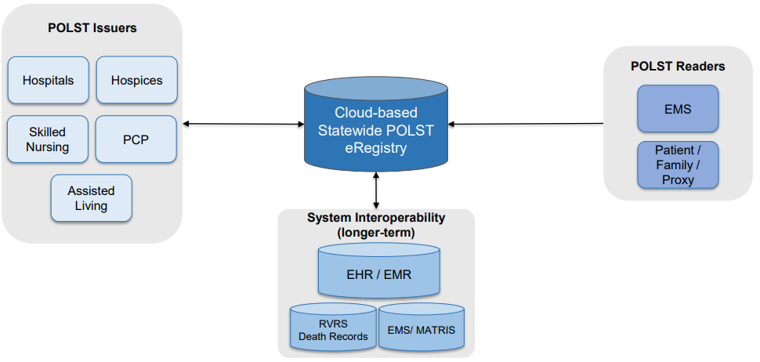
In 2022, EOEA expanded the POLST program team and governance structure to begin program start-up and to align on a workplan with key stakeholders. The POLST program team has been facilitating “Clinical Partnership” meetings with 3 test cohorts (Cooley Dickinson Hospital, Fairview Hospital, Lowell General Hospital) which are focused on the transition of MOLST to POLST forms and processes. The POLST program team is preparing training presentations, reviewing sample protocols for the “start-up kit,” and reviewing and responding to questions and comments from the stakeholder meetings and discussions.
EOEA and the POLST program team will continue to engage with the provider community to develop educational materials to drive statewide adoption of the new form and to inform the future development and implementation of the ePOLST Registry. EOEA plans to create a continuous quality improvement process to iterate on the educational material and training modules to improve adoption rates.

Clinical Gateway API & FHIR Integration
In an effort to align with national trends and the latest rules from the Centers for Medicare and Medicaid Services (CMS) and the Office of the National Coordinator for Health Information Technology (ONC), the Mass HIway team has built new Application Programming Interface (API) services including Fast Healthcare Interoperability Resources (FHIR) standard integration capabilities. FHIR is the emerging standard which describes data formats and elements and an application programming interface (API) for exchanging clinical and administrative data. The foundational APIs have been developed including new OAuth 2.0 security features and the ability to integrate FHIR-based messages.

CG API-FHIR Project Background
For over ten years, providers have been able to submit to the Massachusetts public health registries using Direct Messaging. However, new standards and approaches to exchanging secure clinical information are emerging. Recent regulations and FHIR accelerators are removing barriers to clinical data sharing and are creating demand for real-time, synchronous access to data to support public health reporting, care quality, care coordination and value-based care.
The Mass HIway is positioning itself to align with these trends and leading FHIR interoperability efforts by developing API and FHIR integrations to the Clinical Gateway. This will enable providers in the Commonwealth to send/receive messages synchronously with the public health registries from their EHR systems using current and emerging message formats (HL7 v2, HL7 FHIR, and other formats). The APIs will complement and, in several cases, replace current less efficient and more complex methods to collect, receive, query, access, or disclose data from and by external stakeholders.
The Clinical Gateway API and FHIR Integration project will implement and maintain secure, standards-based APIs with FHIR integration by redesigning the current state architecture and data systems and revising business and technical processes and related support efforts.

CG API-FHIR 2022 Technical Update
In 2022, the technical infrastructure was designed, developed and implemented to support the new CCG plans to extend web services to include RESTful APIs and capabilities for FHIR Integration, including FHIR-HL7 message transformation services to and from the source registry systems.
Development for the Syndromic Surveillance, Children’s Behavioral Health Initiative (CBHI), and Mass Cancer Registry (MCR) APIs was completed by the end of January 2022. APIs for the Massachusetts Immunization Information System (MIIS), Electronic Lab Reporting (ELR) and Intake, Enrollment, Assessment and Transfer Service System for BSAS (IEATS / OTP) were completed by the end of February 2022. And, in May 2022, development work for the remaining supporting components, including OAuth 2.0 functionality, was completed.
Use cases have been identified for the RESTful API and are being implemented with some Mass HIway early adopter groups (discussed below). And, the Mass HIway continues work to identify provider groups interested and capable of utilizing a FHIR API or FHIR transformation services. Once use cases have been defined, the proposed FHIR API solutions will be scoped, and an assessment of technology and capability gaps will be conducted to determine the necessary development and change areas.
Additionally, the technical components (e.g., Amazon Web Services, Rhapsody engine) and new FHIR capabilities of the Consolidated Clinical Gateway development could be leveraged to support other FHIR API initiatives and a range of FHIR-enabled HIE services. The Mass HIway will continue to gather and consolidate stakeholder feedback related to APIs and FHIR-based HIE services to inform direction and planning. As discussed below, several interested parties have been identified and the Mass HIway team is working with the providers as well as the state agencies and other stakeholders to implement these new API services.

CG API-FHIR 2022 Provider Engagement Update
The Mass HIway Account Management team completed an intensive review of the 2022 Interoperability Standards Advisory (ISA) provided by the Office of the National Coordinator for Health Information Technology (ONC). The ISA process represents the model by which the ONC coordinates the identification, assessment, and public awareness of interoperability standards and implementation specifications that can be used by the healthcare industry to address specific interoperability needs including, but not limited to, interoperability for clinical, public health, research and administrative purposes. Utilizing the ISA, the Mass HIway team created reference documentation focusing on the data standards applicable to public health reporting and related to FHIR.
Significant research was completed by the team in understanding the major EHR vendors’ Application Programming Interface (API) capabilities, with particular attention to Epic’s App Orchard program. And a cross-disciplinary Mass HIway team connected with five large provider organizations on Epic to understand capabilities and learn more about the challenges and potential benefits of moving to APIs and FHIR based reporting.
The Account Management team worked closely with the M&E team to create resources and documentation for the onboarding of provider organizations to the RESTful API for DPH reporting, including 1) Transport Instructions, 2) Implementation Guide, 3) Testing Plan, and 4) Rollout Plan.
By the end of 2022, the Account Management Team had initiated development work with Tufts Medicine and Advocates, Inc. to establish their respective API endpoints for public health reporting. The team is in the process of onboarding Advocates Inc., a large behavioral health organization, to submit its Child and Adolescent Needs and Strengths (CANS) report via a RESTful API. The team anticipates onboarding to be complete in the first quarter of 2023.
The team is also working with Trinity Healthcare on behalf of Mercy Medical Center and Tufts Medicine on RESTful API pilots for submission of syndromic surveillance to the Department of Public Health (DPH). The Trinity Healthcare transition to API is also expected to be complete in the second quarter of 2023. The team is facilitating all testing meetings, documenting all requirements on behalf of DPH and supporting workflow changes at the healthcare organizations. When complete, it is anticipated these engagements will provide successful examples of organizations using the API and will inform future adoption of APIs.

Budget

Background & Funding Rates
The Mass HIway is funded through a combination of federal funding, state matching funds, and participant contributions. The legislature created the Health Information Trust Fund, M.G.L. c. 10, s. 35RR, to finance the Mass HIway. The HIT Trust Fund receives appropriations in the Commonwealth’s annual budget to cover the state share of HIT projects. Participants contribute participation fees for their use of the Mass HIway based on tiers of provider type and size (ex. Large hospital, small hospital, etc.), in accordance with 101 CMR 20.13.
Since the sunsetting of the Health Information Technology for Economic and Clinical Health (HITECH) Act in September 2021, a component of the American Recovery and Reinvestment Act of 2009 (ARRA) program, and its related funding provisions, federal funding has been reduced considerably. Federal funding available to support the Mass HIway now primarily comes through the Medicaid Enterprise System (MES) program within CMS.
Under MES, the Mass HIway can employ different Federal Financial Participation (FFP) rates based on the activities performed. For CMS-approved design, development and implementation (DDI) activities, MES offers 90% enhanced FFP. As a CMS certified MES System and upon the completion of DDI covered activity, the Mass HIway may be eligible for 75% “enhanced” operational funding to support its ongoing operational activities, to the extent that those activities benefit the Medicaid program. And finally, MES allows for 50% standard FFP for any additional operational costs, also to the extent that these benefit the Medicaid program, not qualifying for enhanced FFP.
The CMS MES program requires states to allocate the costs under these three activity rate groups based on the systems’ benefit to Medicaid, typically measured as share of patients. As of October 2022 in Massachusetts, approximately 30% of the population receives health care through MassHealth and thus that is generally used as the CMS required cost allocation factor.

Budget Management
In response to reduced federal participation levels, the Mass HIway employs strategies to maintain current operations and continue priority development areas while accounting for limited federal revenue. These strategies are implemented through adjusted operations and support which include lowering operating costs by renegotiating vendor contracts, refocused provider outreach and reorganized technical operations.
The Mass HIway will continue to evaluate an increased private funding share and policy updates to support foundational services, end-user value, innovation areas and aligned HIE investments. In light of the changing revenue landscape, the Mass HIway will continue to assess strategies that draw support from users and stakeholders as well as those that enable valuable services and programs.

Conclusion
This report describes key services and activity the Mass HIway and partners have taken to improve provider interoperability and health information exchange throughout the state, delivering valuable, secure Direct Messaging and Provider Directory services, enabling Public Health Reporting through the Consolidated Clinical Gateway and streamlining event notifications through the Statewide Event Notification Service Framework.
The Mass HIway program will continue to engage and inform providers, build awareness and promote best practice in the use of health information exchange and advancement of interoperability. And the Mass HIway will continue to develop an enhanced infrastructure to align with new standards, such as the use of APIs and FHIR for exchanging secure clinical information, and to respond to the growing demand for real-time, synchronous access to data to support public health reporting, care quality, care coordination and value-based care.

85 FR 25642

