Blue Hills

STATE RESERVATION

White-Tailed Deer Management Program

2022 Deer Management Plan

September 9, 2022

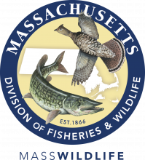

A Joint Publication of the
Massachusetts Department of Conservation & Recreation and
Massachusetts Division of Fisheries & Wildlife

Commonwealth of Massachusetts

Charles D. Baker
Governor

Karyn E. Polito
Lt. Governor

Executive Office of Energy & Environmental Affairs

Beth Card
Secretary
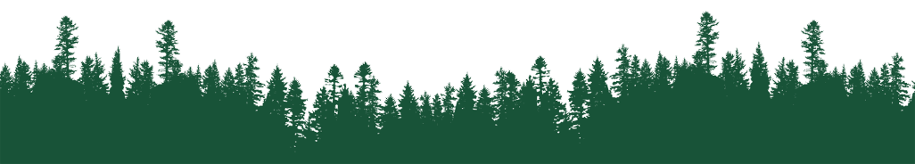

Department of Conservation & Recreation

Douglas Rice
Commissioner

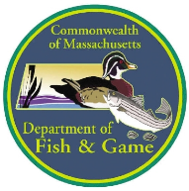
Department of Fish & Game

Ronald Amidon
Commissioner

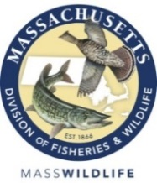
Massachusetts Division of Fisheries & Wildlife

Mark Tisa
Director

Table of Contents

Contents
Table of Contents 3
1.0 The Blue Hills Reservation 4
2.0 Context for Deer Management in the Blue Hills 4
3.0 Rationale & Objectives for Deer Management in the Blue Hills 5
4.0 Context & Need for Continued Deer Management 5
4.1 – Continued Deer Abundance 5
4.2 – Long-Term Effort & Commitment 5
4.3 – Commitment to Continued Deer Management in 2021 6
5.0 Permitted Archery Hunting During November 6
5.1 – Timing and Length 6
5.2 – Management Areas and Hunter Distribution 6
5.3 – Hunter Selection and Access Permitting 7
5.4 – Antlerless Permits 8
5.5 – Hunter Orientation 8
5.6 – Public Recreational Access 8
6.0 COVID-19 Considerations 8

1.0 The Blue Hills Reservation

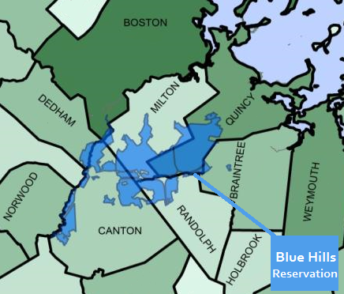
The Massachusetts Department of Conservation and Recreation (DCR) manages and stewards the Blue Hills Reservation. The Reservation encompasses an area of over 7,000 acres and is situated less than ten miles south of downtown Boston in the communities of Braintree, Canton, Dedham, Milton, Quincy, and Randolph. A small portion of Fowl Meadow (north and west of the Neponset River) is located within the Hyde Park neighborhood of the City of Boston. The protection of this area as public open space began over 120 years ago with its establishment in 1893 by the Metropolitan Park Commission. As a public parkland and forested area, the Reservation contains a wide variety of natural resources, vegetation, wildlife, and cultural and archaeological resources, and its topography includes prominent hills (Great Blue Hill and Chickatawbut Hill), as well as open fields and several ponds and streams.

2.0 Context for Deer Management in the Blue Hills

The Massachusetts Department of Conservation and Recreation (DCR) and the Massachusetts Division of Fisheries and Wildlife (MassWildlife) have legislative mandates and missions to protect and manage a myriad of natural resources including forests, wildlife, and the habitats upon which a diversity of wildlife depends. From the canopy to the understory, healthy forest ecosystems are made up of trees and plants of multiple species and age classes and the diversity of vegetation provides suitable and sustainable habitat for a rich and varied wildlife community. From the perspective of long-term forest management, tree regeneration is critical to the long-term survival of forests and their ability to recover from natural disturbances. Forests that contain high deer population densities are vulnerable to deer over-browsing young trees, which can prevent forest regeneration. In addition, extremely high deer densities can promote the spread of some invasive species and significantly reduce biodiversity.

DCR’s management of the Blue Hills Reservation is guided by the existence of a comprehensive Resource Management Plan (RMP) that was approved by the DCR Stewardship Council in April 2011. In 2015, the DCR put forth the first Blue Hills Deer Management Plan detailing the context for the hunt. In addition to following the recommendations within the Blue Hills RMP, DCR and MassWildlife were issued a legislative mandate in the 2014 Environmental Bond Bill (Chapter 286 of the Acts of 2014), which was signed into law by former Governor Deval Patrick in August 2014.

3.0 Rationale & Objectives for Deer Management in the Blue Hills

The primary objective and rationale for developing and implementing a deer management program is to maintain an ecologically sustainable deer density that allows for the continuous growth and development of forest regeneration. DCR is trying to reduce the negative impacts that high deer densities have on the regenerating forest to ensure a healthy forest composed of an adequate diversity of tree species and age classes. DCR’s program for white-tailed deer management is not intended to provide a new recreational opportunity in the Blue Hills. Rather, the program provides a concrete, practical, and workable solution intended to deal with a critical environmental problem.

4.0 Context & Need for Continued Deer Management

4.1 – Continued Deer Abundance

Between March and May of 2022, DCR conducted deer abundance surveys in the Blue Hills utilizing the pellet count survey methodology. This methodology has been used over the last several years in the Blue Hills and is also used by DCR’s Division of Water Supply Protection (DWSP) to estimate deer abundance at the Quabbin Reservoir Reservation.

Recent advances in pellet count survey methodology have allowed more accuracy in these surveys. Counting deer droppings instead of individuals has several distinct advantages:

- Deer droppings are easy to see, don’t move, and can be counted over a longer period of time.
- Counting droppings is relatively straightforward and can be done with a minimal amount of equipment or personnel.
- Pellet count surveys allow a finer-scale look at deer numbers by area within the Reservation.
- Pellet counts allow data to be collected in a more representative and random way in and around the Reservation and does not rely on the roads and trail network, which can limit the bias and lead to more realistic estimates of density.

In addition to this, a recently-published paper has provided a solid frame work for conducting this type of survey over large forested areas. For additional information regarding previous year pellet surveys, readers are encouraged to read Section 7 of the 2016 Program Overview & Results / 2017 Results of Deer Abundance Surveying report and Section 4 of the 2018 Blue Hills Deer Management Plan and 2019 Blue Hills Deer Management Plan.

The 2022 pellet survey provided a higher overall density estimate throughout most of the Reservation. Deer densities remain above the MassWildlife’s statewide goal of 6-18 deer/mi². It is important to maintain densities in this range to reduce the negative impacts high deer populations have to the habitat and forest within and around the Blue Hills Reservation.

4.2 – Long-Term Effort & Commitment

In the 2015 Blue Hills Deer Management Plan, DCR and MassWildlife noted that most deer management programs designed to address extremely high deer densities typically start with an aggressive reduction phase during the initial years. Once densities are reduced to a suitable level, a long-term management phase can be implemented utilizing more moderate hunting efforts to maintain the accomplishments achieved during the reduction phase. This model was successfully implemented as part of the Quabbin Reservoir Watershed deer management program, which began in 1991 with nine (9) days of shotgun hunting. Within a few years, deer densities at the Quabbin were substantially reduced and the program moved from a reduction phase toward a maintenance phase.

4.3 – Commitment to Continued Deer Management in 2022

The use of licensed public hunters in managing deer populations is one of the most widely used management methods employed throughout the United States. In Massachusetts, it is the primary management tool supported by MassWildlife and has been shown to be successful in addressing situations involving deer overabundance and vegetation over-browse. The Quabbin Reservoir controlled deer hunt is the most notable example. In addition, DCR manages thousands of acres of forest and parkland across the Commonwealth where licensed hunters are allowed to hunt during the regulated seasons. Moreover, regulated hunting is an activity that DCR fully supports by providing public land for hunters to engage in this management activity.

In light of DCR’s commitment to long-term deer management in the Blue Hills and the successful efforts undertaken between 2015 and 2020, DCR will continue to implement controlled hunting in the Blue Hills in 2022. Based upon the experience of implementing and assessing the outcomes of six controlled hunts and the success of controlled hunting efforts in 2021, DCR will implement a controlled hunting plan in 2022 that mirrors the permitted archery hunt conducted in 2021. All areas included in this year’s hunts have already been opened to archery hunting in previous years.

5.0 Permitted Archery Hunting During November

Over the last several years (and even prior to DCR’s initiation of controlled deer hunting in the Blue Hills Reservation) a number of private property owners near or adjacent to the Blue Hills have voluntarily allowed archery hunters onto their land during the annual archery season to hunt deer. This informal program has been successful in harvesting a number of deer each year and highlights the importance of cooperation between landowners and deer hunters.

5.1 – Timing and Length

To supplement the efforts already taking place on nearby and adjacent private property and to enhance DCR’s overall Deer Management Program for the Blue Hills Reservation, DCR will continue to permit limited archery hunting in certain designated areas of the Blue Hills on Mondays through Thursdays between November 7th through November 23th. There will be no hunting on Thursday, November 24, 2022 in observance of the Thanksgiving holiday. In accordance with state hunting regulations, hunters will be allowed to start hunting one-half hour before sunrise to one-half hour after sunset.

5.2 – Management Areas and Hunter Distribution

Archery hunting will be limited to the areas of the Reservation listed in the table below and outlined on the map that follows.

In order to organize and distribute hunters effectively, archery hunters will be separated into two groups and each group will be assigned to one of two archery zones. Each zone will include several management areas. Hunters assigned to Zone 1 may hunt in any of the management areas listed within that zone. Hunters assigned to Zone 2 may hunt in any of the management areas listed within that zone. Hunting zones and the management areas within each zone are outlined in the table on the following page:

 | Archery Zone | Management Area | Acres Open to Hunting  (Per Management Area) | Acres Open to Hunting  (Per Zone) | Number of Hunters
 | ZONE 1 | Fowl Meadow | 387 | 929 | 100
 |  | Little Blue | 70
 |  | Brookwood Farm | 26
 |  | Great Blue | 58
 |  | Houghton’s Pond | 43
 |  | Ponkapoag | 187
 |  | Nike Site | 158
 | ZONE 2 | Chickatawbut | 1,004 | 1,693 | 125
 |  | Wampatuck | 612
 |  | Braintree Site | 77
 |  | TOTAL | 2,622 | 2,622 | 225

5.3 – Hunter Selection and Access Permitting

Licensed archery hunters must complete and submit an application to DCR to participate in this archery hunting opportunity. All applicants are required to have a valid 2022 Massachusetts hunting license.

From among the applicant pool, DCR will conduct a random lottery to select 225 archery hunters to receive access permits. These access permits will be valid on all days in which archery hunting will be allowed in designated areas of the Reservation (as outlined above) during the hunting period and permitted hunters will be allowed to hunt based upon their schedule and availability. Given this flexibility, it is highly unlikely that there will be 225 archery hunters in designated management areas on any given day.

If selected to participate, any archery hunter under the age of 18 must be accompanied while hunting by an adult over the age of 21 who is also a registered hunter possessing a valid Massachusetts hunting license. The accompanying adult must participate in the mandatory virtual orientation session and will not be allowed to hunt.

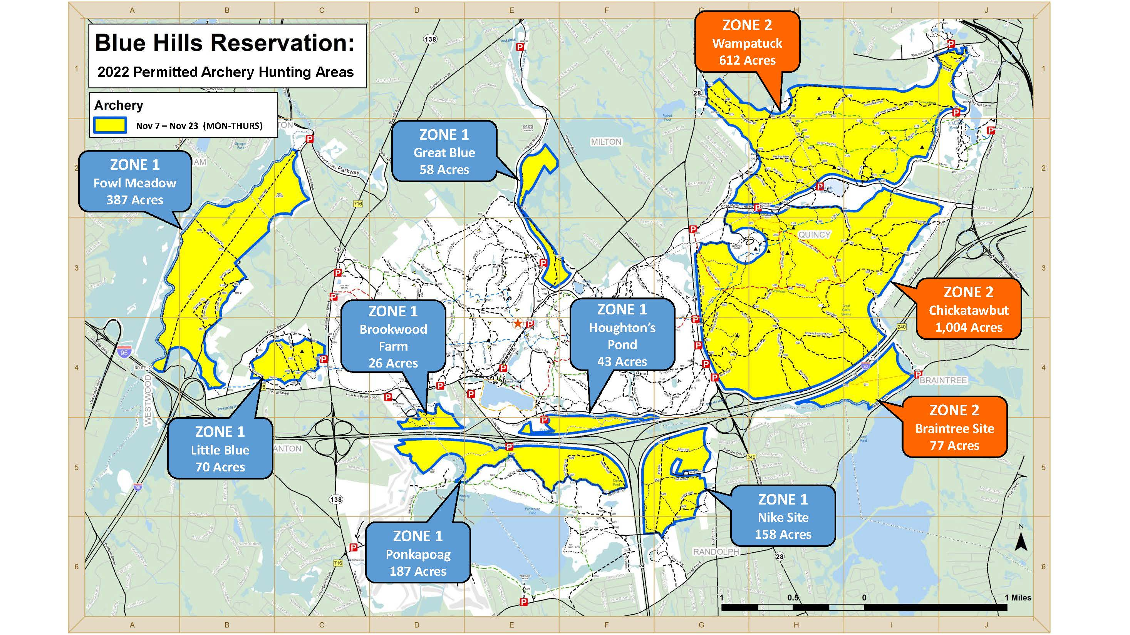

5.4 – Antlerless Permits

MassWildlife will make antlerless deer permits specific to the Blue Hills Reservation available to applicants selected to receive an archery access permit. Selected hunters will be able to purchase their antlerless permits online or at any licensed vendor. Hunters selected to participate will be required to purchase at least two (2) antlerless permits. The use of any Zone 10 antlerless permits will be prohibited from use in the Blue Hills.

5.5 – Hunter Orientation

All archery permittees will be required to complete a virtual orientation. Among other topics, the virtual orientation will cover the elements of the Blue Hills Deer Management Plan, the goals and objectives of the program, an orientation to the area, and safety considerations. Any selected archery hunter who fails to fulfill this requirement will not receive an access permit and will not be allowed to hunt in the Blue Hills.

5.6 – Public Recreational Access

General public access for recreation will not be restricted in those areas in which hunting will take place. Members of the general public who choose to enter those areas in which hunting will be taking place are advised to take proper precautions by wearing blaze orange clothing, vests, and hats.

6.0 COVID-19 Considerations

In accordance with the Commonwealth’s response to the COVID-19 pandemic, all hunting activities are still permitted in accordance with the regulations (including licenses) for the appropriate hunting season.

Permitted hunters participating in the 2022 archery hunt will be asked to abide by current state or local public health restrictions that are in place.

To view a copy of the approved 2011 Blue Hills Resource Management Plan, and the 2015 Blue Hills Deer Management Program, please use the following links: https://www.mass.gov/files/documents/2016/08/mz/sections1-4.pdf http://www.mass.gov/files/documents/2016/08/xd/appendices.pdf https://www.mass.gov/doc/2015-blue-hills-deer-management-plan/download
DeCalesta, D.S. 2013. Reliability and precision of pellet-group counts for estimating landscape-level deer density. Human-Wildlife Interactions 7(1):60-68.

