During the response to public comment period for the 2022 DSPR project proposals, the Commonwealth, as part of the Forest as Climate Solutions (FACS) Initiative, underwent an extensive review of forest management activities on state public lands that are managed by three Divisions, the Division of State Parks and Recreation (DSPR), the Division of Water Supply Protection (DWSP) and the Division of Fisheries and Wildlife (DFW). DSPR has applied the FACS lens on all of its existing projects. For more information on FACS click on this link. Forests as Climate Solutions | Mass.gov . This includes the 2022 DCR Forest Management projects, to which these public comments refer. The Forest Management Program continues to evaluate recommendations made during this process. As updates to the projects are made, they will be posted in the “Project Update Summaries” section of the website.
Thanks to everyone for their interest, participation, and contribution of questions and comments to the DCR’s Forest Management Program’s 2022 Proposals. Many of the questions and comments have similar themes and have been grouped to reduce redundancy and represent responses to comments 1, 2, 4, 5, 6, 11, 12, and 14, found in the proposal questions document.
Dissenting Comments Regarding Forest Management for the Following Ecosystem Services:
- sustainable wood products
- Climate Change, carbon capture and storage
- fire prevention
- treatment for insects and disease,
- ecosystem restoration
- liquidation of plantations
- improvement of wildlife habitat
- diversification of even-aged forests, and forest restoration
- improvement of recreational experiences

Sustainable Wood Products and Climate Change Mitigation and Adaptation
It is important to remember that the UN’s Intergovernmental Panel on Climate Change (IPCC), states that Forest management plays a key role through mitigation of climate change. (Nabuurs, et al., 2007) The IPCC recognizes the socio-economic importance of forest management as society is dependent upon the goods, services, and financial values of the forest. Other external guidance for the 2022 proposals came from documents such as the Massachusetts Climate Change Adaptation Report​, and the Massachusetts 2050 Decarbonization Road Map. https://www.mass.gov/service-details/2011-massachusetts-climate-change-adaptation-report https://www.mass.gov/doc/ma-decarbonization-roadmap-lower-resolution/download

As stated in the 2022 Forest Management Proposal Presentation, the DCR Forest Management Program has begun working with climate partners such as the Northern Institute of Climate Scientists (NIACS) with their Climate Adaptation Workbook, and the Massachusetts Department of Fish and Game with their Wildlife Climate Action Tool to develop mitigation and adaptation measures to create more resilient forests. Forest resiliency is paramount to management and is inextricably linked to long term carbon sequestration and storage. A forest that is resilient to the stressors of climate change will maximize the balance between carbon capture and carbon storage. While management for climate change is one of the top objectives noted on the 2022 proposals, biodiversity is equally important, as it is a major component of both resilience and the adaptive capacity of a forested ecosystem. The IPCC has recognized the importance of forest management to meet climate change goals as well as other goals. The report states:
Forestry mitigation activities can be designed to be compatible with adapting to climate change, maintaining biodiversity, and promoting sustainable development. (Nabuurs, et al., 2007)
The IPCC findings have recently been reinforced by The Lawrence Livermore National Laboratory. They worked with researchers across a variety of sectors (forests, agriculture, etc.) to review economically productive, equitable, and scientifically vetted approaches for reducing and mitigation atmospheric carbon. The DCR’s CFI data was used by researchers at Yale University as part of this study. The researchers found that while passive management can increase carbon in the forest by 30% relative to harvesting, implementing sound silviculture will "... promote forests that are more resilient to natural disturbances relative to exploitation-focused management or passive management." These silvicultural treatments "...stored 50% more carbon in the forest-carbon bools and wood products than passive management or exploitation-focused management". "Forests treated with regeneration-focused management experienced lower carbon losses with natural disturbances and faster accrual of the lost carbon storage relative to passive management." Additionally, these practices did not cost money, but provided net economic benefits relative to a no harvest scenario; Roads to Removal – Options for carbon dioxide removal in the US (roads2removal.org) . While the DCR manages its forests for a wide variety of ecosystem services, sustainable wood products are just one service among equals. The DCR understands we’re not going to produce equal amounts of all those services on each of our acres. Wood is a byproduct of many of our management projects, and a measure of sustainability. Sustainability is not just about balancing growth with removals; it’s also about balancing our consumption with equitable production.
The non-profit Healthy Forests, Healthy Communities advocates for active management, noting that non-management of forests that were previously managed separates people from forest ecology and forest succession. (https://healthyforests.org/2022/12/proforestation-separates-people-from-forests). However, this is the exact opposite approach that is being promoted within several initiatives concerning environmental justice. Within the realm of environmental justice, the DCR is attempting to foster connections, stewardship ethics, and healthier environments for these communities. Healthy Forests, Healthy Communities also explains that “A United Nations report pointed out that at least 10 World Heritage sites – the places with the highest formal environmental protections on the planet – are net sources of carbon pollution. This includes the iconic Yosemite National Park.” (https://healthyforests.org/2022/12/proforestation-separates-people-from-forests/).
A non-active management approach to all lands within the DCR constitutes a single strategy to address the myriad of stressors found within the forests of Massachusetts. Single strategy practices have proven to be less effective in achieving the multiple goals and objectives of a forest or landscape than a combination of numerous proven approaches. Single strategy practices are the leading factor behind spruce budworm outbreaks in Maine and southern pine beetle outbreaks across the southern US. In Massachusetts, CFI plots without a discernable history of management are the lowest performers in carbon sequestration, physical complexity, and biodiversity. This is not surprising, as in the words of Mark Bradford, Professor of Soils and Ecosystems Services, Yale University “The false narrative in New England that ‘nature will fix itself’ ignores the current state of many of our forests and the critical role that sound forest management plays in restoring and sustaining forest lands and the livelihoods of those that depend on them.” (https://environment.yale.edu/news/article/healthy-forests-its-never-about-cutting-individual-tree) . This sentiment regarding the current state of our forests is echoed by Tom Worthley, Associate Extension Professor, University of Connecticut “The problem is that nature just isn’t natural anymore because of the unanticipated consequences of the actions of human beings in the landscape. We have air pollution, water pollution, deer over-abundance, absence of fire, non-native invasive plants and invasive insects and the solutions to these problems require intervention or management to keep the forest healthy and productive.” (https://today.uconn.edu/2022/10/helping-our-forests-adapt-to-climate-change/) Such land management practices - heavily influenced by advances in science, a deeper understanding of forest dynamics, and using multiple strategies and approaches - have been and should continue to be successfully implemented for the landscape’s ongoing recovery from the exploitative periods of the 19th Century and resilience into the future.
US Forest Service’s Forest Products Laboratory Economics and Statistics Research Section issued a report in 2017 that estimated each person uses approximately 52 cubic feet of wood each year. This wood took the form of a wide array of products: paper, lumber, firewood, bark mulch, additives to plastic products, and even toothpaste (https://doi.org/10.2737/FPL-RP-701) . Another way to describe these findings is that each person in the United States uses the wood equivalent of an 18-inch diameter tree, 80 feet tall, each year.
Based on Massachusetts’ population in 2017, its residents would have consumed a total of over 359,450,000 cubic feet of wood, or about 6.9 million of trees. Harvest removals from forest land that remain as forests, not land use conversion, at that time was estimated to be a little more than 19,000,000 cubic feet of wood per year on about 32,000 acres each year (there’s a bit of a difference between FIA estimates and estimates from cutting plans, as we would expect). Using the information above, that equates to 365,385 trees, or approximately 11 trees per acre on harvested lands. While this harvested wood is not the exact same wood fiber that Massachusetts residents might use, this level of harvesting represents a meager 5% of our consumption – among the lowest in the Northeastern United States.
At that intensity of removals, there would need to be harvesting on over 604,750 acres, or 20% of Massachusetts’ forest land, across Massachusetts each year to satisfy that consumption. None of us want to see 20% of our forest harvested each year – that would not be sustainable. The point here is that all of us together in Massachusetts use a lot of wood, so we have an environmental responsibility to understand that climate change and other environmental factors impact where our wood comes from, and that our exported demand for wood is contributing to climate change and negatively impacting the environment. Understanding that we can work to better balance our consumption more sustainably with in-state production, against the amount of demand we export, will have positive impacts both within and beyond our borders.
Currently, across public and private forest land in Massachusetts, the wood harvested during forest management projects accounts for about 5% of the wood we all use. In fact, harvesting annually occurs on only about 1% of all Massachusetts forest land. Explained another way; a cord of wood contains about 80-85 cubic feet of solid wood; and each of us on average consumes about 66% of that each year, but only replace of 5%.
Where does the other 95% of our wood come from, and what are the environmental and social costs of that wood production? Is it produced with the same environmental and workers’ rights protections as we have here in Massachusetts? The answer is no, on both counts. Massachusetts has some of the highest worker protection standards in the country, along with some of the strictest Best Management Practices. Massachusetts Forestry Best Management Practices have the force of law, which is also unusual in this country. To further the point, the United States is on-par regarding the environmental protection standards found in other highly developed countries. The top producers of industrial roundwood, in the world, are the United States, Russia, China, and Brazil. Russia, China, and Brazil have abysmal environmental records, and Brazil is harvesting within tropical rainforests to meet our demand (in 2021 the United States imported $3.8 billion in Brazilian wood products). The main point here is that we must do better than providing less than 5% of our own wood use. Through carefully planned, sustainable, harvesting we can realize important climate change, wildlife habitat, and economic benefits.
We understand, and agree, that atmospheric and forest carbon is of tremendous concern right now. The mitigative potential of forests to absorb atmospheric carbon and mitigate emissions is important; but is inextricably linked with forest resiliency to climate change and, the ability of forests to adapt while still meeting all the demands we place on them.
Our Continuous Forest Inventory, or CFI program, is one of the best tools the Division of State Parks and Recreation has to help understand the mitigative potential of the forests it manages, as well as their adaptive capacity and response with respect to climate change. Our CFI program is very similar to the United States Forest Service’s nationwide Forest Inventory and Analysis program (FIA), in that it functions like the census but for the lands and vegetation managed by the Division.

Carbon Storage and Sequestration
on DCR Forest Land
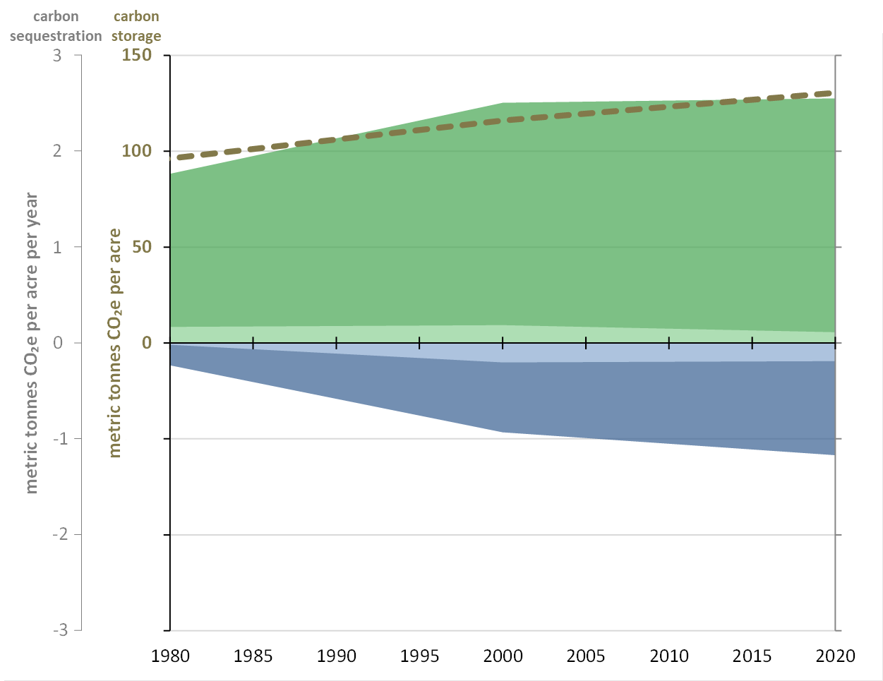
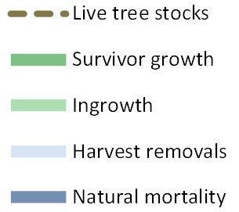
Carbon in live trees ≥ 5 inches DBH

*Natural mortality is currently a little more than six times – 6.2 – greater than harvest removals. As you can see natural mortality has been increasing in our forests.
By taking repeated measurements of trees over the past 60 years, on over 2000 plots across the lands the Division manages, we can estimate the magnitude of carbon stocks and trends in components of change. The brown dashed line near the top of the graph above shows a trend of continuously increasing forest carbon stocks – a net increase in carbon stocks, or storage, in our forest land, but currently increasing at a slightly slower rate than in decades past. While the net result of the process, as shown by this brown line, is useful, it is even more important to understand how and why it is changing. The green and brown areas that represent flux – sequestration or change per acre per year, are called the “components of change” when discussing forest growth and dynamics.
The darker green area above the x-axis represents survivor growth, the most substantial component of our growth at present. It is positive – adding to our stored carbon each year and so is above the x-axis in positive territory. As we can see, the increase in survivor growth is not as rapid as it once was.
The smaller, lighter green area immediately above the x-axis represents ingrowth, or the growth of small or young trees into our forest land. This is again, an addition to stored carbon, and so is shown above the x-axis. These are smaller trees and so while it's still adding to overall growth, we wouldn't expect it to be as much as survivor growth. A point of concern is the data indicates that ingrowth has been decreasing over the past 20 years.
The large darker blue area below the x-axis represents natural mortality. Since this removes carbon from the live tree pool it’s also below the x-axis. As you can see, natural mortality has been increasing in our forests. Factors that can be causing this include stressors such as forest pests, droughts, and severe weather. The legacy of landscape-scale patterns of agricultural abandonment, succession, and changes in age structure also induce stress on the forest. The effects of these natural disturbances are compounded when trees become crowded and don't have the room, or resources, they need to remain vigorous and resilient.
Finally, immediately below the x-axis, represented by the thin light blue area, is the carbon in live trees removed during forest management each year. This is another component of change, and is a removal of carbon from live tree stocks; so it's below the x-axis. Harvest removals increased from 1980 to the turn of the century, then have declined a bit. It’s important to note that it doesn’t include the carbon in harvested wood that is stored in long-lived products for long periods of time, though we do keep track of that. At present, harvest removals are only about 13% of net growth, which has an important relationship with sustainability as discussed earlier.
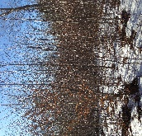
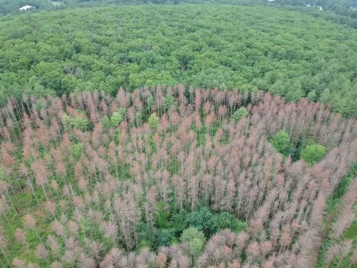
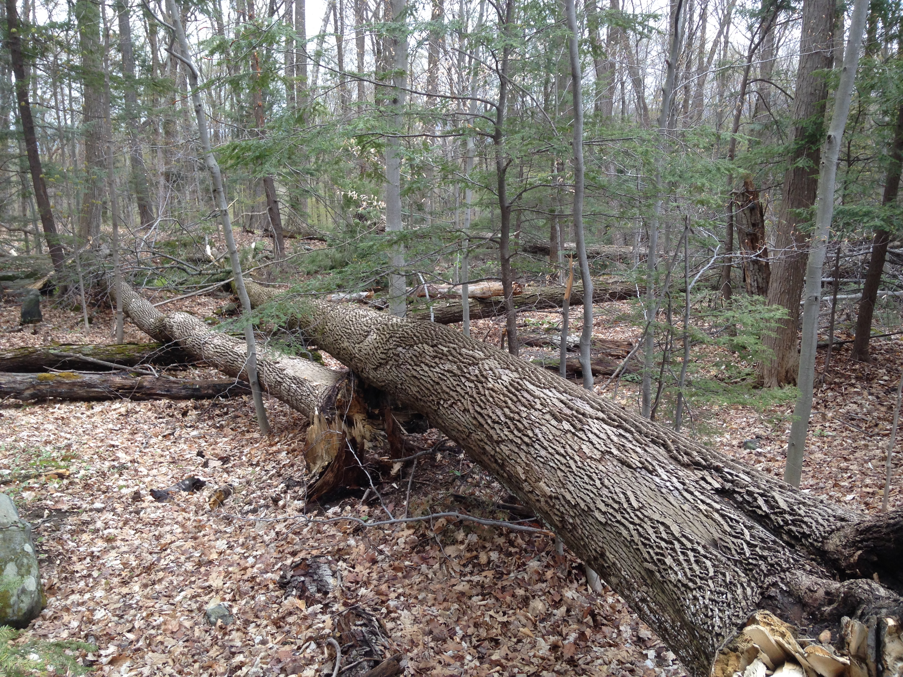
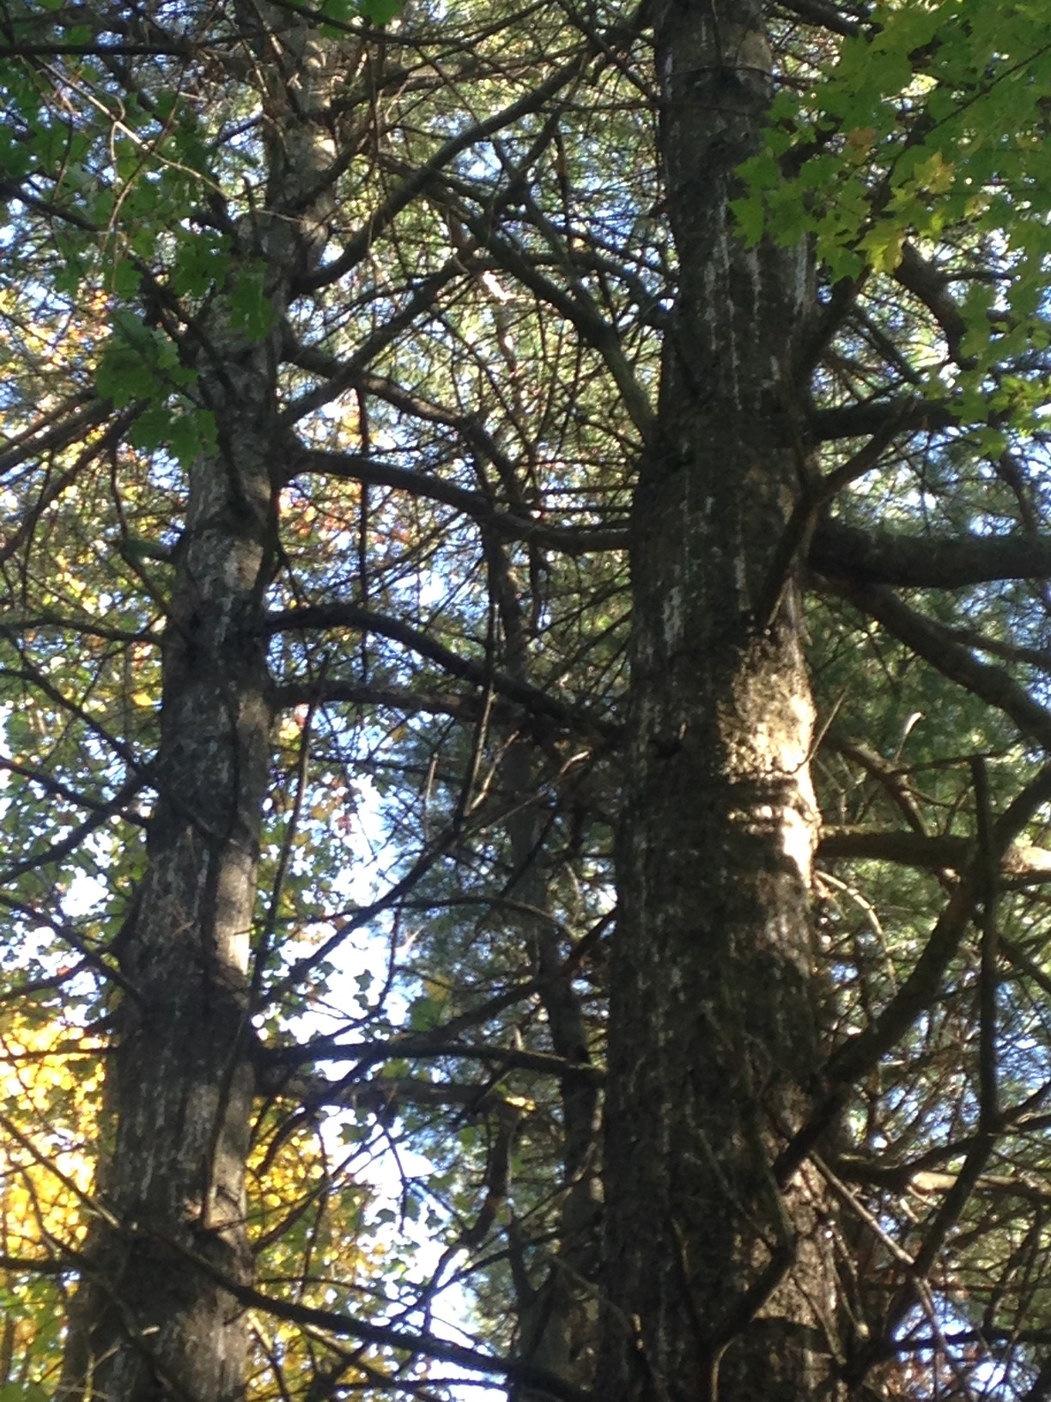
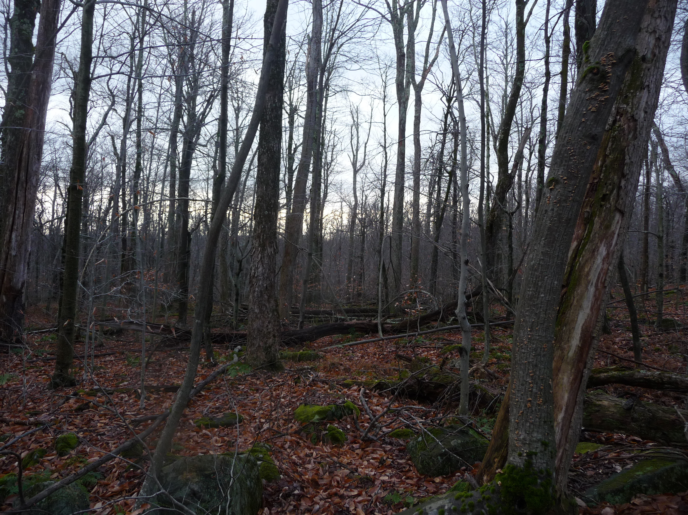
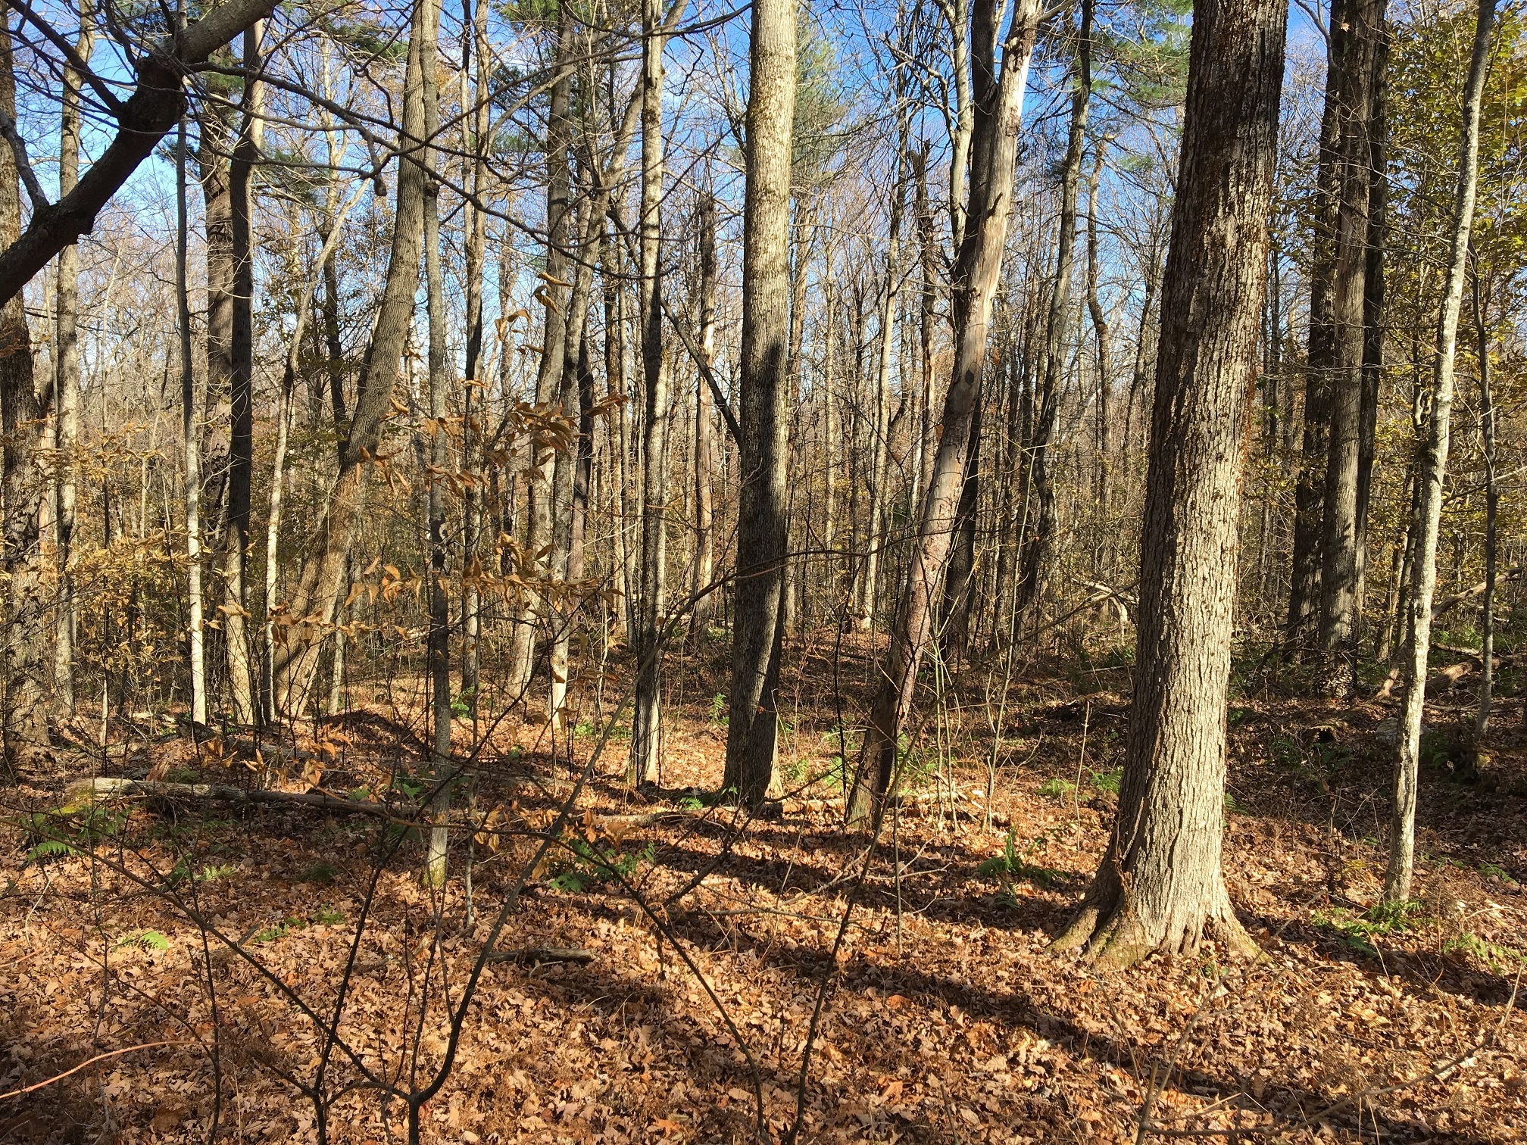
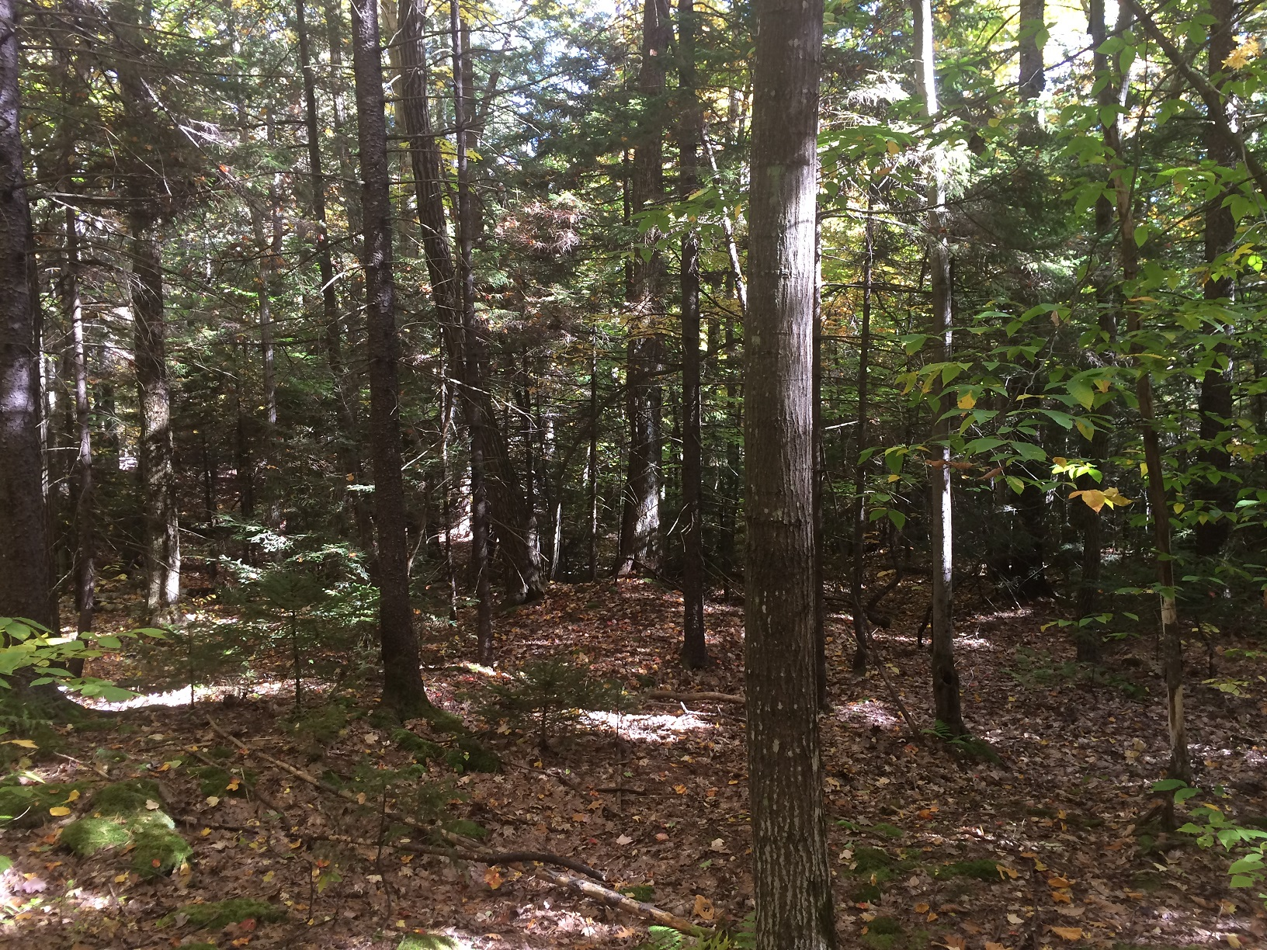
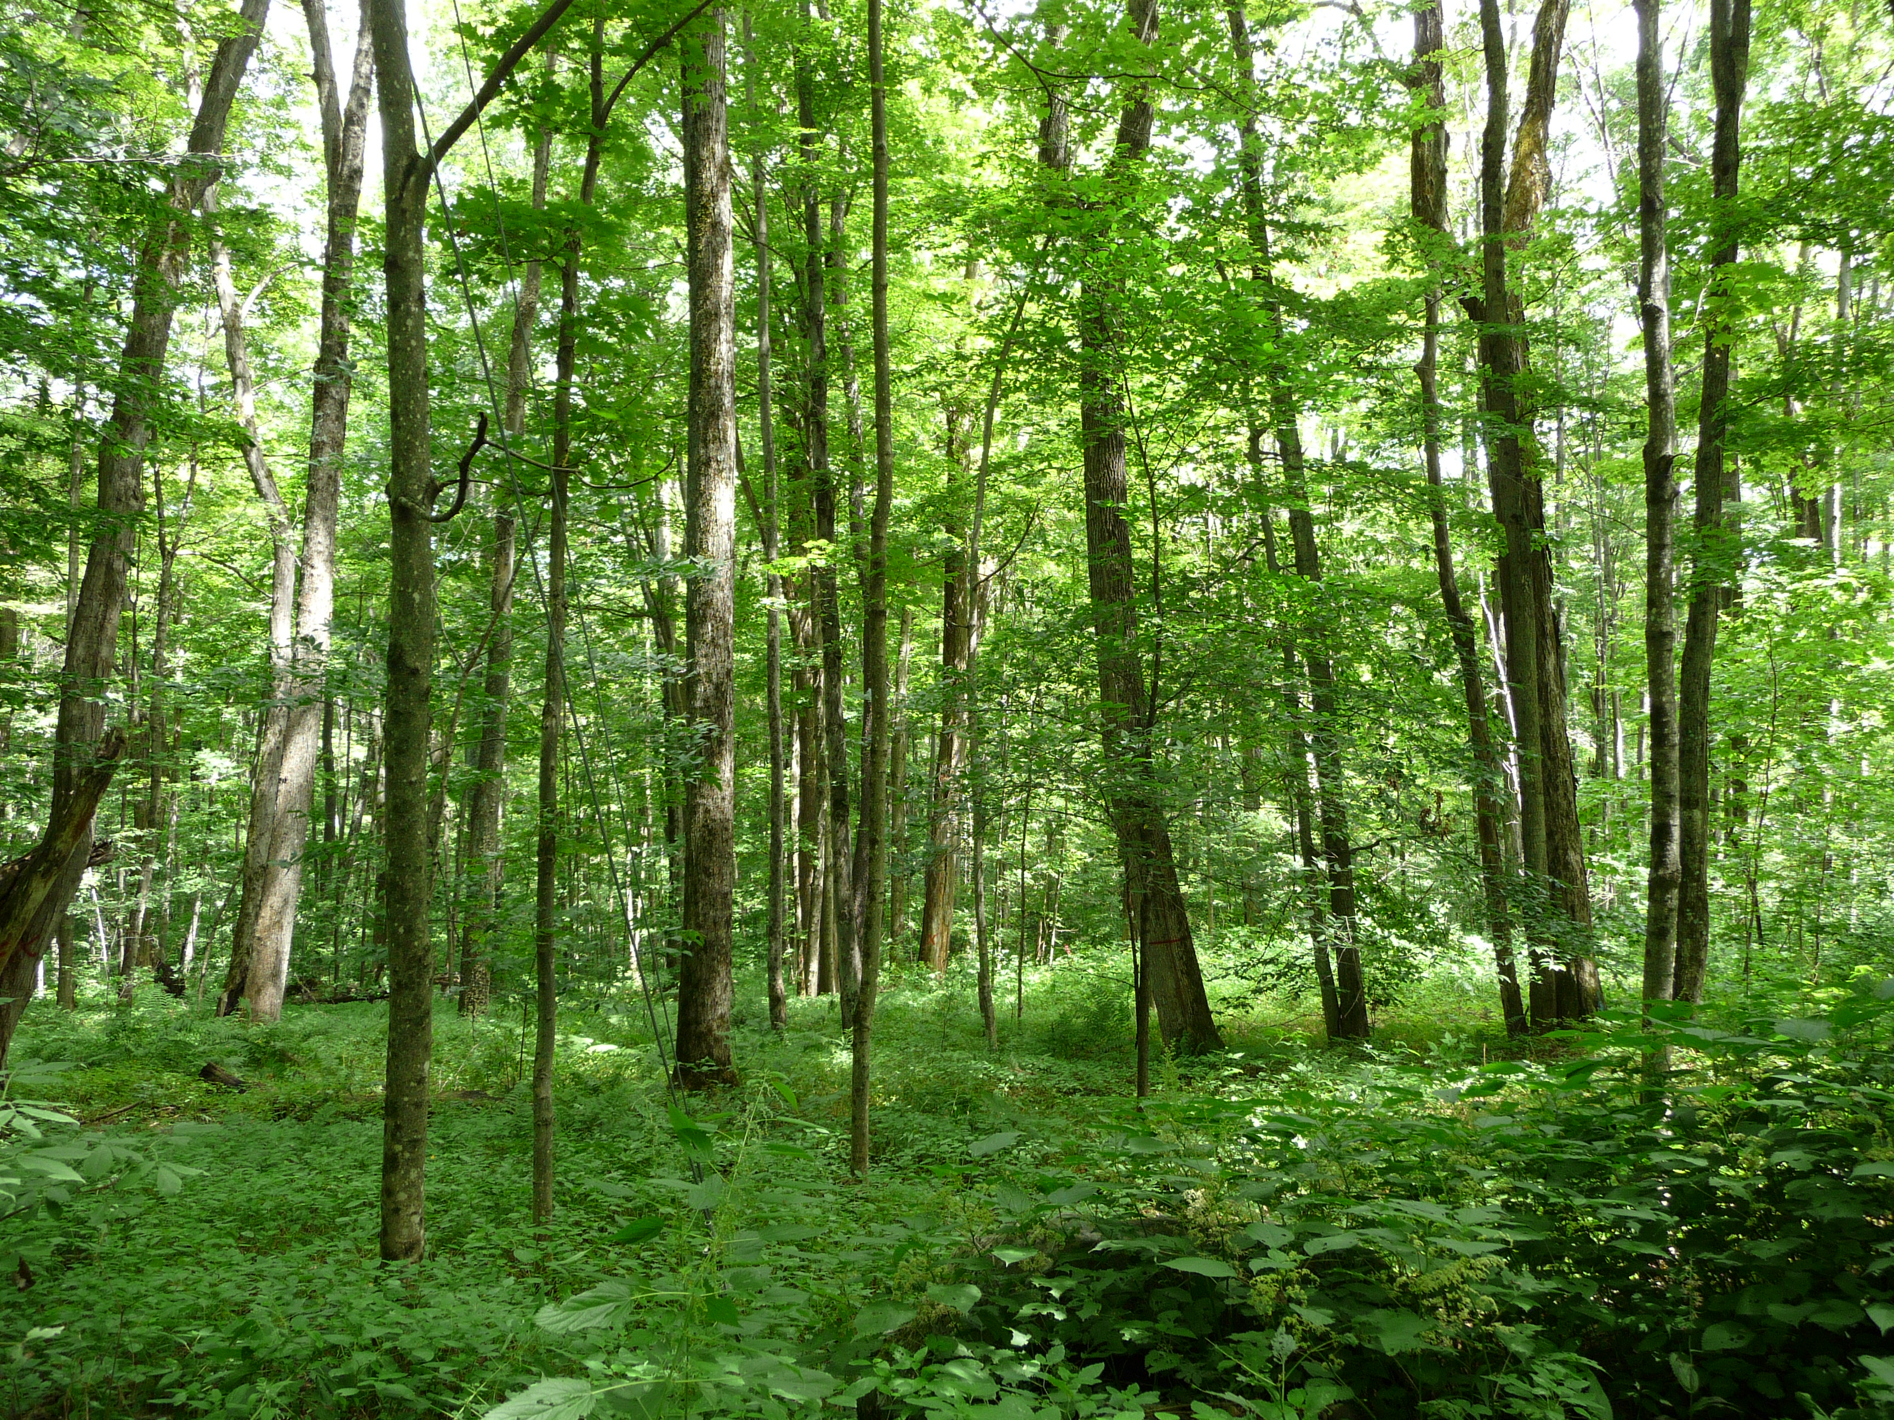
Negative Net Growth Stands
Range of Carbon Flux in and out of Live Tree Pool on DCR Lands
carbon sequestration: net growth all live trees ≥5” dbh, pounds of carbon per acre per year
area by class of sequestration/net growth

Average Stands
Highest-Performing Stands
Under-performing Stands

The previous graph depicted trends, averaged across all DCR’s forest lands. It’s important to understand not all forest land performs equally when it comes to carbon storage and sequestration; and this has important relationships and feedback loops with forest resiliency and adaptation to climate change. Forests that are not resilient cannot sequester or store as much carbon as those that are. This pie chart shows the proportion of area of DCR’s forest land by category of net growth, or carbon sequestration in live trees; with net Growth being calculated as survivor growth, plus ingrowth, minus mortality.
On DCR forests, CFI data indicate a wide variability on each forest’s ability to sequester and store carbon. The variability is largely related to the overall health, resiliency, and stocking levels of the forest. For instance, as stand density increases so does natural mortality. As noted above trees within the DCR’s forests are 6 times more trees are dying than are being harvested. Natural competition for resources dictates some trees will do well while others will fail. Other stressors include weather, pests, and pathogens. Foresters using trained judicial decisions, create favorable conditions for trees that demonstrate an ability to continue to thrive by reducing competition for resources, and risk from pests and pathogens. This technique is recommended as a strategy by the Northern Institute of Applied Climate Science (NIACS). https://adaptationworkbook.org/niacs-strategies/forest_carbon_management#approach-417
Starting from the top and moving clockwise are categories of increasing sequestration. For example, in area represented by the blue wavy lines, nearly 19% of DCR forest land, there is more carbon in live trees that are dying than are growing. These areas are effectively emitting more carbon from live trees than they are storing. The next six slices show the area of forest land in categories spanning ranges of 500 pounds – a quarter ton – of carbon, per acre, per year. At the other end of the spectrum, live trees are storing, on balance, over one- and one-half tons – 3000 pounds – of carbon per acre per year on 2.1% of our lands.

Why do forests store carbon differently?
In the upper right corner are some examples of areas that are experiencing negative net growth. These include areas where a large proportion of the trees are affected by a pest or pathogen; or an area experiencing an extreme disturbance affecting all the large trees, where there is no understory ready to take their place. For example, areas suffering heavy emerald ash borer mortality, failing plantations, dense hemlock stands suffering from hemlock looper infestations, etc. Here, trees are dying faster than they’re growing. Just because a live tree dies, it doesn’t mean the carbon disappears from the site; but I think it’s safe to say that we prefer to grow more live trees than dead ones. These large, dead trees are important for nutrient cycling, microsite variability, and myriad other reasons, and so in our forest management projects we carefully craft retention standards to meet project goals.
In the lower right corner are stands that are underperforming. These could include stands suffering from repeated ice damage; stands where the vegetation has been shifted toward browse-resistant species like beech. However, beech is susceptible to damaging agents like beech bark disease and so sequester carbon more slowly. Stands that are growing so dense where trees crowns are fighting against each other for space and light have few leftover growing resources to allocate to defenses. Airflow through an extremely dense canopy is limited, and so are more susceptible to fungal outbreaks, or insect infestations that rely on pheromone concentrations such as southern pine beetle.
Continuing to the lower-left corner are average stands. These may be stands that are nice to walk through; stands with a limited understory and a single canopy layer. However, these areas of average complexity and of average age tend to have average carbon sequestration rates.
Finally, in the upper-left corner are some examples of some of the highest-performing stands. One example of these stands are young, dense, vigorously growing stands where trees are rapidly growing in height and diameter. These stands may have upwards of 5,000 or even 10,000 seedlings per acre. In fact, over an average year of forest management projects, upwards of 2,000,000 of these seedlings may be established. They are rapidly sequestering carbon as they grow and race to the sky, as well as providing important habitat that has been noticeably declining for the past 4 decades. Another example of these sites that continue to rapidly sequester carbon are older stands that are highly complex. These have multiple species and sizes of trees comingling with each other, creating canopies with multiple layers. These will often be on rich soils, with fully utilized growing space and ecological niche.
All this is to say, that the relationship between forest carbon, and forest resiliency, is very interrelated. DCR foresters are evaluating the characteristics of each site to develop treatments that enhance stands’ resiliency to climate change and facilitate adaptation. Moving areas from the underperforming part of the pie chart, to sequester carbon at higher rates and move them to the green and black colored slices in the pie chart above, while balancing all the other ecosystem services for which DCR manages. DCR foresters are often evaluating every tree in a project area to make sure the stand, and landscape as a whole, is better positioned to mitigate and adapt to climate change while providing the full range of ecosystem services on which we all depend.
The following has been taken from the NIACS workbook.

Reduce competition for moisture, nutrients, and light.
Competition for resources between plants is a primary mechanism in plant succession and evolution (Weiner 1990). Plants compete aboveground for light and belowground for water and nutrients, such as nitrogen and phosphorus (Casper and Jackson 1997). A changing climate is expected to alter competitive relationships in forest ecosystems as growing seasons become longer, carbon dioxide (CO2) levels increase, precipitation patterns change, and temperatures increase. Reducing competition for limiting resources for desired tree species, particularly for seedlings and saplings, will increase the ability of forest systems to cope with the direct effects (moisture stress, increased temperatures) and indirect stress (increased pressure from pests and pathogens) of climate change (Evans and Perschel 2009). Reducing competition by alleviating climatic and biological stressors for desired species at early stages of recovery from disturbance can accelerate structural development in forest ecosystems (Dwyer et al. 2010) and increase carbon sequestration both during and following drought (Bottero et al. 2017).

Fire Prevention
The Landscape Designations for DCR Parks & Forests ²: Selection Criteria and Management Guidelines for forest health and protection recommends mechanical treatments such as fire breaks and mowing, along with prescribed fire, to reduce the buildup of hazardous fuels that can lead to a catastrophic wildlife. Mechanical treatments are supported by the National Cohesive Wildland Fire Management Strategy Northeast Regional Action Plan.³ Goal 1 of the action plan aims to restore and maintain resilient landscapes by: expanding the use prescribed fire, managing the risk of wildfire, and using prescribed fire to create unique habitats and sustain ecosystems. The plan also calls for the use of non-fire treatments that involve mechanical, biological, or chemical methods. This methodology aims to remove event fuels before a wildfire occurs. These activities are crucial because human populations continue to grow in forested areas, with homes and infrastructure near wildland fuels. These event fuels may also represent an economic opportunity to satisfy forest product demands ranging from biomass to higher valued products.
To better understand forest management, fire management, fire prevention, and resiliency the following is a link to an article by The Nature Conservancy https://www.nature.org/en-us/about-us/where-we-work/united-states/idaho/stories-in-idaho/wildfires-and-forest-management/.
Treatment for insects and disease
As with many of the objectives of the 2022 proposals, they are intertwined. Forest health is a great concern to the program for reasons mentioned in the climate change/forest resiliency and fire management/fire hazard prevention section. Global product markets have increased the amount of insect pests and pathogens that are having a negative effect on our forests. The mortality of trees within our forests is increasing to a point where many of our forests are under performing. In some instances our forests are net carbon emitters, as is the case with the Conway State Forest. By removing declining trees/stands we can reduce stocking of infected trees, while increasing growth and sequestration rates. NIACS has a dedicated web page in its Climate Strategies Workbook devoted to potential solutions. https://adaptationworkbook.org/niacs-strategies/forest_carbon_management#approach-416
The following is from the NIACS workbook found in Strategy 2.

Maintain or improve the ability of forests to resist pests and pathogens
Insect pests and pathogens affect large areas of forest across the U.S. annually. Although impacts are typically diffusely distributed across forest ecosystems, damage from insects and pathogens can cause large-scale transformations of forests through changes to species composition, forest productivity, and carbon stocks (Clark et al. 2009; Williams et al. 2016). Approximately 6% of forests are at risk to lose at least 25% live basal area in the next 15 years from insects and pathogens (Krist et al. 2007), with an estimated reduction of 21 TgC yr-1 in live biomass (Williams et al. 2016). Climate change has the potential to add to or intensify the impact of insect pests and forest pathogens, particularly where site conditions may increase the susceptibility of forests to damage (Spittlehouse & Stewart 2003). Management actions that alter the density, structure, or species composition may reduce the vulnerability of forest stands to carbon losses from these agents.

Examples
- Thinning to reduce density of a host species to reduce infestation
- Increasing diversity of tree species within forest stands
- Creating a diversity of age classes or stand structures to reduce the availability of preferred hosts for pests and pathogens
- Using pesticides or biological control methods to manage pest populations in infested areas

Improvement of wildlife habitat, diversification of even-aged forests, forest restoration, and ecosystem management
The American Bird Conservancy (ABC) and Cornell School of Ornithology has reported that 2.9 Billion birds disappeared in north America since 1970.
American Bird Conservancy https://abcbirds.org/3-billion-birds/
Cornell https://www.allaboutbirds.org/news/vanishing-1-in-4-birds-gone/?__hstc=161696355.fc7debf47f591bbf2f2153ad70663b67.1670442387852.1670442387852.1670442387852.1&__hssc=161696355.2.1670442387852&__hsfp=1383244671&_gl=1*zr98x1*_ga*ODk0Njk3MTgzLjE2MjcwMzU1Nzc.*_ga_QR4NVXZ8BM*MTY3MDQ0MjM4Ny4zLjEuMTY3MDQ0MjQ1My42MC4wLjA.&_ga=2.237678662.733105240.1670442387-894697183.1627035577#
The Conservancy has listed the top 20 most threatened bird habitats in the U.S., and one of these threatened habitat types falls within the boundaries of the lands owned by the Commonwealth of Massachusetts; early successional habitat in eastern deciduous forests http://abcbirds.org/wp-content/uploads/2015/05/habitatreport.pdf . The lack of this general forested habitat condition has also been noted in Mass Wildlife’s State Wildlife Action Plan.
Cornell, Mass Wildlife, and the ABC are not the only organizations researching the loss of early successional habitats; and the wildlife which rely on these conditions. National organizations such as Audubon, Partners in Flight, US Fish and Wildlife Service, USDA Forest Service, USDA Natural Resource Conservation Service, National Fish and Wildlife Foundation, Ruffed Grouse Society, American Woodcock Society, National Wild Turkey Federation, and the Wildlife Management Institute have also noted the severe declines in the habitats and wildlife which utilize them. Locally, Mass Audubon and Land Trusts have recognized declines in these wildlife species and habitat.
While it is well recognized in the conservation world that these declines have occurred due to the loss of habitat to human development, as well as forest maturation ^{4.} https://www.mass.gov/service-details/state-wildlife-action-plan-swap , research and ongoing discussions are working to quantify the amount of young, medium, and older forest conditions that are needed to help sustain the broad spectrum of forest wildlife. Some of the first research conducted by USFS researchers in the Northeast have suggested Forest stage Class models. The Richard DeGraaf et al. Technical Guide to Forest Wildlife Habitat Management in New England⁵ is widely employed. https://www.fs.usda.gov/nrs/pubs/jrnl/2006/ne_2006_degraaf_001.pdf .

Comparison of Current DCR Forest Stage Class Distribution by Diameter to those of Expert Consensus
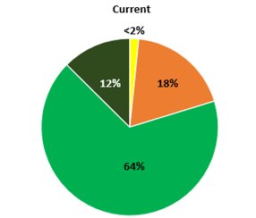
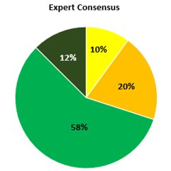

Currently the amount of young forest cover on DCR forests reflects the decline in early seral forests as observed by ABC and others. Currently, DCR lands have less than 2% young forest cover. To help bring DCR’s stage class distribution into balance the program has solicited recommendations from the literature, as well as climate and wildlife researchers. The proposal projects reflect improvements to younger habitats as noted by the ABC and others. While the size of the young forest creation is at the minimal size suggested by DFW and other researchers, it is at the maximum size allowed under the current Landscape Designation Document.

Pine Barrens Restoration
One of the prioritized goals for the proposed projects spelled out in the State Forest Action Plan is biodiversity. The Department of Conservation and Recreation and Mass Wildlife have been in the process of restoring nearly 2,400 acres of pitch pine-scrub oak barrens in the Myles Standish Complex. This year’s proposal on the Manuel F. Correllus State Forests mimics the restoration efforts at Myles Standish. Pine barrens habitats are very sandy, fire prone, and contain many species of conservation need as noted by the Natural Heritage and Endangered Species Program. While the work will reduce the risk from wildfire within the area, it will also restore habitat for plants and animals that thrive in this ecosystem.
If this habitat work is not done, the specialized native plants and animals of the pine barrens will vanish from the area. As the barrens increase in tree density, other plants such as low-bush blueberry and wild indigo are shaded out. As their barren’s habitat disappears, the many animals depending on these plants for food and cover will also disappear.⁵ https://www.mass.gov/info-details/featured-habitat-projects#montague-plains-wma-barrens-restoration-(montague)- .
Improvement of recreational experiences
The objectives and goals of forest management are designed to deliver multiple ecosystem services, to include diverse recreational experiences. Forest Management for recreational pursuits lead to other benefits as well. Creating a landscape with diversified stage classes helps with climate change resiliency and biodiversity. The management of the Bryant Mountain ski area creates early seral habitats for breeding birds, climate resiliency, and provides back country recreation during appropriate times of the year. At the October 27, 2022, Cummington Selectboard meeting, the board and several attendees spoke of their support for the project; and reminisced when the ski area was open. This project is in partnership with DCR Trails program and the Western Mass Back Country Alliance; a 501(C) 3 organization affiliated with the Catamount Trail Association.

Assenting Comments.
The Forest Management Program received supportive comments from individuals, groups, and land trusts. Their reasons for agreement with the management projects ranged from climate change resiliency and biodiversity to insect and disease treatments, and sustainable wood products. The program thanks the entities for their support. These are responses to comments 7, 8, 9, 10, and 13, which can be found in Appendix 2.
General topic list of supportive Comments included:
a) Climate Change adaptation, mitigation (resiliency) and carbon sequestration and storage.
b) treatment for insects and disease.
d) ecosystem restoration.
f) improvement of wildlife habitat.
g) improvement of recreational experiences.
h) sustainable wood products.
Uncategorized Concern – Comment Number 3.
Hello, my name is Tom Hoffman, and I am on the Town of Washington Historic Commission. I attended a presentation on the 24th of October at the Washington Selectman’s meeting, regarding a logging operation in town.
I have a concern about 5 cellar holes from the mid 1800's, that appear to be in the cut zone. There is also an abandoned section of an historic 1804 road, that is in the zone. Kris Masssini has asked me to send him a map with gps coordinates, of the foundations and the road.
I would ask that the foundations and the road are not disturbed by skidder traffic, or the holes filled with slash. Beyond that, the best of luck with the project! Thank you!
The above email raises a concern for the care of historical artifacts such as stone walls, roads, and cellar holes. This concern was echoed by the same person at the Town of Washington Selectboard meeting attended by staff of the Forest Management Program. It is a serious concern, and the Forest Management Program working with DCR’s Cultural Services have standing protocols for the protection and preservation of these resources. During the 45-day internal review, comments and recommendations are received from Cultural Services. Any additional measures that may need to be taken for their care and preservation are implemented during the appropriate phase of the project. Additionally, contractual language ensures these protocols are followed.

Uncategorized Concerns – Comment #15
Many of the concerns raised in this comment were also heard in Franklin County Superior Court in 2020, as part of a lawsuit regarding a Forest Management Project on Wendell State Forest. The lawsuit against the DCR was dismissed.
- Potential for a violation of MGL Chapter 132A, Section 2B

All proposed projects are in areas outside of the METROPOLITAN PARKS DISTRICT. Please refer to MGL 132A for areas outside of the Metropolitan District.

- Justification for Commercial Logging
According to the current Landscape Designation Document, the definition of Commercial Logging is “the practice of forestry with the object of producing timber and other forest produce as a business enterprise or for sale to a business enterprise.” All timber produced through DCR Forest Management Projects are a byproduct of sound and sustainable forest management and not with the object of producing timber as a business enterprise. Therefore, management conducted on DCR properties does fall within the cited definition of commercial logging. Furthermore, logging is the most cost-effective means of accomplishing the objectives of a management project. The DCR would pay to do the same work should the option of selling the timber be removed.

Mass General Law, Chapter 132A clearly states the duties and responsibilities of the Bureau of Forestry:

Section 1F: Duties of bureau of forestry
Section 1F. The bureau of forestry shall, under the supervision of the director, with the approval of the commissioner perform such duties as respects forest management practices, reforestation, development of forest or wooded areas under the control of the department, making them in perpetuity income producing and improving such wooded areas. It shall be responsible for such other duties as are now vested in the division of forestry by the general laws or any special laws and shall be responsible for shade tree management, arboricultural service and insect suppression of public nuisances as defined in section eleven of chapter one hundred and thirty-two, subject to the approval of the director and, notwithstanding the provisions of any general or special law to the contrary, the bureau may require all tree spraying or other treatment performed by other departments, agencies or political subdivisions to be carried out under its direction. The bureau may promulgate rules and regulations to carry out its duties and powers. It shall assume the responsibilities of section one A of chapter one hundred and thirty-two and shall be responsible for such other duties as are not otherwise vested in the division of forestry.
Section 3. The commissioner may, from time to time within the limits of appropriations made therefor, acquire for the commonwealth, by eminent domain under chapter seventy-nine or by purchase, lease or otherwise, any lands suitable for purposes of conservation or recreation lying outside of the urban parks district, and may lay out and maintain such lands for such purposes and erect and maintain such structures and other facilities thereon as may be necessary to render such lands reasonably available and accessible therefor; provided, however, that no land held in trust for public use shall be taken by eminent domain. The commissioner may, with the approval of the governor and council, sell or exchange any land acquired under this section which in his judgment can no longer be advantageously used for purposes of recreation or held for purposes of conservation. He may, with like approval, authorize the construction and maintenance, on any land under control of the department and outside the urban parks district, of towers, poles, wires, pipes, and structures necessary for the purpose of transmitting electric power or intelligence by electricity, and may grant an easement over such land for such purposes. He may, at any time, sell such wood, timber or other product of the lands controlled by the division as the economical management of said lands may require.

- MEPA and legislation found in MGL Ch. 30, sec. 61,

MGL CH 30. Section 61. All agencies, departments, boards, commissions, and authorities of the commonwealth shall review, evaluate, and determine the impact on the natural environment of all works, projects or activities conducted by them and shall use all practicable means and measures to minimize damage to the environment.
The Forest Management Program conducts a 45-day internal review within the Department. All project proposals are sent to Cultural Services, the DCR Office of Natural Resources, and DCR Park Operations. Prior to public review, project proposals are sent to other state agencies such as Mass Wildlife and the Natural Heritage and Endangered Species Program. Additionally, Forest Cutting Plans are filed prior to any pertinent management activities and are subject to MEPA review.

- Concerns Regarding 302 CMR 16.

Prior to any management on DCR lands a Forest Cutting Plan is filed with the service forestry program. This document is reviewed by the Natural Heritage and Endangered Species Program and local Conservation Commission. All specific abuses should be reported to the regulatory agency.
“(1) Land.(a)ENF and Mandatory EIR.1. Direct alteration of 50 or more acres of land unless the Project is consistent with an approved conservation farm plan or forest cutting plan or other similar generally accepted agricultural or forestry practices.” 301 Mass. Reg. 11.03
- Concerns Regarding the Best Management Practices (BMP)

The current Best Practices Manual is dated 2013 and was revised by personnel from both the DCR and the University of Massachusetts. By academic, legal, and industry standards this represents current and accurate information.
Please refer to the comment responses regarding Climate Change and Carbon Sequestration and Storage. The Department is very open to receiving scientific, peer reviewed suggestions to our BMP’s as they relate to the Climate Change Emergency. We have reviewed the suggestions offered within the High Stead Report and suggestions of others made for the implementation of “Proforestation”, however, have concluded that it is not a feasible management regime (see SAF Position Statement in the Appendix). The DCR Forest Management Program uses many approaches in the care of the Commonwealth’s Forest, as each one is different. We do not take a cookie cutter approach. Thinning and regenerative operations, as well as passive management, are all employed by the DCR to promote resiliency, biodiversity, increased carbon sequestration, and increased carbon storage.
For further information. Please refer to the Carbon and Wood Products section of this response document. Additional references include a letter by the faculty of the Yale School Forestry responding to the Connecticut Governor’s Council on Climate Change, and can be found in Appendix I.

- Corruption, Abuse, Malice, Waste

The DCR holds the personnel within the Management Forestry Program to the highest of legal and ethical standards and is reinforced by the requirement that all practicing Foresters be licensed. Should there be any evidence to the contrary, the program would encourage contacting the Forestry Licensing Board and/or the Office of the Inspector General Waste, Fraud, or Abuse Hotline.

Appendix I
Yale letter
SAF Statement

Appendix 2
Comments

A method of vetting articles. Articles submitted to a peer-reviewed publication are sent out to several scientists who work in the same field as the paper’s author. Those reviewers provide feedback on the article and tell the editor of the publication whether or not they think the study is of high enough quality to be published. – UC Berkley. For instance, research corresponding to Forest Management must be vetted by Forest Management experts with advanced education and a portfolio of like research to be considered a peer. A peer-review and a concurring opinion on the quality of work for publishing are not synonymous.

