

Massachusetts Rehabilitation Commission Statewide Rehabilitation Council

A N N U A L R E P O R T 2 0 2 2

T A B L E O F C O N T E N T S 2 0 2 2

A Letter from the Chair
2
Celebrating SRC’s
Doug Mason
6
10

Vocational Rehabilitation Year in Review
12

Committee Reports
4 Vision, Mission, Structure
5 Appointed Members
8 Explore Possibility Summit
18 Recommendations
20 NextGen Feature
22 Disability Inclusion Leaders



State Rehabilitation Council 1

LETTER FR OM THE CHAIR
Inez S. Canada

Apply to join the Statewide

DEAR SRC MEMBERS AND SUPPORTERS:
T
he close of another fiscal year gives us a chance to evaluate our progress and map out the road ahead. In our day-to-day work, the Council’s focus is often on addressing our immediate needs or on collaborating
with the Massachusetts Rehabilitation Commission (MRC) to tackle the next big task. However, the SRC Annual Report invites us to take a moment to reflect on the year and celebrate our achievements. A few of them are below, but we hope that readers will review this full report and join us in celebrating all that the
Statewide Rehabilitation Council accomplished in FY22.
WE HAVE A BUDGET!
For the first time in the five years since I joined the Council, the SRC submitted a budget. With the full support of MRC, we developed and voted to approve an itemized budget for the year. This funding will support requests for ASL Interpreters and Communication Access Real-Time (CART) services at Quarterly meetings; for trainings on how to grow, diversify, and develop our membership; and for hiring administrative support. Thank you to our MRC Liaisons, Deputy Commissioner Kate Biebel and Director Amanda Baczko of the Office of Individual and Family Engagement, for their extraordinary partnership which helped the SRC reach this noteworthy milestone and fulfill one of the goals in the SRC DEI Five-Year Roadmap.

WE HAVE REPRESENTATION ON THE MRC DEIA COUNCIL!
Our commitment to Diversity Equity Inclusion and Accessibility (DEIA) continues to flourish. The principles and practices of DEIA that Health Management Associates taught us have positioned the SRC as strong partners in DEIA work at MRC. The knowledge that the SRC gained, combined with the human resource back- ground and expertise of our SRC DEIA representative (featured on page 6 of this report) adds an important perspective to the DEIA conversation at MRC. The SRC will support the development of equitable policies and practices across MRC and provide meaningful input
on building a culture of belonging that will flow out to MRC consumers. This early, intimate involvement in shaping the consumer experience from inside the Agency is the model of what our SRC is becoming.
OUR INPUT LEADS TO MEANINGFUL CHANGE!
The Consumer Satisfaction and Needs Assessment committee (CSNAC) compiled SRC member feedback on the MRC Consumer Experience Survey. Based on that input, the CSNAC Chair submitted a comprehensive document with suggested changes to the survey design and direct survey questions. MRC was grateful for this clear, thoughtful input and implemented over 90% of the proposed changes. Thanks to the SRC’s input, this new survey will more effectively capture
the needs of consumers and their level of satisfaction with vocational rehabilitation services. Continued review of survey response data will enable the SRC to recommend actionable steps to improving VR services for consumers. Read more about this exciting project on page 10.

These three accomplishments signal the beginning of a new journey for the SRC; one that is revolutionary, yet sustainable. We invite SRC members to leverage their expertise for the good of the diverse communities of individuals with disabilities that the SRC represents.
We encourage all readers to explore the committee highlights to note the amazing work we have ahead. Consider joining the SRC as a voting member or a member of the public. FY22 was not without challenges and FY23 will bring more but let us continue to embrace those challenges as catalysts for growth.

Thank you to our members for your service on the SRC, especially our committee chairs. Thank you, Commissioner Toni Wolf, Deputy Commissioner Kate Biebel, and Assistant Commissioner of VR, Joan Phillips, for your unwavering support of the SRC. Thank you, Amanda Baczko, Director of the Office of Individual and Family Engagement, for the numerous ways you contribute to the SRC. Thank you to our MRC liaisons who support our committee work and thank you to the MRC support staff who work in the background to help the SRC accomplish its tasks.
We see you all and we say a sincere “Thank you.”
With a grateful heart, Inez S. Canada, Esq.
Chair, State Rehabilitation Council

Rehabilitation Council (SRC)
Are you interested in breaking down
employment barriers for individuals with disabilities?
Are you passionate about equity for individuals with disabilities in the workplace?

Contact : mrc.staterehabcouncil@mass.gov

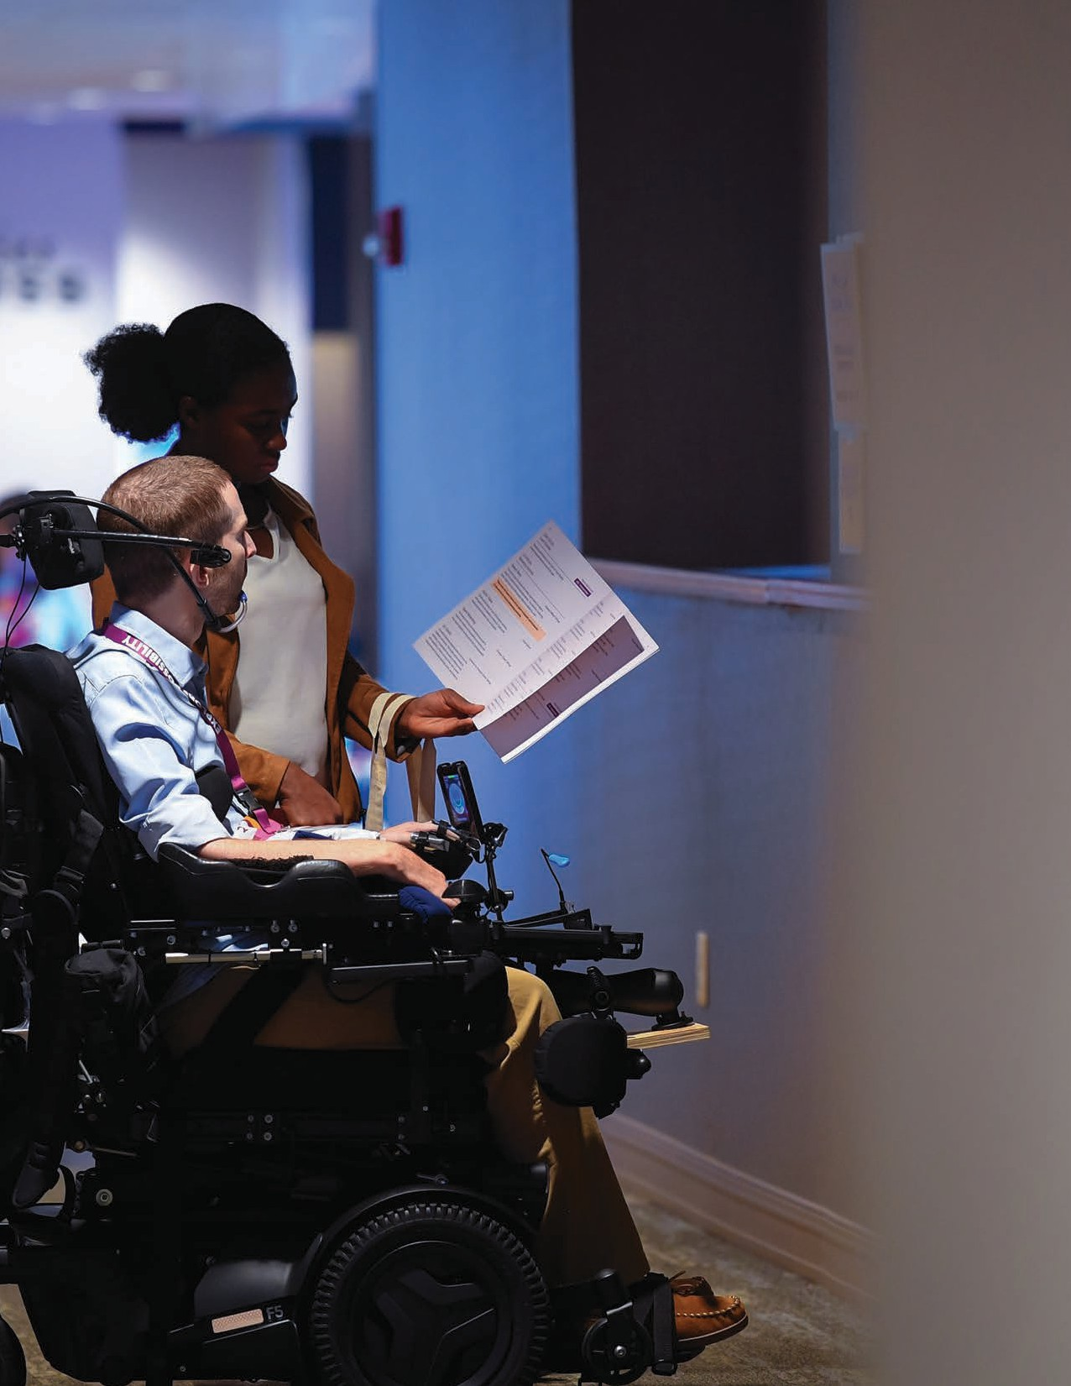

2 State Rehabilitation Council 3

What is the SRC?
The SRC is a diverse, inclusive, and equitable advisory body that gathers representative voices from the disability community to provide input to the Massachusetts Rehabilitation Commission’s (MRC) Vocational Rehabilitation Division.

The Council’s collective and individual thinking plays a substantive role in how the vocational rehabilitation program operates and contributes to the innovation of career and counseling services. Members of the SRC collaborate with MRC in developing goals and priorities for the state plan, and offer input and consultation on policies, practices, and procedures that impact jobseekers.

If you are an employer, individual with a disability, family member, advocate, service provider, and/or someone who wants to make a difference in people’s career-goals, this is the group for you!
Client Assistance Program
Consumer Advocates
Partners
State Rehabilitation Council
State Rehabilitation Council Organizational Structure
Executive Committee
4 State Rehabilitation Council

Business and Employment Opportunity

State Plan and Inter-agency Relations

Comprehensive Needs and Consumer Satisfaction

Policy

Massachusetts Rehabilitation Commission

Vision:
We envision a world where all individuals with disabilities are supported to live their best lives, through consumer-driven, meaningful, competitive, and integrated employment and sustainable careers.

Mission:
We work to promote competitive and sustainable employment for all people with disabilities, including those marginalized by inequalities.
Government Organizational Structure for Funding & Oversight

SRC Appointed Members FY22
Matthew Bander
Disabilities Rep
Youcef J. Bellil
Disabilities Rep
Kate Biebel
MRC Ex-officio Deputy Commissioner
Inez Canada
Disabilities Rep
Lisa Chiango
Disabilities Rep
Barbara Cipriani
Business/Labor/Industries
Dawn E. Clark
Disabilities Rep
Rebecca Davis
Parenting Training/Info Center Rep
Paula Euber
MRC VR Rep
Ronaldo Fujii
Disabilities Rep
Naomi Goldberg
Client Assistance Program (CAP)
Steve LaMaster
Community Rehab Services Provider Rep
Lusa Lo
Higher Education Rep
Catherine D. O’Neil
Business/Labor/Industries
Ellie Starr
Business/Labor/Industries
Cheryl Scott
Workforce Investment Board (WIB)
Olympia Stroud Dept. of Elementary & Secondary Education
Christine Tosti
Disabilities Rep
Heather Wood
Disabilities Rep
Rosanna Woodmansee
Business/Labor/Industries
Vacant
Un-served/Under-served Rep
Vacant
Statewide Independent Living Council (SILC) Rep
5
Office of Special Education and Rehabilitation Services
Rehabilitation Services Administration (RSA)
Required under law for all state Vocational Rehabilitation Programs
Massachusetts Executive Office of Health and Human Services
Massachusetts State Rehabilitation Council

United States Department of Education

Massachusetts Rehabilitation Commission
PARTNERS

Doug Mason
A Lifetime of Experience
in Pursuit of Equity
B Y NICK PIZZ OLA T O

Disability advocacy wasn’t always Doug Mason’s focus, but growing up in the segregated south, his pursuit for equity began at an early age. After the passage of the Civil Rights Act of 1964, 14-year-old Doug and his best friend went to the segregated Rexall Drug Store in his hometown and ordered an ice cream float. Then they took a seat at a table together, for everyone to see, that change was coming. Since that day, Doug has sat at many tables as an agent of change. Doug always created opportunities for himself, and he had the support and encouragement of his family.
“My mother was the most influential person in my life,” he said.
“She stressed that she wanted more for my siblings and me” Doug’s achievements added to his enthusiasm for creating opportunity and equality in his professional and personal life.
oug was the first member of his immediate family to go to college, attending Virginia Union University
in 1969 and majoring in accounting. He completed a four-year program in just three years, moved to Boston to explore employment options, and spent the early part
D
of his career in multiple finance roles, from being an auditor at John Hancock to exploring the role of a
public accountant. He began working at the Boston office of the international CPA firm Coopers & Lybrand, where he became the first person of color in that office to become a manager.

After five years at Coopers & Lybrand, of the 600 professional staff employed, he noticed that while 40% of the workforce were women, only six were people of color. “As you see the inequities that exist, you realize that there is a fight that must be had,” Doug recalled.

He shared, “I looked at it as a continuation of fighting inequity and inequality and doing whatever I could to level the playing field.” He asked his mentor about the hiring disparity. He, in turn, brought the question to executives at the firm. To Doug’s surprise, executives asked him what he thought needed to be done to fix the situation.
He shared that many students of color can do the work, but the firm needed to look in the right places to find them.

Doug was asked to establish an internship program that provided opportunities to minority students. He knew right where to look, Historically Black Colleges and Universities, like Virginia Union, his alma mater. “It’s the way I was raised. Everyone has a personal responsibility and obligation to help someone whose circumstances are different.”

Doug brought that mentality to every organization he joined; they included the Boston Redevelopment Authority, where he was the first black person to hold a management position. While there, he focused on recruiting and hiring women and people of color to create an equitable workforce so that the accounting department better represented the people they were serving in Boston.

During his thirty-year career in finance, Doug became active in civil and professional groups that all focused on increasing awareness of diversity, equity, and inclusion. He was on
the Board of Directors for the Urban League of Eastern Massachusetts and a founding member of the Codman Square Housing Development Corporation, which focused on creating affordable housing for Dorchester residents. Doug was a member of the Boston Private Industry Council, where he
was a mentor to young professionals starting their careers in accounting and finance. He also helped to restore the Boston
Chapter of the National Association of Black Accountants. He even had the opportunity to teach Economics at Harvard University.

In 2000, Doug’s life changed when he was diagnosed with multiple scoliosis (MS). Doug had spent his life overcoming adversity and being an advocate for himself and others, so he started to learn more about disability related systems and how could they better assist the people like him who needed
them. “I was so naïve that I did not realize “hidden disabilities” existed,” he said.

“Throughout the process of obtaining services to live independently, I became aware of many people experiencing disabilities who could not advocate for themselves,” Doug shared. He began working with an Independent Living Center to help him transition to his new lifestyle. While receiving home-
making services through the Home Care Assistance Program (HCAP) through, supported by the Massachusetts Rehabilitation Commission’s (MRC) he began to attend the quarterly meetings of the HCAP Advisory Council and later became a member.

His attention to detail and focus on advocacy were noticed, and he was asked to join the Statewide Rehabilitation Council (SRC), the advisory group to vocational rehabilitation at MRC. “I was surprised to be asked,” Doug said. “But, it’s another way for me to continue to contribute and help someone else that needs assistance.”

“I was approached by SRC’s Chair Inez Canada to join the Council because of my passion and history of being an advocate.” Doug represents the SRC on the MRC Diversity, Equity, Inclusion, and Accessibility Council bringing his knowledge and passion to the table to advocate for people with disabilities, people of color, women, and members of the LGBTQ+ community.

“We have a lot of growing to do,”
Doug shared. Still, he’s focused on two things: creating a representative work- force at MRC and ensuring the agency reaches individuals in underserved communities. “We want to know who the agency is serving, and we’re starting to see that data and analyzing it, so we’re on the right track.”

When he’s not working with the SRC, the 72-year-old focuses on helping raise his grandson. “I want to have as much of a positive influence on him as I can,” Doug laughed. He knows that the fight for equity and accessibility isn’t over, but through education and advocacy, he’s hopeful that society will start to change for the better.

But Doug’s fast to remind us that it takes everyone doing their part, saying, “Everyone can talk about what’s right or wrong, but what are you doing to fix it.”


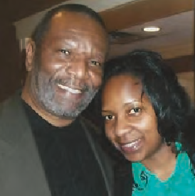

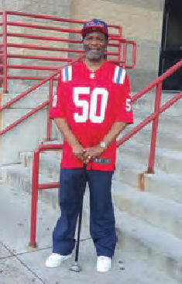
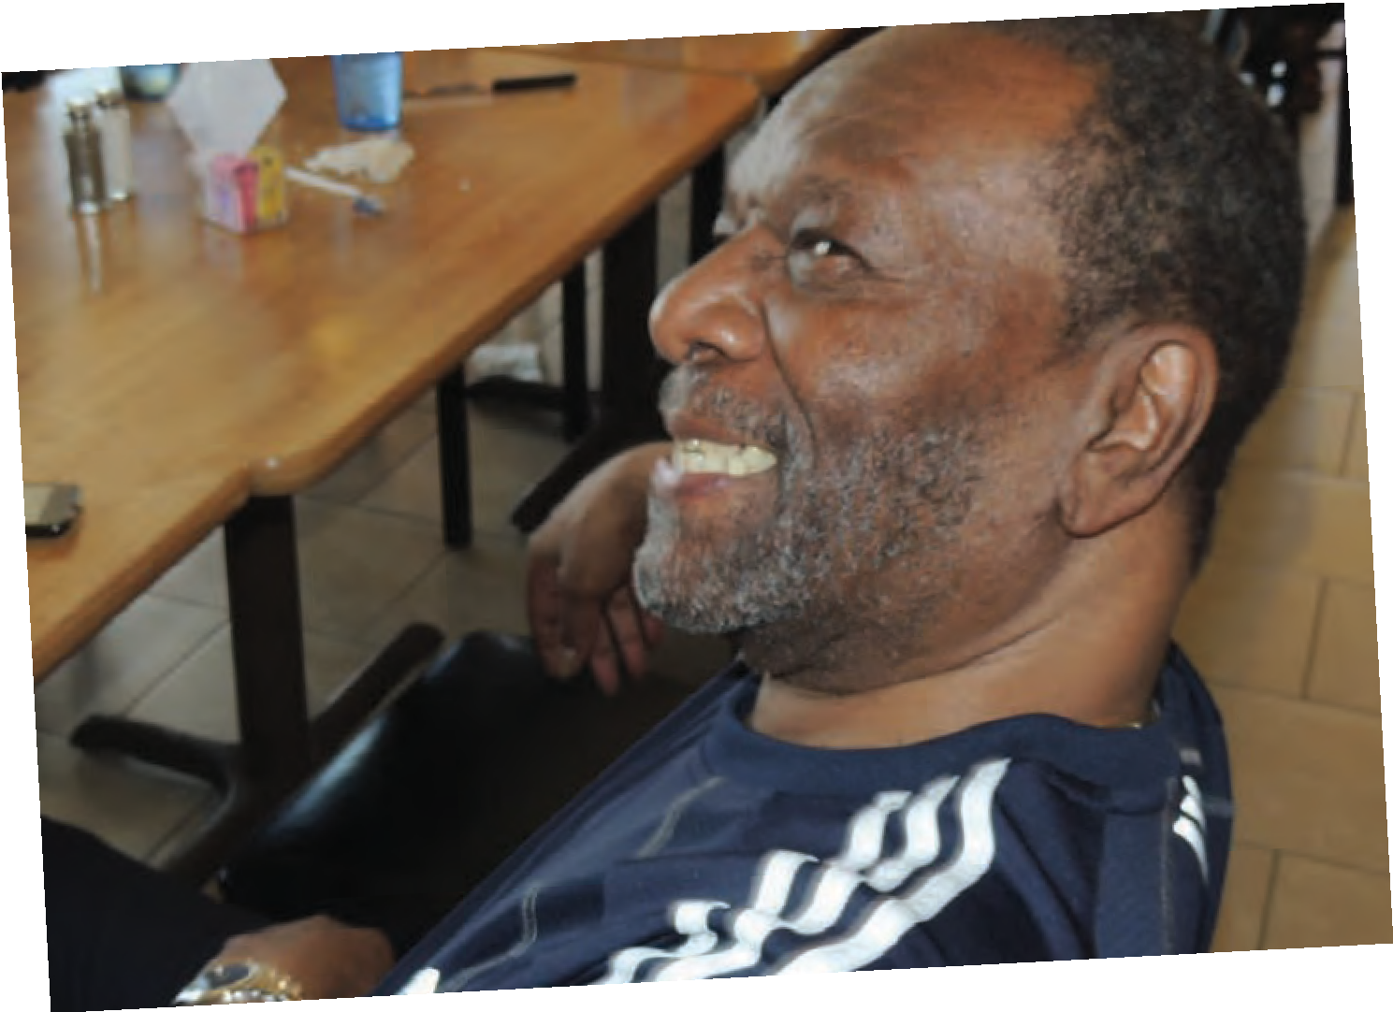
6 State Rehabilitation Council 7

We are here to focus on our resilience, to celebrate one another, continue to learn from one another, and work together as we make Massachusetts more inclusive,” she said.

Jazz composer, teacher, musician, and keynote speaker Matt Savage spoke to the audience about his experience living as a person with autism and being a piano savant as a child. “When I was a child, loud noises made me uncomfortable,” he shared with the audience. When Matt turned six, he started to play the piano and found that “music started to really open me up to the outside world. To have a visual representation of a piano key match the pitch of a note, it helped me grow into music.” At seven, he started playing jazz, inspired by piano greats like Thelonious Monk. “It was hard for me to stop, and since then, the piano has always been a part of my life.”

“It’s been a pleasure and privilege to teach this type of music. Some may think that music jobs for people with disabilities may be difficult.

There were people there with many disabilities, and everyone embraced one another. I didn’t feel alone or that
I stuck out in a crowd. It felt natural and easy for me to ask for accommodations.”

Summit Success

Inaugural Explore Possibility Summit Celebrates Disability Community
But the arts are therapeutic and essen- tial,” Matt concluded before playing
an original piece for the 500 people in attendance.

The event fostered a learning environment for attendees, offering diverse workshops to help them understand resources, services, and tools that were available from MRC and our statewide partners.

Alison Scher, an MRC employee who has received MRC services, shared that she loved the energy in the room.

“I’m a professional with a disability, a parent with a disability, and I’m proud to be a part of the community.
We can continue to make an impact by working together.”
JOEY BUIZON
Supervisor of Employment Services Massachusetts Commission
for the Blind
“I was able to chat with people who had just joined the MRC community,”
said Brendan Shea, who also attended the Summit. “It was a great opportunity for them to
see and meet other people who use services. There was some- one who had questions about securing rides and mobility.
They talked to other people who use wheelchairs and me, and
we were able to give him advice, which is different from when you
meet with a vocational rehabilitation (VR) counselor. You’re meeting with
your peers.”

B Y NICK PIZZ OLA T O
T
“I’ve been with the agency for more than 20
years, and I’ve been to previous conferences,
and this one was the best.”
“I’m so happy with how the event was structured and laid out,” said Amanda. “And I’d be lost without the

he event fostered a learning environment for attendees, offering diverse workshops to help them understand resources, services, and tools
that were available from MRC and our statewide partners.

The very first guest for the Massachusetts Rehabilitation Commission’s (MRC) Inaugural Explore Possibility Summit arrived slightly before 8:00 a.m. at the Royal Plaza Hotel and Trade Center in Marlborough, Massachusetts. By 8:30 a.m., the lobby was buzzing with hundreds of other individuals with disabilities, their families, MRC providers, government agencies, and MRC staff as attendees came together to learn more about services and celebrate the community’s collective resiliency. The Summit brought together members of the disability community and allies in person for the first time since the pandemic. People were able to meet with experts, see the future of job training with virtual reality, take part in professional networking,
and even have professional headshots taken. It was designed by and made specifically for the disability community.

“I’m so thrilled with how the Summit went,” said Amanda Baczko, MRC’s Director of Individual and Family Engagement, who led the way in planning the event. “We were so fortunate to connect our agency with the people we serve. We put a lot of thought into the topics, activities, providers, and speakers for the Summit, and we received great feedback throughout the day. It’s exciting to be able to offer an event like this and create a safe and engaging space for people with disabilities.”

The day began with Commissioner Toni Wolf welcoming guests and sharing remarks about what the Summit meant to MRC and the community. “One word comes to mind when I think about today, and that is magical.
To some like, Destiny Lomonte, an MRC disability inclusion leader, it was a relief to feel included. “I felt welcomed, and it was because we were all one community,” she said.
support of the Summit’s Planning Committee. It was a truly collaborative effort to make sure we were thoughtful about the day. I also want to send a huge thank you to
the team at the Brain Injury Association of Massachusetts. They are experts in event planning and were essential in helping us find a venue, event registration, and support.”

The day ended with a panel featuring people with lived experiences sharing their stories. George Farrington, a brain injury survivor, said one of his strategies to excel in his personal and work life is how he has learned to change the way he thinks about who he is. “I’ve learned I have different abilities, not disabilities,” he shared.

Joey Buizon, the Supervisor of Employment Services at the Massachusetts Commission for the Blind, shared that he’s proud to be a part of the disability community. “I’m a professional with a disability, a parent with a disability, and I’m proud to be a part of the community. We can continue to make an impact by working together.”

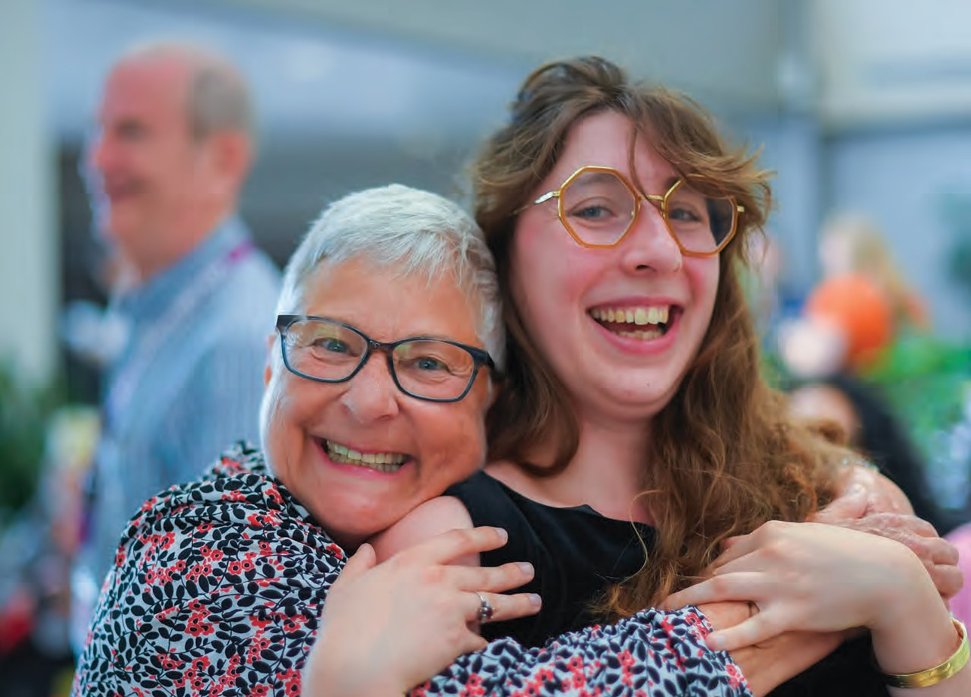

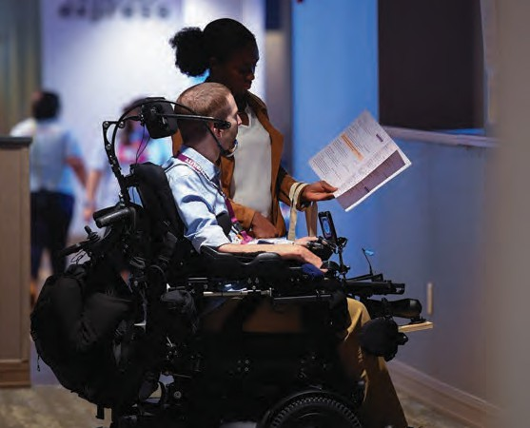












8 State Rehabilitation Council 9

Vocational Rehabilitation YEAR IN REVIEW JULY 1, 2021 - JUNE 30, 2022

3.40% Developmental/
MASSACHUSETTS REHABILITATION COMMISSION
3,021 citizens with disabilities have been successfully placed into competitive employment based on their choices, interests, needs and skills
(increase of 264 or 10.8% from prior year)
The earnings of these successfully placed employees in MA in the first year were
$75.7 million.
Estimated public benefits savings from people rehabilitated in MA were
$22.7 million.
Average Hourly Wage: $17.64
Average Work Hours Weekly: 27.3
*The returns to society based on increases in lifetime earnings range from
$14 to $18 for each $1 invested in the MRC Vocational
Rehabilitation program.
*$5 is returned to the government in the form of increased taxes and reduced public assistance payments for every $1 invested in the MRC Vocational Rehabilitation
program.
$3,962 cost per individual served.

2.20% Neurological
Disabilities

1.50% Traumatic
Brain Injury

Intellectual Disabilities
4.90% Other
Disabilities
5.10% Deaf and Hard
of Hearing
8.20% Substance
Abuse

8.90% Orthopedic
Disabilities

19.40% Learning
Disabilities

47.60% Psychiatric
Disabilities

DIS ABILITIES

1.10%
2.00%
Native

0.60%
Did not Identify

44.70%
Female

54.70%
Male
3.90% Asian/Pacific American Islander

Hispanic/ Latinx
13.40%

17.50%
Black/African American
Chose not to Identify

78.10%
White

GENDER RA CE

*Based on Commonwealth Corporation Study
New jobseekers seeking services (new referrals): 9,499
New individuals applying for services: 6,802
Jobseekers actively receiving services: 19,505
Jobseekers enrolled in training/education programs: 14,149
Placements Leading to Successful Employment Outcomes: 85.1%
Individuals employed with medical insurance: 99.8%
Individuals with disabilities employed in competitive, integrated employment: 3,021

10 State Rehabilitation Council 11

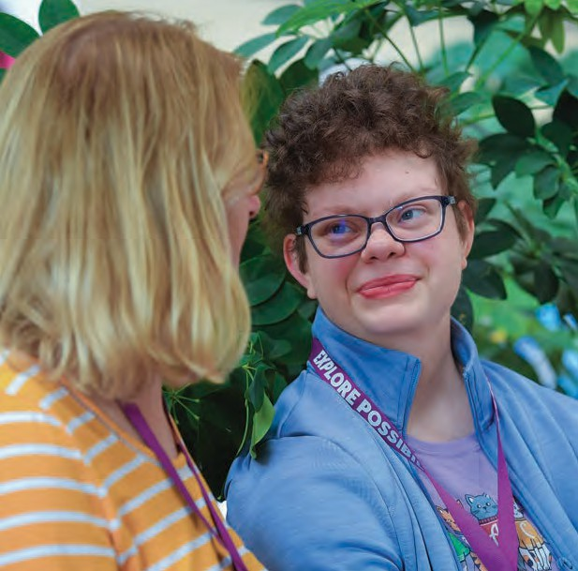
Business & Employment Opportunity Committee

Chairperson: Steve LaMaster

The SRC Business and Employment Opportunity (BEO) Committee is responsible for reviewing, analyzing, and providing guidance to the MRC on methods and best practices for employment and employment services.

A continued interest of the BEO this past year has been to Increase awareness and access to state job opportunities for people with disabilities in the Commonwealth.

BEO Committee received regular feedback from MRC on its involvement with the Disability Em- ployment Action Committee (DEAC), an
interagency group working to increase employ- ment of people with disabilities to reach equity goals that have been established. In April MRC created a 1-page document: “How to create a MassCareers profile” that it provided to the committee to be circulated amongst interested people and supporters in the Commonwealth.

The committee learned in June that the DEAC planned and hosted a speed recruiting event with 20 hiring managers within Executive Office of Health and Human Services, and other state agencies, including the Dept of Revenue, Mass Office on Disability, Dept Housing Community Development, Mass Dept of Transportation.
The DEAC members regarded the event as a modest success, given that within a week, agencies were actively requesting resumes, and at least one individual with disabilities had been offered employment at the DTA in Fitchburg. The committee hopes to work with MRC to offer specific recommendations designed to promote awareness of the MassCareers opportunities, such as notifications to centers for independent living, community rehab providers, and to share information with organizations like Work Without Limits and the
Association for People in Supported Employment.

BEO worked to develop a robust communications, marketing, and branding strategy for the SRC.

A working group formulated a timeline for the BEO committee to develop and finalize an updated set of SRC Recruitment materials, opportunities for feedback from committee, SRC Executive Committee, and opportunities for the
full SRC to give input, and projected completion in October 2022. A content draft of material for recruitment was produced and was reviewed and updated at the BEO meeting held in June, in August, all SRC members were invited to the
SRC Executive Committee meeting for discussion of the draft materials, and in August, the final drafts were sent to MRC’s Communications Team so that print and social media materials could be developed.

BEO began work to better understand what an update of self-employment resource materials would benefit from and require from MRC.

Committee members have convened a working group in order to better understand the needs for both MRC counselors to support these endeavors and the needs of MRC self- employment seekers.

The workgroup of this committee created a list of survey questions to be put out by the policy
committee, and gathered data across MRC Areas, which appear to show the greatest efforts/ successes toward successful closures involving Self-employment in the Greenfield and Worcester Areas. The committee plans to receive an update from this workgroup this fall, and proposes to work with MRC toward the following three tasks:

- Adapt the “VR S-E Guide from University of Montana Rural Institute on Inclusive Communities, RTC:Rural,” for use with individuals receiving services and VR counselors
- Develop a self-employment resource club
- Establish regional partnerships with universities that house a small business development center.

Consumer Satisfaction & Needs Assessment Committee

Co-Chairs: Ronaldo Fujii, MD PhD and Olympia Stroud

The Statewide Consumer Satisfaction & Needs Assessment Committee ensures individuals with disabilities perspectives are included in the process of evaluating MRC vocational rehabilitation services. During the fiscal year, the committee participated and provided input to other SRC committees and ensured that insights pertaining to individuals were communicated to the right people. The committee actively participated in the MRC Explore Possibility Summit and provided feed- back to MRC and SRC in how to improve future events and increase SRC visibility.

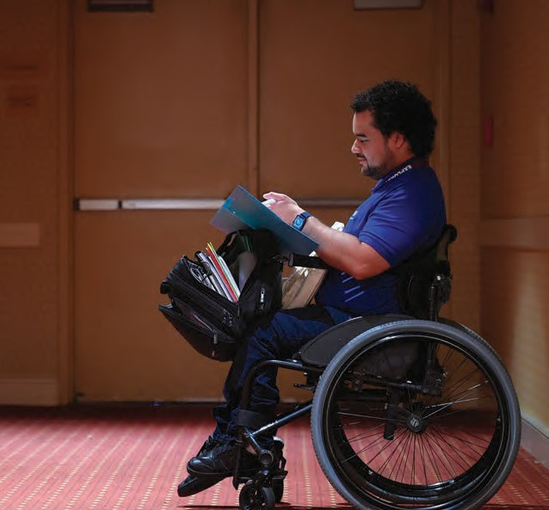
12 State Rehabilitation Council 13
C O M M I T T E E
R E P O R T S
F O R
2 0 2 2

MRC Experience Survey Tool

The committee actively participated in the selection of vendors and the review and improvement of the survey tool MRC developed.
The Committee collaborated with the agency to provide insight on the research activities and improvement of process and analyses. Our aim was to ensure the survey results could be used to shape future SRC recommendations to MRC for improving vocational rehabilitation services.

Recruitment

Creating a diverse environment starts by hearing the voices of all types of backgrounds and building well-rounded representation. The Committee actively recruited new members to the SRC, focusing on the inclusion of un/ underrepresented communities, such as the transgender community (who is known to have higher incidences of disability), people of different ethnicities, cultural backgrounds, and identities. All are welcomed and encouraged to become active participants in the SRC.

Hearing the voices of those we serve

Individuals receiving services from MRC had the opportunity to share their experiences during the committee meetings. We are committed to systematically including time for testimonials and life experiences that can help other individuals reach their VR goals with MRC as they navigate their life struggles. We encourage individuals to bring their experiences to the meetings so the committee may build actionable recommendations for MRC.

Policy Committee

Chairperson: Naomi Goldberg

The Policy Committee reviews and analyzes Vocational Rehabilitation (VR) policies and procedures to ensure service delivery aligns with federal and state VR regulations and policy guidance. The committee recommends revisions to and the development of policies that help individuals better understand the VR process and what is necessary to attain competitive integrated employment. Also, it recommends changes to policies to fix systemic matters as appropriate. Finally, the committee periodically reviews and recommends updates to the council bylaws.

Learning About Procurement


At the beginning of FY22, the committee continued to focus on the State Plan recommen- dation to increase the SRC’s understanding and knowledge of MRC procurement and contracting processes. This recommendation, which had been carried over from the previous year, was originally focused on ensuring that procurement and contracting processes do not create barriers to or delays in services. As the committee explored the recommendation, it determined that the committee did not have sufficient knowledge of these complicated processes and therefore was not prepared to offer meaningful feedback on how to improve. Consequently, the recommendation was rewritten to reflect the need to learn about these processes.

For the first half of the fiscal year, the committee met with various fiscal and program staff, including Business Improvement Partners to learn about these complex processes and the existing barriers to assist in resolving them.
During the learning process, the committee explored several procurement related items that it determined warranted attention based on the initial recommendation that was made. Through its research, the committee learned that state procurement processes that MRC must follow are complicated and somewhat inflexible, making it challenging to access services in particular scenarios. Although the committee could not ultimately recommend solutions for resolving certain barriers that it explored, the learning process helped the committee gain a better understanding of how these processes work. This has served to strengthen SRC


members’ overall knowledge of the VR program, which can only enhance its ability to provide meaningful feedback to MRC going forward.

In consideration of the SRC’s focus on DEI, the committee was particularly interested in continuing to address the recommendation relative to increasing capacity of Competitive
Integrated Employment Services (CIES) vendors to serve individuals’ cultural and linguistic needs.
After learning about the various challenges in hiring and retaining employees with these capacities, as well as the limited number of
vendors available in various communities in the state, the committee focused on how MRC could increase the capacity of vendors to provide language access (internally or through a third-party vendor). In doing so, the committee learned that there must be an existing funding

14 State Rehabilitation Council 15
C O M M I T T E E
R E P O R T S
F O R
2 0 2 2

mechanism in place if requiring CIES vendors to contract for language access and that putting that mechanism in place would be complicated. From there, the committee learned about the potential ways in which MRC could incentivize

basics of vocational rehabilitation. The second is to create informational materials for jobseekers that explain the basics of the VR process in clear and understandable language. To date, the committee has begun the process of curating and developing appropriate orientation materials. It has also begun to identify important VR topics for which individuals could benefit from further explanation. Once topics are selected, the committee will draft basic fact sheets in easy-to-understand language that could be distributed to jobseekers. The committee will continue its focus on these recommendations during FY23.
vendors to offer more language access options. MRC committed to looking into these potential mechanisms and considering what would work best. The committee eventually chose to close its work on the procurement recommendation with a commitment to continue to intermittently track the status of the language access issue.

Developing Written Materials

For the remainder of the fiscal year, the committee began working on its two newly assigned state plan recommendations for FY23. The first, is
to develop SRC orientation materials focused
on understanding the role of the SRC and the
16 State Rehabilitation Council

State Plan & Interagency Relations Committee

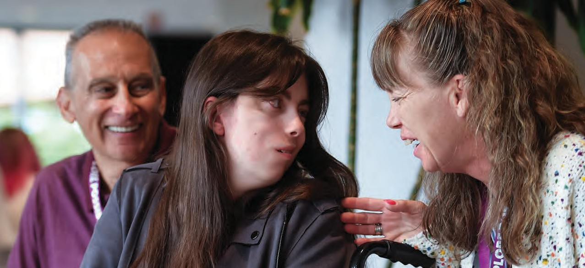
Chairperson: Joe Bellil

The State Plan and Interagency Relations Committee ensures the SRC meets its obligations regarding input from jobseekers in the development of both the MRC public
Vocational Rehabilitation State Plan and the Workforce Innovation and Opportunity Act (WIOA) Combined State Plan.

Supported Committees through the SRC Recommendation Process

During the FY22 State Plan Committee meetings, committee members reviewed and responded to MRC’s responses to the FY22 SRC Recommen- dations. The committees, in partnership
with MRC, worked on their assigned recommen- dations throughout the year. The committee members appreciated the support given by MRC’s staff liaisons. Each MRC liaison brought
a wealth of information to the committees, which helped the members progress through their work.

Provided Input to the VR Section of the State Plan

The committee members welcomed a presentation by Cheryl Scott, the Executive Director for the MassHire State Workforce Board, on the Workforce Innovation and Opportunity Act (WIOA). The WIOA requires the submission of a State Plan that includes a four-year strategy and operational plan for the continuing imple- mentation of the state’s workforce development system, with an update after two years.

The SRC held a special meeting to provide input into MRC’s draft of the state plan’s VR section.
The VR section of the state plan included getting the latest recommendations and MRC’s response from the SRC. In addition to collecting data on the progress of the goals and any other input that the SRC had, SRC members were encouraged to attend one of the two WIOA State Plan Modifi- cation Virtual Public Sessions.

Guided the FY23 SRC Recommendation Process

The committee discussed the focus of the SRC FY23 Recommendations. The members strongly encouraged each SRC committee to ensure their recommendations have a Diversity, Equity, and Inclusion (DEI) lens on it. Each committee reviewed the recommendations that they were working on currently and discussed what
FY23 recommendations should be in light of FY22 accomplishments and expected FY23 job-seeker-related needs. The FY23 SRC Recommendations were presented and approved by the SRC Members.

C O M M I T T E E
R E P O R T S
F O R
2 0 2 2

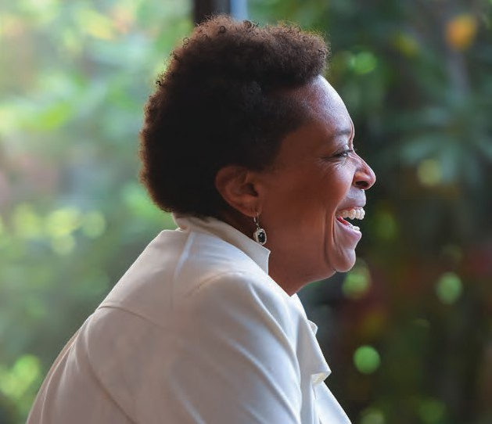
17

FY23 RECOMMENDATIONS

LEAD: POLICY COMMITTEE
Develop SRC orientation materials focused on
understanding the role of the SRC and the basics of
vocational rehabilitation
LEAD: POLICY COMMITTEE
Create informational materials for job-seekers that explain the basics of the
VR process in clear and understandable language.
LEAD: EXECUTIVE COMMITTEE
The Office of Individual and Family Engagement will partner
with the SRC to host a forum that promotes the work of the SRC
to focus on recruitment of diverse members.

LEAD:
BUSINESS & EMPLOYMENT
Support employment of individuals with disabilities in
the Commonwealth through developing a baseline
understanding of current data and trends, which can inform a high-
level strategy to increase the numbers of state employees with disabilities.
Include the principles of diversity, equity, and inclusion lens in this work, and work with
MRC to ensure the robustness of this effort.

LEAD:
BUSINESS & EMPLOYMENT
Increase availability and accessibility of SRC materials
online and develop a robust communications, marketing, and
branding strategy for SRC.
Make materials available to SRC for review related to accessibility to all
including from a DEI lens.

LEAD:
BUSINESS & EMPLOYMENT
Develop a baseline understanding of self- employment, including but not limited to assessing needs
(individuals with disabilities and counselor), data trends (state and
national), and identified best-practices and partners, to inform a strategy for
self-employment services within MRC.

18 State Rehabilitation Council 19

M R C L A U N C H E S N E X T G E N C A R E E R S
WHAT’S
NEXT?

“Working with a peer mentor allows me to control my career goals. They listen and help guide me on my path.”
Destiny Lomonte
MRC Disability Inclusion Leader

mployment of individuals with disabilities has been a national concern for decades. States across the country have worked tirelessly on
E
performance-driven incentives, programs, and legislation to improve the unemployment rate of individuals with disabilities. Yet despite these efforts, the national employment rate for people with disabilities has remained the same.

Massachusetts plans to change that. Together with stakeholders, partners, and allies, the Massachusetts Rehabilitation Commission (MRC) works to expand what’s possible in the lives of people with disabilities and provides services that break down barriers.
B Y C OLLEEN G. C A SEY
Thanks to a competitive $17 million Innovation Grant the agency received from the federal Rehabilitation Services Administration (RSA), MRC launched NextGen Careers- a new program to help young adults ages
18-30 with disabilities to explore the world of work.

“NextGen Careers will focus on the whole person, providing wraparound services for job-seekers with disabilities who are eager to find a meaningful career,” said MRC Commissioner Toni Wolf. “We’re thrilled to launch this program and modernize this
approach to empowering youth on their job journey.”

The innovative NextGen program will teach job- seekers to advocate for themselves, gain self- confidence, and become self-sufficient on their career path. Individuals enrolled in the program will be paired with a team of mentors, counselors, benefit advisors, and employment specialists to help navigate their career path.

Whether applicants are interested in a certificate program, on-the-job training, apprenticeship, or an internship in Science, Technology, Engineering, Math

“As a NextGen Career Counselor, I know it takes a team effort to achieve anything! Here at NextGen, our team puts the young adult at the center of the team and they lead the efforts to achieve their career goals.”
Kiah Nuahn
Career Counselor

(STEM), NextGen will pair them with a team of dedicated experts in counseling, benefits, and peer support that will be behind them every step of the way.

“As a NextGen Career Counselor, I know it takes a team effort to achieve anything,” said Career Counselor Kiah Nuahn. “Here at NextGen, our team puts the young adult at the center of the team and they lead the efforts to achieve their career goals.”

The NextGen program is currently available for individuals living in the Boston, Roxbury, Braintree, Lawrence, Lowell, Springfield, and Worcester areas. To learn more about NextGen or apply for the program, visit mass.gov/nextgencareers.





20 State Rehabilitation Council 21

Disability Inclusion Leaders Bring MRC Mission to Life
B Y CIND Y W ALKER
At the Massachusetts Rehabilitation Commission (MRC), we’re in the business of possibility. We work with individuals and partners to expand what’s possible in the lives of people with disabilities – and to bring down the physical and societal barriers that limit their potential. Recently, the Office of Individual Family Engagement (OIFE) has introduced seven Disability Inclusion Leaders to help bring its mission to life.

This group of individuals is dedicated to using their collective voice to provide a first-hand experience of living with disabilities. “The goal is to embed the expertise of individuals with disabilities in spaces where decisions are being made at MRC,” shared OIFE Director Amanda Baczko. “These leaders are serving on hiring panels, co-creating policies, participating in leadership teams, and generally providing ongoing feedback to help shape service delivery.” Their life experience will help guide MRC in developing programs, resources, and policies that strengthen the lives of people living with disabilities, family members, their caregivers, and medical providers.

Baczko knows that the Disability Inclusion Leaders are already making a difference. “We’ve already seen a positive impact from inviting Disability Inclusion Leaders to the table,” she said. “We’ve had team members present to the community about their experiences with MRC services, editing the language of experience surveys to make them more culturally responsive, and bringing young adult voice to our NextGen grant activities. It’s been exciting to see the culture shift in MRC as we continue to find new and innovative ways to engage disability leadership in our agency.”

Meet Our Leaders
GEORGE FARRINGTON is very
involved in the brain tumor and brain injury communities. He
is a seven-year brain tumor and brain injury, survivor and is incredibly passionate about creating an inclusive
community. He will never turn down a public speaking engagement to advocate for people with disabilities or educate the public on what life is like for someone living with a disability. He’s stated that his wife and two children are his lifelines, and he lights up when asked to speak about them. His other passions include gardening and cooking, and he claims his eggplant parmesan might change your life.

DESTINY LOMONTE lives in the Lowell area with her four-year- old service dog, Salem, who alerts her to oncoming epilep- tic seizures. For two years, she lived in Germany, and because of that immersive experience,
German is her second language. Destiny wel- comes questions about her experiences living with a rare condition and how she advocates for disability awareness. She loves public speaking and is excited to share her story in the hopes of helping others living in a similar situation navigate MRC programs and support services.

JAMES MCKENZIE was born and raised in Springfield, Massachusetts, where he raised his 16-year-old son and 32-year-old daughter. Since losing most of his right leg during the last two years due
to a blood disease, life for James has slowed down a bit. He enjoys being part of the “think- tank” process and brainstorming to create an immediate connection to MRC programs and stakeholders. He hopes to help formulate a pipeline of services that people in need can access without interruption. “We have got to make these people’s transitions easier. If someone loses their benefits, they could literally die.
We can’t sit here saying if I would’ve only,” James has said.
BRENDAN SHEA currently lives in Greater Boston. He enjoys exercising and, as an amateur engineer, building adaptive devices. As a strong self- advocate, he is comfortable with public speaking and
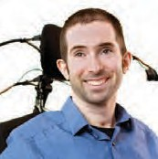
supporting others in finding their advocacy voice. Brendan shared, “I want to develop a better familiarity with the inner workings of MRC and learn more about all of the different state agencies and organizations that partner with people with disabilities.” His passion for advocacy work is centered around policy-related issues.


THERESA “TERRI” SWEENEY
suffered a Traumatic Brain Injury (TBI) on November 24, 1989, after falling backward down an embankment and hitting her head on a rock.
She was attending the Brooks Institute of Photography, but after the accident, she returned home to Southeastern Massachusetts, where she currently lives. She has remained passionate about photography and,
throughout the years, has taught photography to kids with special needs and senior citizens. Terri is partnering with agency staff member Alison Scher to review MRC’s website and resource links. “It’s like being caught in a windstorm of information. So, we’re cutting out a lot
of the outdated and inappropriate word- ing,” reports Terri. She wants to create a “garden” of information that is fun, easy to access, and more streamlined.

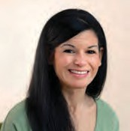
JAEMILLY TORRES
joined the Disability Inclusion Leaders to be a positive voice for injured individu- als. She spends
her days working out and playing with her dog Zoey. She is passion-
Group Disability and Inclusion Leaders photo taken at the
MRC Summit, Summer 2022.
ate about fighting for protections for people with disabilities and training first responders and law enforcement to break down communication
barriers and stereotypes to effectively and safely help someone living with a disability. She’s also focused on empowering people with disabilities
to be strong self-advocates by setting goals for themselves, especially their doctors or day-
habilitation counselors. During her journey, she’s said to those assisting her, “If I fail, I’ll understand what you meant and come back to work on myself more, but if I don’t try, I’ll never know!”

CINDY WALKER lives on the South Shore with her sister’s family and loves spending time with her nieces and nephews. She teaches them about living without limitations and work- ing hard for what they believe
in. Advocacy work has been a part of her life long before the onset of her paralysis. On February 7, 1995, she woke up paralyzed from the waist down due to Transverse Myelitis, an auto-immune disease. Her mom was her north star and constantly encouraged her to keep pushing forward, reminding her that struggling is a part
of everyone’s lives, no matter how big or small the struggle. She hopes to create a universal inclusion space, “normalize” disability, and encourage people to evolve continually.


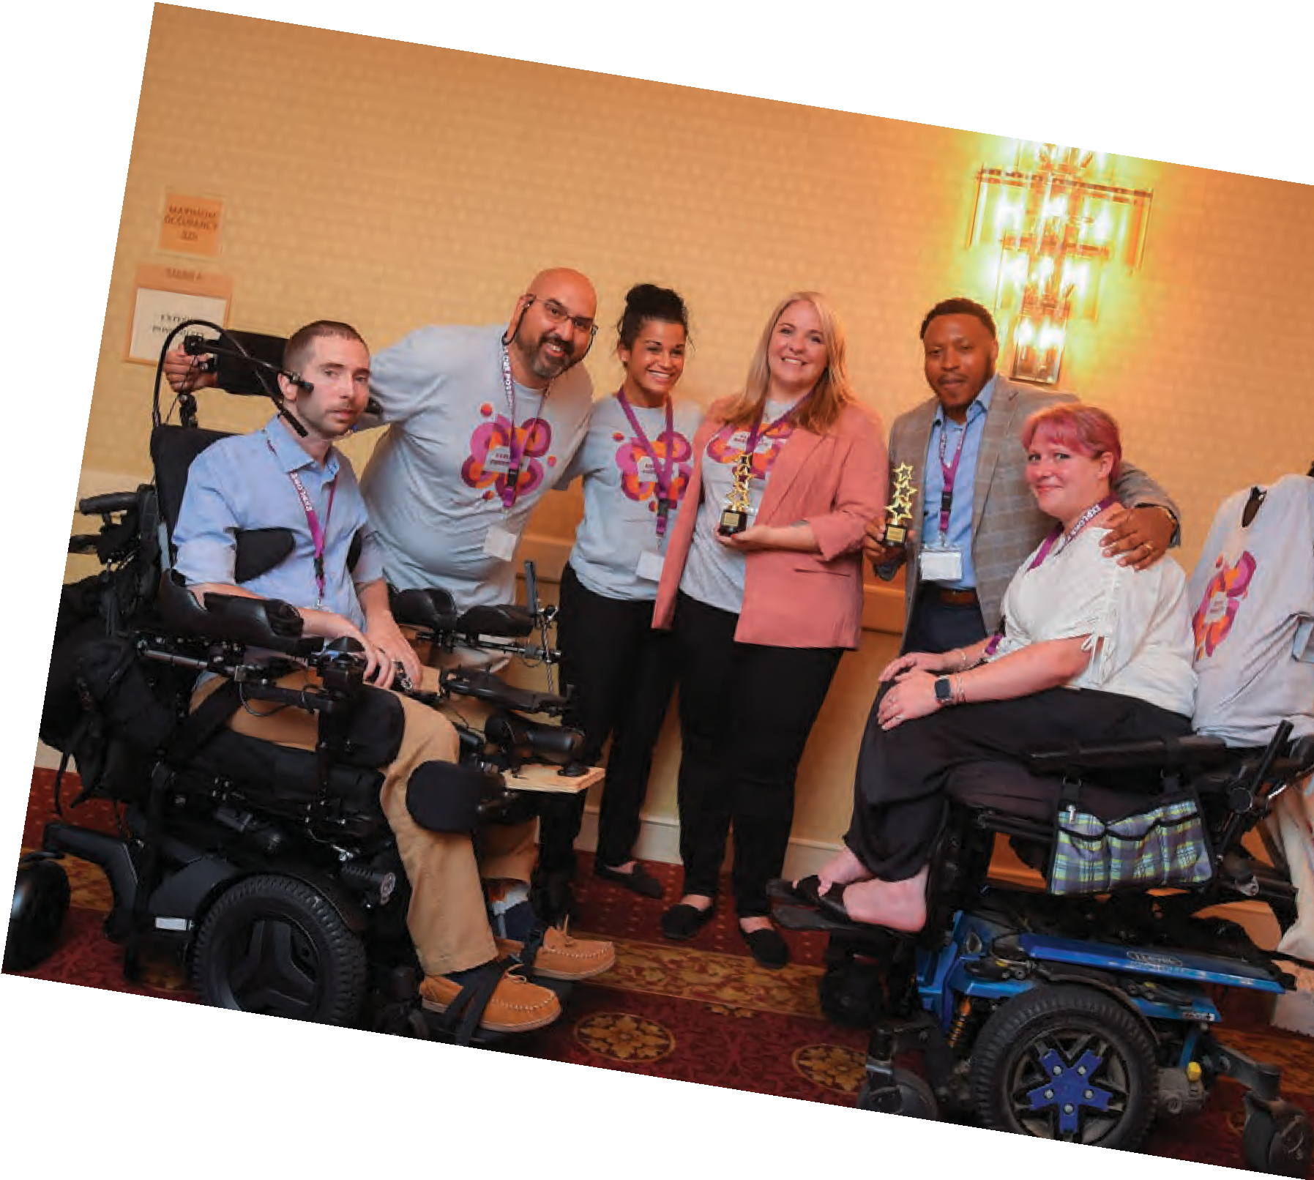

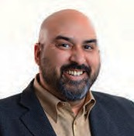


22 State Rehabilitation Council 23

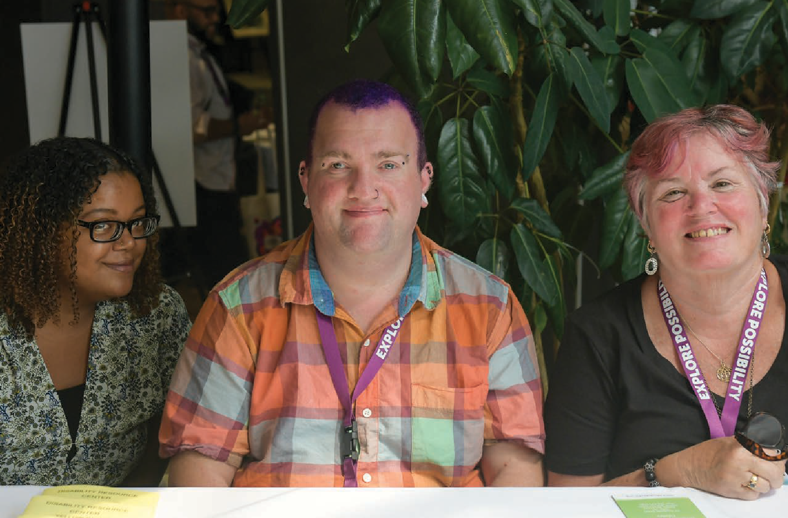

We envision a world where all individuals with disabilities are supported to live their best lives.

Massachusetts Rehabilitation Commission Statewide Rehabilitation Council
600 Washington Street, Boston, MA 02111 | Phone (617) 204-3600 www.mass.gov/mrc/src | MRC.StateRehabCouncil@MassMail.State.MA.Us

