Prepared by the STEM Advisory Council and the Executive Office of Education

Highlights and accomplishments from 2015-2022
Baker- Polito Adminsitration STEM Council Report

Table of Contents
Overview of the Council 2
Goals and objectives 2
Membership 3
STEM in the Commonwealth 4
STEM Economy 4
Women and Minorities in STEM 6
Direct Council Supports 8
Regional STEM Networks 8
Curriculum Grant 9
Design Challenge Grant 9
Internship Grants 10
Initiatives to increase STEM Awareness 11
STEM Week 11
STEM Summit 11
Complimentary Administration STEM Supports 12
Innovation Pathways 12
Early College 12
Skills Capital Grants 12
Career Technical Initiatives 13
STEM Tech Academy 13
STEM Starter Academy 15
STEM Data Dashboard 16
Thank you to our partners 17

STEM Council Overview

The Commonwealth’s STEM Advisory Council was established by M.G.L. Chapter 6, Section 218. The statute charges the STEM Advisory Council to: “(i) confer with participants and parties from the public and private sectors involved with STEM planning and programming; (ii) assess how to increase student interest in, and preparation for, careers in STEM; and (iii) advise on the creation, implementation of and updates to a statewide STEM plan that contains clear goals and objectives to guide future STEM efforts, including the creation of benchmarks for improvements.” The Council serves as the central coordinating entity to bring together participants from state agencies, the legislature, and members of the public and private sectors involved with STEM planning and programming.

Current membership of the STEM Advisory Council is listed on the next page. Members of the Council include individuals from academia, business, government and non-profits who believe in the necessity of a STEM-literate and skilled citizenry ready to meet the needs of a 21st Century workforce. The co-chairs are Lt. Governor Polito, Congressman Auchincloss, and Vertex Executive Chairman Jeff Leiden. By statute, STEM Advisory Council has an Executive Committee that provides strategic direction and guidance.

As the Secretary is an ex officio member of the STEM Advisory Council, the Council Director is part of the Executive Office of Education to ensure alignment with priorities of the Secretary’s Office and the Workforce Skills Cabinet.

The STEM Advisory Council is funded by an annual appropriation of $1.5M in the GAA to the STEM Pipeline Trust Fund (1595-7066).

The STEM Advisory Council has three priorities for STEM education in MA:
- STEM skills for all through applied learning.
- Guided pathways to college, careers, and lifelong learning.
- Alignment to economic & workforce development through employer partnerships.

The Council meets quarterly and is consulted throughout the year. Members also play an intricate role in the two large events of the year, STEM Summit in the spring and STEM Week in the fall. For more information here is the website: https://www.mass.gov/info-details/massachusetts-stem-advisory-council

STEM Council Membership

Lt. Governor Karyn Polito – Co Chair
Representative Alice H. Peisch
Representative Josh Cutler
Secretary James Peyser
Secretary Rosalin Acosta
Secretary Michael Kennealy
Commissioner Carlos Santiago
Commissioner Jeff Riley
Commissioner Amy Kershaw
Senator Patricia D. Jehlen
Senator Jason Lewis
Congressman Jake Auchincloss – Co Chair
Carolyn Kirk - Massachusetts Technology Collaborative
Jennifer Daloisio - Massachusetts Clean Energy Center
Kenneth Turner - Massachusetts Life Sciences Center
Francis X. McDonald – Massachusetts Maritime Academy
Winston Soboyejo – Worcester Polytechnic Institute
Lane Glenn – Northern Essex Community College
Becky Colo – Fitchburg Public Schools
James J. Brosnan – McCann Technical School
Stacey Kaminski – Southeast STEM Network
Matthew Beyranevand - Chelmsford Public Schools
Luai Elamir – National Society of Black Engineers Boston
Matthew Keator – Chelmsford Public Schools
Gary Evee – Evee Consulting
Tim Ritchie – Museum of Science
Dr. Jeffrey Leiden – Co Chair, Vertex Pharmaceuticals
Sam King - Veracode
John Dolan – St. Mary’s Lynn
Daniel P. Shine - Thermofisher
Jen Levitt – Sensata Technologies
Tye Brady - Amazon Robotics
David L. Lucchino -Frequency Therapeutics
Robert “Jay” Ash Jr. – Mass Competitive Partnership
Kathleen Dawson – Minuteman Technical School

STEM Economy

Strengthening STEM education in the Commonwealth’s K-12 schools is a priority of the Baker-Polito Administration. Despite the abundance of jobs in science, technology, engineering and math, just one in six American high school seniors say they are interested in studying STEM in college.

The need for STEM graduates particularly impacts Massachusetts because more than 40 percent of all employment in the Commonwealth revolves around innovation industries such as clean energy, information technology, defense and advanced manufacturing, according to the Massachusetts’ Plan for Excellence in STEM Education. High-demand STEM occupations in Massachusetts can take as long as 70 days to fill, and the number of those jobs are projected to grow faster than the overall number of jobs in the Commonwealth.

STEM jobs are resilient in the labor market. Between 2018 and 2020, the number of Massachusetts STEM jobs have contracted much slower than non-STEM jobs. This suggests that STEM occupations are better able to withstand economic shocks.

Massachusetts has remained at the top of many lists of state competitiveness and will continue its strength in technology and biomedical research, industries which are concentrated in the eastern part of the state. Following the pandemic, the Baker-Polito Administration commissioned a Future of Work report. The Commonwealth’s Future of Work Report notes “Bloomberg’s annual State Innovation Index ranked the state as the “Most Innovative State in America” due to growing entrepreneurial start-ups over the past decade”.

The report also stated that industries expected to see greatest job gains are: Healthcare, Professional, Scientific and Technical Services. Healthcare is likely to be the largest source of employment growth in Massachusetts across all scenarios, expected to add an estimated 210,000-230,000 jobs by 2030.

Some additional highlights from the report include:
  - Ranked 1st in patents per capita
  - Ranked 1st in venture capital funding per GDP
  - Ranked 3rd highest in per-capita personal income
  - Ranked 5th in number of companies headquartered per capita
  - Home to 122 institutions of higher education

Current and Future Growth

Massachusetts is among the states with the highest demand for STEM occupations, adjusted for Population across the U.S. Additionally, growth in STEM jobs will outpace average job growth – and is expected to account for 40% of increase in total employment in the Commonwealth.

Findings from the 2022 CommCorp STEM Report, a yearly STEM snapshot created in partnership with the STEM Council, mirror the Future of Work findings and note that Massachusetts in-demand STEM occupations span healthcare and computer occupations.

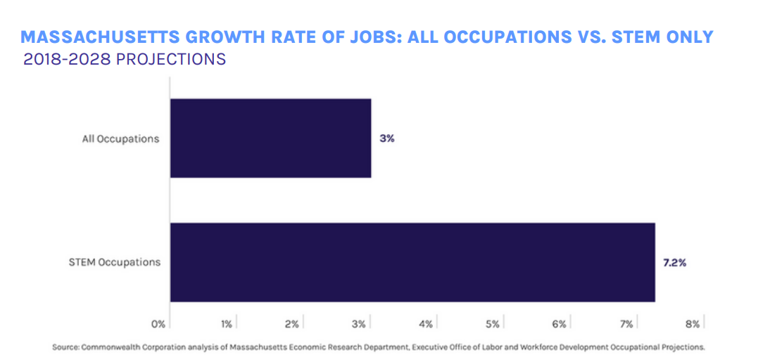

CommCorp also found that STEM-heavy industries are driving Massachusetts’s recent economic growth during the pandemic. Massachusetts’s economy grew by 6.9 percent from 4Q 2020 through 1Q 2021 (October – March), as measured by the increase to Growth Domestic Product (GDP). This growth was led by the professional, scientific, and services industry, which has the highest concentration of STEM jobs across all industries.

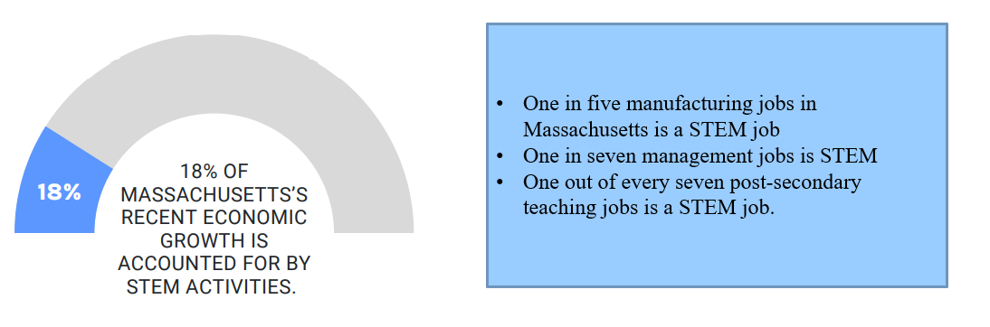
Racial Representation in STEM

Studies have shown that diversity in workplaces, particularly the STEM workforce, improves work performance and engagement, enhances the quality of research and provision of health care, and promotes innovation and growth. Specifically, diversity not only expands the available talent pool, but also increases the range of perspectives and expertise available to solve grand challenges in STEM.

Below breaks down STEM employment by race between 2014 and 2021 and compares it to the workforce as a whole. The increase in racial diversity within STEM fields has exceeded the racial diversity of the overall MA workforce

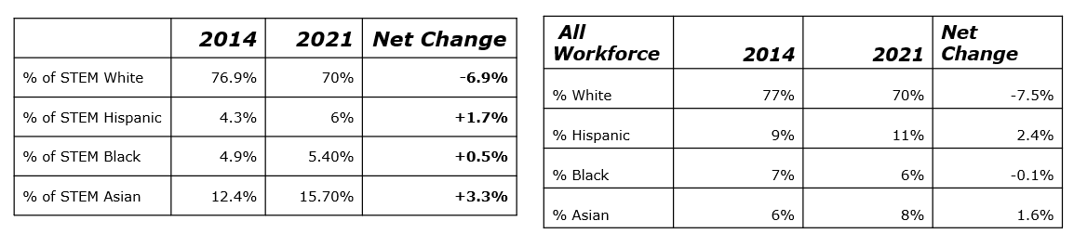
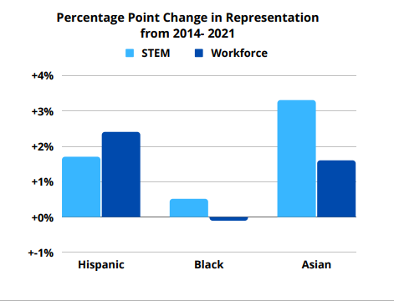

Massachusetts is well-positioned to meet its technical workforce needs given its national leadership in STEM talent. However, without adequately expanding opportunities for training and certification in the disciplines that produce STEM talent, it would impact the availability and quality of the STEM workforce ecosystem. Several industry-ready credentials and stronger partnerships between employers and educational institutions have been developed in the state to support workforce development strategies that augment the technical talent pipeline. To continue decreasing the gender and racial imbalance in STEM workforce, the Commonwealth has continued to expand the pathway and provide more opportunities for traditionally underserved communities.
Women in STEM

STEM jobs in Massachusetts are employed by 49% women and 51% men. However, at leading STEM industry sectors and higher-paying job sectors, it has bigger gender imbalances.
Below is a snapshot comparing labor market data from 2014 to 2021.

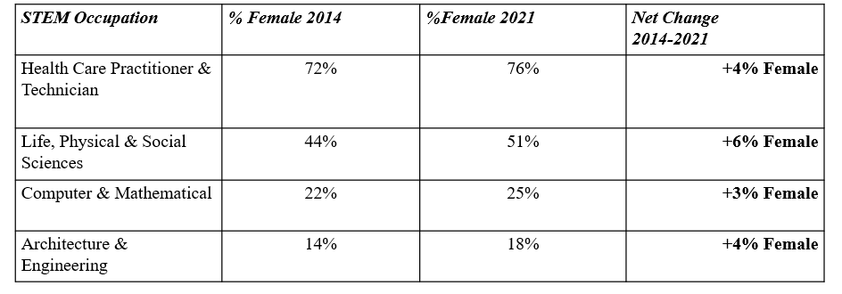

As previously noted, STEM jobs remained more resilient during the pandemic, and the Institute for Women’s Policy Research found that Women in STEM careers were more resistant to job losses and stressors pushing them out of the workforce during the pandemic. Women in science, technology, engineering, and math occupations have more job security and flexibility in their work life, and in some cases, the number of women in STEM jobs grew in 2020.

A recent report from the Equal Employment Opportunity Commission shows that the gender gap in STEM starts as early as high school and remains in higher education. Racial and ethnic disparities that extend beyond the STEM field also start early in the education pipeline. Massachusetts shares the same challenges of improving the representation of women in STEM occupations.

The Baker-Polito administration is working to encourage more young girls into STEM studies, and providing more opportunities for them to pursue STEM-focused careers. Acknowledging there is more work to be done, this report highlights initiatives the Administration and Council have created to strengthen students’ foundational skills and expand course offerings, capital investments, expansions of career and college pathways for young people to pursue industry-recognized credentials, and deepened partnerships with employers and higher-education institutions to offer more work-based learning experiences.

Direct Council Supports – $1.5M line item

STEM Regional Networks

The STEM Advisory Council Allocates $315,000 to nine regional networks each year. Regional STEM Networks serve as hubs for connecting educators, community leaders and industry partners. Each of the nine regions host quarterly meetings and STEM Awareness events throughout the year. This totals 500 community and classroom events a year, not only during the annual STEM Week.

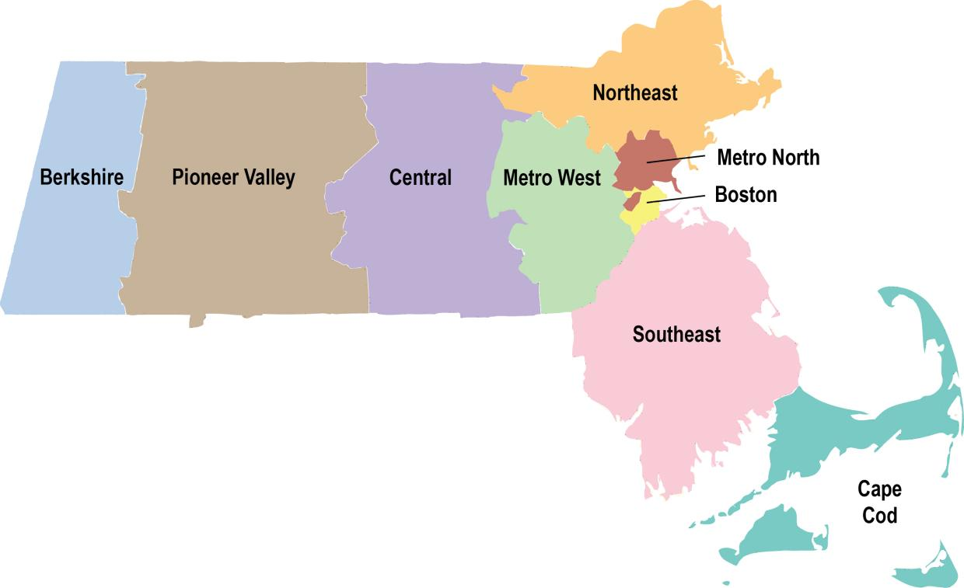

Each network is managed by an executive director and housed in either an institution of higher education or a regional employment board. Managed by the Department of Higher Education under the direction of the STEM Advisory Council, the networks play a key role in cultivating interest and engagement in STEM activities in their regions and implementing the priorities of the STEM Advisory Council.

Contact information for the regional networks can be found on the STEM Council website.

Curriculum Grant

The STEM Advisory Council has administered $5.5M to schools over the past 7 years, with matches of over $1 million. This has helped implement high quality STEM curricula programs in over 230 schools and reach 20,000 students annually.

The purpose of these grants is to increase access to evidence-based, hands-on STEM curricula, in order to increase the relevance and effectiveness of STEM education and to engage more students in applied learning with real-world STEM applications throughout grades PK-12, particularly in schools with high concentrations of low-income and historically under-represented student populations. These grants also fund integrated professional development for teachers, with ongoing support to enable effective implementation. For FY23, the STEM Advisory Council funded 4 grantees for a total of $1,000,463, funded through the STEM Pipeline Fund and federal GEER Funding.

In 2022 the STEM Summit featured a panel on applied learning programs for educators interested in learning more about these programs and how to implement them. This panel can be found on the STEM Council website under Summit content.

The council would like to thank our partners, who played and important role in scaling and providing these Curriculum:
- Project Lead the Way
- I2 Learning
- Museum of Science
- First Robotics

Design Challenge Grant

The STEM Council has administered $1M over the past 4 years to create hands on learning experiences for roughly 20,000 students a year during the annual STEM Week.

The purpose of the STEM Week Design Challenge grant award is to implement a STEM Week 2022 statewide or regional (defined as a minimum of two Workforce Skills Cabinet WIOA regions), multi grade-level (e.g. PK-2, 3-5, 6-8, 9-12, or a combination of offerings), week-long design challenge with corresponding curricula, activities, and teacher support and development.
With the help of this grant, design challenges engage students in over 1,000 classrooms a year during STEM Week.

Internships

The Council created two complimentary internship programs to scale high quality paid opportunities for students. The Council has allocated $1.4M over the past 7 years for STEM@Work and $4M for the creation of a new STEM Stipend program. This led to over 10,000 paid internships across the state and roughly 200 STEM employers engaged by STEM Council programs per year.

STEM@Work: The purpose of the High-Quality STEM focused internship grant (STEM@Work) is to support the Commonwealth’s MassHire Workforce Boards in increasing both the number of employers who offer paid STEM-focused internships to high school students and the number of students who participate in such internships.

STEM Stipend program: The Baker-Polito Administration launched a new internship program that will provide an additional 2,300 high school students with opportunities for paid work experiences in STEM fields and make it easier for companies to hire students by paying their salaries through local MassHire Career Centers and Workforce Boards. Approximately $4 million in grants were awarded to MassHire Boards, schools, and non-profits across the state.

With this new program, the Administration targeted the barriers around short-term employment and recruiting young people, and by addressing these gaps, our administration hopes to boost the pipeline of STEM talent streaming into the Commonwealth’s workforce. By making paid internships in leading STEM industries more accessible for all students, regardless of where they live, this program can help close achievement and opportunity gaps that persist for communities who continue to be underrepresented in STEM industries, such as students of color and girls.

The stipend program also strengthened the Administrations partnership with the Work-Based Learning Alliance (WBLA), which will give hundreds of student’s opportunities to learn through research, experience with cyberattack simulators, and other projects using cybersecurity tools.

The Administration appreciates the employers who are willing to take on this important work to partner with schools, and in doing so, help develop the next generation of STEM leaders, and we hope to see more businesses join the effort.

STEM Council Awareness Events

STEM Week

To build awareness around STEM in the Commonwealth the STEM Council and Regional STEM Networks, created and promoted the annual STEM Week.

The first STEM Week was held in 2018 and has been held annually during the 3rd week of October to promote the importance of STEM education across pre-school through higher education so that students “See Themselves in STEM,” especially those who are under-represented in STEM-related college majors and careers. The Council has provided grants to the Commonwealth’s six Regional STEM Networks to help plan local events for STEM Week. Community events throughout the week are compiled on a statewide calendar for individuals to search.

With the help of our industry and educational partners, there have been roughly 2,000 in person and virtual STEM events over the past 5 years. STEM Week 2022 featured over 200 community events and roughly 1,000 classroom experiences. STEM Week was featured in 40+ local and statewide stories in the news, and support for the events continue to grow.

More information on STEM Week can be found on the STEM Council website.

STEM Summit

To compliment the student focused STEM Week, the STEM Council also hosts an annual STEM Summit alongside our partners at the Umass Donahue Institute and the Mass Business Roundtable.

The STEM Summit is held in the spring as a statewide convening to engage business leaders, educators, and policy makers in strengthening partnerships and sharing best practices regarding STEM education. Over 1,000 individuals engage annually, as it provides an opportunity for cross-sector conversations about STEM workforce challenges and how schools and industry can work together to build a deeper pipeline of talent for meaningful career opportunities in STEM.

These convenings allow for networking and the sharing of best practices which often lead to the implementation of new programs, for example the recent STEM Stipend program. Content from STEM Summit 2021 and 2022 can be found on the STEM Council website.

Additional Supports
Innovation Pathways

Innovation Pathways are early career programs that provide high school students with a coherent course of study focused on a particular field, while also offering them access to college-level courses and internship opportunities to gain work experience. Many of the early career programs are in STEM-related fields, including advanced manufacturing, information technology, environmental and life sciences, health care and social assistance, and business and finance.

To date, 60 high schools across the Commonwealth have designated Innovation Pathways, totaling 150 different programs. Innovation Pathways differ from its sister program – Early College – in that students focus on a specific industry sector, with greater emphasis on career exploration, technical courses, work-based learning experiences and industry-recognized credentials, rather than college credit courses and college planning

Early College

Early college programs combine traditional high school courses with an opportunity to earn college credit at a college or university. Currently, there are approximately 5,400 students enrolled in early college courses at 50 high schools across the Commonwealth, and the Executive Office of Education anticipates that approximately 8,700 students will be enrolled in early college programs by the 2024-2025 school year.

More information on Early College and Innovation Pathways can be found on the STEM Dashboard. STEM Summit 2022 featured a panel explaining more about scaling career pathways and can be viewed on the STEM Council website.

In a May of 2022 Supplemental budget, the Administration filed an outside section that would update chapter 70, the school finance law, to establish early college and innovation pathways as an enrollment category in the Foundation Budget, to provide sustainable and predictable support for the growth of these pathways, which are demonstrating success in expanding access to college and careers for underrepresented students.

Skills Capital Program
To address the labor gaps, the Baker-Polito administration created both a Skills Capital program. Skills Capital grants are awarded by Governor Baker’s Workforce Skills Cabinet, which was created in 2015 to bring together the Secretariats of Education, Labor and Workforce Development, and Housing and Economic Development to align education, economic development and workforce policies to strategize around how to meet employers’ demand for skilled workers in every region of the Commonwealth. Skills grants were created with the goal of replacing outdated equipment and technology, mainly at vocational technical high schools and community colleges.

Approximately 40,000 students across the Commonwealth have directly benefitted from these grants, and 491 grants totaling approximately $204 million have been awarded to 194 different schools and educational institutions across the Commonwealth, with many organizations receiving multiple grants over the years.
Career Technical Initiative

Initially launched in 2020, the Career Technical Initiative (CTI) aims to train skilled workers over the next four years to help close skills gaps and meet the needs of businesses across the Commonwealth. The program provides more Massachusetts residents access to career technical training by using the state’s existing resources at vocational high schools, while simultaneously helping businesses grow by increasing the population of skilled workers able to be employed in trade and construction jobs.

Through September 2022, the investment in CTI is $16.5 million and 800 participants have received training.

STEM Tech Academy

STEM skills gaps continue to be a major short-term and long-term challenge to economic growth.
Even though voc-tech enrollment is growing, capacity is relatively limited (and expensive). Meanwhile, Community college enrollment is shrinking, reducing the number of occupational degrees and certificates. Initial growth of Early College and Innovation Pathways is promising, but needs to be sustained and accelerated (more programs, larger scale). Employer engagement in STEM education is improving, but remains a challenge.

With that in mind, the Administration created the STEM Tech Academy. A new initiative designed to help more young people earn associate degrees and industry certificates in STEM fields. STEM Tech Career Academies will be new six-year programs that enable high school students to earn both a high school diploma and a post-secondary credential at a community college, at no cost to students.
The administration has committed $6.5 million in multi-year grants to cover the costs of planning, implementation, and launch. High schools, community colleges and employers will work together to plan and launch four to six different STEM Tech Career Academies across the Commonwealth.

The goal is to enroll between 1,600 and 2,000 students in the programs.
STEM Tech Career Academies combine and extend key elements of the highly successful Early College and early career Innovation Pathways programs that were launched several years ago, including technical curriculum, work-based learning experiences, post-secondary courses, and college and career coaching. The administration anticipates that by fall of 2023, more than 75 high schools will have students enrolled in Innovation Pathway programs and 65 high schools will have Early College programs, which can serve as starting points for STEM Tech Career Academies.
The initiative is modeled after P-Tech, a grades 9-14 school model where students earn a high school diploma, an industry-recognized associate degree and gain relevant work experience in a growing field. Students completing a P-Tech program are typically provided with hiring preferences by participating employers.

In December of 2022, following schools and organizations each received $1 million grants to launch STEM Career Tech Academies:
Benjamin Franklin Cummings Institute of Technology is partnering with Dearborn STEM Academy, and Cambridge Rindge and Latin to launch a STEM Tech Career Academy focusing on manufacturing, IT, and environmental & life science careers. The partnership will leverage existing dual-enrollment and Early College programs and includes National Grid, Rapid7, and Suffolk Construction as industry partners.
MassBay Community College is partnering with Natick High School to launch a STEM Tech Career Academy focusing on manufacturing and environmental & life sciences. The partnership will leverage existing dual enrolment and Early College programs and includes Northeastern Center for STEM Ed, MIT, MathWorks, and MRSI Systems as industry partners.
Bristol Community College is partnering with BMC Durfee High School, Somerset Berkley High School, Westport High School, Taunton High School, and Attleboro High School to launch a STEM Tech Career Academy focusing on environmental & life sciences careers. The partnership will leverage Early College programs and includes Associates of Cape Cod, Celldex Therapeutics, and Waters Corporation as industry partners.
Haverhill High School and Northern Essex Community College are partnering to launch a STEM Tech Career Academy focusing on manufacturing, healthcare, and environmental & life sciences. The partnership will leverage existing Early College and Innovation pathway programs and includes Lawrence General Hospital, Whittier Health Networks, Holy Family Hospital, New Balance, and Hydracor as industry partners.
Springfield Technical Community College is partnering with West Springfield High School and Veritas Prep Charter School to launch a STEM Tech Career Academy focusing on healthcare, manufacturing, and business and financial services. The partnership will leverage existing Innovation Pathways and Early College programs and includes Baystate Eye Care Group, Each Moment We're Alive, Walgreens, and Springfield Thunderbirds Hockey Club as industry partners.

STEM Starter Academies

The goal of STEM Starter Academies is to recruit, ready, retain and graduate a diverse body of community college students earning STEM certificates and degrees and transferring to 4-year STEM programs or entering the workforce. The Umass Donahue Institute (UMDI) serves as the external evaluator to determine SSA impacts and student outcomes.

Department of Higher Ed launched SSA system-wide at all 15 Massachusetts community colleges in January 2014. From its inception, the SSA initiative has focused on at-scale implementation while encouraging local site adaptation. Over the years, a collaborative learning community has emerged, bringing together state initiative leaders, college program staff, and administrators to share insights and inform both system-level and institutional guidance, data collection, and program evaluation.

In 2020, the Department of Higher Education issued a 6-year report and found that:
- SSA has served nearly 31,000 students who reflect the diversity of the community college population.
- 64% of SSA participants have achieved positive outcomes (degree/certificate, 4-year transfer, STEM workforce entry, retention) and have achieved those outcomes at higher rates than their non-SSA peers.
- Black SSA participants are twice as likely* to achieve positive outcomes— and they earn STEM degrees and certificates at higher rates—than their non-SSA peers. Analyses show that SSA students are achieving positive outcomes.

STEM Data Dashboard

The STEM Dashboard was created to paint a holistic, updated picture of STEM initiates across the Commonwealth. A statewide map allows for filtering of programs including Early College, Innovation Pathways, our Applied Learning curriculums from Project Lead the Way, i2 Learning, and Museum of Science. The Data Dashboard map has the ability to filter by program type, district type, and includes information on each pathway.

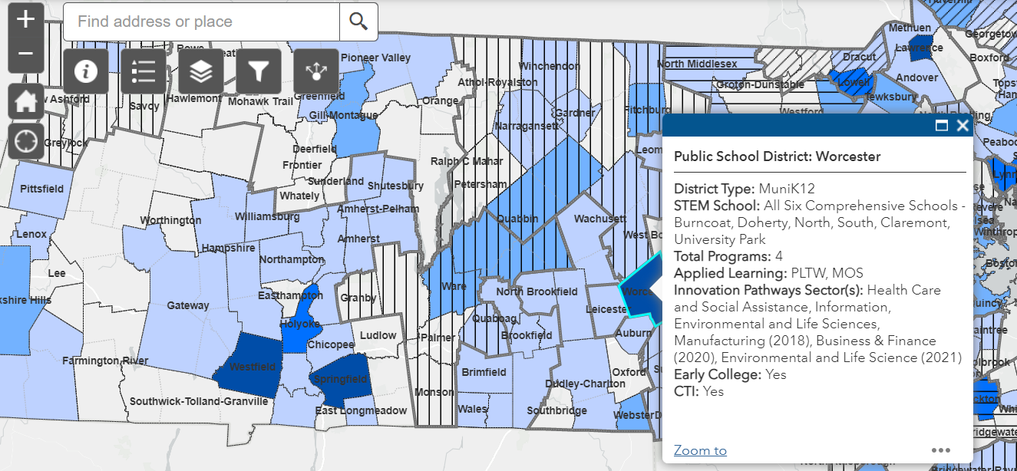

As previously noted in this report, strengthening the STEM pipeline and increasing women and minorities in STEM starts with increasing an interest in STEM at younger ages. The data dashboard includes tableaus that allow for tracking of AP classes and STEM course work and how the Commonwealth compares to national trends. The dashboard also breaks down the data by gender and race

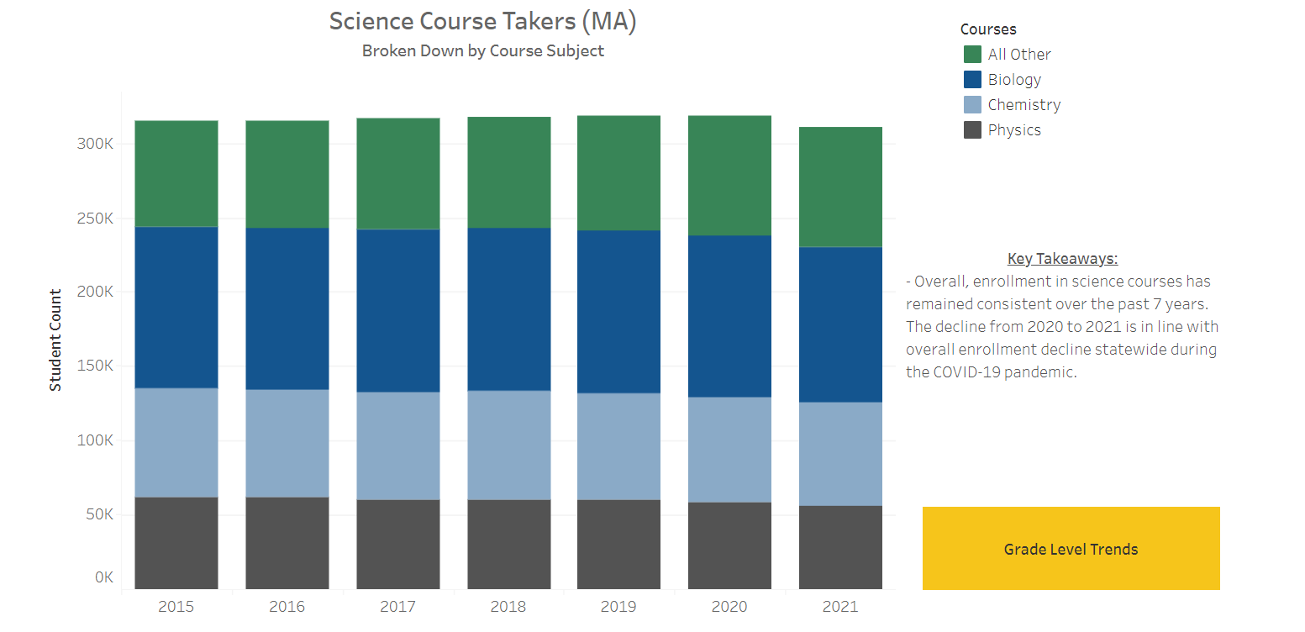
.

Thank you to our partners

In closing, the Council would like to thank our internal and external partners.

With the help of programs like Project Lead the Way, OpenSciEd, Museum of Science, First Robotics, and i2 Learning, the Commonwealth has been able to implement applied learning programs across the state.

We also want to highlight just a few of the many programs within our quasi agencies that provide equipment and training funding to schools and non-profits. These programs build upon programs the Council and Administration have supported, allowing for additional growth in the STEM space.

- Massachusetts Life Science Center
- Awards roughly $20M a year to enhance and expand training programs and reaches over 17,000 students.
- MassCyber Center
- Mentorship program has reached 32 colleges statewide with over 70 mentors from 49 companies.
- Center for Advanced Manufacturing
- In addition to the millions in grants awarded each year, CAM hosts and annual Manufacturing Mashup – this year reaching 1,200 individuals
- Mass Clean Energy Center
- MassCEC has supported over 5,000 student internships at more than 600 clean energy companies.
- Labor and Workforce Development and Commonwealth Corporation
- The WCTF invests in demand-driven programs designed by industry sector partnerships, including STEM fields that train and place unemployed and underemployed workers. Through the end of FY22, over 3,100 unemployed and underemployed adults have enrolled to date, and plans to enroll an additional 1,700 by 2024.
- In addition to the Workeforce Competitiveness Trust Fund, CommCorp releases an annual report on the status of STEM in the Commonwealth which helps drive our goals. Information from this years report was used to create this Advisory Council Report.

