2023 ANNUAL

AGGREGATE DATA REPORT

A S S I S T E D L I V I N G R E S I D E N C E S I N M A S S A C H U S E T T S

October 2024

Executive Office of Elder Affairs

One Ashburton Place, Boston, MA 02018




Maura T. Healey
Governor

Kimberley Driscoll
Lt. Governor
Kathleen E. Walsh
Secretary, EOHHS

Robin Lipson
Acting Secretary, EOEA

Introduction 3
Organization and Leadership 4
Units 7
Residents 10
Services 21
Departures 25
Safety 28
Fees 29
Appendix: Data Collection and Analysis 31

INTRODUCTION
Assisted living residences (ALRs) provide housing, meals, and personalized assistance for older adults and other adults with disabilities. ALRs seek to offer residents the maximum amount of independence while providing assistance with activities of daily living (such as eating and bathing). For more information on ALRs in Massachusetts, see: Assisted Living in Massachusetts: A Consumer Guide.

In Massachusetts, ALRs must be certiﬁed by the Executive Office of Elder Affairs (EOEA).1
As of January 2024, 270 certiﬁed ALRs were operating in Massachusetts.

ABOUT THIS REPORT
This report summarizes Massachusetts ALRs, residents and ALR assistance provided in 2023. Unless otherwise noted, the data presented reﬂects ALRs as of December 31, 2023.

In February 2024, EOEA requested data for calendar year 2023 from each certiﬁed ALR. Approximately 98% of Massachusetts ALRs (265/270) provided at least some data. (See Appendix for more information on data collection and analysis.) EOEA uses this information for certiﬁcation and summarizes the data annually in this public report.

Throughout the report, EOEA uses “N =” to indicate the number of ALRs that provided valid data for each topic. Although 265 ALRs completed the surveys, some ALRs did not answer speciﬁc questions or provided invalid data for some questions (see Appendix for more information on how sample sizes were calculated for each statistic).

Some ALRs reported inconsistent information in their responses (for example, when describing resident gender, a hypothetical ALR would report 32 total residents while reporting 35 total residents when describing resident race). This report describes identiﬁed inconsistencies in footnotes. The Appendix also details some minor corrections EOEA made when the data submitted by ALRs was clearly incorrect.

When providing statistics about ALRs, this report will often refer to a median ALR (for example, the median ALR having 60 traditional units). For each statistic, the median is the number such that half of ALRs are above and half of the ALRs are below (to continue the example, half of ALRs have more than approximately 60 traditional units). The median can be more informative than the average because some ALRs have extreme values on certain characteristics and these outliers can greatly affect the average, but not the median.

1 M.G.L. ch.19D § 3-4.

ORGANIZATION AND LEADERSHIP
Massachusetts laws and regulations allow ALRs to be registered as for-proﬁt or non-proﬁt organizations, and historically most organizations in the state have been for-proﬁt. All ALRs must have a manager, typically known as an executive director, who has general supervision of the ALR.2 ALRs must also have a service coordinator, typically known as a resident care director, whose responsibilities include developing, maintaining, and implementing or coordinating implementation of individualized resident service plans.3

ORGANIZATIONAL STATUS
Roughly 80% of Massachusetts ALRs (213/265) were operated as for-proﬁt organizations (Figure 1). On average, for-proﬁt ALRs had more residents than non-proﬁt ALRs (67 residents vs. 56 residents, respectively).

Figure 1. ALR Tax Status (N=265 ALRs)4

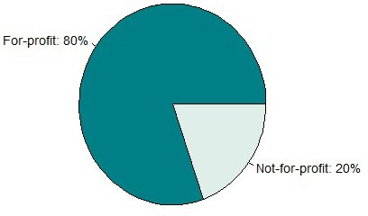

LEADERSHIP TRANSITIONS
Approximately 74% of ALRs reported having one executive director during 2023, 17% of

2 M.G.L. ch.19D, § 15.
3 651 CMR 12.04(2).
4 Throughout the report, N indicates the number of ALRs that provided valid data.

ALRs reported two executive directors during 2023, and the remaining 9% of ALRs reported three or more executive directors during 2023 (Figure 2).

Figure 2. Number of Executive Directors During 2023 (N=265 ALRs)
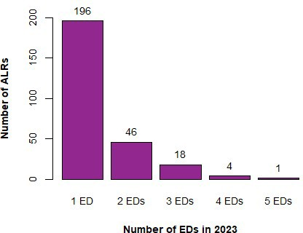

Notes. Includes interim executive directors.

Roughly 72% of ALRs reported one resident care director during 2023 and 21% reported two directors (Figure 3).

Figure 3. Number of Resident Care Directors During 2023 (N=264 ALRs)
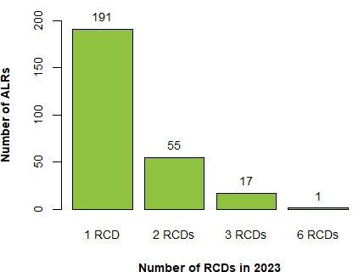

Notes. Includes interim resident care directors.

UNITS
An ALR residence is composed of multiple units where one or more residents live, and each unit must have a half-bathroom (newly constructed units must have a full bathroom) and a kitchenette.5 ALRs can have a traditional residence, up to four special care residences (SCRs), or both.6 SCRs provide care and services for residents who require assistance with specialized needs, such as Alzheimer’s disease and related dementias (ADRD) or mental health needs.

UNITS, BY TYPE
Approximately 87% (231/265) of ALRs reported having traditional units. For these ALRs, the number of traditional units varied, ranging between 8 and 150 units, and the median ALR had 60 traditional units (see Figure 4). In total, the responding Massachusetts ALRs reported having 13,898 certiﬁed traditional units where residents can reside.7

Figure 4. Number of Traditional Units (N=231 ALRs)
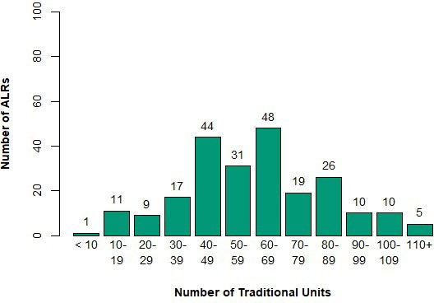

5 651 CMR 12.04.
6 The term ‘residence’ can be used in reference to the entire complex or any separate and distinct section(s) within the complex.
7 This is the number of certiﬁed traditional units in responding ALRs. Because ﬁve ALRs did not provide data, the actual number of certiﬁed units during 2023 was larger.

Approximately 75% (199/265) of ALRs reported having special care units. These units are grouped in SCRs—174 ALRs operated one SCR, 17 ALRs operated two SCRs, three ALRs operated three SCRs, and ﬁve ALRs operated four SCRs. Of the reported SCRs, roughly 99% (234/235 residences) were designated for residents with a diagnosis of ADRD and less than 1% (1/235 residences) were designated for residents with behavioral health needs.8 The number of SCR units varied across ALRs, ranging between seven and 72, with a median ALR having 24 SCR units (see Figure 6). In total, the responding ALRs reported having 5,351 SCR units.

Figure 5. Number of SCR Units (N=199 ALRs)
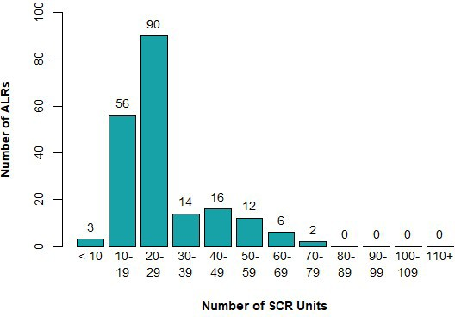

UNITS OCCUPIED
Most ALRs, 74% (195/265), had more than 80% of units occupied in December 2023, with a
median percentage occupied of 90% (Figure 6).9 The median percentage occupied was

8 One ALR with one SCR residence did not describe the resident type.
9 Eight ALRs reported that the ALR had more units occupied on December 31 than reported units available on December 31. The differences ranged from one additional unit occupied to 48 additional units. For these ALRs, EOEA set the percentage occupied to 100%.

steady from January through April at 86%. It then increased to 88% from May through July, further rising to 89% from August through October, and ﬁnally reached 90% in December.10

Figure 6. Percentage of Units Occupied in December 2023 (N=260 ALRs)
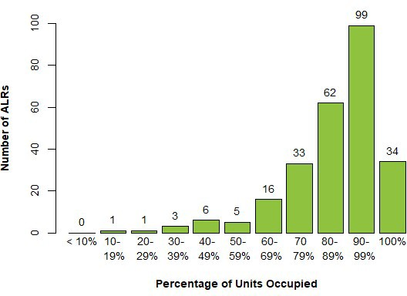

Each ALR unit can be occupied by one or more residents. Approximately 72% of ALRs with traditional units (167/231) had no units occupied by multiple residents, while roughly 44% of ALRs with SCR units (87/199) had no units occupied by two or more residents.11

10 For each month and ALR, the denominator for this calculation is the number of units reported for December 2023. Seven reporting ALRs opened during the year, so the number of ALRs with units varies by month (January – March N=256 ALRs; April N=257 ALRs; May N=258 ALRs; June N=260 ALRs; July – September N=261 ALRs; October N=260 ALRs; November N=261 ALRs; December N=260 ALRs).
11 When reporting the number of units occupied by two or more residents, three ALRs listed more traditional units occupied by two or more residents than reported traditional units that existed. In addition, ﬁve ALRs listed more SCR units occupied by two or more residents than reported SCR units that existed. For these ALRs, EOEA set the percentage occupied by multiple residents to 100%.

RESIDENTS
To describe ALR residents, this report presents two different types of information:12
- Statistics about residents. For example, 24% of Massachusetts traditional ALR residents have been diagnosed with ADRD. The unit of analysis is the ALR resident, and the analysis describes the Massachusetts ALR population. These statistics do not reveal potentially large differences between residents in different ALRs.
- Statistics about ALRs. For example, at 20% (45/228) of ALRs with traditional residents, fewer than 10% of residents have been diagnosed with ADRD. In contrast, at 7% (15/228) of ALRs with traditional residents, more than 50% of traditional residents have been diagnosed. This information illustrates the diversity between different ALRs in Massachusetts. The unit of analysis is the individual ALR and the analysis examines residents as part of an ALR.

For clarity, this report presents statistics about residents in tables, and reports statistics
about ALRs in ﬁgures.

RESIDENTS
The responding ALRs reported a total of 17,388 residents, with 12,149 traditional unit
residents and 5,239 SCR residents as of December 31, 2023.13

The total number of ALR residents (traditional plus SCR) did not vary much by month during the first three months of 2023, but then consistently increased during the rest of the year (Table 1).

Table 1. Number of ALR Residents in 2023, by Month
Month | Number of Residents | %  Change  from Previous
January | 16,189 | -
February | 16,200 | -
March | 16,306 | 0.01
April | 16,346 | -

12 Information about all residents can help policymakers, researchers, nonproﬁt organizations, and businesses better understand the ALR resident population. However, different types of people choose to live in different ALRs and only reporting aggregate statistics across all ALRs might obscure important differences between residents of different ALRs.
13 These statistics are based on ALR reporting of residents by age and gender. When ALRs reported the total number of residents (traditional + SCR) monthly, they reported 17,211 residents at the end of December (Table 1).

May | 16,448 | 0.01
June | 16,653 | 0.01
July | 16,765 | 0.01
August | 16,906 | 0.01
September | 17,007 | 0.01
October | 17,071 | -
November | 17,127 | -
December | 17,143 | -
Notes. This ﬁgure is based on data provided by 259 ALRs. Seven reporting ALRs opened during 2023; these ALRs did not have residents during some early months of 2022. A hyphen indicates a change of less than one percent.

Of those 228 ALRs with traditional units and complete data, the median ALR had 53 traditional unit residents (for variation, see Figure 7). Of those 197 ALRs with SCR units, the median ALR had 24 SCR residents.

Figure 7. Number of ALRs, by Traditional and SCR Residents (N=263 ALRs)
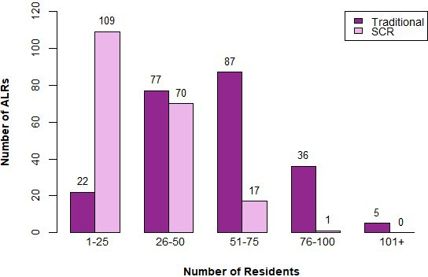

Notes. N=228 ALRs (traditional) and 197 ALRs (SCR)

AGE AND GENDER14
Among traditional unit residents, the most common age range for men, women, and non-binary older adults was 85-89 (see Table 2). The proportion of women in Massachusetts traditional residences was 70%.

Table 2. Number of Traditional Unit Residents, by Gender and Age Group
Age Group | Men | Women | Non-Binary Adults
<50 years old | 5 | 11 | 0
50-54 years old | 10 | 13 | 1
55-59 years old | 33 | 30 | 0
60-64 years old | 75 | 92 | 0
65-69 years old | 165 | 203 | 0
70-74 years old | 286 | 423 | 0
75-79 years old | 474 | 1,003 | 1
80-84 years old | 658 | 1,639 | 4
85-89 years old | 842 | 2,107 | 6
90-94 years old | 751 | 1,914 | 5
95-99 years old | 283 | 855 | 1
100+ years old | 40 | 166 | 2
Total | 3,622 | 8,456 | 20
Notes. Based on data provided by 227 ALRs.

For traditional units, the median ALR percentage of men, women, and non-binary residents
was 29%, 71%, and 0% respectively (see Figure 8 for variation across ALRs).15

14 For nine ALRs, the total number of residents listed in the age-by-gender section differed from the total number of residents listed in the December monthly reporting of residents (187 ALRs reported consistent numbers or did not report data on age-by-gender section). For all the inconsistent ALRs, the discrepancies were minor—only one resident.
15 A recent nationally representative survey found that 0.1% of Americans 50 and older identiﬁed as non-binary.

Figure 8. Number of ALRs, by Percentage of Women Traditional Residents (N=227 ALRs)
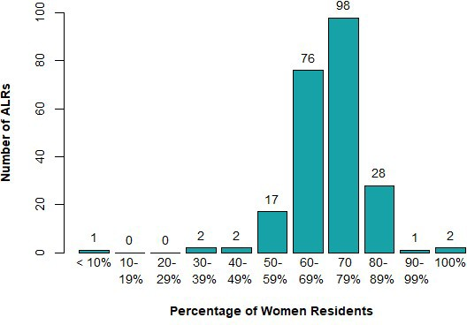

For SCR unit residents, the most common age range for men and women was 85-89, and the most common age ranges for non-binary residents was 80-84 and 85-89 (see Table 3). The proportion of women in Massachusetts SCR residences was 74%.

Table 3. Number of SCR Unit Residents, by Gender and Age Group
Age Group | Men | Women | Non-Binary  Adults
< 50 years old | 1 | 2 | 0
50-54 years old | 0 | 2 | 0
55-59 years old | 12 | 7 | 0
60-64 years old | 17 | 28 | 0
65-69 years old | 39 | 75 | 0
70-74 years old | 90 | 194 | 0
75-79 years old | 208 | 536 | 3
80-84 years old | 329 | 800 | 5
85-89 years old | 361 | 1,036 | 5
90-94 years old | 220 | 791 | 3
95-99 years old | 71 | 324 | 0
100+ years old | 4 | 44 | 1

Total | 1,352 | 3,839 | 17
Notes. This table is based on data provided by 196 ALRs.
For SCR units, the median ALR percentage of men, women, and non-binary residents was
24%, 76%, and 0% respectively (see Figure 9 for variation across ALRs).

Figure 9. Number of ALRs, by Percentage of Women SCR Residents (N=196 ALRs)
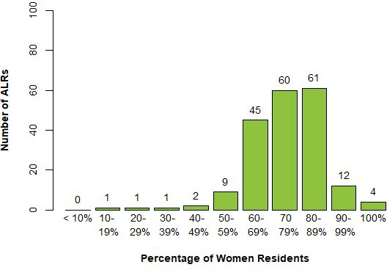

RACE AND ETHNICITY16
Based on the 186 ALRs that collected data on resident race, Massachusetts ALR residents were approximately 93% White (11,409/12,257), 2% Black/African American (201/12,257), less than 1% Asian (106/12,257), less than 1% Hawaiian/Paciﬁc Islander (5/12,257), less than 1% American Indian or Native Alaskan (10/12,257), and 2% Other (271/12,257); ALRs did not know the race of 2% of residents (255/12,257).17 Based on the 156 ALRs that collected data on resident ethnicity, 89% of ALR residents were not Hispanic/Latino

16 EOEA requested data on resident race using the standard federal racial and ethnicity categories, with race and ethnicity being measured separately.
17 For ﬁve ALRs, the total number of residents listed in the age-by-gender section differed from the total number of residents listed in the race section (260 ALRs provided consistent numbers or did not report data on gender or race). The differences ranged from -117 to three.

(9,024/10,167), 1% were Hispanic/Latino (107/10,167), and 10% were Other (972/10,167); ALRs did not know the ethnicity of less than 1% of residents (64/10,167).18

The median ALR percentage of White residents was 99%, and the median percentage of each other race, including other race and unknown race, was 0%. Classifying all non-White residents as residents of color, the median percentage of all residents of color was 1%, although several ALRs had more residents of color (Figure 10). The median ALR had 0% Hispanic/Latino residents and was 100% non-Hispanic/Latino; few ALRs were more than 10% Hispanic/Latino (Figure 11).

Figure 10. Number of ALRs, by Percentage of Residents of Color (N=188 ALRs)
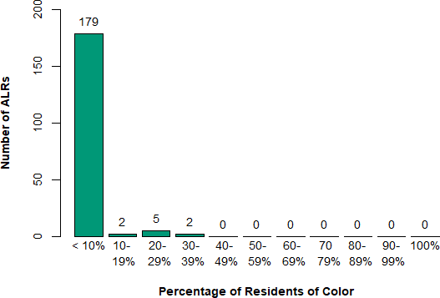

Notes. Residents of Color include those residents reported as Black/African American, Asian, American Indian/Alaska Natives, or Native Hawaiian/Other Paciﬁc Islander.

18 For three ALRs, the total number of residents listed in the age-by-gender section differed from the total number of residents listed in the ethnicity section (262 ARs provided consistent numbers or did not report data on gender or ethnicity). The differences ranged from -101 to zero (for an ALR that only reported the ethnicity of one person).

Figure 11. Number of ALRs, by percentage of Hispanic/Latino residents (N=158 ALRs)
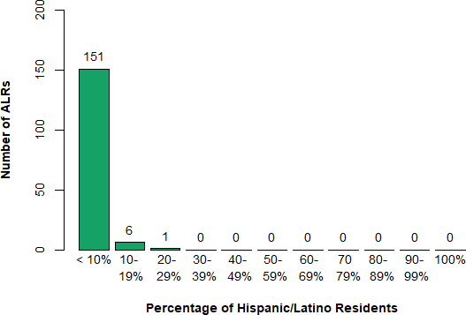

FUNCTIONING
Approximately 24% of ALR traditional unit residents (2,917/12,098) were diagnosed with ADRD, as were 92% of ALR SCR residents (4,795/5,208).19

Of those ALRs with traditional residents, the median ALR had 22% traditional unit residents diagnosed with ADRD (for variation, see Figure 12). Of those ALRs with SCR residents, the median ALR had 100% SCR residents diagnosed with ADRD.

19 For one ALR, the total number of traditional residents listed in the age-by-gender section was less than the total number of traditional residents with Alzheimer’s disease or related dementia (that is, these ALRs reported more traditional residents with dementia than traditional residents). This ALR listed three more traditional residents with dementia than total traditional residents. For 16 ALRs, the total number of SCR residents listed in the age-by-gender section was less than the total number of SCR residents with Alzheimer’s disease or related dementia (that is, these ALRs reported more SCR residents with dementia than SCR residents). For 12 of the 16 ALRs, the ALR listed one or two more SCR resident with dementia than total SCR residents. The maximum difference was -7. For these ALRs, EOEA set the percentage with dementia to 100%. These percentages are calculated using the total number of residents listed in the age-by-gender section for the relevant 263 ALRs as the denominator (12,149 for traditional and 5,239 residents for SCR).

Figure 12. Number of ALRs, by Percentage of Residents with ADRD and Type (N=265 ALRs)
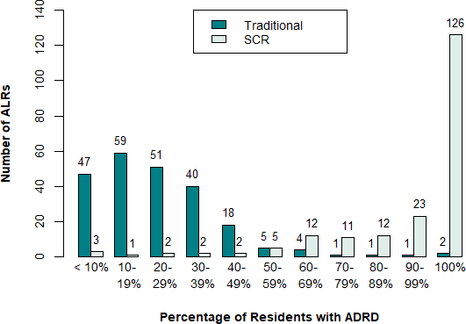
Notes. N=230 ALRs (traditional) and 199 ALRs (SCR)

HEALTH CARE PROXY
Approximately 72% of ALR traditional unit residents (8,736/12,149) had a Health Care Proxy
on ﬁle with their ALR, as did 94% of ALR SCR residents (4,930/ 5,239).²⁰

Of those ALRs with traditional residents, the median ALR had 76% traditional unit residents with a Health Care Proxy on ﬁle (for variation, see Figure 13). Of those ALRs with SCR residents, the median ALR had 96% SCR residents with a Health Care Proxy on ﬁle.

20 For 10 ALRs, the total number of traditional residents listed in the age-by-gender section was less than the total number of traditional residents with a health care proxy (that is, these ALRs reported more traditional residents with a health care proxy than traditional residents overall). The differences ranged from -27 to 103. For 14 ALRs, the total number of SCR residents listed in the age-by-gender section was less than the total number of SCR residents with a health care proxy (that is, these ALRs reported more SCR residents with a health care proxy than SCR residents overall). The differences ranged from -42 to 27. For these ALRs, EOEA set the percentage of residents with a health care proxy to 100%. These percentages are calculated using the total number of residents listed in the age-by-gender section for the relevant 263 ALRs as the denominator (12,149 for traditional and 5,239 residents for SCR).

Figure 13. Number of ALRs, by Percentage of Residents with Health Care Proxy and Type (N=262 ALRs)
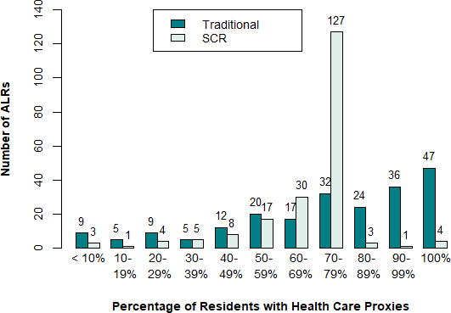
Notes. N=227 ALRs (traditional) and 195 ALRs (SCR)

PROGRAM AND PLAN PARTICIPATION
Some ALR residents participate in government programs that help cover the cost of living in an ALR—2% of residents participated in Group Adult Foster Care (GAFC),21 1% received Section 8 Rental Assistance, and less than 0.1% received MA Rental Voucher Program (MRVP) Rental Assistance (see Table 4 for residents participating in each program).22

21 MassHealth’s GAFC helps older adults with low incomes by paying for personal care services and medication management and administration. GAFC does not pay for room and board, but the Supplemental Security Income (SSI-G) Assisted Living Beneﬁt can cover these costs. To qualify for GAFC in an ALR, an older adult must have SSI-G.
22 These percentages are calculated using the total number of residents listed in the age-by-gender section
as the denominator (17,388 residents).

Table 4. Number of Residents Participating in Program, by ALR Residence Type
Program | Traditional | SCR | Total
GAFC | 274 | 11 | 285
Section 8 | 224 | 11 | 235
MRVP | 6 | 6 | 12
Notes. For traditional residents, this table is based on data provided by 231 ALRs. For SCR residents, this table is based on data provided by 191 ALRs. For total residents, the data was provided by 265 ALRs.

Most ALRs did not report any residents receiving GAFC, Section 8, or MRVP. For example, 190 (of 231) ALRs reported no traditional GAFC residents and 193 (of 199) ALRs reported no SCR GAFC residents. At the ALRs with at least one GAFC resident, these residents were typically less than a quarter of the residents (there was one ALR where most traditional residents received GAFC). Similarly, 222 ALRs had no traditional residents receiving Section 8 and 196 ALRs had no SCR residents receiving Section 8. ALRs with traditional residents receiving Section 8 often had a high proportion of residents receiving Section 8; two ALRs had only Section 8 traditional residents and three more had more than 50% of residents receiving Section 8. One ALR had traditional residents receiving MRVP and one ALR had SCR residents receiving MRVP.

ALRs also reported on whether residents were participating in dual-eligible health plans.23 Approximately 1% were enrolled in Senior Care Options (SCO), 7% were enrolled in Program of All-Inclusive Care of the Elderly (PACE), and less than 0.1% were enrolled in One Care (see Table 5 for residents participating in each insurance plan).

23 These are integrated health plans whose beneﬁciaries are eligible for both Medicaid (MassHealth) and
Medicare.

Table 5. Number of Residents with Dual-Eligible Health Plans, by ALR Residence Type

Plan | Traditional | SCR | Total
SCO | 198 | 5 | 203
PACE | 962 | 266 | 1,228
One Care | 7 | 0 | 7
Notes. This table is based on data provided by 230 ALRs (traditional residents) and 195 ALRs (SCR residents). For total residents, the data came from 264 ALRs.

Most ALRs did not have any residents participating in a dual-eligible insurance plan. For example, 212 (of 231) ALRs reported no traditional residents participating in an SCO and 197 (of 199) ALRs reported no SCR residents participating in an SCO health plan. At the ALRs with at least one resident participating in an SCO, these residents were typically less than a quarter of the residents. Similarly, 172 ALRs reported no traditional residents covered by PACE and 164 ALRs reported no SCR residents covered by a PACE plan. Some ALRs had a high proportion of residents covered by PACE; 12 ALRs had at least 50% of traditional residents covered by PACE, and six ALRs had at least 50% of SCR residents covered by PACE. Three ALRs reported traditional residents covered by One Care.

SERVICES
By law, ALRs in Massachusetts must offer certain services to residents. Speciﬁcally, ALRs must provide “assistance with activities of daily living,” (ADLs) which can include help getting dressed, eating, and so on.24 ALRs are also required to provide self-administered medication management or SAMM.25 ALRs can choose whether to offer other resident services, such as daycare, transportation, limited medication administration (LMA),26 and skilled nursing care.27

MEDICATION ASSISTANCE
Approximately 64% (170/265) of ALRs reported offering LMA to residents. Of the ALRs with traditional residents, 61% (139/228) offered LMA while 78% (153/197) of the ALRs with SCR residents offered LMA.

In traditional units, the most common form of medication assistance was SAMM-only, while in SCR units, LMA-only was most common, slightly more common than SAMM-only (Table 6).28

Table 6. Number of Residents Receiving Medication Assistance, by ALR Residence Type
Assistance | Traditional | SCR | Residents
SAMM-only | 6,274 | 2,070 | 8,344
LMA-only | 648 | 2,710 | 3,358
Both | 268 | 413 | 681
Neither | 4,455 | 192 | 4647
Total | 11,645 | 5,385 | 17,030
Notes. This table is based on data provided by 228 ALRs (traditional residents), 194 ALRs (SCR residents).

24 M.G.L. ch. 19D, § 1.
25 M.G.L. ch. 19D, § 10. For SAMM, ALR staff can only remind and assist residents with taking medication. For example, staff can remind a resident when to take medication and open bottles or other containers. They cannot directly administer any medication to a resident.
26 For LMA, a nurse, an individual designated by the resident, or the resident's representative can administer eye drops, apply medicated cream, and crush medications and place them in a resident’s mouth.
27 Skilled nursing care includes wound care and injections.
28 For 95 ALRs with traditional residents, the total number of traditional residents listed in the age-by-gender section differed from the total number of residents listed in the medication assistance (LMA/SAMM) section (for 132 ALRs the numbers were identical or the ALRs did not report medication assistance information or age-by-gender information). The differences ranged from -32 to 66. For 60 ALRs with SCR residents, the ALRs reported a different number of residents in the age-by-gender section than in the medication assistance section (for 134 ALRs the numbers were identical or the ALRs did not report medication assistance information or age-by-gender information). The differences ranged from -51 to 10.

Among ALRs offering LMA and with traditional residents (139 ALRs), the median ALR had 52% of traditional residents receiving SAMM-only, 4% receiving LMA-only, 0% receiving both, and 36% receiving neither. For SCR residents (N=153 ALRs), the respective median percentages were: 0% (SAMM only), 85% (LMA only), 0% (both), and 0% (neither).

Among ALRs not offering LMA and with traditional residents (N=89), the median ALR had 69% traditional residents receiving SAMM, with 31% not receiving SAMM. For SCR residents (N=44 ALRs), the respective median percentages were: 100% (SAMM) and 0% (not receiving SAMM).

SKILLED NURSING CARE
Approximately 3% (9/264) of ALRs reported offering skilled nursing care to residents in accordance with the allowance of Section 39 of Chapter 2 of the Acts of 2023. Of the ALRs with traditional residents, 4% (8/227) offered skilled care while 3% (6/196) of the ALRs with SCR residents offered skilled care.

Table 7. Number of ALR Residents Receiving Skilled Care in 2023, by Month
Month | Number of Residents | %  Change  from Previous
January | 46 | -
February | 49 | 7%
March | 51 | 4%
April | 51 | 0
May | 50 | -2%
June | 51 | 2%
July | 52 | 2%
August | 46 | -12%
September | 45 | -2%
October | 45 | 0
November | 48 | 7%
December | 54 | 12%
Notes. This figure is based on data provided by 9 ALRs.

ASSISTANCE WITH ACTIVITIES OF DAILY LIVING
Most ALR residents (76%) received help with at least one activity of daily living (Table 8).

Table 8. Number and Percentage of Residents Receiving Assistance with ADLs
Number of ADLs | Residents | Percentage
0 | 4,106 | 24%
1 | 2,427 | 14%
2 | 2,512 | 15%
3 | 2,547 | 15%
4 | 2,324 | 14%
5 | 1,920 | 11%
6 | 1,324 | 8%
Total | 17,160
Notes. This table is based on data provided by 264 ALRs. Percentages do not sum to 100%
due to rounding.

At the ALR level, 17 ALRs had 50% or more of residents receiving no assistance with ADLs, 70 ALRs had most residents receiving assistance with one or fewer ADLs, 140 ALRs had most residents receiving assistance with two or fewer ADLs, and 203 ALRs had most residents receiving assistance with three or fewer ADLs (N=264).29

Respondents also reported the number of residents receiving assistance with specific ADLs, and the most common were bathing, dressing/undressing, and grooming/hygiene (Table 9).

Table 9. Number and Percentage of Residents Receiving Assistance with Specific ADLs
ADL | Residents | Percentage
Bathing | 11,257 | 65%
Dressing/Undressing | 9,645 | 56%
Grooming/Hygiene | 7,755 | 45%
Ambulation | 4,202 | 24%
Eating | 1,289 | 7%
Toileting | 5,814 | 34%
Notes. This figure is based on data provided by 262 ALRs. The denominator for the percentage of resident calculation is the total number of residents as reported in response to the number of ADLs provided to each resident (17,160) plus 53 and 100 (the number of residents in the ALRs that did not provide the number of ADLs provided to each resident).

29 For eight ALRs, the total number of residents listed in the age-by-gender section differed from the total number of residents listed in the ADL (the numbers were identical for 253 ALRs and the remaining ALR did not report ADL information). The differences ranged from -16 to 47.

OTHER SERVICES
Roughly 68% (181/265) of ALRs offered residents free transportation for routine medical appointments, 80% (212/265) of ALRs offered free transportation for shopping, and 85% (224/265) of ALRs offered free transportation for social events.

Over 99% (262/265) of ALRs employed or consulted with a certiﬁed dietician or nutritionist
when designing their menus in 2023.

Approximately 2% (5/264) offered Daycare for non-residents.

DEPARTURES
ALR residents effectively rent an apartment and can choose to move out when the residency agreement ends. ALRs cannot legally prohibit residents from living in their unit without formally terminating the tenancy and obtaining an eviction order.31

MOVE OUTS
ALRs reported that 8,043 residents moved out during 2023 (N=265 ALRs).32 The median ALR had 30 residents move out during 2023.

LENGTH OF STAY
Most ALR residents who moved out had resided in their ALR for fewer than two years (Table 10).

Table 10. Number of Residents, by Length of Stay Before Moving Out
Length of Residency | Residents
< than 3 months | 1,374
3-5 months | 879
6-8 months | 645
9-11 months | 634
1 year – 1 year 11 months | 1,684
2 years – 2 years 11 months | 973
3 years – 3 years 11 months | 588
4 years – 4 years 11 months | 440
5 years – 5 years 11 months | 314
6 years – 6 years 11 months | 198
7 years – 7 years 11 months | 104
8 years – 8 years 11 months | 71
9 years – 9 years 11 months | 48
10 years – 14 years 11 months | 69
15+ years | 22
Total | 8,043
Notes. This table is based on data provided by 264 ALRs. Four ALRs reported that none of their residents moved out during 2023.

31 M.G.L. ch. 19D § 9.
32 For each resident who left, ALRs provided both the reasons for moving out and the length of stay before moving out. For 92 ALRs, the total numbers of residents moving out in the reasons section differed from the total number of residents moving out in the length of stay section (173 ALRs reported identical numbers of residents). For 55 of the inconsistent ALRs the differences were three or less, and the differences ranged from zero to 78. This report uses the length of stay sum; the reasons sum was 8,043 residents (Table 10).

REASONS FOR MOVING OUT
The most common reason for moving out of the ALR was death, followed by moving to a skilled nursing facility (Figure 11).

Table 11. Number of Residents, by Reason for Moving Out (All Residents)
Reason | Residents
Death | 3,252
Moved to Skilled Nursing Facility/Higher Care | 2,298
Respite Stay Concluded | 513
Moved to Another ALR in Massachusetts | 532
Returned Home or to Other Independent Living | 441
Financial/Non-Payment | 529
Moved Out of State | 276
Behavior/Aggressive | 61
Hospice* | 23
No Reason Provided/ Would Not Disclose/  Unknown* | 24
Never Physically Moved in* | 10
Location* | 6
Family Relocating* | 4
Moved in with Family* | 4
Dissatisfaction* | 3
Other (respondent listed or left blank) | 23
Total | 7,999
* Respondent-listed reason
Notes. This figure is based on data provided by 265 ALRs. Respondent-listed reasons provided three or fewer times are categorized as Other.

Examining only people who were ALR residents for less than three months, the most common reason for moving out of the ALR was death followed by conclusion of respite stay (Table 12).33

33 For 26 ALRs, the total number of residents listed in the reason-for-leaving-only-residents-staying-less than-three-months differed from the total number of residents listed as staying less than three months (for 129 ALRs, the numbers were identical, or the ALRs had no residents leave within three months, or the ALR did not provide valid data). The differences ranged from one to 33.

Table 12. Number of Residents, by Reason for Moving Out (In ALR Less Than 3 Months)
Reason | Residents
Respite Stay Concluded | 414
Death | 384
Moved to Skilled Nursing Facility/Higher Care | 309
Returned Home or to Other Independent Living | 178
Moved to Another ALR in Massachusetts | 93
Moved Out of State | 36
Financial/Non-Payment | 28
Behavior/Aggressive | 14
Hospice* | 7
Never Physically Moved In* | 6
Other (respondent listed or left blank) | 14
Total | 1,483
* Respondent-listed reason
Notes. This table is based on data provided by 235 ALRs. Respondent-listed reasons provided three or fewer times are categorized as Other.

SAFETY
ALRs can choose to install video surveillance in public areas or maintain a backup generator to provide electricity during power outages.

VIDEO SURVEILLANCE IN PUBLIC AREAS
Approximately 77% (203/265) of ALRs reported having video surveillance. Of these ALRs, 98% (198/203) reported that the surveillance covered main entrances, 93% (189/203) reported the surveillance covered other entrances, 63% (124/198) reported surveilling common areas, and 54% (107/198) reported the surveillance covered hallways.

BACKUP GENERATOR
Approximately 93% (247/265) of ALRs reported having a backup generator in case of power
outage.

FEES
Aside from the roughly 20% of ALRs (53/265) that reported housing affordability restrictions due to government ﬁnancing requirements (such as 40B, Low Income Housing Tax Credits, Project Based Vouchers), there are no legal restrictions on ALR service fees. Fees vary within an ALR depending on the unit size, amenities, resident services required, residence type, and other factors.

LOWEST AND HIGHEST FEES
The lowest and highest fees varied widely across ALRs—the lowest fee for any traditional resident in Massachusetts was $95 and the lowest for an SCR resident was $78, while the highest fees for a traditional and SCR resident were $22,320 and $20,460 respectively (see Figures 14 and 15 for variation across ALRs). For ALRs with traditional residents, the median lowest monthly fee was $4,000, and the median highest monthly fee was $8,795. For SCR units, the median lowest monthly fee was $7,081 and the median ALR highest fee was $10,550.

Figure 14. Number of ALRs, by Lowest/Highest Fees for Traditional Units (N=228 ALRs)
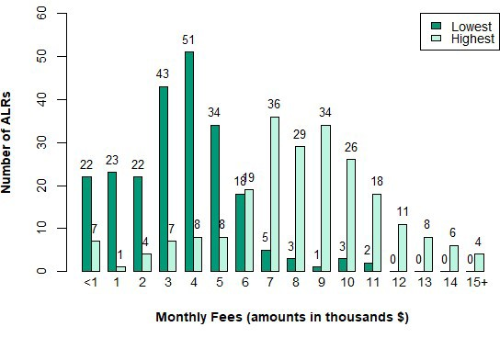
Notes. One ALR with SCR units reported the lowest fee was $0; that lowest fee is not
displayed.

Figure 15. Number of ALRs, by Lowest/Highest Fees for SCR Units (N=195 ALRs)
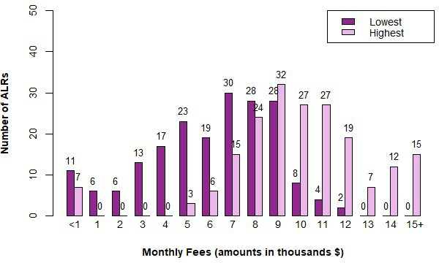

APPENDIX: DATA COLLECTION AND ANALYSIS
On February 1, 2024, EOEA’s Director of Assisted Living Certiﬁcation & Compliance emailed all ALR executive directors with a request to provide ALR 2023 data via an online survey. The email included a link to the survey and informed ALRs that, “in accordance with [regulations] 651 CMR 12.04(13)(a)(2) all Massachusetts certiﬁed Assisted Living Residences (ALRs) must submit an accurate report of 2023 information to the Executive Office of Elder Affairs (EOEA) on or before March 1st.”34 Attached to the email were survey instructions and a PDF of the survey. EOEA did not send any reminders. LeadingAge Massachusetts and the Massachusetts Assisted Living Association sent reminders to ALRs that did not submit.

Of the 270 ALRs contacted, 265 submitted at least some survey data. The following ﬁve
ALRs did not submit any data:

Elizabeth Calsey House at Lions Mouth Road, Amesbury
- Seasons of Danvers, Danvers
- Swan Brook, Swansea

The Assisted Living Residences at Hancock Park, Quincy
- The Residence at AdviniaCare Northbridge, Northbridge

One ALR completed the survey twice; the submissions were compared and found to be similar, and only data from the second submission was included and analyzed in this report.

The complete online survey contained 47 items, and many items had multiple sub-items. The survey used a skip logic where appropriate (for example, ALRs without SCR were not presented with questions about SCRs) such that some ALRs were presented with fewer questions.

Only a few items (such as identifying the ALR and site address) required responses to continue. For the remaining items, after skipping items, respondents would be notiﬁed which items had been skipped when they tried to move to the next page.

34 The survey ended up being accessible until March 14, 2024, and four ALRs completed the survey between March 2, 2023, and March 14, 2023. EOEA allowed two ALRs to submit after this deadline because they had completed or mostly completed the survey but did not click “Submit” to complete the survey process. Two additional ALRs submitted when the survey was brieﬂy reopened to allow the aforementioned ALRs to submit.

RESPONDENTS
Executive directors typically completed the survey (Table A1).

Table A1. Primary Respondent Title
Title | Frequency  Listed
Executive Director | 225
Chief Operating Officer or Chief Financial  Officer | 2
Resident Care Director | 14
Owner | 3
Business Manager or General Manager | 7
Other | 14
Total | 265

DATA INCONSISTENCIES AND ANOMOALIES
To minimize frustration, EOEA did not include automatic logic checks that required
respondents to provide consistent information across sections.

The online survey did present information that respondents could use to check the consistency of answers. For example, after the respondent entered the total number of residents in the age-by-gender section, that information would be presented when the respondent entered in the number of residents by race so that respondents could compare the totals (this information was also provided when respondents were reporting ethnicity and ADLs). Similarly, after respondents completed the survey but before submission, the online survey conducted three consistency checks and reported inconsistencies to respondents. Respondents could then choose whether to update their responses. Some respondents who were aware of these inconsistencies submitted the surveys with the inconsistencies.

When respondents submit inconsistent information, EOEA cannot easily determine which information is most accurate. For example, if the ALR reports 101 total residents when describing resident gender while reporting 98 total residents when describing resident race, which is correct? As most of the inconsistencies involved a few residents, EOEA typically made no changes to the data and noted the inconsistencies in report footnotes.

When the inconsistencies led to impossible results, EOEA modiﬁed the results and noted the issue in footnotes. For example, when reporting the number of units that existed on December 31, 2023, and that were occupied on December 31, 2023, eight ALRs listed

more units occupied than units that existed. When calculating the occupancy rate, EOEA
set the occupancy rate for these ALRs to 100% (instead of 100+%).

EOEA CHANGES AND CORRECTIONS
The submitted forms also contained clear errors or highly implausible data. In these situations, EOEA changed the data to missing or corrected the data.35 Speciﬁcally, EOEA made the following changes before analyzing the data:
- Two ALRs reported one traditional unit. According to EOEA records, all ALRs that have traditional residences have eight or more certiﬁed traditional units, and so EOEA reclassiﬁed the ALR unit numbers according to the number of certiﬁed units in EOEA records as of October 30, 2023 (link).
- Two ALRs reported one SCR unit. According to EOEA records, all ALRs that have SCR residences have seven or more certiﬁed SCR units, and so EOEA reclassiﬁed the ALR unit numbers according to the number of certiﬁed units in EOEA records as of October 30, 2023 (link).
- One ALR reported having zero traditional units. However, this ALR also reported traditional residents receiving services and provided monthly fee information related to traditional units. For this ALR, EOEA reclassiﬁed the number traditional units according to the number of certiﬁed units in EOEA records as of October 30, 2023 (link).
- When reporting the number of non-binary traditional and SCR residents, one ALR consistently summed the number of men and women in each age group to calculate the number of non-binary residents. For this ALR, EOEA changed the number of non-binary residents to missing.
- One ALR reported that all of their residents were under the age of 50 when reporting the number of traditional and SCR residents by age-gender. This is highly unlikely as they refer to themselves as a "senior living community." For this ALR, EOEA changed the age-gender of all residents to missing.
- The online survey tool incorrectly summed the total number of traditional residents for one ALR. EOEA corrected this to the actual sum.
- The online survey tool incorrectly summed the total number of ADLs for two ALRs.
EOEA corrected the total to the actual sum.
- Three ALRs reported that their ALR did not provide LMA services but reported in another section that a number of residents were receiving LMA services. For these ALRs, EOEA changed whether they provided LMA services to yes.

35 When the submitted data was merely improbable—such as a small ALR composed entirely of men, women, or non-binary adults—EOEA did not change the data.

- Three ALRs reported not providing limited medication assistance (LMA), but then reported providing LMA services to speciﬁc residents. EOEA classiﬁed these ALRs as providing LMA.

Finally, for characteristics, EOEA replaced non-responses in some categories with zeros. For example, when respondents provided data for some categories (e.g., 10 women between 80-84) but did not complete the ﬁeld for the number of men between 90-94, EOEA imputed zero men aged 90-94. Because respondents completed some categories (for example, 10 women between 80-84), EOEA assumed that the respondent meant to indicate zero residents when leaving the category ﬁeld blank rather than indicating that the respondent did not know the number. If the respondent left all categories blank, EOEA assumed the respondent did not report the relevant information for that characteristic and did not impute zero. EOEA performed this imputation for demographic characteristics, medication assistance, number and type of ADLs, and moveout duration and reason.

CALCULATING THE NUMBER OF ALRs PROVIDING VALID INFORMATION
EOEA determined whether an ALR reported valid data for an item (i.e., should be included in the N) as follows:
- ALR Tax Status (Figure 1). EOEA considers all submissions as valid data because the
online survey requires ALRs to answer this item and select a valid option.
- Executive Directors (Figure 2). EOEA considers a response as valid data if the ALR reported between one and 10 directors. (EOEA assumes that numbers outside this range are likely errors.)
- Resident Care Directors (Figure 3). EOEA considers a response as valid data if the ALR reported between one and 10 directors. (EOEA assumes that numbers outside this range are likely errors.)
- Traditional Certiﬁed Units (Figure 4). EOEA considers a response as valid data if the ALR reported more than zero units. Note that when an ALR indicates one or two units, EOEA resets the number to the registered number of units.
- SCR Certiﬁed Units (Figure 5). EOEA considers a response as valid data if ALR reported more than zero units. Note that when an ALR indicates one or two units, EOEA resets the number to the registered number of units.
- Units Occupied (Figure 6). EOEA considers a response as valid data if the ALR reported one or more units occupied in December.
- Total Residents (Figure 7). EOEA considers a response as valid data if the ALR reported one or more traditional residents when reporting age/gender and one or more SCR residents when reporting age/gender.
- Number of Residents by Month (Table 1). EOEA considers a response as valid if the ALR reported more than one resident in any month.

- Traditional Resident Gender (Table 2 and Figure 8). EOEA considers the response as valid data if the ALR reported more than one male, female, or non-binary resident. Note this item only appears if the ALR reported traditional units.
- SCR Resident Gender (Table 3 and Figure 9). EOEA considers the male/female count as valid data if the ALR reported more than one male, female, or non-binary resident. Note this item only appears if the ALR reported SCR units.
- Resident Race (Figure 10). EOEA considers a response as valid data if the ALR reported a number greater than 0 for any race (reporting all residents as race unknown is not considered valid data).
- Resident Ethnicity (Figure 11). EOEA considers a response as valid data if the ALR reported a number greater than zero for any race (reporting all residents as ethnicity unknown is not considered valid data).
- Residents with ADRD (Figure 12). EOEA considers a response as valid data for traditional/SCR residents if the ALR reported having traditional/SCR units and reported a number, including zero, for traditional/SCR residents with ADRD.
- Residents with Health Care Proxy (Figure 13). EOEA considers a response as valid data for traditional/SCR residents if the ALR reported having traditional/SCR units and reported a number, including zero, for traditional/SCR residents with a proxy.
- Residents in Programs/Plans (Table 4). EOEA considers a response as valid data for traditional/SCR residents if the ALR reported having traditional/SCR units and reported a number, including zero, for traditional/SCR residents for any program or plan.
- Residents in Housing Programs (Table 5). EOEA considers a response as valid data for traditional/SCR residents if the ALR reported having traditional/SCR units and reported a number, including zero, for traditional/SCR residents in a housing program.
- Limited Medication Administration. EOEA considers a response as valid data if the ALR selected a response option.
- Number of Residents with Self-Administered Medication Management & Limited Medication Administration (Table 6). EOEA considers a response as valid data for traditional/SCR residents if the ALR reported having traditional/SCR units and reported a number, including zero, for traditional/SCR residents receiving assistance.
- Skilled Care. EOEA considers a response as valid data if the ALR selected a response option.
- Skilled Care-Monthly (Table 7). EOEA considers a response as valid data if the ALR reported a number for any month. Note this item only appears if the ALR reported providing skilled care services.

- Residents Requiring Assistance with Number of Activities of Daily Living (Table 8). EOEA considers a response as valid data if the ASAP reported a number, including zero, for any number of ADLs.
- Residents Requiring Assistance with Speciﬁc Activities of Daily Living (Table 9). EOEA considers a response as valid data if the ASAP reported a number, including zero, for any speciﬁc ADL.
- Rep-Payee. EOEA considers a response as valid data if the ALR selected a response option.
- Daycare Programs. EOEA considers a response as valid data if the ALR selected a response option.
- Transportation. All submission count as valid data because ALRs that do not check any boxes might not offer any transportation (i.e., blank responses are a valid response).
- Dietician. EOEA considers a response as valid data if the ALR selected a response option.
- Unique Residents. EOEA considers a response a valid data if the ALR reported one or more unique residents.
- Length of Residency (Table 10). EOEA considers a response as valid data if the ALR reported a number for any duration.
- Move Out Reasons (Table 11). EOEA considers a response as valid data if the ALR reported a number for any reason.
- Move Out Reasons-3 Months or Less (Table 12). EOEA considers a response as valid
data if the ALR reported a number for any reason.
- Video Surveillance. EOEA considers a response as valid data if the ALR selected a response option.
- Surveillance Policy & Procedures. EOEA considers a response as valid data if the ALR selected a response option. Note this item only appears if the ALR reported surveillance.
- Video Surveillance Coverage. EOEA considers a response as valid if ALR selected at least one response option. Note this item only appears if the ALR reported surveillance.
- Backup Generator. EOEA considers a response as valid data if the ALR selected a response option.
- Highest and Lowest Monthly Fees (Figures 14 and 15). EOEA considers a response as valid data for traditional/SCR residents if the ALR reported having traditional/SCR units and reported a dollar amount greater than zero for that category of residents.
- Respondent Title (Table A1). All submissions count as valid data because the online
survey requires ALRs to answer this item and select a valid option.

