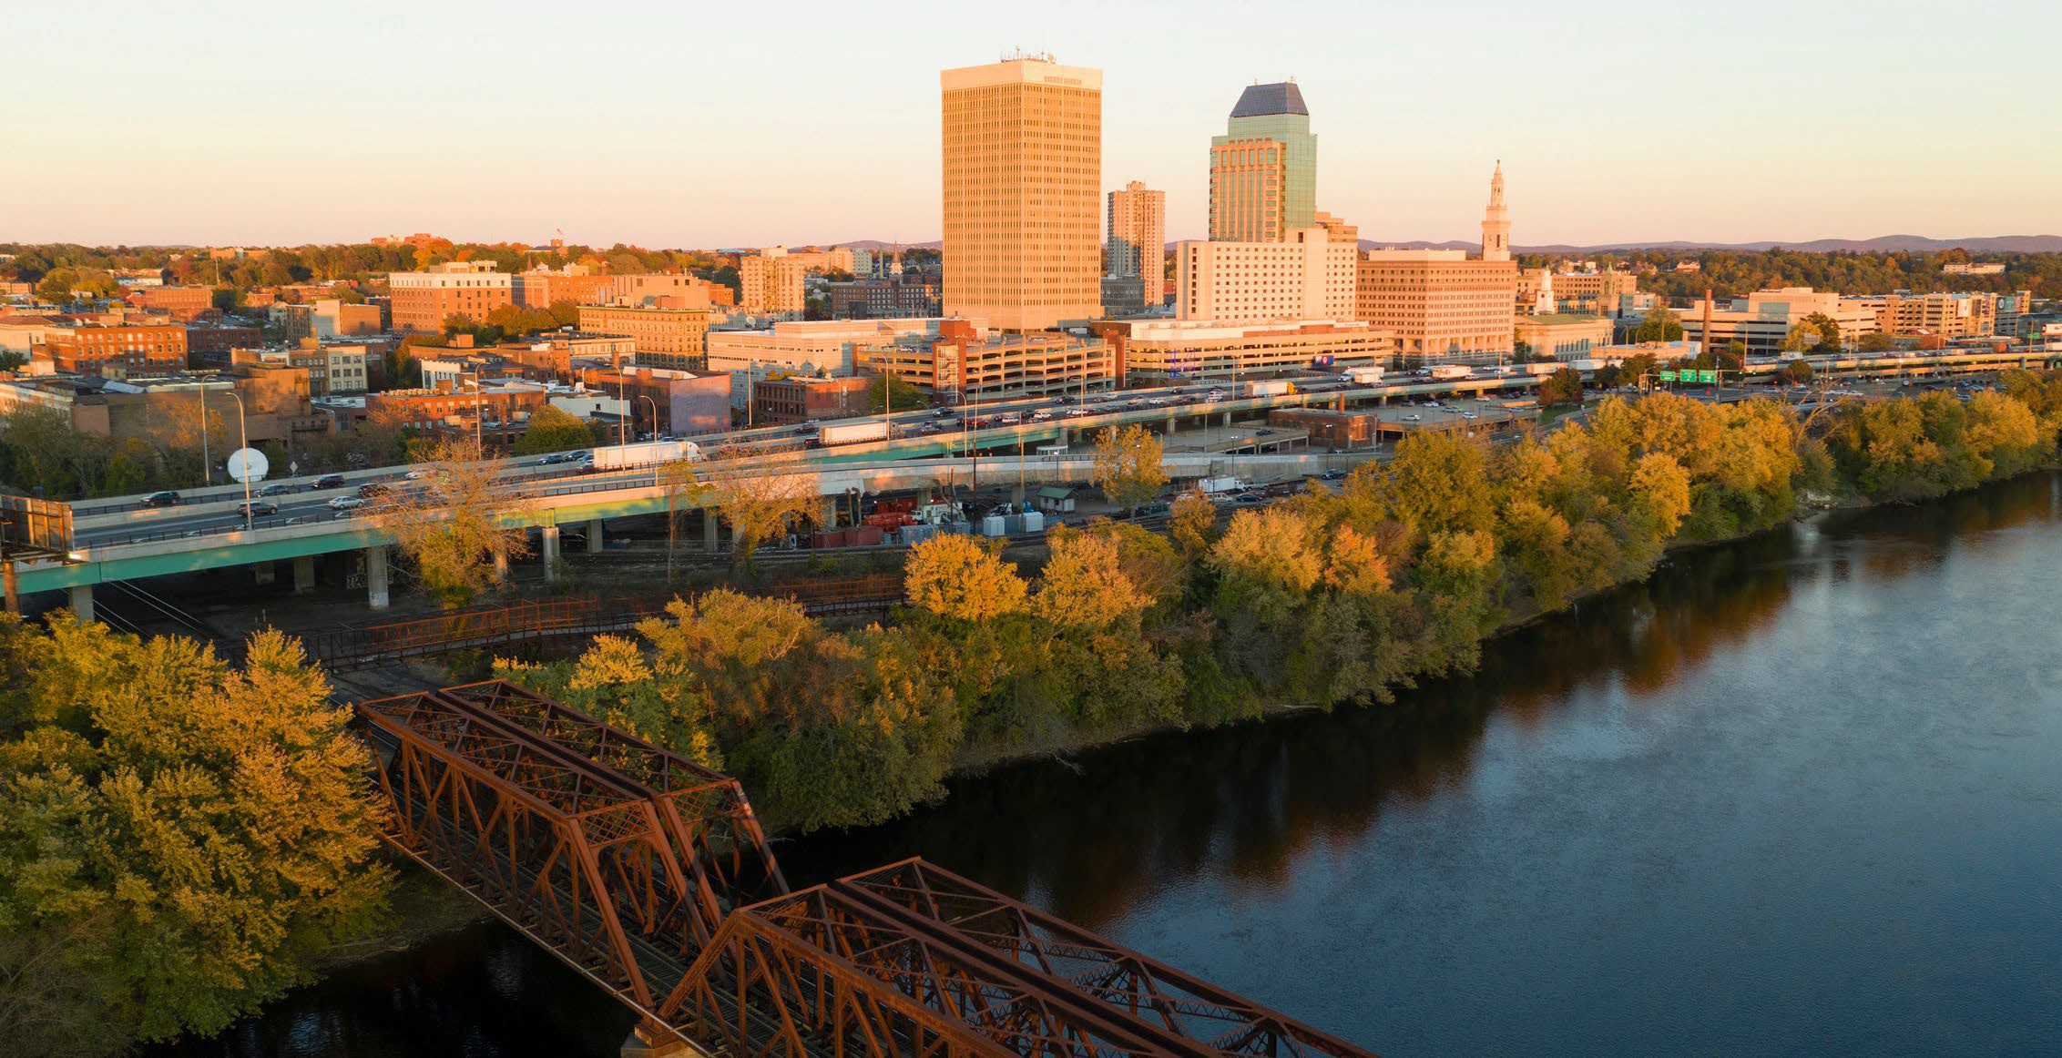
A Community Driven Analysis to Promote Equity & Health in Problem Gambling
OUR VOICE,
OUR COMMUNITY:

ACKNOWLEDGMENT

DPH/OPGS would like to thank the community of Springfield, MA and the over 150 community members who lent their voices to continue our efforts to lift community voice and promote equity. Special thanks to Rebecca Bishop and Dr. Haner Hernandez, Massachusetts Center of Excellence on Problem Gambling Prevention, Scott Formica, Social Science Research & Evaluation, Dr. Rodolfo R Vega, Corina Pinto, MS, JSI Research & Training Institute, Inc.

Additionally, we would like to extend our appreciation to Commissioner Helen Caulton-Harris, and the City of Springfield’s Department of Health and Services team for their partnership and collective efforts on this project. Lastly, thank you to Alafia “Terrie” Thompson and Xavier Williams for their dedication and commitment to community engagement and lifting up community voices.

1. TABLE OF CONTENTS

- EXECUTIVE SUMMARY 1
- INTRODUCTION 3
- BACKGROUND 4
A Brief History of Springfield, Massachusetts 6
Role of the Office of Problem Gambling Services (OPGS) 6
Role of the Office of Problem Gambling Services (OPGS) 6
- METHODOLOGY AND RECRUITMENT 7
Assessment Questions 8
Demographics of Interviewees 8
- FINDINGS 9
Theme 1: Gambling: Perceptions and Beliefs 9
Theme 2: COVID-19 12
Theme 3: Healthcare 13
Theme 4: Employment 14
Theme 5: Food Systems 15
Theme 6: Community Leadership 16
- DISCUSSION 17
- NEXT STEPS 19
Sharing Outcomes and Creating Partnerships 19
Recommendations 20

EXECUTIVE SUMMARY

Purpose

The purpose of this study was to obtain information from the Springfield community about gambling and gambling prevention through MDPH Office of Problem Gambling© CHW Pilot Program. The initiative used Community Health Workers (CHWs) to collect the attitudes toward gambling in the Springfield community and the strengths and challenges impacting residents.

Methods

The study used a community-based participatory research (CBPR) approach. The study consisted of three phases; the first phase was identifying and training CHWs. During this phase, CHWs received extensive training on problem gambling prevention, how to con- duct interviews with community members, how to use a scripted series of questions, and how to document the content of these interviews. In the second phase, Springfield residents were recruited by CHWs and in the last phase of the study, CHWs interviewed Springfield residents to create an in-depth narrative of their perceptions, life experiences, and challenges they
are experiencing.

The purpose of this study was to obtain information from the Springfield community about
“
gambling and gambling prevention through a CHW Pilot Program.’’

Findings

The study addressed these questions: 1) What do community members believe are the problems in Springfield? The data yielded that community members believed housing, employment, and food security to be problems in Springfield; 2) What do
community members think are the solutions to these problems? Participants offered various solutions that spanned community, state, federal, and national levels;
3) What are some community strengths? Who are the leaders in the community? Who makes decisions that impact the community? And who do people listen to?
Participants suggested that Springfield residents, including community leaders, business representatives, and clergy, are the most valuable sources of information about problem gambling, social determinants of health, and other issues of concern; and 4) What helpful resources exist in the community? Participants high- lighted the importance of the family and community contexts. They mentioned community agencies, community leadership, the ability to share resources and help each other, and resilience as strengths. They mentioned the mayor, church leaders, volunteers, grassroots leadership, college students, and teachers as leaders in black and brown communities.

Recommendations

The suggested solutions offered by the community, traverse interlocking systems such as local government, community agencies, state agencies, federal govern- ment agencies, and national advocacy organizations. For example, increase access to culturally responsive mental health services, increase communication and trust between local government, community agencies, and communities of color and increase the numbers and/or visibility of advocacy organizations assisting communities of color, so community members know where to go to get support.

INTRODUCTION

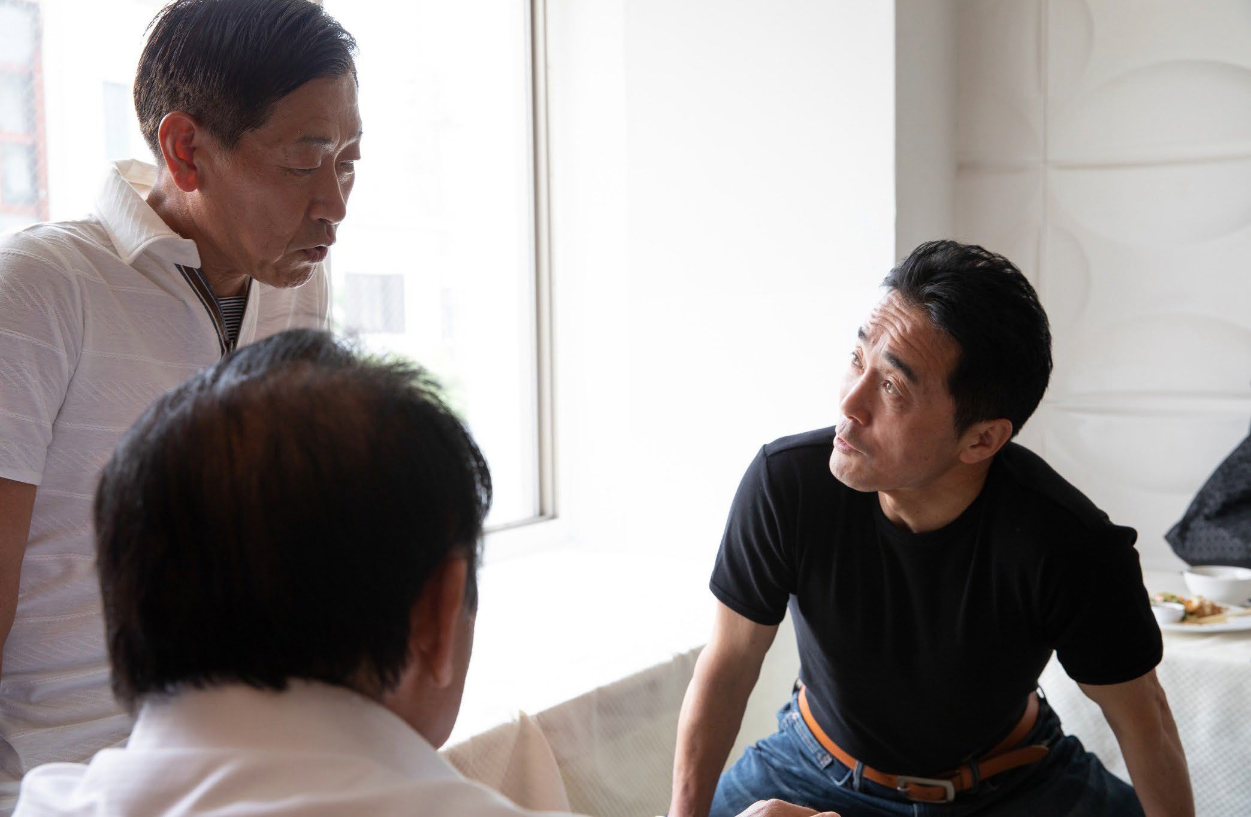
This report describes the efforts and outcomes
of a community-level problem gambling prevention initiative implemented by the City of Springfield Department of Health (SDOH) funded by the Massachusetts Department of Health’s (MDPH)
Office of Problem Gambling Services (OPGS).
The initiative used CHWs to uncover the perceptions of gambling in the Springfield community along with its strengths and challenges impacting residents.

In 2018, The MGM Corporation opened a casino in downtown Springfield. To prevent possible harm
caused by the presence of the casino on the residents of Springfield and the surrounding community,
MDPH Office of Problem Gambling© developed
a pilot test initiative that leveraged Mass in Motion (MiM), an existing community-based program. MiM is a statewide initiative grounded in public health principles that promotes and facilitates access
to food and safe physical activity. MiM and OPGS center on health equity and consider the context in which Massachusetts residents live, work, play, and rest to develop effective interventions and programming.

MDPH/OPGS and SDOH officers harnessed the expertise, respect, and social capital created by the Springfield-MiM program to conduct a community- based needs, assets, and readiness assessment
MiM is a statewide initiative grounded in public health principles that promotes and facilitates access to food and safe physical activity.”

to develop a community-led approach to create system-level changes to address problem gambling. The specific approach adopted by OPGS centered around the use of Community Health Workers (CHWs). These are front- line public health workers with lived experience who are trusted by the community and have “an unusually close understanding of the community served.”
“

- BACKGROUND

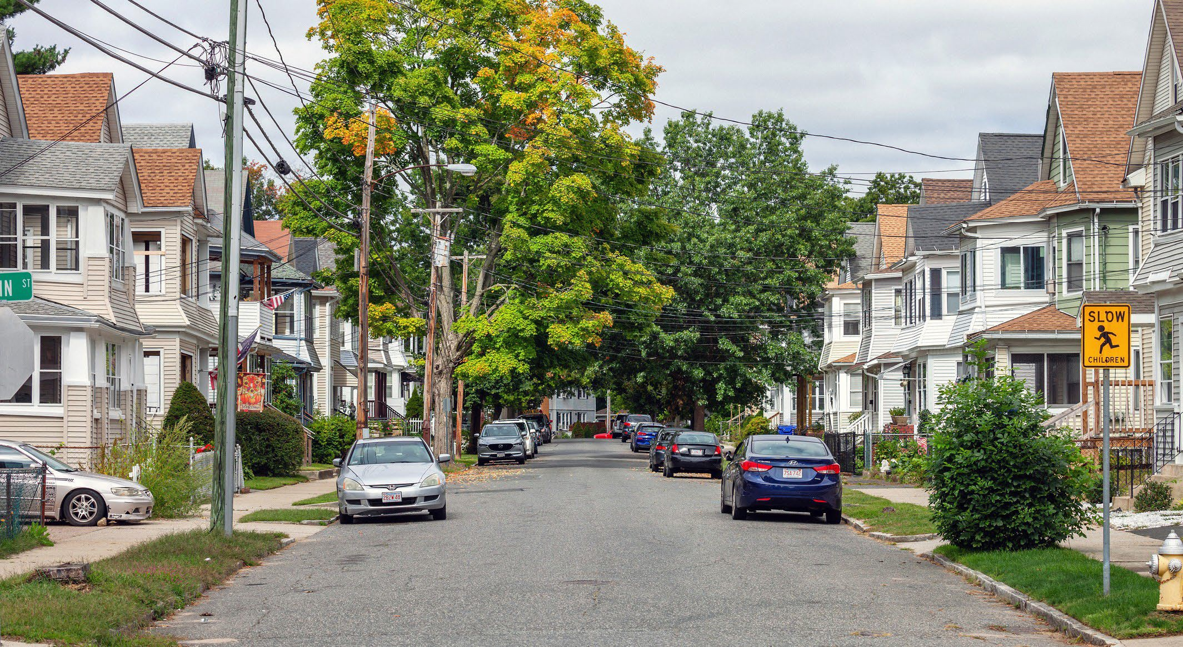

On November 22, 2011, Governor Deval Patrick signed “An Act Establishing Expanded Gaming in the Common- wealth” legislation that allowed for the construction
of three casinos, which was expected to “create thousands of jobs for Massachusetts residents in the areas of construction, hospitality and tourism while also generating $300-$500 million in new revenue
for the Commonwealth. The Expanded Gaming Act also allocated significant resources to a Public Health Trust Fund (PHTF) to mitigate the harms associated with gambling through research, prevention, intervention, treatment, and recovery support services. The Public Health Trust Fund is overseen by the Executive Office of Health and Human Services (EOHHS), and a strategic plan was adopted in 2016, which is implemented primarily by the Massachusetts Department of Public Health (MDPH) Office of Problem Gambling Services (OPGS) and the Massachusetts Gaming Commission (MGC)1.

OPGS provides relevant public health programs and services, and MGC conducts relevant research and responsible gaming activities. In July 2013, Springfield voters approved the casino project at a referendum, with 58% of voters in favor. The project then became one of three proposals competing to win the Western Massachusetts casino license, in addition to Hard Rock’s proposal in West Springfield, Big E fairgrounds, and Mohegan Sun’s proposal for Palmer, just off the Massachusetts Turnpike. The impact of gambling
on individuals and communities was an ongoing concern of the public and policymakers in relation to casino approval, and that concern was not misplaced.

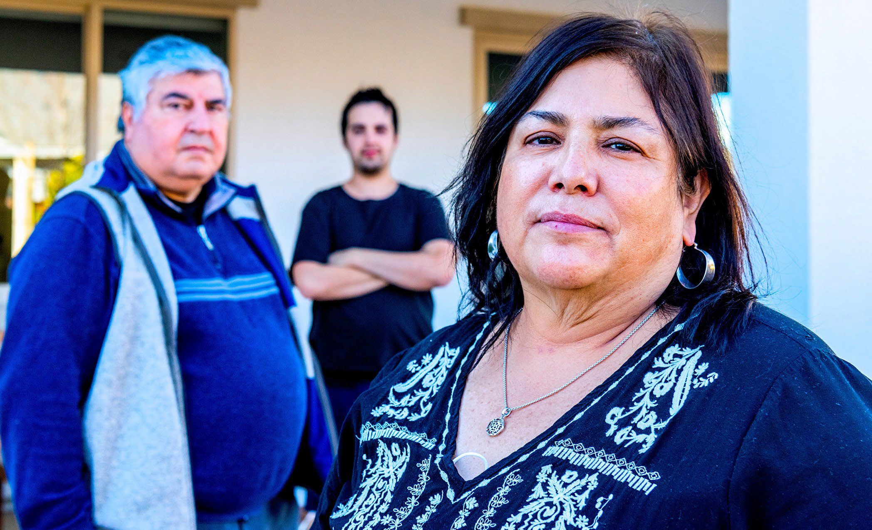

1massgaming.com

On November 22, 2011, Governor Deval Patrick signed “An Act Establishing Expanded Gaming
“
in the Commonwealth” legislation that allowed for the construction of three casinos.”

A Brief History of Springfield, Massachusetts

- The 1936 floods in Springfield led to urban renewal efforts that isolated the Black community in the Hill neighborhood
- In the 1960s, Puerto Ricans began moving to Springfield’s North End neighborhood
- From 1967 to 1979, riots spurred by xenophobia, poverty, injustice, and police brutality broke out in New England cities, including Springfield, in August 1975.
- The I-91 corridor was built in the 1960s and separates Hispanic and Black neighborhoods from the rest of the city where jobs, shops, and services are located
- Today, about half of the Puerto Ricans in New England continue to live along the I-91 corridor from New Haven to Holyoke in Massachusetts.

Springfield residents’ social, economic, and health conditions have not improved. Springfield is one of the poorest cities in Hampden County, has the lowest ranking in leading health indicators in the state, led the nation in asthma prevalence, has the highest Hispanic school segregation indexes in the nation, and was severely impacted by both the opioid and Covid epidem- ics. In sum, the MGM Casino was established amid a community that remains severely impacted by policies based on structural racism.
In these historical, sociological, and geographical conditions, Springfield’s first casino was built. The impact of gambling on people and communities has always been a concern of Springfield residents and political officials. This report seeks to begin to acknowl- edge and address these concerns. To do so, we first must understand the intersectionality of gambling and the community in order to develop strategies to mitigate harm.

Role of the Office of Problem Gambling Services (OPGS)

The role of the OPGS is to mitigate the deleterious effects of problem gambling on Massachusetts residents. These potential problems are magnified when a casino is placed amid a community that has been historically disenfranchised and thus affected by generational poverty and oppression. Problem gambling is a disorder that exacerbates the negative impact
of conditions embedded in the social determinants of health, that is, in the life contexts in which people work, live, age, and worship2. This level of complexity calls for a public health response. The OPGS embraces a public health approach by implementing comprehensive multi-leveled strategies involving the participation
of the individuals most affected by the problem.

Role of Community Health Workers (CHWs)

The roles and responsibilities of community health workers, who are on the front lines of healthcare, perfectly encapsulate a public health response. CHWs increase health knowledge and self-sufficiency through a range of culturally appropriate services such as outreach and engagement; education, coaching, and informal counseling; social support; advocacy; care coordination; basic screenings and assessments; and research and evaluation. CHWs serve as a liaison/ intermediary between individuals, communities, and health and social services to facilitate access to care, improve the quality and cultural responsiveness
of service delivery, and address social determinants of health.

2Braveman, P., & Gottlieb, L. (2014). The social determinants of health: it’s time to consider the causes of the causes. Public health reports, 129(1_suppl2), 19-31.

- METHODOLOGY AND RECRUITMENT
In this section, we describe the methods we used to conduct the initial steps of our program: the recruit- ment, engagement, and interviewing of Springfield residents to create an in-depth narrative of their perceptions, life experiences, and challenges they are experiencing.

The CHWs received extensive training on problem gambling prevention, conducting interviews with community members using a scripted series
of questions, and documenting the content of these interviews. Due to COVID-19, all interviews with members of the Springfield community were conducted over the phone or via videoconferencing (Zoom) from November 2020 to July 2021.

Potential community participants were recruited by the CHWs using their own personal and business communi- ty networks. Other recruitment methods included reaching out to individuals, community agencies, and local businesses through unsolicited phone calls. Initial recruitment efforts were supplemented by contacting individuals who were recommended in earlier
A qualitative analysis consisting of data coding and thematic analysis uncovered the following themes: gambling, health care, and the impact of COVID-19
on their lives and their community.”
“

discussions with community members or snowball sampling. Individuals who took part in interviews were asked to provide basic demographic and historical information, including their location of residence
(a neighborhood in Springfield), their gender, age, ethnicity/ancestry, race, and history of problem gambling, as well as other factors that influence health behaviors.

A qualitative analysis consisting of data coding and thematic analysis uncovered the following themes: gambling, health care, and the impact of COVID-19
on their lives and their community. It also revealed the participants’ experiences around critical life contexts such as family, community, food accessibility, and employment.

Assessment Questions

As a first step to developing systems-level solutions, CHWs asked the following core questions to assess the perceptions and impacts of problem gambling at a community level.

- What do community members believe are the problems in Springfield?
- What do community members think are the solutions to these problems?
- What are some community strengths?
- Who are the leaders in the community? Who makes decisions that impact the community? And who do people listen to?
- What helpful resources exist in the community?

Demographics of Interviewees

CHWs interviewed 151 individuals made up
of community residents (138), community leaders (5), and organizational representatives (8). The eight organizational representatives were not asked to provide personal background information, such as gender identity, race, and ethnicity, as they responded on their organization’s behalf and not as individual community members. Out of the 143 community residents/leaders interviewed, 81 identified as female, 59 identified
as male, and three members preferred not to answer. All community residents/leaders interviewed were provided the opportunity to self-identify by racial and ethnic categories and/or to opt-out of these categorizations.

Language interpretation was provided for 48 interviewees in either Vietnamese or Spanish.

143
COMMUNITY RESIDENTS/ LEADERS WERE INTERVIEWED
59
identified as male
81
2
identified as female

preferred
not to answer

5. FINDINGS

Below, we provide the main themes related to each area, followed by selected citations that exemplify the theme.

Theme 1: Gambling: Perceptions and Beliefs

In the opinion of some participants, gambling is not discussed in the community, and a respondent referred to it as taboo. Some participants stated that some people are unaware of the risks associated with gambling until they experience a problem. Some people grew up in families where gambling was part of family life. As such, they do not see gambling as problematic. They see it as hope, as a coping mechanism, an escape that is done for leisure.

SUB-THEME | QUOTE
GAMBLING IS NOT DISCUSSED. IT IS AKIN TO A TABOO. | “...our community of color here, people don’t talk about gambling. If they win, they will tell you about the winning, but they won’t tell you about the loss before they get to the win. The thought may be that if you don’t talk about the issue then a problem with gambling doesn’t exist. The subject  of gambling is almost taboo in our community. The presence of the casino only brought gambling issues that already existed in our city to light and more noticed in the public eye.”

SUB-THEME | QUOTE
GAMBLING IS NOT DISCUSSED. | “Gambling in our community is not a subject that gets discussed a lot, so it is hard to say if we evenknow how to identify gambling problems within our community of color.”
SUB-THEME | QUOTE
GAMBLING NOT RECOGNIZED AS A PROBLEM. | “…The bad part is people who [are] gambling in our community don’t have the money to gamble withand they don’t realize when and if gambling becomes a problem.”  “…black people do not understand the huge risks associated with the odds of losing in gambling. …Bingo is an area with a huge potential for gamblingproblems or addiction.”
SUB-THEME | QUOTE
PEOPLE ARE NOT AWARE OF THE RISKS ASSOCIATED WITH GAMBLING. | “Gambling is always seen as a leisure thing...something you can control. A good card game or a lottery ticket at the gas station is not seen as an issue and I don’t think people know if gambling is a problem until they have lost everything.  I really don’t think our communities of color in Springfield can recognize gambling problems as a real issue even though it very well may be a big problem.”
SUB-THEME | QUOTE
GAMBLING IS NOT SEEN AS PROBLEMATIC BECAUSE IT WAS PART OF THE PERSON’S FAMILY LIFE. | “I was unaware what problem gambling was because I grew up in a household where my grandmother, grandfather and other family members played numbers, bingo, scratch, and lottery tickets. We used it as entertainment and thought it  was normal, never a problem until the family would lose money.  We had to help take care of our grandparents when they did lose money, but we just looked at it as the norm, which s not good. Because of the way I grew up, gambling was not the main concern of the household like drug addiction and alcohol use was, therefore it just got swept under the rug.”

SUB-THEME | QUOTE
GAMBLING IS SEEN AS WAY TO COPE WITH FINANCIAL STRESS | “…Gambling in the black community tends to be more like Keno, the lottery, Bingo, or card games where people are trying  to double their money to pay a bill or fix their stressed financial situation.”
GAMBLING IS HOPE. IT IS AN ESCAPE MECHANISM | “Black and Latino community members tend to over fantasize winning money without understanding the risk. In this case gambling is a game of hope that allows people to escape reality in their difficult situation.”

The findings of this study also include the voices of 25 members of the Vietnamese community. This Asian-American group is not often represented in gambling research; thus, it is worth discussing their contributions in a separate section. They contrasted the gambling done for “relaxation” during the Vietnam War to the gambling addiction they experienced in Springfield, MA. Some acknowledge that gambling might be a problem, but when they occur, those problems are attributed to the individuals’ lack of willpower or strength. They widely acknowledge how problem gambling affects the family and the community. However, about a third of the Vietnamese respondents stated
that gambling is not a problem in the community.

SUB-THEME | QUOTE
HISTORICAL CONTEXT | “During war time in Vietnam, they usually played cards for relaxation with only a small amount of money involved. However, living in the Vietnamese community here in Springfield ...many people have got addicted to gambling which caused them  to have to sell their homes or even get killed over gambling debts.”
GAMBLING IS A PROBLEM IN THE VIETNAMESE COMMUNITY AND HAS A NEGATIVE IMPACT ON THE FAMILY | “...gambling is a problem in the Vietnamese community that people don’t talk about. She said her ex-husband used to gamble a lot and left her in a bunch of debt, so she is anti-gambling.  She also said his gambling got so bad that he was never home to help her take care of the house or his kids.”  “...gambling is a problem in the Vietnamese community. It can cause family abuse and other family issues as well as put people in serious debt or cause them to become unemployed. He said he would never hire anybody that is addicted to gambling  to prevent employee theft in the store.”  “…gambling is a problem in the Vietnamese community. She explained that her husband used to gamble a lot before they had kids. Now with all of the increased debt the gambling caused, their expenses are going up, so they have no spare change or extra money to cover needed bills. She said as a solution she makes him go pick up the kids and pick up extra shifts at work, so he has no free time to go gambling.”
GAMBLING IS NOT A PROBLEM - IT IS ENTERTAINMENT | “...Gambling is present in the Vietnamese community especially involving betting on competitive soccer and football. gambling  is [not] an issue in the community because it is for entertainment purposes [only]. [I myself] gamble on occasion.”

Theme 2: COVID-19

Community members expressed concerns about the lack of community awareness of the severity of COVID-19. They mentioned that COVID-19 has raised awareness of inequities in the community and that its emergence has exacerbated such inequities. They acknowledged that more education is needed to address misinformation, but providers need to bridge the existing mistrust.

SUB-THEME | QUOTE
COVID WASN’T TAKEN SERIOUSLY IN THE COMMUNITY | “COVID-19 is very scary because people weren’t taking it serious[ly] until it was too late.”
IMPACT ON MENTAL HEALTH | “The impact that it (COVID-19) has had on my mental health has been devastating.”
COVID RAISED AWARENESS OF INEQUITIES | “The current COVID-19 pandemic is a glaring example  of the huge lack of equity and health disparities that exist for communities of color even here on a local level. In regard to deaths in this pandemic our communities of color are the hardest hit.”
MADE THE SITUATION WORSE | “The COVID-19 Pandemic has only made the situation worse which creates more issues like mental health problems and suicide.”
CLOSURE OF COMMUNITY VENUES SUCH AS COMMUNITY CENTER, A GATHERING PLACE LED TO LONELINESS THUS TAKING A TOLL | “The community center had to be closed because of COVID-19 for several weeks on an ongoing basis in the earlier part of this pandemic. As a result, people have been expressing their feelings of loneliness because of the inability to socialize and connect with other people; it is a very difficult situation for people of color in our community. The pandemic ishaving an effect on both peoples’ emotional and mental health in a huge way and  with limited access to things like the community centers and churches people start to feel hopeless or depressed. The pandemic is taking a bigger toll on our community of color here in Springfield than anyone could have anticipated.”

SUB-THEME | QUOTE
COVID EXACERBATE EXISTING MALAISES IN THE COMMUNITY | “We are in unprecedented times in the Springfield community of color which in this pandemic is a trifecta of COVID-19, intense racism, and high unemployment all together which  in turn intensifies the issues our community is already facing.”
ONGOING EDUCATION IS NEEDED TO CONFRONT MISTRUST, MISINFORMATION | “Vaccination fears and misinformation has caused a lot  of confusion on how COVID-19 is transmitted, how it is caused, if the vaccine is safe, and especially in black communities  a general mistrust for the government when it comes to vaccines and medical procedures due to things that have happened historically. In this case of the vaccine during the COVID-19 pandemic the fears and misinformation in or among black communities can lead to a continued higher rate of deaths  in our community. We have to keep educating our local black communities of Springfield and keep providing opportunities to access clinics for the vaccine. The Springfield Department of Health and Human Services is doing a good job of providing the vaccine clinics in communities of color; we all just have  to keep educating black people so they go to get the vaccine.”
Theme 3: Healthcare

This topic covered many issues including, but not limited to, lack of health insurance or being underinsured, (racial) health inequities, mental health, access to quality care, addiction, and explicit and implicit racism. Several community members shared that the pandemic highlighted many of these issues by bringing them to the frontline. Many of these health issues are interrelated - health insurance coverage struggles, COVID-19 exacerbating the issues, and racist medical practices and ideas.
SUB-THEME | QUOTE
HEALTH INSURANCE | “Being uninsured or underinsured has always been a struggle for our community; however, the pandemic has shown the situation to be worse than we all thought it was. Simple things such as doc- tor’s appointments or emergency room visits have become even more difficult. This includes healthcare administration and staff being dismissive of pain and symptom, based on your being black. People in our community have lost their lives in this pandemic based on these types of racially biased practices.”  “Health Insurance cover [sic] is a major issue in our communities of color in Springfield as well as our country overall. Our communities are either under insured, uninsured, or do not know the benefits and rights they have under the current insurance he/she has for medical care. This is one of many reasons people of color in our community do not get the proper treatment,  in some cases don’t receive accurate diagnosis, and in unfortunate cases end up deceased.”

Theme 4: Employment

The participants mentioned the lack of job opportunities, the need for positions offering a living wage, and how the employment landscape was affected by job losses due to COVID-19. Older adults being on a fixed income were also discussed as forms of unemployment and underemployment. They also commented on the lack of professional jobs for college graduates, the burden of student loans, and the impact of unemployment on communities of color.

SUB-THEME | QUOTE
LIMITED JOB OPPORTUNITIES, NO LIVING WAGE³, JOB LOSS DUE TO COVID-19 | “The black and brown community in Springfield has always had problems with poverty because of unfair employment practices and limited opportunities to quality jobs that pay a wage that families or indi- viduals can survive on to have the basic things like enough food and safe shelter. Many of the minimum wage jobs locally are occupied by black and brown people and minimum wage is not a living wage, which continues the cycle of poverty in our community.”
LACK OF JOBS FOR COLLEGE GRADUATES - BURDEN OF STUDENT LOAN | “The unemployment rate among black and brown people has always been high in Springfield for the most part. The pandemic has shown how large the unemployment gap is in our community. Front line workers are the majority of the jobs people in our community tend to have (retail, fast food, CNAs, Nurses, Teachers, etc.). When stores or businesses have done recent layoffs  people of color were the first to be let go or the first to be put in a position that they had to face the dangers of the COVID-19 virus with little or no protection.”  “When unemployment happens in the community of color  it is more devastating because a large amount of our households are the working poor or single income households struggling  to put food on the table.”

3Living wage is “the hourly rate that an individual in a household must earn to support Definition found on https://livingwage.mit.edu/. Accessed on June 29, 2021.

Theme 5: Food Systems

Several community members discussed food insecurity as a problem in their neighborhoods, even though it was not included as a topic in the guideline questions. When discussing problems in the community, community members mentioned: Food scarcity, increased access to unhealthy foods (through bodegas, corner stores, liquor stores, and fast-food establishments), decreased access to healthy food (limited in corner stores and bodegas), limited access to full-line grocery stores, and affordability as critical areas of concern. Some individuals noted that communities of color have less access to healthy foods and greater access to fast food and liquor stores.

SUB-THEME | QUOTE
ACCESS TO HEALTHY FOOD | “The inner-city grocery stores…are located in neighborhoods where black and brown residents are low income and with very little or no transportation at all.”
PRICE GOUGING | “These small grocery stores price gouge their surrounding communities of color because they know they have limited resources to find better options
AFFORDABILITY | “People cannot get as much as they need to survive the week or properly feed their families because of the high prices they have to buy much less due to the very high prices.”

Theme 6: Family and Community Strengths

Many quotes highlighted the importance of the family and community contexts for the participants. They mentioned community agencies, community leadership, the ability to share resources and help each other, and resilience
as strengths. Six out of the eight organizational representatives referenced resilience, unity, and adaptability
of communities of color as community strengths. At least fifteen community members also stated that resilience, perseverance, and hard work among communities of color are critical to community survival, highlighting
the importance of social support when societal support is unavailable.

IMPORTANT ROLE OF THE FAMILY | “She believes that family is the foundation of strength in the black community. She stated family is everything, family is what keeps us together, family is what keep[s] us strong in the communities of color in Springfield. Our strong sense of family is why we survive from generation to generation. Family is the motivator for our community to keep pushing to do well.”  “...the Vietnamese community’s strength comes from [its] bonding as a close-knit group, [the] sharing [of] information and resources with people within the community, the sense of caring [that] people share for each other, and helping each other in the community.”

SUB-THEME | SUB-THEME
COMMUNITY AND RESILIENCY | “One of the strengths of this community is its resilience... the sheer grit people of color here have. They have learned to do the most out of practically nothing, to be extremely resourceful with the little that they are offered and have.”
COMMUNITY AGENCIES AND FAITH-BASED INSTITUTION | “Springfield has a lot of churches in our community that help with certain donations for less fortunate families.”

Theme 7: Community Leadership

Respondents recognized the presence of several leaders in the community. They mentioned the mayor, church leaders, volunteers, grassroots leadership, college students, and teachers as leaders in black and brown communities. They also recognized the lack of involvement or utilization of these leaders and the fact that leaders change over time.

COMMUNITY LEADERS UNDERUTILIZED | “One community member suggested utilizing these leaders, “we have many leaders in communities that are under sourced and underutilized.”
ROLE OF BLACK LEADERSHIP | “... [For example], in the black community volunteers from within the community play a big role in taking action for positive change as well as teachers make a positive impact in helping the community lead through the work they do with the children.”
A VIETNAMESE PARTICIPANT REFERENCED WEALTHIER INDIVIDUALS, ELDERS, AND THE MAYOR AS IMPORTANT COMMUNITY LEADERS IN THE SPRINGFIELD AREA | “...Rich people in the community and senior citizens/elders in [our] community and Mayor Sarno… [are our] community leaders.”
LEADERSHIP WAXES AND WANES OVERTIME | “[I can] not really tell what leadership currently exist[s] in the Black and Latino community...there aren’t really any clear leaders There are people who are quietly and successfully doing community work, but people have not heard of them. The leadership in the minority community seems to be on mute right now when previously that leadership was out making a difference. There is a huge difference between then and now.”

The purpose of the MDPH Office of Problem Gambling© CHW Pilot Program was to create an innovative new approach to addressing health disparities associated with problem gambling. The dedication and engagement efforts of the CHWs produced 151 community conversa- tions with community residents. The findings of those conversations provide ample guidance on how best

6. DISCUSSION
to move forth with the integration of CHWs in the implementation of public health response to problem gambling. The findings of this report will inform CHWs on the primary community contexts that should be included in the response, upstream contributors to address those issues, and the resources available
to do so.

Community contexts

The findings point to the saliency of three community sectors or contexts that should be attended to: housing (affordability), employment (lack of available jobs paying a living wage), and food security (availability and accessibility). From the participants’ perspective, those three contexts are the critical social determinants of health that most impact the community. These sectors relate to problem gambling because, as the respondents mentioned, they contain related stressors that contribute to participation in gambling activities that, in turn, may turn into problem gambling.

Upstream factor

The respondents also identified upstream factors related to problem gambling that are grounded on historical instances of structural racism, which now contribute to existing inequities. For example, stressors such as the lack of access to healthy food, housing insecurity, and access to jobs that pay a living wage
could be tracked down to the insertion of the I-90 corridor, which severed brown and black neighborhoods from the central city where more resources are available.

Another issue is the lack of trust between the respondents and authority figures, and such mistrust has been amply documented in the literature [reference]. It is relevant here because accurate information about the relationship between gambling and problem gambling would not be credible if the information source is not trusted.

Several clear implications emerged from the analysis of the interviews.

- CHWs are uniquely positioned to engage communities as information gatherers and as public health educators on sensitive health equity issues like problem gambling because of their role
as culturally humble community members doing public health work.
- Many, but not all, respondents expressed an understanding of how problem gambling negatively impacts their community and its relationship to other comorbid conditions.
- Because some types of gambling are normalized
in marginalized communities, there is a need to build a sustainable “workgroup that focuses on community action through creative awareness campaigns about [the different forms of] problem gambling as well as its effects in the community”
- Springfield residents, including community leaders, business representatives, and clergy, are the most valuable sources of information about problem gambling, social determinants of health, and
other issues of concern.

  - Food insecurity arose as a priority health issue even though it was not specifically asked about in the interview script used by CHWs. Further assessment should be conducted related to food insecurity.
  - Providing interpretation services to gather feedback from the Vietnamese and Spanish-speaking commu- nities demonstrates how this project was communi- ty-centered and culturally humble.
  - Gaps continue to exist in communicating services and resources available for community members to improve their health. Further assessment is needed to determine where precisely these gaps exist and how to improve communication. Some community members were very aware of government and
non-profit support, while others expressed that no support was available.
  - Church leaders remain essential resources
for communities of color. They are an underutilized resource and collaborator for health officials
in equity-based interventions.
  - In future assessments, usage of specific terminology should be clarified, including, but not limited to, gender, sex, race, and ethnicity, to reduce confusion.
  - One ethnic group that is categorized as white in the United States Census and yet research has shown them to have racialized experiences in the United States, especially post 9/11, are Middle Eastern people. Due to the small number of community members interviewed in this project, Middle Eastern people are classified as part of the white population in this report. For future projects that gather large- scale data on Middle Eastern people, project planners should consider separating Middle Eastern peoples from the rest of the white population
to study the impacts of racism on health outcomes for this population.
  - Respondents emphasized local, state, and national solutions to the problems caused by gambling and other comorbid conditions. This shows community members are interested in complex, multi-layered, structural interventions for problem gambling.
  - Further assessment with the Vietnamese community is needed to continue understanding some of the conflicting narratives expressed in interviews about gambling as entertainment, community insulation, and American identity.

7. NEXT STEPS

Sharing Outcomes and Creating Partnerships

The results of the CHW interviews will be shared
at a community meeting. Members of the community who participated in the interviews and the community at large will be invited to review the primary outcomes.

MDPH Office of Problem Gambling will use the findings of CHW Pilot Program to continue to do work with CHWs around problem gambling.
In the future, it is essential to follow up on this work with further community action that helps to clarify further the relationship between problem gambling and the social determinants of health. The establishment of a working group led by CHWs would help conceptualize short- and long-term recommendations for mitigating problem gambling among Springfield residents. To support this effort, offering education to the working group about the social determinants of health and health and racial equity would ensure that recommendations reflect systems-level change interventions and program/policy priorities for the immediate and long-term future.

Recommendations

The following are some proposed solutions offered by community members that would fall under the influence of the local government and/or community agencies:

- Increase access to culturally responsive mental health services
- Convert empty buildings into affordable and livable housing
- Increase the number of stores offering healthy food options
- Increase self-advocacy of marginalized communities by providing opportunities for training and listening to community members’ opinions on what is needed
- Offer culturally relevant gambling support services and other social services provided by the health department and community-based agencies.
- Mandate/increase cultural sensitivity training for healthcare staff so that they can adequately support all patients to the best of their ability
- Increase funding and other supports for school systems
- Increase communication and trust between local government, community agencies, and communities of color
The following solutions were shared almost exclusively by Vietnamese community members:

- Increase police presence in the Forest Park area to address crime and improve gun control
- Increase small business and job support services
- Increase Vietnamese representation in healthcare
- Increase COVID-19 safety measures - mask mandate, social distancing, etc.
- Hold youth accountable for the community level problems
- State and/or National Solutions

The following are some proposed solutions by community members that would fall under the influence of state and/or federal government agencies and national advocacy organizations:

- Provide universal healthcare.
- Provide better quality healthcare for all people.
- Increase the number of people of color that work in healthcare.
- Increase awareness and teaching about the impact of structural racism on health, healthcare, and COVID-19-related issues.
- Increase societal education about what problem gambling looks like and its impacts on communities of color and other marginalized groups, ensuring that all medical and behavioral health professionals, community members, politicians, the media, etc. have the same understanding of problem gambling.
- Increase the numbers and/or visibility of advocacy organizations assisting communities of color,
so community members know where to go to get support.

