**2023 Community Water Fluoridation** **Status**

Massachusetts Department of Public Health

Office of Oral Health

December 2023

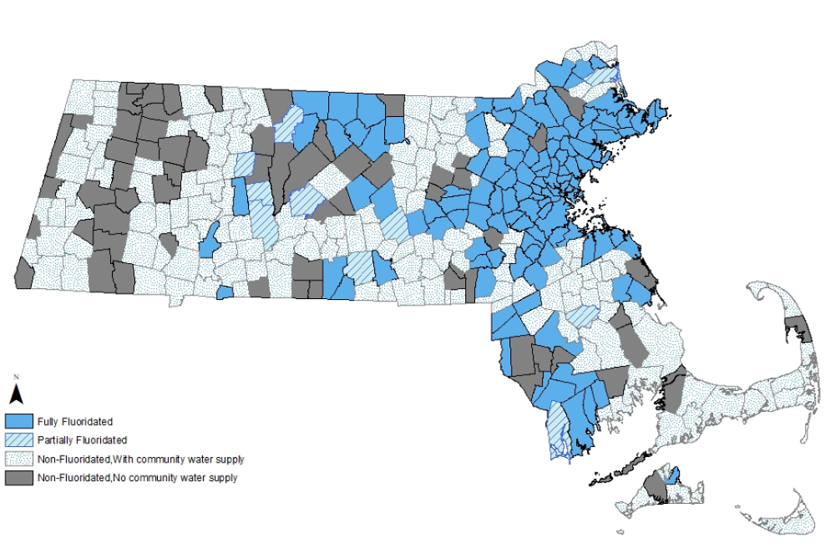

Please note: The status of some fluoridated communities may be different than what is listed due to the temporary suspension of fluoride.