### 2023 CHES Mental Health Report Section 1. Community Health Equity Initiative Overview

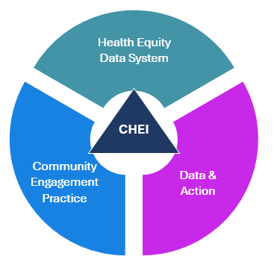The Community Health Equity Initiative (CHEI) is a health equity data and response system implemented by the Massachusetts Department of Public Health’s Bureau of Community Health and Prevention (BCHAP) in collaboration with community, the Massachusetts Department of Public Health (DPH), and other state agency partners.

The overarching goal of CHEI is to promote the health of Massachusetts residents and reduce health inequities that are shaped by systemic racism and other systems of oppression through its health equity data and response system. This system is centered around three foundational pillars: a data system rooted in health equity, authentic community engagement, and intentional focus on data & action.

A key component of the health equity data system is the Community Health Equity Survey (CHES). CHES is a population-based survey conducted to better understand the most pressing health needs facing Massachusetts residents and to help DPH, sister agencies, and communities across the state change conditions that get in the way of health. The survey is developed in collaboration with community members, community-based organizations, municipal partners, and internal partners within DPH and other state agencies.

The 2023 CHES was administered to Massachusetts residents ages 14 and older from July through October 2023. The survey was primarily administered online with a paper survey option available to individuals for which online surveys are not accessible. The survey gathers important information across various topic areas, including health outcomes, behaviors, and social drivers of health. The overall sample size for the 2023 CHES was 18,276, with representation across members of various communities of focus, including people of color, people with disabilities, rural residents, and more.

For more information about CHEI and CHES, visit the CHEI website: [www.mass.gov/CHEI](http://www.mass.gov/CHEI).