2023 CHES Mental Health Report – Conclusion, Resources, and Acknowledgements

Conclusion
Mental health is a core component of our overall health and the building blocks for overall mental well-being include factors at the individual, family, community, institution, and systems levels.
Data from the 2023 CHES and other statewide data sources show that the overall burden of poor mental health in Massachusetts is high. The data also show that rates of poor mental health outcomes are disproportionately high within certain communities. Communities of color, members of the LGBTQA+ community, people with disabilities, and school-aged youth were among the communities that reported the highest burden of poor mental health outcomes, including psychological distress, social isolation, and suicidal ideation.
There is no single cause for poor mental health outcomes. Findings from the 2023 CHES help to demonstrate the connection of mental health outcomes with factors along the health inequity pathway. Social and structural drivers such as employment, economic stability, housing, health care access, social support, experiences with violence and discrimination, environmental exposures, and others were shown to be closely tied to mental health outcomes. Unsurprisingly, communities of focus that experience disproportionately high levels of poor mental health were also shown to experience inequities within these various drivers of health.
Addressing inequities within these various drivers of health is important for promoting mental health equity. The 2023 CHES showed that members of communities of focus that had access to positive building blocks for mental health, such as economic stability, access to timely and quality health care, stable housing, and reduced exposures to discrimination and violence, had significantly better mental health outcomes.
Critical work to promote mental health is being carried out by different groups and institutions, including community organizations, resident leaders, health care organizations, academic institutions, and government agencies. More work and resources are still needed, however, to fully address the mental health needs of Massachusetts residents. No single solution or strategy alone can provide us all with equal opportunities for mental well-being. However, a deeper understanding of the root causes of mental health inequities combined with a firm commitment to work together to implement solutions to address these root causes can help to bridge the equity gap and promote health and well-being for all residents.

Resources
One of the primary goals of the Community Health Equity Initiative is to support state, local and community partners in using data to better understand resident experiences and take action to advance health equity. This mental health report is part of a collection of resources to help fill important gaps of information and inform policy and inform policy and practice change to promote health equity. This report and other resources are available on the CHEI website. Additional resources include an overview of the Community Health Equity Initiative, detailed data tables, data dashboards, and racial justice framing resources.
Data & Action is one of the foundational pillars of CHEI. The purpose of the Data & Action Support model is to share CHES data and findings back with community-based organizations, municipalities, health systems, and other partners and support their use of the data for action. CHEI has partnered with regional Data & Action Support Providers across Massachusetts to offer capacity building and assistance to community partners. These providers offer a wide range of services, including providing customized data analyses and supporting the use of data to inform programming, apply for grant funding, and advocate for policies that reduce health inequities.
For more information, please visit our website or contact the CHEI team.
Website: www.mass.gov/CHEI
Contact: CHEI@mass.gov

Acknowledgments
The Community Health Equity Initiative would not be possible without the generous support from our many partners.
Community Engagement Advisory Committee (CEAC)
Our CEAC was instrumental in helping us make key decisions during survey development, community outreach, and survey dissemination. Member organizations include:
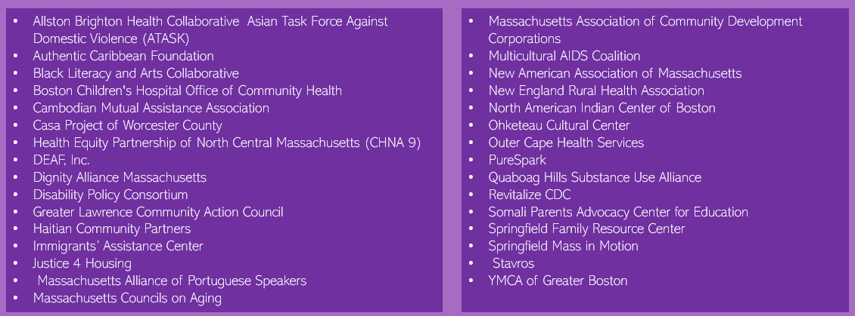

2023 CHES Survey Dissemination Mini Grantees
Our 2023 survey mini grantees conducted important outreach within communities across Massachusetts, including many communities that are often underrepresented in public health data.
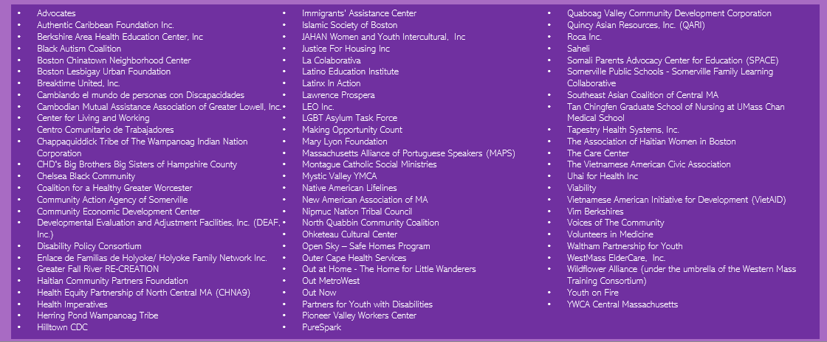

CHEI Mental Health Advisory Group
The CHEI Mental Health Advisory Group helped to design and make decisions on survey questions related to mental health. The advisory group also helped to support the analysis, interpretation, and development of key findings seen within this report. Members of this advisory group comprise volunteers that represent various programs and initiatives across the Department, including: the Culturally and Linguistically Appropriate Services (CLAS) Initiative, Division for Children and Youth with Special Health Care Needs, Division for Pregnancy, Infancy, and Early Childhood, Division of Child/Adolescent Health and Reproductive Health, Bureau of Community Health and Prevention’s Office of Statistics and Evaluation, Pregnancy, Infancy, and Early Childhood Division, Division of Community Health Planning and Engagement, and Women, Infants, & Children Nutrition Program.

