2023 CHES Mental Health Report - Drivers of Mental Health Inequities
Discrimination and Mental Health
The CHEI Health Inequities Framework demonstrates that there is no single pathway that leads to mental well-being and no single cause that fully explains why certain populations have worse mental health outcomes. Many individual-level, environmental, social, structural, and historical factors work together to influence overall mental health. This section will highlight findings from the 2023 CHES that help demonstrate how inequities in social opportunities, resources, and key exposures contribute to inequities in mental health outcomes.

Societal Resources
Our social and physical environments are inseparably linked to our health. The health promoting and health impairing exposures we interact with in our daily lives have an important impact on our mental well-being and overall health. As illustrated in the CHEI Health Inequities Framework, patterns of exposures to these determinants of health are shaped by systems of oppression, leading to inequities in health. The 2023 CHES gathered information from residents on their experiences with many key exposures within their physical and social environments.
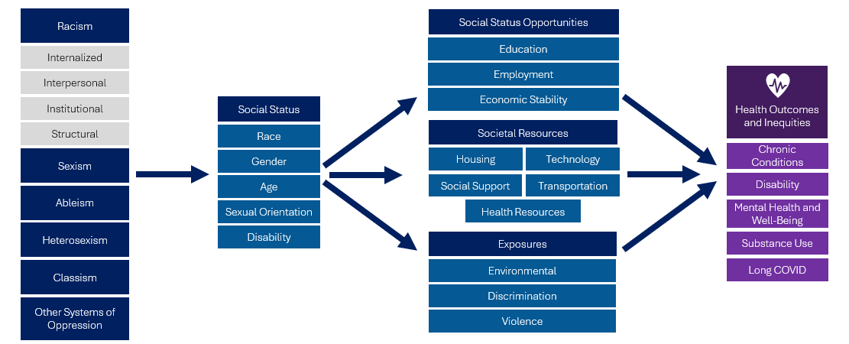

Discrimination
Discrimination is differential treatment experienced by stigmatized groups and is the result of systems of oppression that shape our communities and environments. Within communities of color, discrimination is the result of institutional and cultural racism that help generate negative stereotypes. Discrimination has been shown to be a risk factor for adverse mental and physical health outcomes and contributor to health disparities. For example, internalized and interpersonal racism has been linked to psychosocial trauma, stress, and maladaptive coping behaviors.
Despite being an important driver of health inequity, there is a general lack of public health data sources that quantify and qualify experiences of discrimination. The 2023 CHES helps to fill this surveillance gap by gathering data on experiences of discrimination and connecting them to mental health outcomes.

Figure 18. CHES 2023 - Experiences of Discrimination and Mental Health Indicators

Individuals who reported experiencing some form of discrimination had worse mental health overall compared to those who reported never experiencing discrimination. Those who reported experiencing discrimination in the past 12 months were 2.7 times as likely to have high or very high psychological distress, 4.1 times as likely to report suicidal ideation, and 4 times as likely to report social isolation compared to those who did not experience discrimination.

Table 17. 2023 CHES - Experiences of Discrimination by Communities of Focus
 | Ever Experienced Discrimination  Weighted % | Experienced Discrimination in the Past 12 months  Weighted %
Race/Ethnicity
American Indian/Alaska Native | 75.9*** | 35.8***
ANHPI¹, nH/nL​² | 43.7*** | 14.5
Black, nH/nL | 69.2*** | 30.2***
Hispanic or Latine/a/o | 60.9*** | 24.9***
Middle Eastern or North African | 75.1*** | 34.8***
Multiracial, nH/nL | 73.4*** | 31.5***
White, nH/nL (ref) | 51.6 | 15.6
Sexual Orientation
Asexual | 62.7*** | 26.1***
Bisexual/Pansexual | 75.9*** | 28.1***
Gay or Lesbian | 81.4*** | 35.0***
Queer | 88.6*** | 51.5***
Questioning/Not Sure | 69.1*** | 29.1***
Straight/Heterosexual (ref) | 50.4 | 15.3
Transgender Identity
Transgender | 90.2*** | 60.6***
Not Transgender (ref) | 53.5 | 17.0
People with Disabilities
Blind/Vision Impaired | 69.3*** | 33.6***
Cognitive Disability | 72.1*** | 38.4***
Deaf/Hard of Hearing | 57.1* | 20.6***
Learning/Intellectual Disability | 67.7*** | 40.3***
Mobility Disability | 64.7*** | 28.9***
Self-Care/Independent Living Disability | 72.3*** | 39.3***
One or More Disabilities | 66.3*** | 29.7***
No Disability (ref) | 50.1 | 14.6
¹Reported ever seeing or hearing someone getting physically attacked, beaten, stabbed, or shot in the neighborhood they were living.
*** p<.0001, ** p<.001, * p<.05 P-values from Pearson chi-square test indicate whether weighted responses from those identifying as specified group significantly differ from those identifying as the noted reference group.
Discrimination Within Communities of Focus
Communities of Color
- Respondents who identified as American Indian/Alaska Native, Black, Hispanic/Latine/o/a, Middle Eastern or North African, or Multiracial reported significantly higher rates of discrimination in their lifetime compared to White respondents.
- Approximately 3 in 4 respondents who identified as American Indian/Alaska Native, Middle Eastern or North African, or Multiracial reported experiencing discrimination in their lifetime.
- 7 in 10 respondents who identified as Black reported experiencing discrimination in their lifetime, with 3 in 10 experiencing it in the past year.
LGBTQA+ Community
- Respondents who identified as asexual, bisexual, pansexual, gay, lesbian, queer, or questioning were significantly more likely to experience discrimination compared to respondents who identified as heterosexual.
- Nearly 9 in 10 respondents who identified as queer reported experiencing discrimination in their lifetime, with over half reporting experiencing discrimination in the past 12 months.
- 9 in 10 respondents who identified as transgender reported experiencing discrimination in their lifetime, 6 in 10 in the past 12 months.
People with Disabilities
- Respondents who reported having one or more disabilities were over twice as likely to report experiencing discrimination in the past 12 months compared to those who reported not having disabilities.

Figure 19. CHES 2023 – Adult High or Very High Psychological Distress by Experiences of Discrimination within Communities of Focus

*People of color include respondents that reported one of the following race/ethnicities: American Indian / Alaska Native, Asian, Native Hawaiian, Pacific Islander, Black, Hispanic/Latine/a/o, Middle Eastern/North African, or Multiracial.
**LGBQA includes respondents that reported their sexual orientation as being lesbian, gay, bisexual, queer, asexual, or other.
Reducing exposure to discrimination within communities of focus through addressing root causes of interpersonal and cultural racism and providing support to victims of discrimination are integral for mental health equity promotion. As seen in Figure 19, members of various communities of focus that reported either never experiencing discrimination or not experiencing discrimination in the past 12 months had significantly lower rates of psychological distress compared to those who did experience discrimination in the past 12 months. For example, among people with disabilities, over 72% of those who experienced discrimination in the past 12 months had high or very high psychological distress compared to 50% who experienced discrimination but not in the past 12 months. This provides evidence that strategies to reduce exposure to discrimination may be effective in promoting mental health.

Williams DR, Mohammed SA. Racism and Health I: Pathways and Scientific Evidence. Am Behav Sci. 2013 Aug 1;57(8):10.1177/0002764213487340. https://doi.org/10.1177/0002764213487340
Williams DR, Lawrence JA, Davis BA, Vu C. Understanding how discrimination can affect health. Health Serv Res. 2019 Dec;54 Suppl 2(Suppl 2):1374-1388. https://doi.org/10.1111/1475-6773.13222
Williams DR, Mohammed SA. Discrimination and racial disparities in health: evidence and needed research. J Behav Med. 2009 Feb;32(1):20-47. https://doi.org/10.1007%2Fs10865-008-9185-0

