**2023 CHES Mental Health Report - Drivers of Mental Health Inequities**

Economic Stability and Mental Health

The CHEI Health Inequities Framework demonstrates that there is no single pathway that leads to mental well-being and no single cause that fully explains why certain populations have worse mental health outcomes. Many individual-level, environmental, social, structural, and historical factors work together to influence overall mental health. This section will highlight findings from the 2023 CHES that help demonstrate how inequities in social opportunities, resources, and key exposures contribute to inequities in mental health outcomes.

**Social Status Opportunities**

Social status opportunities, like education, employment, and economic stability, are important drivers of health equity. They serve as important facilitators of mental health and well-being, influencing a wide range of mid- and downstream factors that influence overall health.

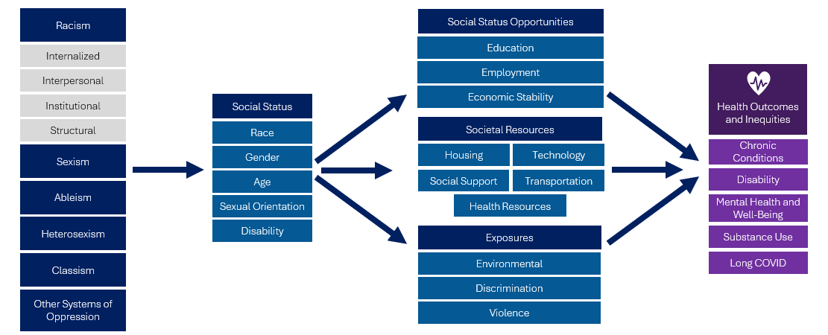

Social status opportunities are closely connected to one another. At the individual level, having access to quality education and having safe and steady employment are important contributors to the economic stability of individuals and families. At the community level, overall economic stability contributes to neighborhood-level conditions that can lead to increased education and employment opportunities[1]. At the systems level, systems of oppression help shape social status opportunities, creating patterns of advantages and disadvantages that lead to inequities in health, including mental health. CHES 2023 gathers important information on various social status opportunities and their connections to mental health.

***Economic Stability***

Economic stability is the ability of individuals, households, and communities to meet their basic and essential needs sustainably. Having economic stability contributes to one’s ability to access important resources like housing, technology, transportation, health care, and healthy foods[2]. The absence of economic stability negatively impacts mental health by threatening the ability of individuals and groups to attain necessary health-related resources, influencing health-related behaviors, and increasing levels of psychological distress[3].

Data from the 2023 CHES demonstrate a clear relationship between economic stability and mental health. The following economic indicators included in the survey were all significantly associated with various mental health outcomes:

* *Basic Needs:* Trouble paying for basic needs in the past 12 months, including food or groceries, childcare, health care, and housing.
* *Benefits:* Applying for or receiving governmental benefits, like housing or food assistance.
* *Economic Security:* Self-reported end-of-month finances.

Figure 8. 2023 CHES– Paying for Basic Needs and Mental Health Indicators

Adults that reported having trouble paying for basic needs in the past 12 months had significantly worse mental health outcomes. Those who reported trouble paying for basic needs were over 4 times as likely to report psychological distress and social isolation compared to those that did not. They were also nearly 3 times as likely to report suicidal ideation.

*Table 5. 2023 CHES Economic Indicators and Adult Mental Health*

|  | **Psychological Distress –**  **High/Very High**  **Weighted %** | **Suicidal Ideation**  **Weighted %** | **Social Isolation**  **Weighted %** |
| --- | --- | --- | --- |
| **Paying for Basic Needs1** |  |  |  |
| Trouble Paying for Any Basic Needs in Past Month | 35.4*** | 13.6*** | 25.7*** |
| No Trouble Paying for Any Basic Needs in Past Month (*ref*) | 8.1 | 4.7 | 6.4 |
| **Applying For/Receiving Benefits Past Year2** |  |  |  |
| Applied For/Received Any Benefits | 50.9*** | 10.9*** | 23.4*** |
| Did Not Apply For/Receive Benefits Listed *(ref)* | 26.8 | 6.4 | 10.4 |
| **Finances At End of Month** |  |  |  |
| Not Enough to Pay for Things Needed | 61.0*** | 13.9*** | 31.9*** |
| Just Enough to Pay for Things Needed | 35.9*** | 7.4*** | 13.1*** |
| Having Money Left Over After Paying for Things Needed *(ref)* | 19.5 | 5.2 | 7.0 |

1 Basic needs include childcare or school, food or groceries, formula or baby food, health care, housing, technology, transportation, and utilities. 2 Benefits include cash assistance, disability assistance, food assistance, housing assistance, and Special Supplemental Nutrition Program for Women, Infants, and Children (WIC)  
*** p<.0001, ** p<.001, * p<.05 P-values from Pearson chi-square test indicate whether weighted responses from those identifying as specified group significantly differ from those identifying as the noted reference group.

Many of the communities of focus that experienced inequities in mental health also reported inequities in economic stability.

* People identifying as American Indian/Alaska Native, Black, nH/nL, Hispanic or Latine/o/a, Middle Eastern or North African, or Multiracial reported significantly higher rates of having trouble paying for basic needs compared to White, nH/nL adults. They also were significantly more likely to have applied for or received benefits and to have no money left over at the end of the month to pay for things they need.
* Members of the LGBTQA+ community experienced high rates of economic insecurity. For example, over 6 in 10 adults that identified as transgender reported having trouble paying for basic needs. Adults who identified as LGBQA were significantly more likely to report having trouble paying for basic needs compared to those who identified as straight/heterosexual.
* People with disabilities were nearly twice as likely to report trouble paying for basic needs, nearly 3 times as likely to have applied for or received benefits, and over twice as likely to have not enough money at the end of the month to pay for things they need compared to people without disabilities.

*Table 6. 2023 CHES - Adult Economic Indicators by Communities of Focus*

|  | Trouble Paying for Any Basic Needs in Past Month1  Weighted % | Applied For or Received Any Benefits2  Weighted % | Not Enough Money to Pay for Necessities at End of Month  Weighted % |
| --- | --- | --- | --- |
| **Race/Ethnicity** |  |  |  |
| American Indian / Alaska Native | 50.2*** | 27.1*** | 44.0*** |
| ANHPI1, nH/nL​2 | 26.6** | 38.4*** | 25.2*** |
| Black, nH/nL | 55.5*** | 39.1*** | 51.1*** |
| Hispanic or Latine/a/o | 44.4*** | 39.3*** | 59.0*** |
| Middle Eastern or North African | 48.3*** | 30.8*** | 27.0* |
| Multiracial, nH/nL | 48.7*** | 26.4*** | 30.7*** |
| White, nH/nL (*ref*) | 31.3 | 14.5 | 18.2 |
| **Sexual Orientation** |  |  |  |
| Asexual | 49.4*** | 32.6*** | 33.9*** |
| Bisexual/Pansexual | 53.5*** | 23.8*** | 29.3*** |
| Gay or Lesbian | 37.4* | 20.4 | 23.8 |
| Queer | 55.7*** | 21.6* | 29.9*** |
| Questioning/Not Sure | 42.8* | 29.3*** | 29.6* |
| Straight/Heterosexual (*ref*) | 33.0 | 18.4 | 22.1 |
| **Transgender Identity** |  |  |  |
| Transgender | 62.6*** | 33.4*** | 41.9*** |
| Not Sure | 55.7*** | 40.5*** | 45.4*** |
| Not Transgender (*ref*) | 35.0 | 19.5 | 23.6 |

*Table 6 (continued)*

|  | Trouble Paying for Any Basic Needs in Past Month1  Weighted % | Applied For or Received Any Benefits2  Weighted % | Not Enough Money to Pay for Necessities at End of Month  Weighted % |
| --- | --- | --- | --- |
| **People with Disabilities** |  |  |  |
| At Least One Disability | 54.3*** | 39.4*** | 45.4*** |
| Blind/Vision Impaired | 56.2*** | 48.5*** | 49.6*** |
| Cognitive Disability | 63.1*** | 51.0*** | 59.8*** |
| Deaf/Hard of Hearing | 38.7* | 25.5*** | 19.1*** |
| Learning/Intellectual Disability | 60.1*** | 70.8*** | 68.1*** |
| Mobility Disability | 54.6*** | 46.5*** | 51.8*** |
| Self-Care/Independent Living Disability | 61.8*** | 62.2*** | 65.3*** |
| No Disability (*ref*) | 29.4 | 13.6 | 18.0 |

1 Basic needs include childcare or school, food or groceries, formula or baby food, health care, housing, technology, transportation, and utilities.   
2 Benefits include cash assistance, disability assistance, food assistance, housing assistance, and Special Supplemental Nutrition Program for Women, Infants, and Children (WIC)  
*** p<.0001, ** p<.001, * p<.05 P-values from Pearson chi-square test indicate whether weighted responses from those identifying as specified group significantly differ from those identifying as the noted reference group.

*Figure 9. 2023 CHES - Percent with High or Very High Psychological Distress by Trouble Paying for Basic Needs Within Communities of Focus*

*People of color include respondents that reported one of the following race/ethnicities: American Indian/Alaska Native, Asian, Native Hawaiian, Pacific Islander, Black, Hispanic/Latine/a/o, Middle Eastern/North African, or Multiracial.   
**LGBQA includes respondents that reported their sexual orientation as being lesbian, gay, bisexual, queer, asexual, or other.   
*** Basic needs include childcare or school, food or groceries, formula or baby food, health care, housing, technology, transportation, and utilities.

Promoting economic stability within these populations may have a positive impact on health. Figure 9 demonstrates that members of communities of focus with more economic stability were more likely to have better overall mental health outcomes compared to those that were more economically unstable. For example, among people of color, the rate of psychological distress who did not report trouble paying for basic needs was 21.2% compared to 58.5% that did. This suggests that programs and interventions to improve economic stability within communities of focus may be effective in promoting overall mental health equity. It is important to note, however, that inequities still persist among members of these communities with higher levels of economic security. For example, 2 out of 3 adults that identified as transgender and reported not having trouble paying for basic needs still had high or very high psychological distress, suggesting that addressing economic insecurity alone is not sufficient to address inequities in mental health within these communities.

1. National Center for Chronic Disease Prevention and Health Promotion (US) Office on Smoking and Health. Community Health and Economic Prosperity: Engaging Businesses as Stewards and Stakeholders—A Report of the Surgeon General [Internet]. Washington (DC): US Department of Health and Human Services; 2021 Jan. CHAPTER 2, How Neighborhoods Shape Health and Opportunity. Available from: <https://www.ncbi.nlm.nih.gov/books/NBK568862/>
2. Daniel Kopasker, Catia Montagna, Keith A. Bender, Economic insecurity: A socioeconomic determinant of mental health, SSM - Population Health, Volume 6, 2018, Pages 184-194, ISSN 2352-8273, <https://doi.org/10.1016/j.ssmph.2018.09.006>.
3. Watson B, Osberg L. Healing and/or breaking? The mental health implications of repeated economic insecurity. Soc Sci Med. 2017 Sep;188:119-127. doi: <https://doi.org/10.1016/j.socscimed.2017.06.042>