**2023 CHES Mental Health Report - Drivers of Mental Health Inequities**

Employment and Mental Health

The CHEI Health Inequities Framework demonstrates that there is no single pathway that leads to mental well-being and no single cause that fully explains why certain populations have worse mental health outcomes. Many individual-level, environmental, social, structural, and historical factors work together to influence overall mental health. This section will highlight findings from the 2023 CHES that help demonstrate how inequities in social opportunities, resources, and key exposures contribute to inequities in mental health outcomes.

**Social Status Opportunities**

Social status opportunities, like education, employment, and economic stability, are important drivers of health equity. They serve as important facilitators of mental health and well-being, influencing a wide range of mid- and downstream factors that influence overall health.

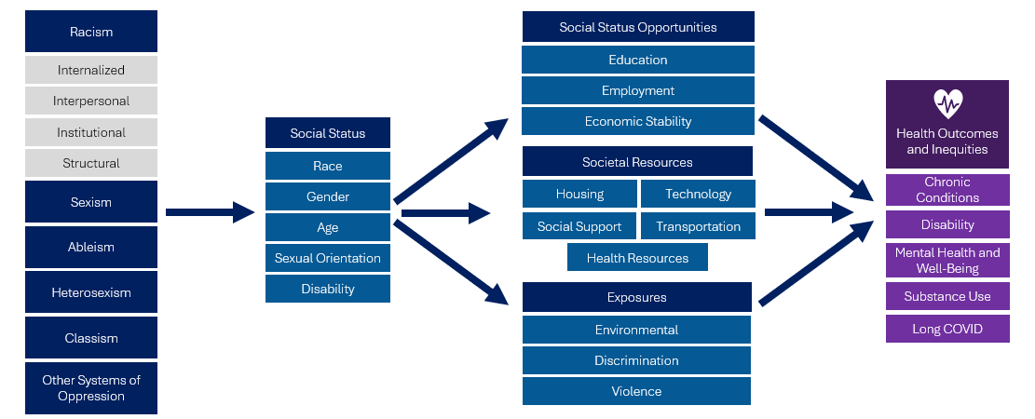

Social status opportunities are closely connected to one another. At the individual level, having access to quality education and having safe and steady employment are important contributors to the economic stability of individuals and families. At the community level, overall economic stability contributes to neighborhood-level conditions that can lead to increased education and employment opportunities[1]. At the systems level, systems of oppression help shape social status opportunities, creating patterns of advantages and disadvantages that lead to inequities in health, including mental health. CHES 2023 gathers important information on various social status opportunities and their connections to mental health.

***Employment***

Having safe and steady employment is important for promoting physical and mental health. Employment is not only an important contributor to the economic security of individuals and families, but the nature and conditions of work have a large impact on overall health[2]. There are many factors related to employment that affect health. For example:

* *Workplace:* Employers have a responsibility of creating healthy and safe workplaces that not only provide protection from physical harm, but also provide opportunities for growth, connection and community, work-life balance, and a sense of meaning and dignity[3]. Healthy workplaces can help promote overall mental health and well-being as well as minimize stressors that can lead to poor mental health outcomes.
* *Wages and Benefits*: Employment that provides livable wages for individuals to be able to afford basic needs is tied closely to overall economic security and can help promote overall mental health[4]. In addition to wages, many individuals rely on their employers for access to important health-related benefits like paid sick leave and health insurance. In the United States, approximately 60% of people under age 65 had employment-sponsored health insurance in 2023[5].
* *Job Security:* Job security is the ability and perception of an individual to maintain employment. Having sustained job security is important for economic stability and for mental health. Greater job security is associated with lower risk for psychological distress and anxiety[6].

Because employment includes many factors, the overall relationship between employment and mental health is complex. While being employed is generally linked to economic stability and more positive health outcomes, not all jobs and workplaces are equally health-promoting. The nature of work, workplace environment, and other factors related to employment are important contributors to mental health.

The 2023 CHES helps us to better understand the relationship between employment and health by including several indicators related to employment:

* Employment status (including number of jobs) and past-year employment
* Industry and occupation
* Employment changes and reason for changes
* Telework
* Paid sick leave access and use

This report will highlight employment data related to employment status, job loss or reduction, and working multiple jobs and their connections to mental health. A future Employment Spotlight will focus on various other aspects of employment and explore inequities by industry, occupation, changes in employment, access to paid sick leave, and telework.

*Table 7. 2023 CHES - Adult Employment and Mental Health Indicators*

|  | **Psychological Distress –  High/Very High**  **Weighted %** | **Suicidal Ideation**  **Weighted %** | **Social Isolation**  **Weighted %** |
| --- | --- | --- | --- |
| **Employment Status** |  |  |  |
| Currently Employed *(ref)* | 32.6 | 7.4 | 12.1 |
| Out of Work <1 Year | 61.6*** | 16.9*** | 24.8*** |
| Out of Work >1 Year | 60.2*** | 15.1*** | 33.1*** |
| Unable to Work | 57.0*** | 13.7*** | 31.6*** |
| **Working Multiple Jobs** | 39.1*** | 10.4*** | 15.4*** |
| **Job Loss/Reduction** | 47.3*** | 14.4*** | 20.8*** |

1 Includes those that reported leaving their job, taking unpaid leave, and working fewer hours in the past year.   
*** p<.0001, ** p<.001, * p<.05 P-values from Pearson chi-square test indicate whether weighted responses from those identifying as specified group significantly differ from those identifying as the noted reference group. For working multiple jobs, the reference group is those that reported having one job. For job loss or reduction, the reference group is those that did not report any change in employment status in the past year.

Data from 2023 CHES demonstrates a strong connection between employment and mental health. Individuals that reported being out of work were nearly twice as likely to report high or very high psychological distress and over twice as likely to report suicidal ideation and social isolation compared to those that reported being currently employed.

The relationship between employment and health was more pronounced within certain communities of focus. Among adults who reported being unemployed[7]:

* Individuals identifying as gay, lesbian, bisexual/pansexual, or asexual had significantly higher rates of psychological distress than those who identify as straight/heterosexual (Figure 10).
* People with disabilities were significantly more likely to report high or very high psychological distress (62.0% vs 48.7%) and suicidal ideation (17.0% vs 8.1%) compared to people without disabilities.

*Figure 10. 2023 CHES - Percent of High or Very High Psychological Distress Among Unemployed Adults by Sexual Orientation\**

*Respondents identifying as queer or questioning are not included in this figure due to small numbers.

Increased access to safe and stable employment with adequate wages and benefits may be an effective strategy to promote mental health equity. Individuals within communities of focus that reported being employed had better mental health outcomes overall compared to those that were unemployed. For example, within the LGBQA community, rates of psychological distress among employed adults were significantly lower compared to unemployed adults (79.1% vs 52.2%) (Figure 11). This suggests that investments in promoting employment within these communities may be important to address mental health inequities.

*Figure 11.2023 CHES – High or Very High Psychological Distress by Employment Status Within Communities of Focus*

*People of color include respondents that reported one of the following race/ethnicities: American Indian / Alaska Native, Asian, Native Hawaiian, Pacific Islander, Black, Hispanic/Latine/a/o, Middle Eastern/North African, or Multiracial.   
**LGBQA includes respondents that reported their sexual orientation as being lesbian, gay, bisexual, queer, asexual, or other.  
*** Not employed includes individuals that reported being out of work or unable to work.

1. National Center for Chronic Disease Prevention and Health Promotion (US) Office on Smoking and Health. Community Health and Economic Prosperity: Engaging Businesses as Stewards and Stakeholders—A Report of the Surgeon General [Internet]. Washington (DC): US Department of Health and Human Services; 2021 Jan. CHAPTER 2, How Neighborhoods Shape Health and Opportunity. Available from: <https://www.ncbi.nlm.nih.gov/books/NBK568862/>
2. Ross, C. E., & Mirowsky, J. (1995). Does Employment Affect Health? Journal of Health and Social Behavior, 36(3), 230–243. <https://doi.org/10.2307/2137340>
3. Office of the U.S. Surgeon General. The U.S. Surgeon General’s Framework for Workplace Mental Health & Well-being. 2022. <https://www.hhs.gov/sites/default/files/workplace-mental-health-well-being.pdf>
4. “Effects Of Minimum Wages On Population Health, " Health Affairs Health Policy Brief, October 4, 2018. <https://doi.org/10.1377/hpb20180622.107025>
5. Kaiser Family Foundation. Employer-Sponsored health Insurance 101. Published May 28, 2024. <https://www.kff.org/health-policy-101-employer-sponsored-health-insurance/>
6. Wang ML, Narcisse MR, Togher K, McElfish PA. Job Flexibility, Job Security, and Mental Health Among US Working Adults. JAMA Netw Open. 2024 Mar 4;7(3):e243439. <https://doi.org/10.1001/jamanetworkopen.2024.3439>
7. Unemployed includes those that reported currently being out of work and those unable to work.