2023 CHES Mental Health Report - Drivers of Mental Health Inequities
Environmental Exposures and Mental Health
The CHEI Health Inequities Framework demonstrates that there is no single pathway that leads to mental well-being and no single cause that fully explains why certain populations have worse mental health outcomes. Many individual-level, environmental, social, structural, and historical factors work together to influence overall mental health. This section will highlight findings from the 2023 CHES that help demonstrate how inequities in social opportunities, resources, and key exposures contribute to inequities in mental health outcomes.

Societal Resources
Our social and physical environments are inseparably linked to our health. The health promoting and health impairing exposures we interact with in our daily lives have an important impact on our mental well-being and overall health. As illustrated in the CHEI Health Inequities Framework, patterns of exposures to these determinants of health are shaped by systems of oppression, leading to inequities in health. The 2023 CHES gathered information from residents on their experiences with many key exposures within their physical and social environments.
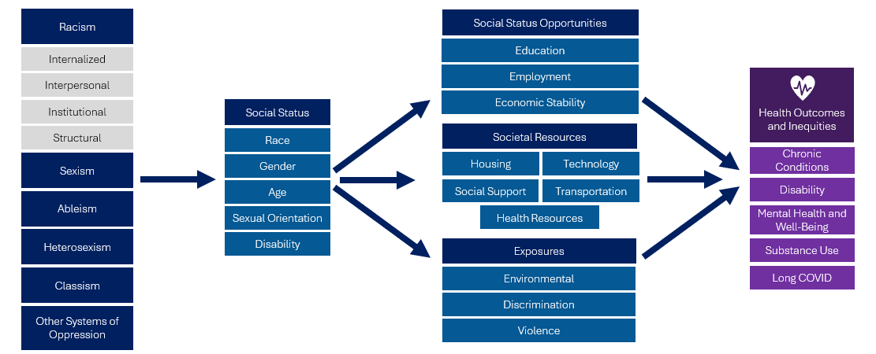

Environmental Exposures
Environmental health is centered on the relationship between people and their environment and is an integral component of public health. Environmental exposures include a wide range of external factors commonly classified as chemical, physical, biological, mechanical, or psychosocial hazards. Systemic and structural inequities strongly influence our community characteristics and our levels of exposure to various environmental hazards. For example, policies and institutional practices that enforce and maintain racial segregation have led to higher median blood lead levels in Black children compared to White children, impacting cognitive development and functioning.
The 2023 CHES gathered information related to several important environmental exposures, including exposures in the home, air quality, water quality, and extreme temperatures. This section will highlight findings related to these environmental exposures and their connection to mental health.

Table 13. 2023 CHES– Adult Environmental Exposures in Home and Psychological Distress
Psychological Distress –
High/Very High
Weighted %
Problems in Home
Lead paint or pipes | 47.9***
Mold or water leaks | 54.0***
Noise from neighborhood | 53.7***
Not enough heat during the winter | 67.9***
Pests (e.g., bugs, roaches, mice, rats) | 52.3***
Poor air quality or air pollution | 65.4***
Too hot during the summer | 58.9***
Water is not safe to drink | 50.7***
No reported problems in the home | 24.7
Environmental Impacts Experienced in Past 5 Years
Feeling unwell due to poor air quality, very hot days, or allergies | 45.5***
Flooding in my home or on my street | 46.2***
More ticks or mosquitoes | 37.5***
Unable to get to work or do my job due to weather | 49.0***
Very cold or very hot temperatures at home, work, or school | 47.2***
None of these | 21.9
*** p<.0001, ** p<.001, * p<.05 P-values from Pearson chi-square test indicate whether weighted responses from those identifying as specified group significantly differ from those identifying as the noted reference group.

As seen in Table 13, adults who reported having issues with various environmental exposures in their home had higher rates of high or very high psychological distress compared to those that did not.
Extreme temperatures
- Adults who reported having problems dealing with extreme temperatures, like being too hot in the summers or not having enough heat in the winters, were significantly more likely to report psychological distress and suicidal ideation.
Biological Exposures
- Adults who reported having problems with pests in the home were 2.1 times as likely to report high or very high psychological distress compared to adults who did not.

Environmental Exposures Associated with Worse Mental Health Outcomes

Table 14. 2023 CHES - Environmental Exposures by Communities of Focus
 | Not Enough Heat During the Winter in Home  Weighted % | Pests in Home  Weighted % | Flooding in Home or Street in Past 5 Years  Weighted %
Race/Ethnicity
American Indian/Alaska Native | 9.2* | 17.8* | 13.8
ANHPI¹, nH/nL​² | 4.7 | 10.7* | 5.0***
Black, nH/nL | 8.4*** | 15.1* | 9.3*
Hispanic or Latine/a/o | 7.1*** | 16.9*** | 7.5***
Middle Eastern or North African | 11.3*** | 12.9 | 18.5**
Multiracial, nH/nL | 11.4*** | 20.1*** | 16.6***
White, nH/nL (ref) | 5.1 | 12.7 | 11.3
Sexual Orientation
Asexual | 7.7* | 20.9*** | 12.4*
Bisexual/Pansexual | 9.6*** | 20.7*** | 16.7***
Gay or Lesbian | 5.5 | 15.2** | 12.2*
Queer | 14.2*** | 23.7*** | 24.2***
Questioning/Not Sure | 13.3*** | 24.9*** | 17.3**
Straight/Heterosexual (ref) | 5.1 | 11.9 | 9.5
Transgender Identity
Transgender | 14.0*** | 23.8*** | 21.7***
Not Transgender (ref) | 5.4 | 12.8 | 10.3
People with Disabilities
At Least One Disability | 11.2*** | 18.9*** | 12.7***
Blind/Vision Impaired | 10.4*** | 21.6*** | 14.0*
Cognitive Disability | 13.3*** | 20.9*** | 15.2***
Deaf/Hard of Hearing | 8.4*** | 12.6 | 9.7
Learning/Intellectual Disability | 11.8*** | 19.4*** | 11.0
Mobility Disability | 12.2*** | 19.8*** | 11.3
Self-Care/Independent Living Disability | 13.7*** | 20.8*** | 12.0
No Disability (ref) | 4.0 | 11.4 | 9.7
*** p<.0001, ** p<.001, * p<.05 P-values from Pearson chi-square test indicate whether weighted responses from those identifying as specified group significantly differ from those identifying as the noted reference group.
As seen in Table 14, many communities experiencing disproportionately high poor mental health outcomes also reported high rates of environmental exposures.
LGBTQA+
- Respondents that identified their sexual orientation as asexual, bisexual or pansexual, queer, or questioning or not sure reported significantly higher rates of not having enough heat in their homes during winter, having pests in their home, and experiencing flooding in their home or street in the past 5 years compared to respondents that identified as straight or heterosexual.
- A high percentage of respondents that identified as transgender reported having not enough heat in their homes (14.0%), pests in the home (23.8%), and experiencing flooding in their homes and streets in the past 5 years (21.7%).
People with Disabilities
- Respondents who reported having 1 or more disabilities had significantly higher rates of not having enough heat in their homes during winter, having pests in their home, and experiencing flooding in their home or street in the past 5 years compared to respondents that did not report having a disability.
Many Environmental Exposures Are Higher Within Communities of Focus
People of Color
- Respondents that identified as Black, Hispanic, Hispanic or Latine/a/o, Middle Eastern or North African, or Multiracial reported significantly higher rates of not having enough heat in their homes during winter, having pests in their home, and experiencing flooding in their home or street in the past 5 years compared to respondents that identified as White, nH/nL.
- Respondents that identified as Middle Eastern or North African reported some of the highest rates of not having enough heat in their homes during winter (11.3%) and experiencing flooding in their homes or streets (18.5%) compared to all other race and ethnicities.
- Respondents that identified as American Indian or Alaska Native reported high rates of not having enough heat in their homes during winter (9.2%) and pests in home (17.8%).

Reducing levels of negative environmental exposures can be an important part of an overall strategy to promote mental health equity. As seen in Figure 16, members of various communities of focus that did not report having pests in their home were significantly less likely to have high or very high psychological distress compared to those that did report having pests in their home. Among people with disabilities, the rate of psychological distress was lower among those that did not have pests in their home compared to those that did (50.9% vs 68.0%).

Figure 16. 2023 CHES– Adult High or Very High Psychological Distress by Exposure to Pests in the Home within Communities of Focus

*People of color include respondents that reported one of the following race/ethnicities: American Indian/Alaska Native, Asian, Native Hawaiian, Pacific Islander, Black, Hispanic/Latine/a/o, Middle Eastern/North African, or Multiracial.
**LGBQA includes respondents that reported their sexual orientation as being lesbian, gay, bisexual, queer, asexual, or other.

American Public Health Association. Topics & Issues: Environmental Health. Accessed August 2024. https://www.apha.org/topics-and-issues/environmental-health
Institute of Medicine (US) Committee on Enhancing Environmental Health Content in Nursing Practice; Pope AM, Snyder MA, Mood LH, editors. Nursing Health, & Environment: Strengthening the Relationship to Improve the Public's Health. Washington (DC): National Academies Press (US); 1995. 2, Overview of Environmental Health Hazards. Available from: https://www.ncbi.nlm.nih.gov/books/NBK232390/
Reuben A, Manczak EM, Cabrera LY, Alegria M, Bucher ML, Freeman EC, Miller GW, Solomon GM, Perry MJ. The Interplay of Environmental Exposures and Mental Health: Setting an Agenda. Environ Health Perspect. 2022 Feb;130(2):25001. doi: https://doi.org/10.1289/EHP9889
National Institutes of Health. NIH Research Matters: Racial Segregation makes consequences of lead exposure worse. 2022 August 30. https://www.nih.gov/news-events/nih-research-matters/racial-segregation-makes-consequences-lead-exposure-worse

