## 2023 CHES Mental Health Report - Equity Framing and Data Overview

## Mental Health Equity Framing and Key Drivers

Mental Health is a core component of overall health and includes our emotional, psychological, and social well-being. Our mental health affects nearly all aspects of our lives and is important for maintaining meaningful relationships, coping with everyday stress, and making choices[1]. Our mental health exists on a continuum and is more than just the absence of mental illness[2]. Individuals living with a mental health condition can have high levels of mental well-being, just as those without a mental health diagnosis are not guaranteed to have positive overall mental health.

**CHEI Health Inequities Framework**

The building blocks for positive mental health include factors at the individual, family, community, environment, institution, and systems levels[3]. However, not everyone has equal opportunities to achieve positive mental health. The CHEI Health Inequities Framework (Figure 1) helps to illustrate the various pathways that lead to poor health outcomes and health inequities, including mental health.

*Figure 1. CHEI Health Inequities Framework*

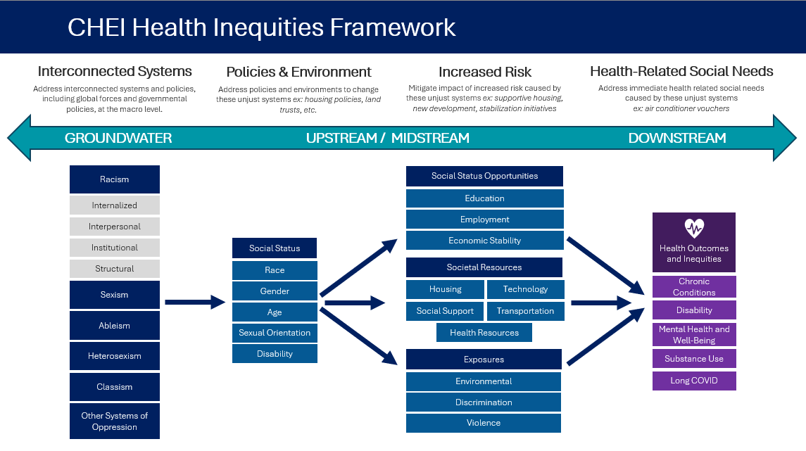

This framework shows that poor health outcomes and health inequities that exist within and across communities are driven by systemic racism and other systems of oppression. These systems create, maintain, and attribute value to various social status categories, such as race, which leads to differential access to social resources and opportunities and differential exposure to various proximal determinants of health. While individual-level biological factors and health-related behaviors play an important role in one’s mental health, the systematic and unjust patterns of poor mental health across populations are largely driven by interconnected systems that impact the social determinants of health[4]. The 2023 CHES gathers information along this health inequity pathway to help us better understand the root causes of health inequities, including mental health inequities.

## Mental Health in Massachusetts

In this section, we provide a brief overview of the state of mental health in Massachusetts focusing on findings from the Community Health Equity Survey (CHES). The chapter also includes highlights from other Massachusetts statewide data systems, including the Behavioral Risk Factor Surveillance System (BRFSS) [5], Youth Health Survey (YHS), and Youth Risk Behavior Survey (YRBS) [6]. We will then highlight communities in Massachusetts that experience inequities in poor mental health outcomes. It is important to note that the data in this chapter focuses primarily on mental illness and other poor mental health outcomes, which is only one component of mental health.

**Mental Illness and Poor Mental Health Outcomes**

Mental illness includes health conditions that involve significant changes in our thinking, emotions, or behavior that disrupt our everyday life[7]. Mental illnesses are among the most common health conditions in the U.S., with more than 1 in 5 adults living with a mental illness[8], nearly 1 in 2 adolescents having a current or past mental disorder, and over 1 in 5 youth having a seriously debilitating mental illness either currently or at some point in their lives[9]. Many mental illnesses are also closely linked to our physical health. People with a mental health condition have increased morbidity and mortality associated with a range of physical health conditions, including heart disease, diabetes, and stroke[10]. Individuals with a chronic condition such as cancer are also more likely to develop a mental health condition like depression[11].

***Psychological Distress***

Psychological distress is defined as a state of emotional suffering characterized by symptoms of depression and anxiety, along with other somatic symptoms[12]. The 2023 CHES measures psychological distress using the Kessler Psychological Distress Scale, a widely used, validated scale to assess non-specific psychological distress[13]. Respondents’ answers are scored and categorized into the following levels of psychological distress: low, medium, high, and very high.

Figure 2. 2023 CHES - Psychological Distress by Age Group (Years)

Overall levels of psychological distress for adult and youth respondents in the 2023 CHES were high. Nearly 1 in 3 adults (32%) aged 18 and older and 1 in 2 youth (46%) aged 14 to 17 had high or very high levels of psychological distress. Psychological distress was highest among youth and young adult age groups.

Trends in psychological distress from the 2023 CHES are consistent with data from other MA statewide surveys. Mental health data from the 2022 BRFSS showed that approximately 14% of MA adults have persistent poor mental health, with the highest rates among the 18-24 age group (22%) and lowest among those 75 and older (6.1%). Data from the 2022 YHS and YRBS show that among MA high school students, nearly 1 in 3 (32%) reported their mental health was not good always or most of the time.

***Suicide***

Suicide is one of the leading causes of death in the United States among all age groups and the second leading cause of death among people aged 10 to 34. In 2022, over 13 million US adults had serious thoughts of suicide in the past year[14]. The 2023 CHES included two questions related to suicide: (1) Suicidal Ideation – “In the past 12 months, did you ever think about doing something to end your life?” (2) Suicide Attempts – “In the past 12 months, how many times did you do something to try to end your life?”.

Figure 3. 2023 CHES - Suicidal Ideation by Age Group (Years)

Overall, 7.4% of adults aged 18 and older and 14.7% of youth aged 14 to17 reported suicidal ideation in the past year.

Young adults aged 18 to 24 had the highest reported rates of suicidal ideation (17.9%).

Data on suicidal ideation from the 2023 CHES are comparable to findings from other statewide surveys. Data from the 2022 YHS/YRBS showed that among MA high school students, 19.7% reported injuring oneself intentionally without wanting to die and 7.6% attempted suicide in the past year. The 2022 MA BRFSS estimates that approximately 3.9% of adults have seriously considered suicide in the past year, which is lower than the 2023 CHES estimate. This difference is likely due to methodological and sampling differences.

***Social Isolation***

Social relationships play an important role in mental well-being and social isolation can impact overall mental health. Persistent social isolation has been linked to several poor health outcomes, including depression, dementia, heart disease, suicidal behavior, and psychosis[15],[16]. Social isolation likely increased as a result of the COVID-19 pandemic, particularly among older adults, leading to increased risk of associated mental health outcomes[17].

Isolation in the 2023 CHES was defined as not having many people to talk to or spend time with on a regular basis and included the following question: “How often do you feel isolated from others?”. Social isolation within CHES is defined as those that reported feeling isolated from others “usually” or “always”.

Figure 4. 2023 CHES - Social Isolation by Age Group (Years)

Overall, 13.2% of adults aged 18 and older and 15.6% of youth aged 14-17 reported usually or always feeling isolated from others.

Social Isolated was highest among young adults aged 18 to 24. Older adults reported the lowest rates of social isolation.

National and statewide data on social isolation is limited. In the U.S., it is estimated that 1 in 3 adults aged 45 and older are lonely and nearly 1 in 4 adults 65 and older are socially isolated[18]. Estimates of social isolation from the 2023 CHES are generally lower than these national estimates, particularly among older adults. Differences in social isolation rates in this age group are likely due to methodological and sampling differences[19].

***Other Health Outcomes and Substance Use***

Mental health is associated with other health outcomes, including chronic conditions and substance use. Research has consistently shown a bidirectional relationship between chronic conditions and mental health[20]. Mental health disorders are associated with higher incidences of chronic conditions such as diabetes, cardiovascular disease, cancer, and respiratory conditions. Additionally, the burden of managing chronic conditions can contribute to psychological distress[21].

Poor mental health can also increase one’s risk for substance use and misuse. More than one in four adults living with a serious mental health disorder also has a substance use disorder[22]. Substance use can also contribute to and exacerbate poor mental outcomes. Outreach and services to individuals and communities affected by substance addiction and strategies that focus on prevention are critical for mental health promotion.

Findings from the 2023 CHES help to quantify the association between substance use and mental health. For example, tobacco use, medical marijuana use, and non-medical marijuana use were significantly associated with psychological distress, suicidal ideation, and social isolation (Table 1).

*Table 1. 2023 CHES - Substance Use and Mental Health Indicators*

|  | **Psychological Distress –  High / Very High**  **Weighted %** | **Suicidal Ideation**  **Weighted %** | **Social Isolation**  **Weighted %** |
| --- | --- | --- | --- |
| **Tobacco Use** |  |  |  |
| Past Month Use | 54.1*** | 14.3*** | 24.7*** |
| No Use in Past Month (ref) | 30.8 | 7.4 | 12.1 |
| **Non-Medical Marijuana Use** |  |  |  |
| Past Month use | 49.1*** | 17.8*** | 20.2*** |
| No Use in Past Month (ref) | 30.2 | 6.5 | 12.4 |
| **Medical Marijuana Use** |  |  |  |
| Past Month Use | 56.6*** | 20.5*** | 26.8*** |
| No Use in Past Month (ref) | 31.3 | 7.2 | 12.6 |

*** p<.0001, ** p<.001, * p<.05.

In addition to the substance use reported here, CHES also collects data on the use of other substances and respondents’ preferences for resources to help manage the use of alcohol or other drugs. More findings related to substance use will be made available in future CHEI resources.

1. American Public Health Association. <https://www.apha.org/topics-and-issues/mental-health>
2. World Health Organization. World Mental Health Report: Transforming Mental Health for All. 2022. <https://www.who.int/teams/mental-health-and-substance-use/world-mental-health-report>
3. Prevention United. What is Mental Health Promotion? The Building Blocks of Mental Health Promotion. <https://preventionunited.org.au/how-prevention-works/what-is-mental-health-promotion/>
4. Allen J, Balfour R, Bell R, Marmot M. Social determinants of mental health. Int Rev Psychiatry. 2014 Aug;26(4):392-407. <https://pubmed.ncbi.nlm.nih.gov/25137105/>.
5. A Profile of Health Among Massachusetts Adults, 2022. Massachusetts Behavioral Risk Factor Surveillance System. Massachusetts Department of Public Health. <https://www.mass.gov/doc/a-profile-of-health-among-massachusetts-adults-2022/download>
6. Health & Risk Behaviors of Massachusetts Youth, 2021. Massachusetts Youth Risk Behavior Survey and Massachusetts Youth Health Survey. Massachusetts Department of Elementary and Secondary Education and Department of Public Health. <https://www.mass.gov/doc/health-and-risk-behaviors-of-massachusetts-youth-2021/download>
7. American Psychiatric Association. <https://www.psychiatry.org/patients-families/what-is-mental-illness>
8. Centers for Disease Control. <https://www.cdc.gov/mentalhealth/learn/index.htm>
9. Merikangas KR et al. Lifetime prevalence of mental disorders in U.S. adolescents: results from the National Comorbidity Survey Replication--Adolescent Supplement (NCS-A). J Am Acad Child Adolesc Psychiatry. 2010 Oct;49(10):980-9. doi: 10.1016/j.jaac.2010.05.017. Epub 2010 Jul 31. PMID: 20855043; PMCID: PMC2946114. <https://pubmed.ncbi.nlm.nih.gov/20855043/>
10. Osborn DP. The poor physical health of people with mental illness. West J Med 2001; 175(5): 329–32. <https://www.ncbi.nlm.nih.gov/pmc/articles/PMC1071612/>
11. National Institute of Mental Health. <https://www.nimh.nih.gov/health/publications/chronic-illness-mental-health>
12. Belay AS, Guangul MM, Asmare WN, Mesafint G. Prevalence and Associated Factors of Psychological Distress among Nurses in Public Hospitals, Southwest, Ethiopia: A cross-sectional Study. Ethiop J Health Sci. 2021 Nov;31(6):1247-1256. <https://www.ncbi.nlm.nih.gov/pmc/articles/PMC8968359/>
13. Kessler RC, Andrews G, Colpe LJ, Hiripi E, Mroczek DK, Normand SL, Walters EE, Zaslavsky AM. Short screening scales to monitor population prevalences and trends in non-specific psychological distress. Psychol Med. 2002 Aug;32(6):959-76. <https://pubmed.ncbi.nlm.nih.gov/12214795/>
14. Substance Abuse and Mental Health Services Administration. (2023). Key substance use and mental health indicators

    in the United States: Results from the 2022 National Survey on Drug Use and Health (HHS Publication No.

    PEP23-07-01-006, NSDUH Series H-58). Center for Behavioral Health Statistics and Quality, Substance Abuse and

    Mental Health Services Administration. <https://www.samhsa.gov/data/report/2022-nsduh-annual-national-report>
15. Wang, J., Lloyd-Evans, B., Giacco, D. et al. Social isolation in mental health: a conceptual and methodological review. Soc Psychiatry Psychiatr Epidemiol 52, 1451–1461 (2017). <https://doi.org/10.1007/s00127-017-1446-1>
16. Centers for Disease control and Prevention, Alzheimer’s Disease and Healthy Aging Program. Loneliness and Social Isolation Linked to Serious Health Conditions. <https://www.cdc.gov/aging/publications/features/lonely-older-adults.html>
17. Murayama H, Okubo R, Tabuchi T. Increase in Social Isolation during the COVID-19 Pandemic and Its Association with Mental Health: Findings from the JACSIS 2020 Study. International Journal of Environmental Research and Public Health. 2021; 18(16):8238. <https://doi.org/10.3390/ijerph18168238>
18. National Academies of Sciences, Engineering, and Medicine. 2020. Social Isolation and Loneliness in Older Adults: Opportunities for the Health Care System. Washington, DC: The National Academies Press. <https://doi.org/10.17226/25663>.
19. Many of the national data on isolation among older adults, including the National Health and Aging Trends Study, are gathered from in-person interviews and other qualitative methods. CHES is primarily administered online, which may not be accessible to those without reliable internet access and lower digital literacy. The sampling method for 2023 CHES also relied in part on community partner outreach, including community-based organizations supporting older adult populations. Older adults that were connected to the survey by these organizations may be more connected to social support services and less likely to experience social isolation than the general population, potentially resulting in lower rates of isolation compared to other data sources.
20. Martin Prince, Vikram Patel, Shekhar Saxena, Mario Maj, Joanna Maselko, Michael R Phillips, Atif Rahman, No health without mental health,The Lancet, Volume 370, Issue 9590, 2007, Pages 859-877, ISSN 0140-6736, <https://doi.org/10.1016/S0140-6736(07)61238-0>.
21. Katon WJ. Epidemiology and treatment of depression in patients with chronic medical illness. Dialogues Clin Neurosci. 2011;13(1):7-23. <https://doi.org/10.31887/DCNS.2011.13.1/wkaton>
22. Substance Abuse and Mental Health Services Administration. Mental Health and Substance Use Co-Occurring Disorders. April 24 2023. <https://www.samhsa.gov/mental-health/mental-health-substance-use-co-occurring-disorders>