2023 CHES Mental Health Report - Drivers of Mental Health Inequities
Health Care Access and Mental Health
The CHEI Health Inequities Framework demonstrates that there is no single pathway that leads to mental well-being and no single cause that fully explains why certain populations have worse mental health outcomes. Many individual-level, environmental, social, structural, and historical factors work together to influence overall mental health. This section will highlight findings from the 2023 CHES that help demonstrate how inequities in social opportunities, resources, and key exposures contribute to inequities in mental health outcomes.

Societal Resources
Equitable access to important societal resources, such as housing, social support, technology, and transportation, are necessary to promote health equity. Access to these resources is closely connected to many of the social status opportunities described in the previous section. Economic stability, employment, and education can promote access and utilization of these resources to promote health. Policies, systems, and institutions create patterns of advantage and disadvantage that help shape inequities in resource access. CHES 2023 gathers important information on these key resources and connects them to mental health outcomes. The following sections will highlight findings related to three important societal resources: (1) Social Networks and Support, (2) Housing, and (3) Health Care Access.
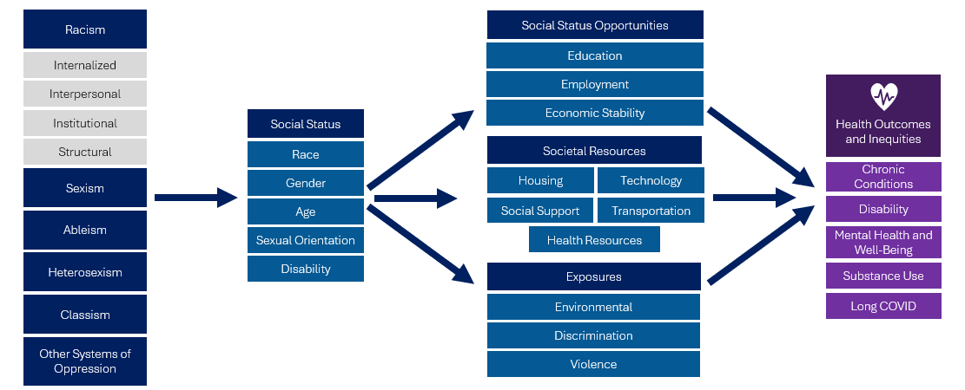

Access to Quality Health Care
Having access to affordable, quality health care is important for overall health. However, significant barriers to health care access exist within many communities that contribute to inequities in health, including mental health. Economic barriers and affordability of health care are major contributors to inequitable health care access, but financial hurdles are not the only hurdles that individuals and families face. Inadequate health insurance coverage, language access barriers, provider shortages, transportation barriers, lack of or insufficient paid sick leave policies, and racial bias and discrimination are some examples of non-financial barriers to health care. Provider shortages are a particular challenge within mental health care, with more than half the U.S. population living in a Mental Health Professional Shortage Area. These barriers to health care are largely driven by systems and policies that systematically promote access within some communities and obstruct access for others, namely communities of color.

The 2023 CHES gathered important information related to health care access, including:
- Health insurance coverage and type
- Usual sources of health care
- Access to needed care in the past 12 months and reasons for not receiving care
- Access to telehealth visits

Table 11. 2023 CHES - Health Care Access and Mental Health Indicators
 | Psychological Distress –  High/Very High  Weighted % | Suicidal Ideation  Weighted % | Social Isolation  Weighted %
Expenses - Adult
Trouble Paying for Health Care Expenses | 60.7*** | 16.4*** | 28.6***
No Trouble Paying for Health Care Expenses (ref) | 27.7 | 6.2 | 10.7
Experiences of Discrimination
Experienced Discrimination While Getting Health Care | 64.8*** | 24.5*** | 39.1***
Did Not Experience Discrimination While Getting Health Care (ref) | 57.2 | 18.5 | 26.7
Receiving Needed Health Care
Did Not Receive Needed Health Care | 72.2*** | 23.8*** | 42.5***
Did Not Receive Needed Mental Health Care | 64.2*** | 22.0*** | 30.0***
Received Needed Mental Care (ref) | 23.8 | 4.3 | 9.1
Health Insurance - Adult
No Health Insurance Coverage (ref) | 57.0 | 14.4 | 29.7
Health Insurance Coverage | 30.0*** | 6.9*** | 12.0***
*** p<.0001, ** p<.001, * p<.05
P-values from Pearson chi-square test indicate whether weighted responses from those identifying as specified group significantly differ from those identifying as the noted reference group.
Health Insurance Coverage
- Adults that reported not having health insurance coverage were nearly twice as likely to have high or very high psychological distress, 2.1 times as likely to have suicidal ideation, and 2.5 times as likely to report social isolation.
Health Care Expenses
- Adults that reported having trouble paying for health care expenses were significantly more likely to report having an unmet health care need in the past year compared to those that did not have trouble (40.5% vs. 12.8%). They were also 2.2 times as likely to have high or very high psychological distress, 2.6 times as likely to report suicidal ideation, and 2.7 times as likely to report social isolation.

Connection Between Health Care Access and Mental Health
Discrimination in Health Care
- Adults that reported experiencing discrimination while getting health care were over twice as likely to report not receiving health care that they needed in the past year compared to those that did not report experiencing discrimination while getting health care (50.5% vs 24.4%). They also reported significantly higher rates of psychological distress, suicidal ideation, and social isolation compared to those that did not experience discrimination while getting health care.

As seen in Table 12, many communities of focus experience barriers to accessing health care. A high percentage of residents from communities of color, the LGBTQA+ community, and the disability community reported not receiving the health care that they needed in the past year. Adults that identify as queer or transgender and adults with disabilities also reported significantly higher rates of experiencing discrimination while receiving health care.

Table 12. 2023 CHES– Adult Health Care Access and Barriers by Communities of Focus
 | Trouble Paying for Health Care Expenses  Weighted % | Experienced Discrimination While Receiving Health Care  Weighted % | Did Not Receive Needed Health Care¹  Weighted %
Race/Ethnicity
American Indian/Alaska Native | 17.9 | 19.6 | 24.2**
ANHPI¹, nH/nL​² | 8.8 | 14.1** | 12.6
Black, nH/nL | 19.3** | 23.6 | 21.9***
Hispanic or Latine/a/o | 15.7 | 15.0 | 21.3***
Middle Eastern or North African | 14.7 | 22.1 | 27.7***
Multiracial, nH/nL | 25.2*** | 22.1 | 21.8***
White, nH/nL (ref) | 14.7 | 24.0 | 13.0

Table 12 (Continued)
 | Trouble Paying for Health Care Expenses  Weighted % | Experienced Discrimination While Receiving Health Care  Weighted % | Did Not Receive Needed Health Care¹  Weighted %
Sexual Orientation
Asexual | 18.7* | 14.5* | 22.2***
Bisexual/Pansexual | 23.4*** | 18.9 | 22.6***
Gay or Lesbian | 14.5 | 20.0 | 18.6***
Queer | 36.7*** | 33.6*** | 33.3***
Questioning/Not Sure | 27.3*** | ^ | 15.9
Straight/Heterosexual (ref) | 13.6 | 21.7 | 12.1
Transgender Identity
Transgender | 33.7*** | 30.4*** | 34.9***
Not Sure | 29.0*** | 20.0 | 26.1***
Not Transgender (ref) | 14.7 | 20.8 | 13.7
People with Disabilities
Blind/Vision Impaired | 23.6*** | 30.4*** | 23.6***
Cognitive Disability | 30.7*** | 32.9*** | 30.7***
Deaf/Hard of Hearing | 16.9 | 35.9*** | 16.9
Learning/Intellectual Disability | 28,5*** | 35.7*** | 28.5***
Mental Health Disability | 31.3*** | 33.3*** | 31.3***
Mobility Disability | 26.8*** | 40.2*** | 26.8***
Self-Care/Independent Living Disability | 27.5*** | 39.4*** | 27.5***
One or More Disabilities | 25.1*** | 30.0*** | 25.1***
No Disability (ref) | 12.0 | 16.5 | 12.0
¹ Includes respondents that reported having some form of health care need that was unmet in the past 12 months.
*** p<.0001, ** p<.001, * p<.05
P-values from Pearson chi-square test indicate whether weighted responses from those identifying as specified group significantly differ from those identifying as the noted reference group.
Improving access to health care services, including mental health care, within communities of focus is important to promote mental health equity. As seen in Figure 15, rates of psychological distress within people of color, those identifying as LGBTQA, and people with disabilities were significantly lower among those that received the health care that they needed compared to those that did not. Within communities of color, the rate of psychological distress was 53% lower for those that received the health care they needed compared to those that did not. This suggests that eliminating barriers to health care access can be an effective step towards health equity promotion.
Figure 15. CHES 2023 – Adult High or Very High Psychological Distress by Unmet Health Care Needs Among Communities of Focus
*People of color include respondents that reported one of the following race/ethnicities: American Indian / Alaska Native, Asian, Native Hawaiian, Pacific Islander, Black, Hispanic/Latine/a/o, Middle Eastern/North African, or Multiracial.
**LGBQA includes respondents that reported their sexual orientation as being lesbian, gay, bisexual, queer, asexual, or other.

2021 National Healthcare Quality and Disparities Report. Rockville (MD): Agency for Healthcare Research and Quality (US); 2021 Dec. Access to Healthcare and Disparities in Access. https://www.ncbi.nlm.nih.gov/books/NBK578537/
National Center for Health Workforce Analysis. Behavioral Health Workforce 2023 Brief. December 2023. https://bhw.hrsa.gov/sites/default/files/bureau-health-workforce/Behavioral-Health-Workforce-Brief-2023.pdf
Institute of Medicine (US) Committee on Understanding and Eliminating Racial and Ethnic Disparities in Health Care. Unequal Treatment: Confronting Racial and Ethnic Disparities in Health Care. Smedley BD, Stith AY, Nelson AR, editors. Washington (DC): National Academies Press (US); 2003. https://doi.org/10.17226/12875

