2023 CHES Mental Health Report - Drivers of Mental Health Inequities
Housing and Mental Health
The CHEI Health Inequities Framework demonstrates that there is no single pathway that leads to mental well-being and no single cause that fully explains why certain populations have worse mental health outcomes. Many individual-level, environmental, social, structural, and historical factors work together to influence overall mental health. This section will highlight findings from the 2023 CHES that help demonstrate how inequities in social opportunities, resources, and key exposures contribute to inequities in mental health outcomes.

Societal Resources
Equitable access to important societal resources, such as housing, social support, technology, and transportation, are necessary to promote health equity. Access to these resources is closely connected to many of the social status opportunities described in the previous section. Economic stability, employment, and education can promote access and utilization of these resources to promote health. Policies, systems, and institutions create patterns of advantage and disadvantage that help shape inequities in resource access. CHES 2023 gathers important information on these key resources and connects them to mental health outcomes. The following sections will highlight findings related to three important societal resources: (1) Social Networks and Support, (2) Housing, and (3) Health Care Access.
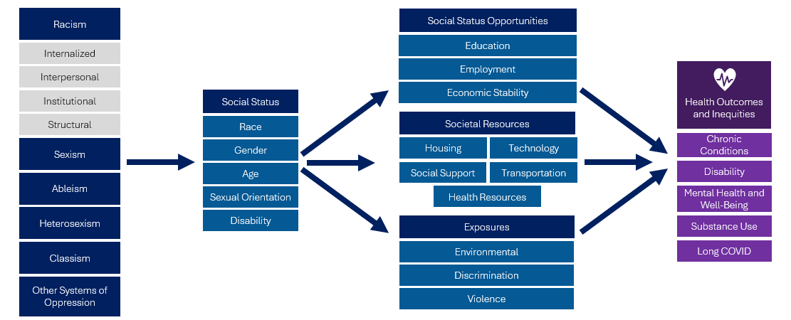

Housing
As a key social determinant of health, housing plays a critical role in health and health equity. There are many aspects of housing that have important connections to mental health, as summarized in the figure below.

Figure 13. Housing and Mental Health Pathways
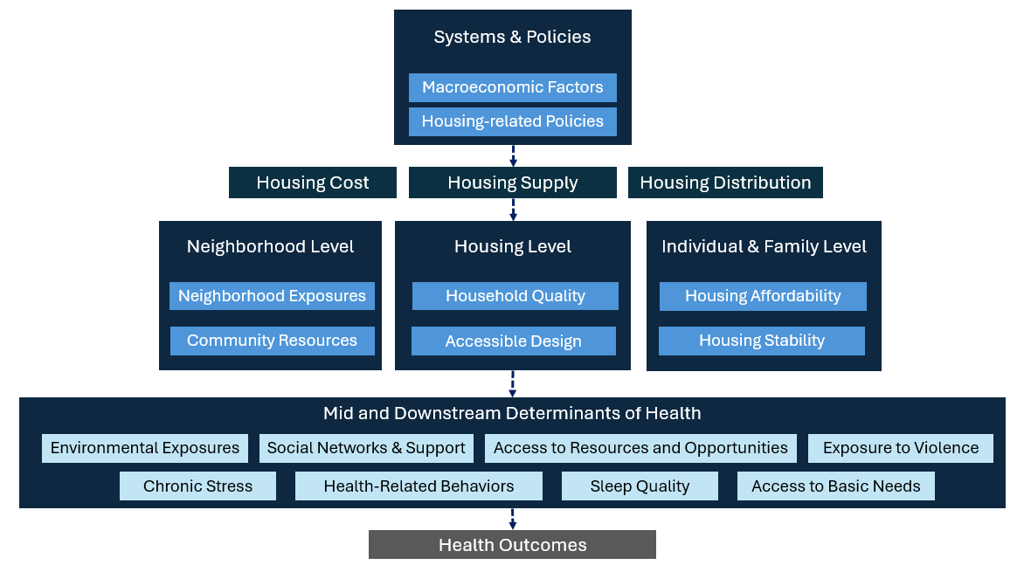

Systems Level
Federal, state, and local regulations and policies, and macroeconomic factors shape the overall housing landscape, influencing the cost, supply, distribution, and quality of homes. These systems and policies create patterns of advantage and disadvantage, resulting in inequitable access to safe and affordable housing within and across communities resulting in inequities in access to intergenerational wealth-building, impacting long-term family security and community stability. As an example, historical laws, policies, and institutional practices that enforced racial segregation in the U.S. created and maintained racially distinct neighborhoods and communities and led to unjust home devaluation and neighborhood disinvestment within communities of color. Past and present-day laws, policies, and practices related to segregation continue to drive economic inequity, patterns of violence and crime, and concentrations of poor health across communities.

Neighborhood Level
Where we live strongly influences our level of access to community resources that influence our health, such as transportation, green space, and educational and job opportunities. Our neighborhoods also influence our social networks and levels of social support, which serve as important facilitators for positive mental health and well-being. Key exposures at the neighborhood level, such as violence, crime, and environmental hazards, also increase our risk for poor health outcomes. Exposure to neighborhood violence and crime, which are shaped by systemic racism, segregation, land use, and social control, can lead to poor mental health outcomes like chronic and post-traumatic stress. Environmental risk factors like air pollution, water quality, hazardous waste, noise, extreme temperature, and weather events strongly influence our physical and mental health. Inequities in environmental exposures that disproportionately impact specific populations and groups, including many communities of color, are likely to worsen as a result of climate change.

Housing Level
Housing conditions, quality, and design impact health-related household exposures that individuals may experience in their homes. Household-level hazards like lead and carbon monoxide, extreme hot and cold temperatures, and exposures such as pests and mold can lead to or exacerbate chronic conditions, infectious diseases, and chronic stress. Poor housing quality and inaccessible housing design can also inhibit physical access and mobility within the home and can increase risk of physical injury, especially for individuals with disabilities.

Individuals and Families
Individual and family-level dimensions of housing also play an essential role in health. Housing affordability is closely tied to overall economic stability and access to basic needs. Individuals and families that spend a high percentage of their income on rent, mortgage, and other housing-related costs are at higher risk for food insecurity and poor health outcomes. Housing unaffordability can also lead to overcrowding, which can negatively impact relationships and lead to poor sleep quality and chronic stress.
Housing stability has also been shown to be an important facilitator of overall health. People in unstable or uncertain living arrangements are at higher risk for depression, anxiety, substance use, psychological distress, and suicide. Acute and chronic homelessness, the most extreme forms of housing instability, has a dramatic impact on physical and mental health. People who experience homelessness die nearly 30 years earlier than the average American. Children are particularly vulnerable to the negative health impacts related to housing instability and can experience higher rates of malnutrition, vaccine-preventable infectious diseases, asthma, obesity, and dental and vision problems, as well as emotional, behavioral, and developmental issues. Consequently, these children miss more school and are less successful academically. Families with children with special health care needs are more likely to fall behind in rent or mortgage payments and experience homelessness, creating a cycle of poor health, housing insecurity, and poverty from an early age.
The 2023 CHES collected important information related to housing, including affordability, neighborhood-level violence, and environmental exposures within the home. These include:
- Trouble paying for housing and housing-related expenses.
- Housing stability, or having a steady place to live.
- Current living arrangements.
- Problems in the home (including lead paint or pipes, mold or water leaks, too hot during the summer, not enough heat in the winter, and pests).

Table 10. 2023 CHES - Adult Housing and Mental Health Indicators
 | Psychological Distress –  High/Very High  Weighted % | Suicidal Ideation  Weighted % | Social Isolation  Weighted %
Expenses (past year)
Trouble Paying for Housing Expenses | 63.9*** | 16.2*** | 30.1***
No Trouble Paying for Housing Expenses (ref) | 25.0 | 5.7 | 9.2
Housing Stability
Steady Place to Live (ref) | 28.8 | 6.8 | 10.7
Steady Place to Live but Worried About Losing | 70.4*** | 20.3*** | 37.4***
No Steady Place to Live | 72.0*** | 20.5*** | 41.1***
Problems in Home¹
One or more problems in the home | 49.6*** | 14.2*** | 22.9***
No problems in the home (ref) | 24.7 | 5.2 | 8.8
¹Problems in the home include lead paint or pipes, mold or water leaks, noise from the neighborhood, not enough heat during the winter, pests (e.g., bugs, roaches, mice, rats), poor air quality or air pollution, too hot during the summer, too many people living in the space, and water is not safe to drink.
*** p<.0001, ** p<.001, * p<.05
P-values from Pearson chi-square test indicate whether weighted responses from those identifying as specified group significantly differ from those identifying as the noted reference group.
Housing Expenses and Economic Security
- Adults who reported having trouble paying for housing-related expenses were 2.6 times as likely to report high or very high psychological distress, over 2.8 times as likely to report suicidal ideation, and 3.3 times as likely to report social isolation compared to those who did not have trouble.

Connection Between Housing and Mental Health
Housing Stability
- Adults who reported having a steady place to live had significantly lower levels of psychological distress, suicidal ideation, and social isolation compared to those who did not have a steady place to live.
- Adults who had a steady place to live but were worried about losing their housing had similar rates of psychological distress, suicidal ideation, and social isolation compared to those who reported not having a steady place to live.

Figure 14.CHES 2023 – Adult High or Very High Psychological Distress by Housing Stability within Communities of Focus
* Data within category suppressed due to small numbers.
**People of color include respondents that reported one of the following race/ethnicities: American Indian/Alaska Native, Asian, Native Hawaiian, Pacific Islander, Black, Hispanic/Latine/a/o, Middle Eastern/North African, or Multiracial.
***LGBQA includes respondents that reported their sexual orientation as being lesbian, gay, bisexual, queer, asexual, or other.
Promoting access to safe, stable, affordable housing is a key strategy to promote mental health and health equity. Within communities of focus, those who have access to stable, affordable housing were more likely to have better mental health outcomes. For example, the rate of high or very high psychological distress within residents of color who reported having a steady place to live were significantly lower than residents of color who reported not having a steady place to live (29.0% vs 69.9%).

Matthias Braubach, Jon Fairburn, Social inequities in environmental risks associated with housing and residential location—a review of evidence, European Journal of Public Health, Volume 20, Issue 1, February 2010, Pages 36–42, https://doi.org/10.1093/eurpub/ckp221
Massey DS, Denton NA. American Apartheid: Segregation and the Making of the Underclass. Cambridge, Massachusetts: Harvard University Press; 1993.
U.S. Department of Housing and Urban Development, Office of Policy Development and Research. Evidence Matters: Neighborhoods and Violent Crime. Summer 2016. https://www.huduser.gov/portal/periodicals/em/summer16/highlight2.html
Gochfeld M, Burger J. Disproportionate exposures in environmental justice and other populations: the importance of outliers. Am J Public Health. 2011 Dec;101 Suppl 1(Suppl 1):S53-63. doi: https://doi.org/10.2105/AJPH.2011.300121
Campbell-Lendrum, D., Corvalán, C. Climate Change and Developing-Country Cities: Implications For Environmental Health and Equity. J Urban Health 84 (Suppl 1), 109–117 (2007). https://doi.org/10.1007/s11524-007-9170-x
Davis, A., (May 31, 2007) "Home Environmental Health Risks." OJIN: The Online Journal of Issues in Nursing. Vol. 12 No. 2 Manuscript 4. https://doi.org/10.3912/OJIN.Vol12No02Man04
Krieger J, Higgins DL. Housing and health: time again for public health action. Am J Public Health. 2002 May;92(5):758-68. https://doi.org/10.2105/ajph.92.5.758.
Imrie, R. (2005). Accessible Housing: Quality, Disability and Design (1st ed.). Routledge. https://doi.org/10.4324/9780203616734
University of Wisconsin Population Health Institute, County Health Rankings & Roadmaps. 2019 County Health Rankings Key Findings Report. https://www.countyhealthrankings.org/reports/2019-county-health-rankings-key-findings-report
Gove, Walter R., et al. “Overcrowding in the Home: An Empirical Investigation of Its Possible Pathological Consequences.” American Sociological Review, vol. 44, no. 1, 1979, pp. 59–80. JSTOR, https://doi.org/10.2307/2094818
Taylor, Lauren A. Housing and Health: An Overview of the Literature, Housing Policy Brief, Health Affairs, June 2018. https://www.healthaffairs.org/do/10.1377/hpb20180313.396577/
United States Interagency Council on Homelessness. Data & Trends: State of Homelessness. https://www.usich.gov/guidance-reports-data/data-trends

