2023 CHES Mental Health Report - Drivers of Mental Health Inequities
Social Networks & Supports and Mental Health
The CHEI Health Inequities Framework demonstrates that there is no single pathway that leads to mental well-being and no single cause that fully explains why certain populations have worse mental health outcomes. Many individual-level, environmental, social, structural, and historical factors work together to influence overall mental health. This section will highlight findings from the 2023 CHES that help demonstrate how inequities in social opportunities, resources, and key exposures contribute to inequities in mental health outcomes.

Societal Resources
Equitable access to important societal resources, such as housing, social support, technology, and transportation, are necessary to promote health equity. Access to these resources is closely connected to many of the social status opportunities described in the previous section. Economic stability, employment, and education can promote access and utilization of these resources to promote health. Policies, systems, and institutions create patterns of advantage and disadvantage that help shape inequities in resource access. CHES 2023 gathers important information on these key resources and connects them to mental health outcomes. The following sections will highlight findings related to three important societal resources: (1) Social Networks and Support, (2) Housing, and (3) Health Care Access.
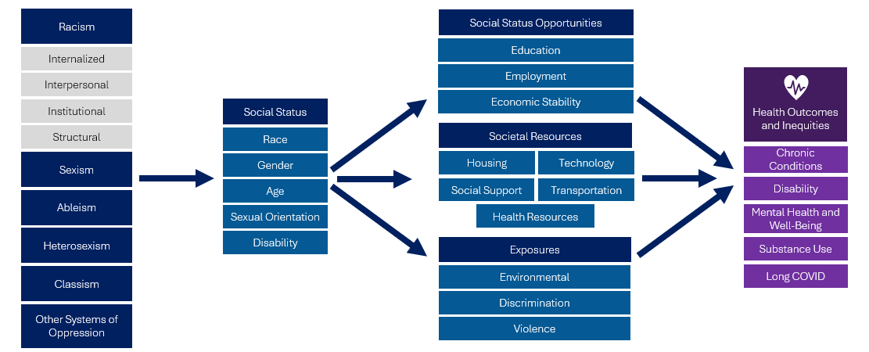

Social Networks and Support
The relationships and interactions that we share with others have a strong connection to our health and the health of our communities. Social networks influence our physical and mental health in many important ways, including:
- Providing social support in the form of emotional support, assistance with tangible needs, and information.
- Providing social influence that reinforces social norms and constrain or enable certain behaviors.
- Our social engagements with others define and reinforce social roles and influence our participation in various activities.
- Shaping person-to-person contact which restricts and promotes exposure to infectious disease.
- Impacting our access to resources like job opportunities, educational opportunities, access to health care, and housing.
- Influencing exposure to negative social interactions like conflict and abuse.

The 2023 CHES gathers important data on social networks and social supports, including:
- Among Youth (aged 14-17 years):
  - Someone to talk to if you needed help with a personal problem.
  - Sense of safety and belonging at school.
  - Family/caregivers that support interests.
- Among Adults (aged 18 years and older):
  - Level of social support (Having someone you can count on for favors, to take care of you if sick, for money for emergencies, to talk to about family relationships, and to help find housing).

Social Support Among Adults
- Among adults who reported not having anyone they could count on for any of the types of social support included in the survey, over half reported high or very high psychological distress (57.2%) and over a third reported social isolation (38.5%).
- Adults with low levels of social support were 2.6 times as likely to report suicidal ideation compared to adults with high social support.

Connection Between Social Support and Mental Health
Social Support Among Youth
Youth who reported having someone to talk to about a person problem had lower rates of psychological distress compared to youth who did not (44.6% vs. 70.2%). They were also nearly half as likely to report suicidal ideation (12.3% vs. 22.9%).

As seen in Tables 8 and 9 on the following page, there is a strong association between social support and mental health. Adults and youth who reported lower levels of social support were more likely to have worse mental health outcomes.

Table 8. 2023 CHES - Adult Social Support and Mental Health
 | Psychological Distress –  High or Very High  Weighted % | Suicidal Ideation  Weighted % | Social Isolation  Weighted %
Social Support¹
Have someone to count on:
For favors (e.g., a ride, borrowing a little money, errands)¹ | 27.3*** | 6.4*** | 9.1***
To take care of you when sick¹ | 25.2*** | 5.8*** | 7.7***
To lend you money for an emergency¹ | 23.7*** | 5.9*** | 7.7***
To talk to if you were having trouble with family relationships¹ | 27.0*** | 6.3*** | 8.7***
To help you find housing¹ | 23.4*** | 5.6*** | 6.9***
For all of the above social supports (High Social Support) ² | 19.2*** | 4.8 *** | 4.6 ***
For none of the above social supports (Low Social Support) | 57.2 | 12.7 | 38.5
*** p<.0001, ** p<.001, * p<.05 P-values from Pearson chi-square test indicate whether weighted responses from those identifying as specified group significantly differ from those identifying as the noted reference group.
¹Reference group is those that reported not having that type of social support.
²Reference group is “none of the above social supports”.
Table 9. 2023 CHES - Youth (aged 14-17 years) Social Support and Mental Health
 | Psychological Distress –  High/Very High  Weighted % | Suicidal Ideation  Weighted % | Social Isolation  Weighted %
Support with Personal Problems
Have someone to talk to about personal problems | 44.6*** | 13.7*** | 14.4***
Do not have someone to talk to about personal problems (ref) | 70.2 | 46.3 | 49.5
Sense of Safety and Belonging
Very much feel safe with family/caregivers¹ | 42.4*** | 11.6*** | 12.9***
Very much feel that I belong at school¹ | 33.5*** | 8.5*** | 6.7***
Very much feel family/caregivers support interests¹ | 39.2*** | 10.5*** | 11.4***
Very much feel all of the above² | 29.8*** | 6.1*** | 4.9***
Do not feel any of the above very much | 84.4 | 52.6 | 53.6
*** p<.0001, ** p<.001, * p<.05
P-values from Pearson chi-square test indicate whether weighted responses from those identifying as specified group significantly differ from those identifying as the noted reference group.
¹Reference group is those that reported somewhat or not at all for that question.
²Reference group is those that “do not feel any of the above very much”.
Figure 12. 2023 CHES High or Very High Psychological Distress by Social Support Levels* Among Communities of Focus
*Social support levels were calculated from the social support module included in the 2023 CHES. This module asked survey takers if they had someone to count on for five different types of social support. High social support is defined as having someone to count on for all types of social support. Medium social support is defined is defined as having someone to count on for 1 to 4 types of social support. Low social support is defined as not having someone to count on for any type of social support.
**People of color include respondents that reported one of the following race/ethnicities: American Indian/Alaska Native, Asian, Native Hawaiian, Pacific Islander, Black, Hispanic/Latine/a/o, Middle Eastern/North African, or Multiracial.
***LGBQA includes respondents that reported their sexual orientation as being lesbian, gay, bisexual, queer, asexual, or other.

Within communities of focus, increased levels of social support were associated with overall better mental health outcomes (Figure 12). For example, adults with disabilities with high levels of social support were half as likely to report having high or very high psychological distress compared to adults with disabilities with low levels of social support. This suggests that work to build and maintain community connections and increase access to social supports within community and school settings may be effective in promoting mental health and mitigating some of the impacts of the inequities experienced within these groups.

Survey respondents were asked if they have someone to count on for five different types of social support. High social support is defined as having someone to count on for all types of social support. Medium social support is defined is defined as having someone to count on for 1 to 4 types of social support. Low social support is defined as not having someone to count on for any types of social support.
Berkman, Lisa F., Ichiro Kawachi, and M. Maria Glymour (eds), Social Epidemiology, 2 edn (New York, 2014; online edn, Oxford Academic, 1 Mar. 2015), https://doi.org/10.1093/med/9780195377903.001.0001
Cohen S. Psychosocial models of the role of social support in the etiology of physical disease. Health Psychol. 1988;7(3):269-97. https://pubmed.ncbi.nlm.nih.gov/3289916/
Marsden, P. V., & Friedkin, N.E. (1993). Network Studies of Social Influence. Sociological Methods & Research, 22(1), 127-151. https://doi.org/10.1177/0049124193022001006
Rook, K. S. (1990). Social relationships as a source of companionship: Implications for older adults' psychological well-being. In B. R. Sarason, I. G. Sarason, & G. R. Pierce (Eds.), Social support: An interactional view (pp. 219–250). John Wiley & Sons.
Morris, M. (1993). Epidemiology and Social Networks:: Modeling Structured Diffusion. Sociological Methods & Research, 22(1), 99-126. https://doi.org/10.1177/0049124193022001005
Granovetter, M. S. (1973). The Strength of Weak Ties. American Journal of Sociology, 78(6), 1360–1380. http://www.jstor.org/stable/2776392
Cohen, S. (2004). Social relationships and health. American psychologist, 59(8), 676.

