2023 CHES Mental Health Report - Drivers of Mental Health Inequities
Violence and Mental Health
The CHEI Health Inequities Framework demonstrates that there is no single pathway that leads to mental well-being and no single cause that fully explains why certain populations have worse mental health outcomes. Many individual-level, environmental, social, structural, and historical factors work together to influence overall mental health. This section will highlight findings from the 2023 CHES that help demonstrate how inequities in social opportunities, resources, and key exposures contribute to inequities in mental health outcomes.

Societal Resources
Our social and physical environments are inseparably linked to our health. The health promoting and health impairing exposures we interact with in our daily lives have an important impact on our mental well-being and overall health. As illustrated in the CHEI Health Inequities Framework, patterns of exposures to these determinants of health are shaped by systems of oppression, leading to inequities in health. The 2023 CHES gathered information from residents on their experiences with many key exposures within their physical and social environments.
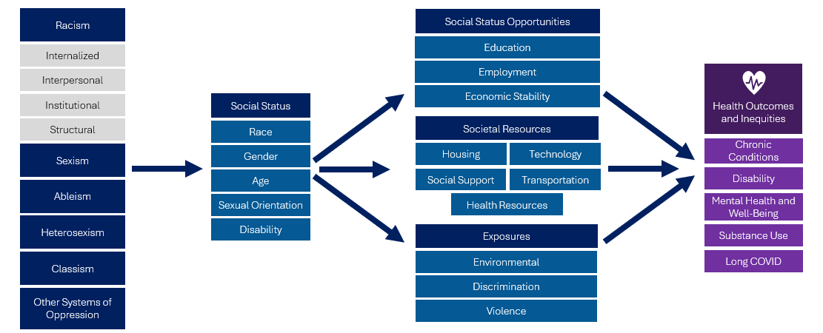

Violence
Many of the social and structural determinants of health highlighted within the CHEI Health Inequities Framework are also drivers of violence exposure. Patterns of socioeconomic disadvantage, diminished social opportunities, and resource deprivation driven by systems of oppression place certain communities at higher risk for and more vulnerable to violence.
Exposure to violence in its many forms can have a devastating impact on physical and mental health. Children who are exposed to violence and other adverse childhood experiences (ACEs) are at greater risk for many immediate and long-term impacts such as mental disorders, substance use, and chronic conditions,. Exposure to violence during adulthood can lead to physical health issues, cardiovascular disease, premature mortality, and poor mental health outcomes, including depression, anxiety, and posttraumatic stress disorder. Violence among older adults, including elder abuse, can increase the risk for stress, depression, fear, and anxiety .
CHES 2023 captures information related to community violence, intimate partner violence, household violence, and sexual violence.
Table 15. 2023 CHES - Experiences of Violence and Mental Health Indicators
 | Psychological Distress –  High/Very High  Weighted % | Suicidal Ideation  Weighted % | Social Isolation  Weighted %
Intimate Partner Violence
Ever | 50.9*** | 15.2*** | 23.4***
In Last 12 Months¹ | 69.1*** | 26.1*** | 34.1***
Never (ref) | 25.6 | 5.6 | 9.5
Household Violence (Youth)
Ever | 80.6*** | 52.2 | 41.4***
In Last 12 Months¹ | 88.3*** | 53.7*** | 51.1***
Never (ref) | 38.1 | 7.6 | 10.5
Sexual Violence
Ever | 53.8*** | 19.1*** | 24.8***
In Last 12 Months¹ | 83.5*** | 12.6*** | 47.3***
Never (ref) | 27.0 | 5.4 | 10.1
Neighborhood Violence²
Ever | 44.1*** | 12.0*** | 20.2***
Very Often¹ | 61.3*** | 19.1*** | 36.8***
Never (ref) | 25.8 | 6.1 | 8.9
*** p<.0001, ** p<.001, * p<.05 P-values from Pearson chi-square test indicate whether weighted responses from those identifying as specified group significantly differ from those identifying as the noted reference group.
¹Reference group is those who reported experiencing that form of violence but not in the last 12 months.
²Reported ever seeing or hearing someone getting physically attacked, beaten, stabbed, or shot in the neighborhood they were living.
Exposure to Violence Associated with Poor Mental Health
- Nearly 7 in 10 respondents who reported experiencing intimate partner violence in the last 12 months reported high or very high psychological distress, over 1 in 4 reported suicidal ideation, and over 1 in 3 reported social isolation.
- Youth who reported experiencing household violence in the last 12 months had very high levels of high or very high psychological distress (88.3%), suicidal ideation (53.7%), and social isolation (51.1%).
- Over 6 in 10 respondents who reported experiencing neighborhood violence very often reported high or very high psychological distress.

Table 16. 2023 CHES - Experiences of Violence by Communities of Focus
 | Ever Experienced Neighborhood Violence¹  Weighted % | Ever Experienced Intimate Partner Violence  Weighted % | Ever Experienced Sexual Violence  Weighted %
Race/Ethnicity
American Indian/Alaska Native | 61.7*** | 43.6*** | 27.9*
ANHPI¹, nH/nL​² | 38.9* | 12.7*** | 6.7***
Black, nH/nL | 63.7*** | 31.5* | 14.6***
Hispanic or Latine/a/o | 57.9*** | 29.8 | 15.3***
Middle Eastern or North African | 49.6*** | 37.0** | 32.1***
Multiracial, nH/nL | 53.0*** | 31.6* | 26.6**
White, nH/nL (ref) | 35.4 | 28.6 | 21.6
Sexual Orientation
Asexual | 52.9*** | 30.9* | 22.8***
Bisexual/Pansexual | 51.7*** | 46.2*** | 46.4***
Gay or Lesbian | 49.7*** | 32.9*** | 27.6***
Queer | 51.6*** | 52.5*** | 53.9***
Questioning/Not Sure | 40.0 | 36.2*** | 34.3***
Straight/Heterosexual (ref) | 39.3 | 25.6 | 16.4
Transgender Identity
Transgender | 52.4*** | 50.8*** | 54.5***
Not Transgender (ref) | 40.5 | 27.3 | 18.7
People with Disabilities
Blind/Vision Impaired | 50.5*** | 38.3*** | 26.7***
Cognitive Disability | 50.4*** | 44.0*** | 38.1***
Deaf/Hard of Hearing | 41.1 | 31.5** | 21.3
Learning/Intellectual Disability | 44.7* | 30.7* | 28.5***
Mobility Disability | 49.2*** | 34.4*** | 27.2***
Self-Care/Independent Living Disability | 46.5*** | 34.9*** | 32.5***
One or More Disabilities | 48.1*** | 37.6*** | 30.0***
No Disability (ref) | 38.4 | 24.5 | 16.2
¹Reported ever seeing or hearing someone getting physically attacked, beaten, stabbed, or shot in the neighborhood they were living.
*** p<.0001, ** p<.001, * p<.05 P-values from Pearson chi-square test indicate whether weighted responses from those identifying as specified group significantly differ from those identifying as the noted reference group.
As seen in Table 16, many communities of focus reported disproportionately high levels of exposure to various forms of violence.
- Many members of the LGBTQA+ community reported experiencing significantly high rates of violence. Over half of respondents who identified as transgender reported ever experiencing neighborhood violence, intimate partner violence, and sexual violence. Over half of respondents who identified as queer reported ever experiencing neighborhood violence, intimate partner violence, and sexual violence.
- People with one or more disabilities were 1.3 times as likely to report experiencing neighborhood violence, 1.5 times as likely to report experiencing intimate partner violence, and 1.9 times as likely to report sexual violence compared to people without a disability.
- Black, nH/nL respondents reported the highest rates of experiencing neighborhood violence compared to all other race and ethnicity groups (63.7%).

Figure 17. CHES 2023 – Adult High or Very High Psychological Distress by Frequency of Exposure to Neighborhood Violence in Current Neighborhood¹ within Communities of Focus

¹ Neighborhood violence in the current neighborhood is defined as reporting seeing or hearing someone get physically attacked, beaten, stabbed, or shot in your current neighborhood.
*People of color include respondents that reported one of the following race/ethnicities: American Indian/Alaska Native, Asian, Native Hawaiian, Pacific Islander, Black, Hispanic/Latine/a/o, Middle Eastern/North African, or Multiracial.
**LGBQA includes respondents that reported their sexual orientation as being lesbian, gay, bisexual, queer, asexual, or other.
Strategies to prevent exposure to violence are critical for overall health equity promotion. As seen in Figure 17, less frequent exposure to neighborhood violence within communities of focus was associated with lower rates of psychological distress. For example, among people of color, rates of psychological distress were significantly lower among those that reported never or rarely experiencing violence in their current neighborhood compared to those that reported experiencing violence somewhat or very often. This suggests that strategies that address root causes of violence, such as socioeconomic disadvantage, diminished social opportunities, and resource deprivation, could help to promote mental health equity across communities.

Armstead TL, Wilkins N, Nation M. Structural and social determinants of inequities in violence risk: A review of indicators. J Community Psychol. 2021 May;49(4):878-906. doi: https://doi.org/10.1002/jcop.22232
Gu W, Zhao Q, Yuan C, Yi Z, Zhao M, Wang Z. Impact of adverse childhood experiences on the symptom severity of different mental disorders: a cross-diagnostic study. Gen Psychiatr. 2022 Apr 22;35(2):e100741. https://doi.org/10.1136/gpsych-2021-100741
Centers for Disease Control and Prevention – Violence Prevention. Help Youth at Risk for ACES. June 29 2023. https://www.cdc.gov/violenceprevention/aces/help-youth-at-risk.html
Rivara et al, The Effects of Violence, Health Affairs, Volume 38, No. 10: Violence & Health. October 2019. https://www.healthaffairs.org/doi/10.1377/hlthaff.2019.00480
Rosen T, Makaroun LK, Conwell Y, Betz M. Violence In Older Adults: Scope, Impact, Challenges, And Strategies For Prevention. Health Aff (Millwood). 2019 Oct;38(10):1630-1637. https://doi.org/10.1377/hlthaff.2019.00577.

