

A N N U A L R E P O R T 2 0 2 3
Massachusetts Rehabilitation Commission Statewide Rehabilitation Council

T A B L E O F C O N T E N T S 2 0 2 3

A Letter from the
6
10
2
Inez Canada Courge for the Times
4 Vision, Mission, Structure FY24
5 Appointed Members FY24
8 Explore Possibility Summit 2023

Chair Career Services
Year in Review

Committee Reports 2023
12
18 FY24 Recommendations 20 Meet Beverly Brewington 22 Building Community



State Rehabilitation Council 1

LETTER FR OM THE CHAIR
Inez S. Canada

DEAR SR C AND MR C:
Are you interested in breaking down employment barriers for individuals with disabilities?

Join the Statewide Rehabilitation Council (SRC)

The SRC is a diverse, inclusive, and equitable advisory body that gathers

This moment is bittersweet as my term as Chair has ended. It has been my pleasure to lead the SRC and I am truly grateful for your willingness to follow. Together we have built a foundation for a stronger more influential SRC. I hope everyone is proud of the Council we have started building
together. I know the Council will continue to grow and thrive under the incoming Chair because everyone serving is dedicated to the SRC’s vision and mission.

Committee Chairs, thank you for your leadership, extraordinary level of service, and commitment to the Council. Thank you for the efforts of the Com- mittees to execute the Council’s mission. We see the untapped potential of the body and I know the SRC will continue working to realize it fully.

SRC Members and attendees, thank you for your service on the Council. Your voice is valuable to the conversation about innovating vocational re- habilitation services to maximize the opportunity for individuals with disabilities to find the support needed to “live their best lives, through consum- er-driven, meaningful, competitive, and integrat- ed employment and sustainable careers.”

MRC Liaisons, thank you for your support of the SRC and its Committee work. Your knowledge of vocational rehabilitation guides our thought
process around what’s possible, keeping our work focused and relevant. We appreciate you and the time you set aside to attend the meetings.
MRC Communications Team, Administrative Sup- port, and webmaster, thank you for your contribu- tions to raise the SRC’s profile, to keep us orga- nized and efficient, and to make sure our public facing materials are current.

Thank you, Commissioner Wolf, Deputy Com- missioner Biebel, Director Baczko, and Deputy General Counsel Defensor for your unwavering support during my term as Chair.

I truly enjoyed working with all of you and getting to know some of you better during my term. I look forward to assisting with the transition of the next SRC Chair and supporting the SRC under its new leadership.

With a grateful heart, Inez S. Canada

representative voices from the disability community to provide input to the Massachusetts Rehabilitation Commission’s Division of Career Services.
Contact mrc.staterehabcouncil@mass.gov

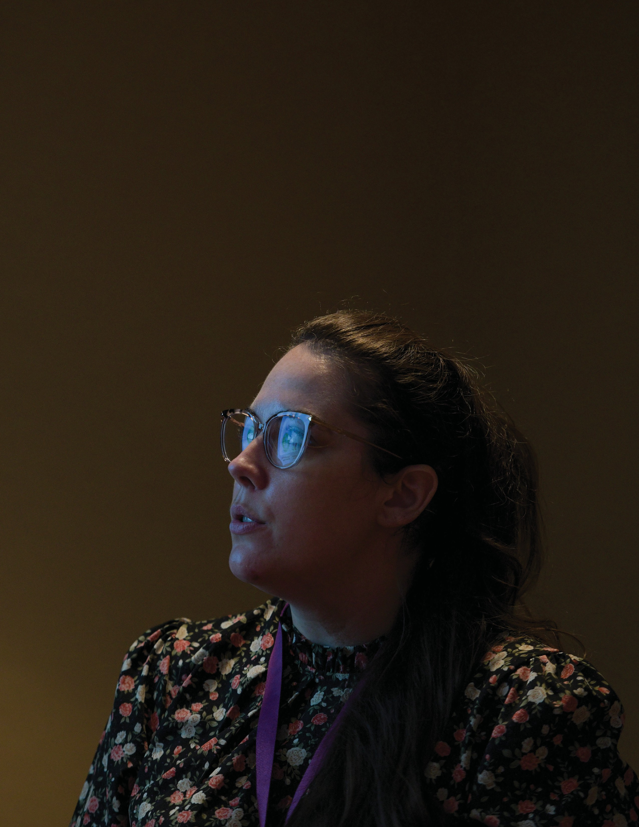
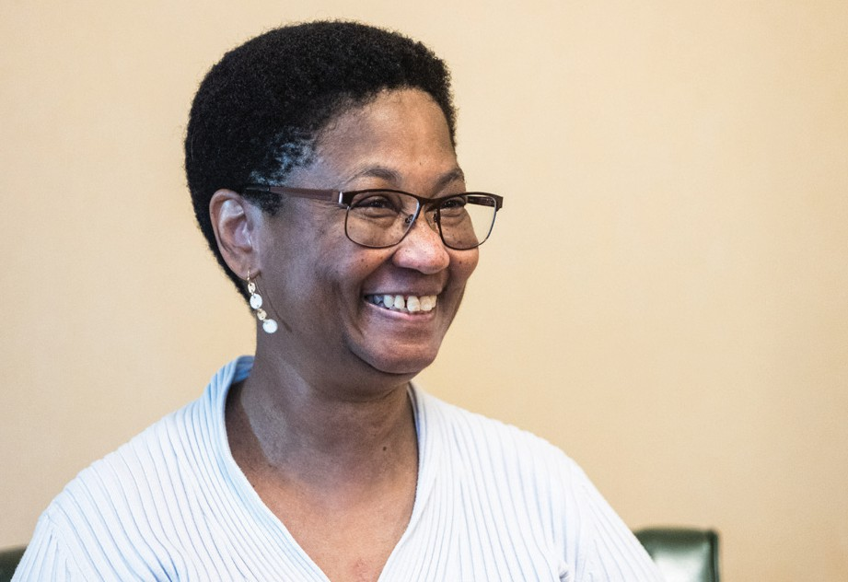
2 State Rehabilitation Council 3

What is the SRC?
The SRC is a diverse, inclusive, and equitable advisory body that gathers representative voices from the disability community to provide input to the Massachusetts Rehabilitation Commission’s (MRC) Vocational Rehabilitation Division.

The Council’s collective and individual thinking plays a substantive role in how the vocational rehabilitation program operates and contributes to the innovation of career and counseling services. Members of the SRC collaborate with MRC in developing goals and priorities for the state plan, and offer input and consultation on policies, practices, and procedures that impact jobseekers.

If you are an employer, individual with a disability, family member, advocate, service provider, and/or someone who wants to make a difference in people’s career-goals, this is the group for you!

Client Assistance Program

Vision:
We envision a world where all individuals with disabilities are supported to live their best lives, through consumer-driven, meaningful, competitive, and integrated employment and sustainable careers.

Mission:
We work to promote competitive and sustainable employment for all people with disabilities, including those marginalized by inequalities.

Government Organizational Structure for Funding & Oversight

SRC Members FY23
Matthew Bander
Disabilities Rep
Youcef “Joe” Bellil
Disabilities Rep
Kathleen Biebel
Deputy Commissioner
Inez Canada
Disabilities Rep
Dawn Clark
Disabilities Rep
Rebecca Davis
Parenting Training/Info Center Rep
Paula Euber
MRC VR Rep
Ronaldo Fujii
Disabilities Rep
Naomi Goldberg
Client Assistance Program (CAP) Director
Steven LaMaster
Community Rehab Services Provider Rep
Dr. Lusa Lo
Higher Education Rep
Christine Tosti
Disabilities Rep
Toni Wolf
Commissioner
Heather Wood
Disabilities Rep
Rosanna Woodmansee
Business/Labor/Industries Rep
Vacant Seats:
- Unserved/Underserved Rep
- State Workforce Development Board Member
- Statewide Independent Living Council (SILC) Chair
- Business/Labor/Industries Reps (3)
- State Educational Agency Rep Responsible for the Public Education of Students with Disabilities
- Individual representing disability groups that include cross section of physical, cognitive, sensory, mental disabilities, and those who have difficulty representing themselves or unable to represent themselves due to their disability
5

Consumer Advocates
Partners
State Rehabilitation Council
State Rehabilitation Council Organizational Structure
Executive Committee

Business and Employment Opportunity

State Plan and Inter-agency Relations

Comprehensive Needs and Consumer Satisfaction

Policy

Massachusetts Rehabilitation Commission

4 State Rehabilitation Council
Office of Special Education and Rehabilitation Services
Rehabilitation Services Administration (RSA)
Required under law for all state Vocational Rehabilitation Programs
Massachusetts Executive Office of Health and Human Services
Massachusetts State Rehabilitation Council

United States Department of Education

Massachusetts Rehabilitation Commission
PARTNERS

I N E Z C A N A D A Courage for the Times

“My last name (Canada) means ‘Gathering Place,” Inez Canada shared recently. “Which is fitting because when people think about me, they’re thinking of a person who brings people together.” She explained that as a leader, her gift has been to hear all the content collected and find the unifying pieces to bring people for common goals. “I focus on the things we can do together, in unity.”
The members of the Statewide Rehabilitation Council (SRC) saw this and appreciated her ability to inspire collaboration. Inez believes that SRC lead- ership recognized, after the death of George Floyd in 2020, that the next Chair needed to bring people together in a non-threatening way. “Everyone needs to feel like they can participate and be allowed to share,” she said.

The SRC is a diverse, inclusive, and equitable advi- sory body that gathers representative voices from the disability community to provide input to the Massachusetts Rehabilitation Commission’s (MRC) Vocational Rehabilitation Division.

As Chair, Inez created a place where people could unite and share ideas, all while strengthening the SRC’s ability to affect change in employment ser- vices offered through MRC.

Born in Mississippi, one of 11 children, Inez was never bored. While her family were extroverts, she found solace in the quiet moments at home. She had a thirst for knowledge, devoured books, and spent her free time writing. “These things were my focus.” At a young age, despite her quiet demeanor, Inez was courageous and began finding her voice. She often settled arguments between her siblings and approached her stern father with out-of-the- box ideas. Inez’s courage would define her profes- sional career.

At Harvard Law School, she became the President of the Black Law Student Association (BSLA). “I seem always to become involved in leadership po- sitions, and not intentionally,” she added. While she was reluctant to become a leader, others spoke of her value in that role. She worked to unify the voice of Black faculty, staff, and students as they began to speak out against racial incidents in classes, anonymous hate speech on campus, and hostile environments.
Inez remembered, “It was a divided law school; the BLSA thoughts about responding were also divid- ed. Some students preferred being in class daily to counter stereotypes, while others wanted to sit out and form study groups to prove themselves through academics. Additionally, others wanted the oppor- tunity to voice their opinion publicly. “As a leader,
it was important to me to bring people together despite the divide,” Inez recalled. In 2002, the BLSA organized a walk-out that made headlines, joined by the late Professor Charles Ogletree and Harvard alumnus and activist Dr. Cornell West. The walk-out incorporated students’ ideas and showed that their
voice mattered in the hallowed halls of Harvard Law.

It was during this time that Inez was diagnosed with an autoimmune disease. Admittedly, she knew noth- ing about the condition, and after she graduated, her symptoms intensified. By 2011, she was hospital- ized and lost her ability to walk and have full use of her hands. After almost two years of intensive thera- py at Spaulding Rehabilitation Hospital, she gained the confidence to return to work. “I can’t sit still,” Inez shared. “To me, work was always an option.” She had a law degree, but the traditional paths of law weren’t her passion; her new situation made them less attractive. She connected with the Massachusetts Rehabilitation Commission (MRC) to help rethink her career. She began investigating roles in Human Re- sources with MRC’s on-the-job evaluation. She saw her experience and passion for knowledge and edu- cation could be helpful to others with disabilities.

She applied for a role at the Massachusetts Office of Disability (MOD) as an advocate for the Client Assistance Program (CAP), a federal program that advocates for individuals with disabilities. The role would empower her to be a leader again; not for an organization, but for one person at a time. “I wanted
to work with people, write, and help educate people about their rights,” she said, remembering what she wanted in her next job. Before getting the job, she attended the MOD Summit at the State House to network and learn more. While there, she met the new Commissioner of MRC, Toni Wolf. Commissioner Wolf encouraged her to join the Statewide Rehabil- itation Council (SRC). In a quick conversation, Inez demonstrated her passion, awareness, and desire
to help those with disabilities. Inez began attending the council’s public meetings and became interest- ed in joining. “Before I was even appointed, I saw that the skills I had would be of value to the council,” Inez said. “It became a natural fit.” As a member of the SRC, Inez’s work on the council focused on orga- nization and improving the knowledge of members on the council.
As her term as Chair ends, Inez knows she is leaving the council in a place of success. “One thing I’ve heard is that the meetings have been efficient and organized,” Inez said. Under her leadership, the SRC is more prepared to be an active voice for Common- wealth residents with a disability. “It was important to me to create processes that a new member could learn easily, so new council members have a solid foundation of knowledge and written policies, and not have to create them as they learn.”

“I don’t want people to compare the next Chair to me,” Inez added. “We all bring different skills.” To her, the SRC has become a council with real influ- ence with a courageous voice about employment services for people with disabilities. Inez is excited that the new SRC Chair, Heather Wood, is a special education teacher and will bring ideas to reach youth and support MRC’s Pre-ETS program and the NextGen Careers vocational model.

Inez commends Commissioner Wolf and MRC lead- ership for encouraging and building real partnership with the SRC. “The scope of our work is focused,” Inez said. “I want members to take the foundational work of the Council and continue to build on that to make real change.”


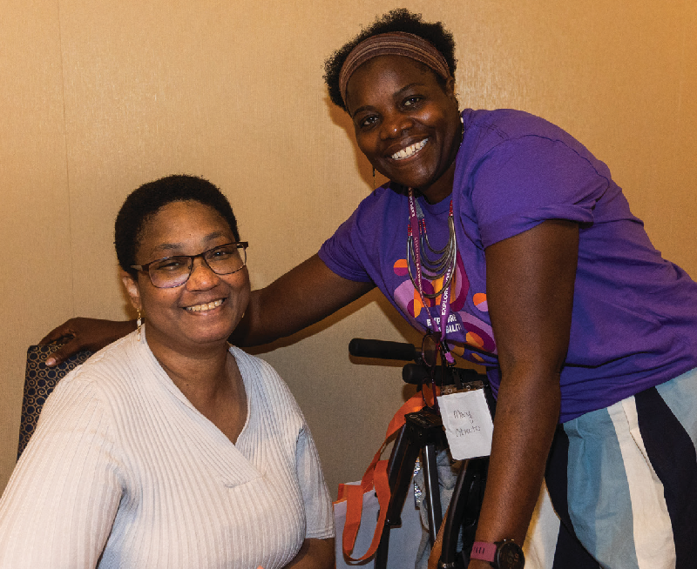
6 State Rehabilitation Council 7

Creating Possibility
2023 EXPLORE POSSIBILITY SUMMIT
These experiences led Jake to work with friends to create the Ahoi app, a Waze for accessibility. It uses crowdsourcing technology for users to share notifications of incomplete walkways or locations they might not be able to enter. “With the help of MRC, we can create a comprehensive map of Boston and Massachusetts to share with other people living with a disability, the best way they can get around their community,” Jake said.

A T MR C ’S SE C OND ANNU AL SUMMIT
B Y NICK PIZZ OLA T O
T
he Massachusetts Rehabilitation Commission’s (MRC) second “Explore Possibility Summit” opened the doors at the Sheraton Framingham Hotel and Conference Center to more than 400 registered
attendees for a day full of inspiration, information, and collaboration. Individuals with disabilities came prepared to meet with MRC staff, providers, and vendors to communicate their needs and learn about existing services so they can live
life on their own terms. The event demonstrated MRC’s determination to be a catalyst for careers and independent living for the people they serve now and in the future.

During her opening remarks, MRC Commissioner Toni Wolf shared the passion of the organization for the disability community and provided encouragement to those in attendance. “The Massachusetts Rehabilitation Commission is here for you today and tomorrow. Don’t forget that.”

Jake Haendel, the Summit’s keynote speaker, shared his story as the only person to survive stage four toxic progressive leukoencephalopathy. In 2017, he fell into a coma, and when he became unresponsive, medical professionals thought he was braindead.
Jake could still hear. He could still think. He could still feel pain in his muscles. He just was unable to communicate with anyone. Thanks to an incredible team of medical professionals and his self- determination, Jake eventually started to communicate and focused on his recovery. Ultimately, he could move independently in his wheelchair but consistently ran into accessibility issues. Sidewalks without curb cuts. Stairs but no elevator. Restaurants with no accessible bathroom.

MRC designed breakout sessions to help foster knowledge, networking, and independence among the attendees. People with disabilities could hear from housing advocates who provided resources for them to use to rejoin their communities and live independently. Seasoned travelers with disabilities shared their tips on exploring the world and encouraging others to travel. MRC’s Job Placement Team members advised people on how to succeed in a hybrid work environment. Members of the disability community had the day to network with their peers and other professionals to help the growth of their careers.

At the end of the Summit, guests filled the ballroom to engage with a panel featuring members of the disability community and advocates who shared their thoughts on Disability Pride. Entrepreneur Roxy Rocker said her definition of pride was, “We are passionate about living our lives.” Family Inclusion Ambassador Firdosa Hassan added, “We must create an inclusive environment for people with disabilities to achieve what’s best for them.”

The Summit received rave reviews, with guests sharing on social media that the event was “Empowering” and allowed them to “See what MRC can do for people with disabilities.”

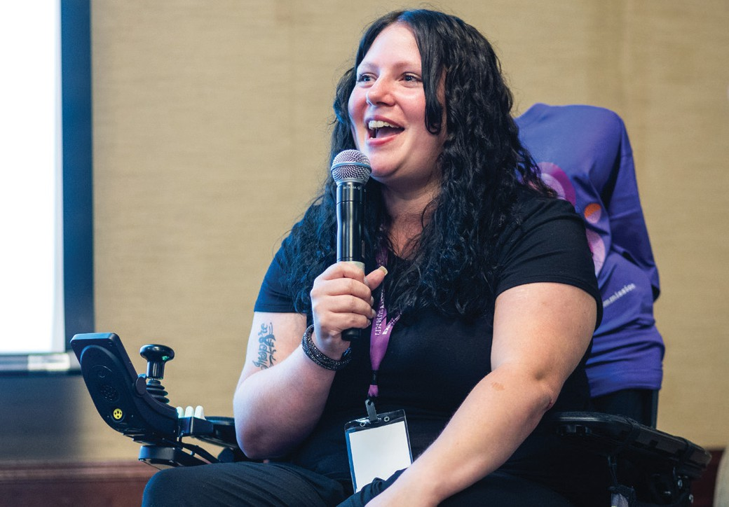
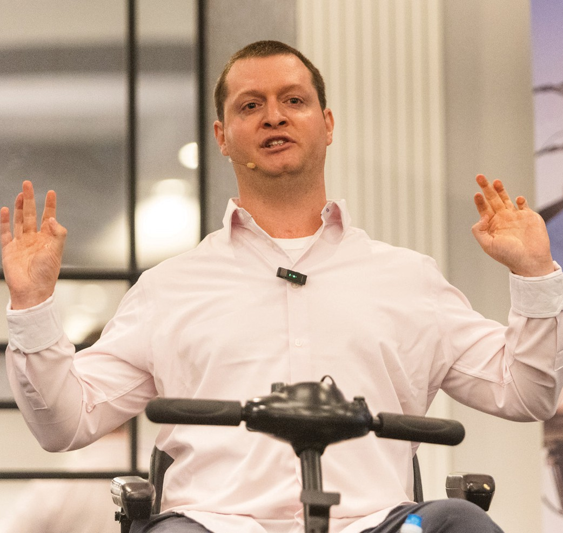
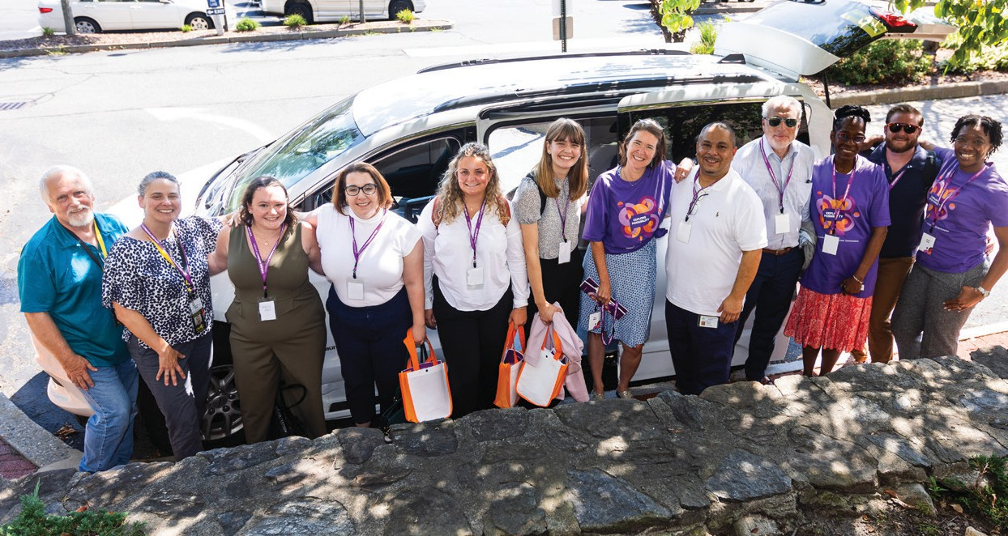
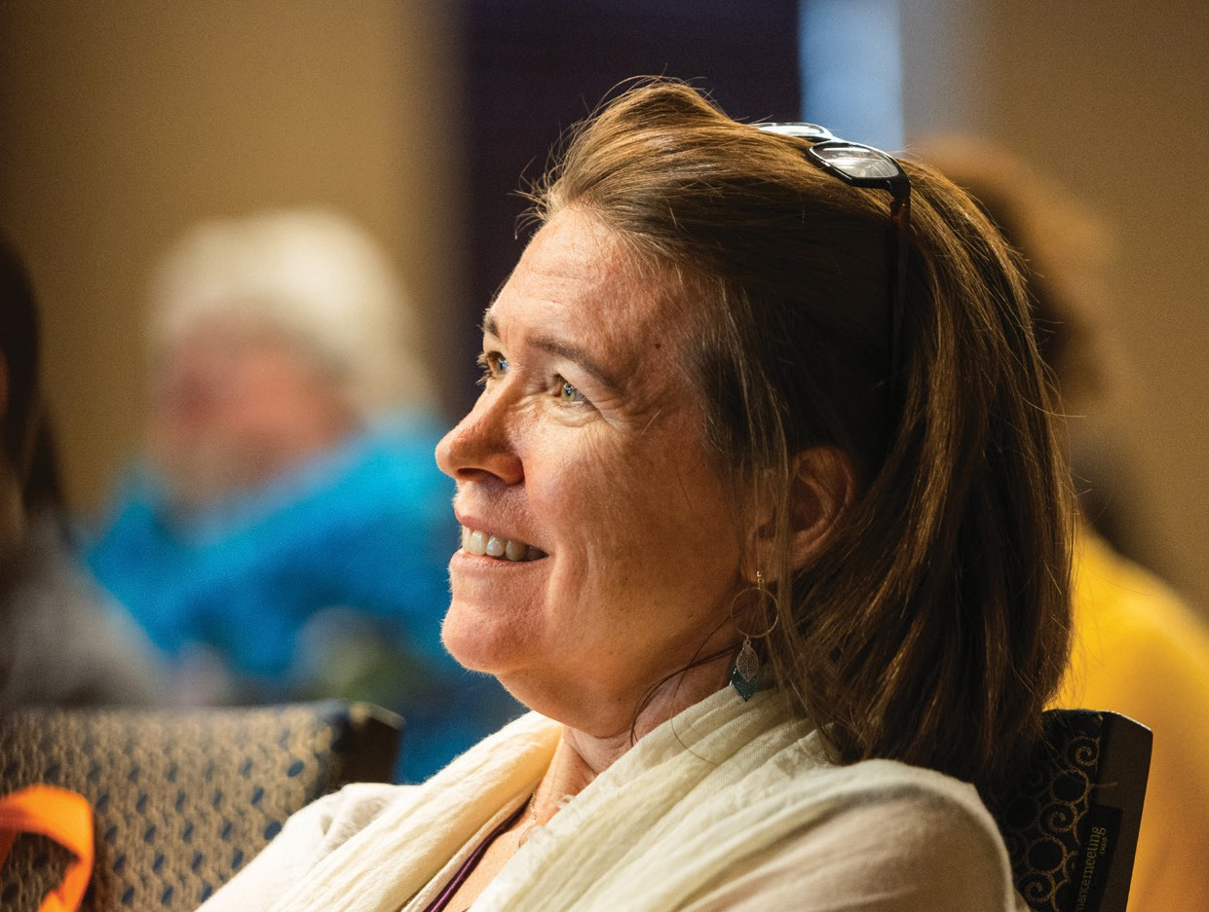



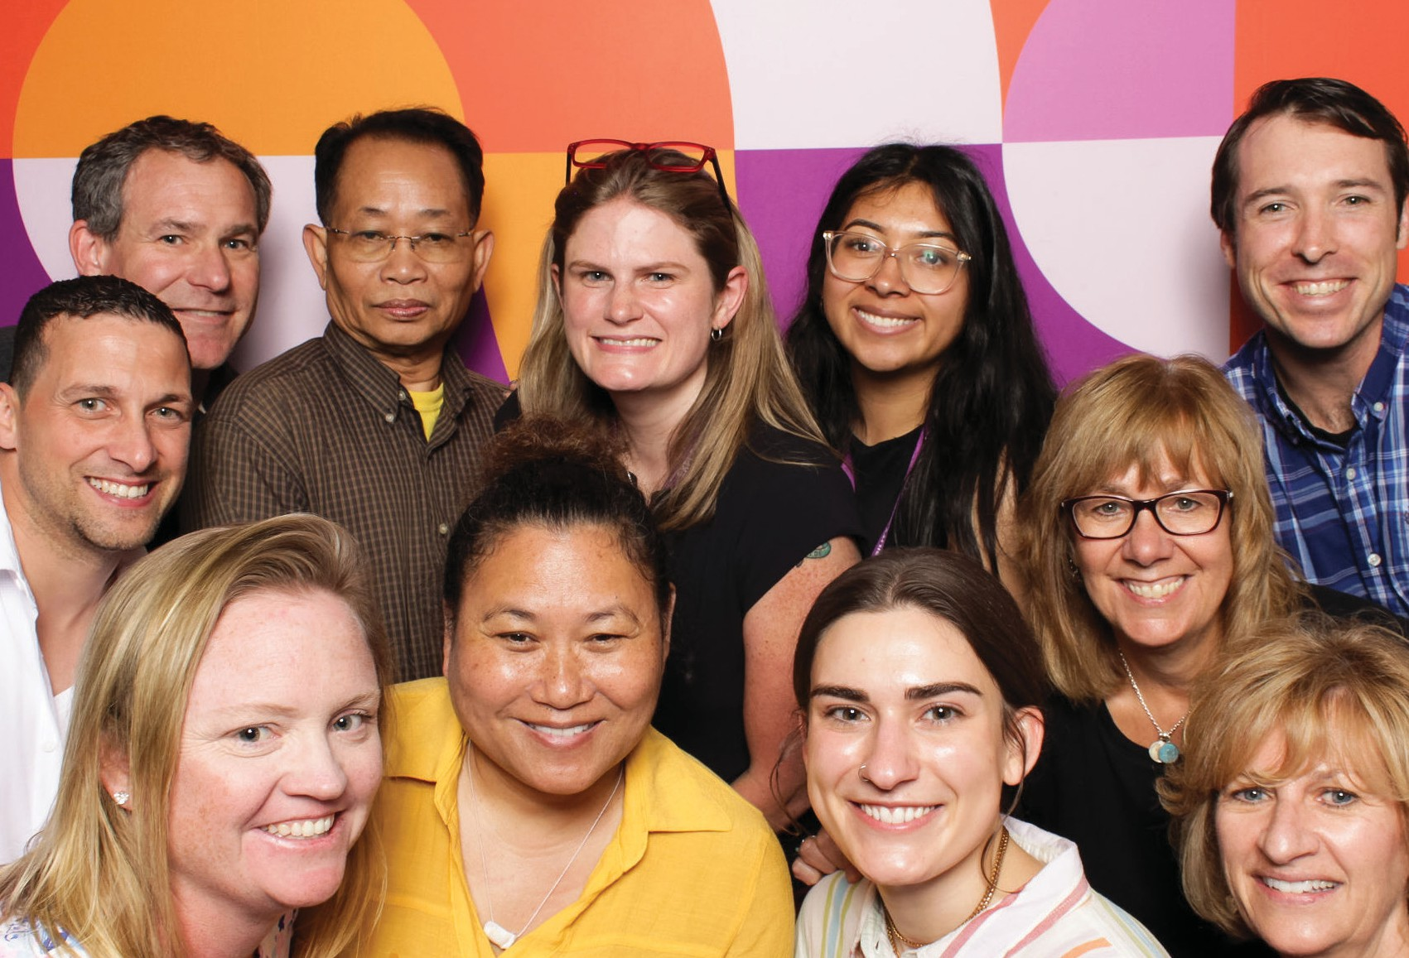
8 State Rehabilitation Council 9

Career Services YEAR IN REVIEW JULY 1, 2022 - JUNE 30, 2023

1.9% Neurological
Disabilities

1.6% Traumatic
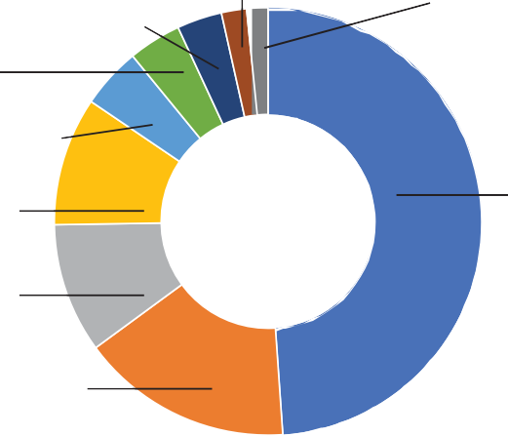
Brain Injury

3.4% Other Disabilities
4% Developmental/ Intellectual Disabilities
KEY FACTS
2,823 jobseekers with disabilities have been successfully placed into competitive employment based on their choices, interests, needs and skills.
The earnings of these successfully placed employees in MA in the first year were
$75.6 million.
Estimated public benefits savings from people rehabilitated in MA were $21.2
million.
Average Hourly Wage: $18.73
Average Work Hours Weekly 27.5
* The returns to society based on increases in lifetime earnings range from $14
to $18 for each $1 invested in the MRC Vocational Rehabilitation program.
* $5 is returned to the government in the form of increased taxes and reduced public assistance payments for every $1 invested in the MRC Vocational Rehabilitation program.

4.6% Deaf and Hard
of Hearing
9.7% Substance
Abuse

9.8% Orthopedic
Disabilities

Learning Disabilities
16%

48.8% Psychiatric
Disabilities

1.3% Chose not
to Identify

P AR TICIP ANTS
Average age at application: 33.4

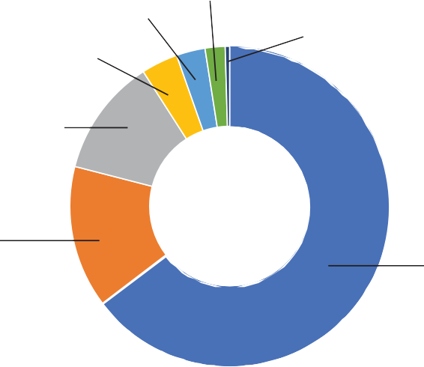
3.3% Asian/Pacific Islander
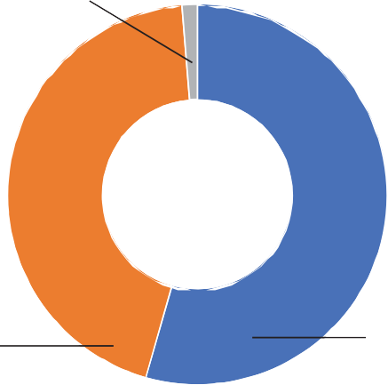
4.2% Chose not
to Identify

13.5% Hispanic/
Latinx

16.3%
Black/African American

2.3% Multiracial

.5%
Native American

73.3%

*Based on Commonwealth Corporation Study

44.3%
Female

GENDER

54.4%
Male

RA CE
White

10 State Rehabilitation Council 11
New referrals: 10,213
Applicants: 7,783
Jobseekers actively receiving services: 21,704
Participants enrolled in training/education programs: 16,026
Placements Leading to Successful Employment Outcomes: 86.5%
Participants employed with medical insurance: 99.4%



Executive Committee
Chairperson: Inez Canada
This Committee guides the goals and prior- ities for the Council’s work, facilitates deci- sion-making for the administrative functions of the Council, and liaises with the MRC Executive leadership team to ensure the Council receives the necessary informa- tion and resources from the agency to offer meaningful input and advice to the voca- tional rehabilitation division of MRC.

This year, the Executive Committee con- tinued its work to bring the SRC and its members into compliance with the federal and state requirements for the advisory body and its members. With the help of our new Administrative Support staff, the SRC has begun to document, organize, and track essential processes and mandates.
This foundation has provided a framework for the SRC’s current operations and will
encourage growth so that successors can continue building a more effective Council of influential advisors for the MRC vocational rehabilitation division.

The Executive Committee did not take the lead on any recommendations this year.

MRC will collaborate with SRC to identify, recruit, and engage more jobseekers and stakeholders from specific backgrounds, groups, and organizations required by federal regulations, including Un-served/ Under-served communities, individu- als with disabilities, and businesses.
Business and Employment Opportunity Committee Chairperson: Steve LaMaster
The SRC Business and Employment Oppor- tunity (BEO) Committee is responsible for re- viewing, analyzing, and providing guidance to the MRC on methods and best practices for employment and employment services.

Support employment of individuals with disabilities in the Common- wealth by promote awareness of the MassCareers opportunities, such as notification of the CILs, Rehabilitation Vendors, and sharing information with organizations like Work Without Limits and the Association for People in Supported Employment.
The committee reviewed an article cited in a CSAVR newsletter that discussed meth- ods to enhance competitive integrated employment (CIE). A method the committee endorsed was state VR sharing information with employers about the business benefits of hiring people with disabilities, to further encourage hiring of people with disabilities. There are six advisory employer boards across the Commonwealth distributed geo-
graphically. MRC has used these boards to showcase participants’ skills and resumes. MRC did an outreach to individuals who attended the employer board events and found that approximately 800 people have achieved employment.

About 100 employers contact MRC with open positions before posting, the num- ber varies month to month. The committee recommended gathering comments from the employers who use MRC and develop a campaign to reach out to other employers.

Increase availability and accessibility of SRC materials online and develop a robust communications, marketing, and branding strategy for SRC. Con- tent review SRC E-brochure and flyer.
MRC worked with feedback generated by the committee to develop two resources which can be used to share information about the work of the SRC and ways to become involved. MRC’s Communications Department drafted the e-brochure and flyer, shared them with the committee for feedback, and have made them available in final form.

Develop a baseline understanding of self-employment, review state and national data trends (to assist with determining the scope of the effort), and assess VRS-E resources (e.g., the University of Montana Rural Institute on Inclusive Communities; potential adaptation, and training for MRC VR staff.
In October 2022 the Committee discussed MRC Self-employment Data, noting that Worcester and Greenfield areas had signifi- cant rates of success over other areas of the state (10% and 19% respectively of success- ful closures in self-employment). Numbers of people achieving successful self-em- ployment across the remaining 17 MRC sites were lower by comparison, averaging 4.14% successful closures.

Greenfield’s site was noted as featuring mentoring to get a business up and running.
A small group from the committee met with an MRC representative and learned that often MRC Counselors lacked training and capacity to meet the needs for people with self-employment goals because such knowledge falls outside the scope of their required vocational licensing requirements. VR counselors must initiate learning oppor- tunities independently to help a participant with a self-employment goal. Even if they
are willing, most counselors lack the capac- ity to learn about self-employment because they manage large caseloads.
A Client Assistance Program (CAP) advo- cate that attends BEO meetings shared that CAP has helped participants seeking self-employment help from MRC and often find that they are not being offered a busi- ness consultant to guide them through the self-employment process. When they are sent to a consultant, it is often very difficult to course correct. CAP noted that consul- tants should be offered in the beginning to


12 State Rehabilitation Council 13
C O M M I T T E E
R E P O R T S
2 3

help a participant under self-employment, the time it takes to build a self-sufficient business, and to help the participant draft a practical business plan. Also, one of the two consultants with which MRC contracts
was not equipped to assist a client CAP was working with because the consultant’s main contract was for tutoring. Finally, our CAP, as well as CAP programs in other states, have found that SCORE (SBA business mentors) are not adept at working with individuals with disabilities.

Jobseeker Satisfaction & Needs Assessment Committee
Chair: Ronaldo Fujii, MD PhD
The Jobseeker Satisfaction & Needs As- sessment Committee ensures jobseeker perspectives are included in the process of evaluating MRC vocational rehabilitation
services. During the fiscal year, the Commit- tee members collaborated to improve the MRC service experience survey tool analysis and made efforts to recruit new members to the council.

Service Experience Survey Tool
The Committee actively reviewed the survey results and analyses methods and proposed additional assessments aiming at improving the visibility and understanding of underserved, black, indigenous and people of color, along with different ethnical groups to issue recommendations to address their specific needs related to vocational rehabil- itation.

Recruitment
The Committee invited members of the so- ciety with technical and scientific expertise to be recruited to the SRC while considering our diversity and inclusion principles. Such individuals would be essential to ensure the
close collaboration with MRC to improve methods, identify gaps and propose solu- tions to improve vocational rehabilitation access to underserved communities.

Policy Committee
Chairperson: Naomi Goldberg
The SRC Policy Committee reviews and an- alyzes Vocational Rehabilitation (VR) policies and procedures to ensure service delivery aligns with federal and state VR regula- tions and policy guidance. The Committee recommends revisions to and the develop- ment of policies that help jobseekers bet- ter understand the VR process and what is necessary to attain competitive integrated employment. Also, it recommends changes to policies to fix systemic matters as appro- priate. Finally, the Committee periodically reviews and recommends updates to the Council Bylaws.

For FY23 the SRC tasked the Policy Com- mittee with two specific recommendations.
The first was to develop SRC orientation materials focused on understanding the role of the SRC and the basics of vocational rehabilitation. The intent behind this recom- mendation was to provide SRC members with information that would assist them in performing their advisory role. The second recommendation was to create information- al materials for jobseekers that explain the basics of the VR process in clear and un- derstandable language. This recommenda- tion was made with an understanding that jobseekers with disabilities often struggle to understand how to navigate the vocational rehabilitation process and what they should expect and often this delays their services from progressing.

Developing SRC Orientation Materials
During the first half of FY23 the committee focused its efforts on developing content that serves to educate SRC members on both the role of the SRC and the basics of vocational rehabilitation. The ultimate goal of these efforts is to help SRC members bet- ter understand their advisory role and the topic on which they are advising.

The committee spent time gathering and reviewing available content on the subject of SRC and vocational rehabilitation from a range of agencies and organizations with this expertise. While the committee under- stood that the topic of vocational rehabil- itation with its various regulations can be complicated, all recognized the critical im- portance of making sure that the materials selected would strike a balance between offering thorough explanations and making sure the language used would be clear and not overly complicated.

The materials that the committee select- ed in the end included a document that provides a brief overview of vocational rehabilitation services and the duties of the SRC as well as a video that provides a more


detailed overview/training of vr basics. The information was forwarded to SRC members and participants for review and can be used going forward as part of an orientation cur- riculum for new SRC members.

C O M M I T T E E
R E P O R T S
2 3
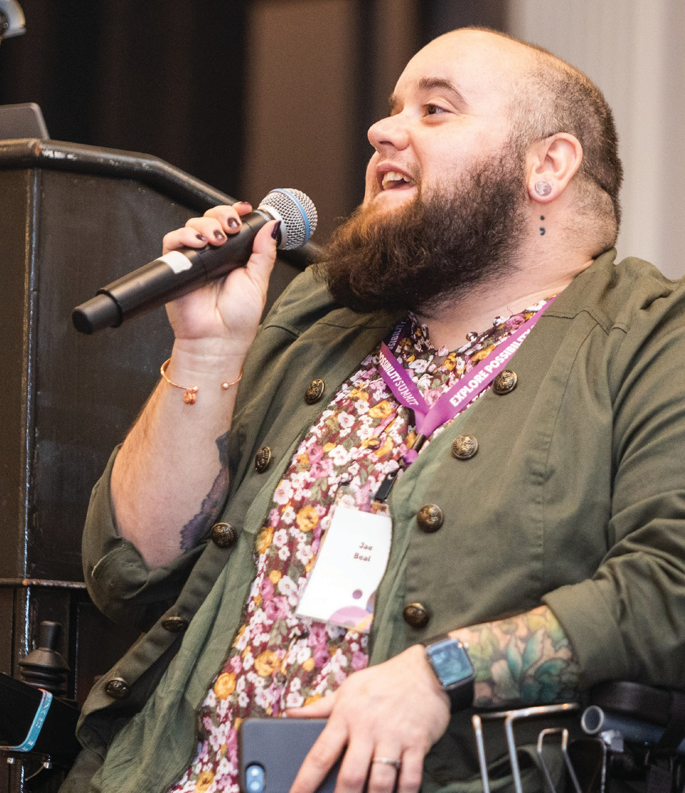
14 State Rehabilitation Council
Create informational materials (e.g., fact sheets) for jobseekers that ex- plain the basics of the VR process in clear and understandable language.
The Policy Committee began this project with an understanding that VR services are individualized and therefore can be com- plicated to explain. With that in mind the committee sought to identify important VR topics that are confusing for jobseekers and would require written explanations using clear and simple language. The ultimate goal of the project was to educate jobseek- ers about the services they are receiving, as well as their rights and obligations so that the services are more effective.
15


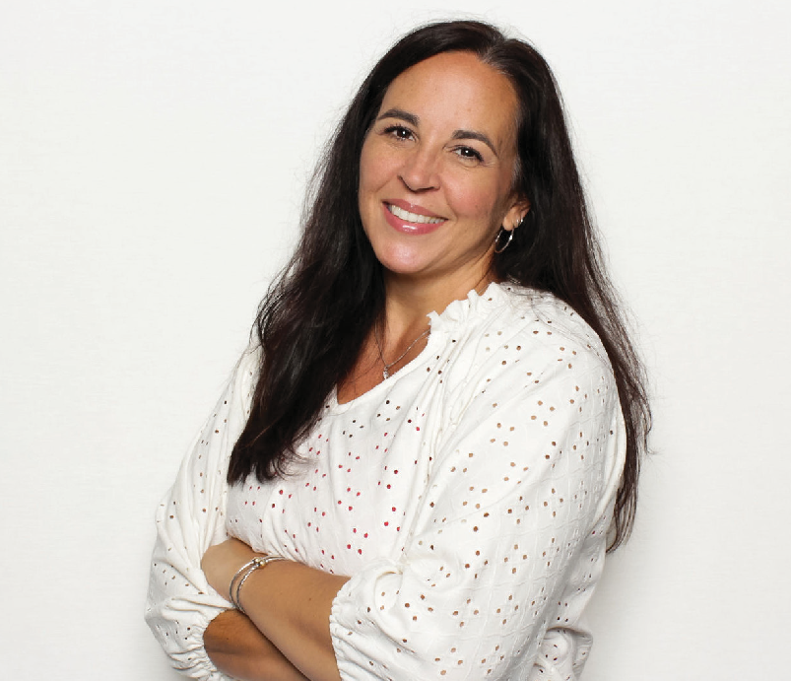
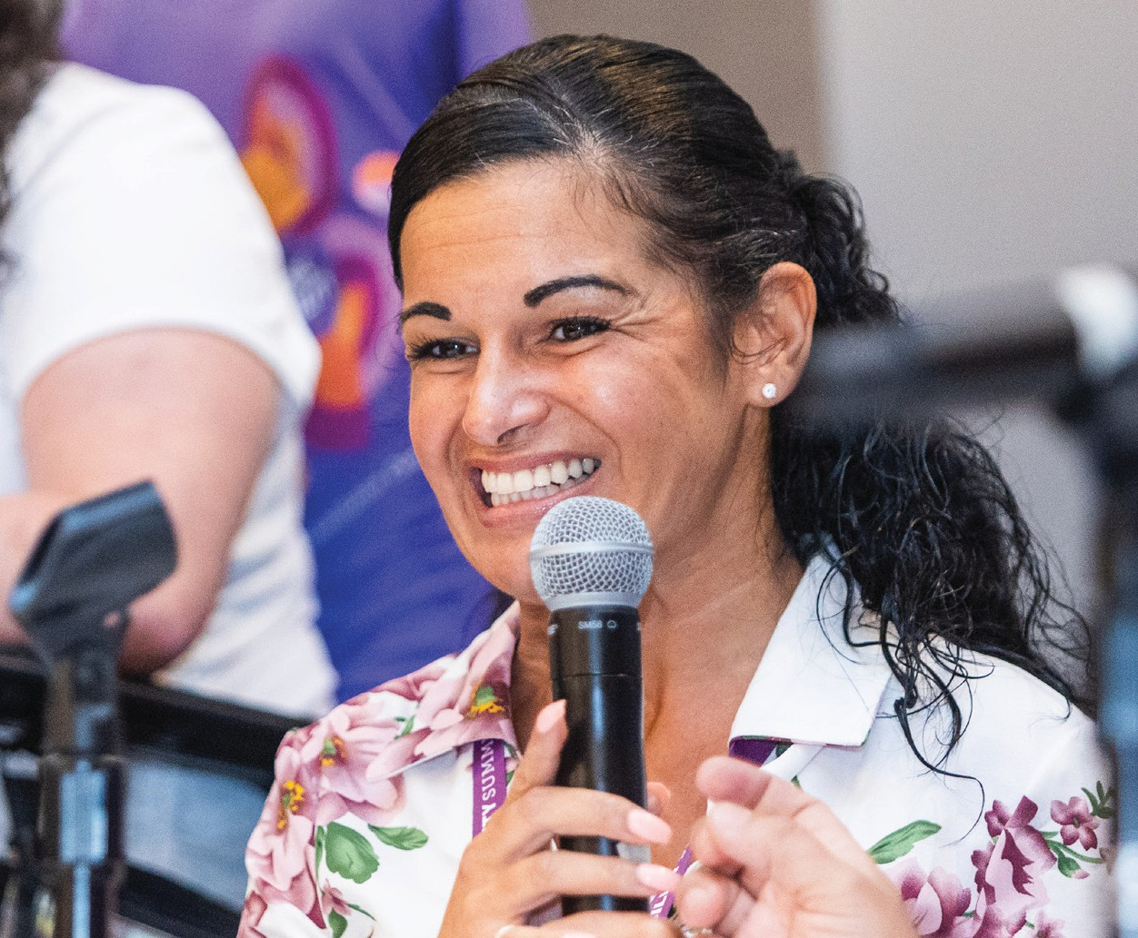
Supported Committees through the SRC Recommendation Process
During the FY23 State Plan Committee meetings, committee members reviewed and responded to Massachusetts Rehabili- tation Commission’s responses to the FY23 SRC Recommendations. The committees, in partnership with MRC, worked on their assigned recommendations throughout the year. The committee members appreciated the support given by MRC’s staff liaisons.
Each MRC liaison brought a wealth of infor- mation to the committees, which helped the members progress through their work.

The committee settled on three VR sub- jects for which it would create facts sheets in simple language; the Individualized Plan for Employment (IPE), financial policies, and due process. Over the course of several months, the committee drafted, reviewed, and revised three fact sheets. At the end
of FY23 the final versions of the three fact sheets will be shared with MRC for potential use with jobseekers.

Fair Hearing and Administrative Review Decisions
At the end of FY23 MRC began providing updates to SRC via the Policy Committee about appeals. This includes summaries of administrative review decisions, fair hearing decisions, as well as summaries of cases that have been settled. The summaries will provide enough information that will allow the reader to understand the basic dispute that led to the appeal and the decision with- out disclosing confidential information that would identify individual participants. The purpose of sharing the decisions is to give

the SRC a better idea of jobseekers’ experi- ences and an opportunity to track patterns of systemic problems if applicable.

Going forward, MRC will provide these sum- maries to the Policy Committee twice a year and that information will be shared with the wider SRC membership.

The State Plan and Interagency Relations Committee Chairperson: Joe Bellil
The State Plan and Interagency Relations Committee (State Plan Committee) ensures the SRC meets its obligations regarding in- put from jobseekers in the development of both the MRC public VR (vocational rehabili- tation) State Plan and the Workforce Innova- tion and Opportunity Act (WIOA) Combined State Plan.
In April of 2023, the Office of Learning and Community Engagement included an online opportunity for MRC participants and their families to provide input and recommenda- tions on how MRC vocational services could effectively support the disability community. The committee plans to continue finding new ways to engage jobseekers in the pro- cess of developing new recommendations.

Provided Input to the VR Section of the State Plan
The State Plan Committee met in May 2023 and reviewed all the submitted draft FY24

Recommendations. The committee then forwarded the final draft list of FY24 Recom- mendations to the Executive Committee for their review. The final FY24Rrecommenda- tions were submitted to MRC for their review and response.

The Executive Committee requested that each person who submitted a recommen- dation provide responses to the following questions during the SRC June Quarterly Meeting: What problem does this recom- mendation aim to solve or what issue does it seek to address? How does this recom- mendation contribute to achieving “com- petitive and sustainable employment for all
people with disabilities,” as stated in the SRC mission, and what is its intended value and purpose in relation to vocational rehabilita- tion? What are the expected outcomes or deliverables of this recommendation, and what impact is it expected to have?
The State Plan Committee is enthusiastic about continuing discussions on enhanc- ing the recommendation process to ensure alignment with DEIA (Diversity, Equity, Inclu- sion, and Accessibility) principles.

16 State Rehabilitation Council 17
C O M M I T T E E
R E P O R T S
2 3

SRC will continue to actively partner with the MRC in the interpreta- tion of survey data and strategies for develop- ing different channels for collecting feedback and disseminating of findings and associated actions taken and the SRC will actively part- ner with the MRC in the interpretation of survey data and strategies regarding dissemination.
Responsible SRC Committee: Customer Satisfaction /Needs Assessment Committee

The SRC will work with the MRC to develop a mechanism and timeline for engagement of Business and Employment Opportunity Commit- tee members during the implementation of the Disability Employment Tax Credit marketing campaign.
Responsible SRC Committee: Business and Employment Opportunity Committee
The SRC will
work with the MRC to assess and potentially enhance current strategies and mechanisms to support Job Seekers in pursuing
self-employment vocational goals.
Responsible SRC Committee: Business and Employment Opportunity Committee

The SRC will collaborate with the MRC to
identify, recruit, and engage more MRC Job Seekers and other stakeholders for SRC membership from specific backgrounds, groups, and organizations required by federal regulations, including Un-served/ Under-served communities, individuals with disabili- ties, and businesses
Responsible SRC Committee:
Executive Committee

SRC FY24 RECOMMENDATIONS

18 State Rehabilitation Council 19

B E V E R L Y B R E W I N G T O N
Pursuing a Career Full of Purpose
life-long resident of Boston, Beverly Brewington recognizes that her career journey has not been the same as oth- ers. She reached out to the Massachu-
setts Rehabilitation Commission (MRC) in 2004 when she started studying for a career in food preparation. Twenty years later, she pivoted her career goals to acquire a degree in psychology and focus her professional life on helping those who have survived domestic abuse and sub- stance use. She wants to be an advocate for them to fulfill their dreams and reach their full potential, despite their past.
A

Beverly’s story is painful and inspirational as she has contin- ued to fight against the odds to achieve her career goals. A phys- ical confrontation resulted in a head injury that caused her to be legally blind. Lying in a hospital bed, doctors told her she would not be the same and would have to relearn how to talk, walk, and other things she had taken for granted.
“I’ll be the first one in my
immediate family to earn
a college degree.”

But that did not deter the former scholastic athlete. A testament to her perseverance and resil- ience, Beverly set a goal to finish high school while navigating
the challenges of her new life. “They wanted to put me in a GED program, and I said no,” Beverly
remembered. “A GED is not a diploma; I wanted to say I graduated from high school.” Beverly did just that.

That’s when she began looking for a path toward a career she would love. In 2004, she enrolled in Bunker Hill Community College (BHCC) to study food preparation. During this time, she partnered with MRC to help her pay for tuition, books, and find tutoring services. Beverly chose food prepa- ration because she loves to nourish people. “Food brings people together,” she laughed. “I love cooking. I’ll go to restaurants and come back home and try to imitate what I had and put my little twist on it.”
And as much as Beverly loved learning and earn- ing credits toward her degree in food service, she couldn’t help but feel this wasn’t her purpose. “It was something inside of me, and I felt like I was meant to help people,” she reflected. “I want to help people who have been through similar situa- tions as myself, and this is my calling.”

She changed her field of study from food prepa- ration to psychology. She was determined to stay on track to graduate in 2024, even if that meant doubling up on coursework during future semes- ters. But Beverly isn’t afraid of hard work or asking for help when she needs it. “Yes, it’s challenging.
But I’m doing it!” she said. “This is where I’m supposed to be.”

Since Beverly started working towards her degree, MRC has been instrumental in providing her with support, services, and resources. MRC has equipped her with a computer and con- nected her with services that have facilitated a conducive learning environment, enabling her to excel in her academic pursuits. “If I know I need some- thing, I’m not accepting no as an answer. We all need help. But if you don’t ask for help, you’re not going to get it.”

Her MRC counselor, Desiree Etienne, has been a part of her
journey during the past few years. “I trust De- siree,” Beverly shared. “It has been great working with Beverly. She is a big advocate for herself,” said Desiree. “She is a goal-oriented person and through it all she strives every day to be the best version of herself.”

Beverly looks forward to 2024 and earning her psychology degree from BHCC. “I’ll be the first one in my immediate family to earn a college de- gree,” she shared. “And I’m going to invite every- one for a graduation party and cook for everyone. To say thank you.”


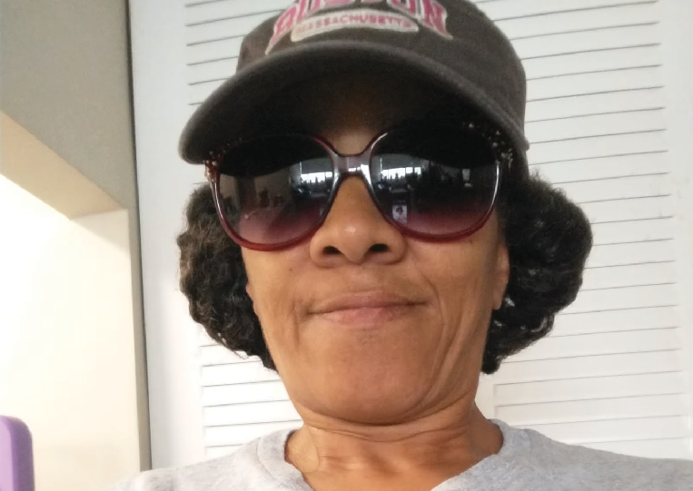
20 State Rehabilitation Council 21

Building Community Through Collaboration


MRC has embarked on a new initiative to provide resources to young adults with disabilities whose transition services were impacted by the COVID-19 pandemic. Working alongside the Department
MRC AND DTA CO-LOCATIONS
- Malden
- New Bedford
- Pittsfield
- Southbridge
- Taunton
- Worcester

MRC AND DDS CO-LOCATIONS
- Braintree
- Fall River
- North Adams

MRC, DTA, AND DMH CO-LOCATIONS
- Hyannis
- Salem
- Springfield

MRC, DTA, DMH, AND DDS CO-LOCATIONS
- Fitchburg
- Lawrence

MRC, DMH, AND DDS CO-LOCATIONS
- Lowell
- Plymouth
23
A G E N C Y C O L L A B O R A T I O N S
of Elementary and Secondary Education (DESE), the Department of Disability Services (DDS), the Massachusetts Commission for the Blind (MCB), the Massachusetts Inclusive Concurrent Enrollment Ini-
tiative (MAICEI), and the Federation for Children with Special Needs, the Coordinated Pandemic-Related Transition Services Project’s goal is to reach out to individuals with disabilities that turned 22 between March 10, 2020 and September 1, 2023 and were transitioned out of high school without a proper handoff to adult services.

Collaboration works.
That’s why we partner with sister agencies, employ- ers, and jobseekers to find solutions that have a real impact in people’s lives.

State agencies have discovered one of the best ways to partner to serve the people of the Commonwealth is to create a space where people can receive multiple services in one place. MRC has a number
of co-located office sites where participants seeking our services also have access to a number of sister agencies, including the Department of Mental Health (DMH), the Department of Transitional Assistance (DTA), and the Department of Developmental Ser- vices (DDS).

Sharing a location with these agencies is not an ex- periment; it’s vital to the people we serve. MRC’s rela- tionship with each agency is essential as we work to break down barriers for people to live independently. Our goal is to build and strengthen relationships, and that has been at the heart of the Adult Community Clinical Services (ACCS) Employment Partnership with the Department of Mental Health (DMH) and
the Empowering to Employ joint initiative with the Department of Transitional Assistance.
Through our ACCS partnership, mental health spe- cialty qualified rehabilitation counselors work with DMH clients to explore their career interests, access

their needs, and determine the best pathways to en- sure successful integrated competitive employment. Our partnership, which began in July of 2019, is now firmly established across the Commonwealth with our 26 specialty mental health counselors working collaboratively with their DMH colleagues to ensure employment is possible for those living with serious mental health conditions.

One of the benefits of this program is that it moves at the pace of the job seeker. ACCS staff introduces MRC to individuals when they are ready to pursue career support. They meet with a Mental Health Counselor to learn about the services provided and explore what kind of careers they are interested in. And because the job seeker is already receiving ACCS services, it allows them to move faster through MRC’s intake process, becoming eligible for services and finding positions that best fit them. To date, there have been more than 1,100 job placements.
The Empowering to Employ maximizes opportunities for individuals with disabilities receiving Transitional Aid to Families with Dependent Children (TAFDC).
The shared vision of the partnership is to use a jointly funded model of engagement and co-case man- agement to provide individualized and meaningful services leading to sustained employment, econom- ic independence, and family stability for DTA clients with disabilities.
COVID-19 disrupted education for all students, but it hit students with disabilities in some areas especially hard. Working together with strategic
initiatives like this, these agencies work together to find communities hit the hardest by the pandemic to provide support and resources, who may not traditionally receive vaccine equity. Specifically, MRC offers resources to those seeking additional education, training, and job placement through traditional employment exploration or the NextGen Careers program.

Creating Economic Opportunity Through Community College Partnerships
Together with Holyoke Community College, Rox- bury Community College, and CISCO, the agency launched its Technology Academy. In its third year, the program offers students with disabilities the opportunity to earn a cyber-security certificate and real-world experience as information technology (IT) support professionals. More than 93 students have graduated from the program, and many have entered into a life-changing career path.

MRC recognizes that the best way to reach job seekers with disabilities is to create strong part- nerships with public and private organizations. The more people we can reach, the more people are aware of the opportunities available to them to find their best path toward career success..

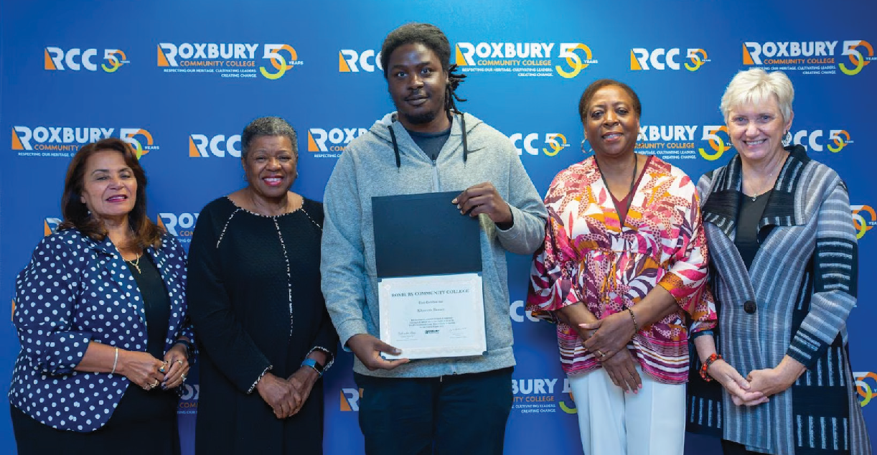

22 State Rehabilitation Council

“We envision a world where all individuals with disabilities are supported to live their best lives.”

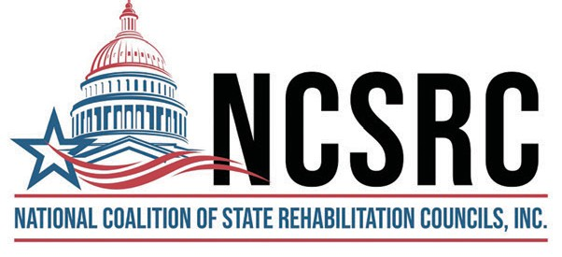
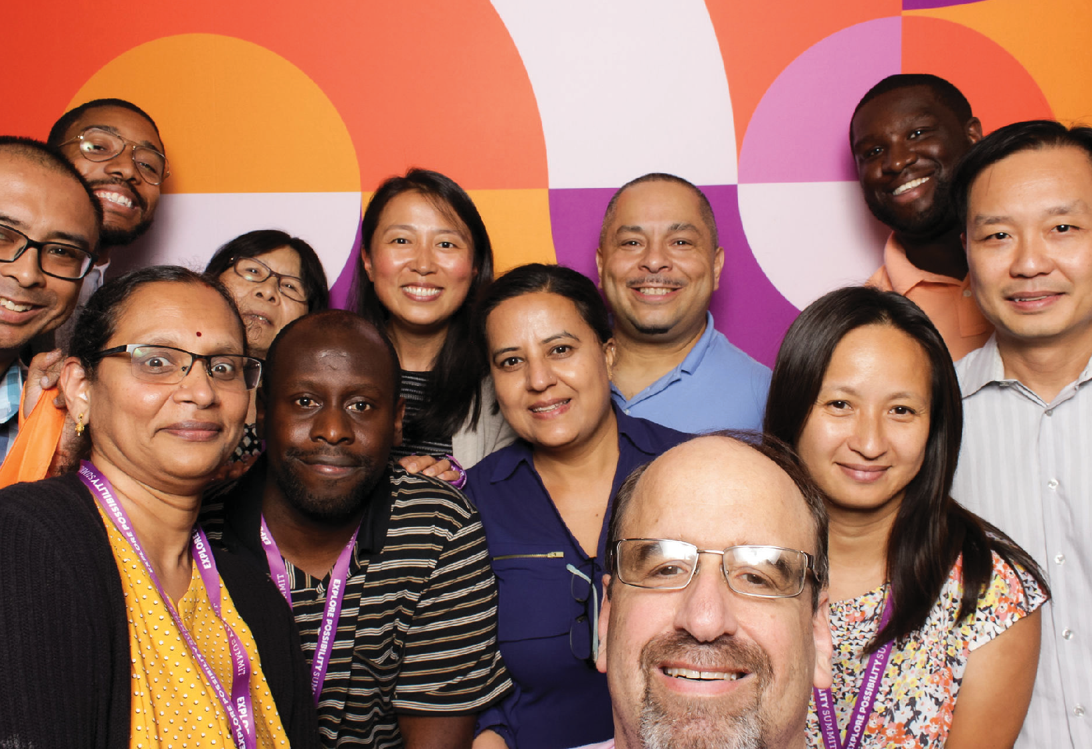
Massachusetts Rehabilitation Commission Statewide Rehabilitation Council
600 Washington Street, Boston, MA 02111 | Phone (617) 204-3600
www.mass.gov/mrc/src | MRC.StateRehabCouncil@MassMail.State.MA.Us

