The Commonwealth of Massachusetts

Executive Office of Health and Human Services

Department of Public Health

250 Washington Street, Boston, MA 02108-4619



KATHLEEN E. WALSH

Secretary

ROBERT GOLDSTEIN, MD, PhD Commissioner

**Tel: 617-624-6000**

**www.mass.gov/dph**

MAURA T. HEALEY

Governor

KIMBERLEY DRISCOLL

Lieutenant Governor

**Results from a Study of PFAS in Deer**

**at Select MassWildlife Bio-check Stations on Cape Cod**

April 18, 2025

**Summary**

* In November and December of 2023, the Massachusetts Department of Public Health (DPH) and the Massachusetts Division of Fisheries and Wildlife (MassWildlife) collaborated to test for PFAS in deer muscle tissue harvested on Cape Cod.
* 33 hunter-harvested deer from Cape Cod were tested for PFAS; only 3 deer had detectable levels, all below the limit of quantification.
* Based on these results, DPH concluded that typical consumption of muscle tissue from deer harvested on Cape Cod is not a public health concern. Thus, DPH is not recommending that people limit consumption of deer harvested on Cape Cod.

**Introduction**

This data brief provides an overview of the sampling and analysis of deer muscle tissue evaluated for per- and poly-fluoroalkyl substances (PFAS), a group of structurally similar synthetic chemicals resistant to heat, water, and oil. PFAS have been used for many years in various industrial processes and consumer goods, including aqueous fire-fighting foams, carpets, waterproof clothing, upholstery, food packaging, personal care items, and metal coatings. PFAS do not readily break down in the environment and can persist in soil and water indefinitely.

Because of their historical use, and persistence in the environment, nearly all people are exposed to PFAS. Perfluorooctanoic acid (PFOA) and perfluorooctane sulfonate (PFOS) have been the most extensively produced and studied of these chemicals. The most consistent finding in studies of humans exposed to elevated levels of PFAS is increased cholesterol levels. Additional effects in humans include increased risk of high blood pressure or pre-eclampsia in pregnant people, decreased infant birth weight, decreased antibody response to vaccines in children, and increased liver enzymes. Studies in humans also suggest that PFOA may increase the risk of kidney and testicular cancer, and that PFOS may increase the risk of liver cancer. PFAS may also be present in livestock and poultry that drink water with elevated levels of PFAS and can build up over time in the tissues of fish and wild game.

In November and December 2023, DPH, in collaboration with MassWildlife, collected samples from muscle tissue of deer harvested by licensed hunters at select deer bio-check stations on Cape Cod. Because the samples collected by DPH were convenience samples, and limited in number, the results were not intended to be generalized statewide. Rather, the results from this limited study were intended to inform DPH as to whether future evaluations of PFAS in deer are warranted. This data brief provides an overview of the methods, data evaluation, and results of this study.

**Sampling Methods**

DPH targeted sample collection for the first week of the deer shotgun season from three pre-determined bio-check stations in Wildlife Management Zone 12 (Cape Cod) in collaboration with MassWildlife. DPH did not target samples of a specific age or sex of deer, but rather, collected convenience samples[1] (also known as grab or opportunity samples) of deer muscle tissue.

MassWildlife staff extracted deer muscle samples according to procedures outlined in DPH’s Sampling Plan[2], which was designed with input from MassWildlife. No deer organs were collected as part of the study.

Table 1 lists the bio-check stations, municipality, Site ID, the number, and type of samples collected at each station, and the sampling dates.

**Table 1. Details of Deer Sampling at MassWildlife Bio-check Stations on Cape Cod**

|  |  |  |  |  |  |  |  |
| --- | --- | --- | --- | --- | --- | --- | --- |
| **Bio-Check Station** | **Municipality** | **Site**  **ID** | **# of Muscle Tissue**  **Samples** | **# of Field**  **Duplicate**  **Samples** | **# of**  **Equipment**  **Blanks** | **# of Field**  **Blanks** | **Sampling**  **Dates** |
| Goose Hummock Shop | Orleans | A | 11 | 1 | 1 | 1 | Nov 27 – 30 |
| Riverview Bait & Tackle | South Yarmouth | B | 11 | 1 | 1 | 1 | Nov 27 – 29 |
| Joint Base Cape Cod | Bourne | C | 11 | 1 | 1 | 1 | Dec 4 |

DPH collected 12 deer tissue samples at each of the three MassWildlife bio-check stations, including 11 primary samples and 1 duplicate sample. To demonstrate the overall integrity of the samples and sampling process, the sampling team collected the following quality control (QC) samples:

* One equipment blank from the field equipment used to collect the deer tissue sample, to verify that PFAS contamination was not introduced by field sampling equipment.
* One field blank to verify that PFAS contamination was not introduced from the sampling environment during field activities. The field blank consisted of a sample of tinfoil handled in the same manner as the field samples.
* One trip blank was included in the shipment cooler to verify that PFAS contamination was not introduced by shipping and handling procedures.

**Data Evaluation**

SGS AXYS Analytical Services (SGS AXYS) (British Columbia, Canada) analyzed the DPH samples, using SGS AXYS Method MLA-110 Rev. 02 Ver. 08, which targets all 40 PFAS compounds from EPA Methods 537.1 and 533.

All field and QC sampling data were validated by SGS AXYS and reported as complete and accurate in accordance with the laboratory quality assurance protocol. DPH evaluated the data according to Quality Assurance/Quality Control (QA/QC) metrics specified in DPH’s Standard Operating Procedures (SOPs)[3]. DPH determined that all data were complete and that overall program data quality objectives were achieved. Thus, DPH concluded that the data were valid and appropriate for evaluating and drawing conclusions.

**Results**

The 33 muscle tissue samples were from deer harvested by licensed hunters from 10 of 15 towns on Cape Cod. Hunters reported the approximate location where deer were harvested. The spatial distribution of the approximate location each deer was harvested from is presented in Figure 1. The 33 deer included 14 females and 19 males, in the following age classifications:

|  |  |
| --- | --- |
| **Age Classification (years)** | **Number of Deer** |
| > 0.5 – 1.5 | 3 |
| > 1.5 – 2.5 | 11 |
| > 2.5 – 3.5 | 5 |
| > 3.5 | 14 |

Of the 40 PFAS compounds analyzed, only PFOS was detected in samples of deer muscle tissue. Of the 33 deer samples, PFOS was detected in three samples (one sample at each bio-check station) at concentrations ranging from 0.108 to 0.147 ng/g. All three detected concentrations were “J” qualified (i.e., concentration reported as “less than the limit of quantification [LOQ]” as defined by the laboratory) and, therefore, considered valid for interpretation by the laboratory.

One other PFAS compound, N-ethyl perfluorooctane sulfonamidoethanol (NEtFOSE), was reported by the laboratory in 26 deer samples. All the NEtFOSE concentrations were “K” qualified, with the concentration reported as “peak detected but did not meet quantification criteria” as defined by the laboratory and, therefore, considered invalid for interpretation by the laboratory. Per the laboratory definition, the “K” qualifier indicates the sample result is potentially biased. The laboratory stated that interference masked the ability to identify chemical markers and that values with the “K” qualifier have a high level of uncertainty in the presence of the reported values. Due to this uncertainty, the NEtFOSE “K”-qualified data are considered unreliable and invalid for evaluation.

Table 2 presents the individual sample results for detections of PFOS in deer muscle tissue.

**Table 2. Detections of PFOS in Deer Muscle Tissue Samples**

|  |  |  |  |  |  |
| --- | --- | --- | --- | --- | --- |
| **Bio-Check Station** | **Town Harvested** | **Deer Sex**  **(Male/Female)** | **Deer Age**  **(yrs)** | **PFOS**  **(ng/g)** | **Q** |
| 113023-DPH-A-11 | Eastham | Female | 2.5 | 0.147 | J |
| 120423-DPH-C-06 | Sandwich | Male | 1.5 | 0.131 | J |
| 112723-DPH-B-07 | S. Dennis | Female | 2.5 | 0.108 | J |

ng/g = nanograms per gram

Perfluorooctane Sulfonic Acid (PFOS) – Detected Compound

Q = Qualifier (laboratory assigned)

J = concentration less than limit of quantification

**Recommendations**

Given that only PFOS was detected in muscle tissue of only 3 of 33 deer sampled, and that the deer with detected PFOS were not harvested near each other, DPH determined that typical consumption of muscle tissue from deer harvested on Cape Cod is not a public health concern. Hence, DPH is not recommending that people limit their consumption of deer harvested on Cape Cod.

For individuals who may be concerned about potential exposure to PFAS from consumption of deer, DPH recommends:

* Reducing or avoiding consumption of internal organs (e.g., liver), which have been shown elsewhere to have higher PFAS concentrations than deer muscle.[4]
* Eating a balanced diet and consuming foods from a variety of sources.

Individuals who are concerned about their health related to PFAS exposure from consumption of deer and/or other sources, should consult with their primary care provider.

Because the samples collected by DPH in collaboration with MassWildlife were convenience samples and limited in number, the results of this study are not intended to be generalized statewide. Rather, the results were intended to inform DPH as to whether future evaluations of PFAS in deer may be warranted. Although sampling of PFAS in deer in other areas of Massachusetts is not currently planned, DPH will consider future sampling opportunities upon request, dependent on the availability of sufficient resources.

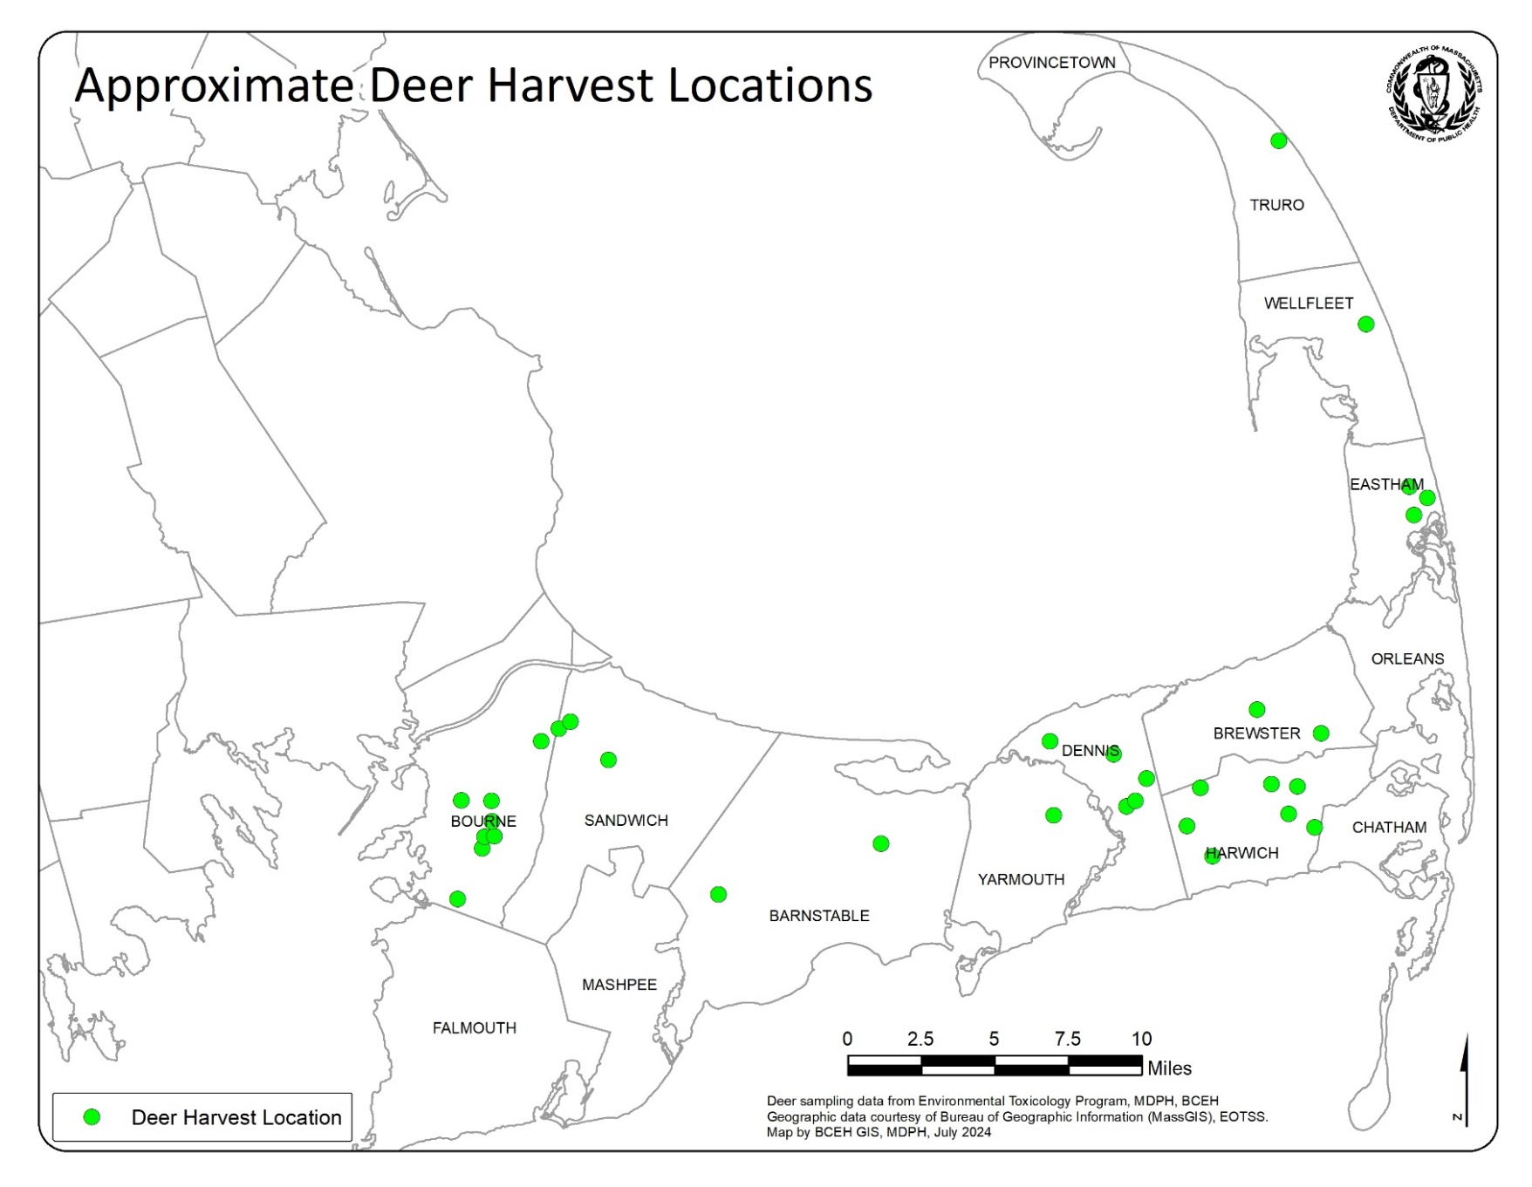**Figure 1. Spatial Distribution of Deer Tissue Samples on Cape Cod**

1. Convenience sampling is a type of non-probability sampling that involves the sample being drawn from that part of the population that is close to hand.
2. DPH Sampling Plan, Evaluation of PFAS in Deer, Select MassWildlife Deer Bio-Check Stations, updated December 2023
3. DPH Standard Operating Procedures, Sampling for Emerging Contaminant Analysis, January 2022
4. |  |
   | --- |
   | [www.wildlife.state.nh.us/hunting/deer-pfas.html](http://www.wildlife.state.nh.us/hunting/deer-pfas.html) |
   | [www.maine.gov/ifw/docs/Maine%20PFOS%20Deer%20Study%20Report%202.8.22_FINAL.pdf](http://www.maine.gov/ifw/docs/Maine%20PFOS%20Deer%20Study%20Report%202.8.22_FINAL.pdf) |
   | <https://widnr.widen.net/s/dnkq7g6ccz/2020-deer-liver-pfas-result-summary-final> |
   | [www.michigan.gov/pfasresponse/fishandwildlife/deer](http://www.michigan.gov/pfasresponse/fishandwildlife/deer) |

  