For Employers with a Private Plan - Instructions for Use

As a Massachusetts employer, you are required to inform your Massachusetts employees and covered contract workers about their rights and obligations under the Massachusetts Paid Family and Medical Leave (PFML) law. You may provide the appropriate form to your employees and covered contract workers by visiting PFML workforce notifications and rate sheets for Massachusetts employers.

In addition, you should complete this page to give to your employees with the notification. To complete, fill out:
- The check boxes on page 2 indicating where employees can find information on your private plan.
- The employer information chart on page 2 and the check boxes indicating what type of plan you provide.
- Private Carrier information on page 3, including the name of the plan, phone number, email, etc., and how to apply.

Note: these documents are provided in Word format for your convenience – for easier completion of fillable fields, minor formatting changes (such as the addition of a company logo), or additions about company-specific policies. Employers are responsible for any edits, revisions, additions, or deletions they make to these forms. DFML disclaims any responsibilities for modifications made to these forms that are inconsistent with the department’s requirements. DFML cannot guarantee that a form that has been modified from this original version will be compliant.

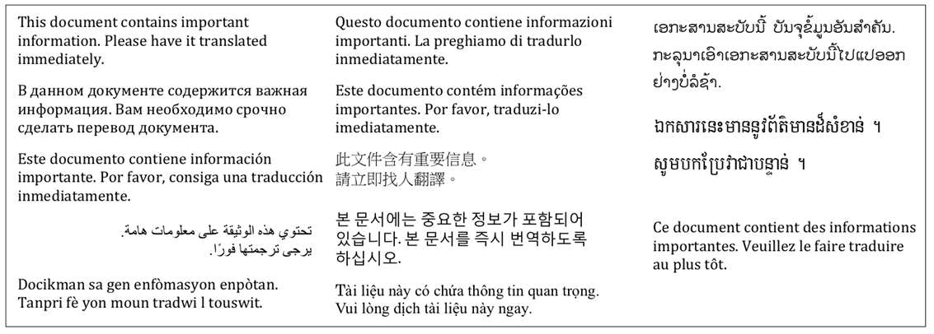
Employer Information

To apply for Paid Family and Medical Leave benefits, you will need the following information about your employer:

(Employer Name)
(Employer Street Address)
(Employer City, State, Zip)
(Federal Employer ID Number) (FEIN)

Plan Type Provided by Employer
An employer may apply for an exemption from the medical leave contribution, family leave contribution, or both. Your employer has elected to provide benefits as follows:

- Has an approved private plan for both family and medical leave benefits;
- Has an approved private plan for family leave benefits only, and is providing medical leave benefits through the DFML;
- Has an approved private plan for medical leave benefits only, and is providing family leave benefits through the Department.

Private Carrier Information
If any part of the PFML program is offered by a Private Carrier, provide the following information:
Private Plan Carrier Name:

Private Plan Carrier Contact Information for Informing Employees on How to File a Claim:

