

Massachusetts Department of Public Health

Bureau of Infectious Disease and Laboratory Sciences

Erin Mann, MPH  
Esther Rei, MPH  
Rashida Haye, MPH  
Petra Schubert, MPH  
Anthony Osinski, MPH  
Lindsay Bouton, MSc

305 South St.  
Jamaica Plain, MA 02130 Published: January 2025

2023

Viral Hepatitis Surveillance Report



**TABLE OF CONTENTS**

Hepatitis A 8

Figure 1. Number of confirmed hepatitis A cases by outbreak status, MA, 2014-2023 8

Figure 2. Number of confirmed hepatitis A cases by recorded sex or gender, MA, 2014-2023 9

Figure 3. Number and average rate of confirmed hepatitis A cases by age group, MA, 2019-2023 10

Figure 4. Number of confirmed hepatitis A cases by risk factors, MA, 2019-2023 10

Figure 5. Number and average rate of confirmed hepatitis A cases by county, MA, 2019-2023 11

Figure 6. Map of number of confirmed hepatitis A cases by county, MA, 2019-2023 12

Figure 7. Map of rate of confirmed hepatitis A cases by county, MA, 2019-2023 12

Figure 8. Number and age-adjusted average rate of confirmed hepatitis A cases by race/ethnicity, MA, 2019-2023 13

Hepatitis B 14

Acute Hepatitis B 15

Figure 9. Rate of confirmed acute hepatitis B in Massachusetts compared to the United States, 2014-2023 15

Figure 10. Number of confirmed acute hepatitis B cases by year, MA, 2014-2023 15

Figure 11. Number of confirmed acute hepatitis B cases by recorded sex or gender, MA, 2014-2023 16

Figure 12. Number and rate of confirmed acute hepatitis B cases by age group, MA, 2019-2023 17

Figure 13. Number and age-adjusted rate of confirmed acute hepatitis B cases by race/ethnicity, MA, 2019-2023 17

Figure 14. Number and rate of confirmed acute hepatitis B cases by county, MA, 2019-2023 18

Figure 15. Number of confirmed acute hepatitis B cases by country of birth, MA, 2014-2023 18

Figure 16. Number of confirmed acute hepatitis B cases by reported risk factors, MA, 2019-2023 19

Table 1: Acute hepatitis B and hepatitis C coinfection, MA, 2019-2023 20

Chronic Hepatitis B 21

Figure 17. Number of chronic hepatitis B cases by year, MA, 2014-2023 21

Figure 18. Number of confirmed and probable chronic hepatitis B cases by recorded sex or gender, MA, 2014-2023 22

Figure 19. Rate of confirmed and probable chronic hepatitis B cases by age group, MA, 2014-2023 23

Figure 20. Number of confirmed and probable chronic hepatitis B cases by race/ethnicity, MA, 2014-2023 24

Figure 21. Age-adjusted rate of confirmed and probable chronic hepatitis B cases by race/ethnicity, MA, 2014-2023 25

Figure 22. Number and rate of confirmed and probable chronic hepatitis B cases by county, MA, 2019-2023 26

Figure 23. Map of confirmed and probable chronic hepatitis B cases by city/town, MA, 2023 26

Figure 24. Map of rate of confirmed and probable chronic hepatitis B cases by city/town, MA, 2023 27

Figure 25. Map of confirmed and probable chronic hepatitis B cases, MA by city/town, 2014-2023 27

Figure 26. Map of average rate of confirmed and probable chronic hepatitis B cases by city/town, MA, 2014-2023 28

Figure 27. Number of confirmed and probable chronic hepatitis B cases by country of birth, MA, 2014-2023 29

Figure 28. Confirmed and probable chronic hepatitis B cases by country of birth for those known to have been born outside the United States, 2014-2023 30

Perinatal Hepatitis B 31

Figure 29. Outcomes of infants managed by the Massachusetts PHBPP, by birth cohort, MA, 2018-2022 31

Figure 30. Gestational parents enrolled in case management with Massachusetts PHBPP by race/ethnicity, 2022 birth cohort 32

Hepatitis C 33

Figure 31. Rate of acute hepatitis C cases in Massachusetts compared to the United States, 2017-2023 33

Figure 32. Number and rate of confirmed and probable hepatitis C cases by recorded sex or gender, age group, race and ethnicity, and county, MA, 2023 34

Figure 33. Map of rate of confirmed and probable hepatitis C cases by city/town of residence, MA, 2018-2023 36

Figure 34. Confirmed and probable hepatitis C cases by year, MA, 2016-2023 36

Figure 35. Number of acute hepatitis C cases reported by age and injection drug use risk, MA, 2016-2023 37

Table 2. Number of confirmed perinatal hepatitis C cases reported by year, MA, 2018-2023 38

Figure 36. Rate of confirmed and probable hepatitis C cases by age group and year, MA, 2016-2023 38

Figure 37. Map of rate of confirmed and probable hepatitis C cases ages 18-39 by city/town of residence, MA, 2018-2023 39

Figure 38. Number and rate of confirmed and probable hepatitis C cases by recorded sex or gender and year, MA, 2016-2023 40

Figure 39. Pie chart of confirmed and probable hepatitis C cases by recorded sex or gender and injection drug use status, MA, 2023 41

Figure 40. Age-adjusted rate of confirmed and probable hepatitis C cases by race/ethnicity and year, MA, 2016-2023 42

Figure 41. Histograms of number of hepatitis C cases by age and recorded sex or gender, MA, years 2008, 2013, 2018, and 2023 43

Figure 42. Number of confirmed chronic hepatitis C cases by risk factor, MA, 2016-2023 44

Figure 43. Number of confirmed and probable acute hepatitis C cases by risk factor, MA, 2016-2023 45

Figure 44. Laboratory-based hepatitis C virus clearance cascade, MA, 2014-2023 46

Appendix 48

**Suggested citation:**

Massachusetts Department of Public Health (DPH), Bureau of Infectious Disease and Laboratory Sciences. 2023 Viral Hepatitis Surveillance Report. https://www.mass.gov/ lists/infectious-disease-data-reports-and-requests. Published January 2025. Accessed [date].

**Requests for additional data:**

https://www.mass.gov/infectious-disease-surveillance-reporting-and-control

**List of Commonly Used Acronyms**

ACIP Advisory Committee on Immunization Practices

BIDLS Bureau of Infectious Disease and Laboratory Sciences

COVID-19 Coronavirus Disease 2019

HAV Hepatitis A Virus

HBV Hepatitis B Virus

HCV Hepatitis C Virus

IDU Injection Drug Use

MAVEN Massachusetts Virtual Epidemiologic Network

DPH Department of Public Health

MSM Male-to-Male sex or Men Who Have Sex with Men

nH/nL Non-Hispanic/Non-Latine

PEP Post-Exposure Prophylaxis

PHBPP Massachusetts Perinatal Hepatitis B Prevention Program

PVST Post-Vaccination Serologic Testing

PWUD People Who Use Drugs

**Background**

**Hepatitis A**

Hepatitis A is a viral liver disease caused by the hepatitis A virus (HAV). There is a vaccine to prevent infection. HAV infection can cause mild to severe illness. It is usually transmitted person-to-person through the fecal-oral route or through consumption of contaminated food or water. Hepatitis A is a self-limited disease that does not result in chronic infection.

HAV infection is immediately reportable in Massachusetts, and reported cases are investigated by the local health jurisdiction, with support from DPH.

In a typical year, fewer than 60 confirmed cases of HAV infection are reported in Massachusetts, many of which are associated with international travel.

**Hepatitis B**

Hepatitis B is a viral liver disease caused by the hepatitis B virus (HBV). There is a vaccine to prevent infection. Acute HBV infection can cause mild to severe illness. Transmission occurs via contact with blood or other body fluids, including from gestational parent to infant at birth, via sexual contact, and through sharing of drug injection equipment. Most people who get the disease recover from it and cannot be re-infected. However, about 10% of adults who get hepatitis B will go on to have chronic (long-term) infection and can pass it on to others. When it is chronic, it can be a serious disease that can lead to cirrhosis (scarring of the liver), liver cancer, and death. The younger a person is when infected, the more likely they are to go on to have chronic infection and to develop serious liver disease. The burden of chronic hepatitis B in the US is greater among people born in regions of the world with high or moderate prevalence of chronic hepatitis B, including much of Asia and the Pacific Islands.

Acute, chronic, and perinatal HBV infections are reportable in Massachusetts. Due to resource limitations, not all cases are investigated by public health officials. Acute cases are thoroughly investigated in an effort to characterize current transmission patterns and detect potential outbreaks. Chronic HBV infections among pregnant people are also thoroughly investigated to help prevent vertical transmission.

Each year, between 1,100 and 2,000 cases of confirmed and probable chronic HBV infection are newly reported to DPH. Chronic cases are predominantly among Asian/Pacific Islander, non-Hispanic/non-Latine and non-US-born persons (where demographic characteristics are known). The highest rates of newly reported chronic cases are in the 30-39 year and the 40-49 year age groups. Suffolk, Norfolk, and Middlesex Counties have higher chronic HBV rates than the Massachusetts state average.

Between 10 and 60 cases of confirmed acute (newly infected) HBV infection are also reported each year. Acute cases are predominantly among White, non-Hispanic/non-Latine persons (where demographic characteristics are known). Injection drug use (IDU) is a significant risk factor for acquisition of acute HBV infection.

HBV infection in a pregnant person poses a serious risk to their infant. However, the risk of transmission of HBV from gestational parent to child can be significantly reduced by quickly providing post-exposure prophylaxis (PEP) to the infant at birth. The Massachusetts Perinatal Hepatitis B Prevention Program (PHBPP) provides case management to HBV-infected gestational parents and their infants, ensuring that the infants receive appropriate PEP, complete the HBV vaccine series, and receive the recommended post-vaccination serologic testing (PVST). The Massachusetts PHBPP provides case management to between 200 and 400 infected parents and their infants each year. It is very rare for an enrolled infant to become infected with HBV.

**Hepatitis C**

Hepatitis C is a liver infection caused by the hepatitis C virus (HCV). There is no vaccine for hepatitis C. The majority of acutely (newly) infected individuals are asymptomatic, but symptoms can include fatigue, loss of appetite, nausea, vomiting, abdominal pain, and jaundice. The majority of people who have acute HCV infection go on to develop chronic infection. Over time, chronic HCV infection can cause liver damage, leading to cirrhosis, liver cancer, and death. HCV infection is spread by direct contact with the blood of another person with HCV infection. Transmission mechanisms can include: sharing equipment used to inject drugs, blood transfusions and organ transplants (primarily prior to 1992 when widespread screening of the blood supply began), from gestational parent to child at birth, sharing personal items such as toothbrushes or razors, tattoos and piercings in non-sterile environments, infection control breaches in healthcare settings, and, rarely, through sexual contact (more likely with HIV co-infection). With the advent of direct-acting antivirals, HCV infection is curable for most people with a weeks-long, well-tolerated course of treatment.

Acute, chronic, and perinatal HCV infections are reportable in Massachusetts. Those cases suspected to be acute infections (based on liver function tests, the presence of jaundice, or seroconversion) are actively investigated by local health jurisdictions, with support from DPH epidemiologists, in order to track the leading edge of the epidemic, identify where and in what groups transmission is actively occurring, and identify outbreaks. Completed case report forms containing basic demographic, clinical, and risk history information are requested from medical providers on any newly reported confirmed cases (i.e., cases with positive RNA test results).

The surveillance case definitions for acute and chronic HCV were updated in 2016, with important differences from prior definitions, such as improving acute case capture and specifying what is considered evidence of infection for confirmed cases. An updated case definition applied in 2020 allowed for more permissive identification of acute cases by removing the requirement for specific symptoms to be associated with a case report. Due to the substantial changes in case definitions, 2016 is most often the earliest year included for HCV data in this report. Since a standardized case definition for perinatal HCV cases was not defined until 2018, that is the earliest year for which those specific data are shown in this report.

In recent years, the number of newly reported confirmed and probable chronic HCV cases in Massachusetts has decreased over 65%, from 7,450 in 2017 to 2,580 in 2023. The highest numbers and the highest rates of newly reported infections were observed in individuals between the ages of 30 and 39 years, reflecting the burden of disease among younger adults who have injected drugs. While the highest number of newly reported infections was among individuals identifying as White, non-Hispanic, the highest rates of infection were observed among individuals identifying as Hispanic and individuals identifying as Black, non-Hispanic, potentially indicative of inequitable access to prevention services such as harm reduction or medical treatment including curative antiviral therapies. Hepatitis C affects residents across the state, with the highest number of cases in Middlesex, Suffolk, and Worcester Counties, and the highest case rates in Berkshire, Hampden, and Suffolk Counties.

The number of acute (newly infected) cases of hepatitis C reported in Massachusetts also declined over time, dropping 27% from 179 in 2017 to 131 in 2023, even with the implementation of a more sensitive case definition implemented in 2020, allowing for increased identification of acute cases. Injection drug use was the most commonly reported risk factor for individuals with acute hepatitis C infection between 2016 and 2023, reported by 86% of those for whom injection drug use status was known. The hepatitis C clearance cascade in Massachusetts, involving analysis of hepatitis C laboratory results, shows that while 58% of those with a positive viral test for hepatitis C have cleared infection, many individuals are still in need of confirmatory testing (at least 13,240 people), and many individuals are living with hepatitis C infection and in need of curative treatment (at least 28,264 people).

**Technical notes**

When reviewing data throughout this report, please note that in some instances data for a particular group (whether it be a city/town or race and ethnicity group) are not displayed due to the Bureau of Infectious Disease and Laboratory Sciences (BIDLS) data standards and suppression rules. This rule requires that if a particular group has case counts of between 1 and 4, and a population of under 50,000, then the data must be suppressed (e.g., not shown at all or displayed as “<5”) to protect patient privacy. In order to present as much data as possible without violating suppression rules, data are aggregated for certain figures. In the instances where pooling multiple years together increased the numerator to ≥5, data could then be provided for that group, which would otherwise be suppressed.

For report data addressing race and ethnicity, please note that all rates that are shown for these data are age-adjusted using the 2000 US standard population, and any difference between groups should not be affected by differences in age distributions across groups.

HAV data in the report are current as of September 3, 2024, HBV data are current as of July 22, 2024, except for the co-infection data (Table 1) which are current as of August 13, 2024. HCV data are current as of July 31, 2024.

Both HBV and HCV are chronic conditions for which both acute and chronic infection are reportable. In this report, acute HBV and chronic HBV cases are largely considered separately from each other, whereas acute HCV and chronic HCV cases are usually aggregated. Acute HBV cases and chronic HBV cases are thought to represent two somewhat distinct groups in the US—the former consisting of individuals recently exposed in the US (with injection drug use the most commonly reported risk factor) and the latter largely consisting of non-US born individuals who may have been exposed as children. Because there is a serologic marker for acute HBV infection, we are relatively confident in our ability to distinguish acute from chronic infection among those who seek testing. Therefore, it is appropriate to separate acute from chronic cases in surveillance reports. There is no such serologic marker for acute HCV infection and many acute infections are asymptomatic, making it more challenging to distinguish between acute and chronic HCV infection among newly reported cases. Both acute HCV cases and chronic HCV cases also report similar risk histories and are thought to be largely overlapping in terms of population characteristics and transmission routes. Thus, acute and chronic cases are aggregated in many instances in this report.

Data from 2020 through 2022 should be interpreted with caution, as the COVID-19 pandemic affected the identification of cases. Significant changes in access to medical services including testing, as well as changes in care-seeking behavior, likely account for some portion of the decreases observed in case counts during these years.

As of January 1, 2020, BIDLS calculates rates per 100,000 population using denominators estimated by the University of Massachusetts Donahue Institute using a modified Hamilton-Perry model (UMDI Oct 2016).[1] Note that rates and trends calculated using previous methods cannot be compared to these. At the time of writing this report, 2020 was the latest year available. 2020 population estimates were used for 2021, 2022, and 2023 denominators.

Viral hepatitis cases described in this report in a given year were classified with the appropriate case definition for that year, consistent with standards used by CDC. Case definitions are available for reference at: <https://ndc.services.cdc.gov/>

# Hepatitis A

Hepatitis A is a liver infection caused by the hepatitis A virus (HAV). It is highly contagious and can be spread easily from one person to another, primarily via the fecal-oral route. The disease is rarely fatal and does not cause chronic infection or liver disease. Once a person has had hepatitis A, they cannot get it again. There is a vaccine that can prevent HAV infection.

HAV infection is immediately reportable in Massachusetts, and every reported case is investigated by the local health jurisdiction, with support from DPH. Health officials collect demographic, clinical and risk data, and make vaccine recommendations for close contacts. Data in this section of the report are current as of September 2024. In some graphs and tables, ten years of data are displayed to show broad trends over time. In others, the most recent five years of data are aggregated to show other patterns, such as differences among demographic groups. From April 2018 to May 2020, an outbreak of over 500 cases occurred primarily among people who use drugs and people with recent experiences of homelessness or unstable housing.

Figure 1. Number of confirmed hepatitis A cases by outbreak status, MA, 2014-2023

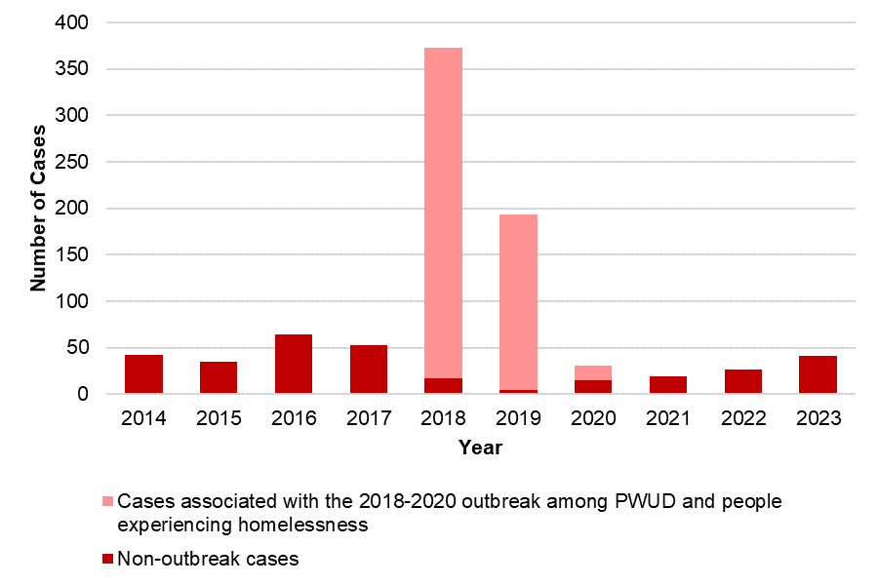

N=877

|  |  |  |  |  |  |  |  |  |  |  |
| --- | --- | --- | --- | --- | --- | --- | --- | --- | --- | --- |
|  | 2014 | 2015 | 2016 | 2017 | 2018 | 2019 | 2020 | 2021 | 2022 | 2023 |
| Outbreak-associated | 0 | 0 | 0 | 0 | 356 | 188 | 16 | 0 | 0 | 0 |
| Non-outbreak associated | 42 | 34 | 64 | 53 | 17 | 5 | 15 | 19 | 27 | 41 |
| Total | 42 | 34 | 64 | 53 | 373 | 193 | 31 | 19 | 27 | 41 |

In a typical year, between 30 and 70 cases of confirmed hepatitis A virus (HAV) infection are reported to DPH; many of these cases are associated with international travel as opposed to local transmission. Between 2018 and 2020, DPH and local health jurisdictions responded to a statewide outbreak that primarily affected individuals experiencing homelessness or unstable housing and/or substance use disorder. Similar outbreaks were observed in other states. DPH partnered with local health jurisdictions and clinical and community-based providers to implement a vaccination response by deploying mobile vaccination providers to shelters, correctional facilities, harm reduction programs, and outreach venues. The outbreak was declared over in spring of 2020, and case counts among individuals with homelessness/unstable housing or substance use disorder remained low through 2022. However, a small outbreak (24 total cases) affecting the same populations occurred between September 2023 and May 2024.

|  |
| --- |
| **DPH encourages continued vaccination of vulnerable populations in accordance with recommendations from the Advisory Committee on Immunization Practices. https://www.cdc.gov/vaccines/acip/index.html** |

Figure 2. Number of confirmed hepatitis A cases by recorded sex or gender, MA, 2014-2023

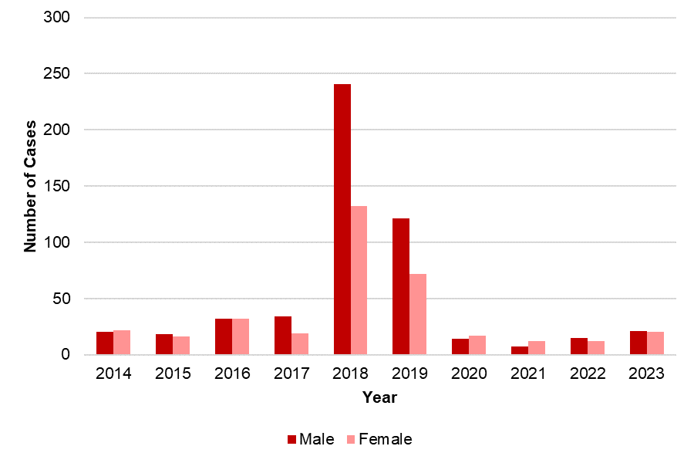

N=877

|  |  |  |  |  |  |  |  |  |  |  |
| --- | --- | --- | --- | --- | --- | --- | --- | --- | --- | --- |
|  | 2014 | 2015 | 2016 | 2017 | 2018 | 2019 | 2020 | 2021 | 2022 | 2023 |
| Male | 20 | 18 | 32 | 34 | 241 | 121 | 14 | 7 | 15 | 21 |
| Female | 22 | 16 | 32 | 19 | 132 | 72 | 17 | 12 | 12 | 20 |
| Total | 42 | 34 | 64 | 53 | 373 | 193 | 31 | 19 | 27 | 41 |

More cases of HAV infection have been reported among males than females, particularly during the 2018-2020 outbreak. There have been no reported cases of HAV among those who are transgender.

**Figure 3**. Number and average rate of confirmed hepatitis A cases by age group, MA, 2019-2023

|  |  |
| --- | --- |
| **Number of cases** | **Rate per 100,000** |
| Two horizontal bar graphs of confirmed HAV cases in Massachusetts from 2019 to 2023 by age group. The first graph shows the total number of HAV cases with the highest case counts among the 30 to 39 year age group and the lowest case count among the 0 to 19 year age group. The second graph shows the average rate of HAV per 100,000 people, with the highest rate among the 30 to 39 year age group and the lowest rate among the 0 to 19 year age group. | Two horizontal bar graphs of confirmed HAV cases in Massachusetts from 2019 to 2023 by age group. The first graph shows the total number of HAV cases with the highest case counts among the 30 to 39 year age group and the lowest case count among the 0 to 19 year age group. The second graph shows the average rate of HAV per 100,000 people, with the highest rate among the 30 to 39 year age group and the lowest rate among the 0 to 19 year age group. |

N=311

Massachusetts residents in the 30-39 year age group account for the greatest number of HAV cases and have the highest rate of infection. Children are rarely infected with HAV in the US since the introduction of the vaccine, which is recommended as part of routine childhood immunizations beginning at 12 months of age.

**Figure 4**. Number of confirmed hepatitis A cases by risk factors, MA, 2019-2023

Horizonal stacked bar graph of risk behaviors and exposures reported by confirmed HAV cases in Massachusetts from 2019 to 2023. The most common reported risk behavior/exposure is injection drug use followed by homelessness. Other reported risk behaviors/exposures include known contact with another case, incarceration, international travel, and MSM.
Legend of stacked bar graph with 3 categories reporting risk behavior/exposure: yes, no, and risk data missing.


N=311

MSM N=178; 133 females are represented in gray in the MSM bar because MSM (men who have sex with men), by definition, excludes females.

Reported cases may include more than one risk factor.

|  |  |  |  |
| --- | --- | --- | --- |
|  | Yes | No | Unknown |
| Injection drug use | 76 | 170 | 65 |
| Homelessness | 47 | 210 | 54 |
| Known contact with another case | 35 | 185 | 91 |
| International travel | 15 | 142 | 154 |
| MSM | 12 | 89 | 77 |
| Incarceration | 6 | 222 | 83 |

Among confirmed cases in 2019-2023, injection drug use (IDU) was the most commonly reported risk factor. Unlike HBV and HCV, bloodborne transmission of HAV is rare; transmission is typically person-to-person via the fecal-oral route. The association with IDU reflects the demographic and social groups impacted by the 2018-2020 and 2023-2024 outbreaks--which are also populations that may have more challenging access to effective hand hygiene and vaccination—rather than transmission via injection itself. CDC’s Advisory Committee on Immunization Practices (ACIP) recommends vaccination for people who use injection or non-injection drugs, people experiencing homelessness, international travelers, men who have sex with men, and others. Vaccination is also given as post-exposure prophylaxis to individuals who are known to have had contact with someone with HAV infection.

Figure 5. Number and average rate of confirmed hepatitis A cases by county, MA, 2019-2023

|  |  |
| --- | --- |
| **Number of cases** | **Rate per 100,000** |
| Two horizontal bar graphs of confirmed HAV cases in Massachusetts from 2019 to 2023 by county of residence. The first graph shows the total number of HAV cases, with the highest case counts in Middlesex County. The second graph shows the average rate of HAV per 100,000 people, with the highest rate in Hampden County. | Two horizontal bar graphs of confirmed HAV cases in Massachusetts from 2019 to 2023 by county of residence. The first graph shows the total number of HAV cases, with the highest case counts in Middlesex County. The second graph shows the average rate of HAV per 100,000 people, with the highest rate in Hampden County. |

N=311

Franklin, Hampden, Hampshire, Middlesex, Suffolk, and Worcester Counties have higher rates of HAV infection than the Massachusetts state average.

Figure 6. Map of number of confirmed hepatitis A cases by county, MA, 2019-2023

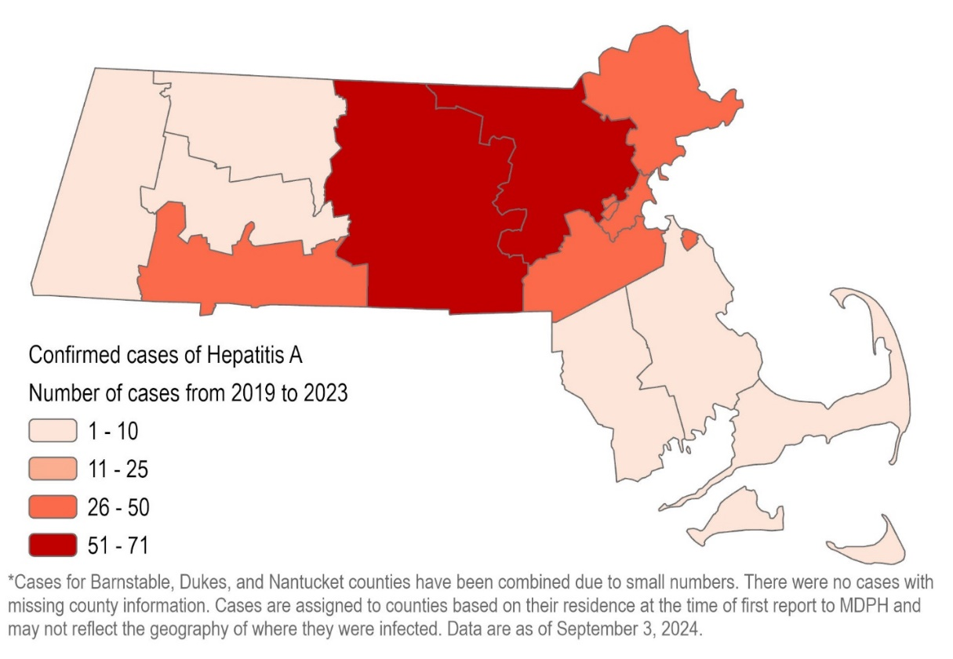

N=311

Figure 7. Map of rate of confirmed hepatitis A cases by county, MA, 2019-2023

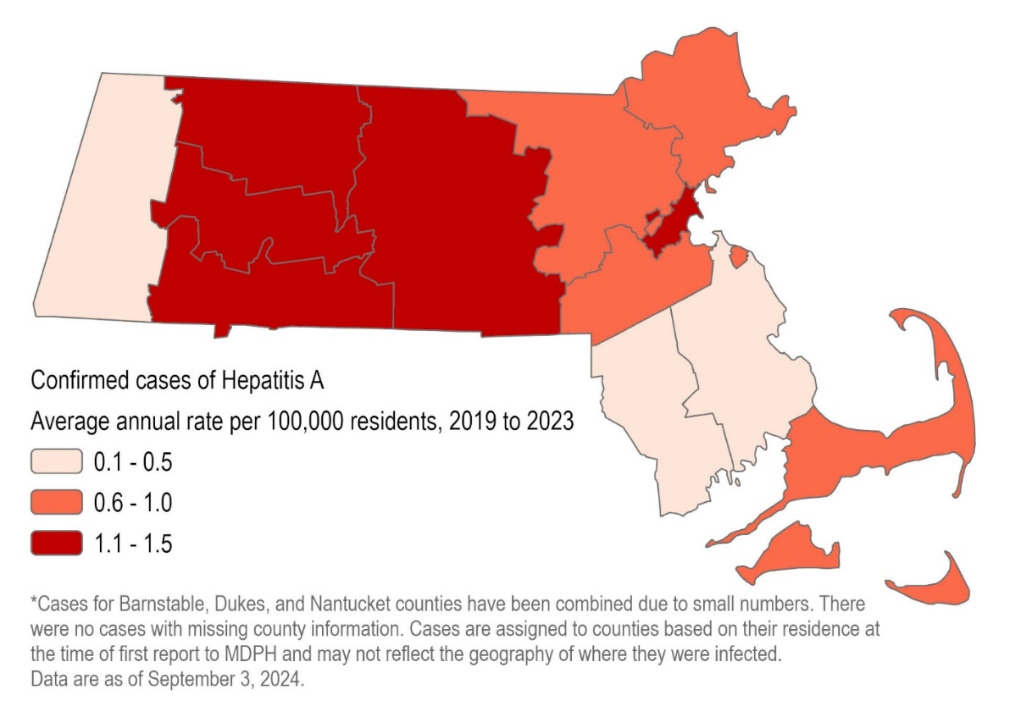

N=311

Figure 8. Number and age-adjusted average rate of confirmed hepatitis A cases by race/ethnicity, MA, 2019-2023

|  |  |
| --- | --- |
| **Number of cases** | **Rate per 100,000** |
| Two horizontal bar graphs of confirmed HAV cases in Massachusetts from 2019 to 2023 by race and ethnicity. The first graph shows the total number of HAV cases, with the highest case counts among white, non-Hispanic/non-Latine individuals. The second graph shows the age-adjusted average rate of HAV per 100,000 people, with the highest rate among white, non-Hispanic/non-Latine individuals. | Two horizontal bar graphs of confirmed HAV cases in Massachusetts from 2019 to 2023 by race and ethnicity. The first graph shows the total number of HAV cases, with the highest case counts among white, non-Hispanic/non-Latine individuals. The second graph shows the age-adjusted average rate of HAV per 100,000 people, with the highest rate among white, non-Hispanic/non-Latine individuals. |

N=311

*The “Other race, two or more races" category refers to combinations of two or more of the following: "White," "Black," “American Indian or Alaska Native," "Asian/Pacific Islander" or "Other"). American Indian or Alaska Natives are included in this category because data for this group alone cannot be displayed due to small case counts (1-4 cases) and small populations (<50,000).

The highest rates of HAV infection are among White, non-Hispanic/non-Latine individuals and Hispanic/Latine individuals. However, it should be noted that there are significant missing data for race/ethnicity (13%), which may affect the calculation and interpretation of rates, especially if data are missing in a nonrandom or biased way. For example, if cases among Black, nH/nL individuals were less likely to have an accurate race or ethnicity reported than cases among White, nH/nL individuals, the calculated rate for Black, nH/nL will be artificially low.

# Hepatitis B

Hepatitis B is a liver infection caused by the hepatitis B virus (HBV). There is a vaccine to prevent infection. HBV is bloodborne, and transmission can occur through direct contact with blood (including via sharing of drug injection equipment), through sexual contact, or from gestational parent to infant. Most adults who get the disease recover from it and can never get it again. However, about 10% of adults who get hepatitis B will develop chronic infection and can spread it to others. When it is chronic, it can be a serious disease that can lead to cirrhosis (scarring of the liver) and/or liver cancer. The younger a person is when infected, the more likely they are to go on to have chronic infection and to develop serious liver disease.

Cases of acute, chronic, and perinatal HBV infection are reportable in Massachusetts. A particular serologic marker makes it possible to readily distinguish between acute and chronic infection in newly reported cases. DPH epidemiologists investigate acute cases in order to characterize current transmission patterns and detect potential outbreaks. The Perinatal Hepatitis B Prevention Program (PHBPP) provides case management to HBV-infected pregnant people and their infants.

Acute HBV cases and chronic HBV cases are thought to represent two somewhat distinct groups in the US. Acute cases are typically those who were recently exposed in the US and chronic cases are predominantly non-US born individuals who may have been exposed as children. Because of these two different populations and because of our ability to distinguish between acute and chronic infection, acute HBV cases and chronic HBV cases are presented separately in this report.

Data in this section of the report, except for the co-infection data (Table 1) are current as of July 2024. The co-infection analysis was conducted separately, using data extracted in August 2024. In some graphs and tables, ten years of data are displayed in order to show broad trends over time. In others, especially for acute HBV infection, which has small case counts, the most recent five years of data are aggregated in order to show other patterns.

# Acute Hepatitis B

Figure 9. Rate of confirmed acute hepatitis B in Massachusetts compared to the United States, 2014-2023

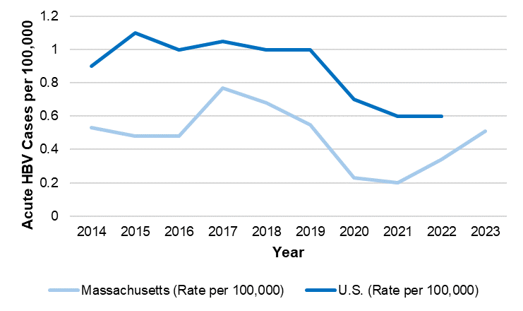

|  |  |  |  |  |  |  |  |  |  |  |
| --- | --- | --- | --- | --- | --- | --- | --- | --- | --- | --- |
|  | 2014 | 2015 | 2016 | 2017 | 2018 | 2019 | 2020 | 2021 | 2022 | 2023 |
| MA | 0.53 | 0.48 | 0.48 | 0.77 | 0.68 | 0.55 | 0.23 | 0.20 | 0.34 | 0.51 |
| U.S. | 0.90 | 1.10 | 1.00 | 1.05 | 1.00 | 1.00 | 0.70 | 0.60 | 0.60 | - |

In Massachusetts, the rate of acute hepatitis B virus (HBV) infection is historically lower than the national rate. This may reflect robust disease prevention work including adult and childhood vaccination and harm reduction services including syringe services. At the time of this report’s writing, the US rate for 2023 had not yet been published; it is unknown if the US rate will increase post-COVID (as the MA rate has) or stay flat.

Figure 10. Number of confirmed acute hepatitis B cases by year, MA, 2014-2023

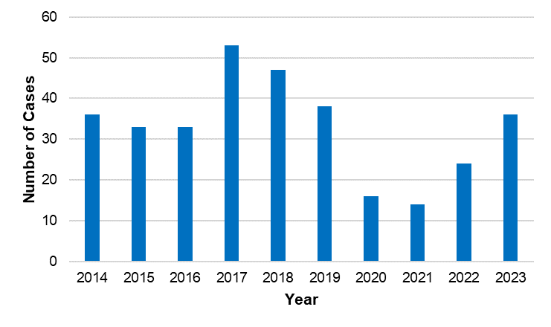

N=330

In a typical year, between 20 and 45 cases of confirmed acute HBV infection are reported to DPH. In 2017 and 2018 there was a higher number of cases due to a small outbreak in Bristol County that was associated with injection drug use.

Figure 11. Number of confirmed acute hepatitis B cases by recorded sex or gender, MA, 2014-2023

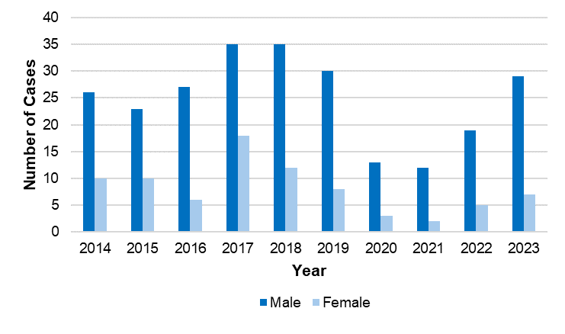

N=330

|  |  |  |  |  |  |  |  |  |  |  |
| --- | --- | --- | --- | --- | --- | --- | --- | --- | --- | --- |
|  | 2014 | 2015 | 2016 | 2017 | 2018 | 2019 | 2020 | 2021 | 2022 | 2023 |
| Male | 26 | 23 | 27 | 35 | 35 | 30 | 13 | 12 | 19 | 29 |
| Female | 10 | 10 | 6 | 18 | 12 | 8 | 3 | 2 | 5 | 7 |
| Total | 36 | 33 | 33 | 53 | 47 | 38 | 16 | 14 | 24 | 36 |

There are more cases of acute HBV infection reported among males than females in Massachusetts, consistent with national trends.

Figure 12. Number and rate of confirmed acute hepatitis B cases by age group, MA, 2019-2023

|  |  |
| --- | --- |
| **Number of cases** | **Rate per 100,000** |
| Horizontal bar graph of acute confirmed HBV cases and rates (per 100,000 people) in Massachusetts from 2019 to 2023 by age group. Massachusetts residents in the 40–49-year age group have the highest rate of acute HBV infections | Horizontal bar graph of acute confirmed HBV cases and rates (per 100,000 people) in Massachusetts from 2019 to 2023 by age group. Massachusetts residents in the 40–49-year age group have the highest rate of acute HBV infections |

N=128

Massachusetts residents in the 40-49 year age group have the highest rate of acute HBV infection, consistent with national trends. Individuals in this age group were too old to have been vaccinated as children, as the ACIP recommendation that all infants in the US be vaccinated by 18 months was not made until 1991.

Figure 13. Number and age-adjusted rate of confirmed acute hepatitis B cases by race/ethnicity, MA, 2019-2023

|  |  |
| --- | --- |
| **Number of cases** | **Rate per 100,000** |
| Horizontal bar graphs of acute confirmed HBV case counts and rates (per 100,000 people) in Massachusetts from 2019 to 2023 by race/ethnicity. The highest case count is among the White race group, and the highest rate is within the Black group. | Horizontal bar graphs of acute confirmed HBV case counts and rates (per 100,000 people) in Massachusetts from 2019 to 2023 by race/ethnicity. The highest case count is among the White race group, and the highest rate is within the Black group. |

N=128

The “Other” category includes combinations of two or more of the following race categories: "White," "Black," “American Indian or Alaska Native," "Asian/Pacific Islander "or "Other."

Although the highest number of acute HBV infections is among White, non-Hispanic/non-Latine individuals, the highest rate is among Black, non-Hispanic/non-Latine individuals, which may suggest unequal access to prevention strategies including vaccination.

Figure 14. Number and rate of confirmed acute hepatitis B cases by county, MA, 2019-2023

|  |  |
| --- | --- |
| **Number of cases** | **Rate per 100,000 people** |
| Horizontal bar graphs of confirmed acute HBV case counts and rates (per 100,000 people) by county in MA 2019-2023. Highest counts of acute cases are seen in Suffolk and Middlesex, and the highest rate is in Suffolk county. | Horizontal bar graphs of confirmed acute HBV case counts and rates (per 100,000 people) by county in MA 2019-2023. Highest counts of acute cases are seen in Suffolk and Middlesex, and the highest rate is in Suffolk county. |
|  |  |

N=128

Bristol, Suffolk, and Worcester Counties have higher rates of acute HBV than the Massachusetts state average.

Figure 15. Number of confirmed acute hepatitis B cases by country of birth, MA, 2014-2023

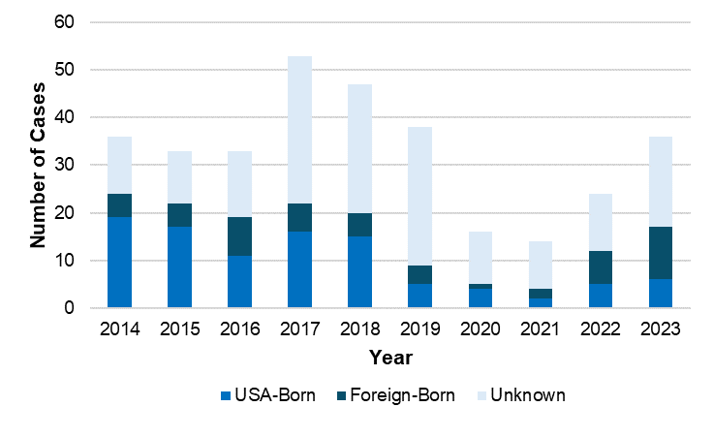

N=330

|  |  |  |  |  |  |  |  |  |  |  |
| --- | --- | --- | --- | --- | --- | --- | --- | --- | --- | --- |
|  | 2014 | 2015 | 2016 | 2017 | 2018 | 2019 | 2020 | 2021 | 2022 | 2023 |
| USA-Born | 19 | 17 | 11 | 16 | 15 | 5 | 4 | 2 | 5 | 6 |
| Foreign-Born | 5 | 5 | 8 | 6 | 5 | 4 | 1 | 2 | 7 | 11 |
| Unknown | 12 | 11 | 14 | 31 | 27 | 29 | 11 | 10 | 12 | 19 |
| Total | 36 | 33 | 33 | 53 | 47 | 38 | 16 | 14 | 24 | 36 |

In a typical year, there are more acute HBV cases reported among US-born persons than among non-US-born persons, although in 2022 and 2023, there were more reported among non-US-born persons than among US-born persons. It should be noted, however, that there are significant missing data for country of birth and these data should be interpreted with caution.

Figure 16. Number of confirmed acute hepatitis B cases by reported risk factors, MA, 2019-2023

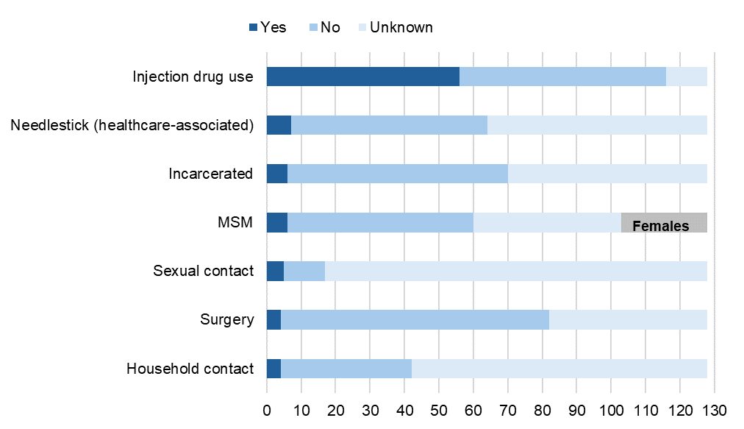

N=128

MSM N=103; 25 females are represented in gray in the MSM bar because MSM (men who have sex with men), by definition, excludes females.

Reported cases may include more than one risk behavior/exposure.

|  |  |  |  |
| --- | --- | --- | --- |
|  | Yes | No | Unknown |
| Injection drug use | 56 | 60 | 12 |
| Needlestick | 7 | 57 | 64 |
| Incarcerated | 6 | 64 | 58 |
| MSM | 6 | 54 | 43 |
| Sexual contact | 5 | 12 | 111 |
| Surgery | 4 | 78 | 46 |
| Household contact | 4 | 38 | 86 |

Among confirmed acute HBV cases 2019-2023, injection drug use (IDU) was the most commonly reported risk factor. Because HBV is known to be transmitted via the sharing of drug injection equipment, the Advisory Committee on Immunization Practices (ACIP) has a longstanding recommendation that adults who inject drugs should be vaccinated against HBV; thus, these cases represent missed opportunities for vaccination.

|  |
| --- |
| **DPH aligns with the 2021 ACIP recommendation that all adults aged 19-59 years old be vaccinated against HBV, as well as adults 60 years or older with risk factors including IDU.** |

Table 1: Acute hepatitis B and hepatitis C coinfection, MA, 2019-2023

|  |  |  |
| --- | --- | --- |
|  | Total acute HBV cases 2019-2023 | Number (%) coinfected with HCV |
| All demographic groups | 128 | 47 (37%) |
|  |  |  |
| Male | 103 | 38 (37%) |
| Female | 25 | 9 (36%) |
|  |  |  |
| American Indian/Alaskan Native, nH/nL | 0 | 0 (0%) |
| Asian/Pacific Islander, nH/nL | 3 | 0 (0%) |
| Black, nH/nL | 20 | 0 (0%) |
| Hispanic/Latine | 16 | 4 (25%) |
| White, nH/nL | 70 | 37 (53%) |
| Other, or more than one race, nH/nL | 14 | 4 (29%) |
| Unknown | 5 | 2 (40%) |
|  |  |  |
| Age <5 years | 0 | 0 (0%) |
| Age 5-14 years | 0 | 0 (0%) |
| Age 15-24 years | 3 | 2 (67%) |
| Age 25-34 years | 21 | 7 (33%) |
| Age 35-44 years | 45 | 22 (49%) |
| Age 45-54 years | 33 | 12 (36%) |
| Age 55-64 years | 15 | 3 (20%) |
| Age 65+ years | 11 | 1 (9%) |

Data in this table are current as of 8/13/2024.

Of 128 confirmed acute HBV cases in 2019-2023, 47 (37%) also had confirmed or probable hepatitis C infection. Of those 47 coinfected individuals, 40 (85%) had hepatitis C reported first. These 40 individuals represent missed opportunities for HBV vaccination, as there is a longstanding recommendation that those with chronic hepatitis C should be vaccinated against HBV. Since 2022, the recommendations for adult hepatitis B vaccination have been expanded further. Most (87%) of the coinfected individuals reported history of IDU.

# Chronic Hepatitis B

Figure 17. Number of chronic hepatitis B cases by year, MA, 2014-2023

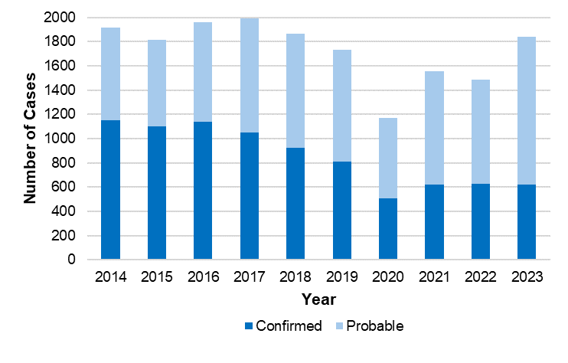

N=17,334

|  |  |  |  |  |  |  |  |  |  |  |
| --- | --- | --- | --- | --- | --- | --- | --- | --- | --- | --- |
|  | 2014 | 2015 | 2016 | 2017 | 2018 | 2019 | 2020 | 2021 | 2022 | 2023 |
| Confirmed | 1,153 | 1,104 | 1,140 | 1,051 | 925 | 809 | 507 | 621 | 625 | 620 |
| Probable | 766 | 711 | 818 | 942 | 938 | 924 | 666 | 936 | 859 | 1,219 |
| Total | 1,919 | 1,815 | 1,958 | 1,993 | 1,863 | 1,733 | 1,173 | 1,557 | 1,484 | 1,839 |

In a typical year, between 1,500 and 2,000 cases of confirmed and probable chronic hepatitis B virus (HBV) infection are newly reported to DPH. It is likely that many of these new reports represent longstanding infections (only being diagnosed and reported for the first time in Massachusetts) as opposed to new infections.

The surveillance case definition for chronic HBV for these years typically requires two positive tests; for certain test types, these two tests must be taken at least six months apart. Reported cases are classified as "probable" following the initial test result and are re-classified as "confirmed" if additional test results are received. During the most recent year of data, 2023, some cases currently reported as probable may eventually be confirmed in future reports as additional information is obtained. Because many probable cases do become confirmed over time, confirmed and probable cases are aggregated in subsequent figures.

Figure 18. Number of confirmed and probable chronic hepatitis B cases by recorded sex or gender, MA, 2014-2023

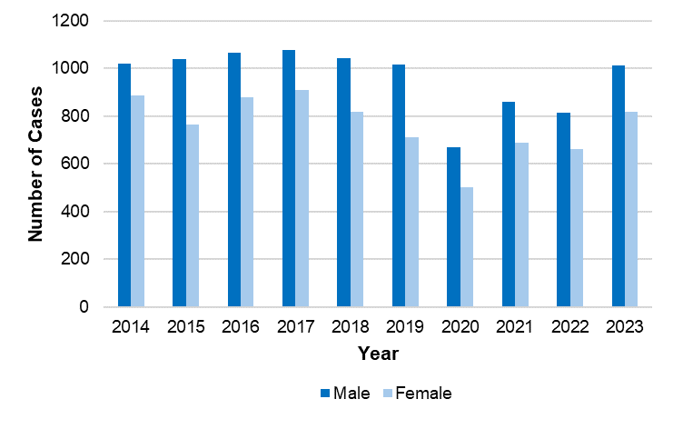

N=17,334

|  |  |  |  |  |  |  |  |  |  |  |
| --- | --- | --- | --- | --- | --- | --- | --- | --- | --- | --- |
|  | 2014 | 2015 | 2016 | 2017 | 2018 | 2019 | 2020 | 2021 | 2022 | 2023 |
| Male | 1,020 | 1,040 | 1,067 | 1,077 | 1,042 | 1,015 | 671 | 861 | 814 | 1,012 |
| Female | 885 | 763 | 879 | 910 | 819 | 712 | 501 | 690 | 661 | 817 |
| Unknown | 14 | 12 | 12 | 6 | 2 | 6 | 1 | 6 | 9 | 10 |

Cases with recorded sex or gender as Transgender reported are included in “Unknown” because data for this group alone cannot be displayed due to small case counts (1-4 cases) and small populations (<50,000).

More cases of chronic HBV infection are reported among males than among females, consistent with national trends.

Figure 19. Rate of confirmed and probable chronic hepatitis B cases by age group, MA, 2014-2023

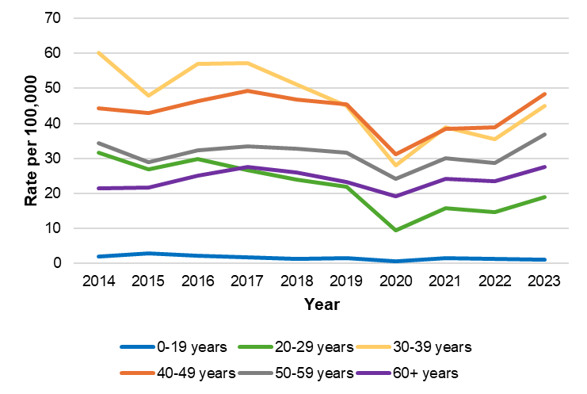

N=17,277

From 2014-2023, there were 57 confirmed and probable chronic hepatitis B cases with missing age.

N

|  |  |  |  |  |  |  |  |  |  |  |
| --- | --- | --- | --- | --- | --- | --- | --- | --- | --- | --- |
|  | 2014 | 2015 | 2016 | 2017 | 2018 | 2019 | 2020 | 2021 | 2022 | 2023 |
| 0-19 years​ | 33 | 48 | 37 | 28 | 22 | 25 | 10 | 24 | 20 | 19 |
| 20-29 years​ | 315 | 271 | 304 | 274 | 246 | 226 | 97 | 164 | 150 | 194 |
| 30-39 years​ | 507 | 496 | 498 | 509 | 463 | 412 | 256 | 355 | 327 | 412 |
| 40-49 years​ | 405 | 383 | 405 | 423 | 398 | 382 | 262 | 324 | 328 | 406 |
| 50-59 years​ | 341 | 289 | 321 | 329 | 317 | 303 | 231 | 287 | 275 | 352 |
| 60+ years​ | 308 | 319 | 381 | 427 | 416 | 380 | 314 | 396 | 384 | 449 |

Rates

|  |  |  |  |  |  |  |  |  |  |  |
| --- | --- | --- | --- | --- | --- | --- | --- | --- | --- | --- |
|  | 2014 | 2015 | 2016 | 2017 | 2018 | 2019 | 2020 | 2021 | 2022 | 2023 |
| 0-19 years​ | 2.00 | 3.00 | 2.30 | 1.70 | 1.40 | 1.60 | 0.60 | 1.50 | 1.30 | 1.20 |
| 20-29 years​ | 31.70 | 27.00 | 29.90 | 26.70 | 23.90 | 22.00 | 9.40 | 15.90 | 14.60 | 18.90 |
| 30-39 years​ | 60.10 | 57.90 | 57.00 | 57.20 | 51.20 | 45.00 | 28.00 | 38.80 | 35.60 | 45.00 |
| 40-49 years​ | 44.40 | 42.90 | 46.40 | 49.20 | 46.80 | 45.40 | 31.20 | 38.50 | 39.00 | 48.30 |
| 50-59 years​ | 34.40 | 29.00 | 32.40 | 33.50 | 32.70 | 31.70 | 24.10 | 30.00 | 28.70 | 36.80 |
| 60+ years​ | 21.50 | 21.60 | 25.20 | 27.50 | 26.10 | 23.20 | 19.20 | 24.20 | 23.50 | 27.50 |

Individuals in the 30-39 year and 40-49 year age groups have the highest rates of newly reported chronic HBV infection. Rates are very low in the 0-19 year age group due to high childhood vaccination rates and a strong Perinatal Hepatitis B Prevention Program (PHBPP).

Figure 20. Number of confirmed and probable chronic hepatitis B cases by race/ethnicity, MA, 2014-2023

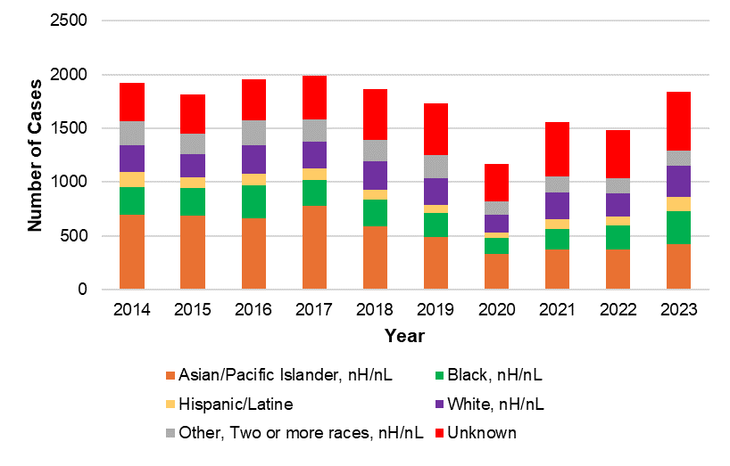  
N=17,334

Where race and ethnicity data are available, chronic cases are predominantly among Asian/Pacific Islander, non-Hispanic/non-Latine individuals, consistent with national trends.

|  |  |  |  |  |  |  |  |  |  |  |
| --- | --- | --- | --- | --- | --- | --- | --- | --- | --- | --- |
|  | 2014 | 2015 | 2016 | 2017 | 2018 | 2019 | 2020 | 2021 | 2022 | 2023 |
| Asian/Pacific Islander, nH/nL | 694 | 691 | 666 | 779 | 593 | 489 | 331 | 374 | 376 | 426 |
| Black, nH/nL | 261 | 258 | 302 | 240 | 243 | 228 | 150 | 191 | 220 | 304 |
| White, nH/nL | 248 | 216 | 269 | 251 | 259 | 249 | 168 | 254 | 222 | 291 |
| Hispanic/Latine | 144 | 98 | 107 | 105 | 97 | 75 | 52 | 89 | 82 | 136 |
| Other, two or more races, nH/nL | 220 | 191 | 230 | 207 | 197 | 208 | 123 | 143 | 139 | 140 |
| Unknown | 352 | 361 | 384 | 411 | 474 | 484 | 349 | 506 | 445 | 542 |

Figure 21. Age-adjusted rate of confirmed and probable chronic hepatitis B cases by race/ethnicity, MA, 2014-2023

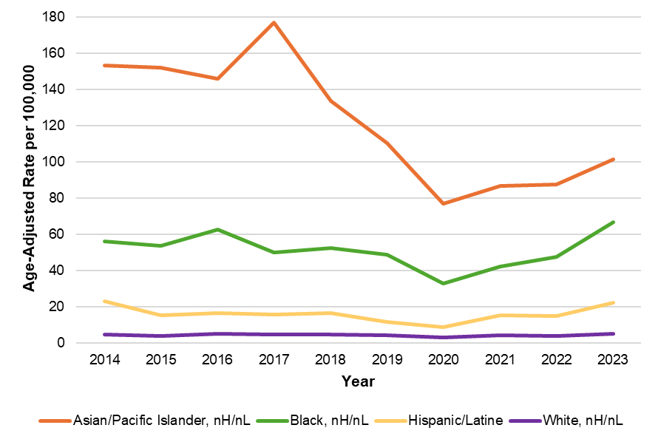  
N=17,277  
From 2014-2023, there were 57 confirmed and probable chronic hepatitis B cases with missing age.

|  |  |  |  |  |  |  |  |  |  |  |
| --- | --- | --- | --- | --- | --- | --- | --- | --- | --- | --- |
|  | 2014 | 2015 | 2016 | 2017 | 2018 | 2019 | 2020 | 2021 | 2022 | 2023 |
| Asian/Pacific  Islander, nH/nL | 153.43 | 152.15 | 146.12 | 177.01 | 133.97 | 110.39 | 77.13 | 86.93 | 87.83 | 101.74 |
| Black, nH/nL | 56.12 | 53.65 | 62.68 | 50.02 | 52.41 | 48.93 | 32.81 | 42.17 | 47.61 | 66.97 |
| White, nH/nL | 4.61 | 3.99 | 5.08 | 4.60 | 4.66 | 4.54 | 2.99 | 4.58 | 3.89 | 5.21 |
| Hispanic/Latine | 22.99 | 15.42 | 16.62 | 15.90 | 16.51 | 11.81 | 8.87 | 15.4 | 15.10 | 22.37 |

Chronic case counts and rates are highest among Asian/Pacific Islander, non-Hispanic/non-Latine individuals, consistent with national trends. Rates are also elevated for Black, non-Hispanic/non-Latine individuals, a trend that is also seen on the national level. It should be noted that there are significant missing data for race/ethnicity, especially in recent years, which may affect the calculation and interpretation of rates, especially if data are missing in a nonrandom or biased way. For example, if cases among Asian/Pacific Islander, nH/nL individuals were less likely to have an accurate race or ethnicity reported in more recent years, it will appear as though rates in this group are decreasing when they are not.

Figure 22. Number and rate of confirmed and probable chronic hepatitis B cases by county, MA, 2019-2023

|  |  |
| --- | --- |
| **Number of cases** | **Rate per 100,000** |
| Horizontal bar graphs of confirmed and probable chronic HBV case counts and rates (per 100,000 people) in Massachusetts from 2019 to 2023 by county.  Middlesex, Norfolk, and Suffolk Counties had higher counts and rates of chronic HBV compared to Massachusetts’s state average. | Horizontal bar graphs of confirmed and probable chronic HBV case counts and rates (per 100,000 people) in Massachusetts from 2019 to 2023 by county.  Middlesex, Norfolk, and Suffolk Counties had higher counts and rates of chronic HBV compared to Massachusetts’s state average. |

N= 7,786

Middlesex, Norfolk, and Suffolk Counties have chronic HBV rates higher than the Massachusetts state average. Note that county is based on the patient’s residence at the time of report and does not necessarily represent where the patient was exposed to HBV.

Figure 23. Map of confirmed and probable chronic hepatitis B cases by city/town, MA, 2023

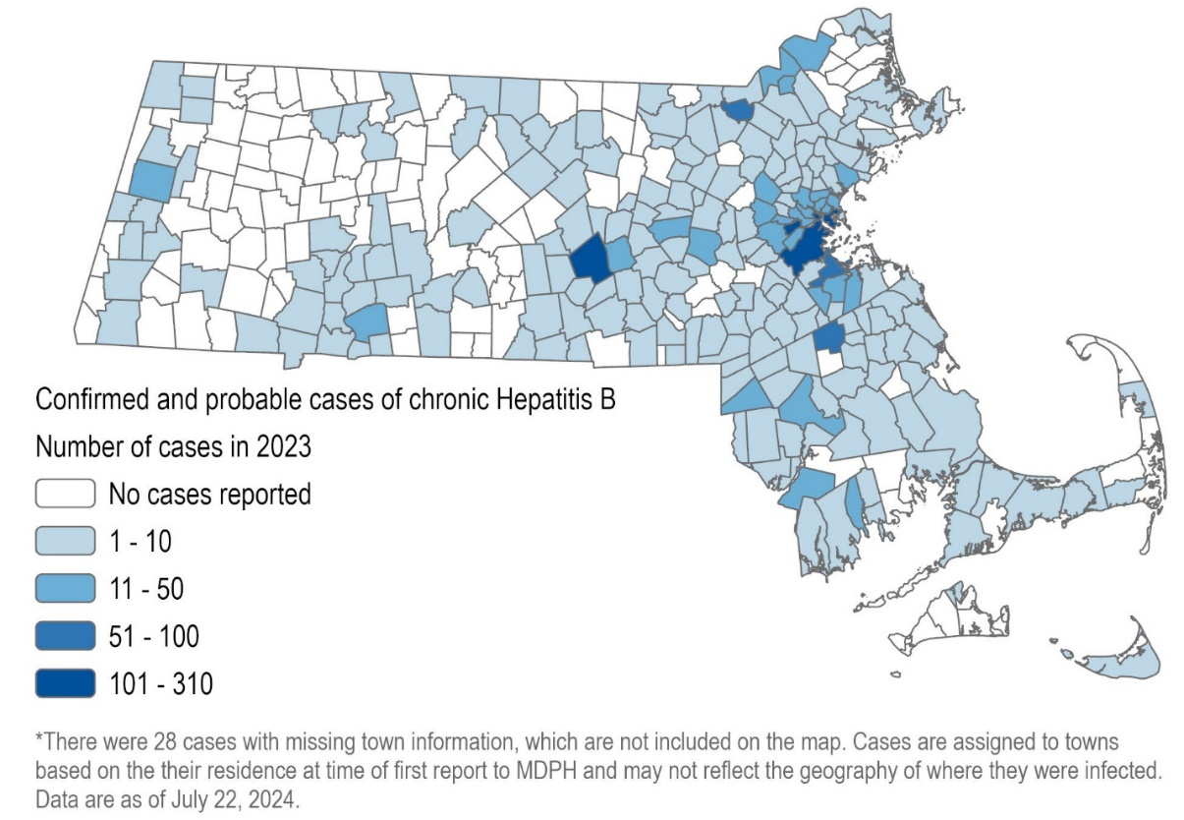

N=1,811

Figure 24. Map of rate of confirmed and probable chronic hepatitis B cases by city/town, MA, 2023

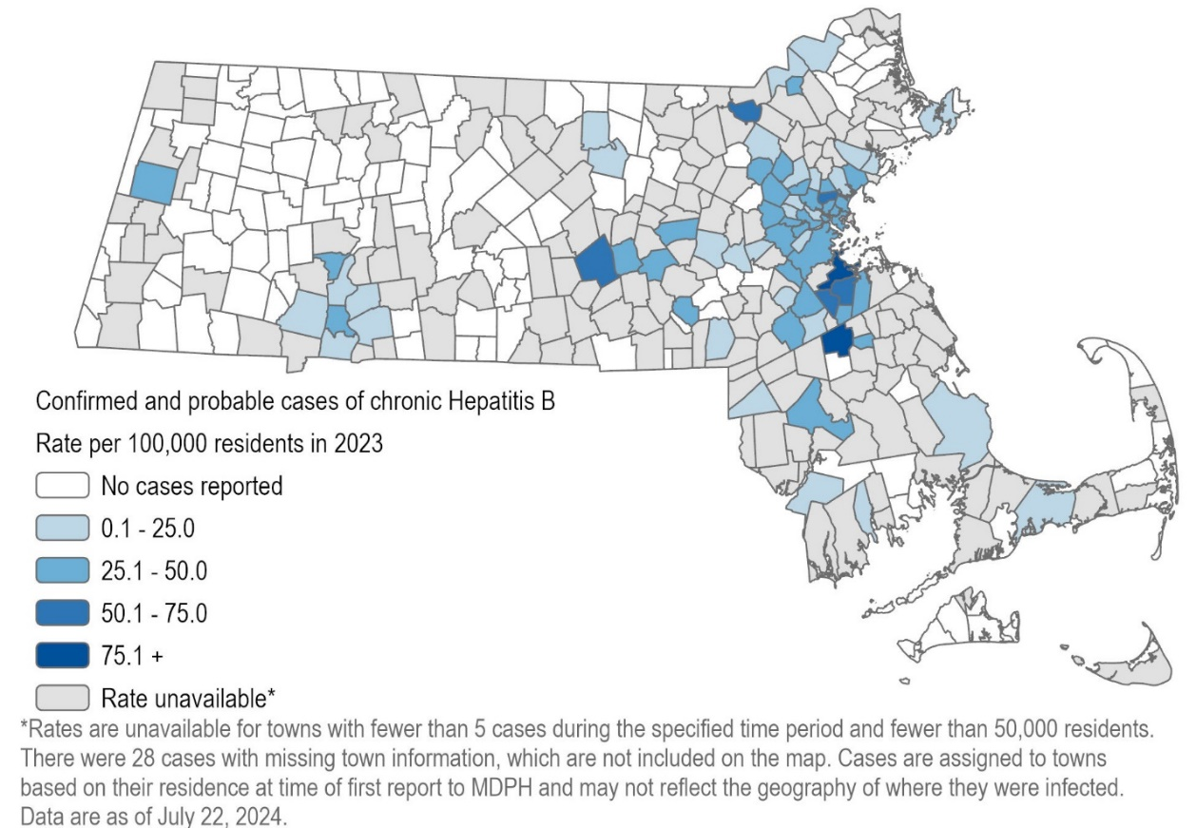

N=1,811

Figure 25. Map of confirmed and probable chronic hepatitis B cases, MA by city/town, 2014-2023

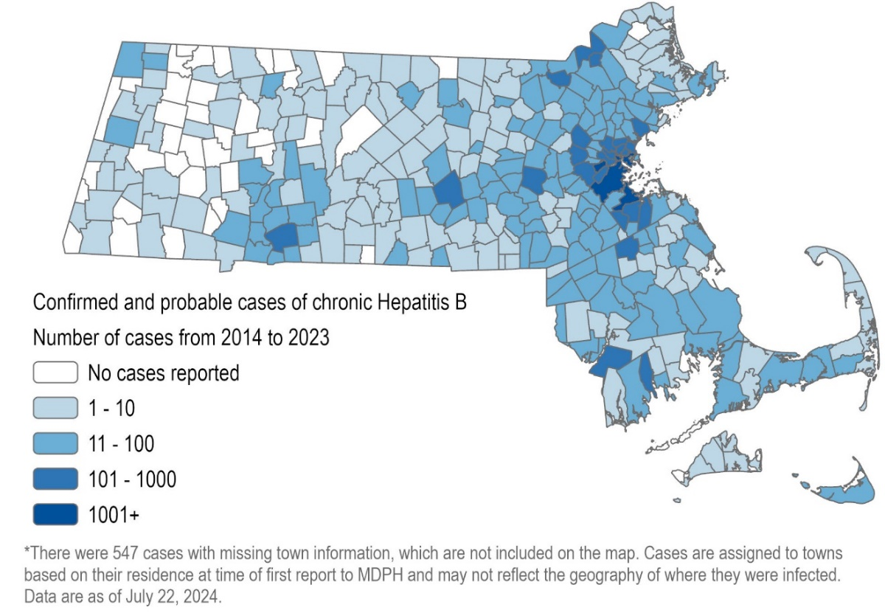

N=16,787

Figure 26. Map of average rate of confirmed and probable chronic hepatitis B cases by city/town, MA, 2014-2023

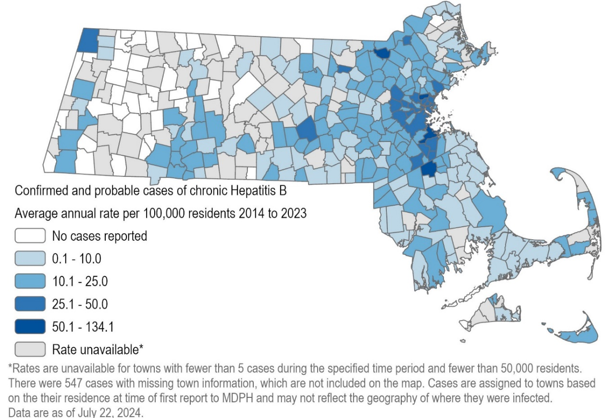

N=16,787

Figure 27. Number of confirmed and probable chronic hepatitis B cases by country of birth, MA, 2014-2023

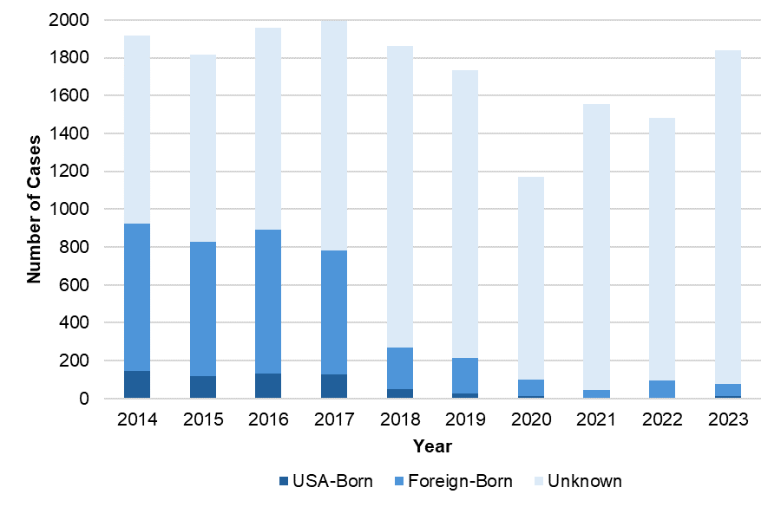

N=17,334

|  |  |  |  |  |  |  |  |  |  |  |
| --- | --- | --- | --- | --- | --- | --- | --- | --- | --- | --- |
|  | 2014 | 2015 | 2016 | 2017 | 2018 | 2019 | 2020 | 2021 | 2022 | 2023 |
| USA-Born | 145 | 117 | 130 | 126 | 50 | 28 | 14 | 6 | 6 | 13 |
| Foreign-Born | 778 | 711 | 763 | 655 | 221 | 185 | 88 | 41 | 91 | 66 |
| Unknown | 996 | 987 | 1,065 | 1,212 | 1,592 | 1,520 | 1,071 | 1,510 | 1,387 | 1,760 |
| Total | 1,919 | 1,815 | 1,958 | 1,993 | 1,863 | 1,733 | 1,173 | 1,557 | 1,484 | 1,839 |

Chronic HBV cases are predominantly among non-US-born individuals, where country of birth is known. (Chronic cases are not typically investigated unless the individual is pregnant, and a provider reporting form for chronic cases was discontinued in 2017, so missing data are significant.) It is likely that many of these individuals were infected before moving to the US, as there are parts of the world where HBV is endemic, including parts of Africa and Asia.

Figure 28. Confirmed and probable chronic hepatitis B cases by country of birth for those known to have been born outside the United States, 2014-2023

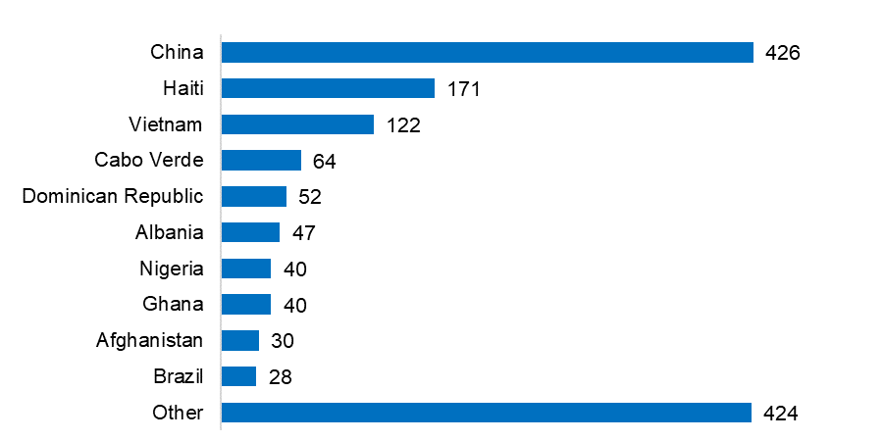

Of 3,599 chronic HBV cases known to have been born outside the US, country of birth is known for 1,444. Foreign-born chronic HBV cases come from a variety of countries, with the highest number of cases from China. These data reflect both the demographics of Massachusetts as well as which countries have higher HBV prevalence.

# Perinatal Hepatitis B

HBV infection in a pregnant person poses a serious risk to their infant. Unless they receive proper post-exposure prophylaxis (PEP), up to 90% of infants born to pregnant persons with HBV get infected, and 85% to 95% of those will become chronically infected. Up to one in four chronically infected individuals who were infected as infants will die from primary hepatocellular carcinoma (liver cancer) or cirrhosis of the liver later in life. However, the risk of transmission of HBV from gestational parent to child can be significantly reduced by quickly providing PEP to the infant at birth; PEP consists of hepatitis B immune globulin (HBIG) and the first dose of hepatitis B vaccine. The Massachusetts Perinatal Hepatitis B Prevention Program (PHBPP) provides case management to HBV-infected gestational parents and their infants, promoting and helping to coordinate appropriate PEP, completion of the HBV vaccine series, and recommended post-vaccination serologic testing (PVST) for enrolled infants.

Figure 29. Outcomes of infants managed by the Massachusetts PHBPP, by birth cohort, MA, 2018-2022

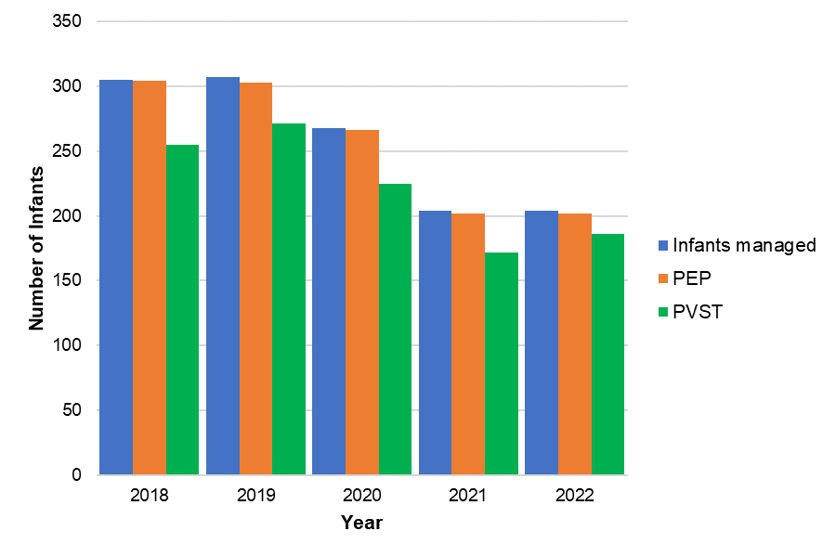  
N=1,288

|  |  |  |  |  |  |  |  |
| --- | --- | --- | --- | --- | --- | --- | --- |
| Birth cohort | Infants managed (N) | Received PEP at birth (N) | Received PEP at birth (%) | Completed vaccine series by 12 months of age (N) | Completed vaccine series by 12 months of age (%) | Received PVST (N) | Received PVST (%) |
| 2018 | 305 | 304 | *>99%* | 287 | *94%* | 255 | *84%* |
| 2019 | 307 | 303 | *99%* | 291 | *95%* | 271 | *88%* |
| 2020 | 268 | 266 | *99%* | 252 | *94%* | 225 | *84%* |
| 2021 | 204 | 202 | *99%* | 194 | *95%* | 172 | *84%* |
| 2022 | 204 | 202 | *99%* | 196 | *96%* | 186 | *91%* |

Data reflect tracking through the next calendar year. For example, the 2019 birth cohort outcomes are calculated at the end of 2020. Infants without the full vaccine series and/or PVST by this cut-off will continue to be case managed and may receive additional doses/testing later.

The Massachusetts PHBPP provides case management to between 200 and 400 HBV-infected gestational parents and their infants each year. Nearly all case managed infants receive PEP at birth, more than 90% complete the vaccine series by 12 months of age, and more than 80% receive PVST. The number of case managed infants has been decreasing over the last several years, consistent with national trends.

Figure 30. Gestational parents enrolled in case management with Massachusetts PHBPP by race/ethnicity, 2022 birth cohort

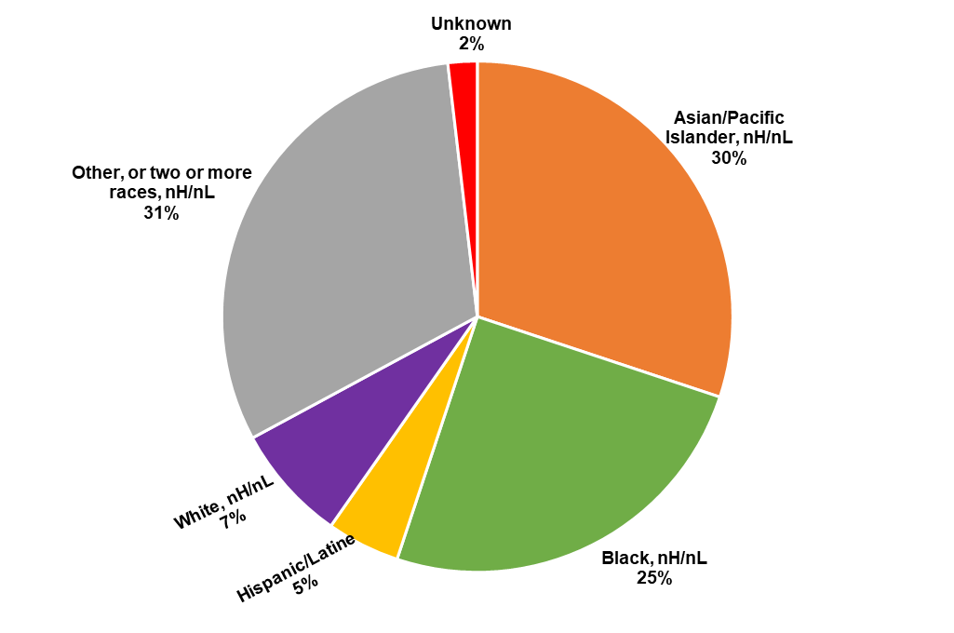N=216

For the 2022 birth cohort, gestational parents enrolled in PHBPP case management mirrored statewide chronic HBV cases in terms of demographic characteristics. The most common race/ethnicities reported were: Other, or two or more races nH/nL; Asian/Native Hawaiian/Pacific Islander, nH/nL; and Black, nH/nL. Of parents where country of birth was known, 90% were born outside the US. Suffolk County (23%) and Middlesex County (21%) had the highest number of case managed parents.

# Hepatitis C

Hepatitis C is a liver infection caused by the hepatitis C virus (HCV). The majority of people who have acute HCV infection go on to develop chronic infection. Over time, chronic HCV infection can cause liver damage, leading to cirrhosis, liver cancer, and death. HCV infection is spread by direct contact with the blood of another person with HCV infection. As seen in the analyses below, injection drug use is the most commonly reported risk factor among HCV cases. With the advent of direct-acting antivirals, HCV infection is curable for most people with a weeks-long, well-tolerated course of treatment.

Acute, chronic, and perinatal HCV infections are reportable in Massachusetts. Acute cases are actively investigated by local health jurisdictions, in conjunction with DPH epidemiologists, and case report forms detailing basic demographic, clinical, and risk history information are requested from providers on all newly reported confirmed (i.e., RNA-positive) cases. Due to the lack of a serologic marker for acute infection, as well as many newly infected individuals showing no symptoms, acute and chronic HCV cases are combined in many of the figures and tables in this section.

Data in this section of the report are current as of July 31, 2024. Given important updates to the acute and chronic case definitions for HCV infection in 2016, that is the first year included in the majority of HCV figures and tables in this report. Standardized classification of perinatal HCV cases was not possible until 2018, which is the first year for which those specific data are shown in this report.

Figure 31. Rate of acute hepatitis C cases in Massachusetts compared to the United States, 2017-2023

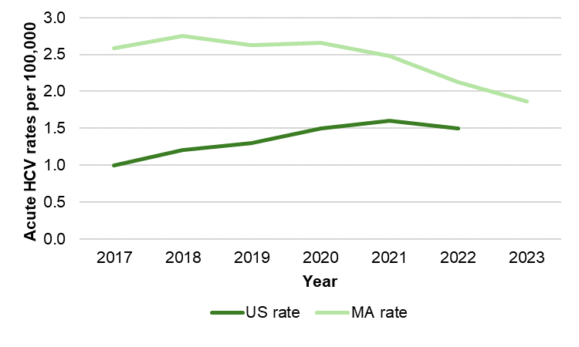

US Rate for 2023 not yet available

Rates of acute hepatitis C virus (HCV) infection in Massachusetts were consistently higher than national rates between 2017 and 2022. On average, the rate of acute HCV infection was 1.8 times higher than the national rate across this time period, though the difference decreased over time. At the time of this report’s writing, the US rate for 2023 had not yet been published.

Figure 32. Number and rate of confirmed and probable hepatitis C cases by recorded sex or gender, age group, race and ethnicity, and county, MA, 2023

**Figure 32A. Recorded sex or gender**

|  |  |
| --- | --- |
| **Number of cases** | **Rate per 100,000** |
| **A horizontal bar chart showing numbers  of hepatitis infection by reported sex or gender. Males had higher numbers  of infection as compared to females.** | **A horizontal bar chart showing rates of hepatitis infection by reported sex or gender. Males had higher rates of infection as compared to females.** |

N=2,540; includes acute, chronic, and perinatal cases

40 cases not included because recorded sex or gender was either transgender or missing. The number of transgender cases is not explicitly included as it is <5.

People with a recorded sex or gender of male in Massachusetts in 2023 had both higher numbers of HCV cases and rates of infection per 100,000 population. Case counts were 1.6 times higher in males than females, and rates of infection were 1.7 times higher in males than females.

**Figure 32B. Age group**

|  |  |
| --- | --- |
| **Number of cases** | **Rate per 100,000** |
| **A horizontal bar chart showing numbers and rates of hepatitis C infection by age group. The highest number and rate of cases was observed among individuals between the ages of 30 and 39.** | **A horizontal bar chart showing numbers and rates of hepatitis C infection by age group. The highest number and rate of cases was observed among individuals between the ages of 30 and 39.** |

N=2,576

4 cases not included due to missing age

The highest numbers and rates of hepatitis C infections were observed in individuals between the ages of 30 and 39, reflecting the burden of disease among younger adults with current or past injection drug use.

**Figure 32C. Age-adjusted race and ethnicity**

|  |  |
| --- | --- |
| **Number of cases** | **Rate per 100,000** |
| **A horizontal bar chart showing numbers and age-adjusted rates of hepatitis C infection by race and Hispanic ethnicity. The highest number of cases is seen in those identifying as White, non-Hispanic, but the highest rates of infection are seen in those identifying as either Hispanic or Black, non-Hispanic.** | **A horizontal bar chart showing numbers and age-adjusted rates of hepatitis C infection by race and Hispanic ethnicity. The highest number of cases is seen in those identifying as White, non-Hispanic, but the highest rates of infection are seen in those identifying as either Hispanic or Black, non-Hispanic.** |

N=2,580

The “Other” category includes combinations of two or more of the following race categories: "White," "Black," “American Indian or Alaska Native," "Asian/Pacific Islander "or "Other." American Indian or Alaska Natives are included in this category because data for this group alone cannot be displayed due to small case counts (1-4 cases) and small populations (<50,000).

Though the highest number of hepatitis C cases in Massachusetts in 2023 was observed among people identifying as White, non-Hispanic/non-Latine, the highest rates of infection were observed among individuals identifying as Hispanic/Latine and Black, non-Hispanic/non-Latine, which may be driven by inequitable access to prevention services such as harm reduction or medical treatment including curative therapies for hepatitis C infection. It should be noted that there are significant missing data for race/ethnicity, which may affect the calculation and interpretation of rates, especially if data are missing in a nonrandom or biased way. For example, if cases among Asian/Pacific Islander, nH/nL individuals were less likely to have an accurate race or ethnicity reported, rates in this group will appear artificially low.

**Figure 32D. County of residence**

|  |  |
| --- | --- |
| **Number of cases** | **Rate per 100,000** |
| A horizontal bar chart showing numbers and rates of hepatitis C infections by county in Massachusetts. While the highest numbers of infections were seen in Middlesex, Suffolk, and Worcester Counties, the highest rates of infection were seen in Berkshire, Suffolk, and Hampden Counties. | A horizontal bar chart showing numbers and rates of hepatitis C infections by county in Massachusetts. While the highest numbers of infections were seen in Middlesex, Suffolk, and Worcester Counties, the highest rates of infection were seen in Berkshire, Suffolk, and Hampden Counties. |

N=2,580

By county, the highest numbers of hepatitis C cases were observed in Middlesex, Suffolk, and Worcester Counties, which all contain significant population centers. The rates of infection by county, however, demonstrate that hepatitis C infection is a statewide issue, with the highest rates of infection in Berkshire, Hampden, and Suffolk Counties.

Figure 33. Map of rate of confirmed and probable hepatitis C cases by city/town of residence, MA, 2018-2023

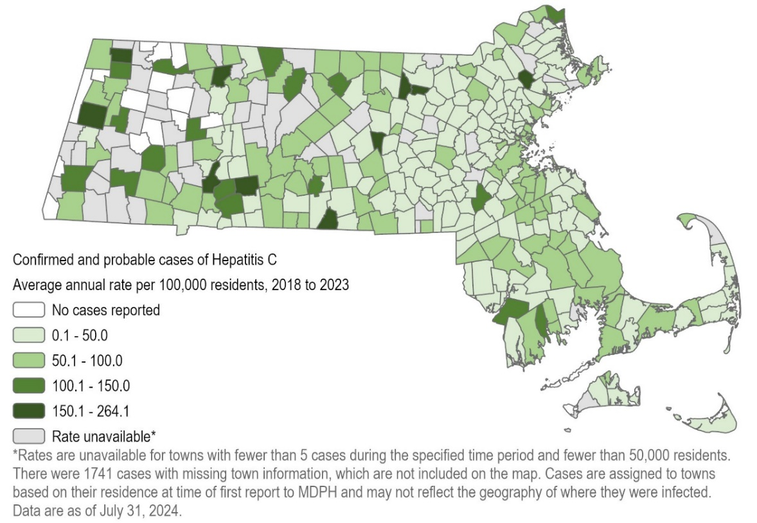

N=20,740; includes acute, chronic, and perinatal cases.

As displayed in this map, hepatitis C affects communities statewide, with very few local jurisdictions reporting no cases between 2018 and 2023, emphasizing the need for broadly available prevention and treatment services.

Figure 34. Confirmed and probable hepatitis C cases by year, MA, 2016-2023

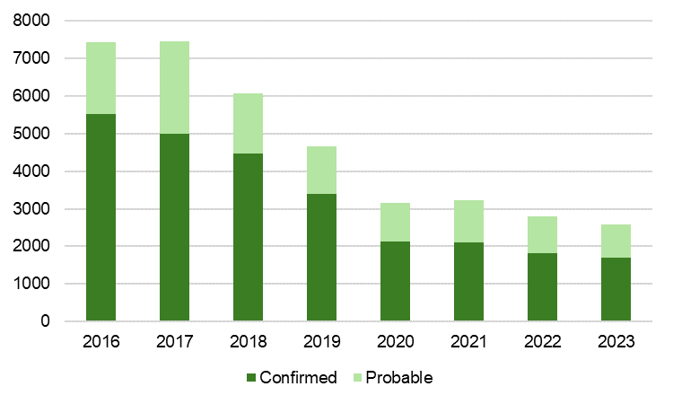

N=37,344

|  |  |  |  |  |  |  |  |  |
| --- | --- | --- | --- | --- | --- | --- | --- | --- |
|  | 2016 | 2017 | 2018 | 2019 | 2020 | 2021 | 2022 | 2023 |
| Confirmed acute | 531 | 173 | 184 | 179 | 177 | 169 | 141 | 123 |
| Confirmed chronic | 4,978 | 4,807 | 4,257 | 3,198 | 1,935 | 1,941 | 1,675 | 1,565 |
| Probable acute | 59 | 6 | 7 | 4 | 10 | 5 | 8 | 8 |
| Probable chronic | 1,845 | 2,464 | 1,606 | 1,262 | 1,030 | 1,099 | 968 | 877 |
| Perinatal | - | - | 15 | 5 | 8 | 8 | 10 | 7 |
| Total | 7,413 | 7,450 | 6,069 | 4,648 | 3,160 | 3,222 | 2,802 | 2,580 |

The number of newly reported confirmed and probable HCV cases has decreased substantially between 2016 and 2023, from a high of 7,450 cases in 2017, down 65% to 2,580 cases in 2023. In Figure 34, the specific types of HCV infection (i.e., acute, chronic, and perinatal) are collapsed, and cases are divided only into probable cases (those with only positive HCV antibody results) and confirmed cases (those with positive viral testing). While data should be interpreted with caution between 2020-2022 due to the impact on screening and clinical services from the COVID-19 pandemic, this decrease is also likely driven in part by the effect of increases in MA of prevention strategies such as harm reduction, with many cities and towns in MA now providing such services. The number of acute HCV cases dropped 27% between 2017 and 2023 from 179 cases to 131, despite an update to the acute HCV case definition that led to more sensitive capture of acute cases. Additionally, because the case definition for perinatal hepatitis C infection was first implemented in 2018, these cases could not be counted in a standardized manner before then.

Figure 35. Number of acute hepatitis C cases reported by age and injection drug use risk, MA, 2016-2023

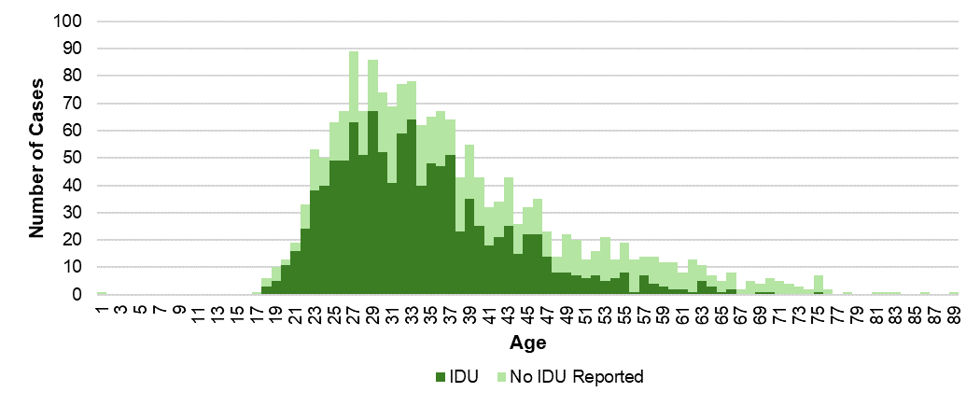

N=1,781

3 cases not included due to missing age, the “No IDU Reported” category includes cases with unknown IDU status.

Acute cases of hepatitis C infection between 2016 and 2023 primarily occurred among adults under 40 years of age, and the predominant risk factor among acute cases is injection drug use.

Table 2. Number of confirmed perinatal hepatitis C cases reported by year, MA, 2018-2023

|  |  |  |  |  |  |  |
| --- | --- | --- | --- | --- | --- | --- |
|  | 2018 | 2019 | 2020 | 2021 | 2022 | 2023 |
| 2 to <6 months old | 2 | 0 | 2 | 3 | 1 | 4 |
| 6 to <12 months old | 2 | 1 | 2 | 0 | 1 | 0 |
| 12 to <18 months old | 1 | 0 | 0 | 0 | 1 | 1 |
| 18 to <24 months old | 8 | 4 | 2 | 5 | 4 | 1 |
| 24 to <30 months old | 1 | 0 | 1 | 0 | 2 | 0 |
| 30 to ≤36 months old | 1 | 0 | 1 | 0 | 1 | 1 |
| Total Cases | 15 | 5 | 8 | 8 | 10 | 7 |

The total number of confirmed perinatal cases of hepatitis C infection was 15 in 2018 and 7 in 2023; no clear trend is evident from year to year. The majority of perinatal cases of hepatitis C infection were identified between 18 and 24 months of age. Testing recommendations for perinatally exposed children were released by CDC in 2023[2], and recommend that testing take place as early as 2 months of age, with an RNA test. Follow-up of suspect perinatal HCV cases is much more limited in comparison to HBV as there is no PEP recommendation at this time.

Figure 36. Rate of confirmed and probable hepatitis C cases by age group and year, MA, 2016-2023

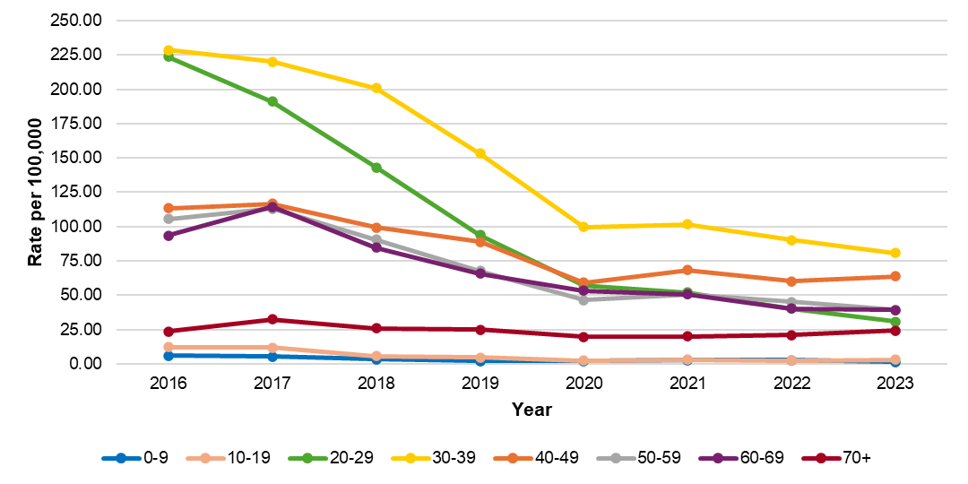

N=36,981, 363 cases not included due to missing age

Rates

|  |  |  |  |  |  |  |  |  |
| --- | --- | --- | --- | --- | --- | --- | --- | --- |
| Age | 2016 | 2017 | 2018 | 2019 | 2020 | 2021 | 2022 | 2023 |
| 0-9 | 5.97 | 5.30 | 3.28 | 2.06 | 1.93 | 2.62 | 2.75 | 1.38 |
| 10-19 | 12.09 | 11.74 | 5.76 | 4.75 | 2.38 | 2.98 | 2.50 | 2.98 |
| 20-29 | 223.72 | 191.24 | 143.14 | 93.85 | 57.20 | 51.86 | 40.28 | 30.78 |
| 30-39 | 228.78 | 220.24 | 201.03 | 153.27 | 99.66 | 101.65 | 90.24 | 80.61 |
| 40-49 | 113.36 | 116.54 | 99.50 | 88.95 | 59.20 | 68.47 | 60.14 | 63.89 |
| 50-59 | 105.69 | 112.99 | 90.70 | 67.63 | 46.32 | 50.81 | 44.99 | 39.18 |
| 60-69 | 93.61 | 114.32 | 84.80 | 65.72 | 53.28 | 50.69 | 40.20 | 39.25 |
| 70+ | 23.53 | 32.27 | 25.73 | 24.95 | 19.58 | 20.07 | 20.93 | 24.23 |

N

|  |  |  |  |  |  |  |  |  |
| --- | --- | --- | --- | --- | --- | --- | --- | --- |
| Age | 2016 | 2017 | 2018 | 2019 | 2020 | 2021 | 2022 | 2023 |
| 0-9 | 44 | 39 | 24 | 15 | 14 | 19 | 20 | 10 |
| 10-19 | 105 | 102 | 50 | 41 | 20 | 25 | 21 | 25 |
| 20-29 | 2,275 | 1,960 | 1,472 | 965 | 578 | 524 | 407 | 311 |
| 30-39 | 1,998 | 1,961 | 1,819 | 1,403 | 952 | 971 | 862 | 770 |
| 40-49 | 990 | 1,003 | 846 | 748 | 505 | 584 | 513 | 545 |
| 50-59 | 1,048 | 1,110 | 880 | 647 | 454 | 498 | 441 | 384 |
| 60-69 | 749 | 927 | 701 | 553 | 452 | 430 | 341 | 333 |
| 70+ | 168 | 240 | 198 | 198 | 160 | 164 | 171 | 198 |
| Total | 7,377 | 7,342 | 5,990 | 4,570 | 3,135 | 3,215 | 2,776 | 2,576 |

363 cases were excluded due to missing age

Between 2016 and 2023, the rates of newly reported confirmed and probable hepatitis C cases decreased for most age groups, though there are clear differences across age groups. Individuals between the ages of 30 and 39 consistently had the highest rates of infection. Between 2016 and 2019, this was followed by those aged 20 to 29 years; beginning in 2020, the second highest rate was observed among those aged 40 to 49 years. The lowest rates of infection were observed among children and teenagers.

Figure 37. Map of rate of confirmed and probable hepatitis C cases ages 18-39 by city/town of residence, MA, 2018-2023

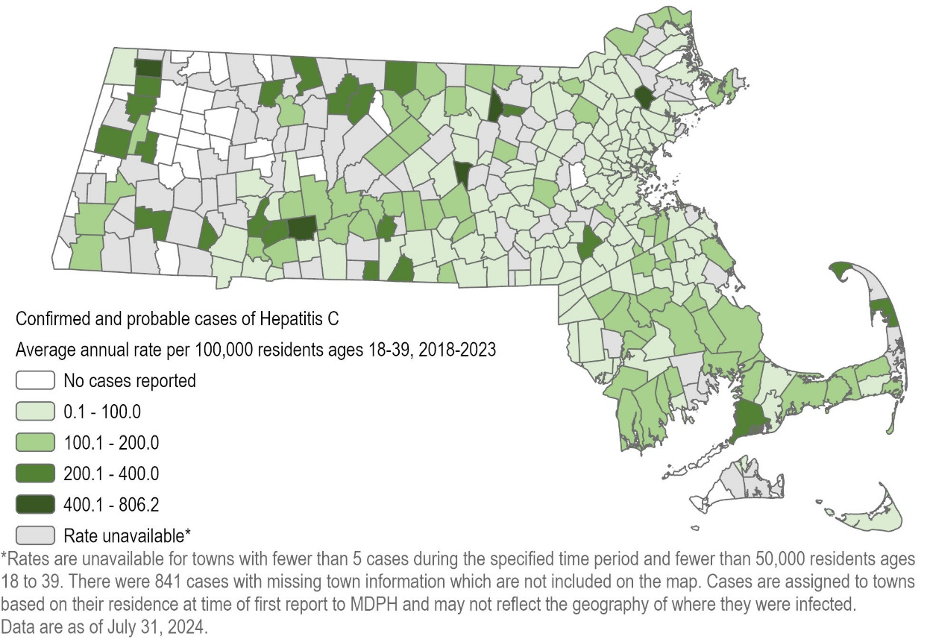

N=9,770, includes acute and chronic cases.

When limited to those individuals between the ages of 18 and 39 years, the map of the rate of confirmed and probable HCV infections between 2018 and 2023 similarly demonstrates that HCV infections are a statewide issue among adults under 40. In this age group, southeastern Massachusetts is an example of an area with relatively high rates of infection.

Figure 38. Number and rate of confirmed and probable hepatitis C cases by recorded sex or gender and year, MA, 2016-2023

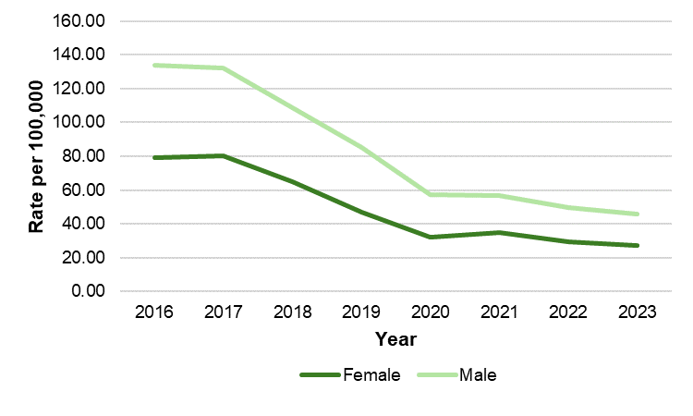

N=36,743

Rate

|  |  |  |  |  |  |  |  |  |
| --- | --- | --- | --- | --- | --- | --- | --- | --- |
|  | 2016 | 2017 | 2018 | 2019 | 2020 | 2021 | 2022 | 2023 |
| Female | 79.05 | 79.99 | 65.15 | 47.18 | 32.08 | 34.76 | 29.37 | 27.00 |
| Male | 133.95 | 132.24 | 108.73 | 85.41 | 57.40 | 56.82 | 49.66 | 45.82 |

N

|  |  |  |  |  |  |  |  |  |
| --- | --- | --- | --- | --- | --- | --- | --- | --- |
|  | 2016 | 2017 | 2018 | 2019 | 2020 | 2021 | 2022 | 2023 |
| Female | 2,797 | 2,847 | 2,330 | 1,691 | 1,161 | 1,258 | 1,063 | 977 |
| Male | 4,469 | 4,440 | 3,668 | 2,889 | 1,958 | 1,938 | 1,694 | 1,563 |

601 cases not included because recorded sex or gender was either transgender or missing. The number of transgender cases is not explicitly included as it is <5 in some years.

The rate of confirmed and probable HCV cases is higher among males as compared to females for every year between 2016 and 2023, though rates for both decrease significantly over time.

Figure 39. Pie chart of confirmed and probable hepatitis C cases by recorded sex or gender and injection drug use status, MA, 2023

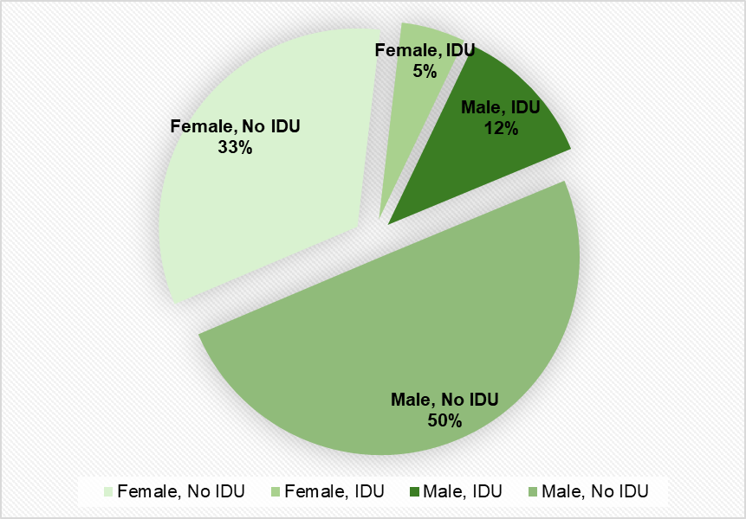

N=2,540. There are a total of 2,580 HCV cases in 2023; 40 cases not included because recorded sex or gender was either transgender or missing. The number of transgender cases is not explicitly included as it is <5. The “No IDU” groups include those cases for whom the risk factor was unknown.

Males made up a greater share of all HCV cases reported in 2023 (62%) than did females (38%). Further, males with HCV were also more likely to report injection drug use as a risk factor than were females with HCV.

Figure 40. Age-adjusted rate of confirmed and probable hepatitis C cases by race/ethnicity and year, MA, 2016-2023

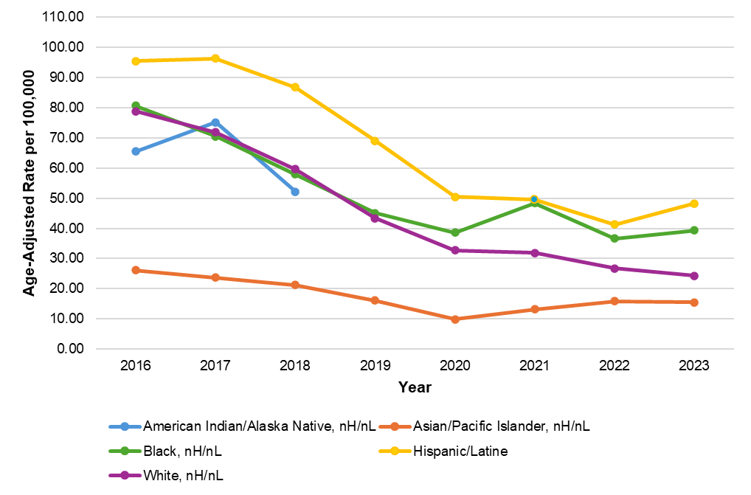

*Rates for the American Indian/Alaska Native population are not displayed for years 2019, 2020, 2022, and 2023 due to N <5

Rates

|  |  |  |  |  |  |  |  |  |
| --- | --- | --- | --- | --- | --- | --- | --- | --- |
| Race/ethnicity | 2016 | 2017 | 2018 | 2019 | 2020 | 2021 | 2022 | 2023 |
| American Indian/Alaska Native, nH/nL | 65.53 | 75.10 | 52.11 |  |  | 48.97 |  |  |
| Asian/Pacific Islander, nH/nL | 26.13 | 23.70 | 21.20 | 16.11 | 9.85 | 13.20 | 15.84 | 15.54 |
| Black, nH/nL | 80.63 | 70.51 | 57.85 | 45.03 | 38.65 | 48.33 | 36.66 | 39.34 |
| Hispanic/Latine | 95.43 | 96.28 | 86.75 | 69.05 | 50.40 | 49.64 | 41.34 | 48.24 |
| White, nH/nL | 78.74 | 71.81 | 59.65 | 43.40 | 32.68 | 31.92 | 26.79 | 24.35 |

N

|  |  |  |  |  |  |  |  |  |
| --- | --- | --- | --- | --- | --- | --- | --- | --- |
| Race/ethnicity | 2016 | 2017 | 2018 | 2019 | 2020 | 2021 | 2022 | 2023 |
| American Indian/Alaska Native, nH/nL | 9 | 10 | 7 |  |  | 5 |  |  |
| Asian/Pacific Islander, nH/nL | 108 | 106 | 96 | 75 | 51 | 71 | 84 | 80 |
| Black, nH/nL | 397 | 367 | 303 | 239 | 190 | 240 | 181 | 194 |
| Hispanic/Latine | 744 | 773 | 704 | 542 | 422 | 414 | 338 | 374 |
| White, nH/nL | 3,840 | 3,602 | 2,954 | 2,118 | 1,593 | 1,537 | 1,270 | 1,170 |
| Other, nH/nL | 665 | 594 | 470 | 463 | 323 | 285 | 257 | 181 |

Rates of newly reported confirmed and probable HCV cases declined for all racial and ethnic groups in Massachusetts between 2016 and 2023, though disparities are evident across groups. Individuals identifying as Hispanic/Latine had the highest rates of reported infection in 2023, followed by individuals identifying as Black, non-Hispanic/non-Latine, potentially pointing to inequitable access to prevention services and curative therapies. Between 2022 and 2023, rates for both of these groups increased slightly while the rate among white nH/nL decreased. The lowest rates of reported infections were observed among individuals identifying as Asian/Pacific Islander, non-Hispanic/non-Latine, though rates in this group also increased slightly between 2020 and 2023. Note that due to small cell sizes, rates for individuals identifying as American Indian or Alaska Native, non-Hispanic/non-Latine can only be displayed for 2016-2018 and 2021.

It should be noted that there are significant missing data for race/ethnicity (a total of 8,891 cases [24%] with unknown race/ethnicity between 2016-2023) which may affect the calculation and interpretation of rates, especially if data are missing in a nonrandom or biased way. For example, if cases among Black, nH/nL individuals were less likely to have an accurate race or ethnicity reported than cases among White, nH/nL individuals, the calculated rate for Black, nH/nL will be artificially low.

Figure 41. Histograms of number of hepatitis C cases by age and recorded sex or gender, MA, years 2008, 2013, 2018, and 2023

**Confirmed & probable hepatitis C cases by age and recorded sex or gender**

|  |  |
| --- | --- |
| **2008** | **2013** |
| A set of four histograms showing the number of newly reported confirmed and probable cases of hepatitis C infection by year, age, and reported sex or gender. In 2008, an increase in cases among young adults is noted; by 2023, reported cases are primarily among young adults, and case counts decrease as time goes on.  N=8,084, 75 missing age or sex | A set of four histograms showing the number of newly reported confirmed and probable cases of hepatitis C infection by year, age, and reported sex or gender. In 2008, an increase in cases among young adults is noted; by 2023, reported cases are primarily among young adults, and case counts decrease as time goes on.  N=7,880, 42 missing age or sex |
| **2018** | **2023** |
| A set of four histograms showing the number of newly reported confirmed and probable cases of hepatitis C infection by year, age, and reported sex or gender. In 2008, an increase in cases among young adults is noted; by 2023, reported cases are primarily among young adults, and case counts decrease as time goes on.  N=5,951, 118 missing age or sex | A set of four histograms showing the number of newly reported confirmed and probable cases of hepatitis C infection by year, age, and reported sex or gender. In 2008, an increase in cases among young adults is noted; by 2023, reported cases are primarily among young adults, and case counts decrease as time goes on.N=2,539, 41 missing age or sex |

Tracking newly reported confirmed and probable cases by age over time enables the monitoring of the leading edge of the HCV epidemic. In 2008, an increase in cases among young people, driven by injection drug use, was evident. The age distribution of newly reported cases took the form of a bimodal curve. As time went on, through 2013, 2018, and 2023, newly reported cases continued to shift into younger age groups. In each year displayed, individuals with a recorded sex or gender of male made up the majority of cases. Additionally, by 2023, the number of newly reported cases had dropped significantly from years prior.

Figure 42. Number of confirmed chronic hepatitis C cases by risk factor, MA, 2016-2023

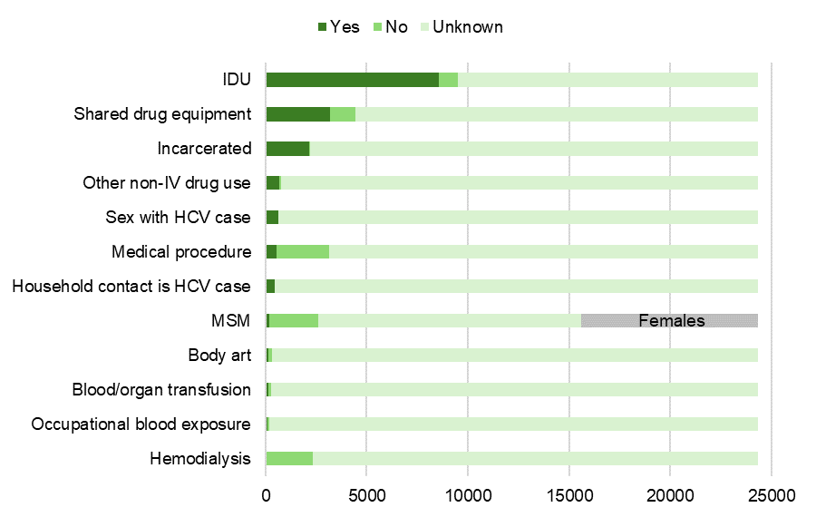

N=24,356  
MSM N=15,596 (includes MSM unknown); 8,760 females are represented in gray in the MSM bar because MSM (men who have sex with men), by definition, excludes females.

The most commonly reported risk factor among confirmed chronic HCV cases between 2016 and 2023 was injection drug use. Other commonly reported risk factors included reporting sharing drug equipment, as well as a history of incarceration. There are significant amounts of missing data in the risk factor analyses (61% unknown for injection drug use, for example). Of those for whom injection drug use status was known, 90% reported it as a risk factor. Less common risk factors include body art such as tattoos or piercings, receiving blood transfusion or organ transplantation, occupational exposure to blood, and hemodialysis.

Figure 43. Number of confirmed and probable acute hepatitis C cases by risk factor, MA, 2016-2023

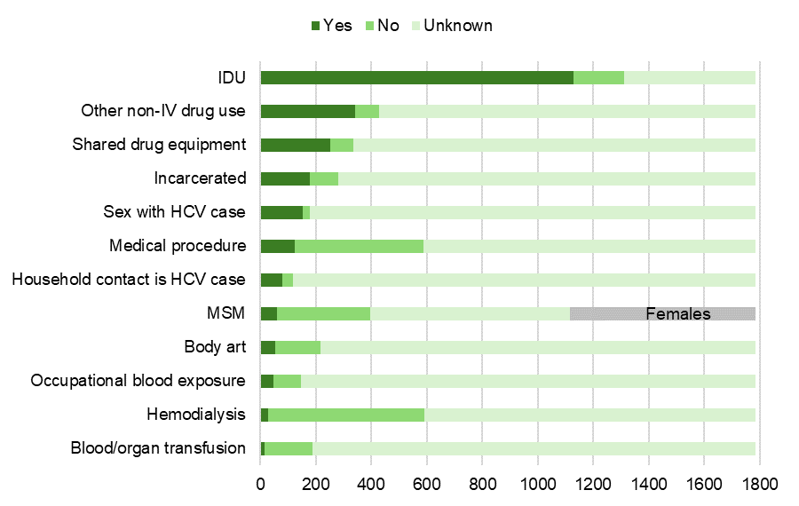

N=1,784

MSM N=1,115 (includes MSM unknown); 669 females are represented in gray in the MSM bar because MSM (men who have sex with men), by definition, excludes females.

Acute cases of HCV infection in Massachusetts are actively investigated by staff at local health departments in conjunction with epidemiologists at DPH. Because of this, completeness for risk history is significantly higher for acute cases than for chronic cases. Among confirmed and probable acute HCV cases reported between 2016 and 2023, injection drug use was again the most commonly reported risk factor (reported by 63% of all acute cases, and 86% of acute cases for whom injection drug use status was known). Other commonly reported risk factors included other, non-injection drug use, sharing drug equipment, and sexual contact with someone with HCV infection. As with chronic cases, potential sources of exposure such as hemodialysis and blood transfusion or organ transplantation were less commonly reported.

Figure 44. Laboratory-based hepatitis C virus clearance cascade, MA, 2014-2023

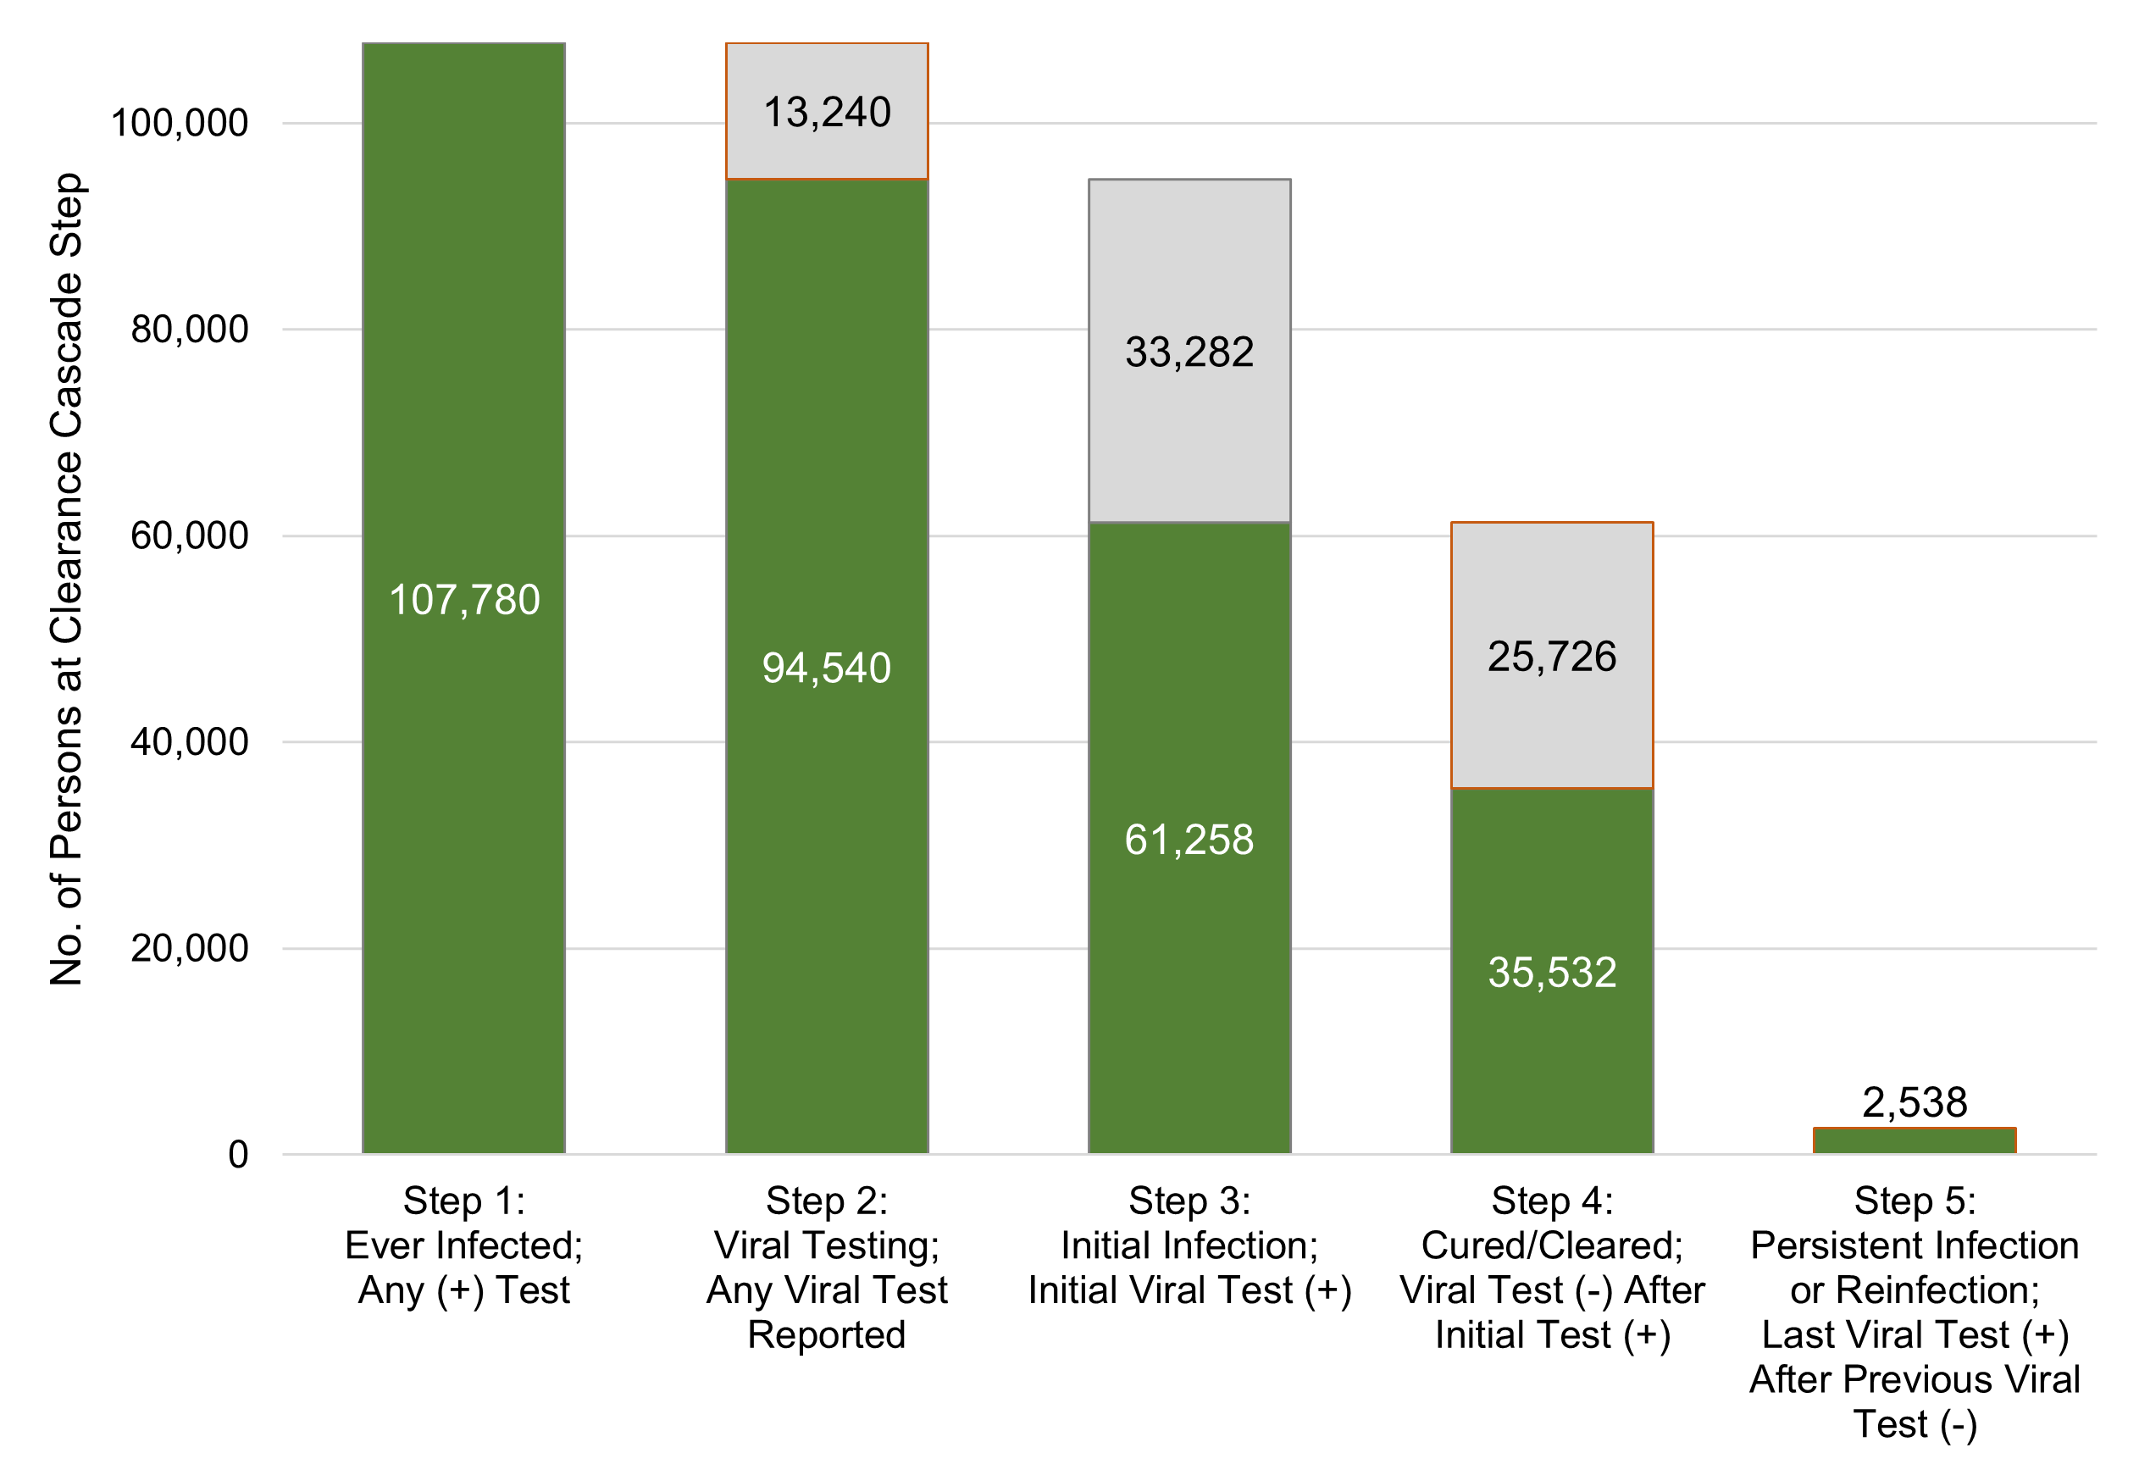

The hepatitis C virus clearance cascade is a framework to measure population-level progress toward HCV clearance or cure. Individuals were included in the cascade if they had a positive HCV test (antibody, RNA, or genotype) reported between January 1, 2014 and December 31, 2022 (Step 1). These ever-infected individuals were then conditionally categorized, using HCV viral tests (RNA, genotype) reported between January 1, 2014 and December 31, 2023, into the remaining steps:

* Step 2 - Viral test performed; any viral test reported
* Step 3 - Initial infection; initial viral test positive
* Step 4 - Cured/cleared; viral test negative after viral test positive
* Step 5 - Persistent infection/reinfection; last viral test positive after previous viral test negative

A total of 107,780 individuals had at least one positive test for hepatitis C during the time period assessed. Of those, 94,540 (88%) had a confirmatory test performed. Of those with confirmatory testing, 61,258 (65%) tested positive, and of those testing positive, 35,532 (58%) cleared infection. Persistent infection or reinfection was noted for 2,538 (4%) of all of those who cleared infection.

These findings are similar to the first iteration of Massachusetts’ hepatitis C clearance cascade, containing data through 2022 and published in the Massachusetts HCV Elimination Plan[3], with one exception: methodologies were refined related to the Persistent Infection or Reinfection category (Step 5) so as to consider the last available RNA result, not any subsequent positive RNA result following a negative. This more accurately describes the current infection status of an individual, and resulted in a lower estimate for reinfection than previously described.

While Massachusetts outperformed the national estimate of 34%, 58% cleared/cured is short of the 80% goal by 2030 set by the US Viral Hepatitis National Strategic Plan and included in the Massachusetts HCV Elimination Plan. Developing a laboratory-based HCV clearance cascade illuminates gaps in confirmatory testing and treatment, as indicated by the sections of the figure highlighted in orange. At least 13,240 people need HCV confirmatory testing and at least 28,264 people need HCV treatment.

# Appendix

Confirmed and probable hepatitis C cases by city/town, MA, 2016-2023

|  |  |  |  |
| --- | --- | --- | --- |
| City/Town | N | Population | Rate |
| Abington | 65 | 17,062 | 54.42 |
| Acton | 21 | 24,021 | 12.49 |
| Acushnet | 47 | 10,559 | 63.59 |
| Adams | 67 | 8,166 | 117.21 |
| Agawam | 105 | 28,692 | 52.28 |
| Alford | 0 | 486 | 0 |
| Amesbury | 97 | 17,366 | 79.79 |
| Amherst | 51 | 39,263 | 18.56 |
| Andover | 56 | 36,569 | 21.88 |
| Aquinnah | 0 | 439 | 0 |
| Arlington | 105 | 46,308 | 32.39 |
| Ashburnham | 24 | 6,315 | 54.29 |
| Ashby | 17 | 3,193 | 76.06 |
| Ashfield | 0 | 1,695 | 0 |
| Ashland | 36 | 18,832 | 27.31 |
| Athol | 128 | 11,945 | 153.08 |
| Attleboro | 225 | 46,461 | 69.18 |
| Auburn | 58 | 16,889 | 49.06 |
| Avon | 21 | 4,777 | 62.8 |
| Ayer | 91 | 8,479 | 153.32 |
| Barnstable | 288 | 48,916 | 84.11 |
| Barre | 32 | 5,530 | 82.67 |
| Becket | 8 | 1,931 | 59.18 |
| Bedford | 30 | 14,383 | 29.8 |
| Belchertown | 57 | 15,350 | 53.05 |
| Bellingham | 55 | 16,945 | 46.37 |
| Belmont | 65 | 27,295 | 34.02 |
| Berkley | 26 | 6,764 | 54.91 |
| Berlin | 6 | 3,158 | 27.14 |
| Bernardston | 11 | 2,102 | 74.76 |
| Beverly | 143 | 42,670 | 47.88 |
| Billerica | 349 | 42,119 | 118.37 |
| Blackstone | 47 | 9,208 | 72.92 |
| Blandford | 6 | 1,215 | 70.55 |
| Bolton | 12 | 5,665 | 30.26 |
| Boston | 4,309 | 675,647 | 91.11 |
| Bourne | 156 | 20,452 | 108.97 |
| Boxborough | 15 | 5,506 | 38.92 |
| Boxford | 7 | 8,203 | 12.19 |
| Boylston | 12 | 4,849 | 35.35 |
| Braintree | 172 | 39,143 | 62.77 |
| Brewster | 26 | 10,318 | 36 |
| Bridgewater | 198 | 28,633 | 98.79 |
| Brimfield | 14 | 3,694 | 54.14 |
| Brockton | 626 | 105,643 | 84.65 |
| Brookfield | 23 | 3,439 | 95.54 |
| Brookline | 88 | 63,191 | 19.89 |
| Buckland | <5 | 1,816 |  |
| Burlington | 52 | 26,377 | 28.16 |
| Cambridge | 332 | 118,403 | 40.06 |
| Canton | 60 | 24,370 | 35.17 |
| Carlisle | 9 | 5,237 | 24.55 |
| Carver | 84 | 11,645 | 103.05 |
| Charlemont | 8 | 1,185 | 96.44 |
| Charlton | 47 | 13,315 | 50.43 |
| Chatham | 19 | 6,594 | 41.16 |
| Chelmsford | 107 | 36,392 | 42 |
| Chelsea | 172 | 40,787 | 60.24 |
| Cheshire | 14 | 3,258 | 61.39 |
| Chester | 8 | 1,228 | 93.07 |
| Chesterfield | <5 | 1,186 |  |
| Chicopee | 543 | 55,560 | 139.62 |
| Chilmark | <5 | 1,212 |  |
| Clarksburg | 6 | 1,657 | 51.73 |
| Clinton | 79 | 15,428 | 73.15 |
| Cohasset | 17 | 8,381 | 28.98 |
| Colrain | 7 | 1,606 | 62.27 |
| Concord | 43 | 18,491 | 33.22 |
| Conway | <5 | 1,761 |  |
| Cummington | 5 | 829 | 86.16 |
| Dalton | 30 | 6,330 | 67.7 |
| Danvers | 98 | 28,087 | 49.85 |
| Dartmouth | 356 | 33,783 | 150.54 |
| Dedham | 157 | 25,364 | 88.43 |
| Deerfield | 16 | 5,090 | 44.91 |
| Dennis | 83 | 14,674 | 80.8 |
| Dighton | 15 | 8,101 | 26.45 |
| Douglas | 40 | 8,983 | 63.61 |
| Dover | 7 | 5,923 | 16.88 |
| Dracut | 116 | 32,617 | 50.81 |
| Dudley | 46 | 11,921 | 55.12 |
| Dunstable | 5 | 3,358 | 21.27 |
| Duxbury | 25 | 16,090 | 22.2 |
| East Bridgewater | 56 | 14,440 | 55.4 |
| East Brookfield | 9 | 2,224 | 57.81 |
| East Longmeadow | 25 | 16,430 | 21.74 |
| Eastham | 15 | 5,752 | 37.25 |
| Easthampton | 59 | 16,211 | 51.99 |
| Easton | 67 | 25,058 | 38.2 |
| Edgartown | 22 | 5,168 | 60.81 |
| Egremont | <5 | 1,372 |  |
| Erving | 8 | 1,665 | 68.64 |
| Essex | 5 | 3,675 | 19.44 |
| Everett | 213 | 49,075 | 62 |
| Fairhaven | 64 | 15,924 | 57.42 |
| Fall River | 996 | 94,000 | 151.37 |
| Falmouth | 260 | 32,517 | 114.23 |
| Fitchburg | 266 | 41,946 | 90.59 |
| Florida | <5 | 694 |  |
| Foxborough | 45 | 18,618 | 34.53 |
| Framingham | 497 | 72,362 | 98.12 |
| Franklin | 88 | 33,261 | 37.8 |
| Freetown | 26 | 9,206 | 40.35 |
| Gardner | 222 | 21,287 | 148.98 |
| Georgetown | 19 | 8,470 | 32.05 |
| Gill | <5 | 1,551 |  |
| Gloucester | 136 | 29,729 | 65.35 |
| Goshen | 0 | 960 | 0 |
| Gosnold | 0 | 70 | 0 |
| Grafton | 42 | 19,664 | 30.51 |
| Granby | 19 | 6,110 | 44.42 |
| Granville | 8 | 1,538 | 74.31 |
| Great Barrington | 56 | 7,172 | 111.54 |
| Greenfield | 208 | 17,768 | 167.23 |
| Groton | 14 | 11,315 | 17.68 |
| Groveland | 14 | 6,752 | 29.62 |
| Hadley | 11 | 5,325 | 29.51 |
| Halifax | 37 | 7,749 | 68.21 |
| Hamilton | 13 | 7,561 | 24.56 |
| Hampden | 18 | 4,966 | 51.78 |
| Hancock | 0 | 757 | 0 |
| Hanover | 38 | 14,833 | 36.6 |
| Hanson | 38 | 10,639 | 51.03 |
| Hardwick | 15 | 2,667 | 80.35 |
| Harvard | 8 | 6,851 | 16.68 |
| Harwich | 49 | 13,440 | 52.08 |
| Hatfield | 11 | 3,352 | 46.88 |
| Haverhill | 401 | 67,787 | 84.51 |
| Hawley | 0 | 353 | 0 |
| Heath | 0 | 723 | 0 |
| Hingham | 45 | 24,284 | 26.47 |
| Hinsdale | 16 | 1,919 | 119.11 |
| Holbrook | 56 | 11,405 | 70.14 |
| Holden | 38 | 19,905 | 27.27 |
| Holland | 17 | 2,603 | 93.3 |
| Holliston | 29 | 14,996 | 27.63 |
| Holyoke | 459 | 38,238 | 171.48 |
| Hopedale | 15 | 6,017 | 35.61 |
| Hopkinton | 44 | 18,758 | 33.51 |
| Hubbardston | 18 | 4,328 | 59.41 |
| Hudson | 52 | 20,092 | 36.97 |
| Hull | 66 | 10,072 | 93.61 |
| Huntington | 10 | 2,094 | 68.22 |
| Ipswich | 35 | 13,785 | 36.27 |
| Kingston | 55 | 13,708 | 57.32 |
| Lakeville | 46 | 11,523 | 57.03 |
| Lancaster | 15 | 8,441 | 25.39 |
| Lanesborough | 11 | 3,038 | 51.73 |
| Lawrence | 510 | 89,143 | 81.73 |
| Lee | 34 | 5,788 | 83.92 |
| Leicester | 45 | 11,087 | 57.98 |
| Lenox | 18 | 5,095 | 50.47 |
| Leominster | 210 | 43,782 | 68.52 |
| Leverett | <5 | 1,865 |  |
| Lexington | 55 | 34,454 | 22.8 |
| Leyden | <5 | 734 |  |
| Lincoln | 9 | 7,014 | 18.33 |
| Littleton | 19 | 10,141 | 26.77 |
| Longmeadow | 17 | 15,853 | 15.32 |
| Lowell | 971 | 115,554 | 120.04 |
| Ludlow | 336 | 21,002 | 228.55 |
| Lunenburg | 30 | 11,782 | 36.38 |
| Lynn | 662 | 101,253 | 93.4 |
| Lynnfield | 19 | 13,000 | 20.88 |
| Malden | 268 | 66,263 | 57.78 |
| Manchester | 6 | 5,395 | 15.89 |
| Mansfield | 56 | 23,860 | 33.53 |
| Marblehead | 38 | 20,441 | 26.56 |
| Marion | 9 | 5,347 | 24.05 |
| Marlborough | 125 | 41,793 | 42.73 |
| Marshfield | 115 | 25,825 | 63.61 |
| Mashpee | 63 | 15,060 | 59.76 |
| Mattapoisett | 21 | 6,508 | 46.1 |
| Maynard | 26 | 10,746 | 34.56 |
| Medfield | 14 | 12,799 | 15.63 |
| Medford | 200 | 59,659 | 47.89 |
| Medway | 25 | 13,115 | 27.23 |
| Melrose | 70 | 29,817 | 33.54 |
| Mendon | 10 | 6,228 | 22.94 |
| Merrimac | 14 | 6,723 | 29.75 |
| Methuen | 202 | 53,059 | 54.39 |
| Middleborough | 123 | 24,245 | 72.47 |
| Middlefield | <5 | 385 |  |
| Middleton | 189 | 9,779 | 276.1 |
| Milford | 83 | 30,379 | 39.03 |
| Millbury | 60 | 13,831 | 61.97 |
| Millis | 26 | 8,460 | 43.9 |
| Millville | 10 | 3,174 | 45.01 |
| Milton | 53 | 28,630 | 26.45 |
| Monroe | 0 | 118 | 0 |
| Monson | 28 | 8,150 | 49.08 |
| Montague | 53 | 8,580 | 88.25 |
| Monterey | 5 | 1,095 | 65.23 |
| Montgomery | <5 | 819 |  |
| Mount Washington | 0 | 160 | 0 |
| Nahant | 9 | 3,334 | 38.56 |
| Nantucket | 43 | 14,255 | 43.09 |
| Natick | 70 | 37,006 | 27.02 |
| Needham | 34 | 32,091 | 15.14 |
| New Ashford | 0 | 250 | 0 |
| New Bedford | 993 | 101,079 | 140.34 |
| New Braintree | <5 | 996 |  |
| New Marlborough | <5 | 1,528 |  |
| New Salem | <5 | 983 |  |
| Newbury | 18 | 6,716 | 38.29 |
| Newburyport | 54 | 18,289 | 42.18 |
| Newton | 164 | 88,923 | 26.35 |
| Norfolk | 47 | 11,662 | 57.57 |
| North Adams | 183 | 12,961 | 201.7 |
| North Andover | 52 | 30,915 | 24.03 |
| North Attleborough | 120 | 30,834 | 55.6 |
| North Brookfield | 27 | 4,735 | 81.46 |
| North Reading | 47 | 15,554 | 43.17 |
| Northampton | 152 | 29,571 | 73.43 |
| Northborough | 24 | 15,741 | 21.78 |
| Northbridge | 68 | 16,335 | 59.47 |
| Northfield | 12 | 2,866 | 59.81 |
| Norton | 130 | 19,202 | 96.72 |
| Norwell | 29 | 11,351 | 36.5 |
| Norwood | 103 | 31,611 | 46.55 |
| Oak Bluffs | 16 | 5,341 | 42.8 |
| Oakham | 5 | 1,851 | 38.59 |
| Orange | 56 | 7,569 | 105.69 |
| Orleans | 23 | 6,307 | 52.1 |
| Otis | 12 | 1,634 | 104.91 |
| Oxford | 59 | 13,347 | 63.15 |
| Palmer | 76 | 12,448 | 87.22 |
| Paxton | <5 | 5,004 |  |
| Peabody | 215 | 54,481 | 56.38 |
| Pelham | <5 | 1,280 |  |
| Pembroke | 60 | 18,361 | 46.68 |
| Pepperell | 48 | 11,604 | 59.09 |
| Peru | <5 | 814 |  |
| Petersham | <5 | 1,194 |  |
| Phillipston | 7 | 1,726 | 57.94 |
| Pittsfield | 520 | 43,927 | 169.11 |
| Plainfield | <5 | 633 |  |
| Plainville | 32 | 9,945 | 45.97 |
| Plymouth | 404 | 61,217 | 94.28 |
| Plympton | 20 | 2,930 | 97.51 |
| Princeton | <5 | 3,495 |  |
| Provincetown | 24 | 3,664 | 93.57 |
| Quincy | 520 | 101,636 | 73.09 |
| Randolph | 142 | 34,984 | 57.99 |
| Raynham | 61 | 15,142 | 57.55 |
| Reading | 42 | 25,518 | 23.51 |
| Rehoboth | 26 | 12,502 | 29.71 |
| Revere | 311 | 62,186 | 71.44 |
| Richmond | <5 | 1,407 |  |
| Rochester | 13 | 5,717 | 32.48 |
| Rockland | 103 | 17,803 | 82.65 |
| Rockport | 14 | 6,992 | 28.6 |
| Rowe | 0 | 424 | 0 |
| Rowley | 13 | 6,161 | 30.14 |
| Royalston | 6 | 1,250 | 68.57 |
| Russell | 10 | 1,643 | 86.95 |
| Rutland | 21 | 9,049 | 33.15 |
| Salem | 205 | 44,480 | 65.84 |
| Salisbury | 81 | 9,236 | 125.29 |
| Sandisfield | <5 | 989 |  |
| Sandwich | 55 | 20,259 | 38.78 |
| Saugus | 129 | 28,619 | 64.39 |
| Savoy | <5 | 645 |  |
| Scituate | 51 | 19,063 | 38.22 |
| Seekonk | 50 | 15,531 | 45.99 |
| Sharon | 35 | 18,575 | 26.92 |
| Sheffield | 17 | 3,327 | 73 |
| Shelburne | 12 | 1,884 | 90.99 |
| Sherborn | 7 | 4,401 | 22.72 |
| Shirley | 144 | 7,431 | 276.83 |
| Shrewsbury | 89 | 38,325 | 33.17 |
| Shutesbury | 6 | 1,717 | 49.92 |
| Somerset | 61 | 18,303 | 47.61 |
| Somerville | 192 | 81,045 | 33.84 |
| South Hadley | 55 | 18,150 | 43.29 |
| Southampton | 9 | 6,224 | 20.66 |
| Southborough | 21 | 10,450 | 28.71 |
| Southbridge | 222 | 17,740 | 178.77 |
| Southwick | 27 | 9,232 | 41.78 |
| Spencer | 68 | 11,992 | 81.01 |
| Springfield | 1,380 | 155,929 | 126.43 |
| Sterling | 16 | 7,985 | 28.63 |
| Stockbridge | 5 | 2,018 | 35.4 |
| Stoneham | 83 | 23,244 | 51.01 |
| Stoughton | 124 | 29,281 | 60.5 |
| Stow | 9 | 7,174 | 17.92 |
| Sturbridge | 32 | 9,867 | 46.33 |
| Sudbury | 24 | 18,934 | 18.11 |
| Sunderland | 11 | 3,663 | 42.9 |
| Sutton | 24 | 9,357 | 36.64 |
| Swampscott | 24 | 15,111 | 22.69 |
| Swansea | 72 | 17,144 | 60 |
| Taunton | 475 | 59,408 | 114.22 |
| Templeton | 56 | 8,149 | 98.17 |
| Tewksbury | 115 | 31,342 | 52.42 |
| Tisbury | 33 | 4,815 | 97.91 |
| Tolland | <5 | 471 |  |
| Topsfield | 12 | 6,569 | 26.1 |
| Townsend | 43 | 9,127 | 67.3 |
| Truro | 8 | 2,454 | 46.57 |
| Tyngsborough | 38 | 12,380 | 43.85 |
| Tyringham | <5 | 427 |  |
| Upton | 19 | 8,000 | 33.93 |
| Uxbridge | 53 | 14,162 | 53.46 |
| Wakefield | 77 | 27,090 | 40.61 |
| Wales | 5 | 1,832 | 38.99 |
| Walpole | 236 | 26,383 | 127.79 |
| Waltham | 203 | 65,218 | 44.47 |
| Ware | 63 | 10,066 | 89.41 |
| Wareham | 191 | 23,303 | 117.09 |
| Warren | 31 | 4,975 | 89.02 |
| Warwick | 7 | 780 | 128.21 |
| Washington | <5 | 494 |  |
| Watertown | 123 | 35,329 | 49.74 |
| Wayland | 21 | 13,943 | 21.52 |
| Webster | 118 | 17,776 | 94.83 |
| Wellesley | 32 | 29,550 | 15.47 |
| Wellfleet | 12 | 3,566 | 48.07 |
| Wendell | <5 | 924 |  |
| Wenham | 9 | 4,979 | 25.82 |
| West Boylston | 149 | 7,877 | 270.23 |
| West Bridgewater | 26 | 7,707 | 48.19 |
| West Brookfield | 24 | 3,833 | 89.45 |
| West Newbury | <5 | 4,500 |  |
| West Springfield | 160 | 28,835 | 79.27 |
| West Stockbridge | <5 | 1,343 |  |
| West Tisbury | 9 | 3,555 | 36.17 |
| Westborough | 59 | 21,567 | 39.08 |
| Westfield | 156 | 40,834 | 54.58 |
| Westford | 36 | 24,643 | 20.87 |
| Westhampton | <5 | 1,622 |  |
| Westminster | 21 | 8,213 | 36.53 |
| Weston | 9 | 11,851 | 10.85 |
| Westport | 73 | 16,339 | 63.83 |
| Westwood | 26 | 16,266 | 22.83 |
| Weymouth | 340 | 57,437 | 84.56 |
| Whately | 0 | 1,607 | 0 |
| Whitman | 72 | 15,121 | 68.02 |
| Wilbraham | 26 | 14,613 | 25.42 |
| Williamsburg | 19 | 2,504 | 108.4 |
| Williamstown | 22 | 7,513 | 41.83 |
| Wilmington | 54 | 23,349 | 33.04 |
| Winchendon | 82 | 10,364 | 113.03 |
| Winchester | 33 | 22,970 | 20.52 |
| Windsor | <5 | 831 |  |
| Winthrop | 86 | 19,316 | 63.6 |
| Woburn | 138 | 40,876 | 48.23 |
| Worcester | 1,562 | 206,518 | 108.05 |
| Worthington | 0 | 1,193 | 0 |
| Wrentham | 36 | 12,178 | 42.23 |
| Yarmouth | 127 | 25,023 | 72.5 |
| Unknown | 2,806 | - | - |

Confirmed and probable HCV cases by county, 2016-2023

|  |  |  |  |
| --- | --- | --- | --- |
| County | N | Population | Rate |
| Berkshire County | 1,053 | 129,026 | 116.59 |
| Bristol County | 3,939 | 579,200 | 97.15 |
| Cape and Islands | 1,333 | 263,851 | 72.17 |
| Essex County | 3,502 | 809,829 | 61.78 |
| Franklin County | 435 | 71,029 | 87.49 |
| Hampden County | 3,426 | 465,825 | 105.07 |
| Hampshire County | 534 | 162,308 | 47 |
| Middlesex County | 5,705 | 1,632,002 | 49.94 |
| Norfolk County | 2,591 | 725,981 | 50.99 |
| Plymouth County | 2,616 | 530,819 | 70.4 |
| Suffolk County | 4,878 | 797,936 | 87.33 |
| Worcester County | 4,526 | 862,111 | 75 |
| Statewide | 37,344 | 7,029,917 | 75.89 |
| Unknown County | 2,806 | - | - |

1. *Strate S, et al. Small Area Population Estimates for 2011 through 2020, report published Oct 2016. Available at:* [*http://pep.donahue-institute.org/*](http://pep.donahue-institute.org/)
2. *Panagiotakopoulos L, Sandul AL, et al. CDC Recommendations for Hepatitis C Testing Among Perinatally Exposed Infants and Children — United States, 2023. MMWR Recomm Rep 2023;72(No. RR-4):1–19. DOI: http://dx.doi.org/10.15585/mmwr.rr7204a1*
3. <https://www.mass.gov/info-details/massachusetts-hcv-elimination-plan>